Hosting-hub
Ui build,

cd hosting-hub /ls hosting-hub ls
go to the,
sudo vim angular.json

In this file we need to change maximumwarring, maxmimumerror then run the npm build,
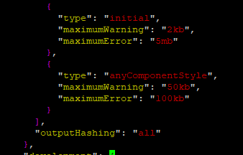

Sudo npm run build
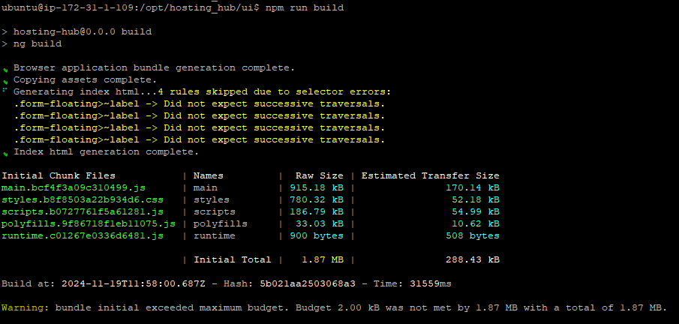
Build completed,

