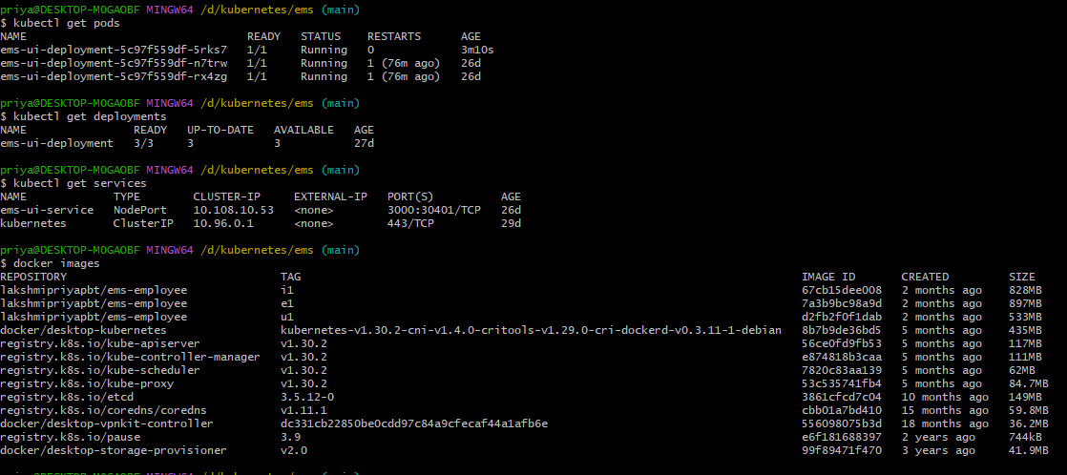

1. Ensure Ingress Controller is Installed
Install NGINX Ingress Controller
kubectl apply -f https://raw.githubusercontent.com/kubernetes/ingress-nginx/main/deploy/static/provider/cloud/deploy.yaml
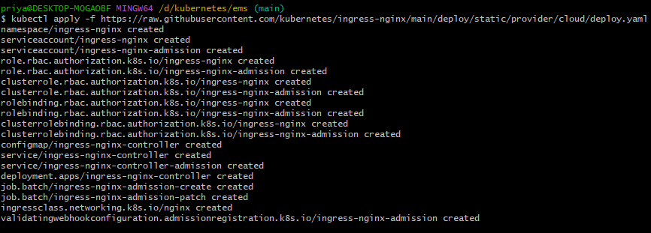

Check if the Ingress Controller pods are running:
kubectl get pods -n ingress-nginx
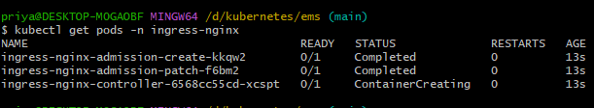

This command should show you the Ingress Controller pods in the ingress-nginx namespace
After installing the Ingress Controller, you can create an Ingress resource that exposes your ems-ui-service.

2. Create an Ingress Resource
Vim ingress.yaml
service named ems-ui-service that you want to expose through Ingress. Create an Ingress resource to route traffic to this service.

Vim ingress.yaml
apiVersion: networking.k8s.io/v1
kind: Ingress
metadata:
name: ems-ui-ingress
namespace: default
spec:
rules:
- host: ems.local # Use this domain in your browser
http:
paths:
- path: /
pathType: Prefix
backend:
service:
name: ems-ui-service
port:
number: 3000

Explanation:
- host: ems.local: This is the domain you'll use to access the service. You'll need to modify your hosts file to point ems.local to your Kubernetes cluster.
- service.name: ems-ui-service: This is the name of the service you are exposing.
- service.port.number: 3000: The port the service is exposing.

Apply the Ingress resource:
kubectl apply -f ingress.yaml

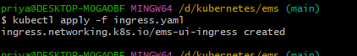

3. Edit the /etc/hosts file (Local machine setup)
To access the service using the ems.local domain, add an entry in your /etc/hosts file
Add the following line (replace with the external IP of your Minikube or Kubernetes setup)

Vim /etc/hosts
127.0.0.1 ems.local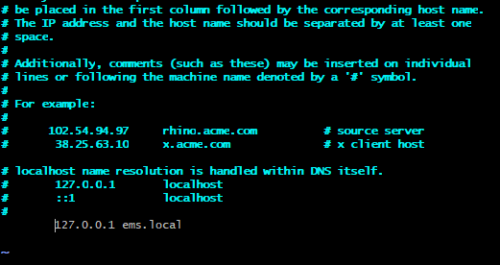
To find the ip of ingresscontroller
kubectl get services -o wide -w -n ingress-nginx
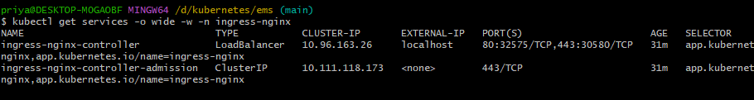

The EXTERNAL-IP of the ingress service will be the one you use.

4.Verify the Ingress
kubectl get ingress
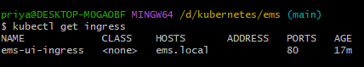

5. Access the Application
http://ems.local:3000
The NGINX Ingress Controller will route the requests to the corresponding service inside the cluster.

6. Check Logs
kubectl logs -n ingress-nginx <nginx-ingress-pod-name>

ingressClassName: nginx

Ingress Controller service (ingress-nginx-controller) is exposed and accessible. You can check the services using
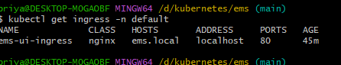

Verify the Service:
Once you've applied the updated YAML, you can verify that the service is running and the ports are correctly exposed:
kubectl get svc -n ingress-nginx
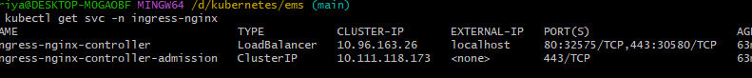

pods are healthy and reachable by verifying their status:
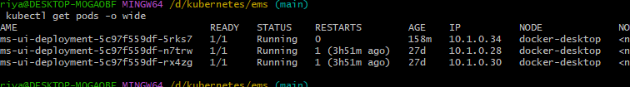

Verify the Ingress Routing

curl -H "Host: ems.local" http://localhost:80
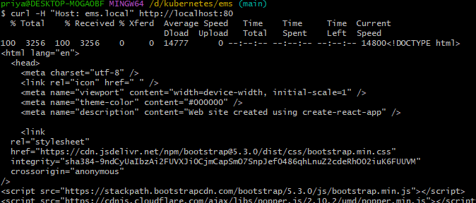

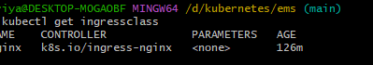

kubectl get pods -n ingress-nginx
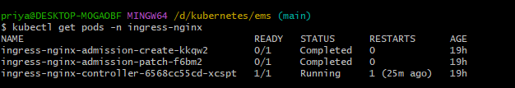

kubectl logs -n ingress-nginx ingress-nginx-controller-6568cc55cd-xcspt
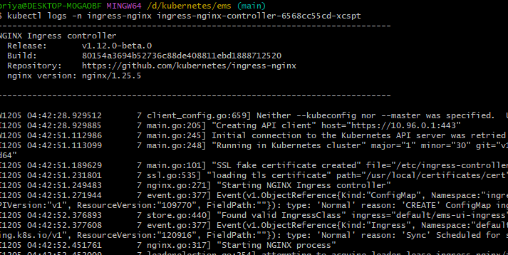

Ping ems.local

Hers in browser with http://ems.local it is not working becoz

It looks like you're editing the /etc/hosts file, which is a typical Linux file path. However, since you're using Windows (based on the prompt MINGW64 from Git Bash), you need to modify the Windows hosts file, not the Linux-style /etc/hosts file.

Steps to Edit the Windows hosts File:

1. Open the Correct hosts File
- Open Notepad as Administrator (important to avoid permission issues).
  - Press Windows key, search for Notepad, right-click and choose Run as Administrator.
- In Notepad, open the file C:\Windows\System32\drivers\etc\hosts.
  - To do this, go to File > Open, and then type C:\Windows\System32\drivers\etc\hosts into the file path box.
  - Make sure to set the file type to All Files in the "Open" dialog box (not just .txt files).

2. Add the ems.local Entry
In the hosts file, add the following line at the end of the file:
127.0.0.1 ems.local

This will map ems.local to 127.0.0.1 (your local machine).

3. Save and Close the File
Save the file and close Notepad.

4. Flush the DNS Cache
After editing the hosts file, you need to flush the DNS cache to apply the changes:
- Open Command Prompt (or PowerShell) as Administrator.
- Run the following command:
ipconfig /flushdns
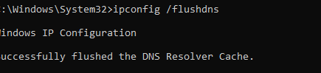

5. Verify DNS Resolution
To check if the ems.local domain is resolved to 127.0.0.1, run the following command in Command Prompt:
ping ems.local
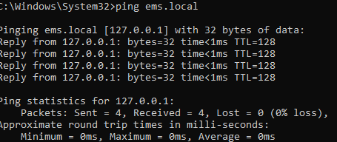

In browser http://ems.local
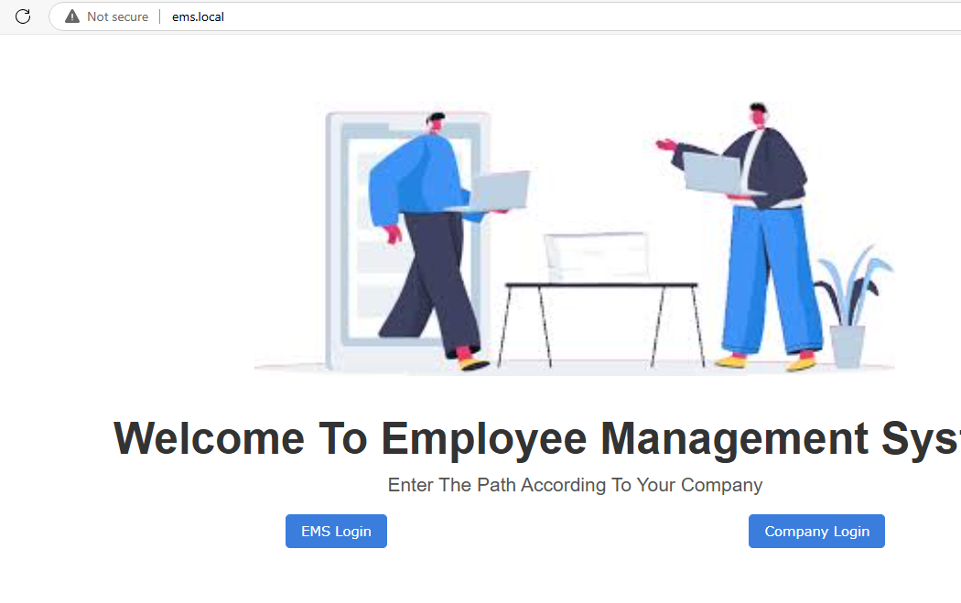

expose our services running inside Kubernetes, use a NodePort service to expose the service on a specific port.

vim ingress-controller-service.yaml

apiVersion: v1
kind: Service
metadata:
name: nginx-ingress-controller
namespace: ingress-nginx
spec:
type: NodePort # Exposes the service on a port on the host machine
ports:
- name: http # Name for HTTP port
port: 80 # HTTP port
targetPort: http # The port where the Ingress controller listens internally
nodePort: 30080 # Expose HTTP traffic on NodePort 30080
- name: https # Name for HTTPS port
port: 443 # HTTPS port
targetPort: https
nodePort: 30443 # Expose HTTPS traffic on NodePort 30443
selector:
app.kubernetes.io/name: ingress-nginx

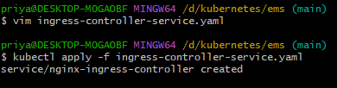

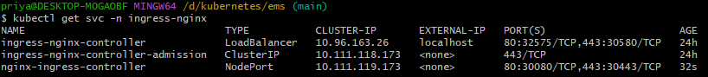

In browser http://ems.local:30080


In browser https://ems.local:30443


