OUTLIERS
An Outlier is a data point that is significantly different from other observations in a dataset. It is an unusually high or low value that does not follow the general pattern of the data.
Example of an Outlier:
Imagine you have the following dataset representing the monthly salaries (in ₹) of 10 employees in a company:
Salaries:
30,000, 32,000, 31,500, 29,800, 30,500, 31,200, 30,700, 29,900, 30,400, 1,50,000
In this dataset, most salaries are around ₹30,000–₹32,000. However, there is one salary of ₹1,50,000, which is much higher than the others.
This ₹1,50,000 salary is an outlier because it is significantly different from the rest of the data.
It could be happened due to:
- A data entry error
- A special case (e.g., a CEO's salary in a dataset of regular employees)
- A genuine high-paying role

Why Outliers Occurs:
Outliers occur due to various reasons, and understanding them helps in deciding whether to remove or handle them differently. Here are the main reasons why outliers occur:
1. Data Entry or Measurement Errors
- Mistakes in data entry (e.g., typing 100000 instead of 10000).
- Sensor malfunctions in automated data collection.
- Misreading measurements in scientific experiments.
Example:
A temperature sensor records 500°C instead of 50°C due to a fault.

2. Natural Variation in Data
- Some data points may be naturally extreme.
- Occurs in real-world scenarios like sports, finance, and human traits.
Example:
In a 100m sprint, most athletes finish in 10–12 seconds, but Usain Bolt's 9.58 seconds is an outlier.
3. Experimental or Sampling Errors
- Data collected from the wrong population.
- Small sample sizes may have extreme values.
Example:
If a survey on monthly expenses accidentally includes one billionaire, their spending would be an outlier.
an outlier.
4. Fraudulent or Malicious Activity
- Outliers may indicate fraud in transactions.
- Used in fraud detection models.
Example:
A person typically spends ₹5,000 per month, but suddenly a ₹5,00,000 transaction appears—this could be fraud.
5. Changes in System Behaviour
- External factors like policy changes or market crashes.
Example:
Stock prices suddenly drop 50% in one day due to unexpected news.

How to Identify Outliers?
Outliers can be identified using visual methods and statistical techniques. Below are some of the most common approaches:
- Statistical Methods (Best for Large Datasets).
- Visual Methods (Best for Quick Analysis).

Statistical Methods:
Outlier detection involves identifying data points that deviate significantly from the rest of the dataset. The most common statistical methods are:
(A) Z-Score Method.
(B) IQR (Interquartile Range) Method.

A) Z-Score Method.
The Z-score Measures how far a data point is from the mean in terms of standard deviations.
Threshold: If Z-score > 3 or Z-score < -3, it is an outlier.

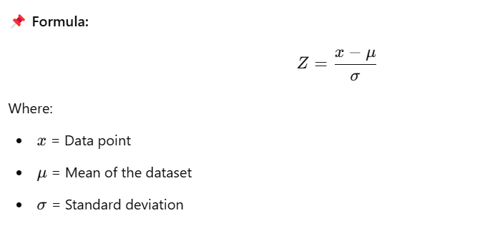

Why we compare the Z-score with 3 as in Threshold:
If Z-score > 3 or Z-score < -3, it is an outlier. because of,
- The 3-sigma rule or empirical formula:
The 3-sigma rule (or) Empirical Formula (or the 68-95-99.7 rule) states that in a normal distribution:
- About 68% of data falls within 1 standard deviation (σ) of the mean (μ).
- About 95% of data falls within 2 standard deviations (σ) of the mean.
- About 99.7% of data falls within 3 standard deviations (σ) of the mean.
- A graphical representation of the 3-sigma rule shows a bell curve (normal distribution) with shaded regions representing standard deviations from the mean.
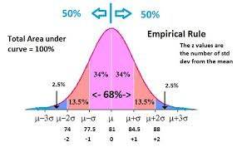

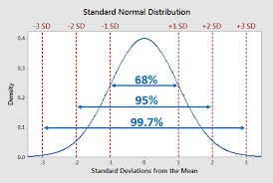

Key points:
- The centre (μ) represents the mean.
- Each σ (sigma) represents a standard deviation.
- 99.7% of data lies within ±3σ.
- Any data point beyond ±3σ (extreme left or right) is considered an outlier.
Conceptual Question:
A teacher is analysing the test scores of 14 students in a recent exam. The scores are as follows:
72,75,78,76,74,75,73,100,74,72,75,73,74,76
Based on the given data, answer the following questions:
- Mean Calculation:
  - What is the mean (μ) of the test scores?
- Standard Deviation Calculation:
  - What is the sample standard deviation (s) of the test scores?
- Z-score Calculation:
  - Using the formula calculate the Z-score for each test score.
- Outlier Detection:
  - According to the 3-sigma rule, any data point with ∣Z∣>3|Z| > 3∣Z∣>3 is considered an outlier.
  - Identify any outliers in the dataset.
- Interpretation:
  - What does a high positive Z-score indicate about a student's test score?
  - What does a negative Z-score indicate?

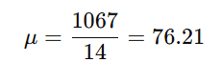
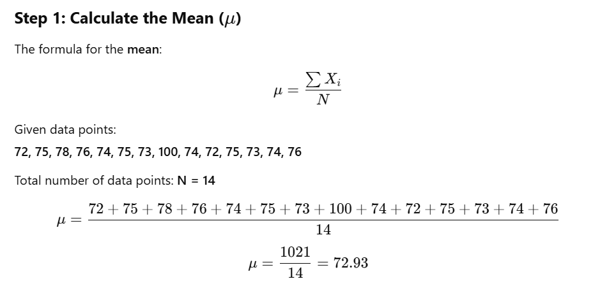
Solution:

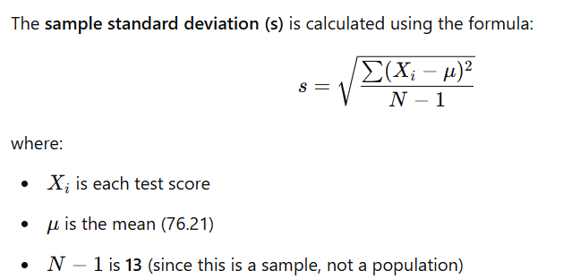
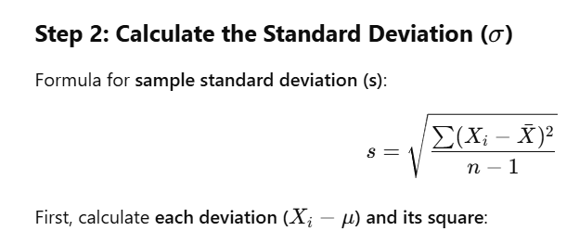

Why we are using the sample standard deviation?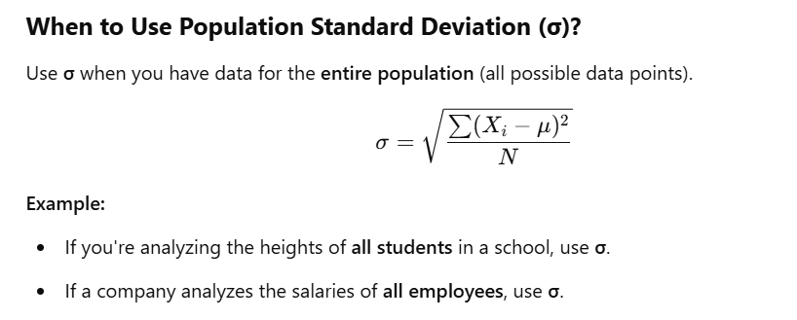
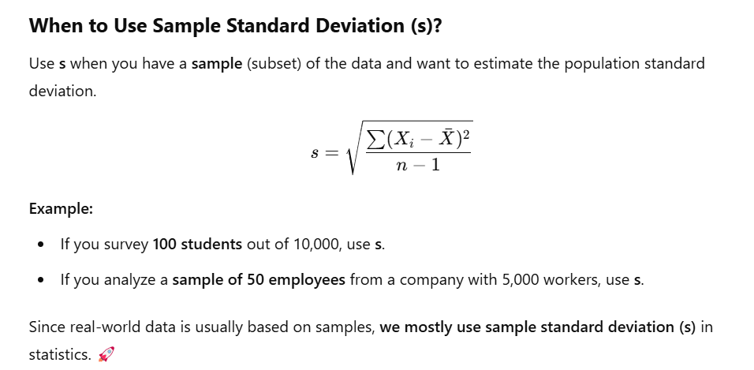
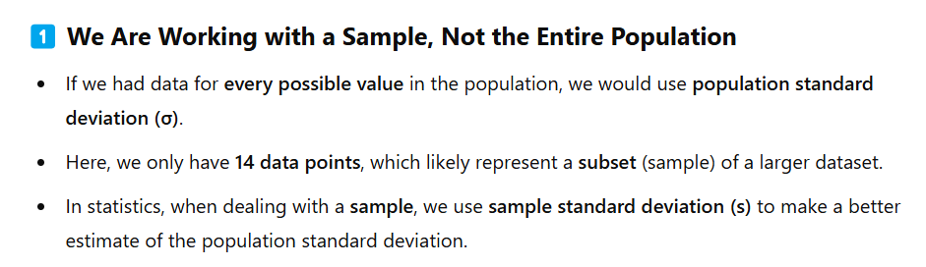
I used the sample standard deviation (s) instead of the population standard deviation (σ) because:
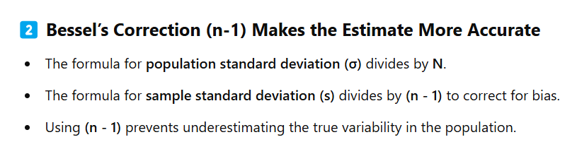

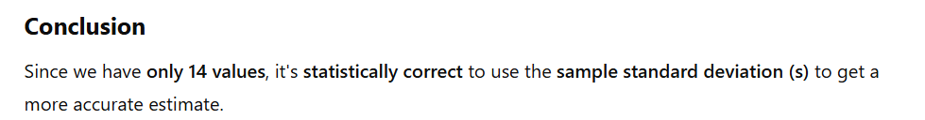

Continuation of the problem:
First, calculate each deviation (Xi First, calculate each deviation (Xi−μ) and its square: and its square:
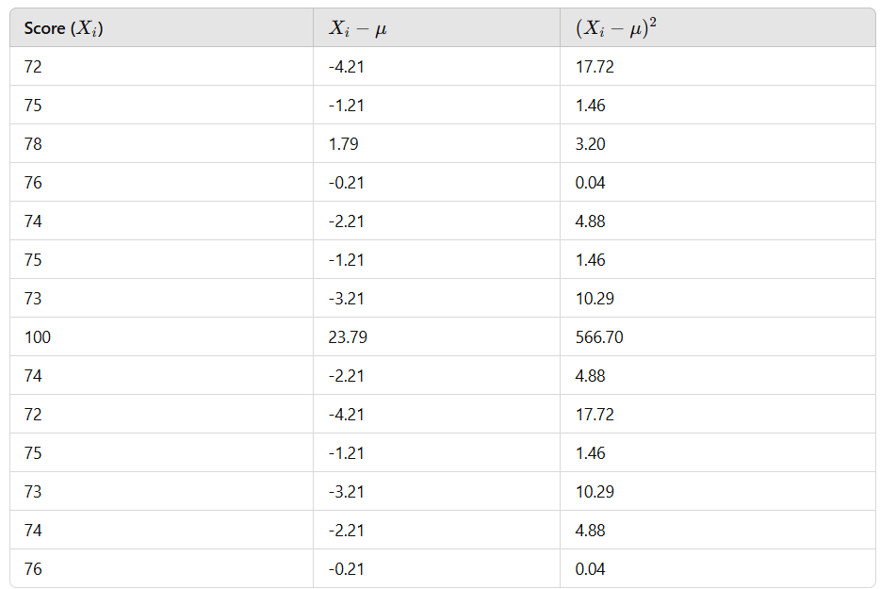
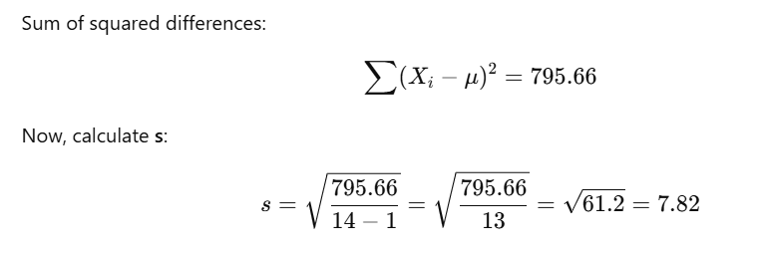

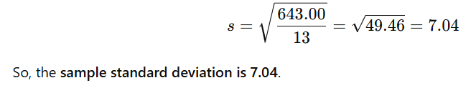

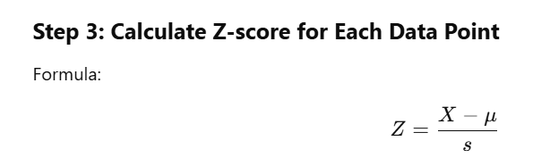

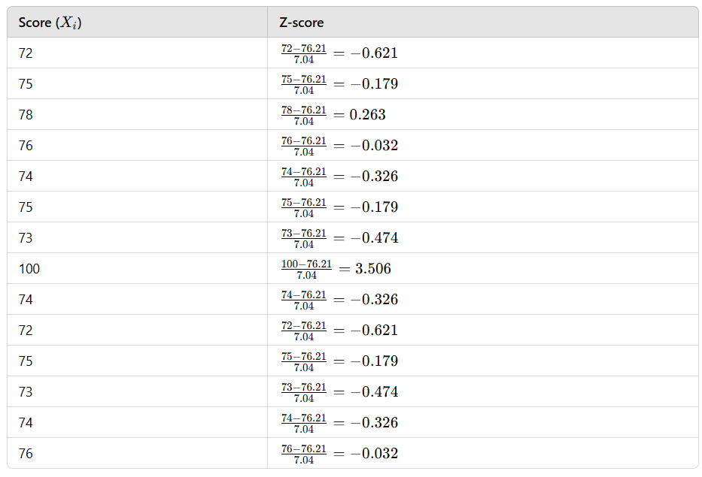

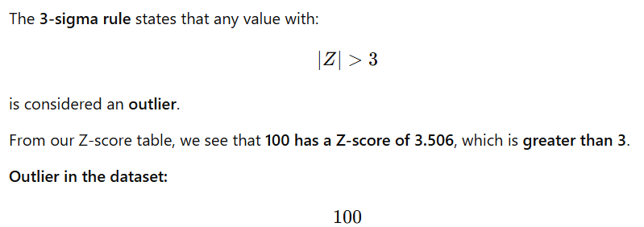
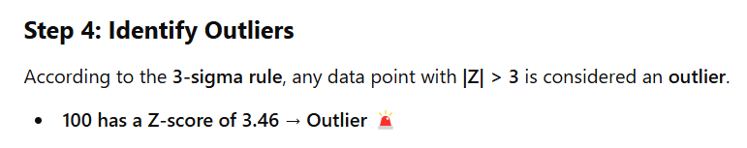

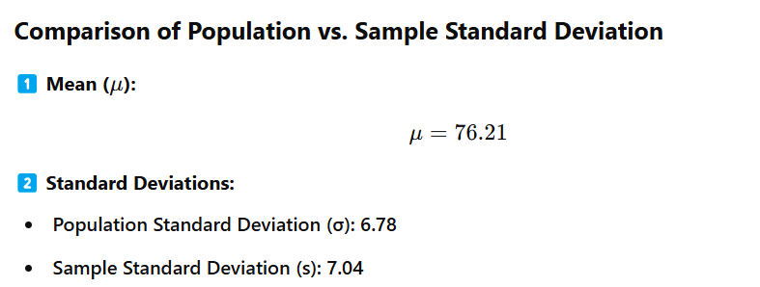
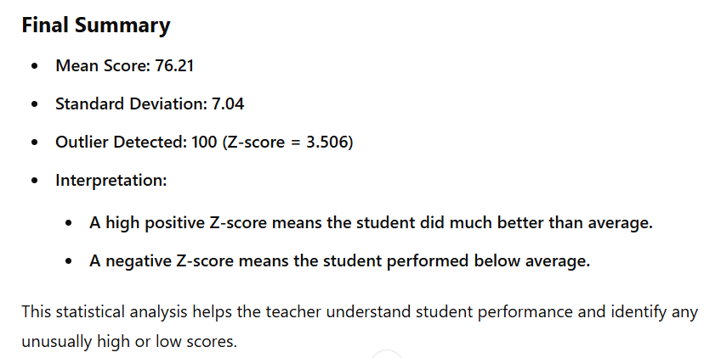

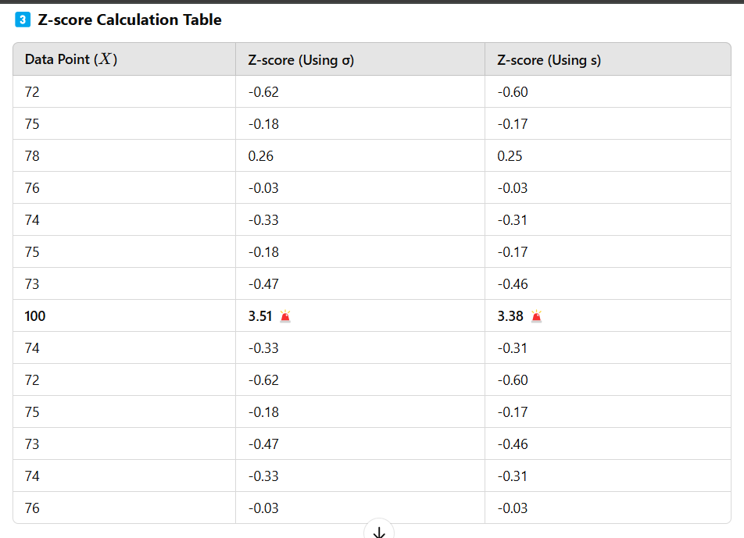

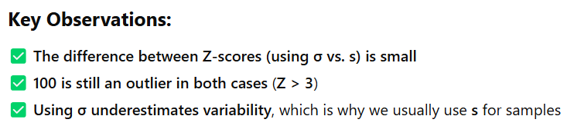

Some questions to compute:
- A class has the following test scores:60,65,70,75,80,85,90,95. Find the z score.
- Heights of People (cm) 150, 155, 160, 165, 170, 175, 180, 185
- Monthly Salaries (in $) 3000, 3500, 4000, 4500, 5000, 5500, 6000, 6500
- Temperature Readings (°C) 15, 18, 20, 22, 25, 28, 30, 35

B) IQR (Interquartile Range):
(Values below Q1 - 1.5 * IQR or above Q3 + 1.5 * IQR are outliers).
1. What is the Interquartile Range (IQR)?
The Interquartile Range (IQR) is a measure of statistical dispersion, representing the middle 50% of a dataset. It is used to understand data spread and identify potential outliers.
The IQR is calculated as:
IQR=Q3−Q1
where:
- Q1 (First Quartile): The 25th percentile (the median of the lower half of the data).
- Q3 (Third Quartile): The 75th percentile (the median of the upper half of the data).
2. Why is IQR Important?
- Resistant to outliers: Unlike the range (which considers extreme values), the IQR focuses on the central spread of the data.
- Used for outlier detection: Data points that fall outside a certain range of IQR are considered outliers.
- Summarizes data distribution: It shows how tightly or loosely the central 50% of values are clustered.

3. How to Calculate IQR (Step-by-Step)
Let's consider a dataset:
10,12,15,18,22,25,27,30,35,40
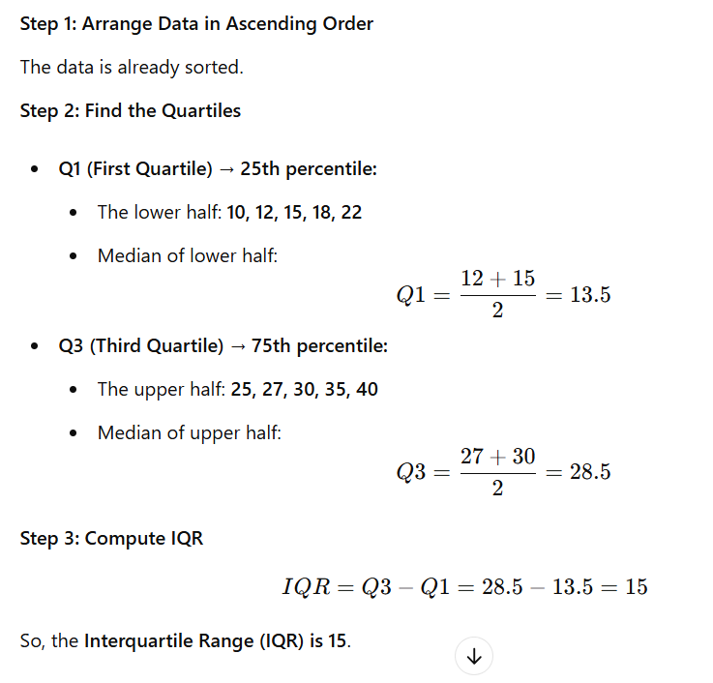

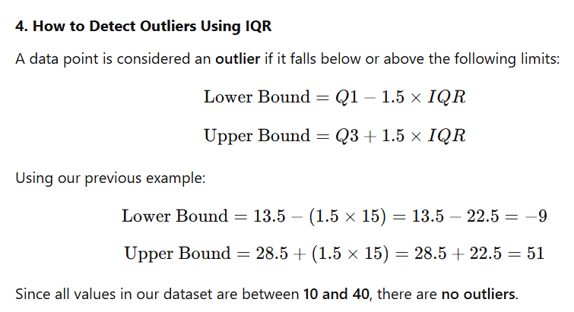

5. Advantages of Using IQR
- Robust to Outliers – Unlike range and standard deviation, IQR is not affected by extreme values.
- Helps in Boxplot Analysis – IQR is used to construct boxplots, which visually represent data spread and outliers.
- Useful for Skewed Distributions – Works well even when the data is not normally distributed.
6. IQR in Boxplots
A boxplot (box-and-whisker plot) visually represents:
- Q1 (25th percentile) – Lower edge of the box.
- Q3 (75th percentile) – Upper edge of the box.
- Median (Q2, 50th percentile) – Line inside the box.
- Whiskers – Extend up to 1.5 × IQR beyond Q1 and Q3.
- Outliers – Plotted as individual points beyond the whiskers.
7. Summary
- IQR = Q3 - Q1
- Used to measure data spread and detect outliers
- More reliable than range for understanding variability
- Key component in boxplots and exploratory data analysis
Some questions to compute:
- Calculate the IQR for the given scores:45,50,55,60,65,70,75,80,85,90.
- Identify outliers using IQR:
10,12,15,18,22,25,27,30,35,40,
- The following are the weekly sales of a store in dollars:
200,220,250,270,300,320,350,400,420,500 ,
Visual Methods (Best for Quick Analysis).
A visualization method for outliers refers to using graphical techniques to detect and analyse outliers (extreme values that differ significantly from other observations) in a dataset. These methods help in understanding data distribution, identifying anomalies, and making informed decisions about handling outliers.
Common Visualization Methods for Outliers:
    - Box Plot (Box-and-Whisker Plot).
    - Scatter Plot.

Box Plot (Box-and-Whisker Plot):
A Box Plot is a statistical visualization used to understand the distribution of a dataset, highlight the central tendency, and detect outliers. It is particularly useful for comparing multiple datasets and identifying skewness.

1. Components of a Box Plot
A box plot consists of five key elements derived from the 5-number summary, so box plot is also known as 5 number summary:
- Minimum (Lower Bound) – The smallest value within the allowed range (not an outlier).
- First Quartile (Q1 - 25th Percentile) – The median of the lower half of the data.
- Median (Q2 - 50th Percentile) – The middle value that separates the data into two equal halves.
- Third Quartile (Q3 - 75th Percentile) – The median of the upper half of the data.
- Maximum (Upper Bound) – The largest value within the allowed range (not an outlier).

Additionally, box plots display:
- Interquartile Range (IQR): IQR=Q3−Q1
      - It represents the middle 50% of the data.
- Whiskers:
    - Extend from Q1 to the minimum and from Q3 to the maximum within the non-outlier range.
- Outliers:
    - Data points lying outside
    - Q1−1.5×IQR or Q3+1.5×IQR are marked as individual points.
2)Example of a Box Plot
Let's consider a dataset:
Data: [5, 7, 10, 15, 20, 22, 25, 30, 35, 40, 100] (with an outlier at 100)
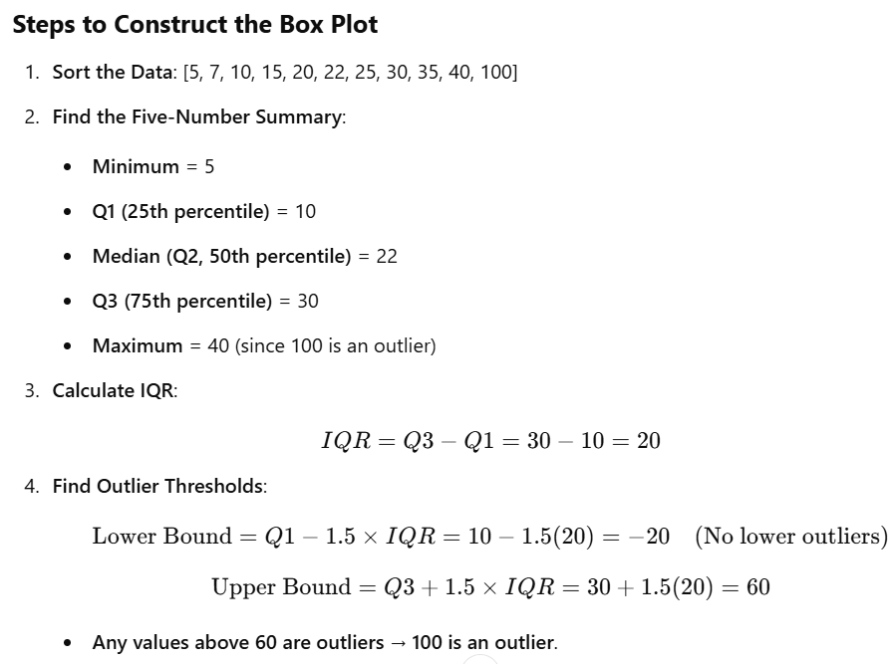

3)Box Plot Implementation:
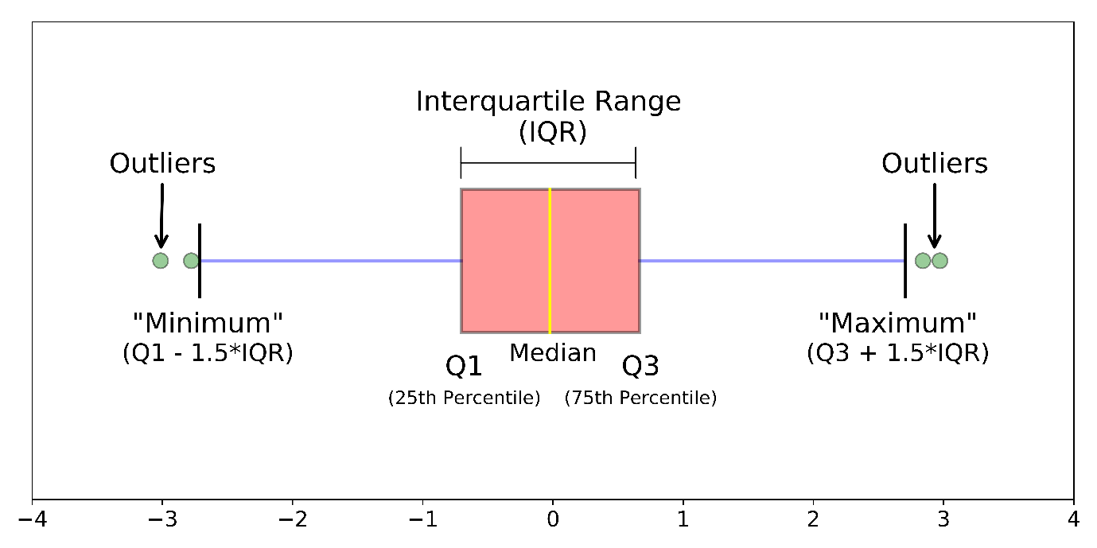
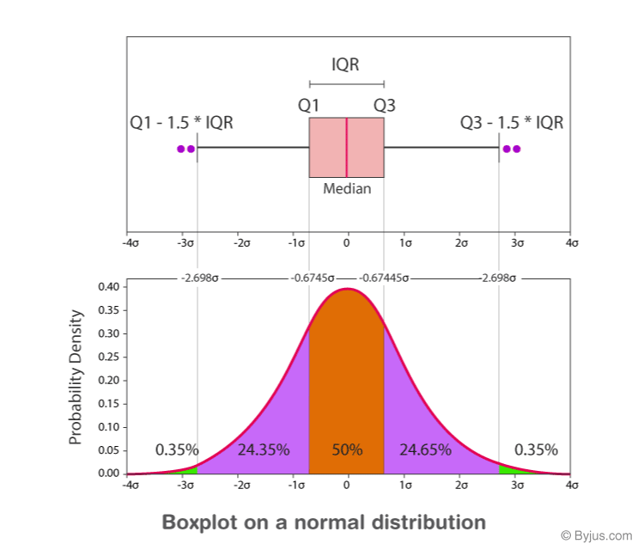
comparing the boxplot with normal distribution:

4. Interpreting the Box Plot
Key Observations
- The box (rectangle):
    - Represents the middle 50% of the data (IQR).
- The horizontal line inside the box:
    - Represents the median (Q2).
- Whiskers:
    - Extend to the smallest and largest values within the non-outlier range.
- Outliers (dots outside the whiskers):
    - Extreme values (100 in this case)

Questions to compute:
- dataset [5, 8, 12, 16, 20, 22, 24, 30, 35, 50, 100].
- If a dataset has Q1 = 20, Q3 = 50, and the minimum and maximum values are 10 and 60, respectively,
- Calculate the IQR.
- Find the whisker limits for detecting outliers.
- Is 65 an outlier?
- Given the dataset [3, 6, 7, 9, 12, 15, 18, 21, 22, 27, 30, 33, 40],
- Compute the five-number summary
- Draw a rough box plot (on paper)

Scatter Plot
A scatter plot is a type of data visualization that represents the relationship between two numerical variables using dots. Each point in the scatter plot corresponds to an observation in the dataset, where:
- The x-axis represents one variable.
- The y-axis represents another variable.
- Each point's position is determined by its values for these two variables.
Why Use a Scatter Plot?
- Detect Relationships (Correlation)
  - Positive correlation: If one variable increases, the other also increases.
    - Example: Higher temperature leads to increased ice cream sales.
    - The points trend upward from left to right
  - Negative correlation: If one variable increases, the other decreases.
1. Example: As speed of a car increases, travel time decreases.
2. The points trend downward from left to right.
  - No correlation: No clear pattern between the variables.
    - Example: Shoe size vs. Intelligence.
    - The points are scattered randomly.
- Identify Outliers
  - Points that are far from the main cluster indicate outliers.
- Observe Clusters in Data
  - Groups of points may suggest different categories or natural groupings.

Scatter plot Implementation:
Sample data: Hours Studied vs Exam Score
Hours studied = [1, 2, 2.5, 3, 3.5, 4, 4.5, 5, 5.5, 6, 7, 8, 9, 10]
exam scores = [50, 55, 60, 62, 65, 67, 70, 72, 75, 78, 85, 88, 92, 95]
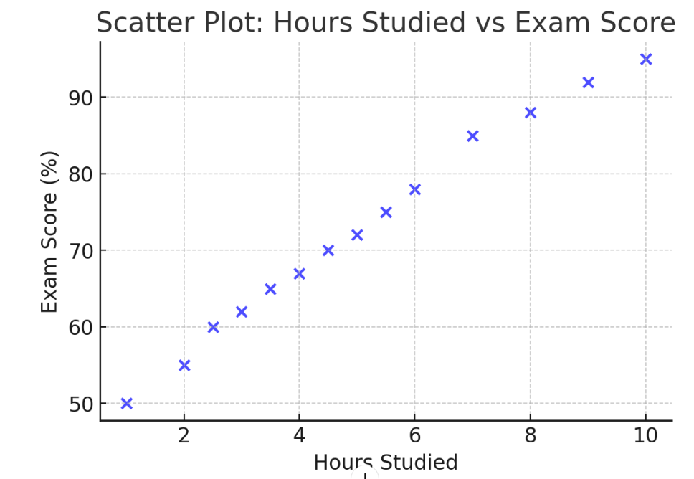

Explanation:
- X-axis represents Hours Studied.
- Y-axis represents Exam Score (%).
- Each point represents a student's performance.
- Trend: More study hours → Higher exam scores.

“The relationship between Hours Studied and Exam Scores.
The plot indicates a positive correlation—students who study more tend to score higher.”

