StreamLearn
Customer Retention & Churn Analysis
Prepared for: Product, Growth & Retention Leadership | July 2026
Data Science & Analytics — Task 2 (2026), Future Interns

Executive Summary
StreamLearn, an online course subscription platform, retains 89.4% of its subscribers month-over-month, but churn is concentrated in a predictable, addressable group: low-engagement customers on the entry-level plan, in their first three months. The overall churn rate across the analyzed base is 10.6%, and the median subscriber who churns does so after just 2.5 months — well before they've had time to build a habit around the product.
Three findings stand out for the business:
- Engagement, not price sensitivity alone, is the strongest predictor of churn. Customers with 4+ weekly sessions churn at 6.5%, versus 14.0% for those with under 1 session/week.
- The first 90 days are the danger zone. Retention drops fastest between month 0 and month 3, then flattens — customers who make it past month 3 are substantially more likely to stay long-term.
- Autopay and mobile app adoption are strong protective factors, and are both levers the business can directly influence through onboarding design.
An active subscriber is worth roughly 4x the lifetime value of one who churns ($234 vs. $58 average LTV) — meaning a moderate improvement in early-tenure retention has an outsized effect on revenue. Recommendations are detailed in Section 6.
10.6%  Overall churn rate | 2.5 mo  Median tenure at churn | $234  Avg. LTV — active customers | $58  Avg. LTV — churned customers

1. Data & Methodology
This analysis uses a simulated dataset of 5,000 StreamLearn subscribers, built to reflect realistic patterns seen in SaaS and subscription businesses (modeled on public churn datasets such as the Telco Customer Churn dataset on Kaggle). Each record includes signup date, plan tier, region, acquisition channel, weekly engagement (sessions/week), courses completed, support tickets filed, mobile app usage, autopay status, tenure, and churn outcome.
Analysis was performed in Python (pandas, matplotlib, scikit-learn): churn rates were computed by segment, a cohort survival analysis was run to build retention curves, and a logistic regression identified which customer attributes most strongly predict churn, holding other factors constant. A companion Excel workbook reproduces the segment-level churn rates with live formulas over the raw data.

2. Churn Overview
Churn is unevenly distributed across plan tiers, regions, and acquisition channels. Basic-plan subscribers — StreamLearn's lowest price point and typically the most price-sensitive, least invested segment — churn at nearly double the rate of Premium subscribers.
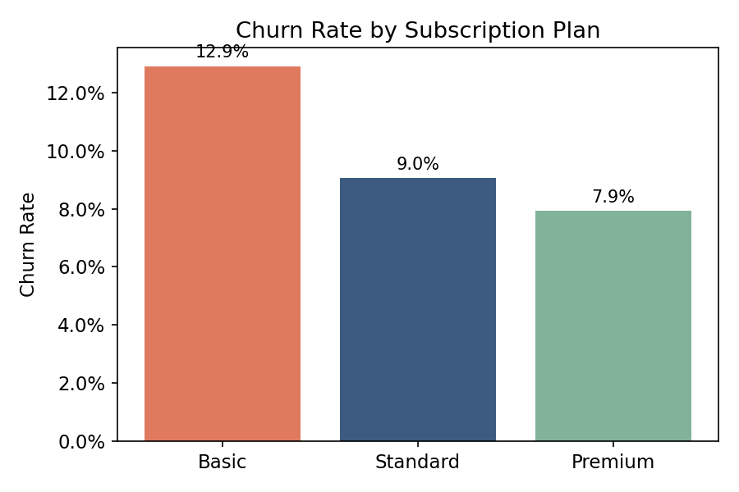
Figure 1. Churn rate by subscription plan.
Regional differences are modest by comparison (8.8%–11.3% across regions), suggesting plan tier and behavior matter more than geography. Referral customers churn least (8.3%), while Paid Ads and Partnership-sourced customers churn most (~11.9%) — consistent with the idea that customers who arrive via personal recommendation start with stronger product fit and trust.
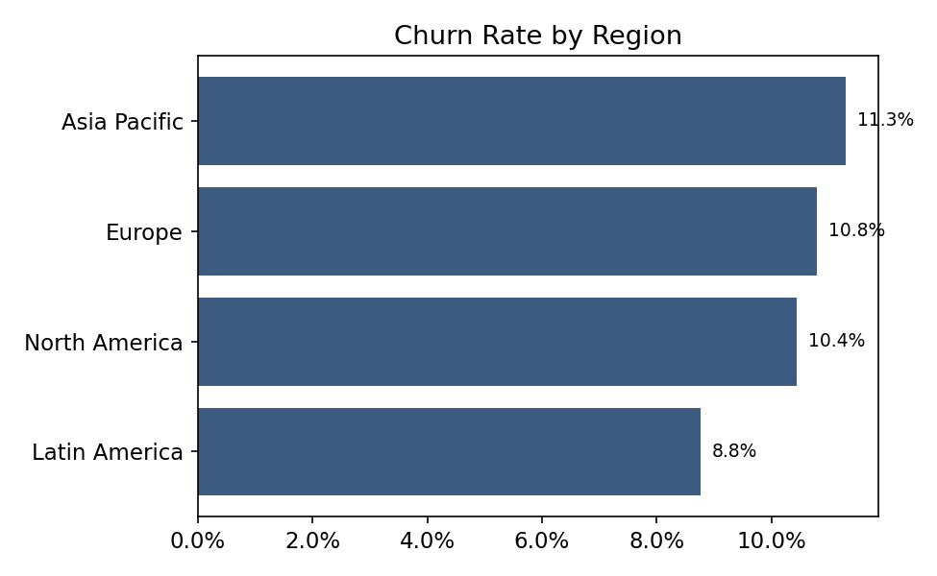
Figure 2. Churn rate by region.

3. What Drives Churn
Weekly engagement is the single clearest signal of churn risk. Customers averaging fewer than one session per week churn more than twice as often as highly engaged customers (4+ sessions/week).
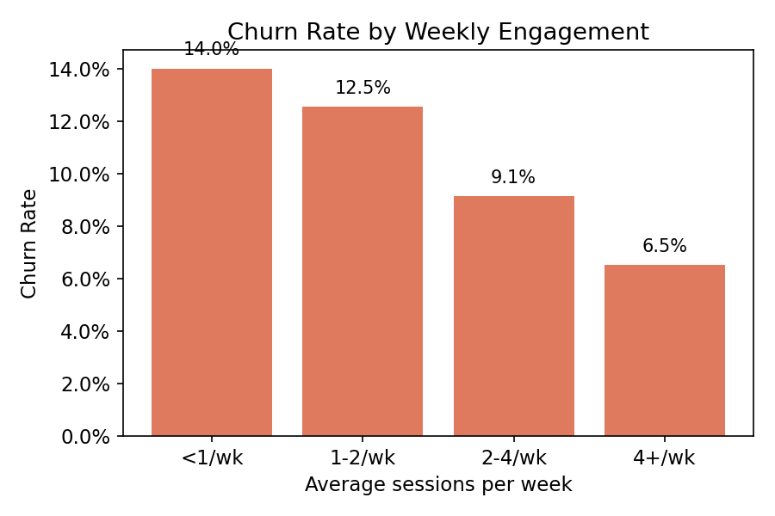
Figure 3. Churn rate by weekly engagement level.
A logistic regression confirms this pattern while controlling for plan, channel, and other factors simultaneously. Weekly engagement and number of courses completed are the two strongest protective factors; a high volume of support tickets is the strongest risk factor, and customers who don't enable autopay or don't use the mobile app are both meaningfully more likely to churn.
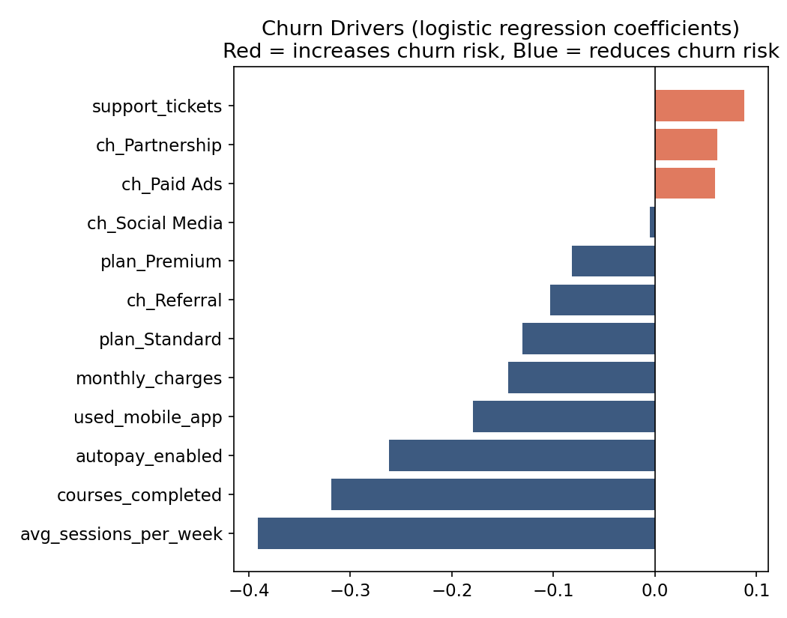
Figure 4. Standardized churn drivers (logistic regression). Bars to the right increase churn risk; bars to the left reduce it.
Support experience matters too: customers with 3+ support tickets churn at 15.3%, roughly 60% higher than those with zero tickets — pointing to unresolved friction as a churn trigger rather than support contact itself being the problem.

4. Retention Curve & Cohort Analysis
The retention curve below tracks what share of subscribers are still active at each month since signup. The steepest drop-off happens in the first three months; after that, the curve flattens considerably — the customers who stay past month 3 have largely found lasting value in the product.
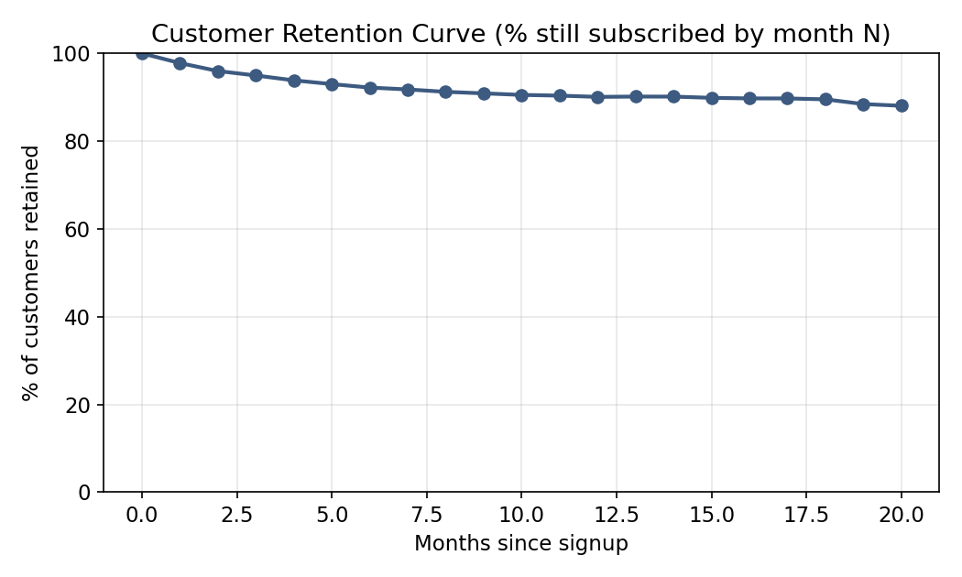
Figure 5. Retention curve: % of customers still subscribed by months since signup.
Viewing retention by monthly signup cohort shows this pattern holds consistently across the last 12 cohorts, with month-1 and month-2 retention as the most variable — and therefore the highest-leverage — points for intervention.
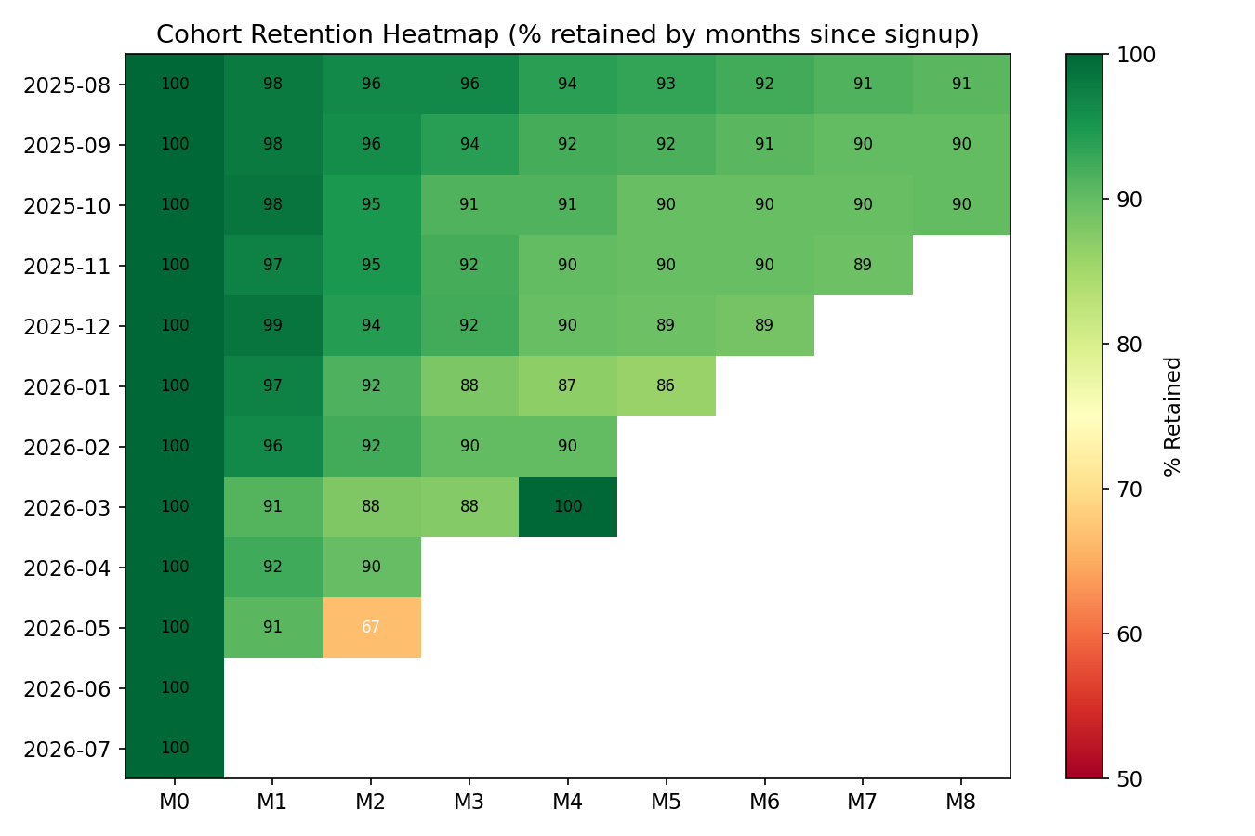
Figure 6. Cohort retention heatmap — % of each signup cohort retained by month.

5. Why Customers Say They're Leaving
Among churned customers, cost is the most commonly cited reason, followed closely by switching to an alternative product and simply not using enough of the content library to justify the subscription. Poor support experience and technical issues are smaller but still material factors.
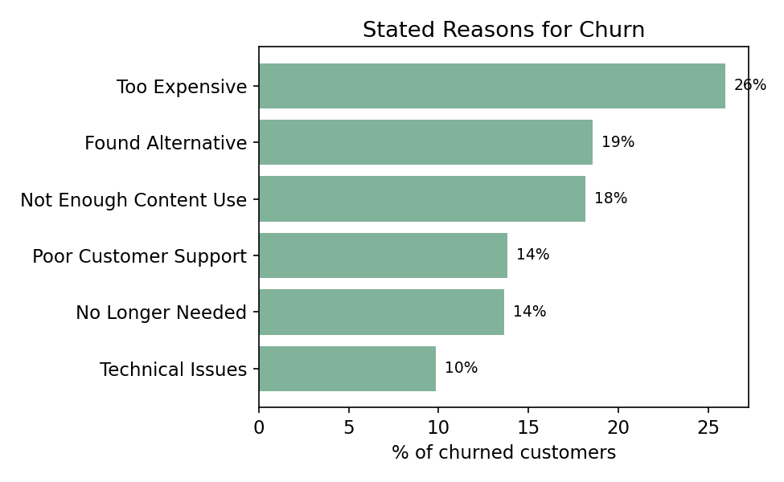
Figure 7. Stated reasons for churn (share of churned customers).
Notably, "too expensive" and "not enough content use" together account for roughly 44% of churn — both are really engagement problems in disguise: customers who aren't using the product regularly stop perceiving it as worth the price, regardless of the actual price point.

6. Recommendations

Fix the first 90 days
- Build a structured onboarding sequence (welcome series, first-course completion nudge, progress milestones) targeting the month 0–3 window, where retention drops fastest.
- Trigger a re-engagement flow (email/push + a curated "quick win" course) for any customer whose sessions drop below 1/week in their first 60 days — this is the segment's clearest early-warning signal.

Make Basic-plan customers stickier
- Test a lightweight annual/semi-annual discount for Basic subscribers to increase switching cost and align price with perceived value.
- Prompt Basic subscribers who complete 3+ courses with a personalized Standard/Premium upsell — engaged users are the best upgrade candidates and upgrading is correlated with lower churn.

Convert passive habits into active ones
- Push mobile app adoption at signup (app-only onboarding bonus or content) — mobile users churn at 9.1% vs. 12.3% for web-only users.
- Encourage autopay enrollment with a small first-renewal incentive; autopay customers churn at roughly two-thirds the rate of manual-renewal customers.

Close the support loop
- Flag customers with 2+ support tickets for a proactive check-in from a customer success rep rather than waiting for a 3rd ticket or a cancellation request.

Prioritize by revenue impact
Because active customers carry roughly 4x the lifetime value of churned ones, even a modest reduction in month 0–3 churn (e.g., 10.6% → 8%) would be worth pursuing before broader, lower-leverage initiatives — the onboarding and engagement fixes above should be sequenced first.

Appendix: Tools & Files
- subscription_data.csv — underlying simulated dataset (5,000 rows).
- StreamLearn_Churn_Analysis.xlsx — Excel workbook with raw data, live churn-rate formulas by segment, and the cohort retention table.
- Python scripts — data generation, churn-rate analysis, cohort survival calculation, and the logistic regression driver model.
Note: all data in this report is synthetically generated for demonstration purposes and does not represent a real company or real customers.

