Wait Zar - Version 1.5+ Beta
http://code.google.com/p/Wait Zar/
Myanmar text in this document requires Myanmar3, PadaukOT, or Parabaik to be installed.

Introduction
Thank you for downloading Wait Zar.
- The only file you need is WaitZar.exe
- The files mywords.txt and config.txt are optional. Put them in the same directory as WaitZar.exe if you unzip it.
- If you don't have Myanmar3.ttf installed, please install it.

Using Wait Zar
Double-click on WaitZar.exe. You should see a new icon in your system tray.
It reads "ENG"
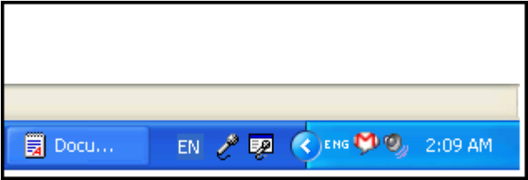

Hold "Ctrl" and hit "Shift", and the icon will change to Burmese.
You'll see "မြ"
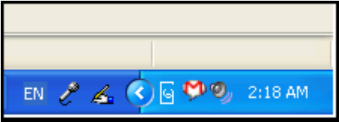

Now, switch to Microsoft Word, change the font to Myanmar3, and type "ko". You will see several options.
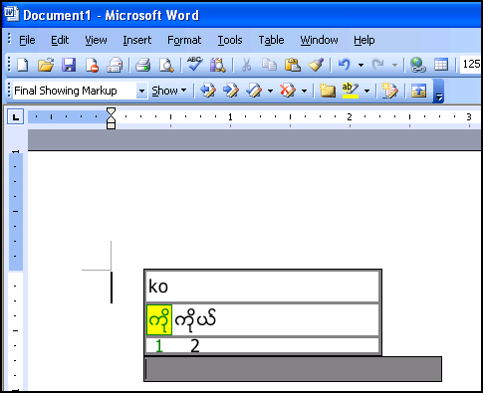

Hit "space" to select the first one. You will see "ကို" appear in the "sentence" window. Hit "5", and you will see "၅" appear in the sentence window too:
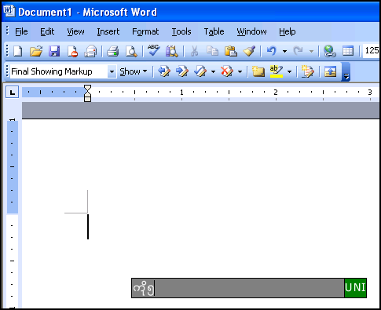

Continue typing words if you want, then press "Enter". You will now see "ကို၅" appear in Word:
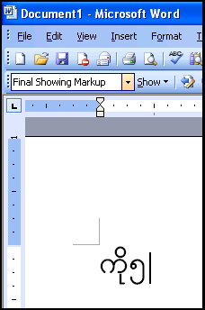

License
Wait Zar is covered under the Apache license, version 2.0. Please see the files LICENSE and NOTICE for more information.

More Information
That's all there is to Wait Zar for now, but if you're interested or need help, here's some more information:

Q: It's not working right!
A: Please report bugs on: http://code.google.com/p/Wait Zar/issues/list
Also, please note that this is still experimental, so some things (hibernating, etc.) may cause the system to glitch.

Q: It's messing up my computer
A: Right-click on the ENG or မြ icon (whichever is showing in your tray) and choose "Exit". This should fix any problems. If right-clicking doens't work, hit Ctrl+Alt+Delete and click on the "Processes" tag. Click on the process "Wait Zar.exe" and choose "End Process". If that doesn't work, Log Out and Log In to your computer (no need to shut it down). Wait Zar makes NO long-term changes to your computer, so killing the process and restarting Wait Zar should fix almost any problem.

Q: Why have the sentence window? Why not just type words directly?
A: If you don't like it, just disable the sentence window in config.txt. But, you should consider using it. For one thing, the sentence window allows Wait Zar to "predict" which word you will type. This means you won't have to hit left/right so often; the first choice is usually correct. Secondly, most Windows programs currently do not support Burmese words, so hitting left/right will move between "zero-width" characters and might be confusing or irritating. Hitting left/right in the sentence window will move correctly between words.

Q: How do I do (something advanced)?
A: Please refer to the user's guide distributed with Wait Zar for the complete documentation.

Q: I use Ctrl+Shift for something else!
A: The file config.text allows you to change the hotkey used to activate Myanmar in WaitZar.

Q: Can I help out?
A: Probably. Wait Zar is very much open-source. A lot of its discussion is in:
http://www.mmgeeks.org/forum/index.php

