SOFTWARICA COLLEGE OF IT & E-COMMERCE
in collaboration with Coventry University

Lab 3: Investigating Process Lifecycles and OS Interaction
Practical Lab Report

Yatharth Thapa (250086)
BSc (Hons) Computer Science, Softwarica College of IT & E-commerce.
ST5003CMD Operating Systems, Security, and Networks
Submitted to Rupak Rajbanshi
Date: 15th September 2026

Table of Contents
Introduction
Task No. 1 - The Long-Running Process
Task No. 2 - Process Identity (PID and PPID)
Task No. 3 - Exit Codes and OS Feedback
Task No. 4 - Standard I/O Streams
Task No. 5 - Conditional Execution and Termination
Key Theoretical Concepts
Conclusion

Table of Figures
Figure 1: Initial creation and compilation attempt for Task 1.
Figure 2: Task 1 running in the background and process monitoring with ps.
Figure 3: Task 2 compilation and executable verification.
Figure 4: Task 2 PID and PPID output and ps verification.
Figure 5: Task 3 source creation and compilation.
Figure 6: Task 3 positive input producing Success.
Figure 7: Task 3 negative input producing Failure.
Figure 8: Task 4 source creation and compilation.
Figure 9: Task 4 standard input and output interaction.
Figure 10: Task 5 source creation and compilation.
Figure 11: Task 5 execution with choice 1.
Figure 12: Task 5 execution with both continue and exit paths.

Introduction
This report documents the practical work completed for Lab 3 of ST5003CMD Operating Systems, Security, and Networks. The lab investigates how C programs interact with the Linux operating system as active processes. The tasks cover long-running processes, process identifiers, parent process identifiers, exit codes, standard input/output streams, and conditional program termination.
The practical work demonstrates that an executable program becomes a process when it runs and is then managed by the Linux kernel. Terminal commands such as ps and echo $? are used to inspect process state and verify the status returned by a program.

Task No. 1 - The Long-Running Process
Objective: Create a program that stays active for approximately 30 seconds so that it can be monitored while running.
#include <stdio.h>
#include <unistd.h>
int main() {
printf("I am starting...\n");
for (int i = 1; i <= 30; i++) {
sleep(1);
}
printf("I am finished.\n");
return 0;
}
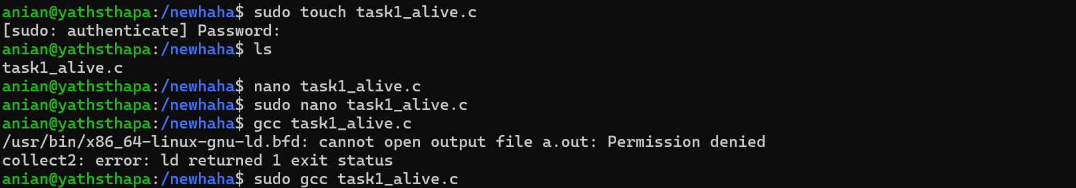
Figure 1: Initial creation and compilation attempt for Task 1.
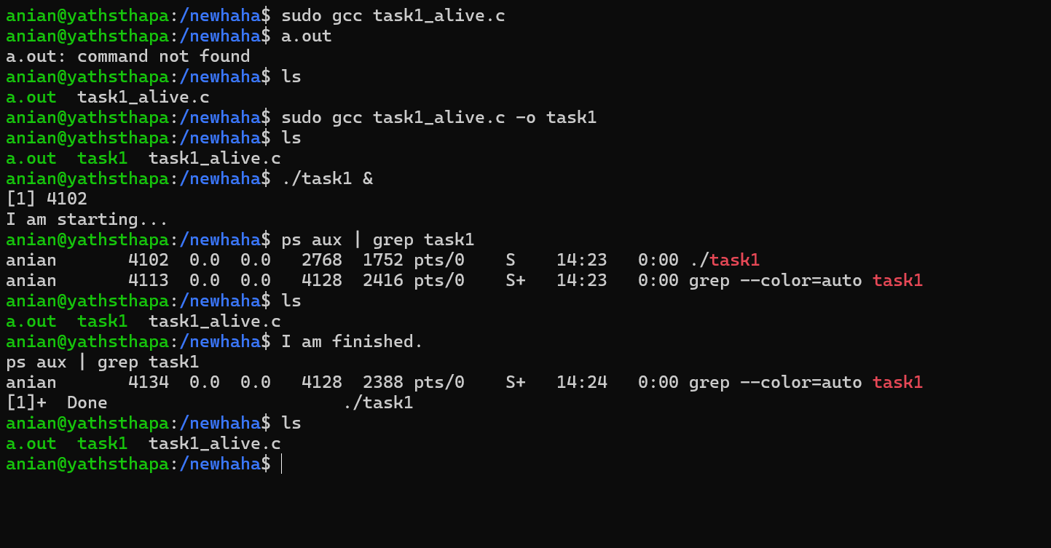
Figure 2: Task 1 running in the background and process monitoring with ps.
Summary: The source file task1_alive.c was compiled into an executable named task1. The program was started with ./task1 & so that it ran in the background. The ps aux | grep task1 command confirmed that the process was active while the program was sleeping. After about 30 seconds, the message “I am finished.” showed that the process completed normally.

Flow Diagram
START
|
Print "I am starting"
|
Repeat 30 times
|
Sleep 1 second
|
Print "I am finished"
|
return 0
|
END

Task No. 2 - Process Identity (PID and PPID)
Objective: Display the Process ID (PID) of the running program and the Parent Process ID (PPID) of the process that launched it.
#include <stdio.h>
#include <unistd.h>
int main() {
pid_t my_pid = getpid();
pid_t my_ppid = getppid();
printf("My PID is: %d\n", my_pid);
printf("My Parent PID is: %d\n", my_ppid);
printf("Sleeping for 20 seconds...\n");
sleep(20);
return 0;
}
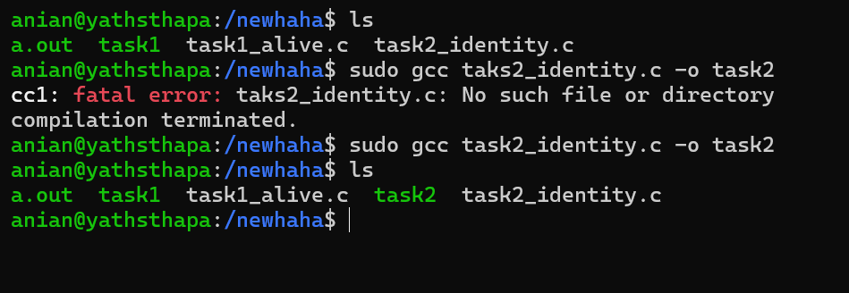
Figure 3: Task 2 compilation and executable verification.
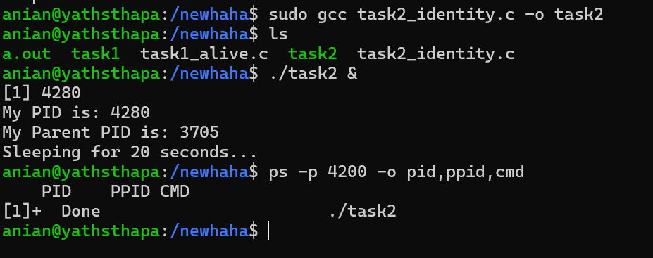
Figure 4: Task 2 PID and PPID output and ps verification.
Summary: The program used getpid() to obtain its own PID and getppid() to obtain the PID of its parent process. The program then remained active for 20 seconds so that its identity could be checked using ps. The screenshot shows the PID printed by the running program and demonstrates how Linux assigns identifiers to active processes.

Flow Diagram
START
|
Get current PID
|
Get parent PID
|
Display PID and PPID
|
Sleep 20 seconds
|
return 0
|
END

Task No. 3 - Exit Codes and OS Feedback
Objective: Use program return values to communicate success or failure to the operating system.
#include <stdio.h>
int main() {
int num;
printf("Enter a number (positive for success, negative for fail): ");
scanf("%d", &num);
if (num > 0) {
printf("Success\n");
return 0;
} else {
printf("Failure\n");
return 1;
}
}
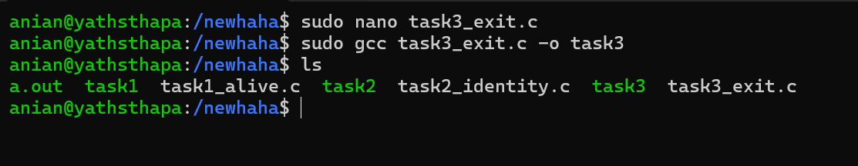
Figure 5: Task 3 source creation and compilation.
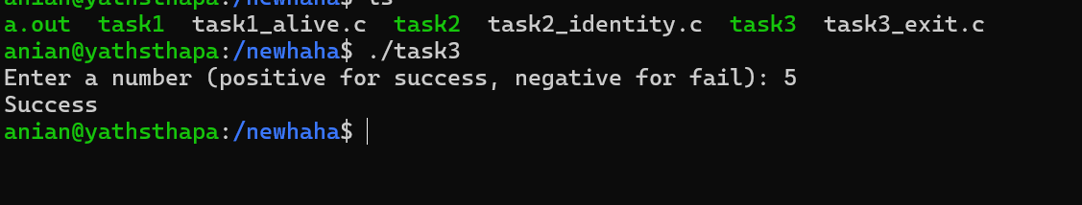
Figure 6: Task 3 positive input producing Success.
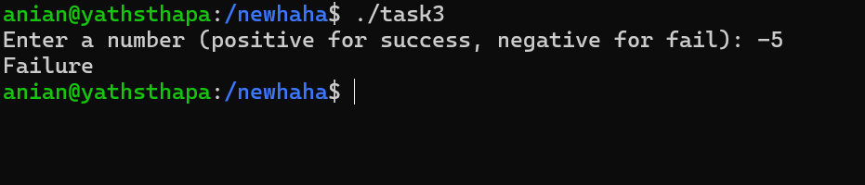
Figure 7: Task 3 negative input producing Failure.
Summary: The program accepted an integer from the user and used an if/else statement to decide the exit status. A positive input displayed “Success” and returned 0, while a negative input displayed “Failure” and returned 1. These values can be checked in Linux using echo $? immediately after program execution.

Flow Diagram
START
|
Read number
|
Is number > 0?
/ \
Yes No
| |
Success Failure
| |
return 0 return 1
\ /
END

Task No. 4 - Standard I/O Streams
Objective: Demonstrate standard input (stdin) and standard output (stdout) using scanf() and printf().
#include <stdio.h>
int main() {
char name[50];
printf("Enter your name: ");
scanf("%s", name);
printf("Hello, %s! Welcome to OS Class.\n", name);
return 0;
}
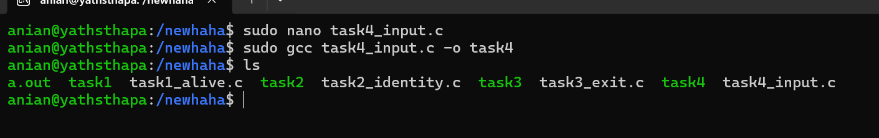
Figure 8: Task 4 source creation and compilation.
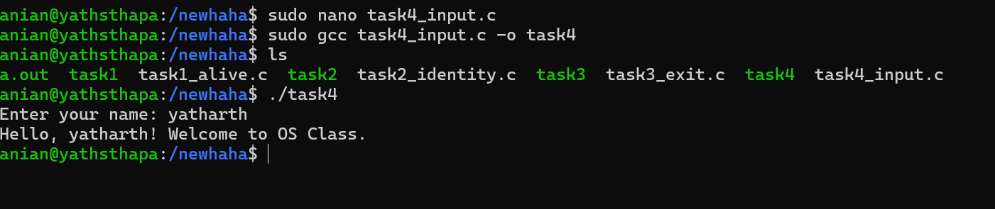
Figure 9: Task 4 standard input and output interaction.
Summary: The program prompted the user to enter a name. scanf() read the value from standard input, and printf() wrote the greeting to standard output. The screenshot shows the entered name “yatharth” and the resulting welcome message.

Flow Diagram
START
|
Prompt for name
|
Read name using scanf
|
Print greeting using printf
|
return 0
|
END

Task No. 5 - Conditional Execution and Termination
Objective: Combine process identity, user input, branching, sleep(), and exit codes in one program.
#include <stdio.h>
#include <unistd.h>
int main() {
int choice;
printf("Current PID: %d\n", getpid());
printf("Do you want to continue? (1 for Yes, 0 for No): ");
scanf("%d", &choice);
if (choice == 1) {
printf("Continuing...\n");
sleep(5);
return 0;
} else {
printf("Exiting...\n");
return 1;
}
}
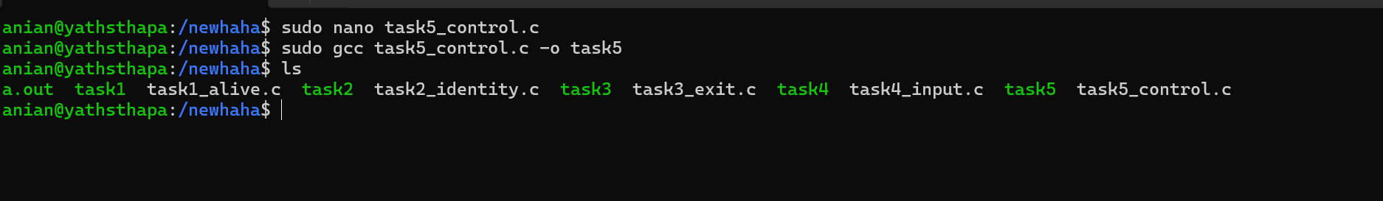
Figure 10: Task 5 source creation and compilation.
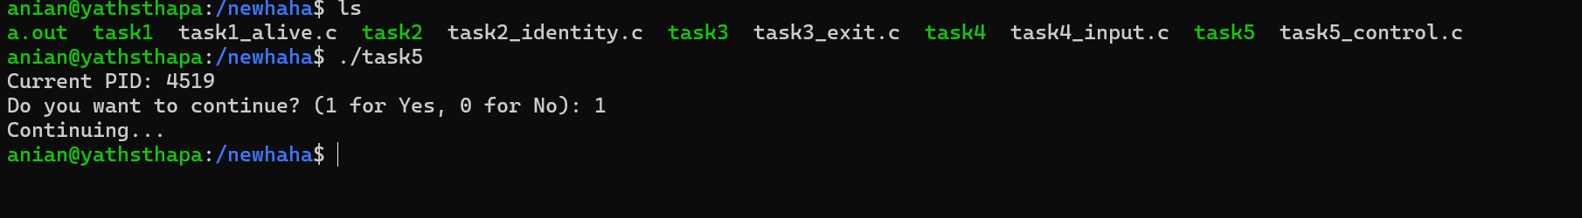
Figure 11: Task 5 execution with choice 1.
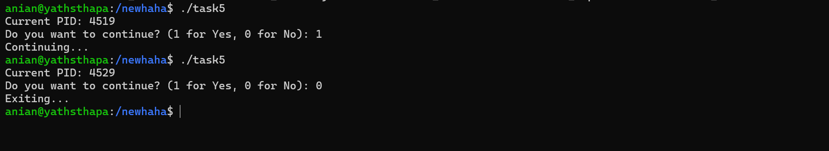
Figure 12: Task 5 execution with both continue and exit paths.
Summary: The program printed its current PID and then asked the user whether execution should continue. Entering 1 followed the success path, displayed “Continuing...”, paused for five seconds, and returned 0. Entering 0 followed the alternate path, displayed “Exiting...”, and returned 1. This demonstrates how program logic determines both execution behaviour and the final status reported to the operating system.

Flow Diagram
START
|
Display PID
|
Read choice
|
Is choice == 1?
/ \
Yes No
| |
Continuing Exiting
| |
Sleep 5 sec return 1
|
return 0
\ /
END

Key Theoretical Concepts
Process: A process is a program that is currently being executed. Once an executable is started, Linux creates and manages a process for it.
PID: PID stands for Process ID. It is a unique numerical identifier assigned to a running process.
PPID: PPID stands for Parent Process ID. It identifies the process that created or launched the current process.
sleep(): sleep() pauses a process for a specified number of seconds while the process still exists and remains managed by the operating system.
Exit Status: A return value of 0 conventionally represents successful termination. A non-zero value such as 1 represents an error, failure, or another program-defined condition.
Standard Input and Output: stdin is the default input stream, normally connected to the keyboard, while stdout is the default output stream, normally connected to the terminal.

Conclusion
Lab 3 demonstrated how C programs interact with the Linux operating system as active processes. The exercises showed how a process can be monitored while running, how PID and PPID identify process relationships, how return values communicate execution status, and how standard input/output streams allow interaction with the terminal. The final task combined these concepts through conditional execution and process termination.

Submission Checklist
- task1_alive.c
- task2_identity.c
- task3_exit.c
- task4_input.c
- task5_control.c
- Terminal screenshots for all verification steps
- Report containing theory, flow diagrams, and practical evidence
- Code and report uploaded to the personal GitHub repository

