SOFTWARICA COLLEGE OF IT & E-COMMERCE
in collaboration with Coventry University

Lab 2: C Programming Basics
Lab Report and Knowledge Check

Student Name: Yatharth Thapa
Student ID: 250086
BSc (Hons) Computer Science
ST5003CMD Operating Systems, Security, and Networks
Submitted to: Rupak Rajbanshi
Date: 09/06/2026

Table of Contents
Task No. 1 - Basic C Program and Return Values | 4
Task No. 2 - User Input and Formatted Output | 5
Task No. 3 - GCC Installation and Verification | 7
Task No. 4 - Four Stages of C Compilation | 8
Task No. 5 - Return Value 50 | 10
Knowledge Check Questions | 11
Conclusion | 14

Table of Figures
Figure 1: Linux working environment and directory listing.
Figure 2: Creation and inspection of the basic Hello World source file.
Figure 3: User-input program source code.
Figure 4: Program using multiple variables and formatted output.
Figure 5: GCC installation and version verification.
Figure 6: Four separate compilation stages and generated files.
Figure 7: Source file and executable verification.

Introduction
This report documents the practical work completed for Lab 2 of ST5003CMD Operating Systems, Security, and Networks. The lab focuses on basic C program structure, standard input and output, GCC installation, the four stages of C compilation, and program return values. The report follows a practical, screenshot-based format, with short summaries explaining the commands and results.

Task No. 1 - Basic C Program and Return Values
The first task was to create a simple C program, compile it, run it, and verify the return status reported to the Linux shell.
#include <stdio.h>
int main() {
printf("Hello, World!\n");
return 0;
}
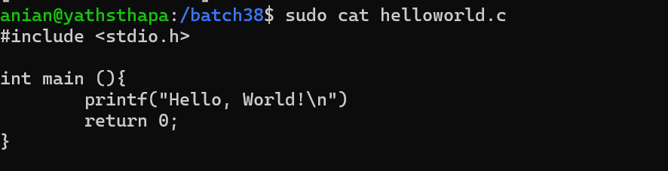
Figure 2: Creation and inspection of the basic Hello World source file.
Summary: The source file was created and checked in the terminal. The program uses the stdio.h header, prints a simple message, and returns 0 to indicate successful execution.
The program can be compiled and checked with:
gcc helloworld.c -o helloworld
./helloworld
echo $?
A return value of 0 indicates successful execution. When the program is modified to return 1, the shell records a non-zero exit status, which conventionally represents failure or another non-success condition.

Task No. 2 - User Input and Formatted Output
The next task demonstrated how C accepts user input through scanf() and displays the value using printf().
#include <stdio.h>
int main() {
int number;
printf("Enter a number: ");
scanf("%d", &number);
printf("You entered: %d\n", number);
return 0;
}
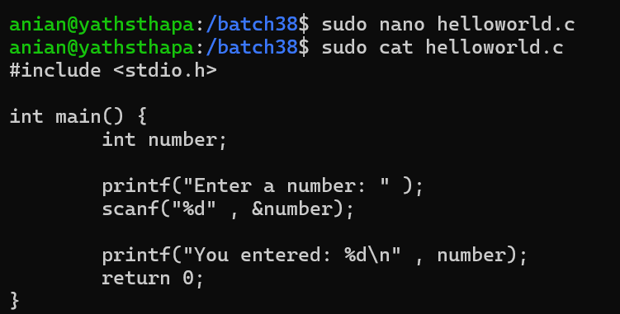
Figure 3: User-input program source code.
Summary: An integer variable was declared and a value was read from standard input using scanf(). The same value was then displayed with printf(), demonstrating basic keyboard input and terminal output.
A second example used multiple data types and format specifiers:
#include <stdio.h>
int main() {
char name[50];
int age;
float height;
printf("Enter your name: ");
scanf("%s", name);
printf("Enter your age: ");
scanf("%d", &age);
printf("Enter your height (m): ");
scanf("%f", &height);
printf("\n--- User Info ---\n");
printf("Name: %s\n", name);
printf("Age: %d years\n", age);
printf("Height: %.2f m\n", height);
return 0;
}
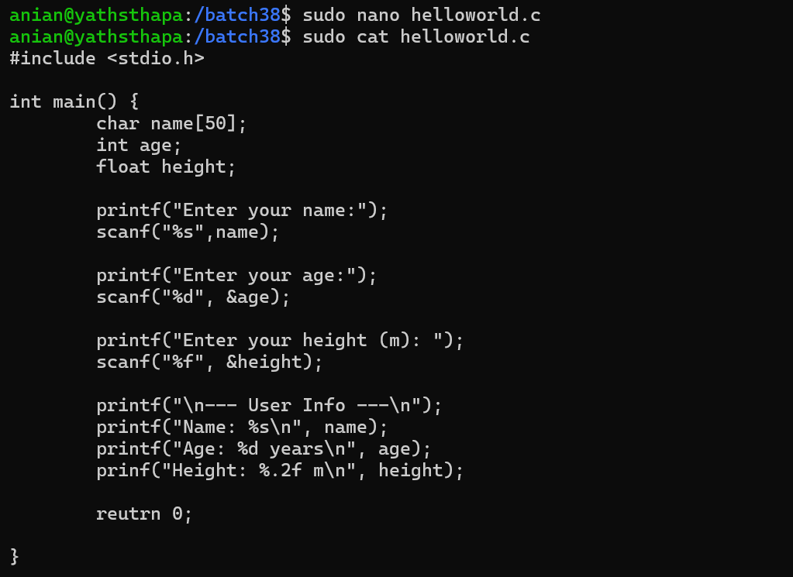
Figure 4: Program using multiple variables and formatted output.
Summary: This program used string, integer, and floating-point variables. The format specifiers %s, %d, and %f were used to read values, while %.2f displayed the height to two decimal places.

Task No. 3 - GCC Installation and Verification
GCC was installed or verified using the Linux package manager and the compiler version was checked from the terminal.
sudo apt install build-essential
gcc --version
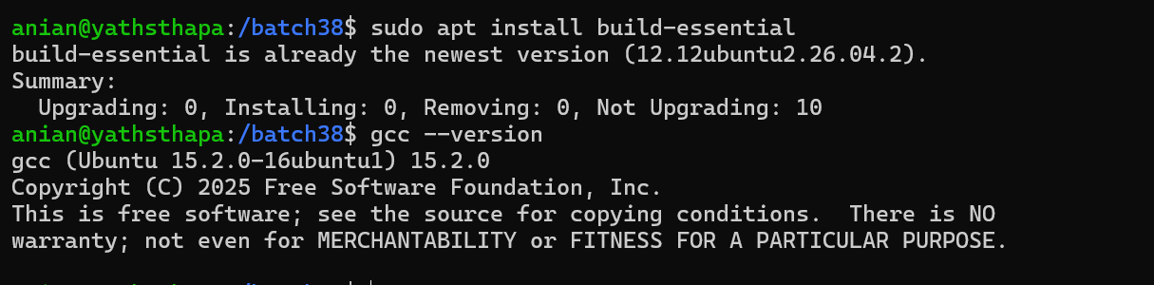
Figure 5: GCC installation and version verification.
Summary: The build-essential package was checked through APT, and gcc --version confirmed that the GNU C compiler was available on the system. This prepared the environment for compiling the C source files.

Task No. 4 - Four Stages of C Compilation
The C compilation process was performed in four separate stages: preprocessing, compilation to assembly, assembly to an object file, and linking to a final executable.
Stage | Command | Output | Purpose
Preprocessing | gcc -E helloworld.c -o helloworld.i | .i | Expands headers and macros
Compilation | gcc -S helloworld.i -o helloworld.s | .s | Generates assembly code
Assembly | gcc -c helloworld.s -o helloworld.o | .o | Creates object code
Linking | gcc helloworld.o -o helloworld | executable | Creates final program

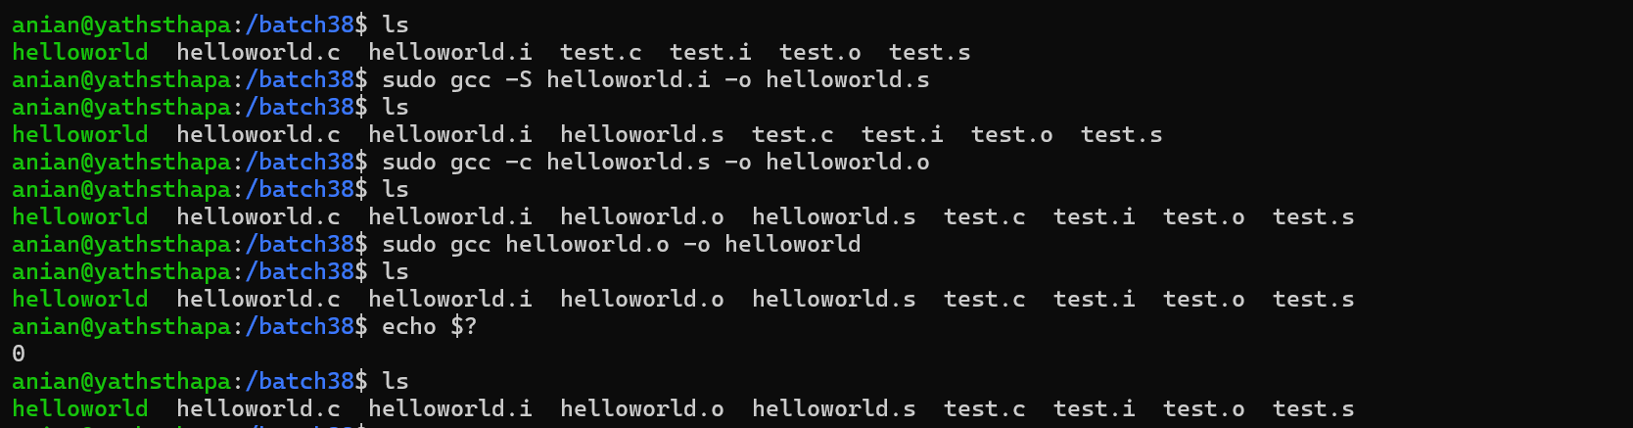
Figure 6: Four separate compilation stages and generated files.
Summary: The commands generated the intermediate .i, .s, and .o files before linking them into the final executable. The ls command was used between stages to confirm that each output file had been created.
The sequence used was:
gcc -E helloworld.c -o helloworld.i
gcc -S helloworld.i -o helloworld.s
gcc -c helloworld.s -o helloworld.o
gcc helloworld.o -o helloworld
./helloworld
echo $?
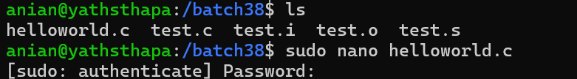
Figure 7: Source file and executable verification.

Task No. 5 - Program Returning Integer Value 50
The final practical task requires a C program whose main() function returns the integer value 50. The returned value can be checked from the shell using echo $?.
#include <stdio.h>
int main() {
printf("Program is returning 50.\n");
return 50;
}
Compilation and verification commands:
gcc task5.c -o task5
./task5
echo $?
After the program finishes, echo $? should display 50. This demonstrates that the return value of main() is communicated to the operating system and stored by the shell as the process exit status.

Knowledge Check Questions
Question 1: What is the purpose of the #include directive in C programming? Provide an example of its usage.
The #include directive instructs the C preprocessor to include the contents or declarations of a header file before compilation.
For example, #include <stdio.h> makes standard input/output declarations such as printf() and scanf() available to the program.
Question 2: Explain the difference between the four stages of compilation. What file extension is produced at each stage?
Preprocessing expands header files and macros and commonly produces a .i file. Compilation converts the preprocessed C code into assembly and produces a .s file. Assembly converts the assembly code into machine/object code and produces a .o file. Linking combines the object code with required libraries to create the final executable.
Question 3: What does a return value of 0 from the main() function indicate to the operating system? What about a non-zero return value?
A return value of 0 conventionally indicates successful program termination. A non-zero value indicates an error, failure, or another program-defined status condition. The Linux shell makes the most recent exit status available through echo $?.
Question 4: Write a C program that declares an integer variable, asks the user to input a value, and displays the entered value back to the user.
#include <stdio.h>
int main() {
int number;
printf("Enter an integer: ");
scanf("%d", &number);
printf("You entered: %d\n", number);
return 0;
}
Question 5: What GCC command would you use to only preprocess a file, generate assembly without assembling it, and create an object file without linking?
Only preprocess:
gcc -E hello.c -o hello.i
Generate assembly:
gcc -S hello.c -o hello.s
Create an object file without linking:
gcc -c hello.c -o hello.o
Question 6: Explain why C is called a compiled language and how this differs from interpreted languages.
C is called a compiled language because a compiler translates the source code into lower-level machine-executable code before the program is run. In an interpreted language, source instructions are generally processed through an interpreter at runtime rather than being transformed through the traditional C compilation pipeline into a native executable beforehand.

Additional Terminal Evidence
Figure 1: Linux working environment and directory listing.
Summary: The terminal environment was used throughout the lab to create source files, compile programs, inspect generated files, run executables, and verify the resulting exit status.

Conclusion
This lab provided practical experience with C program structure, input/output, GCC usage, program exit values, and the four stages of compilation. The exercises showed how a C source file is transformed from high-level code into an executable program and how the Linux shell records the success or failure status returned by main().

GitHub Repository
All source-code files, compilation outputs, screenshots, and the final report should be pushed to the student's personal GitHub repository and submitted through the required course portal.

