**PRACTICAL- 1**

* Print the squares of the numbers 1 - 20. Each number should be on a separate line, next to it the number 2 superscripted, an equal sign and the result. (Example: 102 = 100)
* Your web page must have used the Heading tag.
* There should be a line after the heading.
* The numbers and their squares should be displayed in the center of the web page.
* Atleast two Square values should be highlighted.
* One Square value should be Bold, One should be in Italic, One should be underlined, One wrong value displayed should be striked

**CODE**

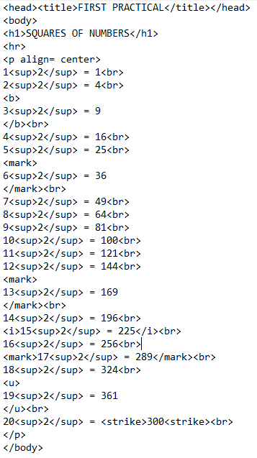

**OUTPUT**

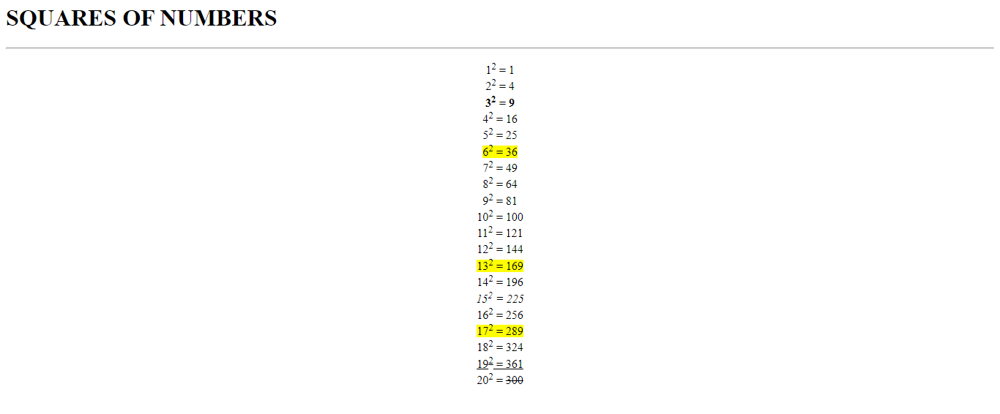

**PRACTICAL- 2**

* Design the web page meeting the following given specifications:
  + Print a long Quote and short Quote. Cite the author of each quote.
  + Print some deleted and inserted text of your Choosing.
  + Print two addresses in the same front used on the front of envelopes ( senders address in top left corner, receivers address in the center).
  + Print ten acronyms and abbreviations of your choosing. Also specify the data that the abbreviations and acronyms represent.
  + Print a paragraph with 4-5 sentences. Each sentence should be in different font.
  + Write a keyboard shortcut key sentence.

**CODE**

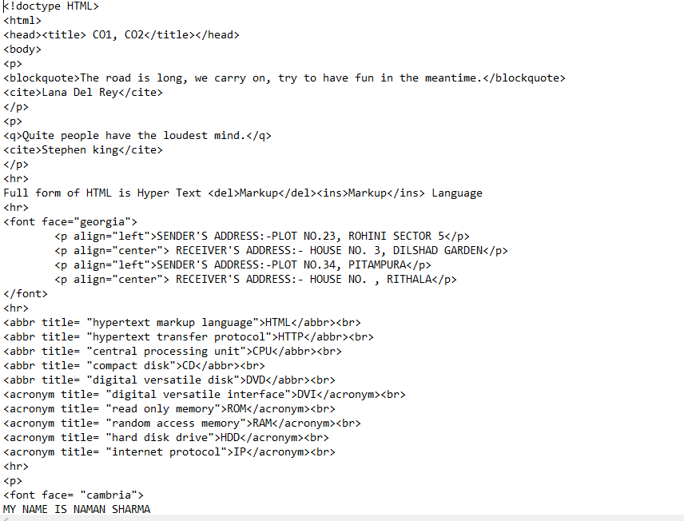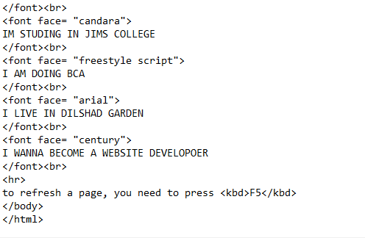

**OUTPUT**

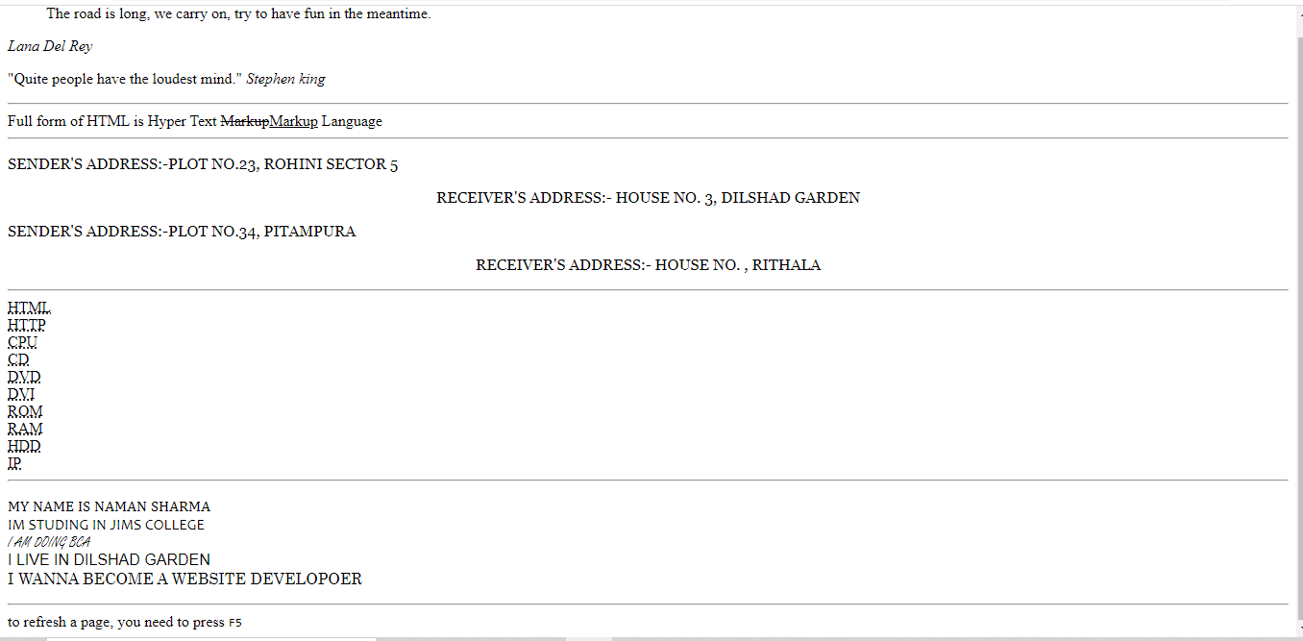

**PRACTICAL- 3**

* Print the Definition List with at least 5 definitions.
* Put the horizontal line of width 100%.
* Display the “ Nested List” heading using marquee tag and use all its major attributes.
* Now, create the given below nested List.

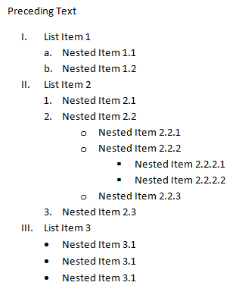

**CODE**

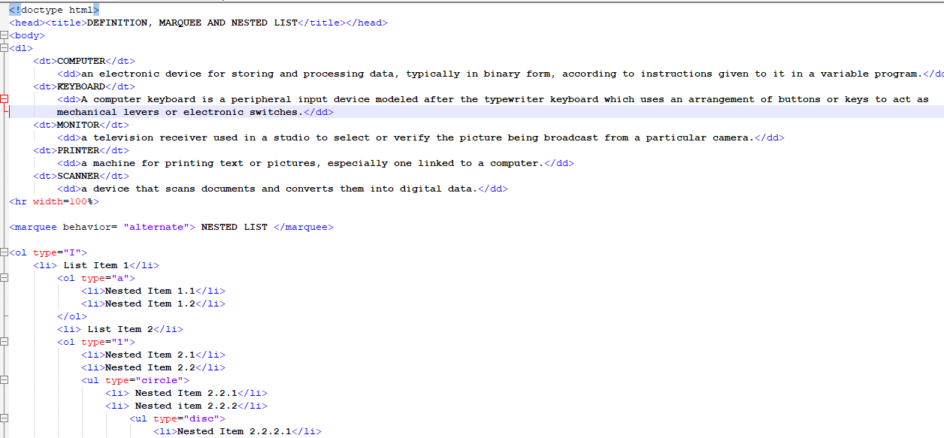

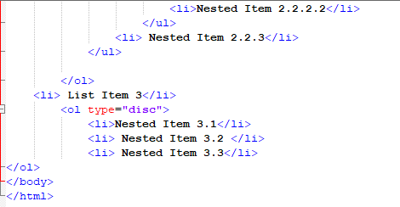

**OUTPUT**

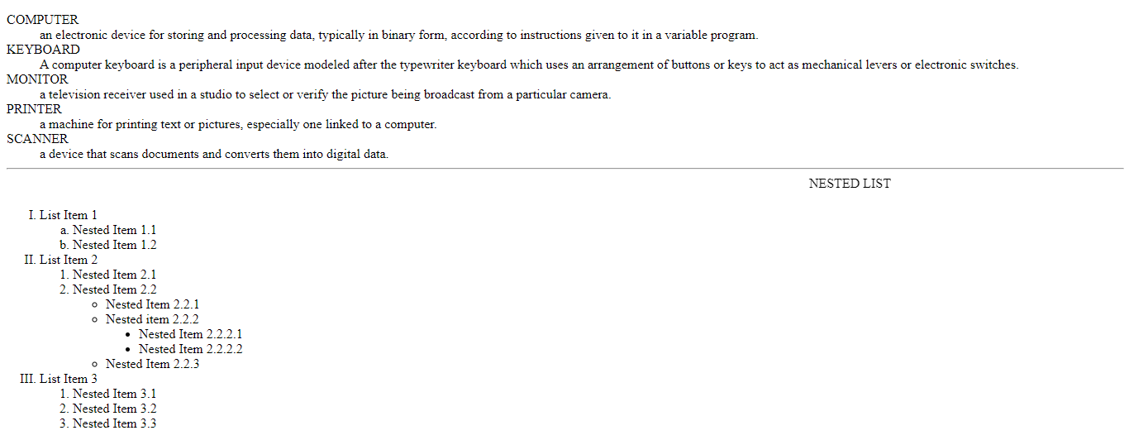

**PRACTICAL- 4**

* Create links to various search engine pages e.g. google, yahoo, altavista etc.
* Insert one image on the web page which can be formatted using different attributes of image tag.
* Create a page with a link at the top of it that when clicked will jump all the way to the bottom of the page.
* Create a page with a link at the bottom of it that when clicked will jump all the way to the top of the page.
* Insert one image link which one clicked opens up the resume in the new web page.
* Insert comments in the HTML anchor tags( top and bottom)
* Beautify and format the web page using different tags and attributes learn so far.

**CODE**

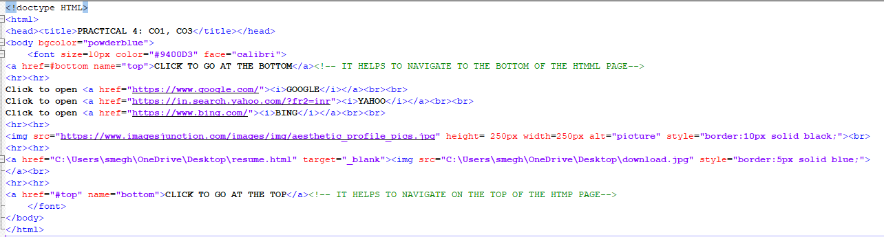

**OUTPUT**

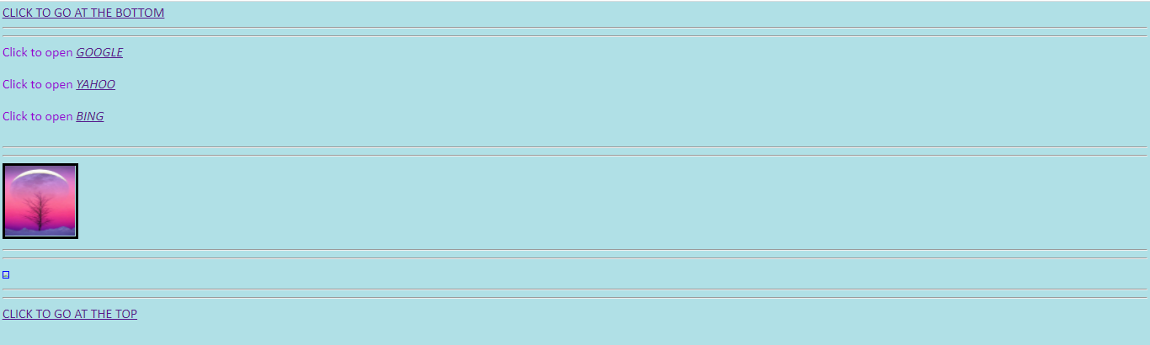

**PRACTICAL- 5**

* Write a program to create HTML table with the following output :
* Apply the background colour on the table.
* Apply caption,
* Increase the cell padding and cell spacing.
* Apply border and border color on the table.
* Each Company name should be the hyperlink opening the company website.
* Create one more table on the top of the web page that must have at least one image of the car.
* Create the Contact Us details at the bottom of the web page.
* On the bottom of the web page there must be the hyperlink to go at the top.

**CODE**

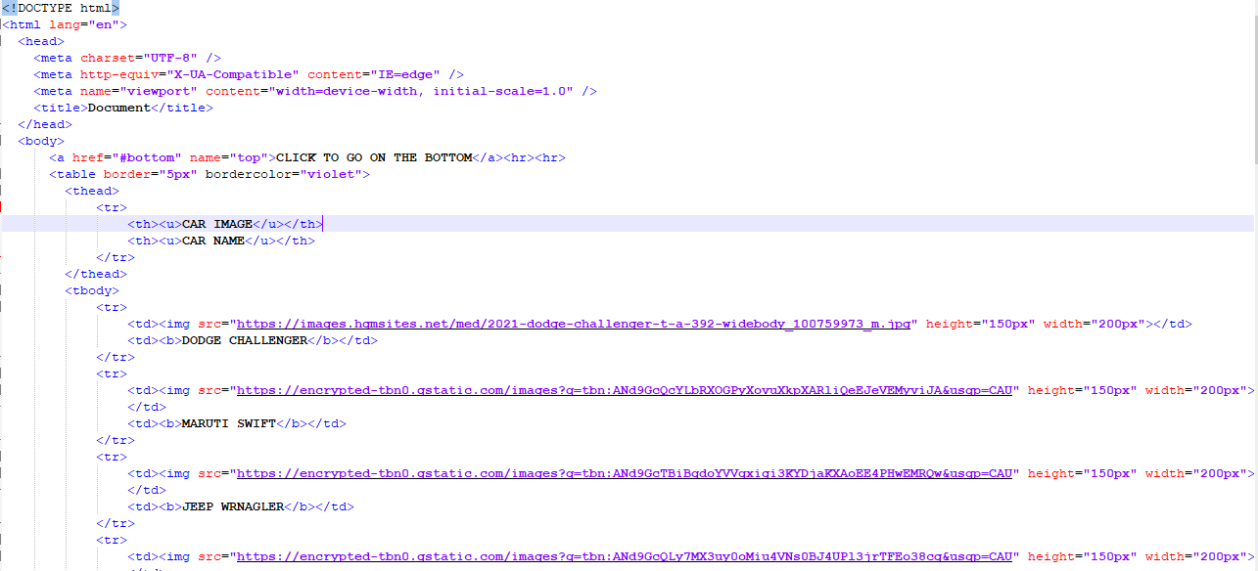

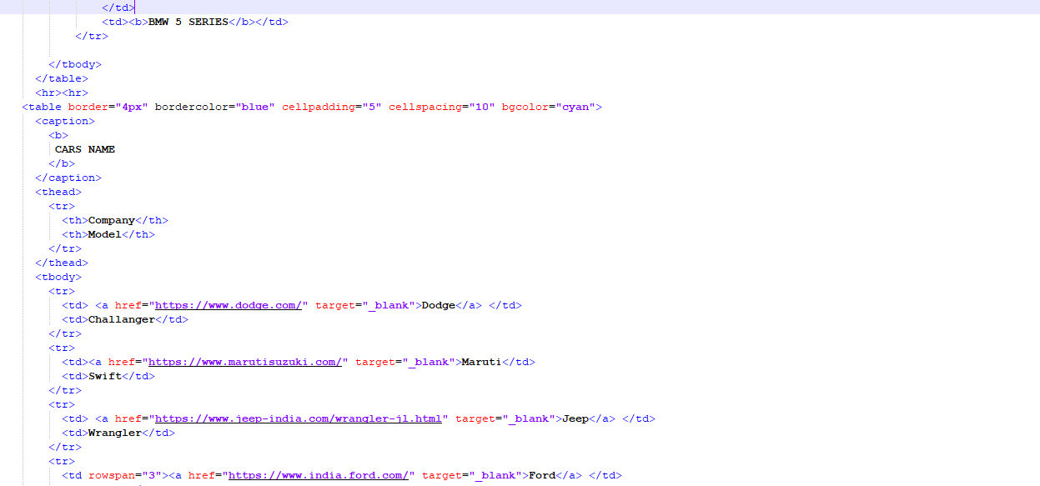

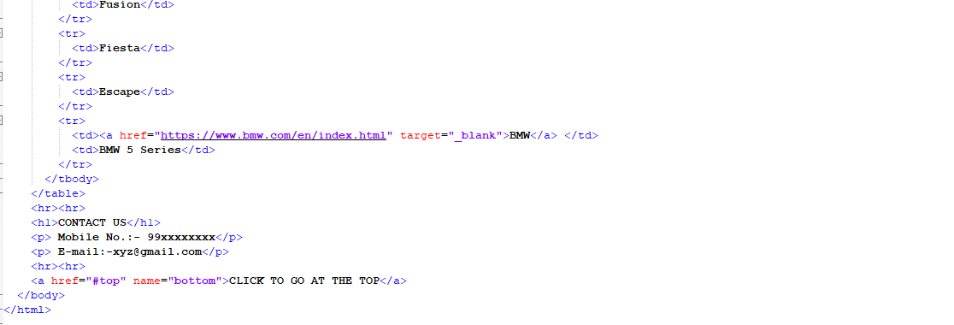

**OUTPUT**

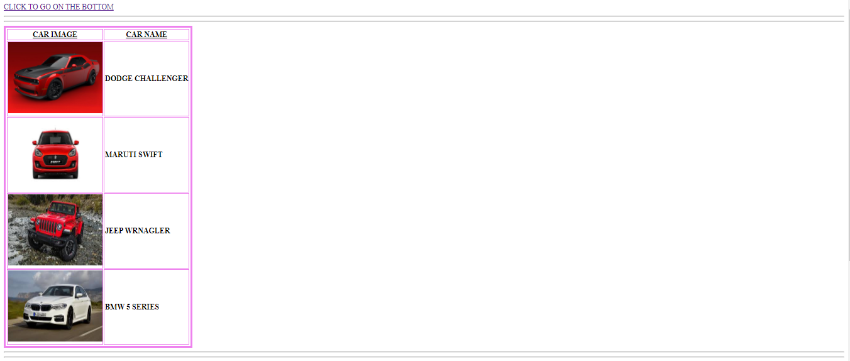

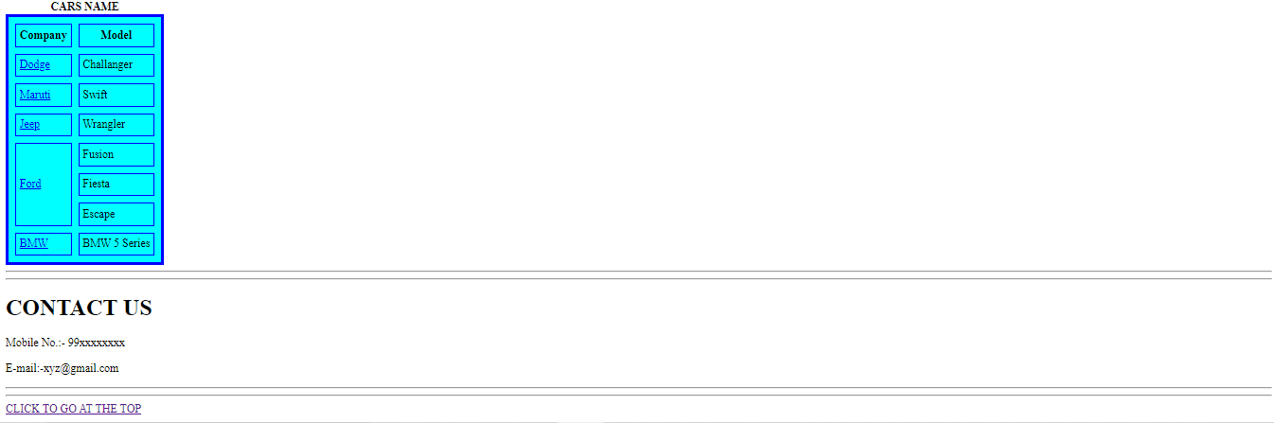

**PRACTICAL- 6**

* All the tables discussed in the class ( 3 Problem , and 3 of test)

**CODE**

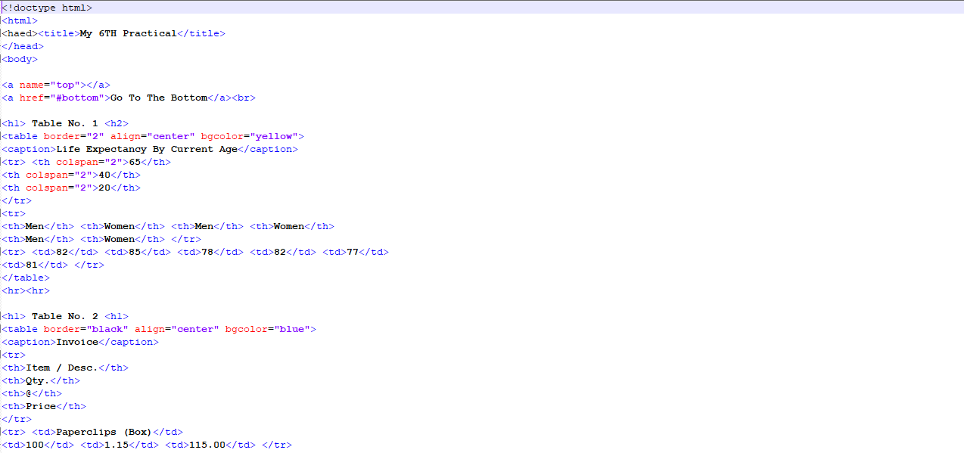

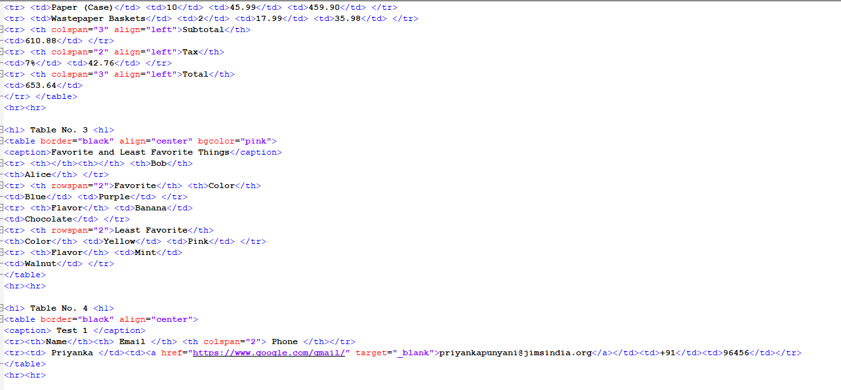

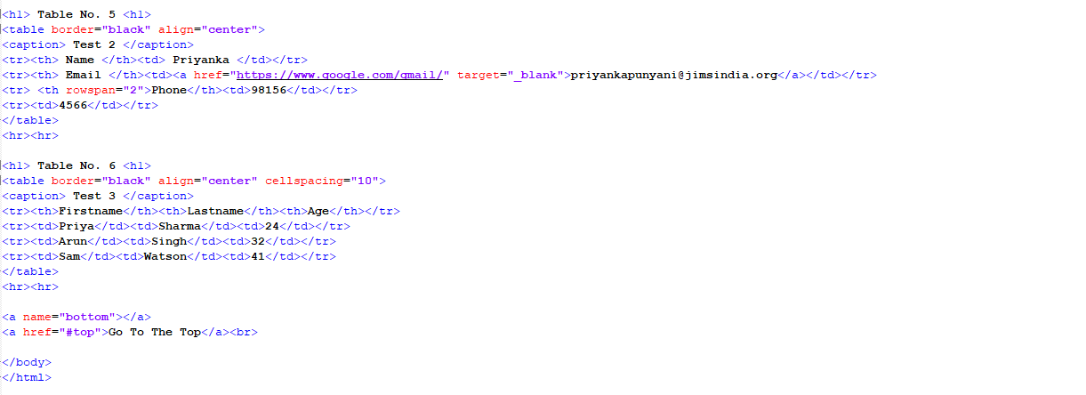

**OUTPUT**

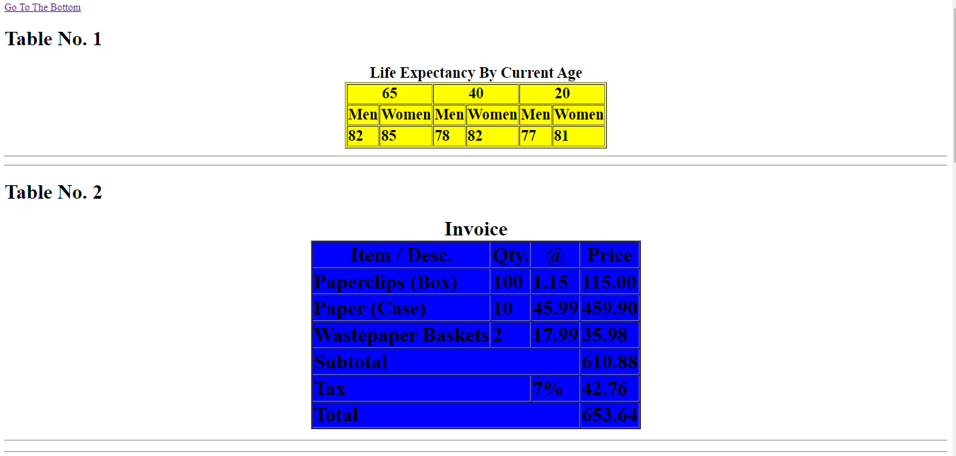

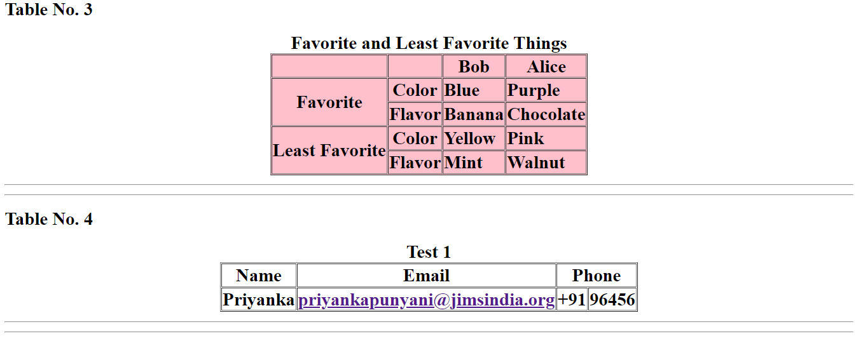

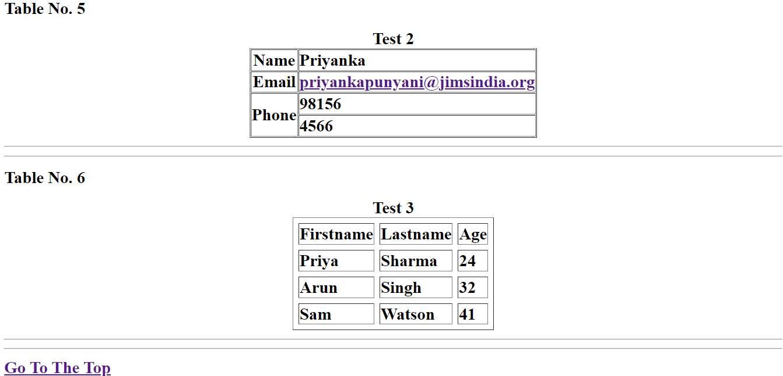

**PRACTICAL- 7**

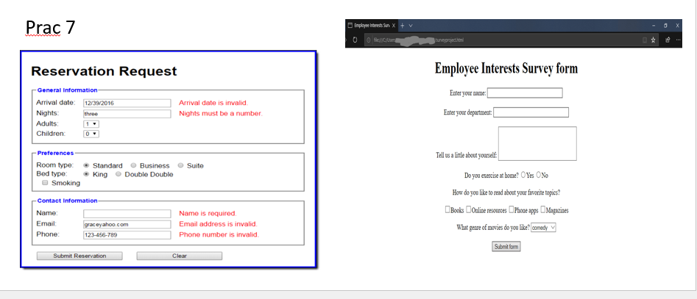

**CODE**

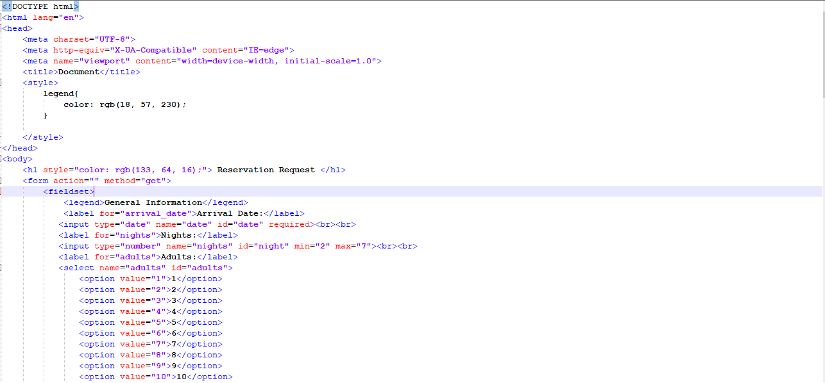

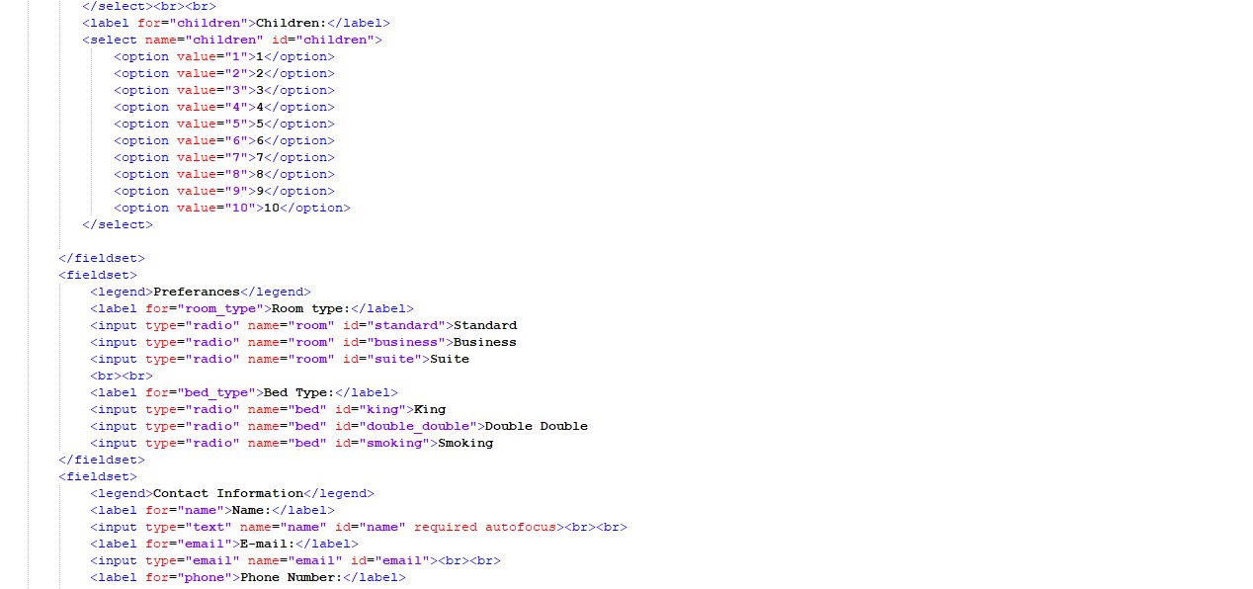

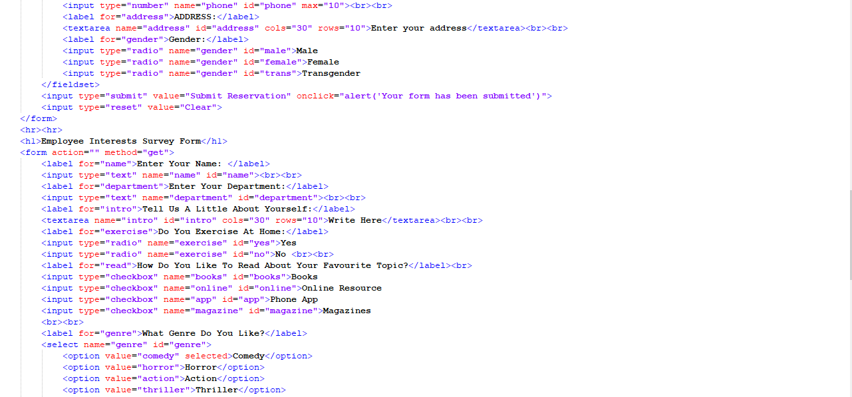

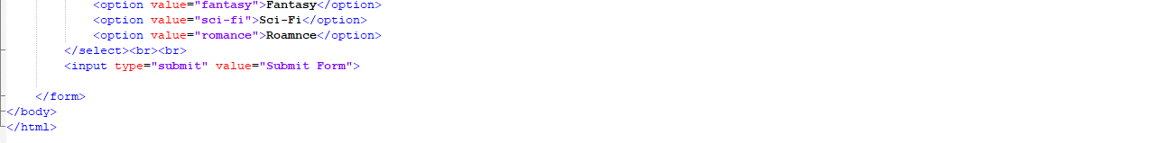

**OUTPUT**

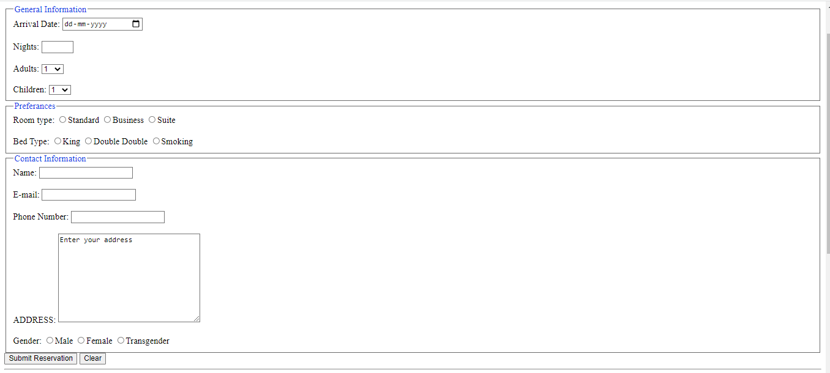

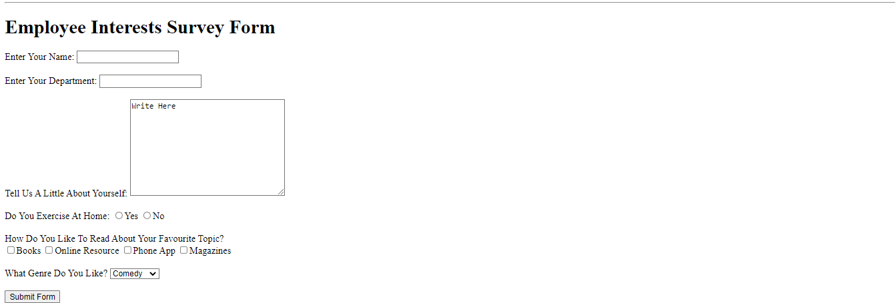

**PRACTICAL- 8**

Frames

• Initially 3 rows (20,40,40)

• Then the second row must be divided into 2 cols . And third row is divided into 3 cols

• Then 1st row will display the prac 7

• Then 2nd row, 1st col should display prac4

• Then 2nd row, 2nd col should display prac2

• Then 3rd row, 1st cols, "Mesg" HELLO Learning HTML. . Then 3rd roe, 2nd cols, " Will open the google site"

• Then 3rd row, 3rd cols, "Will display one car image which when clicked will open the prac 5 of car in the same frame.

**CODE**

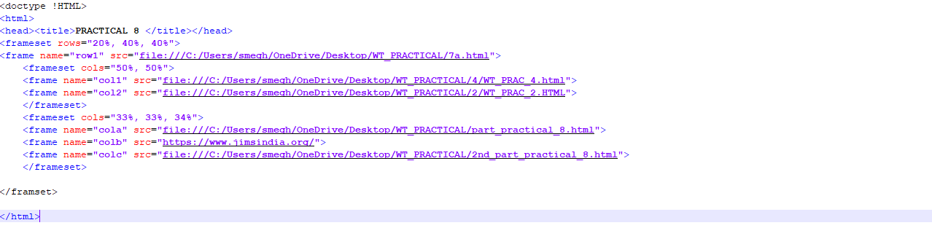

**OUTPUT**

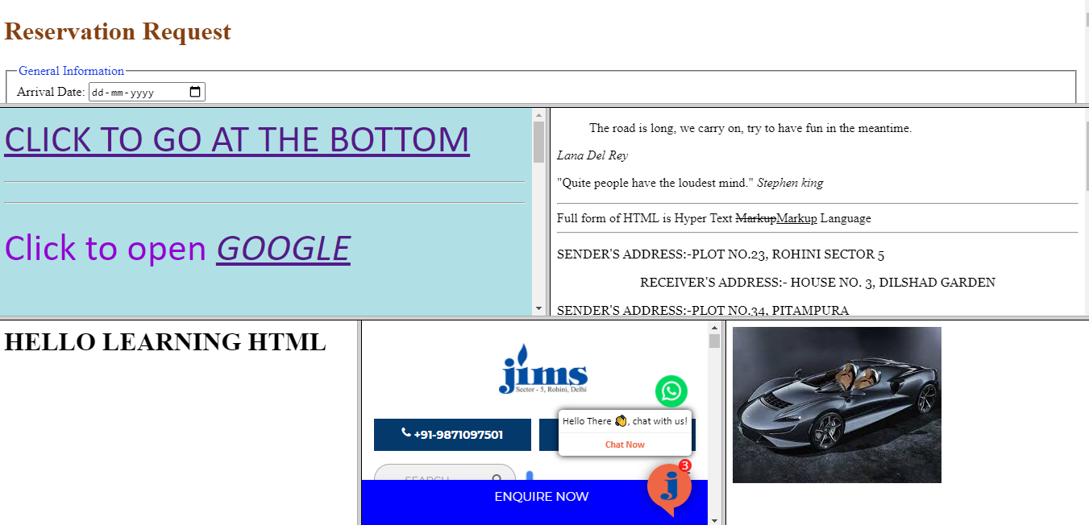

**PRACTICAL- 9**

* WAP to display the teacher details teaching you in 1st semester where teacher details are displayed in the paragraphs and images.
* The details of the teacher must be formatted and styled using the external cascading style sheets

**CODE**

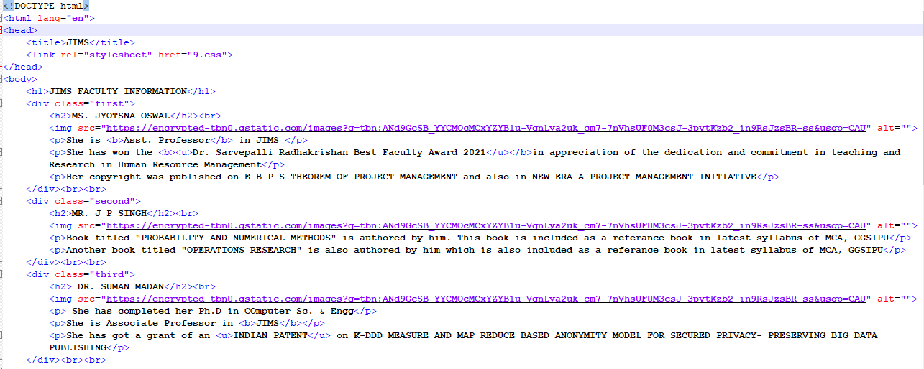

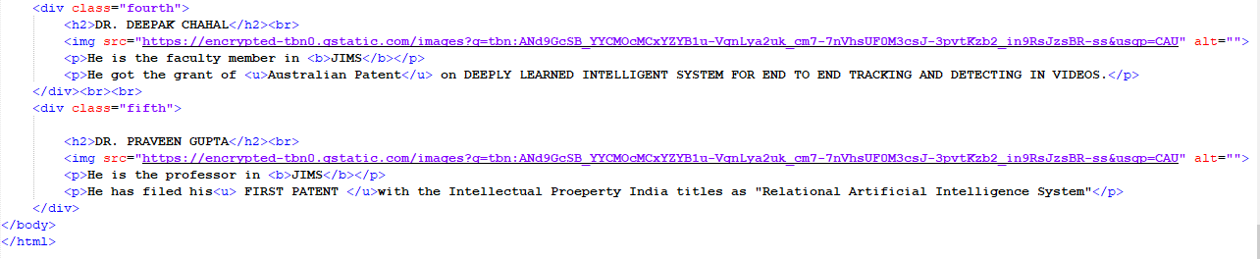

**CSS CODE**

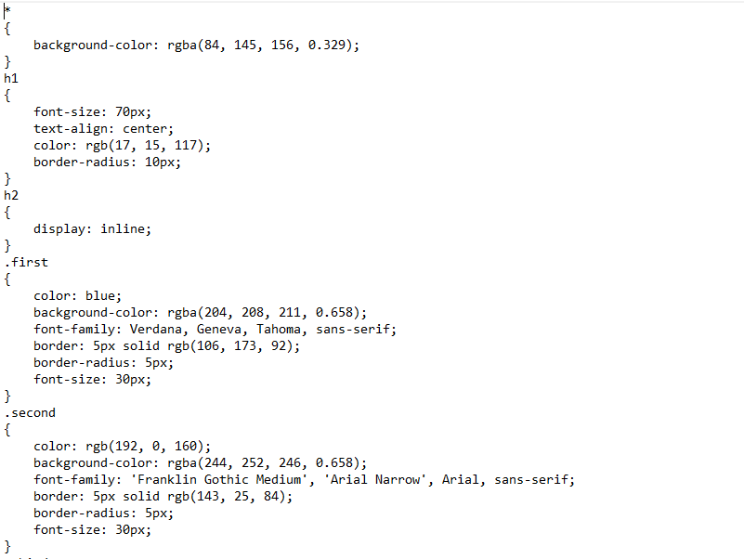

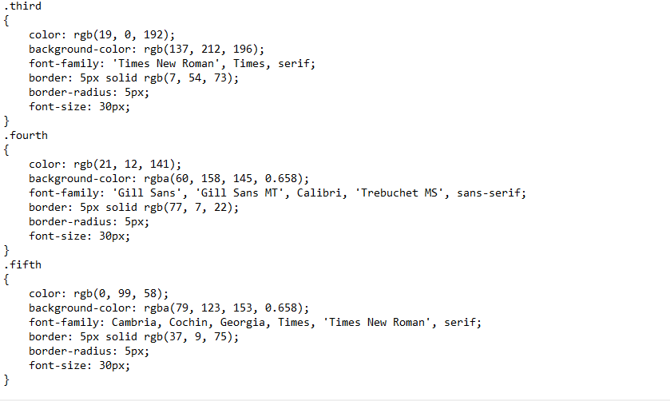

**OUTPUT**

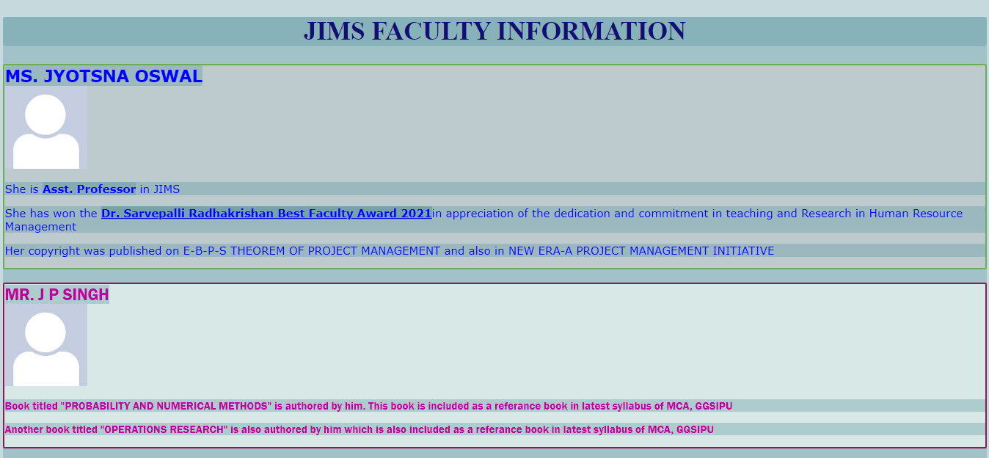

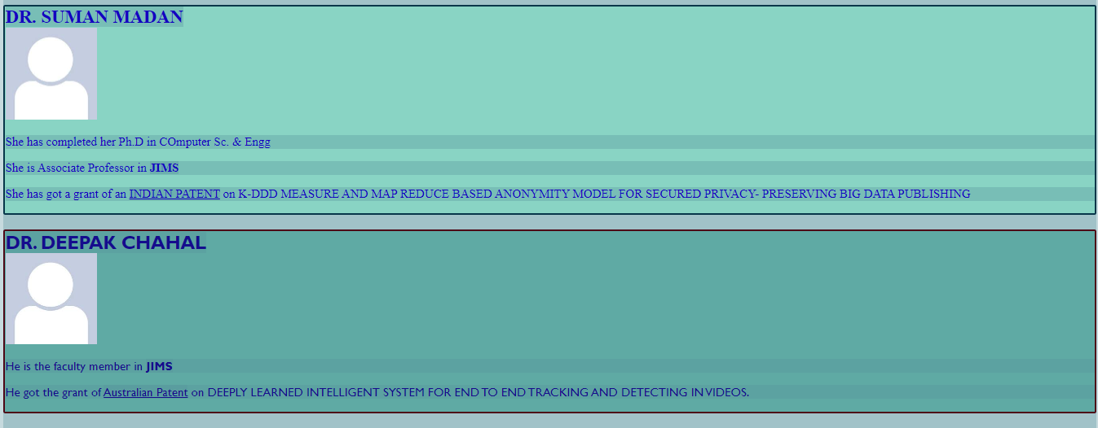



**PRACTICAL- 10**

**CODE**

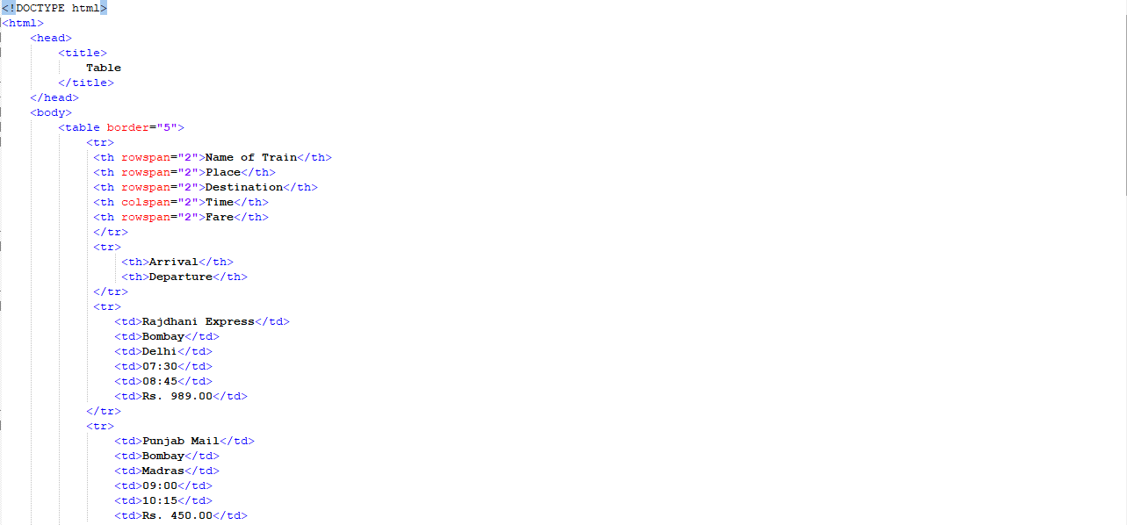

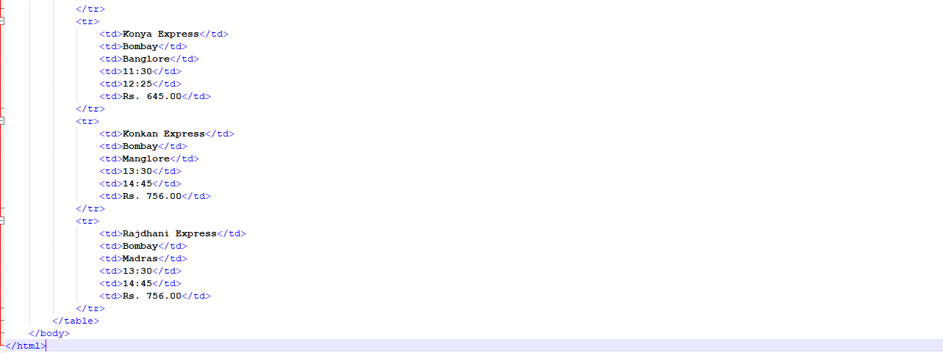

**OUTPUT**

