**Exp. 1 Design an LED flasher**

**Circuit Diagram:**

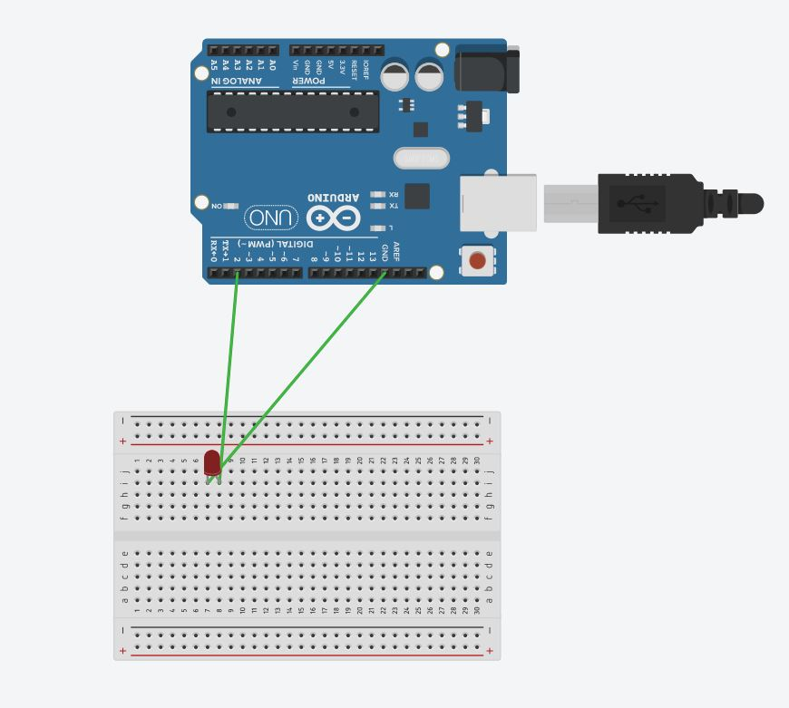

**Theory:** LEDFlasher are semiconductor integrated circuits used to turn on and off groups of light emitting diodes either sequentially or according to a programmed pattern. They are found in circuits used as indicators and controllers, as well as in home-built projects.

**Learning & Observation :**

1. **Observed Blinking of LED.**
2. **Working of Arduino.**
3. **Different sections of Arduino.**
4. **Coding for Arduino to blink a LED.**

**Precautions:**

1. **There should not be any loose connection in the circuit.**
2. **Code should be written properly.**
3. **Arduino should be attached to pc/laptop properly.**

**Code:**

**void setup()**

**{**

**pinMode(2, OUTPUT);**

**}**

**void loop()**

**{**

**digitalWrite(2, HIGH);**

**delay(1000); // Wait for 1000 millisecond(s)**

**digitalWrite(2, LOW);**

**delay(1000); // Wait for 1000 millisecond(s)**

**}**