**Assignment-1**

Course: SC-374

Computational and Numerical Methods

Instructor: Prof. Arnab Kumar

Made by:

Yatin Patel – 201601454

Rutvik Kothari – 201601417

# **Problem: 1**

♦ **Statement:**

With the help of a single code, plot the following functions

(a) $y=e^{x}$

(b) $y=x$

(c) $y=ln(x)$

use suitable ranges of x for each of the functions and judge their properties on various scale of x. Extending this exercise, plot $e^{x}$ and $e^{-x}$ on the same graph and compare them.

♦ **Graphs:**

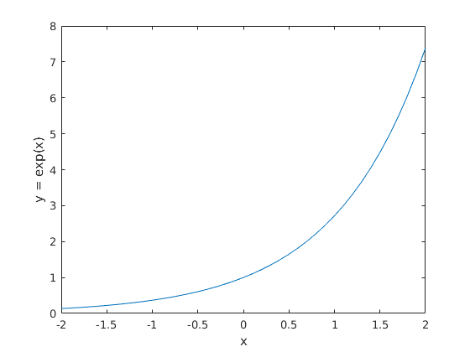

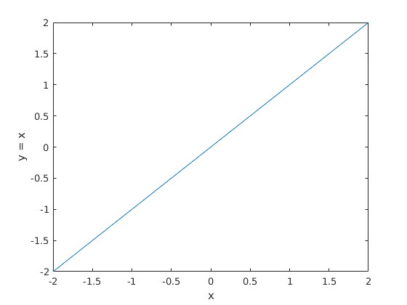

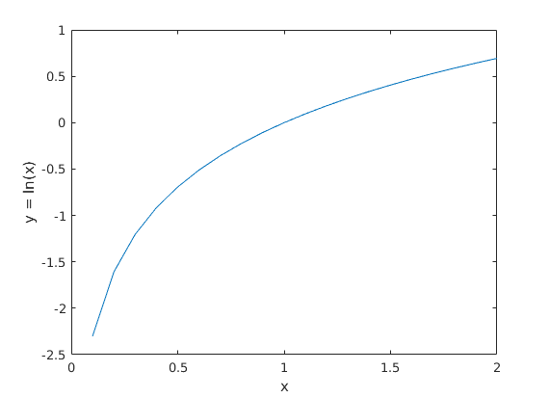

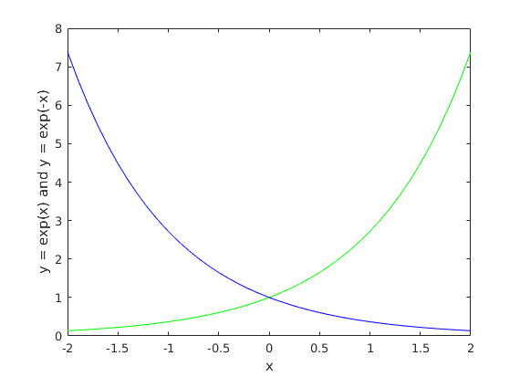

♦ **Observations:**

For the function y = x, Graph of y is straight line passing through origin. $\frac{dy}{dx}=1.$ So, we are getting constant value for the first derivative. So, graph of first derivative will be straight line parallel to x axis.

For the function $y=e^{x}$ and $\frac{dy}{dx}=e^{x}$. So, the first derivative and function itself is same for all x. So for very large values of x slope of the function would be infinite and for very low values of x slope will be nearly equal to zero. We can see that, there is no such x that $\frac{dy}{dx}=0.$ So, there will be no Turing point.

For the function $y=\log\left(x\right).$ Domain of the function is x >0. $\frac{dy}{dx}=\frac{1}{x}$. So, for x > 0 slope always will positive. We can see that the function is strictly increasing at a decreasing rate for increasing x.

For the function $y=e^{x}$ and $y=e^{-x}$, the first derivatives of these functions will be $+∞$ and $-∞$ for very large values of x. We can see that these two functions intersect at (0,1). The slops of these functions can never be zero for any values of x. So, $e^{x}$ will be strictly increasing and $e^{-x}$ will be strictly decreasing.

# **Problem: 2**

♦ **Statement:**

For a fixed parameter a plot the function $y=sin(kx)$ for a few suitably chosen values of k. What is the role of k in determining the profile of the function? Thereafter for k=1 plot $sin(x)$ and $\sin^{2}{x}$ on the same graph within $-π<x< π$. Compare both.

♦ **Graphs:**

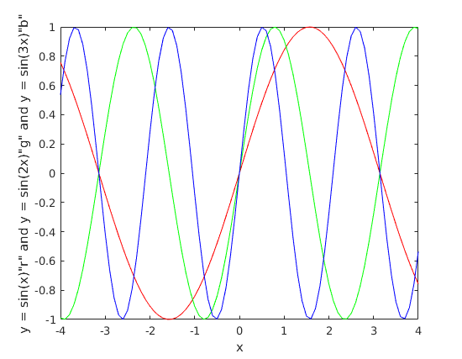

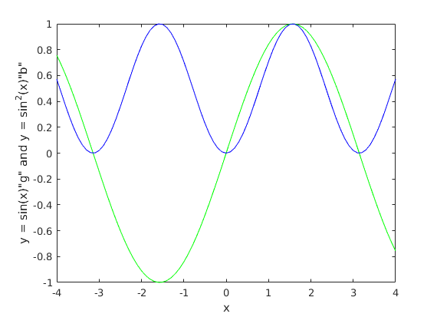

♦ **Observations:**

For the functions $y=\sin\left(kx\right)$, we can see that as we increase the value of k, the period of functions is decreasing. And if decrease the values of k then the period of functions will increase.

We can see that, Function $y{= sin}^{2}{x }$, is always non- negative. For $sin(x)>0$, then $\sin^{2}{x}<sinx$. For the $∀x, x =kπ$, both functions will coincide.

# **Problem: 3**

♦ **Statement:**

Plot the Gaussian function $y=y_{0}e^{-a{\left(x-μ\right)}^{2}}$, for a few suitably chosen values of the parameters $y_{0}$, $a$ and $μ$. Examine the shifting profile of the function with changes in the parameters. Then for $y_{0}=a=1$ and $μ=0$. Consider the first order expansion of the Gaussian function to obtain the Lorentz function. Plot both of them together and compare their behaviour. For every value of x take the difference between the two functions and plot it against x over 0 < x <10.

♦ **Graphs:**

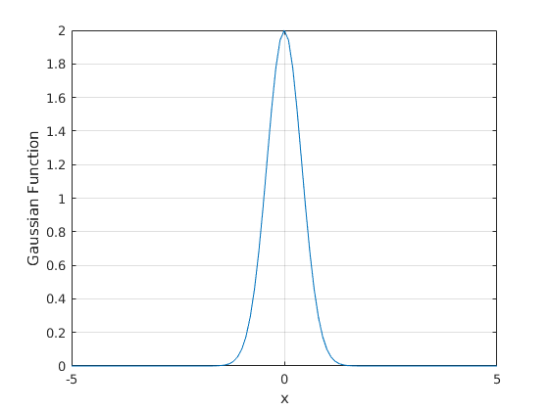

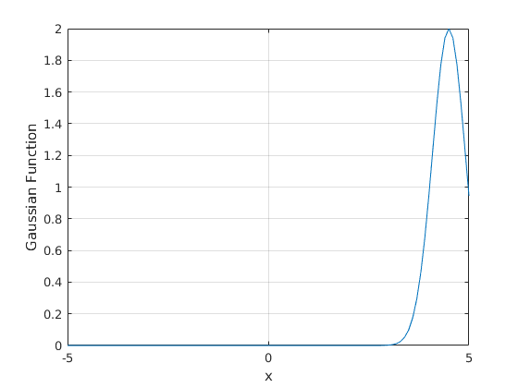

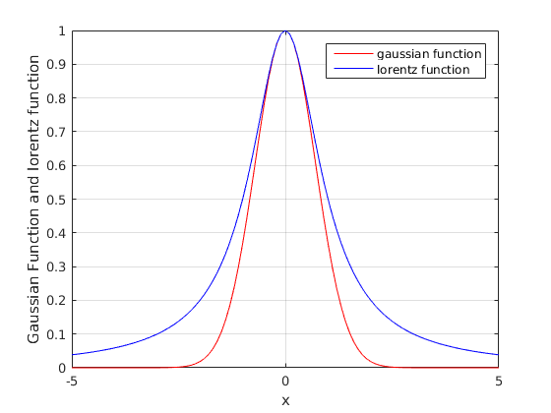

♦ **Observations:**

For the function, $y=y_{0}e^{-a{\left(x-μ\right)}^{2}}$, We have plotted the graphs of y for $μ$ =0 and $μ$ = 9 where $y_{0}=1 and a=1.$ If we change the value of $y_{0}$ the amplitude of the function changes and for negative values of $y_{0}$, the curve gets inverted respect to positive values of $y_{0}$. If we vary values of $μ$, the cure $y=f(x)$ shifts depending on the values of $μ$. If we increase the value of $μ$ the graph shifts rightwards and if we decrease the value of $μ$ the graph shifts leftwards on the x-axis.

If we take the first-order expansion of the Gaussian function that is Lorentz function $y=\frac{1}{\left(1+x^{2}\right)}$. If we compare the Lorentz function with gaussian function then we can see that going far away from $x=0$ from both sides, both functions keep decreasing. Maximum values for both functions attain at $x=0.$ For all values of x, Lorentz function is greater than or equal to gaussian function. We can see from graph that decreasing rate of gaussian is more than Lorentz for all x.

Here, $y=\frac{1}{(1+x^{2})}-e^{-x^{2}}$. We can see that around $x ≅1.7$, y becomes maximum. For 0 to $around 1.7$ y increasing and then y decreases. Gaussian function reaches the value 0 more faster than the Lorentz function because in the denominator of the gaussian function there are many higher order terms. While in the denominator of the Lorentz function there is only one second order term.

# **Problem: 4**

♦ **Statement:**

Plot $y=xln(x)$ and carefully examine it for $0 < x < 2$. Provide an analytical justification for what you observe. Also note the growth of the function for very large $x$.

♦ **Graphs:**

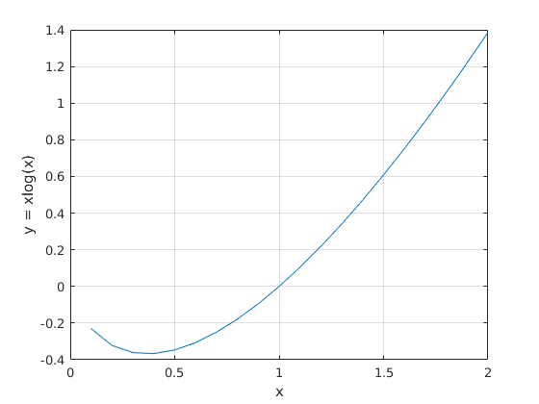

♦ **Observations:**

For the function $y=xlogx$ where $x ∈(0,∞)$, for $0<x<1$ $y$ is taking negative values and for $x>1$ y is taking positive values. Here first derivative of y is $1+logx$. Minimum value of $y= -\frac{1}{e}$ takes place at $x=\frac{1}{e}$. For $0<x<1$, $\log{x }$ will dominate over the function x and for $x>1$

x dominates over the function $logx$.

# **Problem: 5**

♦ **Statement:**

Plot $y(x)$, $y'(x)$, $y''(x)$ for the following polynomial functions,

(A) $y= -ax + x^{3}$

(B $) y=-ax^{2} + x^{4}$

Change a continuously over a suitable range of values ($a>=0$) to observe the shift in the function profiles and their two derivatives. Carefully, check all conditions for a=0.

♦ **Graphs:**

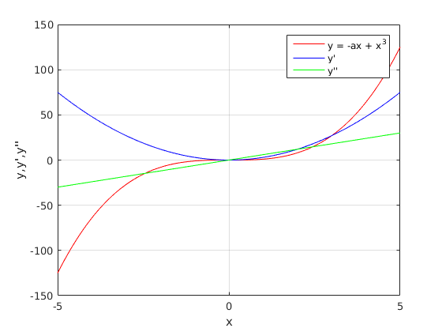

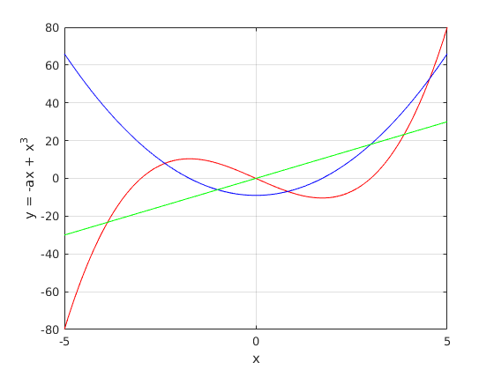

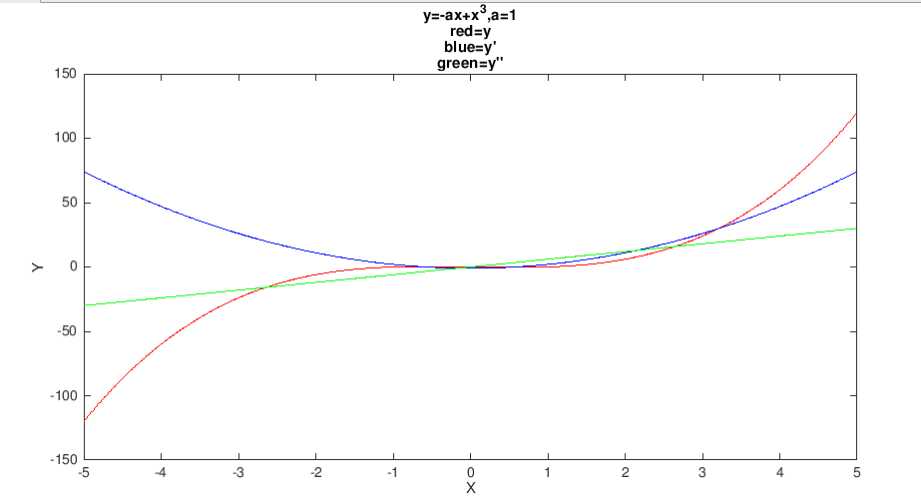

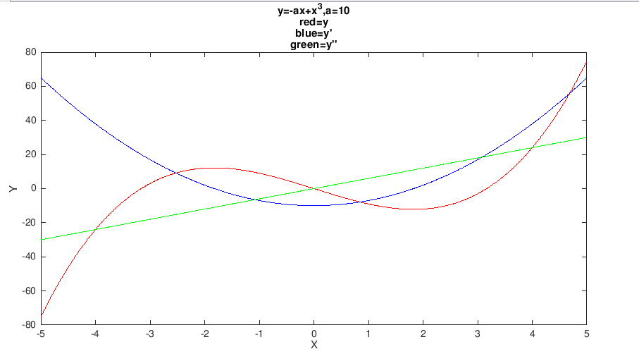

♦ **Observations:**

**For $y= -ax+x^{3}$:-**

We have plotted y for $a=0$ and $a=9$. at a=0, we can see that one minima and one maxima cancel each other creating $a$ inflexion point. For the second case when $a=9$, we can see the curve stretched up and down by a maxima and minima. As we decrease $a$, we can observe that it’s providing the same graph almost as if $a=0$. Thus, as we go on decreasing the value of , we can see that minima come near the maxima. For the derivatives we can say that they also behave as y behaves on decreasing the value of $a$.

**For $y= -ax^{2}+x^{4}$:-**

We have plotted y for $a=0$ and $a=15$. at $a=0$, this hat we can say that the steepness of curve reduces as well as the maxima and minima come closer and closer. For the second case when $a=15$, we can see Mexican hat curve. We can also see its 2 minima and one maxima. As we decrease $a$, we can observe that it’s providing the same graph almost as if $a=0$. Thus, as we go on decreasing the value of , we can see that minima come near the maxima. For the derivatives we can say that they also behave as y behaves on decreasing the value of .