**Assignment-13, 14, 15**

Course: SC-374

Computational and Numerical Methods

Instructor: Prof. Arnab Kumar

Made by:

Yatin Patel – 201601454

Rutvik Kothari – 201601417

**SET - 13**

**Numerical stability and implicit methods**

**Problem - 1**

♦ **Statement:**

The initial-value problem Y’(x) =

**Problem - 2**

♦ **Statement:**

Numerically solve the following system:

$${4x}_{1}+3x_{2}+2x_{3 }+x_{4}=1$$

$$3x_{1}+4x_{2}+3x_{3}+2x_{4}=1$$

$$2x_{1}+3x_{2}+4x_{3}+3x_{4}=-1$$

$$x_{1}+2x_{2}+3x_{3}+4x_{4}= -1$$

Roots are :-

$$x_{1}=0 , x_{2}= 1 ,x_{3}=-1 and x_{4}=0$$

**Problem - 3**

♦ **Statement:**

Numerically Find the inverse of the following matrix:

$$\begin{matrix}1 & 1 & -1 \\ 1 & 2 & -2 \\ -2 & 1 & 1\end{matrix}$$

Inverse Matrix is:-

$$\begin{matrix}2 & -1 & 0 \\ 1.5 & -0.5 & 0.5 \\ 2.5 & -1.5 & 0.5\end{matrix}$$

**SET - 10**

**The Jacobi Iteration and The Gauss-Seidel Methods**

**Problem - 1**

♦ **Statement:**

Numerically solve the following system of equations by both the Jacobi iteration and the Gauss-Seidel methods. Compare the efficiency of both methods.

$${9x}_{1}+x_{2}+x_{3}=10$$

$$2x_{1}+10x_{2}+3x_{3}=19$$

$$3x_{1}+4x_{2}+11x_{3}=0$$

Take initial guess values of $x_{1}^{0} = x_{2}^{0} = x_{3}^{0} = 0$. Try two more sets of initial guess values of your choice, and check for convergence to the actual solution (which you can easily compute by hand from the three foregoing equations).

Roots are:-

$$x_{1}=1 , x_{2}=2 and x_{3}= -1$$

For $, x_{1}=0 ,x_{2}=0 and x_{3}=0$,

Jacobi Method:-

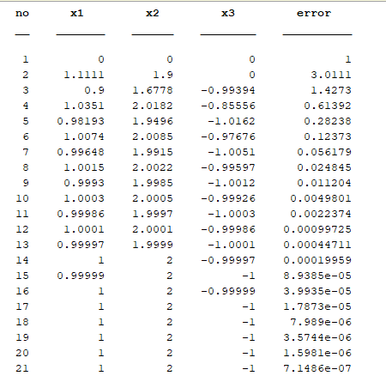

Gauss-Seidel Method:-

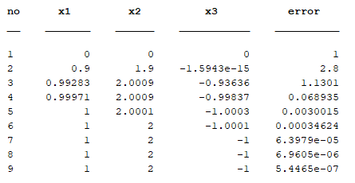

For, $x_{1}=1,x_{2}=2 and x_{3}=3$

Jacobi Method:-

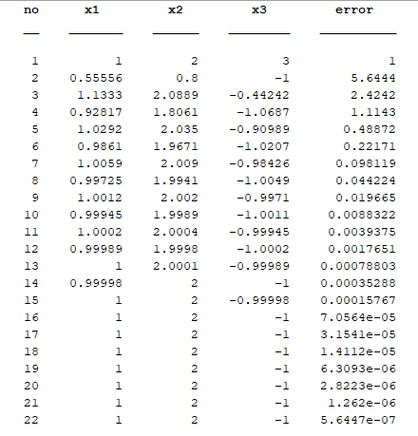

Gauss-Seidel Method:-

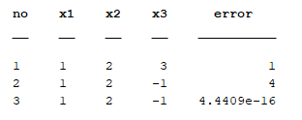

For, $x_{1}=1,x_{2}=2 and x_{3}=3$

Jacobi Method:-

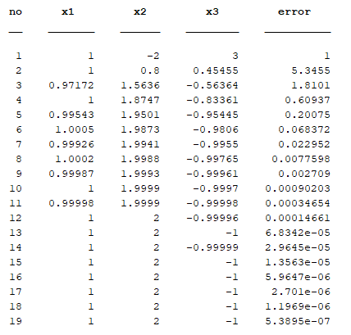

Gauss-Seidel Method:-

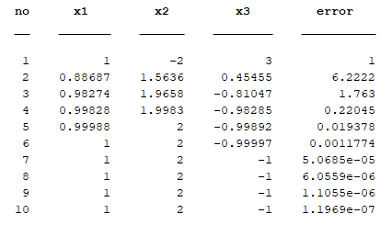

|  |  |  |  |  |  |
| --- | --- | --- | --- | --- | --- |
| Initial Values   |  |  |  | | --- | --- | --- | |  |  |  | | Total Steps for Jacobi Method | Total Steps for Gauss-Seidel method |
| |  |  |  | | --- | --- | --- | | 0 | 0 | 0 | | 20 | 8 |
| |  |  |  | | --- | --- | --- | | 1 | 2 | 3 | | 21 | 2 |
| |  |  |  | | --- | --- | --- | | 1 | -2 | 3 | | 18 | 9 |

So, Gauss-Seidel Method is more efficient then Jacobi Method in terms of faster convergence.

**SET - 11**

**Non-linear system and Newton Method**

**Problem - 1**

♦ **Statement:**

Consider the following system of nonlinear equations.

$$f\left(x,y\right)=x^{2}+4y^{2}-9=0$$

$$g\left(x,y\right)=18y-14x^{2}+45=0$$

1. Plot the foregoing functions on the x-y plane.

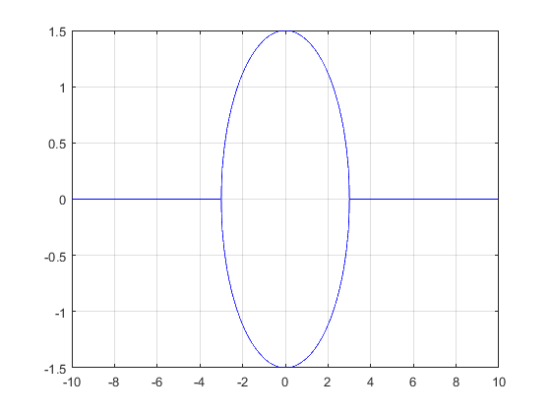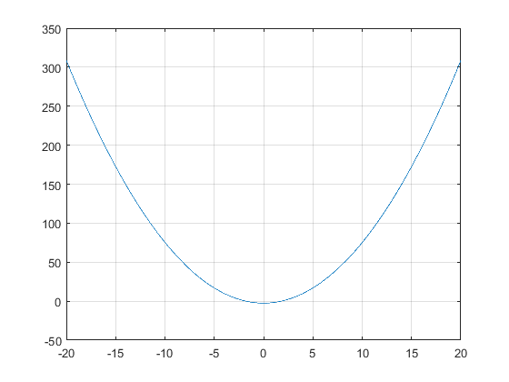

1. Obtain all the roots (where f and g intersect) by the general Newton method.

For $x=1 and y=2$

Roots are:

$$x=2.1372 and y=1.0527$$