**Assignment-12**

Course: SC-374

Computational and Numerical Methods

Instructor: Prof. Arnab Kumar

Made by:

Yatin Patel – 201601454

Rutvik Kothari – 201601417

# **Problem: 1**

♦ **Statement:**

Consider the following initial value problems, Numerically solve both by Euler’s method, for range 0<=x<=6 , separately using h = 0.2,0.1,0.05. For each problem, plot the numerical solutions for every value of h along with the analytical solution. Compare the graphs for errors.

(A) Y’(x) = Y(x) , Y(0)=1.

(a) Graph of function for h=0.2 , h=0.1 and h=0.05

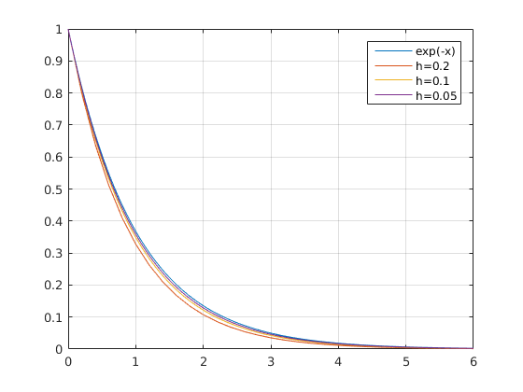

(b) Error function for h=0.2, h=0.1 and h=0.05

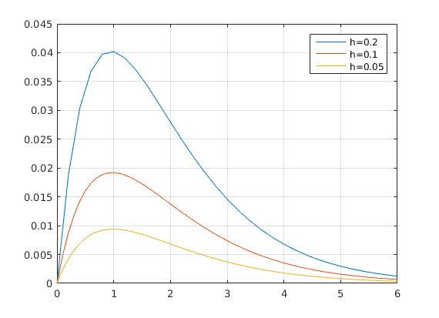

(B) Y’(x) = ( Y(x) + x^2 –2 ) / (x+1) , Y(0)=2.

(a) Graph of function for h=0.2 , h=0.1 and h=0.05

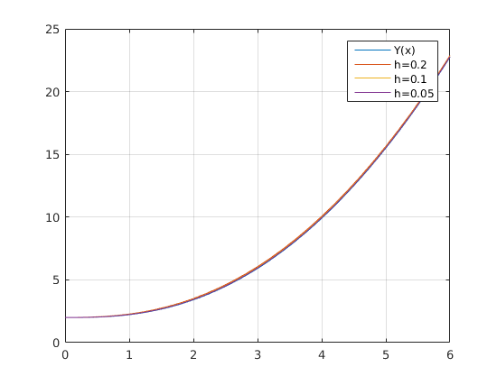

(b) Error function for h=0.2, h=0.1 and h=0.05

