**Assignment-1**

Course: SC-374

Computational and Numerical Methods

Instructor: Prof. Arnab Kumar

Made by:

Yatin Patel – 201601454

Rutvik Kothari – 201601417

# **Problem: 1**

♦ **Statement:**

With the help of a single code, plot the following functions (a) y=exp(x) , (b) y=x , (c) y=ln(x). use suitable ranges of x for each of the functions and judge their properties on various scale of x. Extending this exercise , plot exp(x) and exp(-x) on the same graph and compare them.

♦ **Graphs:**

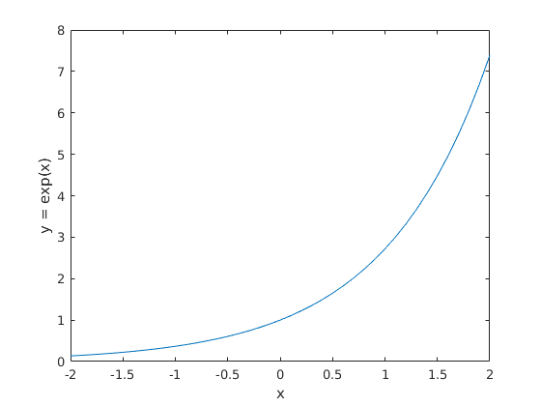

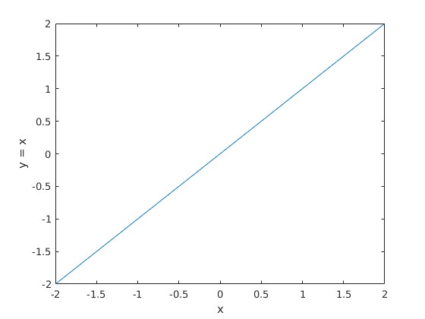

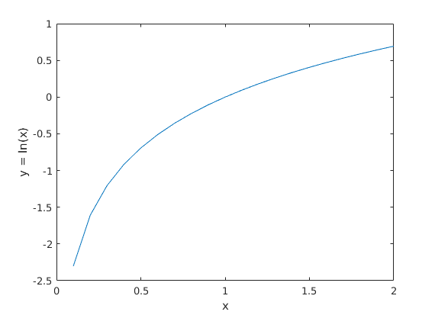

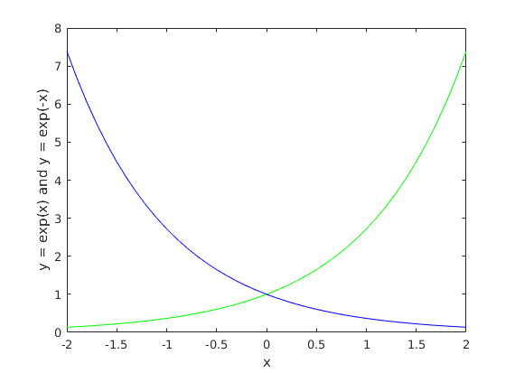

♦ **Observations:**

# **Problem: 2**

♦ **Statement:**

For a fixed parameter a plot the function y=sin(kx) for a few suitably chosen values of k. What is the role of k in determining the profile of the function? Thereafter for k=1 plot sin(x) and sin^2(x) on the same graph within

–pi < x < pi. Compare both.

♦ **Graphs:**

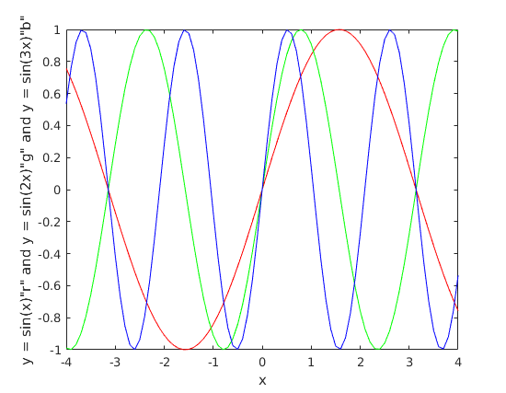

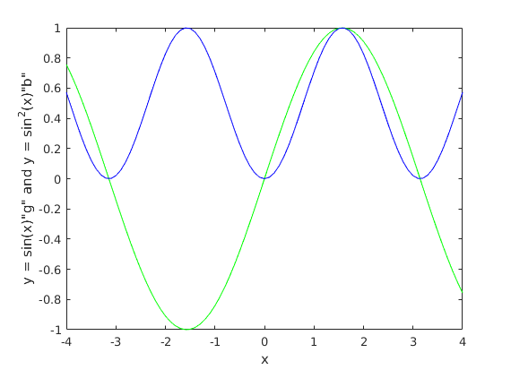

♦ **Observations:**

# **Problem: 3**

♦ **Statement:**

Plot the Gaussian function y= , for a few suitably chosen values of the parameters y0,a and μ. Examine the shifting profile oof the function with changes in the parameters.Then for y0=a=1 and μ=0.Consider the first order expansion of the Gaussian function to obtain the Lorentz function.Plot both of them together and compare their behaviour. For every value of x take the difference between the two functions and plot it against x over 0 < x <10.

♦ **Graphs:**

♦ **Observations:**

# **Problem: 4**

♦ **Statement:**

Plot y=xln(x) and carefully examine it for 0 < x < 2 .Provide an analytical justification for what you observe .Also note the growth of the function for very large x.

♦ **Graphs:**

♦ **Observations:**

# **Problem: 5**

♦ **Statement:**

Plot y(x) , y'(x) , y''(x) for the following polynomial functions ,

(a) y= -ax + x^3

(b)y=-ax^2 + x^4

Change a continuously over a suitable range of values(a>=0) to observe the shift in the function profiles and their two derivatives .Carefully , check all conditions for a=0.

♦ **Graphs:**

♦ **Observations:**