**Assignment-4**

Course: SC-374

Computational and Numerical Methods

Instructor: Prof. Arnab Kumar

Made by:

Yatin Patel – 201601454

Rutvik Kothari – 201601417

# **Problem: 1**

♦ **Statement:**

Write a code, applying the algorithm of the Newton-Raphson method to determine both the real roots of $f(x) = x^{6} - x - 1 = 0$.

♦ **Graphs:**

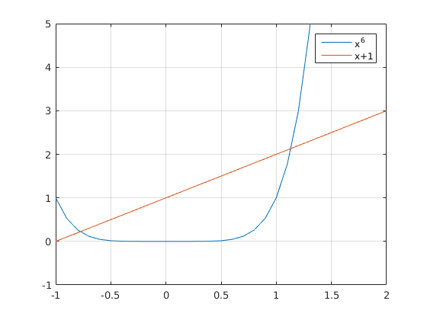

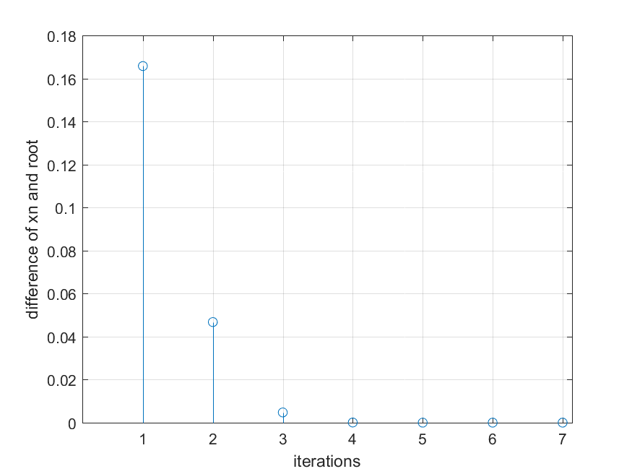

|  |  |  |  |  |
| --- | --- | --- | --- | --- |
| no | x_n | f_x_n | f_x_d | x_n_1 |
| 1 | 1.5 | 8.891 | 44.563 | 1.3 |
| 2 | 1.3 | 2.537 | 21.32 | 1.181 |
| 3 | 1.181 | 0.538 | 12.813 | 1.139 |
| 4 | 1.139 | 0.049 | 10.525 | 1.135 |
| 5 | 1.135 | 0.001 | 10.29 | 1.135 |

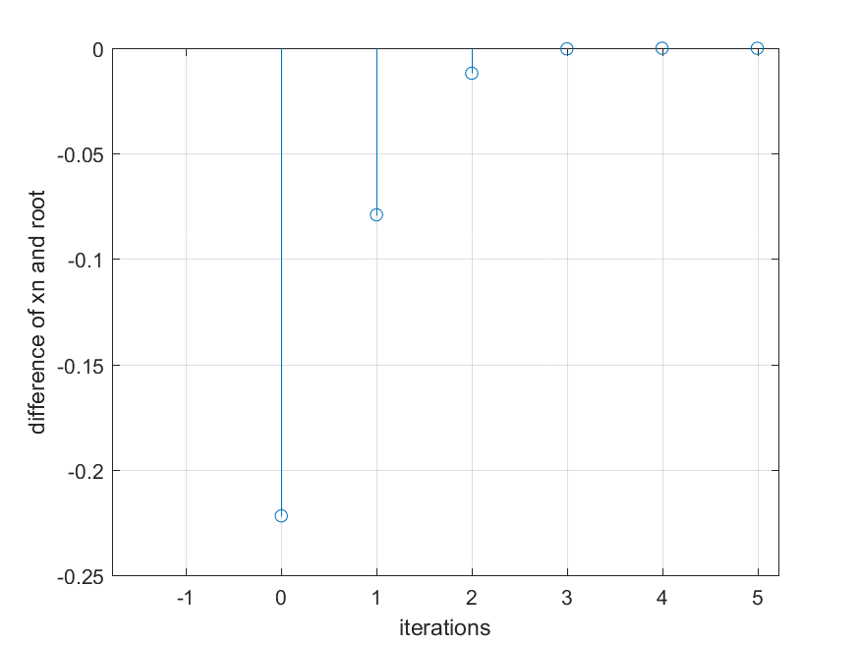

|  |  |  |  |  |
| --- | --- | --- | --- | --- |
| no | x_n | f_x_n | f_x_d | x_n_1 |
| 1 | -1 | 1 | -7 | -0.857 |
| 2 | -0.857 | 0.254 | -3.776 | -0.79 |
| 3 | -0.79 | 0.033 | -2.846 | -0.778 |
| 4 | -0.778 | 0.001 | -2.714 | -0.778 |
| 5 | -0.778 | 0 | -2.711 | -0.778 |

♦ **Observations:**

Smallest Root which we are getting is at x = -0.7781 .

Largest Root which we are getting is at x = 1.1347 .

# **Problem: 2 & 3**

♦ **Statement:**

Use the bisection method to find the real roots of the following functions, using an error tolerance of € = 0.0001.

**(A) $f(x) = x^{3} – x^{2} – x – 1 = 0$**

♦ **Graphs:**

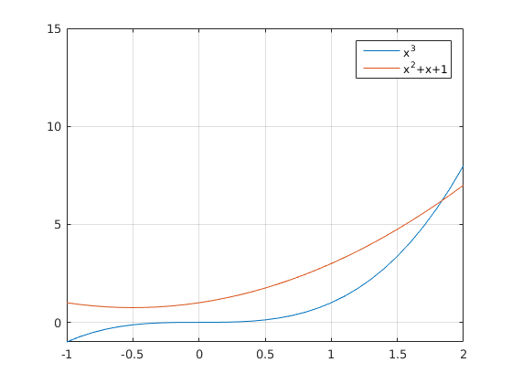

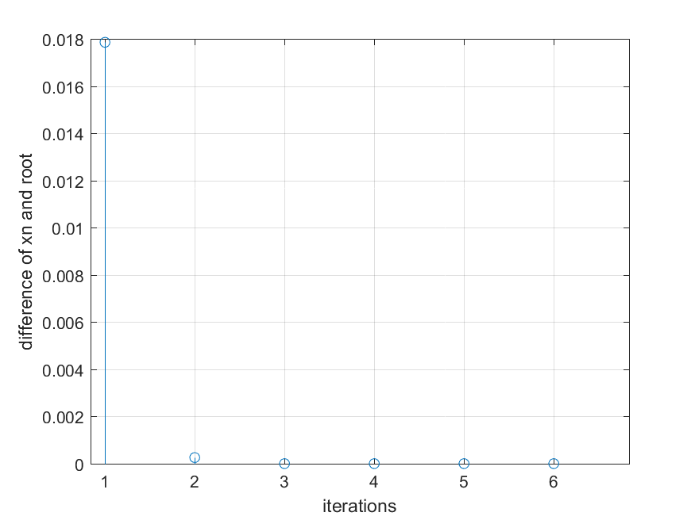

|  |  |  |  |  |
| --- | --- | --- | --- | --- |
| no | x_n | f_x_n | f_x_d | x_n_1 |
| 1 | 2 | 1 | 7 | 1.857 |
| 2 | 1.857 | 0.099 | 5.633 | 1.84 |
| 3 | 1.84 | 0.001 | 5.473 | 1.839 |
| 4 | 1.839 | 0 | 5.47 | 1.839 |

♦ **Observations:**

Root which we are getting is at x = 1.8393 .

**(B) $f(x) = x-1-0.3cosx = 0$**

♦ **Graphs:**

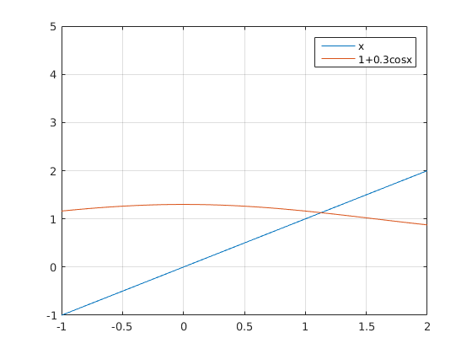

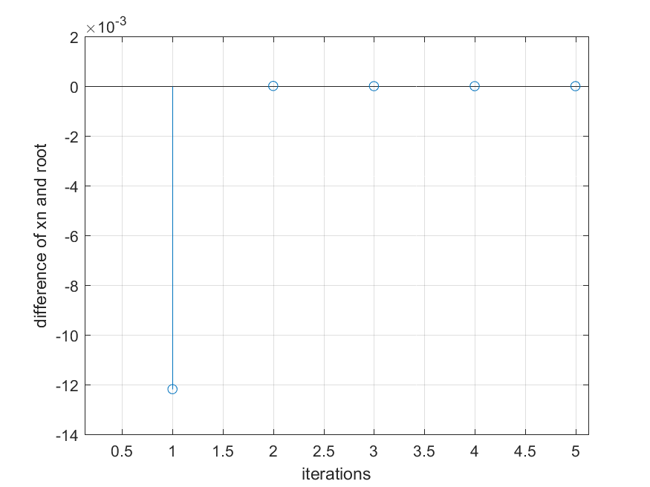

|  |  |  |  |  |
| --- | --- | --- | --- | --- |
| no | x_n | f_x_n | f_x_d | x_n_1 |
| 1 | 2 | 1.125 | 1.273 | 1.116 |
| 2 | 1.116 | -0.015 | 1.27 | 1.128 |
| 3 | 1.128 | 0 | 1.271 | 1.128 |

♦ **Observations:**

Root which we are getting is at x = 1.1284 .

**(C) $f(x) = cosx-sinx-0.5 = 0$**

♦ **Graphs:**

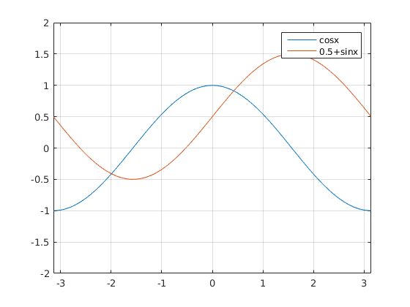

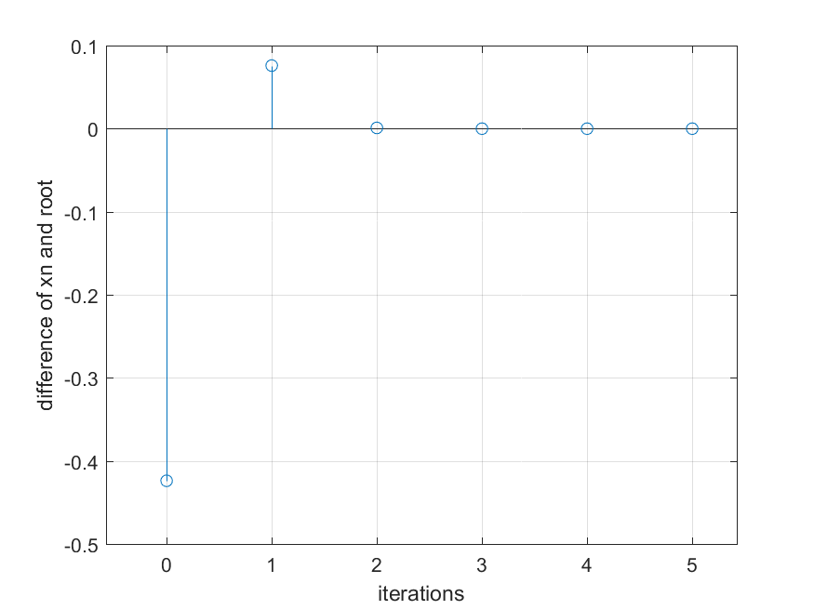

|  |  |  |  |  |
| --- | --- | --- | --- | --- |
| no | x_n | f_x_n | f_x_d | x_n_1 |
| 1 | 0 | 0.5 | -1 | 0.5 |
| 2 | 0.5 | -0.102 | -1.357 | 0.425 |
| 3 | 0.425 | -0.001 | -1.323 | 0.424 |
| 4 | 0.424 | -0 | -1.323 | 0.424 |

♦ **Observations:**

Root which we are getting is at x = 0.4241 .

**(D) $f(x) = x – e^{-x} = 0$**

♦ **Graphs:**

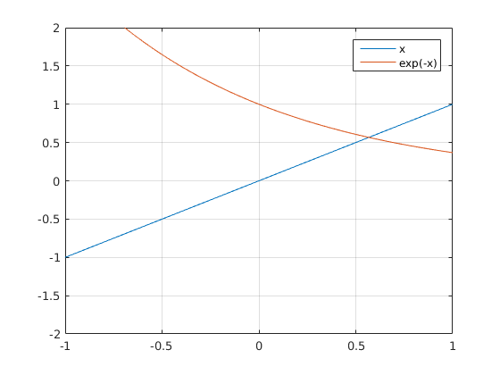

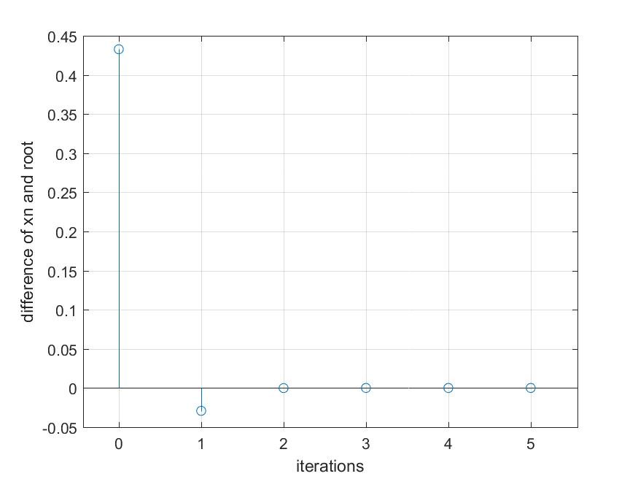

|  |  |  |  |  |
| --- | --- | --- | --- | --- |
| no | x_n | f_x_n | f_x_d | x_n_1 |
| 1 | 1 | 0.632 | 1.368 | 0.538 |
| 2 | 0.538 | -0.046 | 1.584 | 0.567 |
| 3 | 0.567 | -0 | 1.567 | 0.567 |
| 4 | 0.567 | -0 | 1.567 | 0.567 |

♦ **Observations:**

Root which we are getting is at x = 0.5672 .

**(E) $f(x) = e^{-x} - sinx = 0$**

♦ **Graphs:**

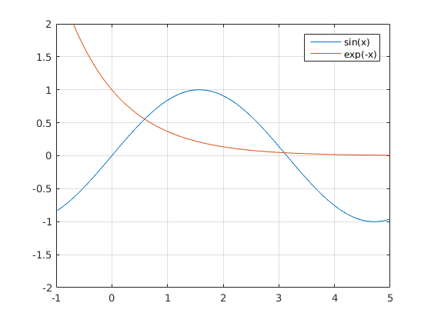

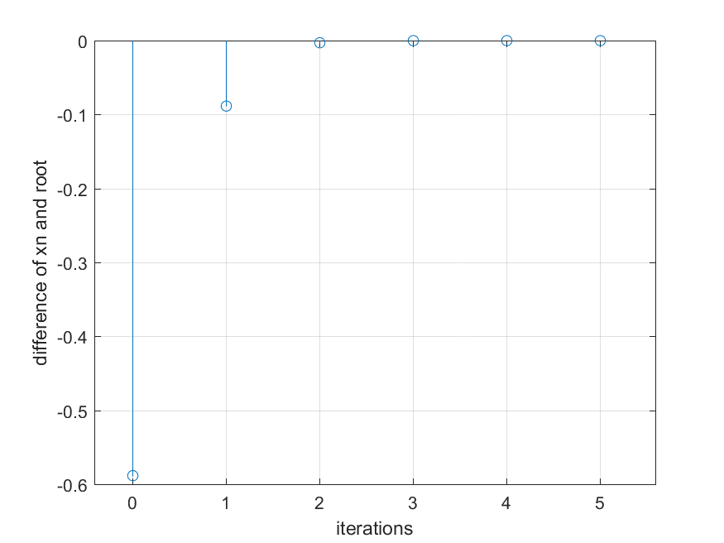

|  |  |  |  |  |
| --- | --- | --- | --- | --- |
| no | x_n | f_x_n | f_x_d | x_n_1 |
| 1 | 0 | 1 | -2 | 0.5 |
| 2 | 0.5 | 0.127 | -1.484 | 0.586 |
| 3 | 0.586 | 0.004 | -1.39 | 0.589 |
| 4 | 0.589 | 0 | -1.387 | 0.589 |

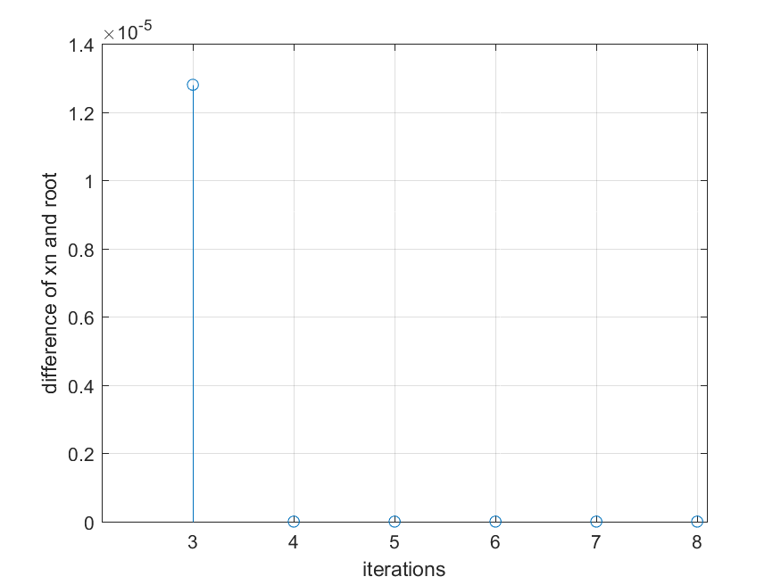

|  |  |  |  |  |
| --- | --- | --- | --- | --- |
| no | x_n | f_x_n | f_x_d | x_n_1 |
| 1 | 4 | 0.775 | 0.635 | 2.78 |
| 2 | 2.78 | -0.292 | 0.873 | 3.114 |
| 3 | 3.114 | 0.017 | 0.955 | 3.096 |
| 4 | 3.096 | 0 | 0.954 | 3.096 |

♦ **Observations:**

Root which we are getting is at x = 0.5885 .

Root which we are getting is at x = 3.0964 .

**(F) $f(x) = x^{3} – 2x - 2 = 0$**

♦ **Graphs:**

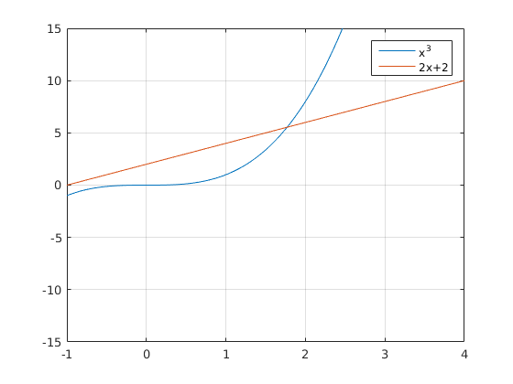

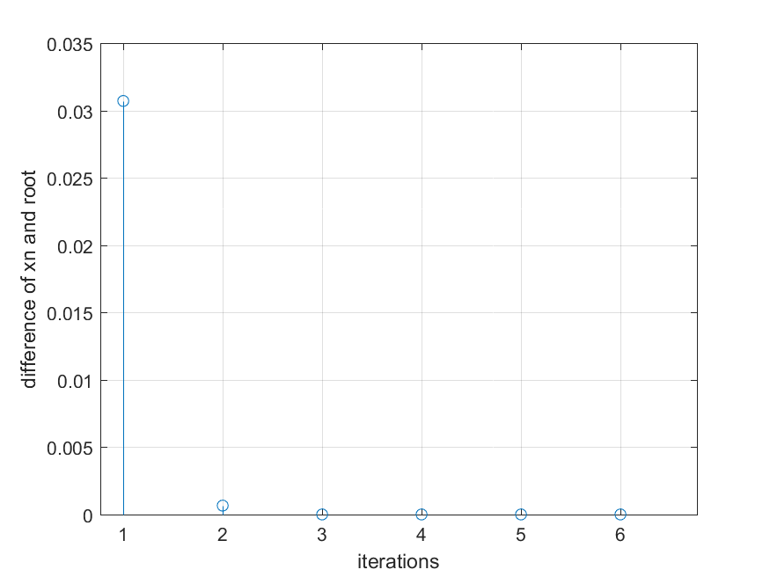

|  |  |  |  |  |
| --- | --- | --- | --- | --- |
| no | x_n | f_x_n | f_x_d | x_n_1 |
| 1 | 2 | 2 | 10 | 1.8 |
| 2 | 1.8 | 0.232 | 7.72 | 1.77 |
| 3 | 1.77 | 0.005 | 7.398 | 1.769 |
| 4 | 1.769 | 0 | 7.391 | 1.769 |

♦ **Observations:**

Root which we are getting is at x = 1.7693 .

**(G) $f(x) = x^{4} – x – 1 = 0$**

♦ **Graphs:**

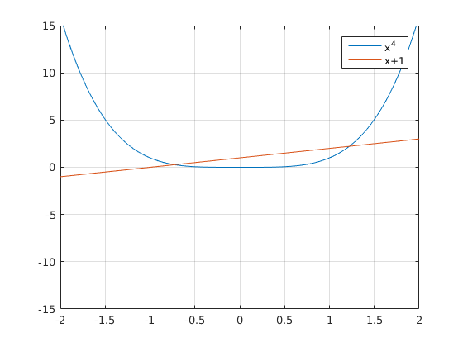

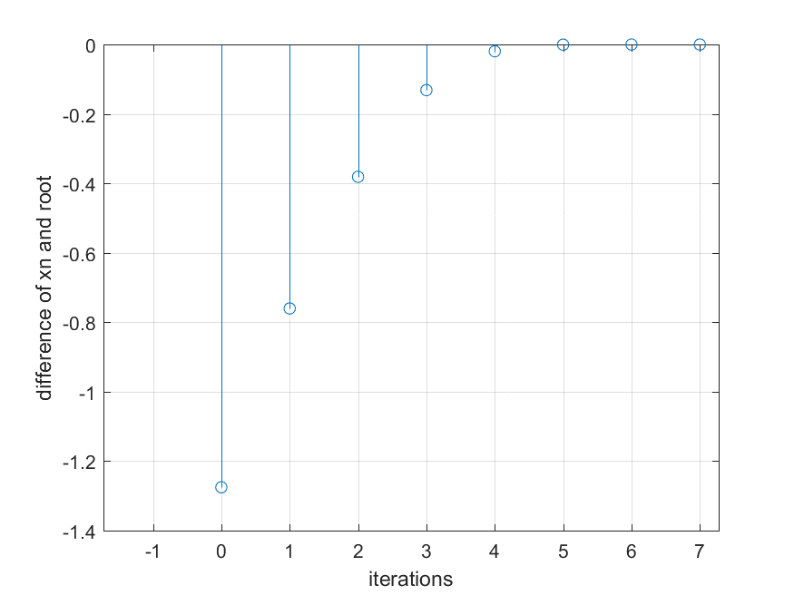

|  |  |  |  |  |
| --- | --- | --- | --- | --- |
| no | x_n | f_x_n | f_x_d | x_n_1 |
| 1 | -2 | 17 | -33 | -1.485 |
| 2 | -1.485 | 5.346 | -14.095 | -1.106 |
| 3 | -1.106 | 1.6 | -6.405 | -0.856 |
| 4 | -0.856 | 0.392 | -3.508 | -0.744 |
| 5 | -0.744 | 0.05 | -2.647 | -0.725 |
| 6 | -0.725 | 0.001 | -2.524 | -0.724 |
| 7 | -0.724 | 0 | -2.521 | -0.724 |

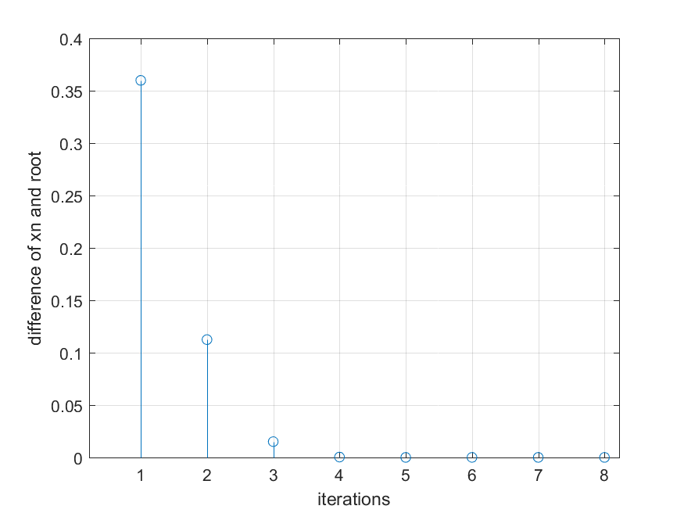

|  |  |  |  |  |
| --- | --- | --- | --- | --- |
| no | x_n | f_x_n | f_x_d | x_n_1 |
| 1 | 2 | 13 | 31 | 1.581 |
| 2 | 1.581 | 3.662 | 14.797 | 1.333 |
| 3 | 1.333 | 0.826 | 8.478 | 1.236 |
| 4 | 1.236 | 0.096 | 6.549 | 1.221 |
| 5 | 1.221 | 0.002 | 6.282 | 1.221 |
| 6 | 1.221 | 0 | 6.277 | 1.221 |

♦ **Observations:**

Smallest Root which we are getting is at x = -0.7245 .

Largest Root which we are getting is at x = 1.2207 .

**(H) $f(x) = e^{x} – x - 2 = 0$**

♦ **Graphs:**

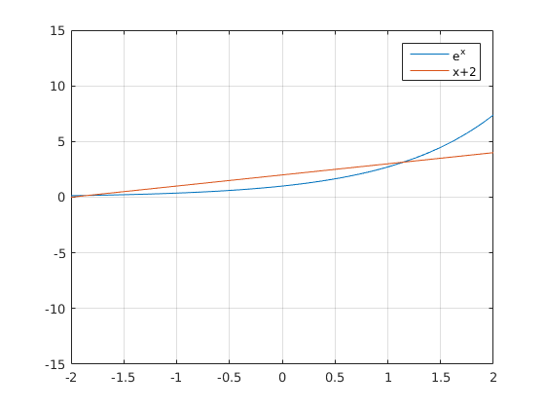

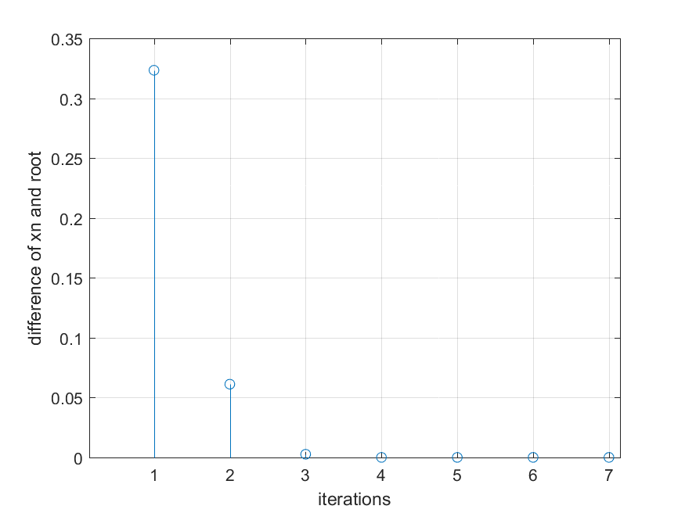

|  |  |  |  |  |
| --- | --- | --- | --- | --- |
| no | x_n | f_x_n | f_x_d | x_n_1 |
| 1 | 2 | 3.389 | 6.389 | 1.47 |
| 2 | 1.47 | 0.878 | 3.347 | 1.207 |
| 3 | 1.207 | 0.137 | 2.345 | 1.149 |
| 4 | 1.149 | 0.006 | 2.154 | 1.146 |
| 5 | 1.146 | 0 | 2.146 | 1.146 |

♦ **Observations:**

Root which we are getting is at x = 1.1462 .

$$(I) f(x) = 1 – x + sinx = 0$$

♦ **Graphs:**

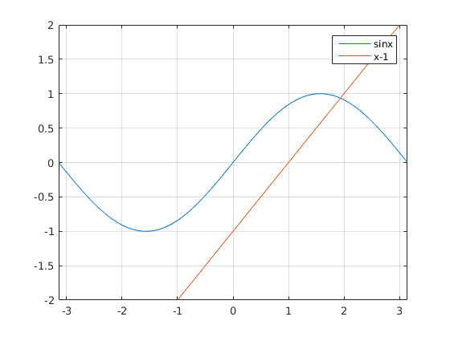

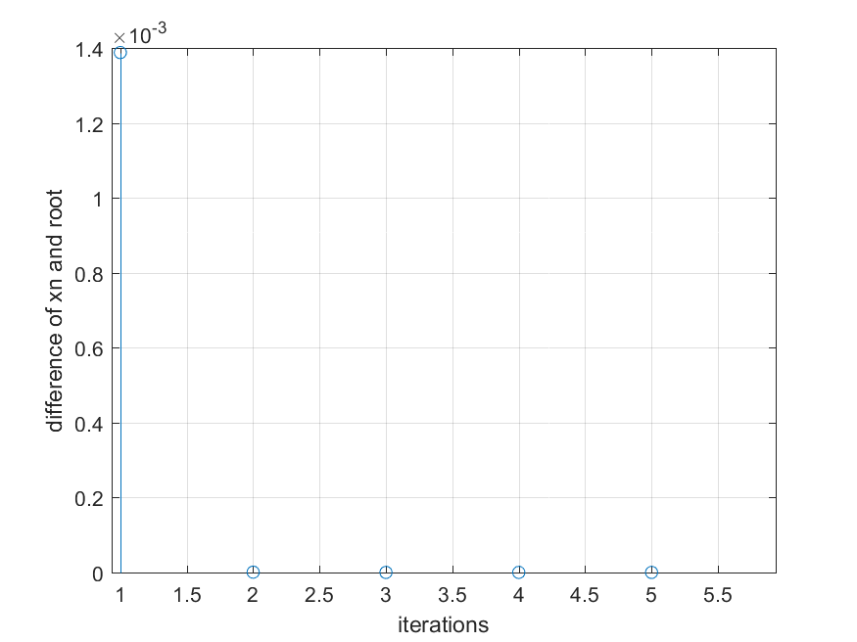

|  |  |  |  |  |
| --- | --- | --- | --- | --- |
| no | x_n | f_x_n | f_x_d | x_n_1 |
| 1 | 2 | -0.091 | -1.416 | 1.936 |
| 2 | 1.936 | -0.002 | -1.357 | 1.935 |
| 3 | 1.935 | -0 | -1.356 | 1.935 |

♦ **Observations:**

Root which we are getting is at x = 1.9345 .

**(J) $f(x) = x - tanx = 0$**

♦ **Graphs:**

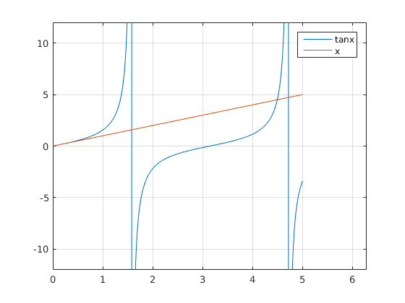

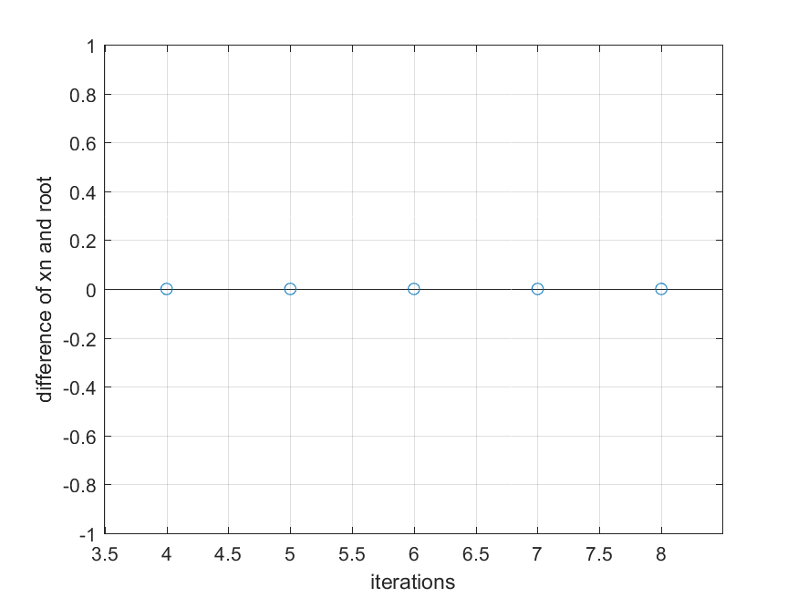

|  |  |  |  |  |
| --- | --- | --- | --- | --- |
| no | x_n | f_x_n | f_x_d | x_n_1 |
| 1 | 4.5 | -0.137 | -21.505 | 4.494 |
| 2 | 4.494 | -0.004 | -20.23 | 4.493 |
| 3 | 4.493 | -0 | -20.191 | 4.493 |

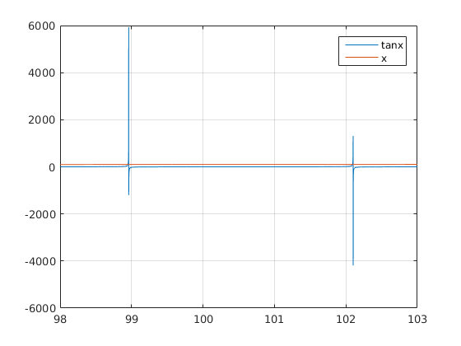

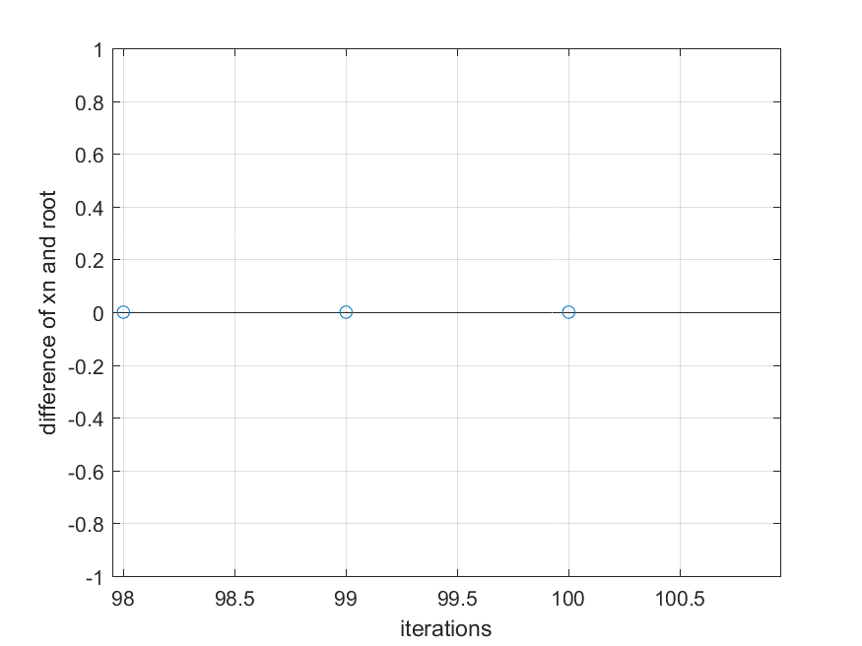

|  |  |  |  |  |
| --- | --- | --- | --- | --- |
| no | x_n | f_x_n | f_x_d | x_n_1 |
| 1 | 98.95 | 0.611 | -9670.496 | 98.95 |

♦ **Observations:**

Smallest non-zero positive Root which we are getting is at x = 4.4934 .

Root closest to x = 100 , which we are getting is at x = 98.9501 .

# **Problem: 4**

♦ **Statement:**

The function y = f(x) = a + x(x-1)^2 , with 0 <=a <=0.1.When a!=0 , there is only one real root of f(x)=0, with root being negative. Analytically check how many roots are obtained for a=0 , and what is the nature of the roots. Thereafter using the Newton – Raphson method , test for the convergence towards the negative real root , through a suitably chosen a values right down to a=0 . In every case your initial guess value should be slightly larger than 1. say 1.01 . For every value of a check how quickly the convergence happens.

**f(x) = a + x(x-1)^2**

(A) for a=0.1,

♦ **Graphs:**

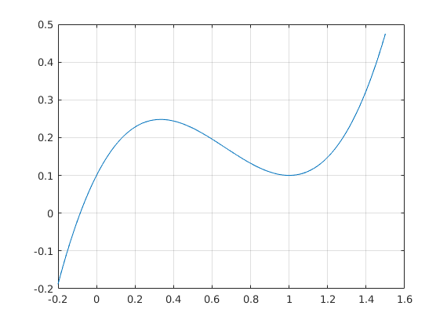

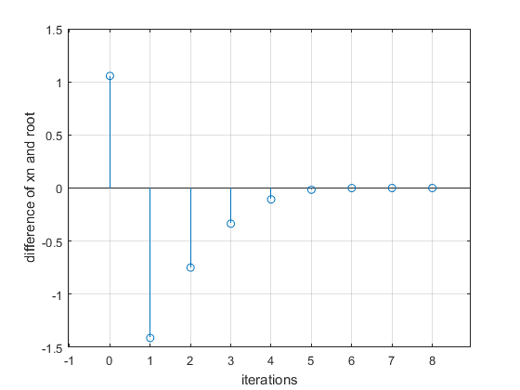

|  |  |  |  |  |
| --- | --- | --- | --- | --- |
| no | x_n | f_x_n | f_x_d | x_n_1 |
| 1 | 1.01 | 0.05 | 0.02 | -1.458 |
| 2 | -1.458 | -8.759 | 13.21 | -0.795 |
| 3 | -0.795 | -2.511 | 6.075 | -0.382 |
| 4 | -0.382 | -0.678 | 2.963 | -0.153 |
| 5 | -0.153 | -0.153 | 1.681 | -0.062 |
| 6 | -0.062 | -0.02 | 1.258 | -0.046 |
| 7 | -0.046 | -0.001 | 1.191 | -0.046 |
| 8 | -0.046 | -0 | 1.189 | -0.046 |

♦ **Observations:**

Root which we are getting is at x = -0.0850.

(A) **For a=0.05,**

♦ **Graphs:**

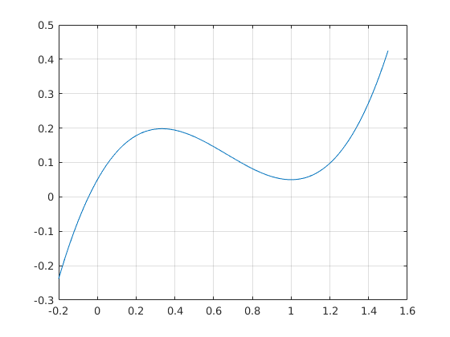

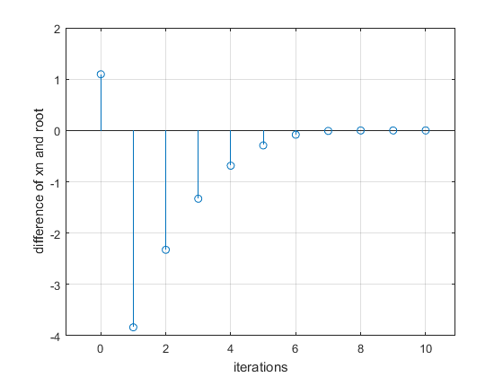

|  |  |  |  |  |
| --- | --- | --- | --- | --- |
| no | x_n | f_x_n | f_x_d | x_n_1 |
| 1 | 1.01 | 0.1 | 0.02 | -3.921 |
| 2 | -3.921 | -94.857 | 62.809 | -2.411 |
| 3 | -2.411 | -27.947 | 28.08 | -1.416 |
| 4 | -1.416 | -8.16 | 12.674 | -0.772 |
| 5 | -0.772 | -2.322 | 5.874 | -0.376 |
| 6 | -0.376 | -0.613 | 2.93 | -0.167 |
| 7 | -0.167 | -0.128 | 1.753 | -0.094 |
| 8 | -0.094 | -0.013 | 1.404 | -0.085 |
| 9 | -0.085 | -0 | 1.362 | -0.085 |
| 10 | -0.085 | -0 | 1.361 | -0.085 |

♦ **Observations:**

Root which we are getting is at x = -0.0457.

(A) for a=0,

♦ **Graphs:**

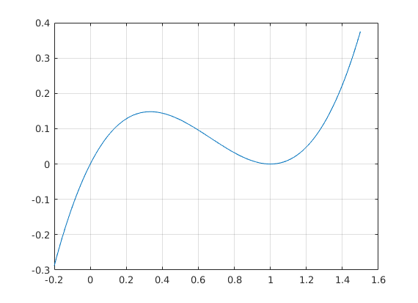

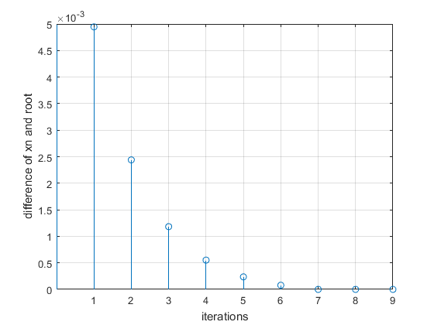

|  |  |  |  |  |
| --- | --- | --- | --- | --- |
| no | x_n | f_x_n | f_x_d | x_n_1 |
| 1 | 1.01 | 0 | 0.02 | 1.005 |
| 2 | 1.005 | 0 | 0.01 | 1.003 |
| 3 | 1.003 | 0 | 0.005 | 1.001 |
| 4 | 1.001 | 0 | 0.003 | 1.001 |
| 5 | 1.001 | 0 | 0.001 | 1 |
| 6 | 1 | 0 | 0.001 | 1 |
| 7 | 1 | 0 | 0 | 1 |

♦ **Observations:**

Root which we are getting is at x = 1.0001.