**Assignment-5**

Course: SC-374

Computational and Numerical Methods

Instructor: Prof. Arnab Kumar

Made by:

Yatin Patel – 201601454

Rutvik Kothari – 201601417

# **Problem: 1**

♦ **Statement:**

Write a code, applying the algorithm of the secant method to determine both the real roots of $f\left(x\right)=x^{6}−x−1=0$.

♦ **Graphs:**

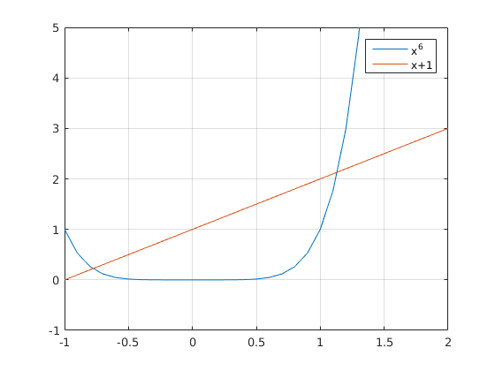

|  |  |  |  |  |
| --- | --- | --- | --- | --- |
| no | x_n | f_x_n | f_x_d | x_n_1 |
| 1 | 2 | 61 | 0 | 0 |
| 2 | 1.5 | 61 | -52.1094 | 1.4147 |
| 3 | 1.4147 | 8.8906 | -3.289 | 1.2694 |
| 4 | 1.2694 | 5.6016 | -3.6869 | 1.194 |
| 5 | 1.194 | 1.9147 | -1.2118 | 1.1502 |
| 6 | 1.1502 | 0.7029 | -0.5377 | 1.1367 |
| 7 | 1.1367 | 0.1652 | -0.1442 | 1.134 |

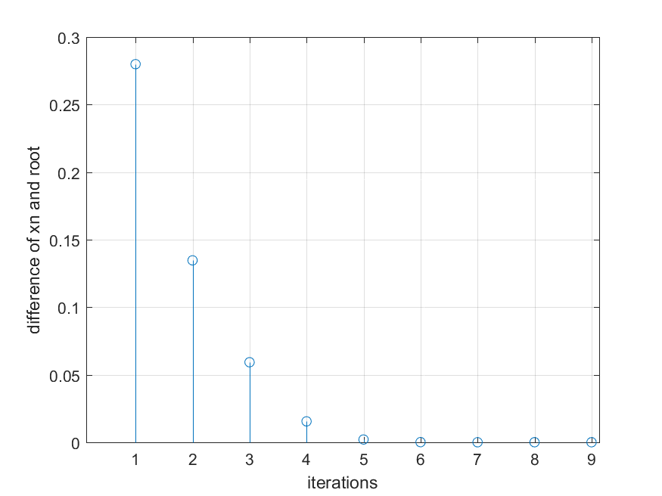

|  |  |  |  |  |
| --- | --- | --- | --- | --- |
| no | x_n | f_x_n | f_x_d | x_n_1 |
| 1 | 1 | -1 | 0 | 0 |
| 2 | 2 | -1 | 62 | 1.0161 |
| 3 | 1.0161 | 61 | -61.9154 | 1.0307 |
| 4 | 1.0307 | -0.9154 | 0.0834 | 1.1757 |
| 5 | 1.1757 | -0.8319 | 1.2971 | 1.1237 |
| 6 | 1.1237 | 0.4652 | -0.5759 | 1.1337 |
| 7 | 1.1337 | -0.1106 | 0.0998 | 1.1348 |

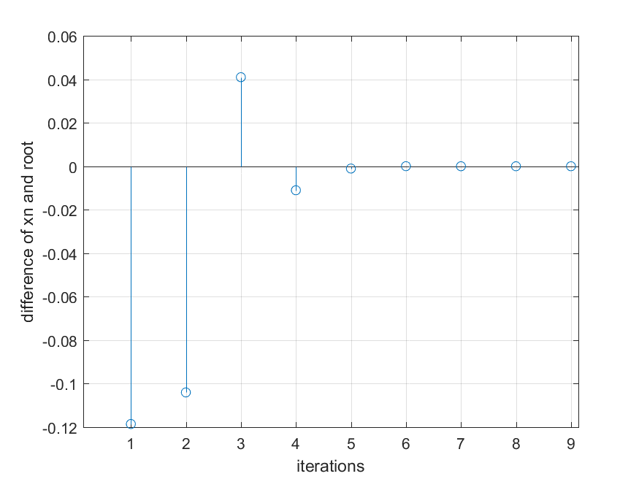

♦ **Observations:**

Largest Root which we are getting is at x = 1.1347 .

# **Problem: 2**

♦ **Statement:**

Use the bisection method to find the real roots of the following functions, using an error tolerance of € = 0.0001.

**(A) $f\left(x\right)=x^{3}–x^{2}–x–1=0$**

♦ **Graphs:**

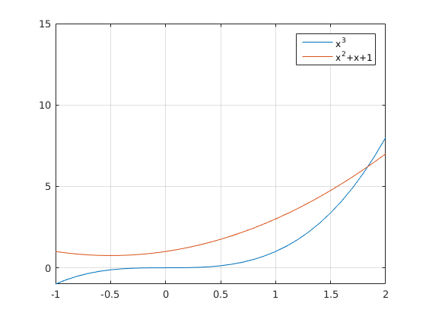

|  |  |  |  |  |
| --- | --- | --- | --- | --- |
| no | x_n | f_x_n | f_x_d | x_n_1 |
| 1 | 2 | 1 | 0 | 0 |
| 2 | 2.5 | 1 | 4.875 | 1.8974 |
| 3 | 1.8974 | 5.875 | -5.5414 | 1.8612 |
| 4 | 1.8612 | 0.3336 | -0.2117 | 1.8403 |
| 5 | 1.8403 | 0.1219 | -0.1164 | 1.8393 |

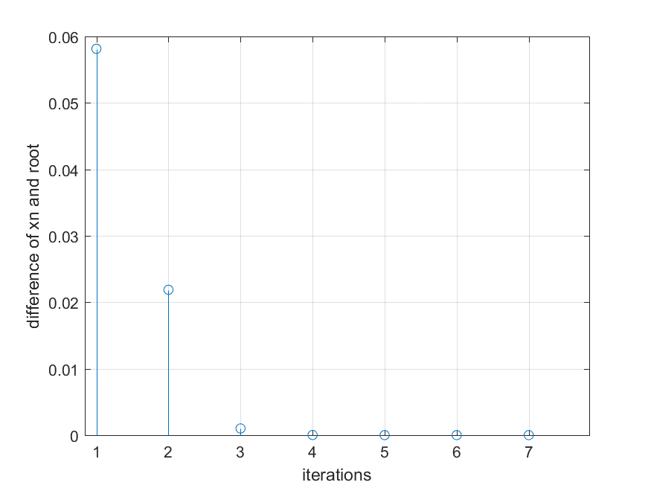

|  |  |  |  |  |
| --- | --- | --- | --- | --- |
| no | x_n | f_x_n | f_x_d | x_n_1 |
| 1 | 1.5 | -1.375 | 0 | 0 |
| 2 | 2 | -1.375 | 2.375 | 1.7895 |
| 3 | 1.7895 | 1 | -1.2614 | 1.8331 |
| 4 | 1.8331 | -0.2614 | 0.2277 | 1.8396 |
| 5 | 1.8396 | -0.0337 | 0.0351 | 1.8393 |

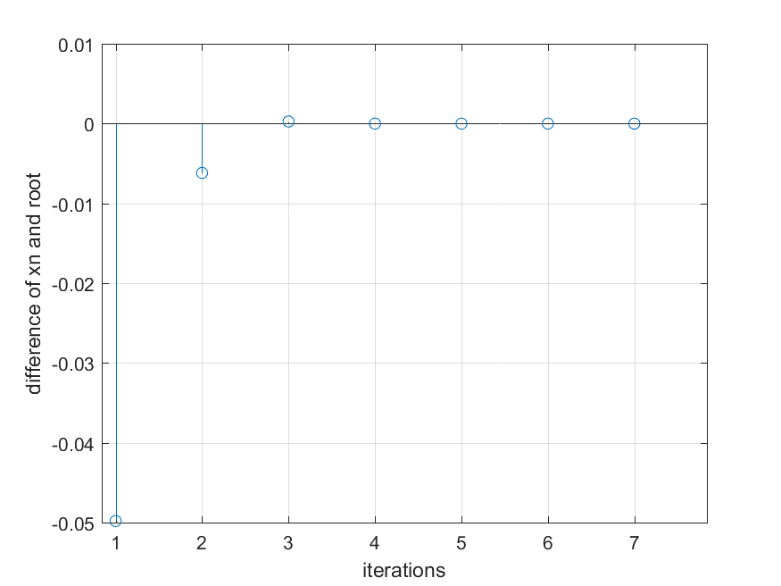

♦ **Observations:**

Root which we are getting is at x = 1.8393 .

**(B) $f\left(x\right)=x−1−0.3cosx=0$**

♦ **Graphs:**

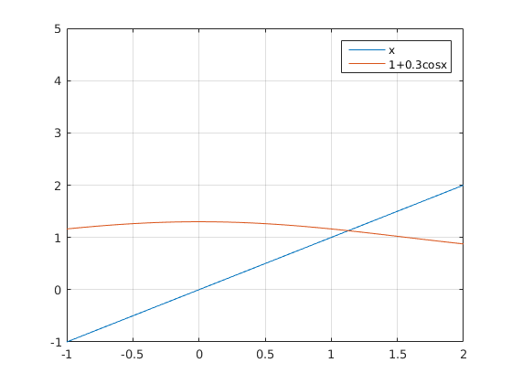

|  |  |  |  |  |
| --- | --- | --- | --- | --- |
| no | x_n | f_x_n | f_x_d | x_n_1 |
| 1 | 1.5 | 0.4788 | 0 | 0 |
| 2 | 2 | 0.4788 | 0.6461 | 1.1295 |
| 3 | 1.1295 | 1.1248 | -1.1235 | 1.1284 |

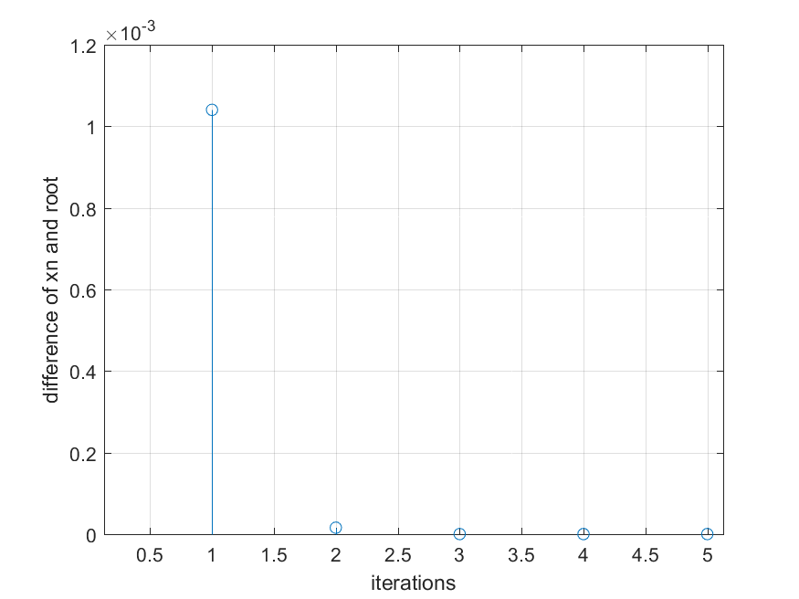

|  |  |  |  |  |
| --- | --- | --- | --- | --- |
| no | x_n | f_x_n | f_x_d | x_n_1 |
| 1 | 1 | -0.1621 | 0 | 0 |
| 2 | 1.5 | -0.1621 | 0.6409 | 1.1265 |
| 3 | 1.1265 | 0.4788 | -0.4813 | 1.1284 |

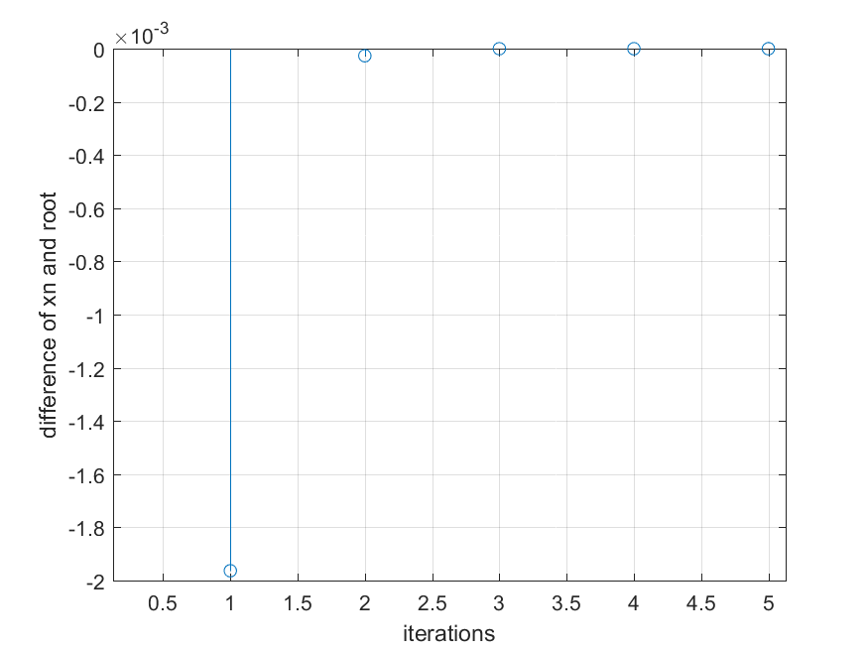

♦ **Observations:**

Root which we are getting is at x = 1.1284 .

**(C) $f\left(x\right)=cosx−sinx−0.5=0$**

♦ **Graphs:**

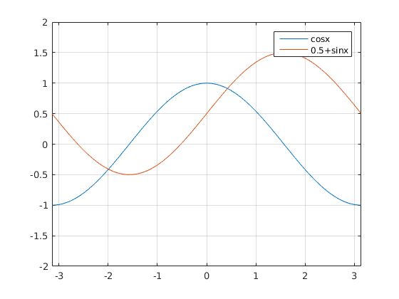

|  |  |  |  |  |
| --- | --- | --- | --- | --- |
| no | x_n | f_x_n | f_x_d | x_n_1 |
| 1 | 1 | -0.8012 | 0 | 0 |
| 2 | 1.5 | -0.8012 | -0.6256 | 0.3597 |
| 3 | 0.3597 | -1.4268 | 1.5108 | 0.4231 |
| 4 | 0.4231 | 0.084 | -0.0828 | 0.424 |

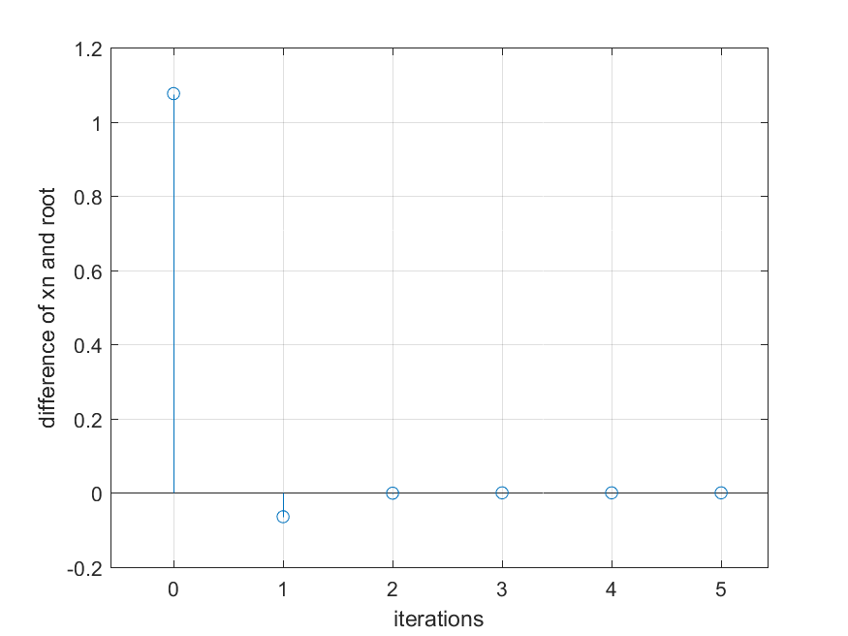

|  |  |  |  |  |
| --- | --- | --- | --- | --- |
| no | x_n | f_x_n | f_x_d | x_n_1 |
| 1 | 0 | 0.5 | 0 | 0 |
| 2 | 1 | 0.5 | -1.3012 | 0.3843 |
| 3 | 0.3843 | -0.8012 | 0.8534 | 0.4219 |
| 4 | 0.4219 | 0.0522 | -0.0494 | 0.424 |

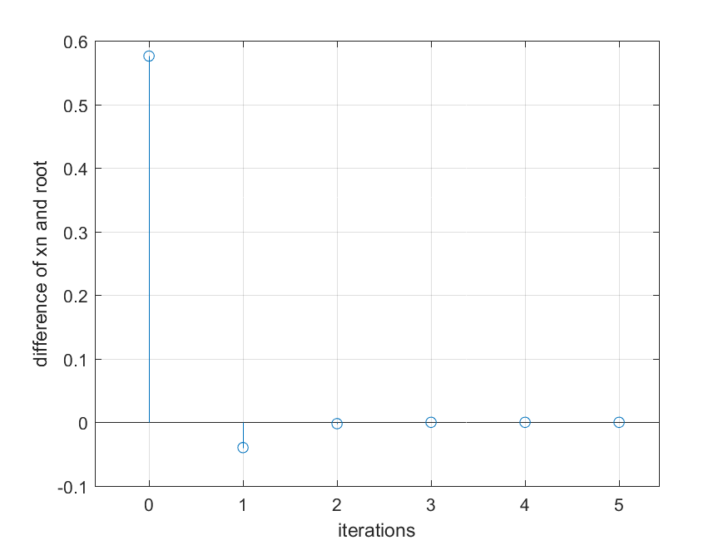

♦ **Observations:**

Root which we are getting is at x = 0.4241 .

**(D) $f\left(x\right)=x–e^{−x}=0$**

♦ **Graphs:**

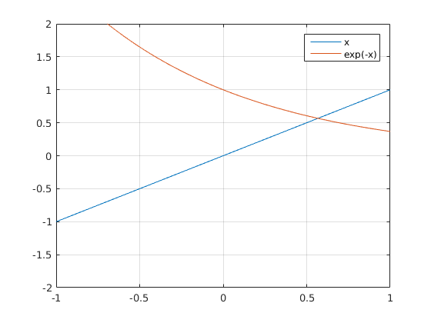

|  |  |  |  |  |
| --- | --- | --- | --- | --- |
| no | x_n | f_x_n | f_x_d | x_n_1 |
| 1 | 1 | 0.6321 | 0 | 0 |
| 2 | 1.5 | 0.6321 | 0.6447 | 0.5098 |
| 3 | 0.5098 | 1.2769 | -1.3677 | 0.5756 |
| 4 | 0.5756 | -0.0908 | 0.104 | 0.5672 |

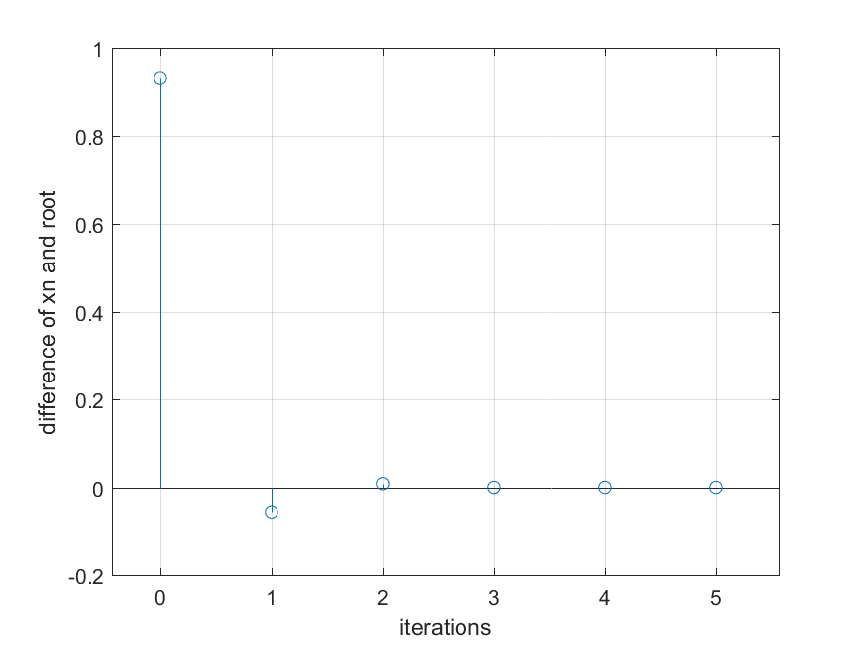

|  |  |  |  |  |
| --- | --- | --- | --- | --- |
| no | x_n | f_x_n | f_x_d | x_n_1 |
| 1 | 0 | -1 | 0 | 0 |
| 2 | 1 | -1 | 1.6321 | 0.6127 |
| 3 | 0.6127 | 0.6321 | -0.5613 | 0.5638 |
| 4 | 0.5638 | 0.0708 | -0.076 | 0.5672 |

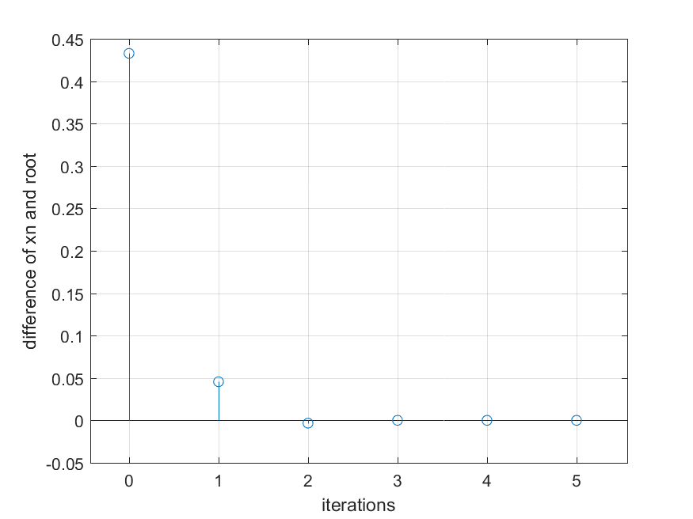

♦ **Observations:**

Root which we are getting is at x = 0.5672 .

**(E) $f\left(x\right)=e^{−x}−sinx=0$**

♦ **Graphs:**

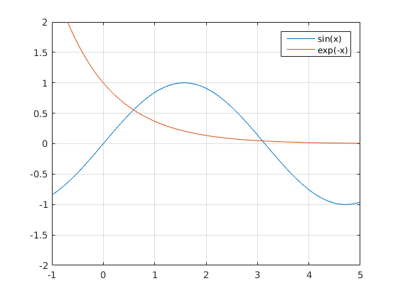

|  |  |  |  |  |
| --- | --- | --- | --- | --- |
| no | x_n | f_x_n | f_x_d | x_n_1 |
| 1 | 3 | -0.0913 | 0 | 0 |
| 2 | 4 | -0.0913 | 0.8665 | 3.1054 |
| 3 | 3.1054 | 0.7751 | -0.7665 | 3.0953 |
| 4 | 3.0953 | 0.0086 | -0.0096 | 3.0964 |

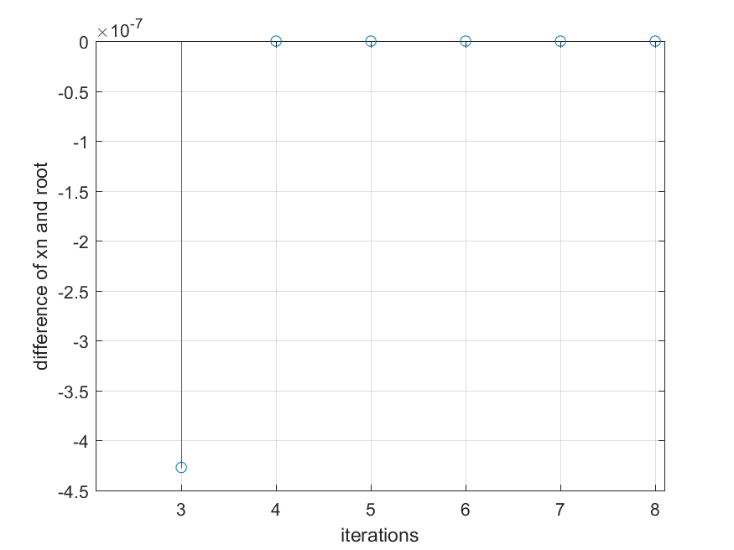

|  |  |  |  |  |
| --- | --- | --- | --- | --- |
| no | x_n | f_x_n | f_x_d | x_n_1 |
| 1 | 0 | 1 | 0 | 0 |
| 2 | 1 | 1 | -1.4736 | 0.6786 |
| 3 | 0.6786 | -0.4736 | 0.3532 | 0.5691 |
| 4 | 0.5691 | -0.1204 | 0.1476 | 0.5893 |
| 5 | 0.5893 | 0.0272 | -0.0282 | 0.5885 |

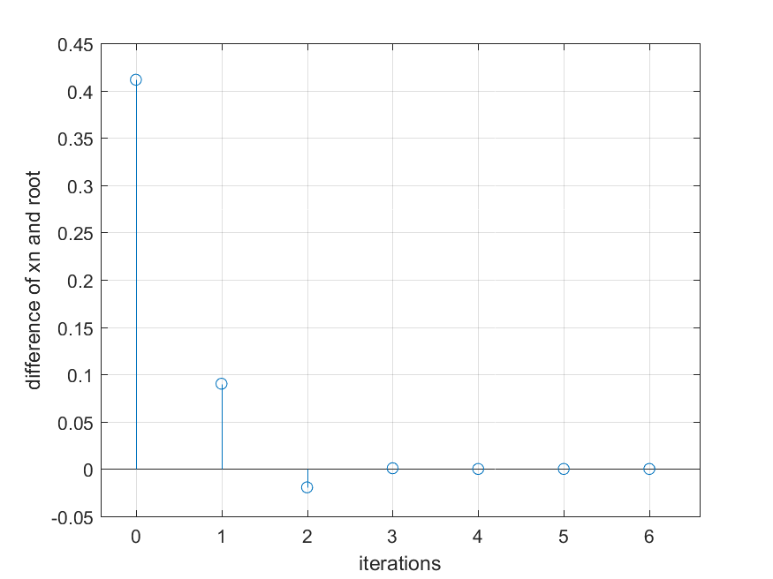

♦ **Observations:**

Root which we are getting is at x = 0.5885 .

Root which we are getting is at x = 3.0964 .

**(F) $f\left(x\right)=x^{3}–2x−2=0$**

♦ **Graphs:**

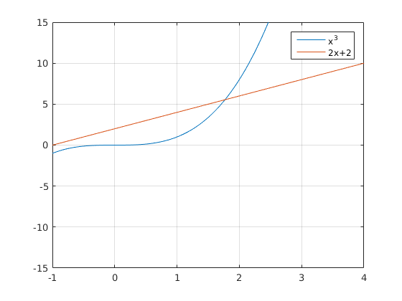

|  |  |  |  |  |
| --- | --- | --- | --- | --- |
| no | x_n | f_x_n | f_x_d | x_n_1 |
| 1 | 2 | 2 | 0 | 0 |
| 2 | 3 | 2 | 17 | 1.8824 |
| 3 | 1.8824 | 19 | -18.0951 | 1.8265 |
| 4 | 1.8265 | 0.9049 | -0.4649 | 1.7735 |
| 5 | 1.7735 | 0.4401 | -0.4085 | 1.7695 |
| 6 | 1.7695 | 0.0316 | -0.0303 | 1.7693 |

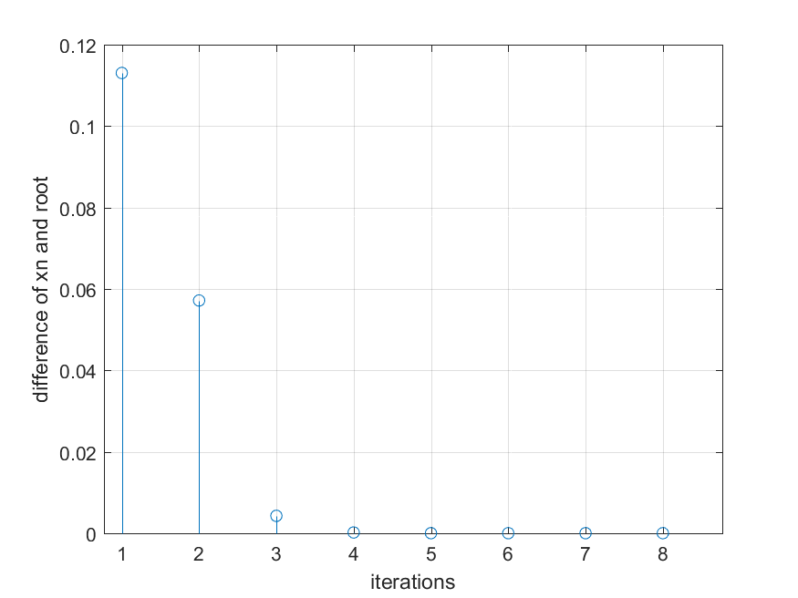

|  |  |  |  |  |
| --- | --- | --- | --- | --- |
| no | x_n | f_x_n | f_x_d | x_n_1 |
| 1 | 1 | -3 | 0 | 0 |
| 2 | 2 | -3 | 5 | 1.6 |
| 3 | 1.6 | 2 | -3.104 | 1.7423 |
| 4 | 1.7423 | -1.104 | 0.9081 | 1.773 |
| 5 | 1.773 | -0.1959 | 0.223 | 1.7692 |

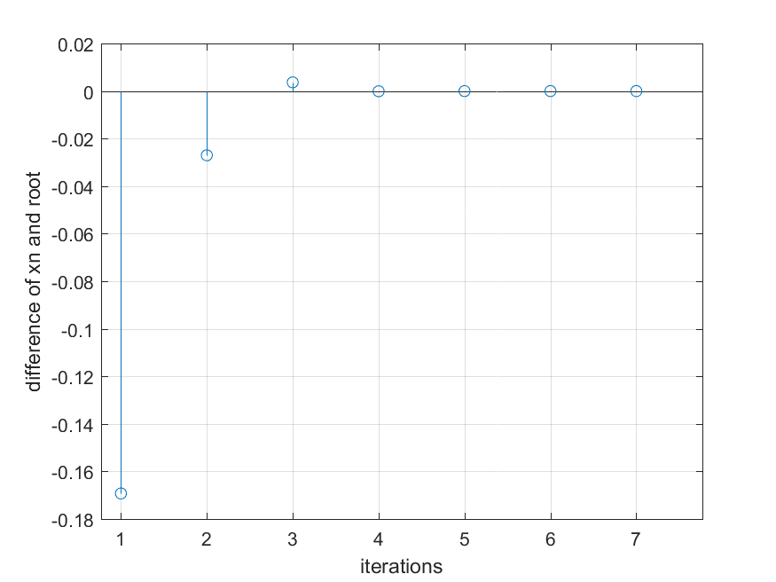

♦ **Observations:**

Root which we are getting is at x = 1.7693 .

**(G) $f\left(x\right)=x^{4}–x–1=0$**

♦ **Graphs:**

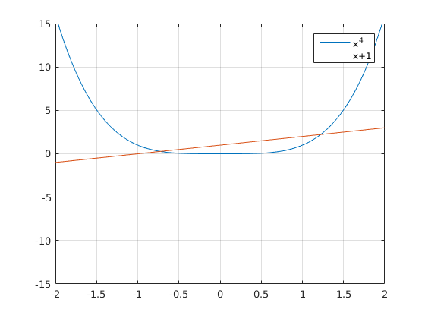

|  |  |  |  |  |
| --- | --- | --- | --- | --- |
| no | x_n | f_x_n | f_x_d | x_n_1 |
| 1 | 1 | -1 | 0 | 0 |
| 2 | 2 | -1 | 14 | 1.0714 |
| 3 | 1.0714 | 13 | -13.7536 | 1.1223 |
| 4 | 1.1223 | -0.7536 | 0.2178 | 1.2474 |
| 5 | 1.2474 | -0.5358 | 0.7098 | 1.2168 |
| 6 | 1.2168 | 0.1741 | -0.1989 | 1.2206 |
| 7 | 1.2206 | -0.0249 | 0.0239 | 1.2207 |

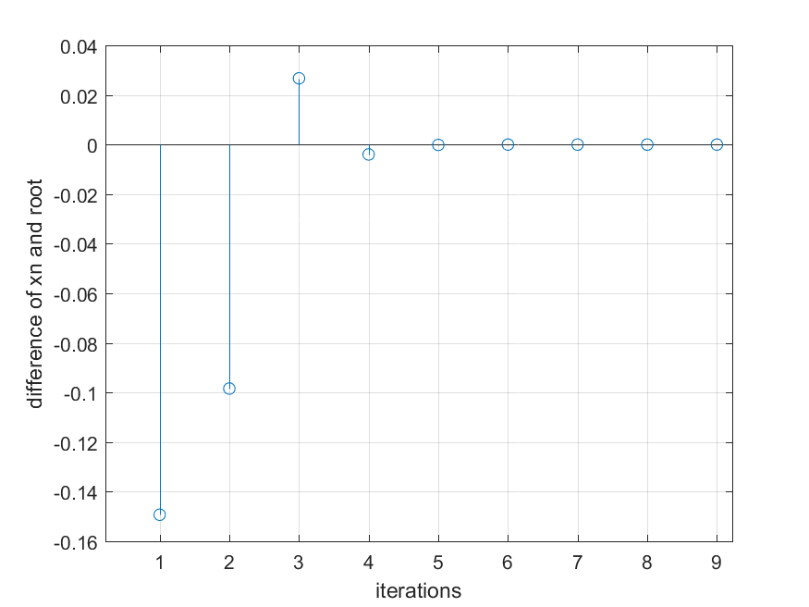

|  |  |  |  |  |
| --- | --- | --- | --- | --- |
| no | x_n | f_x_n | f_x_d | x_n_1 |
| 1 | -1 | 1 | 0 | 0 |
| 2 | 0 | 1 | -2 | -0.5 |
| 3 | -0.5 | -1 | 0.5625 | -0.8889 |
| 4 | -0.8889 | -0.4375 | 0.9507 | -0.679 |
| 5 | -0.679 | 0.5132 | -0.6217 | -0.7156 |
| 6 | -0.7156 | -0.1085 | 0.0864 | -0.725 |
| 7 | -0.725 | -0.0222 | 0.0234 | -0.7245 |

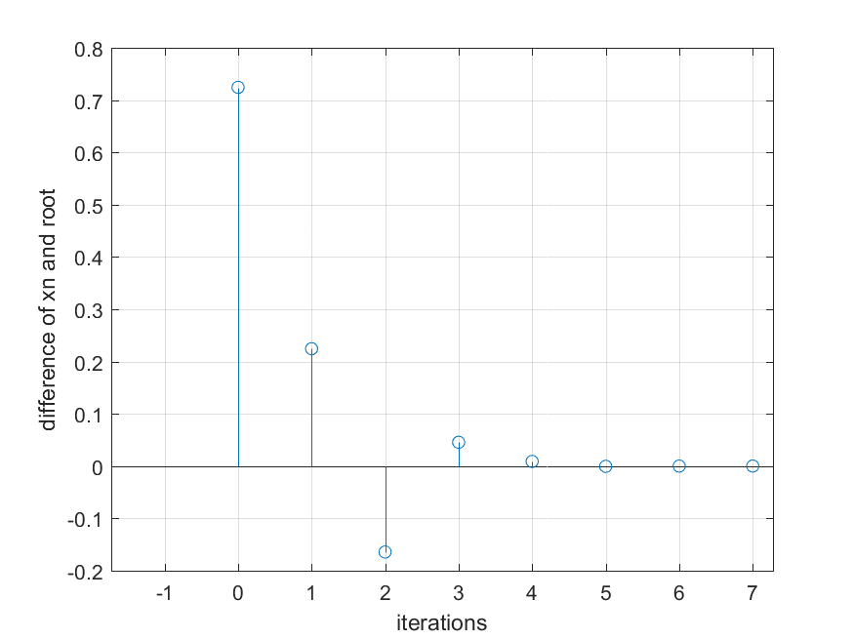

♦ **Observations:**

Smallest Root which we are getting is at x = -0.7245 .

Largest Root which we are getting is at x = 1.2207 .