**Assignment – 1, 2**

Course: SC-374

Computational and Numerical Methods

Instructor: Prof. Arnab Kumar

Made by:

Yatin Patel – 201601454

Rutvik Kothari – 201601417

**Assignment - 1**

**The Binary Search and Information Entropy**

Average information content is given by the formula, $<I> = -k\sum_{i}{P_{i}\log_{2}{P_{i}}}$, in which $k$ is constant and $P_{i}$ is the probability of an event.

1. For a two-outcome problem (eg. a coin toss), Show that $<I>$ peaks at $P=\frac{1}{2}$.

$$f\left(p\right)= <I> = -k (plog_{2}\left(p\right)+\left(1-p\right)\log_{2}\left(1-p\right))$$

$$f^{'}\left(p\right)= -k(\log_{2}{p}+1-1-\log_{2}\left(1-p\right) )$$

$$f^{'}\left(p\right)=0 for maximize,$$

$$\log_{2}{p}=\log_{2}\left(1-p\right)$$

$$p=1-p$$

$$p=\frac{1}{2}$$

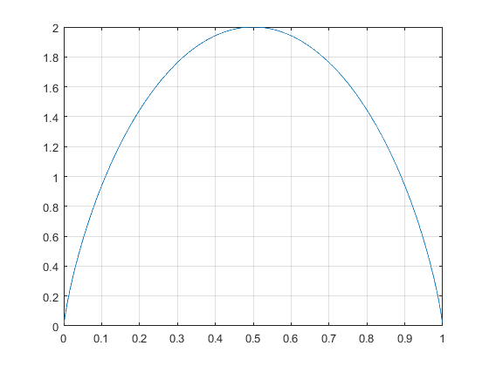

1. Apply a very small perturbation as $P=\frac{1}{2}+ε$, in which $ε≪\frac{1}{2} .$ Show that in this perturbative approach $<I> =a-bε^{2}$, with $a=k$ and $b=\frac{4k}{ln2}$.

$$<I> = -k (\left(ε+\frac{1}{2}\right)\ln\left(ε+\frac{1}{2}\right)+\left(\frac{1}{2}- ε\right)\ln\left(\frac{1}{2}-ε\right))$$

$$<I> = -k (\left(ε+\frac{1}{2}\right)\ln\left(\frac{2ε+1}{2}\right)+\left(\frac{1}{2}-ε\right)\ln\left(\frac{-2ε+1}{2}\right))$$

$$<I> = -k(\left(ε+\frac{1}{2}\right)\left(\frac{2ε}{\ln\left(2\right)}-1\right)+\left(\frac{1}{2}- ε\right)\left(-\frac{2ε}{\ln\left(2\right)}-1\right))$$

$$<I> = -k\left(\frac{4ε^{2}}{\ln\left(2\right)}-1\right)$$

$$<I> =k-\frac{4k}{\ln\left(2\right)}ε^{2}$$

$$a=k and b=\frac{4k}{\ln\left(2\right)}$$

1. Plot for both the actual function and the approximate function together and then compare the graph for closeness on the line. For plotting choose $k=1$.

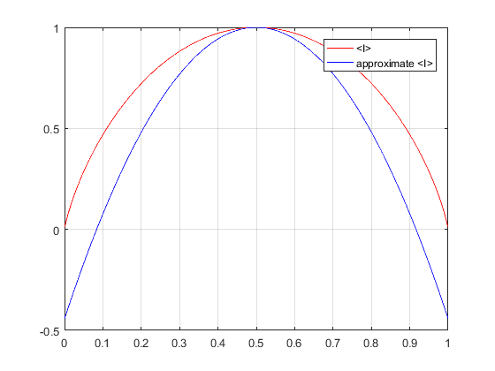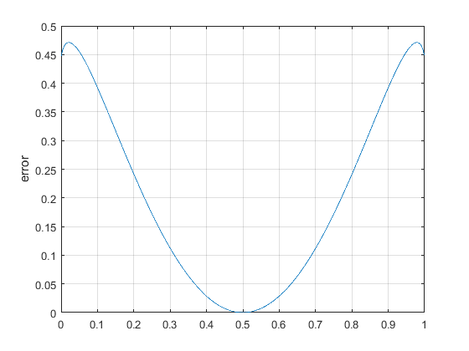

**Assignment - 2**

**An Astrophysical Inflow**

In the problem of spherically symmetric astrophysical accretion, interstellar ﬂuid matter (a very thin gas) travels a great distance (almost from inﬁnity) along radial lines and falls on to a massive star (or a neutron star or even a black hole) located at the origin of coordinates. The star can be treated as a point-like particle, and the rate of the ﬂuid ﬂow (matter ﬂowing in unit time) on to it is given as

$$\dot{m}=\frac{πG^{2}M^{2}ρ_{∞}}{c_{s}^{3}\left(∞\right)} {\left(\frac{2}{5-3γ}\right)}^{\frac{5-3γ}{2γ-2}}$$

in which G is Newton’s universal gravitational constant, M is the mass of the central astrophysical object, ρ∞ is the constant density of the gas at inﬁnity, cs(∞) is the speed of sound at inﬁnity, and γ is a dimensionless number called the polytropic exponent (1 ≤ γ ≤ 5/3). The velocity of the ﬂuid ﬂow v, as a function of the radial distance from the centre r, is given by the equation

$$f\left(v,r\right)=\frac{v^{2}}{2}+n{\left(\frac{\dot{μ}}{vr^{2}}\right)}^{\frac{1}{n}} -\frac{GM}{r}-nc_{s}^{2}\left(∞\right)=0$$

$$\dot{μ}=\left(\frac{\dot{m}}{4}πρ_{∞}\right)c_{s}^{2n}$$

$$n=\frac{1}{γ-1}$$

Solve Eq.(1) by the bisection method to ﬁnd v(r), using the values M = 2 × 1030 kg, cs(∞) = 10 km s−1, ρ∞ = 10−21 kg m−3 and n = 2.5. These values are typical of accretion of the interstellar medium on to a star. Each value of r in Eq.(1) will give a set of two real and physical roots of v. The plot of v(r) is shown in Fig. 1, in which v is scaled as the Mach number, v(r)/cs(r). Obtain a similar plot.

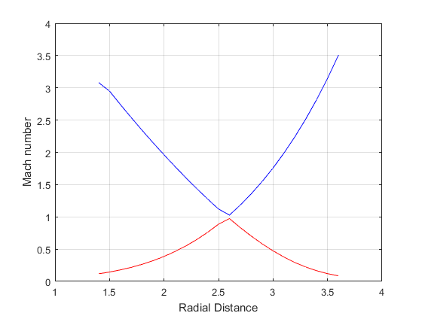

**Assignment - 3**

**A Nuclear Outflow**

High-energy impacts and collisions among elementary particles can result in an outflow of nuclear fluid. The rescaled equations of the steady outflow are,

xyR^2 = 1 , (2) y^2 + 3x^2 − 4x = B, (3)

the velocity of an acoustic wave in the nuclear matter is u 2 = x(3x − 2). On the same graph now plot R versus u.