**Assignment-3**

Course: SC-374

Computational and Numerical Methods

Instructor: Prof. Arnab Kumar

Made by:

Yatin Patel – 201601454

Rutvik Kothari – 201601417

# **Problem: 1**

♦ **Statement:**

Write a code, applying the algorithm of the bisection method to determine both the real roots of $f(x) = x^{6} - x - 1 = 0$.

♦ **Graphs:**

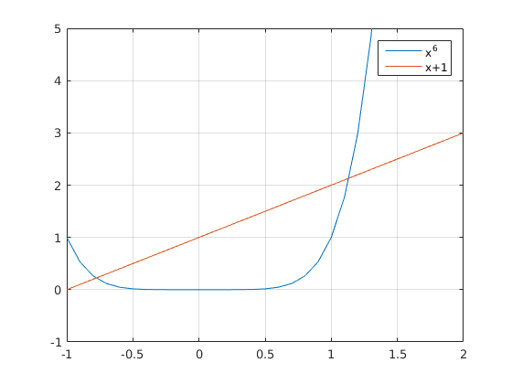

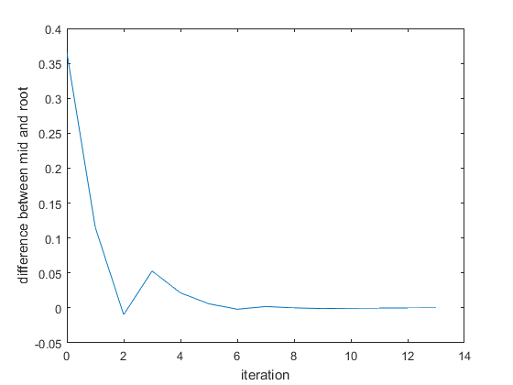

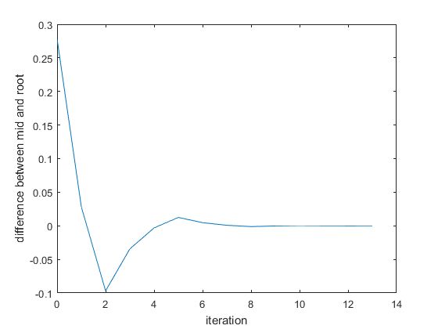

♦ **Observations:**

Smallest Root which we are getting is at x = -0.7781 .

Largest Root which we are getting is at x = 1.1347 .

# **Problem: 2**

♦ **Statement:**

Use the bisection method to find the real roots of the following functions, using an error tolerance of € = 0.0001.

**(A) $f(x) = x^{3} – x^{2} – x – 1 = 0$**

♦ **Graphs:**

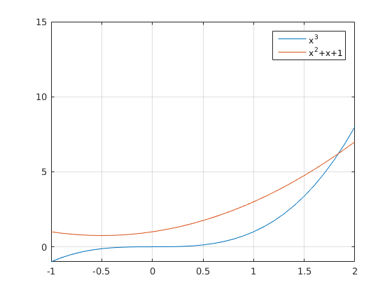

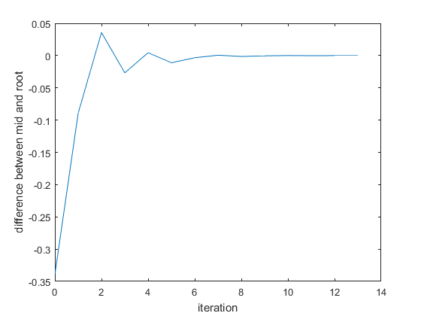

♦ **Observations:**

Root which we are getting is at x = 1.8393 .

**(B) $f(x) = x-1-0.3cosx = 0$**

♦ **Graphs:**

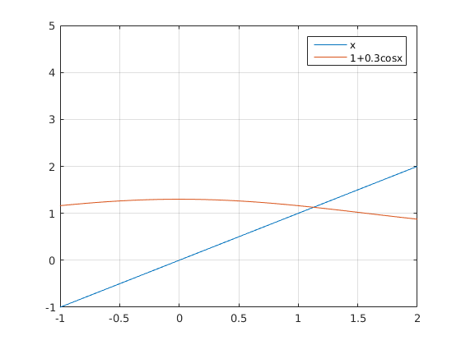

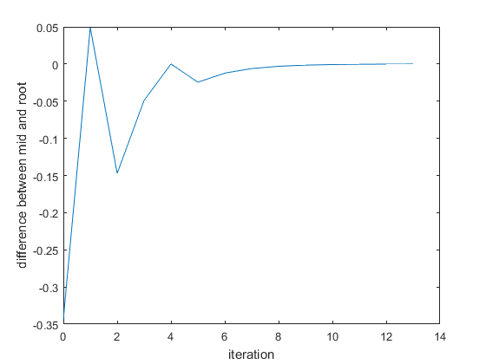

♦ **Observations:**

Root which we are getting is at x = 1.1284 .

**(C) $f(x) = cosx-sinx-0.5 = 0$**

♦ **Graphs:**

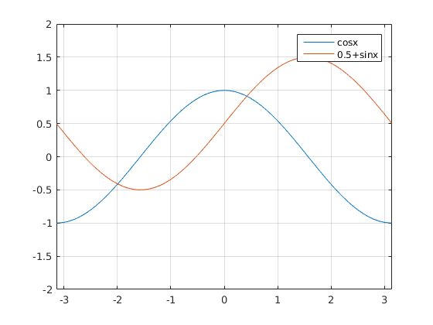

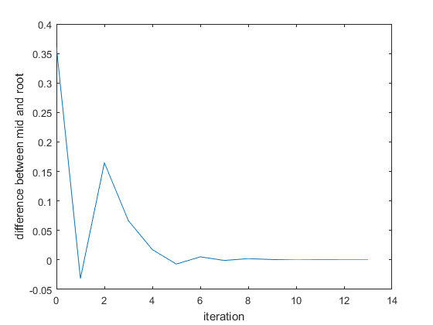

♦ **Observations:**

Root which we are getting is at x = 0.4241 .

**(D) $f(x) = x – e^{-x} = 0$**

♦ **Graphs:**

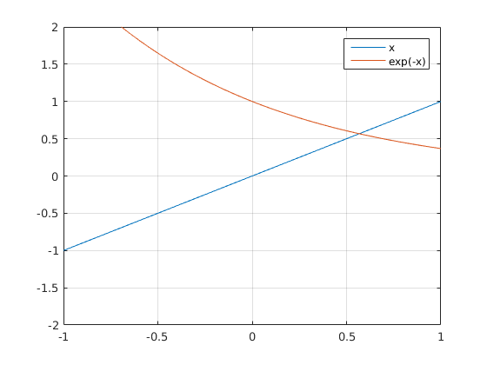

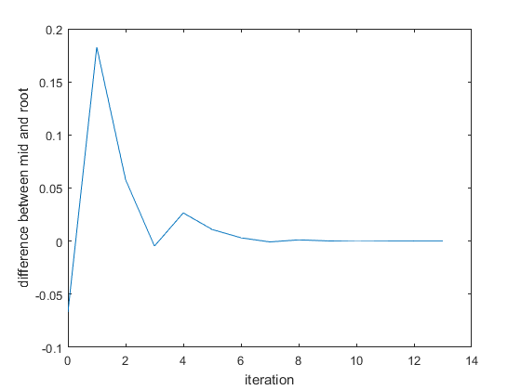

♦ **Observations:**

Root which we are getting is at x = 0.5672 .

**(E) $f(x) = e^{-x} - sinx = 0$**

♦ **Graphs:**

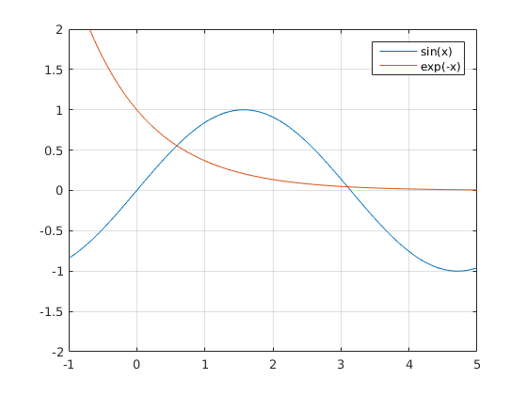

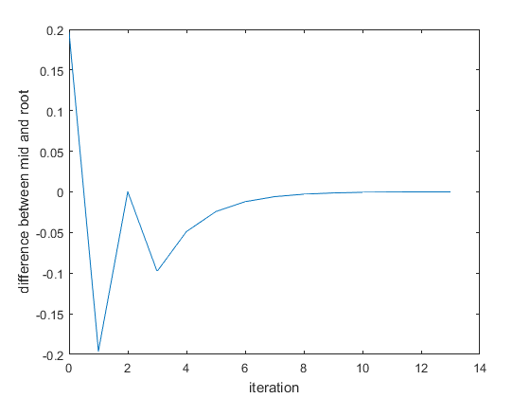

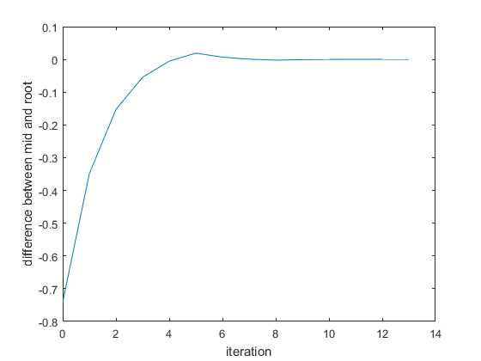

♦ **Observations:**

Root which we are getting is at x = 0.5885 .

Root which we are getting is at x = 3.0964 .

**(F) $f(x) = x^{3} – 2x - 2 = 0$**

♦ **Graphs:**

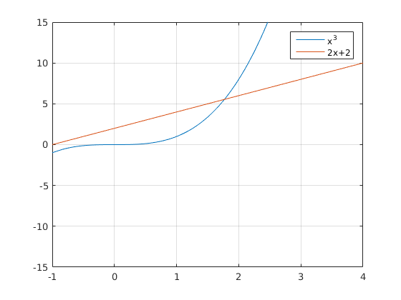

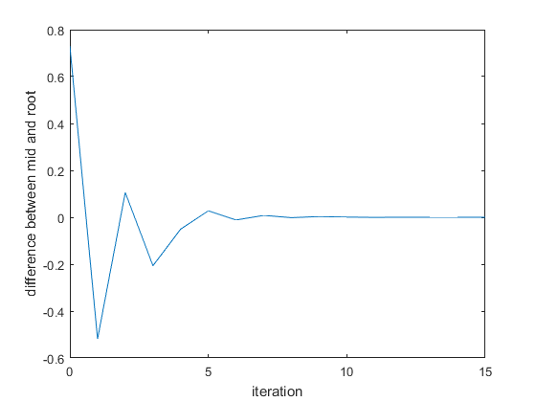

♦ **Observations:**

Root which we are getting is at x = 1.7693 .

**(G) $f(x) = x^{4} – x – 1 = 0$**

♦ **Graphs:**

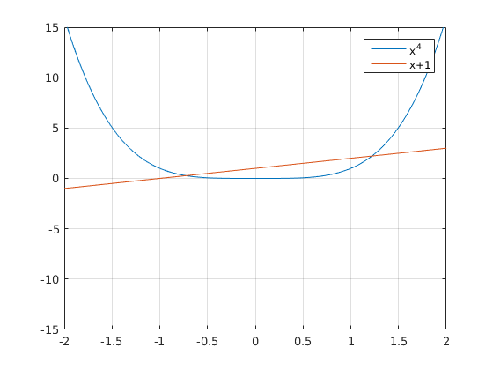

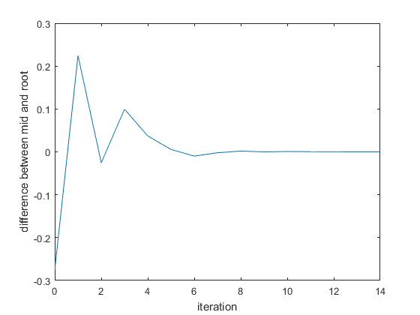

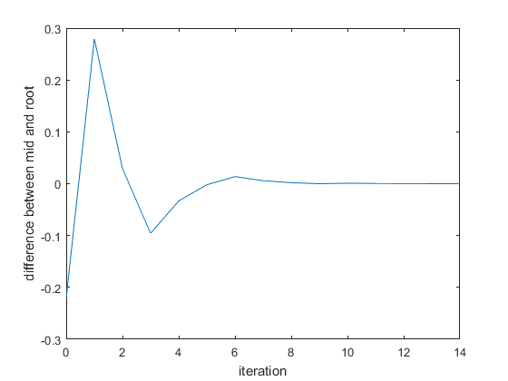

♦ **Observations:**

Smallest Root which we are getting is at x = -0.7245 .

Largest Root which we are getting is at x = 1.2207 .

**(H) $f(x) = e^{x} – x - 2 = 0$**

♦ **Graphs:**

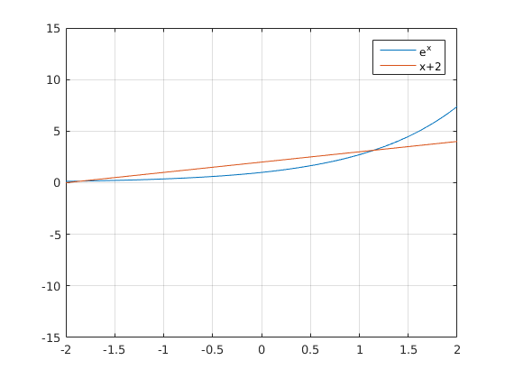

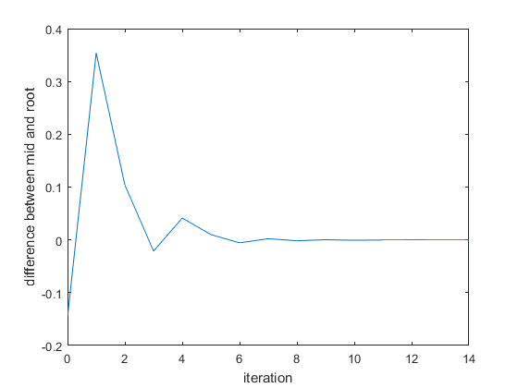

♦ **Observations:**

Root which we are getting is at x = 1.1462 .

$$(I) f(x) = 1 – x + sinx = 0$$

♦ **Graphs:**

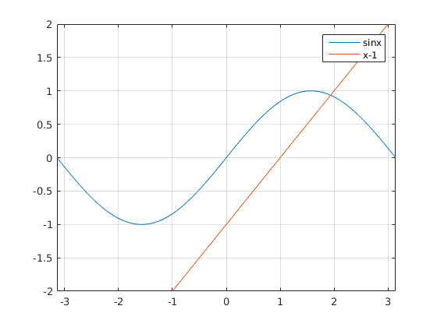

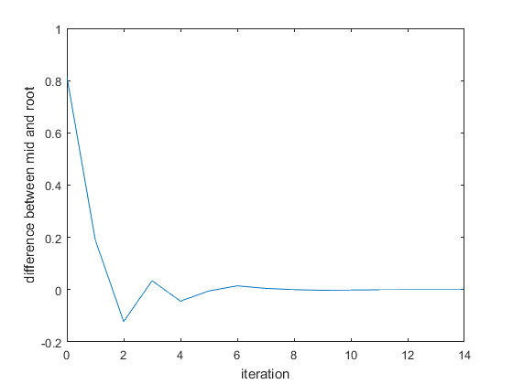

♦ **Observations:**

Root which we are getting is at x = 1.9345 .

**(J) $f(x) = x - tanx = 0$**

♦ **Graphs:**

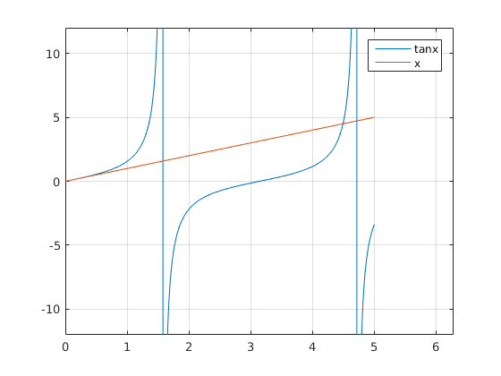

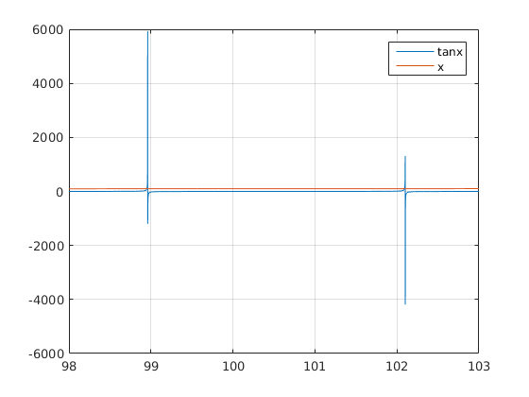

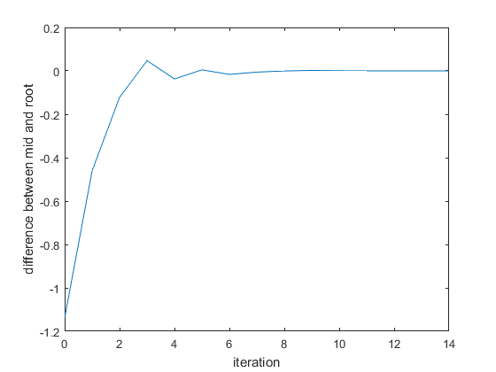

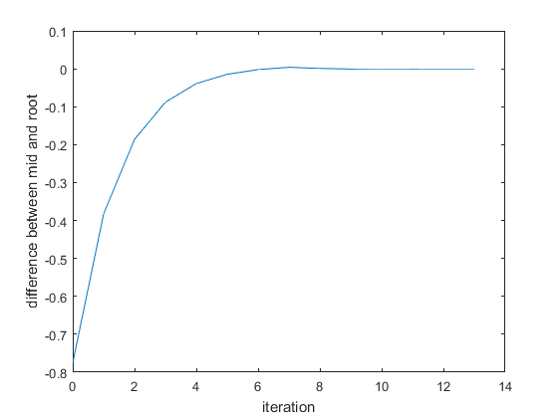

♦ **Observations:**

Smallest non-zero positive Root which we are getting is at x = 4.4934 .

Root closest to x = 100 , which we are getting is at x = 98.9501 .