**Assignment-16, 17, 18**

Course: SC-374

Computational and Numerical Methods

Instructor: Prof. Arnab Kumar

Made by:

Yatin Patel – 201601454

Rutvik Kothari – 201601417

**Assignment : 16**

**Problem: 1**

♦ **Statement:**

(a) On the initial value problem set of set-15, apply both the second-order and forth-order Runge-Kutta methods. Plot the results of both the methods along with the exact integral solution for comparison.

F(x) = sinx + cosx ,

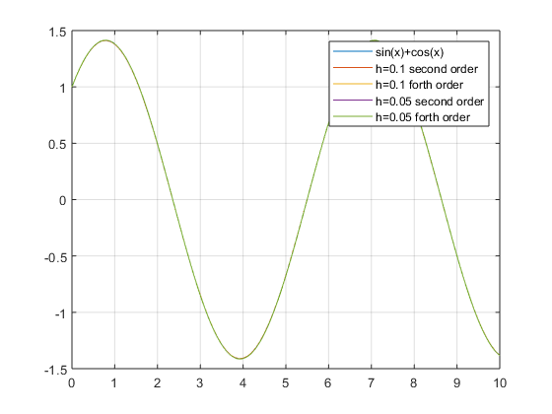

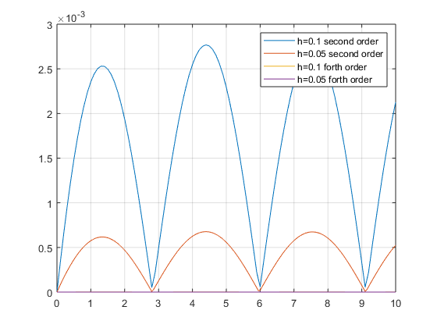

(b) Apply both the second and forth – order Runge – Kutta methods on the initial-value problem, Y’(x)=-Y(x)+ (x^0.1)(1.1+x) , Y(0)=0 for 0<=x<=5.Plot the results of both methods along with the exact integral solution for comparision.The exact integral solution is Y(x)=x^1.1 . Use h=0.1,0.05,0.025,0.0125,h=0.00625.

(a) For h=0.1 ,

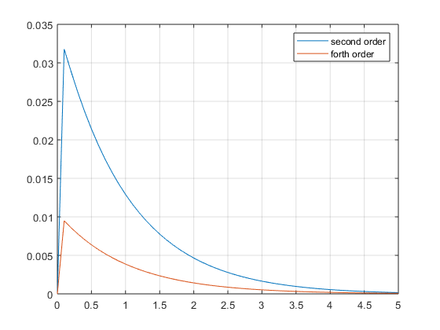

(b) For h=0.05 ,

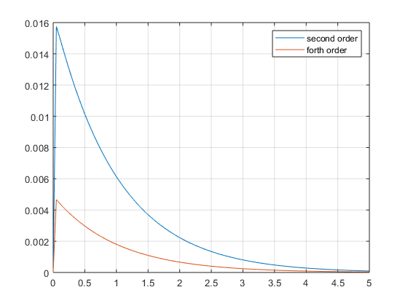

(c) For h=0.025 ,

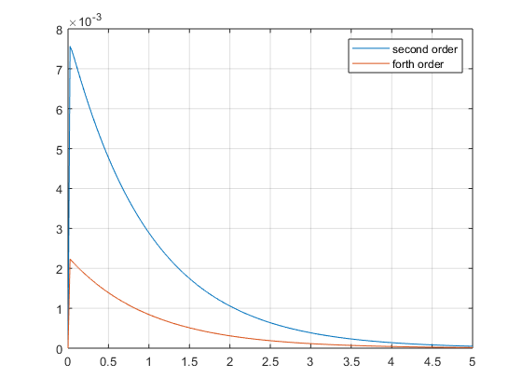

(d) For h=0.0125 ,

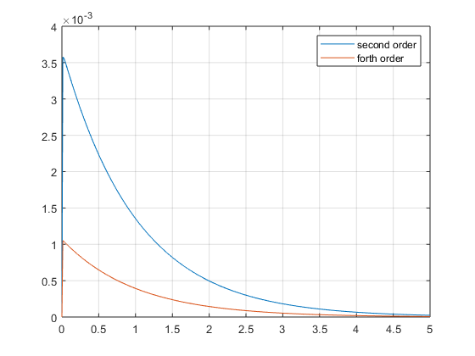

(e) For h=0.00625 ,

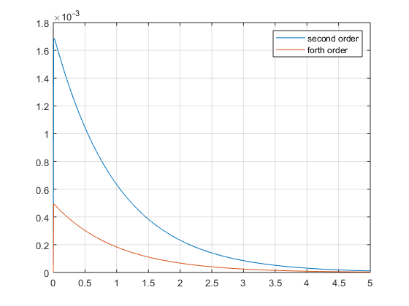

* Plot of function and second and fourth order functions:

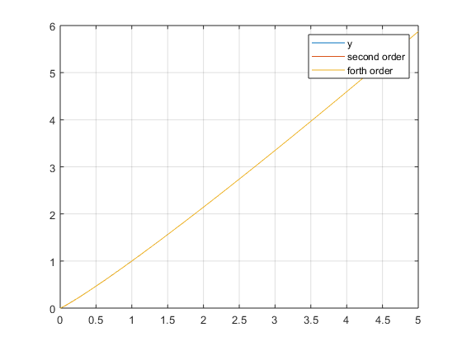

**Assignment : 17**

**Problem: 1**

♦ **Statement:**

Y1’ = AY1(1-BY2),

Y2’ = Cy2(Dy1-1) ,

(a) Given A = 4, B=0.5,C=3,D=1/3 , apply the fourth order Runge-kutta method with Y1(0)=3,y2(0)=5,h=0.01,0.005 for 0<=x<=4.Plot Y1(x) vs x,y2(x) vs x,Y1 vs y2.

(a) For h=0.01,

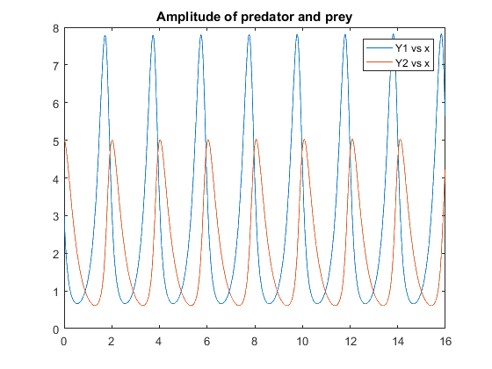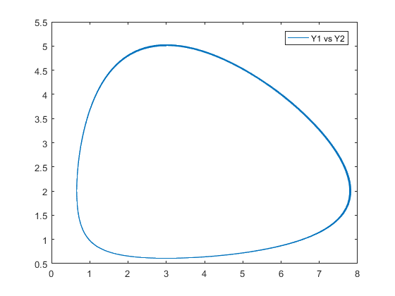

1. For h=0.005,

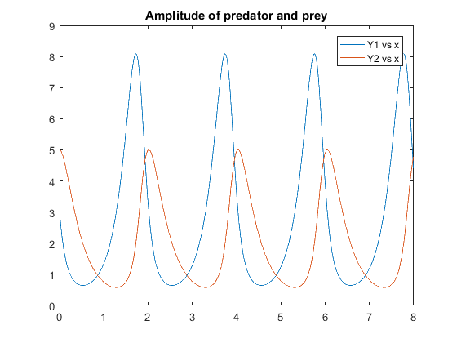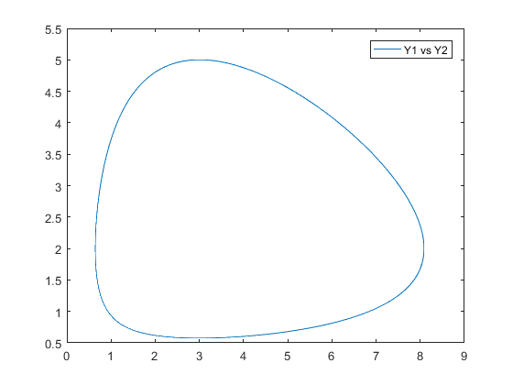

(b) Repeat this exercise for initial values Y1(0)=3, Y2(0)=1,1.5,1.9.

1. Y1(0) = 3 , Y2(0) = 1,

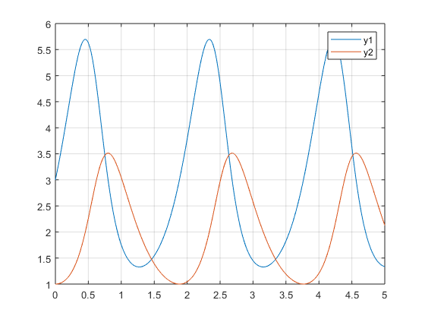

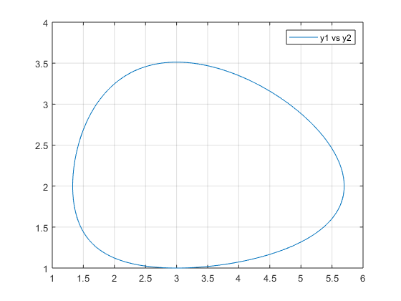

1. Y1(0) = 3 , Y2(0) = 1.5,

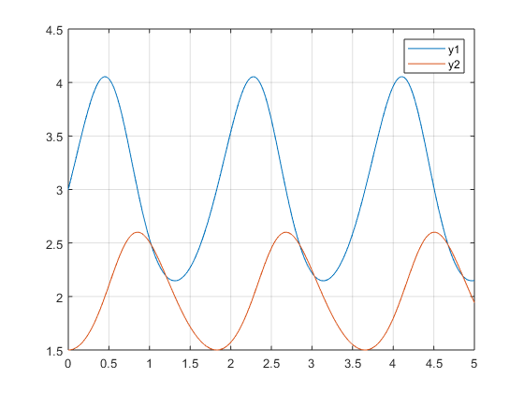

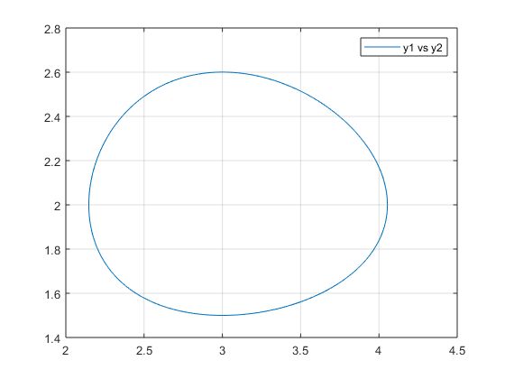

1. Y1(0) = 3 , Y2(0) = 1.9,

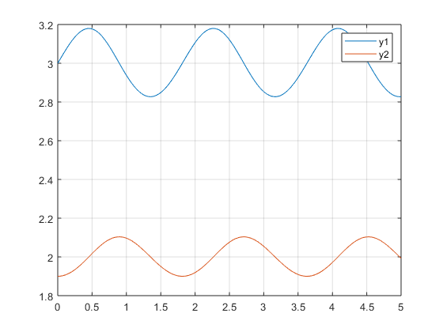

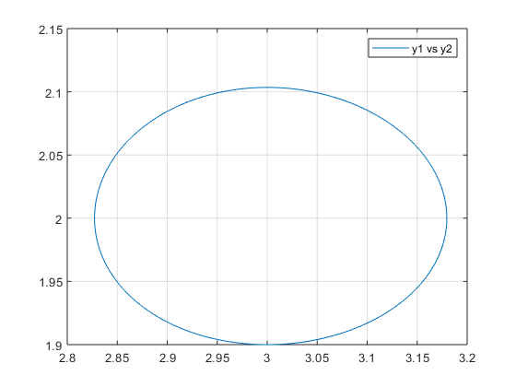

**Assignment : 18**

**Problem: 1**

♦ **Statement:**

Consider the boundary – value theorem,

Whose actual solution is Y(x)=ln(1+(x^2)). For 0<=x<=1, obtain a numerical solution at xi= 0.1,0.2,...,0.9. use h=1/40.

Plot of the function :

