1000

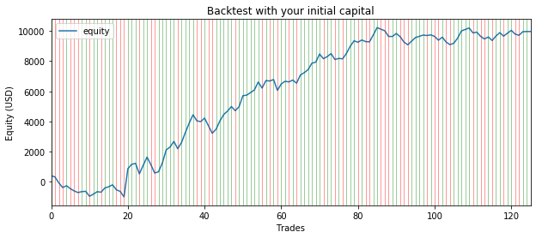

Net Profit : $9962.19

Number Winning Trades : 75

Number Losing Trades : 50

Percent Profitable : 60.00%

Avg Win Trade : $299.374

Avg Los Trade : $-249.818

Largest Win Trade : $1863.099

Largest Los Trade : $-716.293

Profit Factor : 1.80

