Git : Git exercise
Started

Follow the steps :
- Create a repository
- Make some changes -- add some files, change content of some files
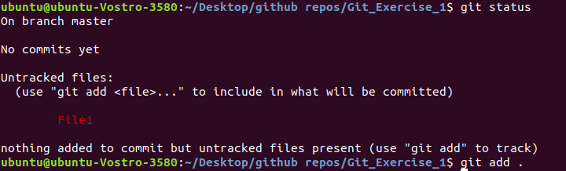
- commit changes
- repeat steps 1-3 for 2 more times. try to remove and ignore some files . Use git diff before each commit.
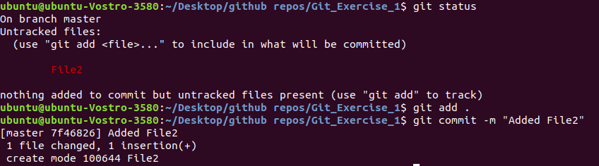
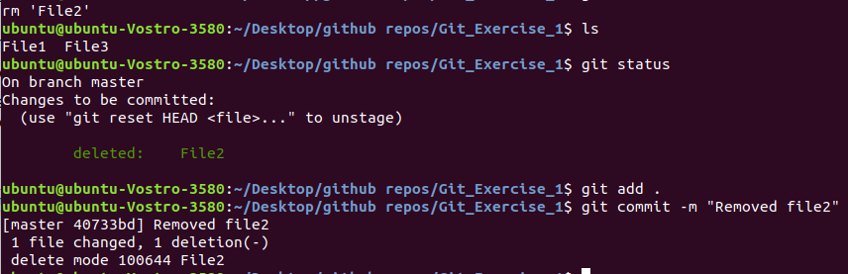
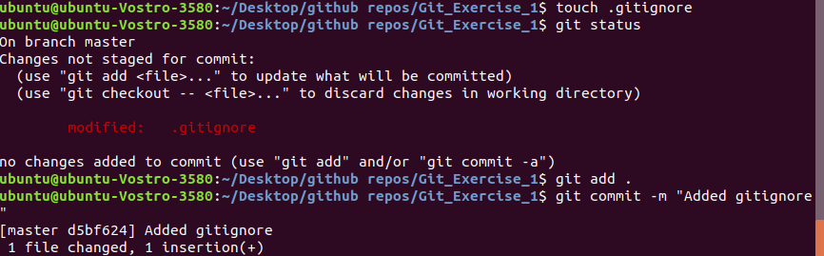

- create changes and revert those changes using git when those changes are not added to staging are
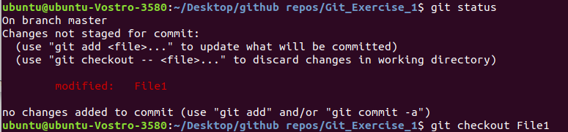
- create changes and revert those changes after adding changes to staging area
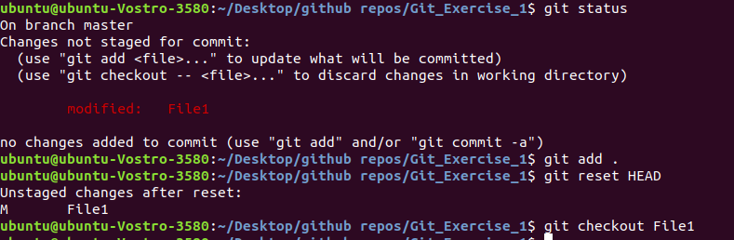
- create change and revert those changes after committing those changes .
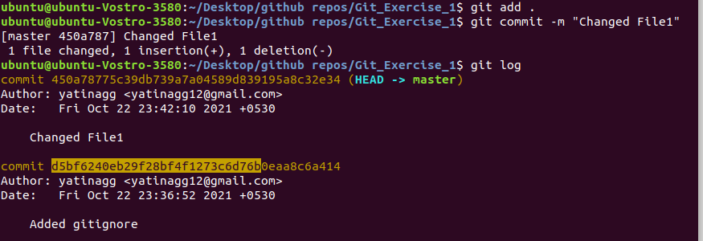
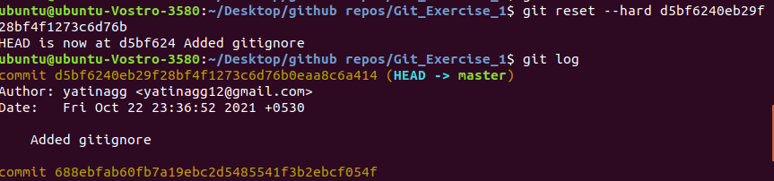

- Check repository status before adding changes to staging area, after adding changes to staging area and after committing changes .
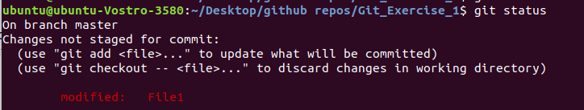
- Display all the commits .
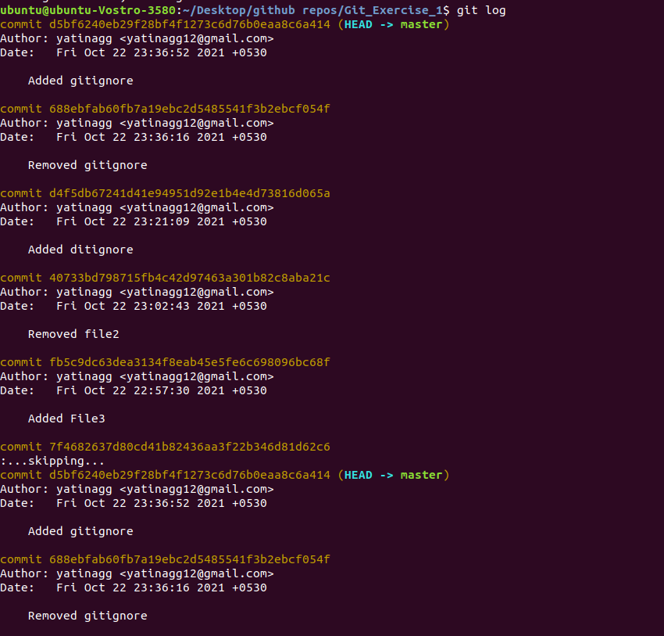
- Display a specific commit .
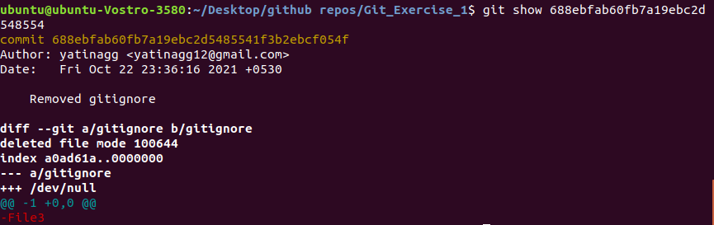
- create branches called "feature1" and "feature2" from master.
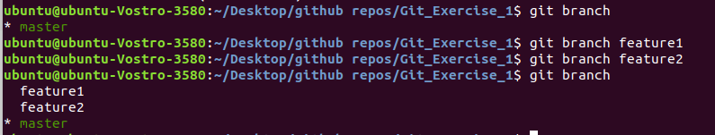

11 . Delete branch "feature2".
- Make some commits on "feature1".
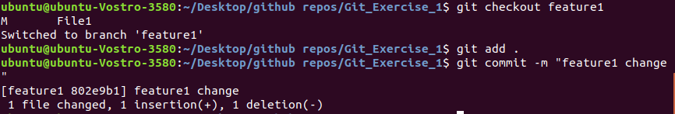
- Make some commits on branch "master".
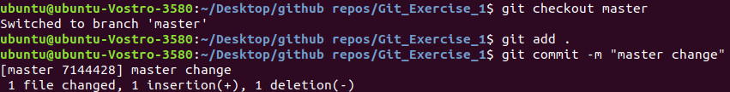
- merge branch "feature1" in "master" (make some conflicts by changing same file on same line in both the branches)
15.create branch "feature2" from master .
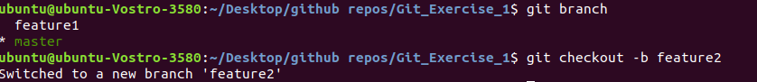
- Make some commits on "feature2".
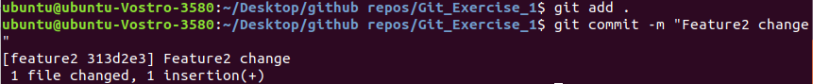
- Make some commits on branch "master".
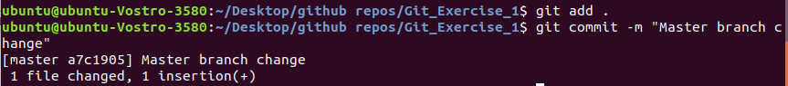
- rebase branch "master" in "feature2" (make some conflicts by changing same file on same line in both the branches) .
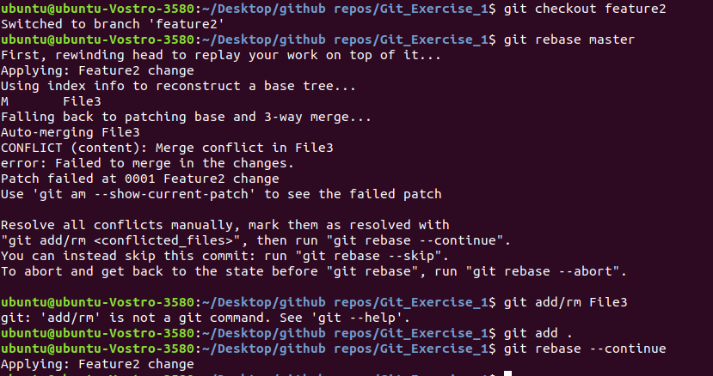
- find the differences between "merge" and "rebase" in above cases.
Rebase will bring back the old master before feature2 commits were added and merge will fuse the feature2 changes into master branch.
- Use git stash
- create a repository on github for your working repository and push changes on remote repository.
