Git : Exercise: Git Tags
Started

- Create a repository and push to github.
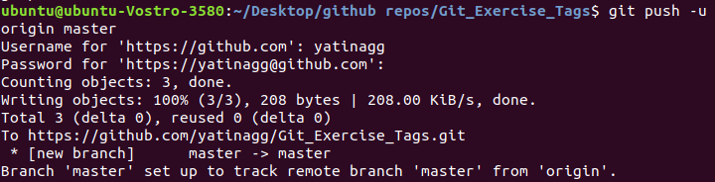
- Create two files in master branch, then create a tag 1.0.0 for first release from master.
- Now, perform some changes in previous files and create another tag 1.0.1.
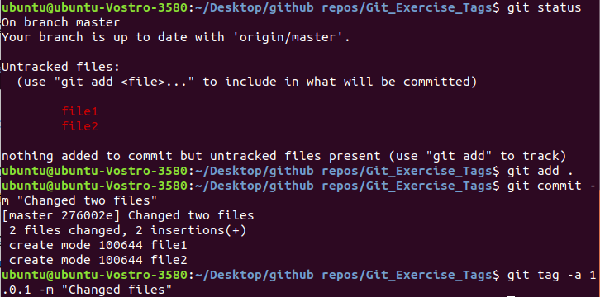
- Now, create another file file3 and create a tag 1.1.0.
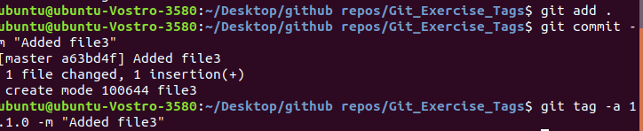
- Now in 1.0.1 release, do some changes in existing files and create another tag 1.0.2.
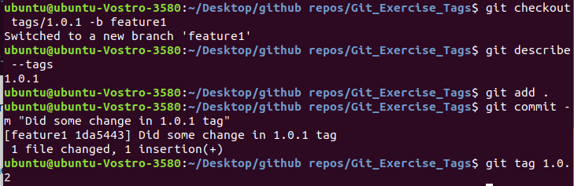
- Also do some changes in release 1.1.0, create a tag for next release 1.1.1.
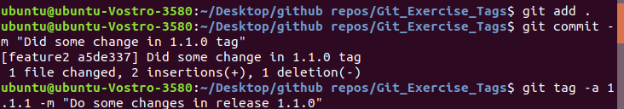
Note: Tags should have clear description and all tags should be pushed to github.
