Git : Exercise: git branch, rebase, merge
Started

- Create two folders project1 and project2 locally. Create a repository in github or bitbucket, name it test_project.



- Switch to project1
- Switch to a new branch – 'staging'.
- Add a file in it - 'test1' and add content to it 'This is first commit'.
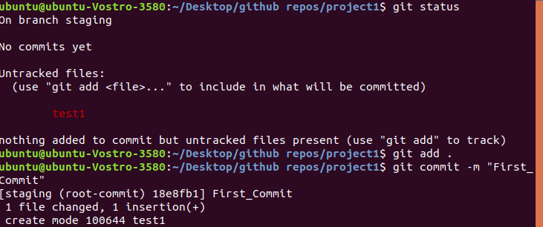
- Push it to github.
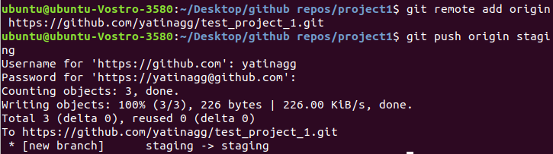
- Move to folder project2.
- Clone the repo in project2.
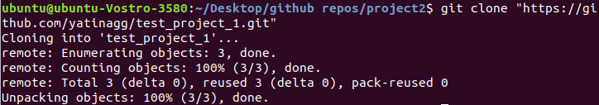
- Switch to staging.
- Change the text in file 'test1' to 'This is second commit'.
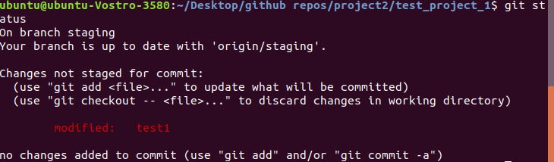
- Commit and push to remote branch.
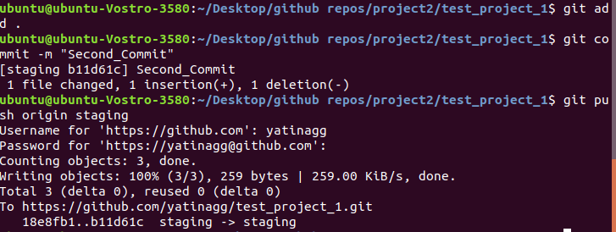
- Move to project1.
- Switch to staging branch.
- Change the text in file 'test1' to 'This is third commit'.
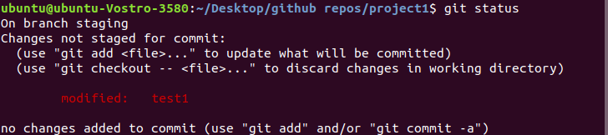
- Commit and push to remote branch. (Explain what happened here).
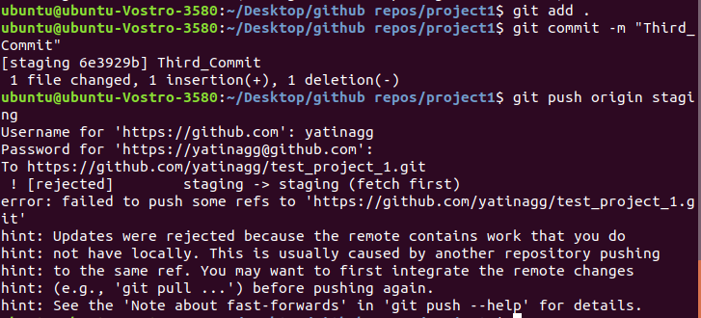
- Switch to master.
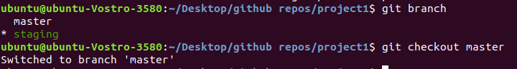
- Merge staging branch into master.
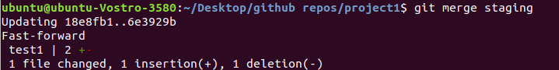

- Create a new branch testing.
- Change the text to 'A is an alphabet' and commit.
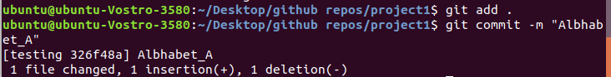
- Repeat the 'step 18' seven times and each time update the alphabet 'A' to 'B' to 'C' etc.(Don't forget to commit the change everytime)
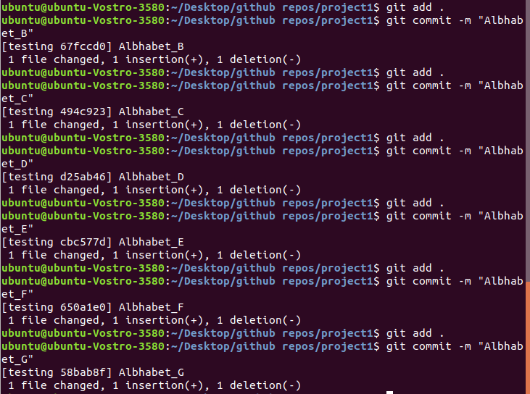
- Push the branch to github.
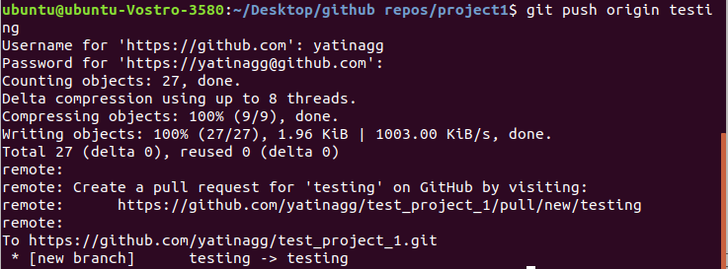
- Checkout to master.
- Change the text '1 is a number' and commit.
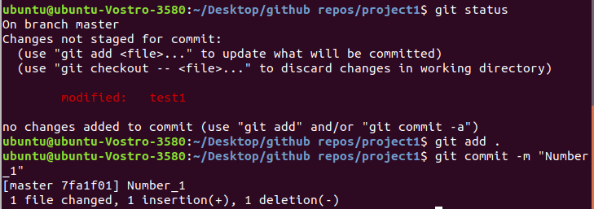
- Repeat the 'step 22' seven times and each time update the number '1' to '2' to '3' etc.(Don't forget to commit the change everytime)
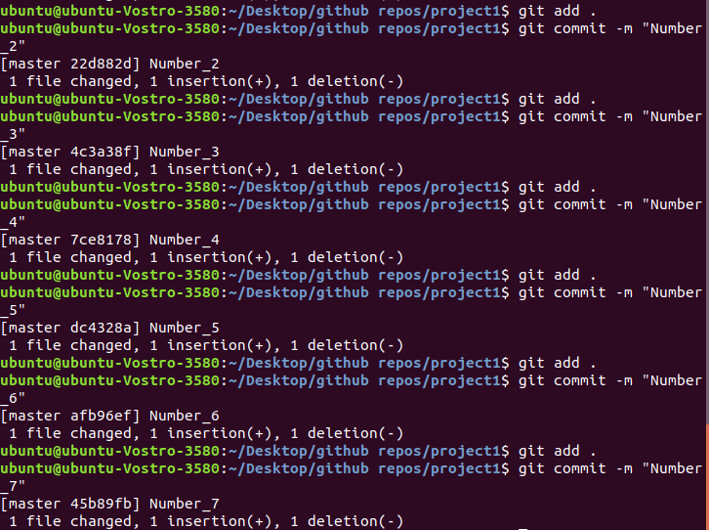
- Push master branch to github.
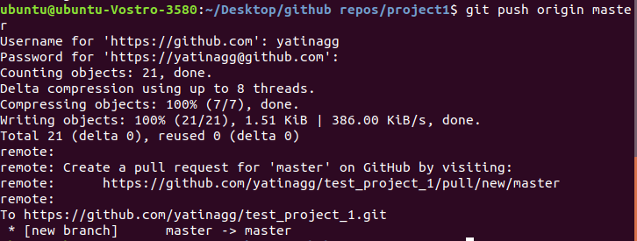
- Now, rebase testing into master(and don't push the new master and testing branch).
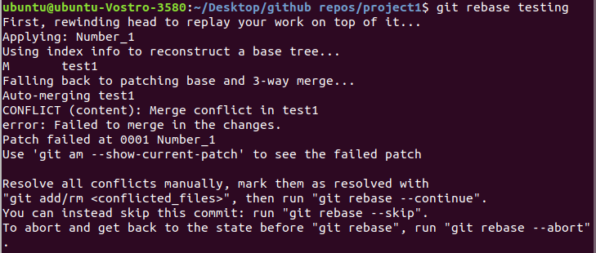
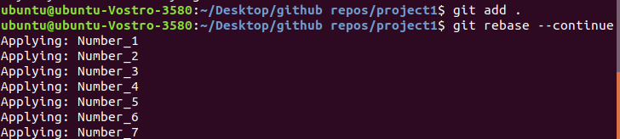
- Move to project2.
- Track testing branch.
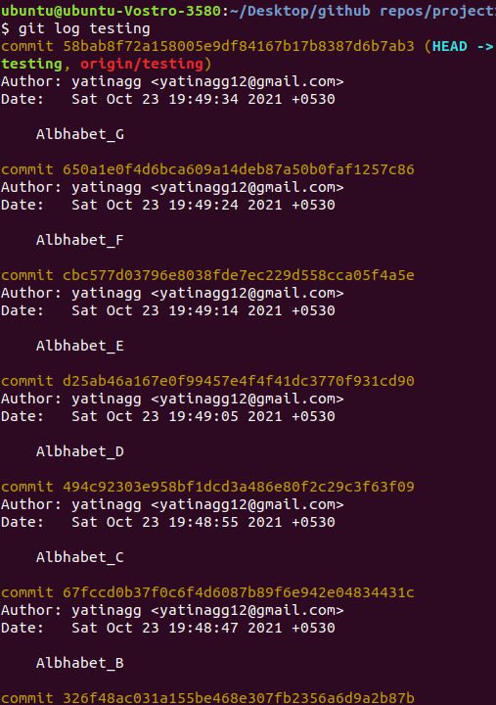
- Checkout to master.
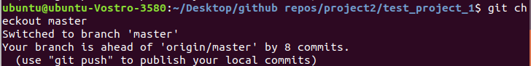
- Merge branch testing into master.
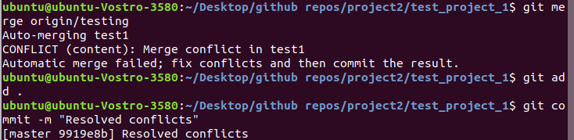
- Share your views about the difference between master and testing.
Master branch contains all the commits of numbers while testing branch contains all the commits of alphabets

