**Software Requirements**

Searchguard version : 5.4.1-14

Kibana Version: 5.4.1

Elasticsearch: 5.4.1-1

Logstash: 5.4.1

Filebeat: 5.4.1

OS: Amazon Linux

**- > Installing Elasticsearch**

Prerequisite: Java 8

*wget* [*https://download.elastic.co/elasticsearch/elasticsearch/elasticsearch-5.4.1.noarch.rpm*](https://download.elastic.co/elasticsearch/elasticsearch/elasticsearch-5.4.1.noarch.rpm)

*sudo rpm -ivh elasticsearch-5.4.1.noarch.rpm*

Now open /etc/elasticsearch/elasticsearch.yml

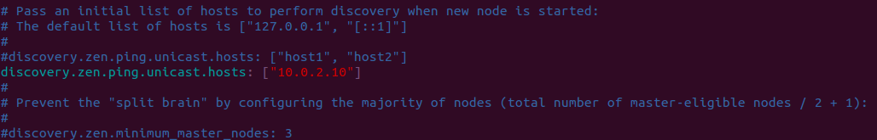

and ensure that discovery.zen.ping.unicast.hosts set to localhost or hostname of machine or private ip address(as shown).

Now to start elasticsearch */etc/init.d/elasticsearch start*

To test if everything going fine run

*curl -X GET '*[*http://localhost:9200*](http://localhost:9200/)*'* (9200 is port on which elasticsearch runs)

**- > Installing Logstash**

Prerequisite: Java 8

Download and install the public signing key:

rpm --import https://packages.elastic.co/GPG-KEY-elasticsearch

Add the following in your /etc/yum.repos.d/ directory in a file with a .repo suffix, for example logstash.repo

[logstash-5.4]

name=Logstash repository for 5.4.1 packages

baseurl=https://packages.elastic.co/logstash/5.4/centos

gpgcheck=1

gpgkey=https://packages.elastic.co/GPG-KEY-elasticsearch

enabled=1

And your repository is ready for use. You can install it with:

yum install logstash

**- > Installing Kibana**

Prerequisite: Java 8

wget https://artifacts.elastic.co/downloads/kibana/kibana-5.4.1-x86_64.rpm

sha1sum kibana-5.4.1-x86_64.rpm

sudo rpm --install kibana-5.4.1-x86_64.rpm

cd /usr/share/elasticsearch/bin

- > **Installing Searchguard plugin in elasticsearch**

1) ./elasticsearch-plugin install -b com.floragunn:search-guard-5:5.4.1-14

Output:

-> Downloading com.floragunn:search-guard-5:5.4.1-14 from maven central

[=================================================] 100%

@@@@@@@@@@@@@@@@@@@@@@@@@@@@@@@@@@@@@@@@@@@@@@@@@@@@@@@@@@@

@ WARNING: plugin requires additional permissions @

@@@@@@@@@@@@@@@@@@@@@@@@@@@@@@@@@@@@@@@@@@@@@@@@@@@@@@@@@@@

* java.io.FilePermission /proc/sys/net/core/somaxconn read

* java.lang.RuntimePermission accessClassInPackage.sun.misc

* java.lang.RuntimePermission accessClassInPackage.sun.nio.ch

* java.lang.RuntimePermission accessClassInPackage.sun.security.x509

* java.lang.RuntimePermission accessDeclaredMembers

* java.lang.RuntimePermission getClassLoader

* java.lang.RuntimePermission loadLibrary.*

* java.lang.RuntimePermission setContextClassLoader

* java.lang.RuntimePermission shutdownHooks

* java.lang.reflect.ReflectPermission suppressAccessChecks

* java.security.SecurityPermission getProperty.ssl.KeyManagerFactory.algorithm

* java.security.SecurityPermission setProperty.ocsp.enable

* java.util.PropertyPermission com.sun.security.enableCRLDP write

* java.util.PropertyPermission es.set.netty.runtime.available.processors write

* java.util.PropertyPermission java.security.debug write

* java.util.PropertyPermission java.security.krb5.conf write

* java.util.PropertyPermission javax.security.auth.useSubjectCredsOnly write

* java.util.PropertyPermission sun.nio.ch.bugLevel write

* java.util.PropertyPermission sun.security.krb5.debug write

* java.util.PropertyPermission sun.security.spnego.debug write

* javax.security.auth.AuthPermission doAs

* javax.security.auth.AuthPermission modifyPrivateCredentials

* javax.security.auth.kerberos.ServicePermission * accept

See http://docs.oracle.com/javase/8/docs/technotes/guides/security/permissions.html

for descriptions of what these permissions allow and the associated risks.

–-------> search-guard-5 Installed ←--------------------

2) chmod u+x search-guard-5/tools/install_demo_configuration.sh && search-guard-5/tools/install_demo_configuration.sh

Output:

## Search Guard Demo Installer ##

Warning: Do not use on production or public reachable systems

Continue? [y/N] y

This script maybe require your root password for 'sudo' privileges

Elasticsearch install type: rpm/deb

Elasticsearch config dir: /etc/elasticsearch

Detected Elasticsearch Version: 5.4.1

Detected Search Guard Version: 5.4.1-14

### Success

### Execute this script now on all your nodes and then start all nodes

### After the whole cluster is up execute:

sudo /usr/share/elasticsearch/plugins/search-guard-5/tools/sgadmin.sh -cd /usr/share/elasticsearch/plugins/search-guard-5/sgconfig -cn searchguard_demo -ks /etc/elasticsearch/kirk.jks -ts /etc/elasticsearch/truststore.jks -nhnv

### or run ./sgadmin_demo.sh

### Then open https://localhost:9200 an login with admin/admin

### (Just ignore the ssl certificate warning because we installed a self signed demo certificate)

Note: Searchguard plugin will append its own configuration at the bottom of the /etc/elasticsearch/elasticsearch.yml. You may have to reconfigure certain parameters to avoid duplicity.

If you get sg_admin.sh inside “/usr/share/elasticsearch/plugins”, please move it to “search-guard-5/tools/”.

3) ./sgadmin_demo.sh

WARNING: JAVA_HOME not set, will use /usr/bin/java

Search Guard Admin v5

Will connect to localhost:9300 ... done

### LICENSE NOTICE Search Guard ###

If you use one or more of the following features in production

make sure you have a valid Search Guard license

(See https://floragunn.com/searchguard-validate-license)

* Kibana Multitenancy

* LDAP authentication/authorization

* Active Directory authentication/authorization

* REST Management API

* JSON Web Token (JWT) authentication/authorization

* Kerberos authentication/authorization

* Document- and Fieldlevel Security (DLS/FLS)

* Auditlogging

In case of any doubt mail to <sales@floragunn.com>

###################################

Contacting elasticsearch cluster 'searchguard_demo' and wait for YELLOW clusterstate ...

Clustername: searchguard_demo

Clusterstate: YELLOW

Number of nodes: 1

Number of data nodes: 1

searchguard index already exists, so we do not need to create one.

Populate config from /usr/share/elasticsearch/plugins/search-guard-5/sgconfig/

Will update 'config' with /usr/share/elasticsearch/plugins/search-guard-5/sgconfig/sg_config.yml

SUCC: Configuration for 'config' created or updated

Will update 'roles' with /usr/share/elasticsearch/plugins/search-guard-5/sgconfig/sg_roles.yml

SUCC: Configuration for 'roles' created or updated

Will update 'rolesmapping' with /usr/share/elasticsearch/plugins/search-guard-5/sgconfig/sg_roles_mapping.yml

SUCC: Configuration for 'rolesmapping' created or updated

Will update 'internalusers' with /usr/share/elasticsearch/plugins/search-guard-5/sgconfig/sg_internal_users.yml

SUCC: Configuration for 'internalusers' created or updated

Will update 'actiongroups' with /usr/share/elasticsearch/plugins/search-guard-5/sgconfig/sg_action_groups.yml

SUCC: Configuration for 'actiongroups' created or updated

Done with success

4) Now edit /etc/elasticsearch/elasticsearch.yml and make this parameter from true to false as

searchguard.ssl.http.enabled: false

5) Now restart elasticsearch

6) check by

curl -XGET –-user admin:admin [http://localhost:9200](http://localhost:9200/)

Output:

{

"name" : "ELK1",

"cluster_name" : "searchguard_demo",

"cluster_uuid" : "NhkUm3j7RLuKrYf1P1etuA",

"version" : {

"number" : "5.4.1",

"build_hash" : "2cfe0df",

"build_date" : "2017-05-29T16:05:51.443Z",

"build_snapshot" : false,

"lucene_version" : "6.5.1"

},

"tagline" : "You Know, for Search"

}

Note: Don't copy command from word as it will format it and thus wrong command can be copied

–--> Searchguard configured in elasticsearch ←----------

**Applying Searchguard in Kibana**

7) mkdir -p /opt/package

8) cd /opt/package

9) wget https://github.com/floragunncom/search-guard-kibana-plugin/releases/download/v5.4.1-3/searchguard-kibana-5.4.1-3.zip

10) bin/kibana-plugin install <file:///opt/package/searchguard-kibana-5.4.1-3.zip>

11) Edit kibana.yml as

server.host: "local-ip-address"

elasticsearch.url: [https://127.0.0.1:9200](https://127.0.0.1:9200/)

elasticsearch.username: "kibanaserver"

elasticsearch.password: "kibanaserver"

elasticsearch.ssl.verificationMode: none

server.ssl.enabled: false

12. Edit /usr/share/elasticsearch/plugins/search-guard-5/sgconfig/sg_config.yml

Under authz add

type: noop

**Curator Installation**

13. rpm --import <https://packages.elastic.co/GPG-KEY-elasticsearch>

14. yum install elasticsearch-curator -y

15. cd /opt/

16. mkdir curator_config

17. cd curator_config/

**Installation of s3-repository plugin**

18. cd /usr/share/elasticsearch

19. bin/elasticsearch-plugin install repository-s3

20. service elasticsearch restart

Command to register s3-repository

21. curl --insecure -XPUT --user admin:admin 'https://localhost:9200/_snapshot/s3_repository?verify=false' -H 'Content-Type: application/json' -d '

{

"type": "s3",

"settings": {

"bucket": "elkstackbucket",

"region": "us-east-1"

}

}'

**Make Curator Removal Script**

#!/bin/bash

22. curator_cli --ssl-no-validate --use_ssl --http_auth admin:admin show_indices

23. curator_cli --ssl-no-validate --use_ssl --http_auth admin:admin snapshot --repository s3_repository --ignore_unavailable --partial --filter_list '[{"filtertype":"age","source":"creation_date","direction":"older","unit":"days","unit_count":45},{"filtertype":"pattern","kind":"prefix","value":"filebeat"}]'

24. curator_cli --ssl-no-validate --use_ssl --http_auth admin:admin delete_indices --ignore_empty_list --filter_list '[{"filtertype":"age","source":"creation_date","direction":"older","unit":"days","unit_count":45},{"filtertype":"pattern","kind":"prefix","value":"filebeat"}]'

→ → At this point searchguard is applied in elasticsearch and kibana on master node ← ←

**Configuring Data Node**

**Installing Filebeat on Data Node**

1) curl -L -O <https://artifacts.elastic.co/downloads/beats/filebeat/filebeat-5.4.1-x86_64.rpm>

2) sudo rpm -vi filebeat-5.4.1-x86_64.rpm

3) configure /etc/filebeat/filebeat.yml as

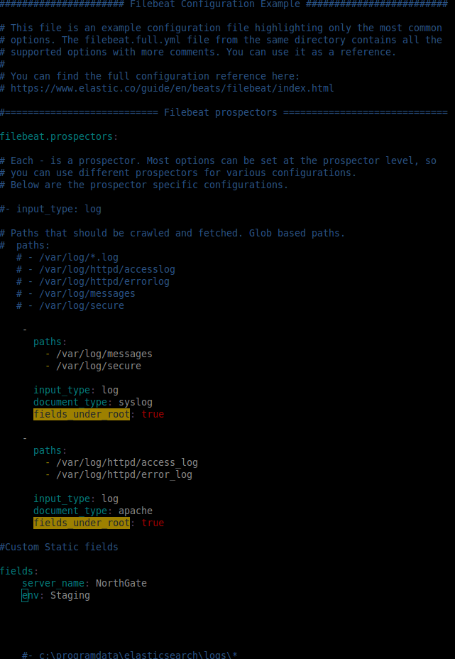

Expand images to see configuration.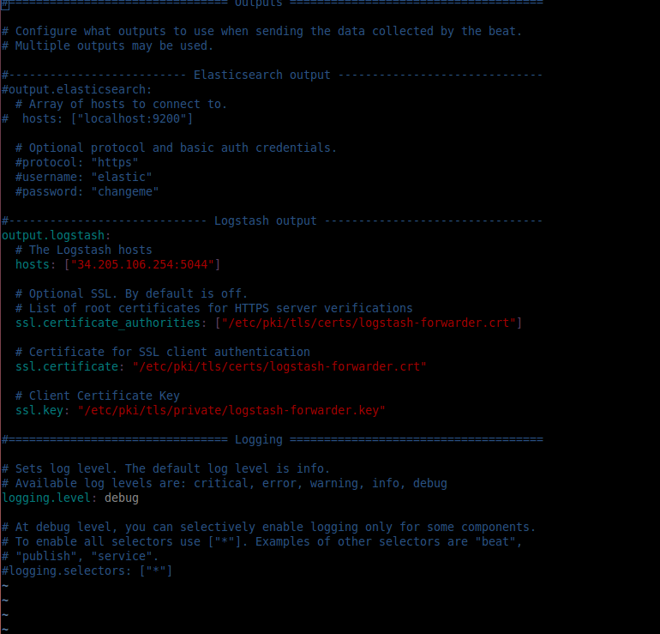

In ssl.certificate_authorities same .crt goes that lies in ELK Server or Master Node.

During Installation we keep it in /etc/pki/tls, in folder certs logstash_forwarder.crt and in folder private as logstash_forwarder.key

IP in hosts is of ELK Server or Master node or node in which logstash is running.

4) Start Filebeat by /etc/init.d/filebeat restart

**Switch to ELK Server**

1) Now we need to add configuration files that hear filebeat, collect logs, apply filters and push to elasticsearch.

2) We add these configuration files in /etc/logstash/conf.d as

02-beats-input.conf(to hear beats)

10-syslog-filter.conf(to filter syslogs)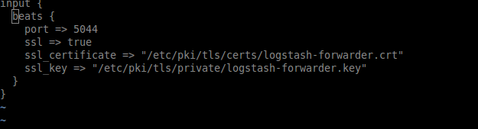

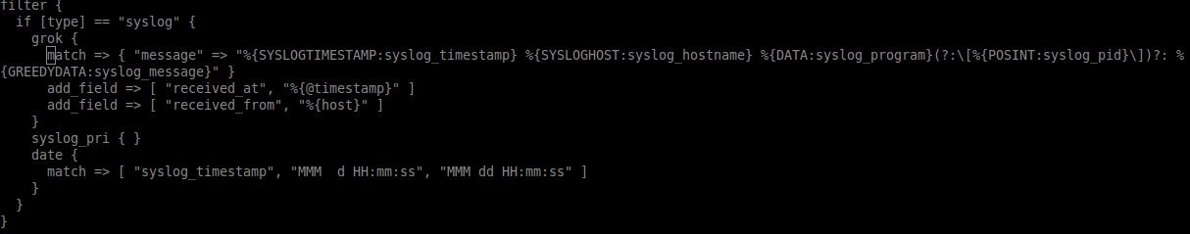

15-apache-error.conf(to filter apache error logs)

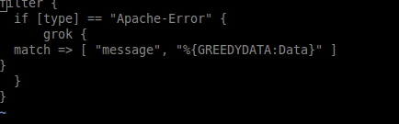

20-apache-access.conf(to filter apache access logs)

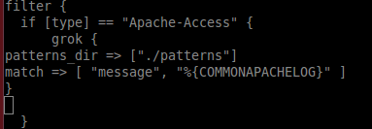

25-audit.conf(to filter audit logs)

30-elasticsearch-output.conf (to push to elasticsearch)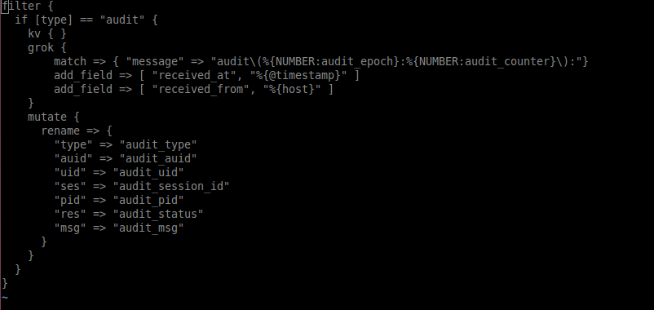

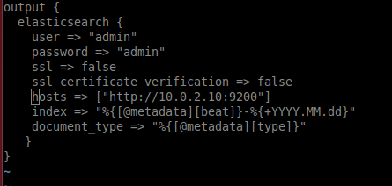

3) Now to run this configurations go to /usr/share/logstash/bin and type

./logstash -f /etc/logstash/conf.d (If logstash not previously running)

(else first stop logstash and then run this command)

4) Hit kibana, enter admin:admin password in secureguard and go to Discover, Hit on Data node server, you must be able to see logs coming in access log of Data node server on Kibana in last 15 minutes check.

**Interaction with Kibana**

1. You must be able to see logs coming from data nodes(via filebeat). If not then ensure correct index is selected. In our case index is filebeat-*. Means filebeat index correspond to every timestamp get selected.

2. If no index exists, then go to Management, and click on Index Pattern. From there provide index, kibana will implicitly check for index and if that index not exist then it will pop up error. If index exist then select @timestamp in Time Field Name and click create. It will look like this:

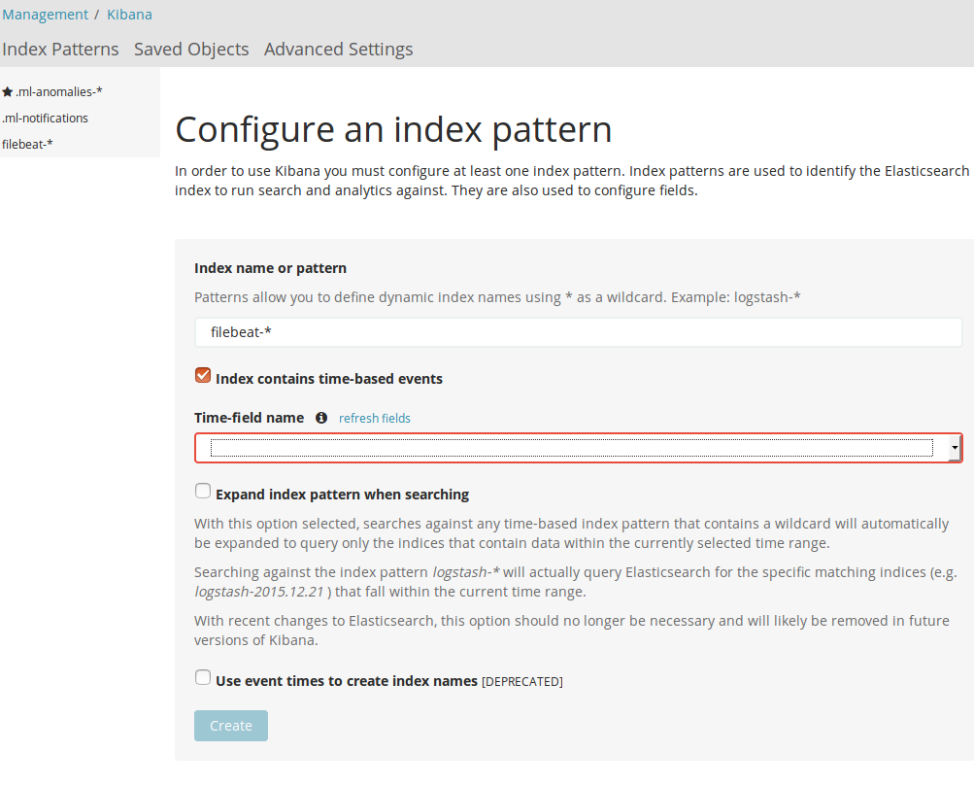

Here filebeat-* already exists but in your case it will not.

3. Now as index is made, go to Discover. If logs are coming then you will be able to see logs as by default whenever kibana open, by default it show logs for 15 minutes. If no logs are visible to you increase time from 15 minutes to time you expect as

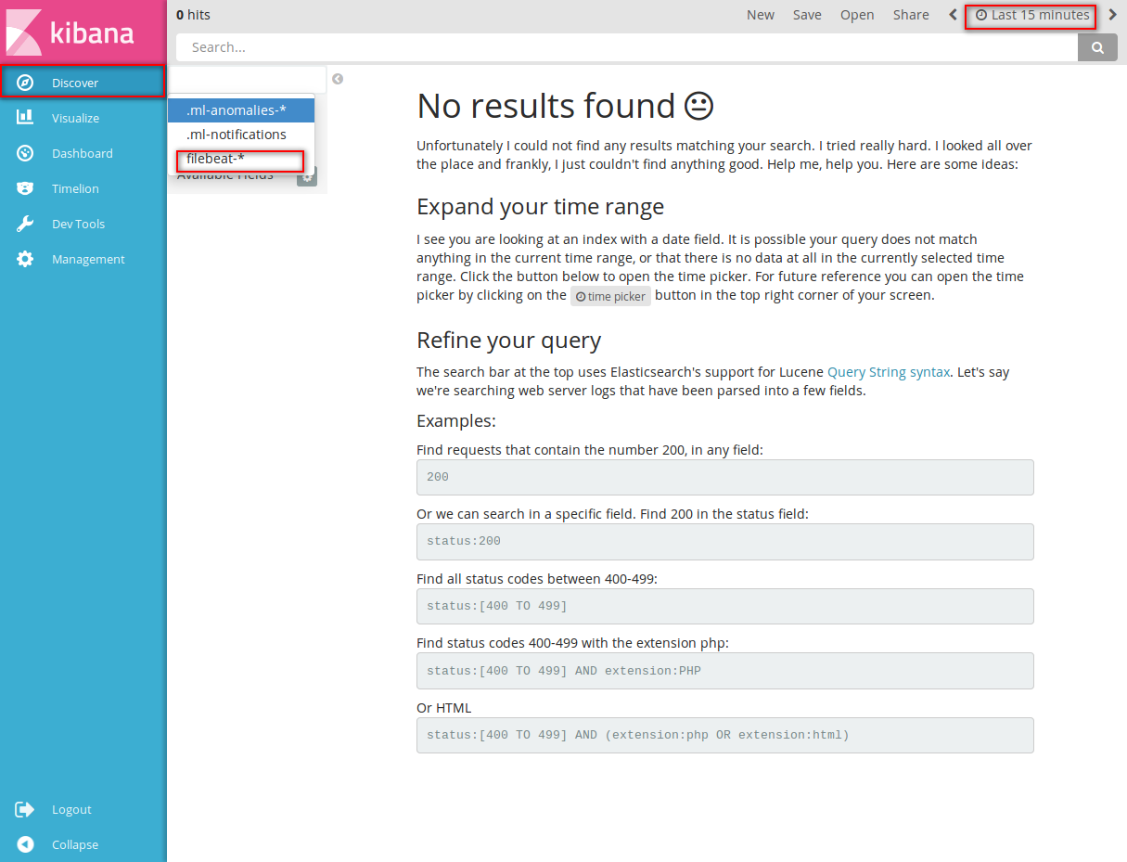

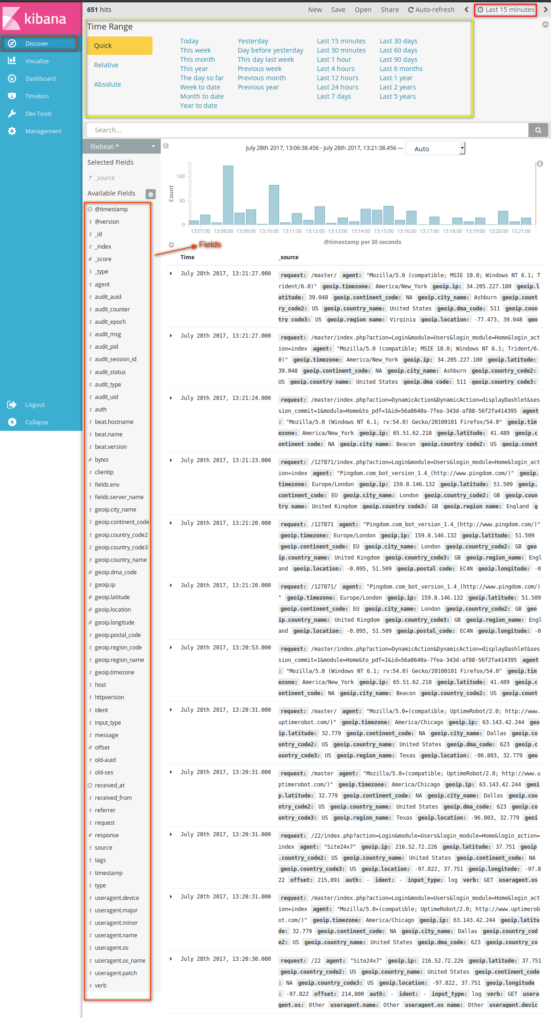

4. Now as you go to Kibana Visualize you will see it

For how to make graphs refer this online tutorial @youtube [https://www.youtube.com/watch?v=mMhnGjp8oOI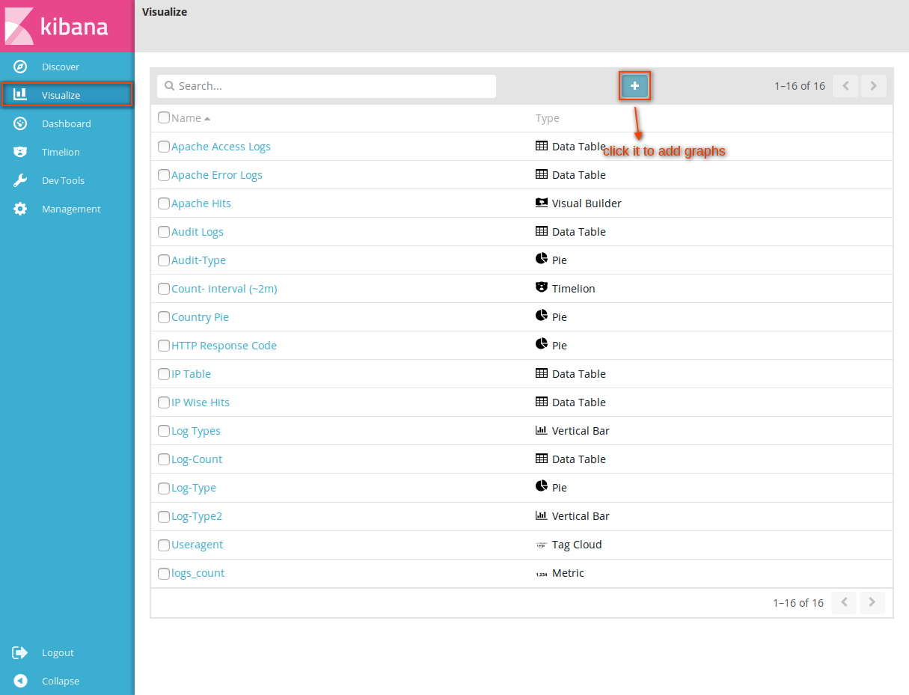](https://www.youtube.com/watch?v=mMhnGjp8oOI)

5. Now we go to Dashboard, and can make or view Dashboards as

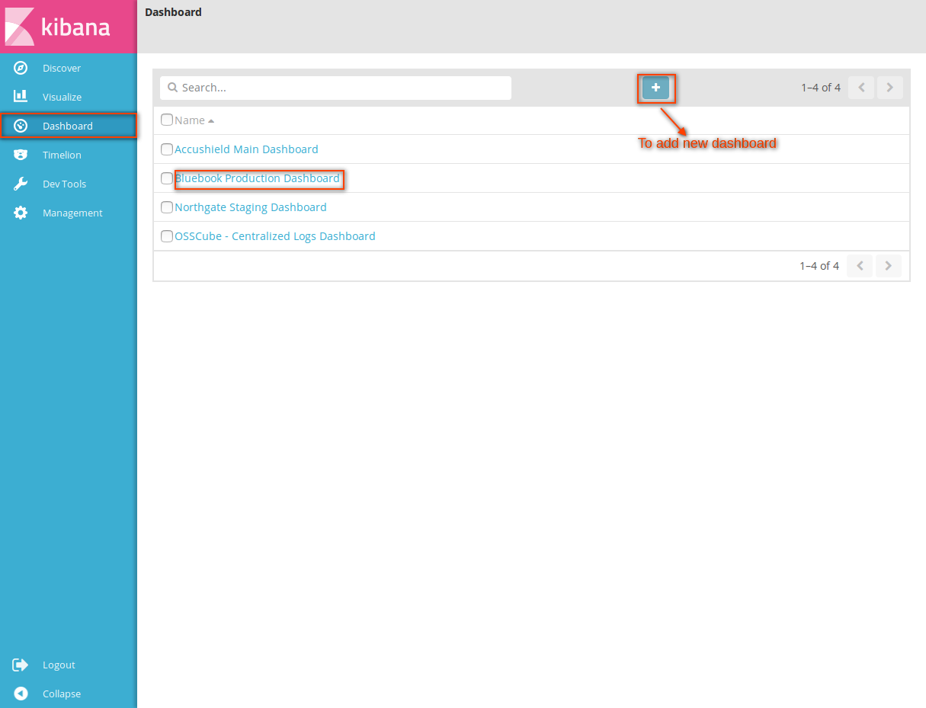

In this way we can progress with kibana. Now add nodes and start monitoring servers in interactive way.