**JBOSS6 Documentation**

**version**: 6.1

**Platform Requirements:**

**1. Java Requirements**

Oracle JDK 1.6 or 1.7, OpenJDK 1.6 or 1.7, IBM JDK 1.6 or 1.7

**2. Hardware Requirements**

a. Disk Space: >=1.5GB,

b. CPU: Intel Core 2 Duo, Intel Core 2 Quad and Intel Xeon CPUs improve server performance for high demand applications.

c. RAM: >=1.5GB

To deploy and run small to medium applications, 2 GB or more is required.

4 GB or more is recommended to run larger applications, or to run a server managed via a Graphical User Interface (GUI).

**Installation**

**1. Add epel7 repository**

wget <http://dl.fedoraproject.org/pub/epel/epel-release-latest-7.noarch.rpm>

rpm -ivh epel-release-latest-7.noarch.rpm

**2. Install Java 7**

sudo yum install java-1.7.0-openjdk.x86_64 -y

# IT may take some time

#test by

java -version

# must show java version "1.7.0_151"

**3. Install Jboss6.1 Application Server**

wget <http://download.jboss.org/jbossas/6.1/jboss-as-distribution-6.1.0.Final.zip>

mv jboss-as-distribution-6.1.0.Final.zip /usr/share/jboss6.1Final.zip

cd /usr/share/

unzip jboss6.1Final.zip

# If in case zip or unzip is not installed then run

# yum install zip unzip -y

# and then try unzipping it

vi /etc/environment

# set environment varible as

export JBOSS_HOME="/usr/share/jboss-6.1.0.Final"

export JAVA_HOME="/usr/lib/jvm/java-1.7.0-openjdk-1.7.0.151-2.6.11.1.el7_4.x86_64/jre/bin/java"

# save and exit

source /etc/environment

cd /usr/share/jboss-6.1.0.Final/bin/

./run.sh -b 0.0.0.0

# May be firewall create issue if doing on virtual machine, allow all in iptables to allow access outside from virtual machine.

#check by

ps -aux|grep jboss|grep -v grep

# you must see jboss process running

# now run localhost:8080

# and you must see jboss page as

# Add following lines in /usr/share/jboss-6.1.0.Final/server/default/deploy/hornetq/hornetq-jms.xml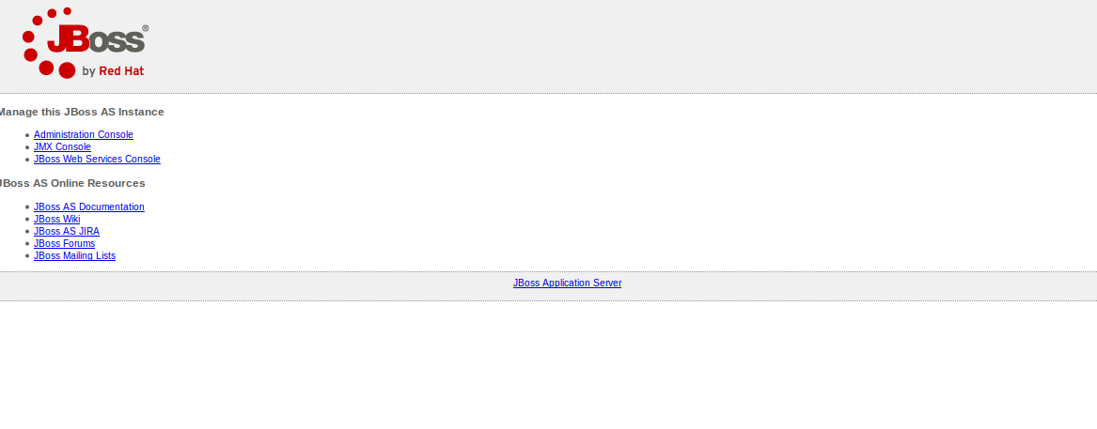

<topic name="TestTopic">

<entry name="/topic/TestTopic"/>

</topic>

# change user(role) in place of guest as jboss in file hornetq-configuration.xml