Configuring Email in Zabbix

1. Create Media Type as

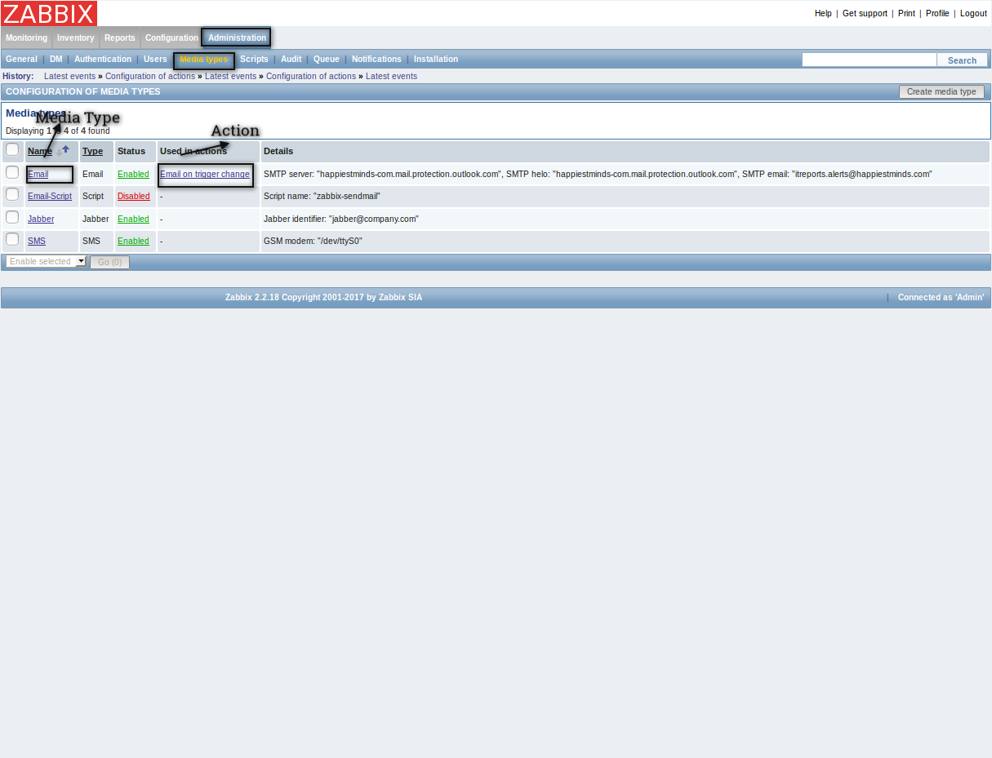

2. Configure SMTP in media type if Type is Email, otherwise if it is Email-Script then keep script in /usr/local/share/zabbix/alertscripts or if not work there then in /usr/lib/zabbix/alertscripts and run from there. Script must be as

echo -e "Subject: $2\n$3" | sendmail -v $1

and mention its name in zabbix. Otherwise for Email configure SMTP as:

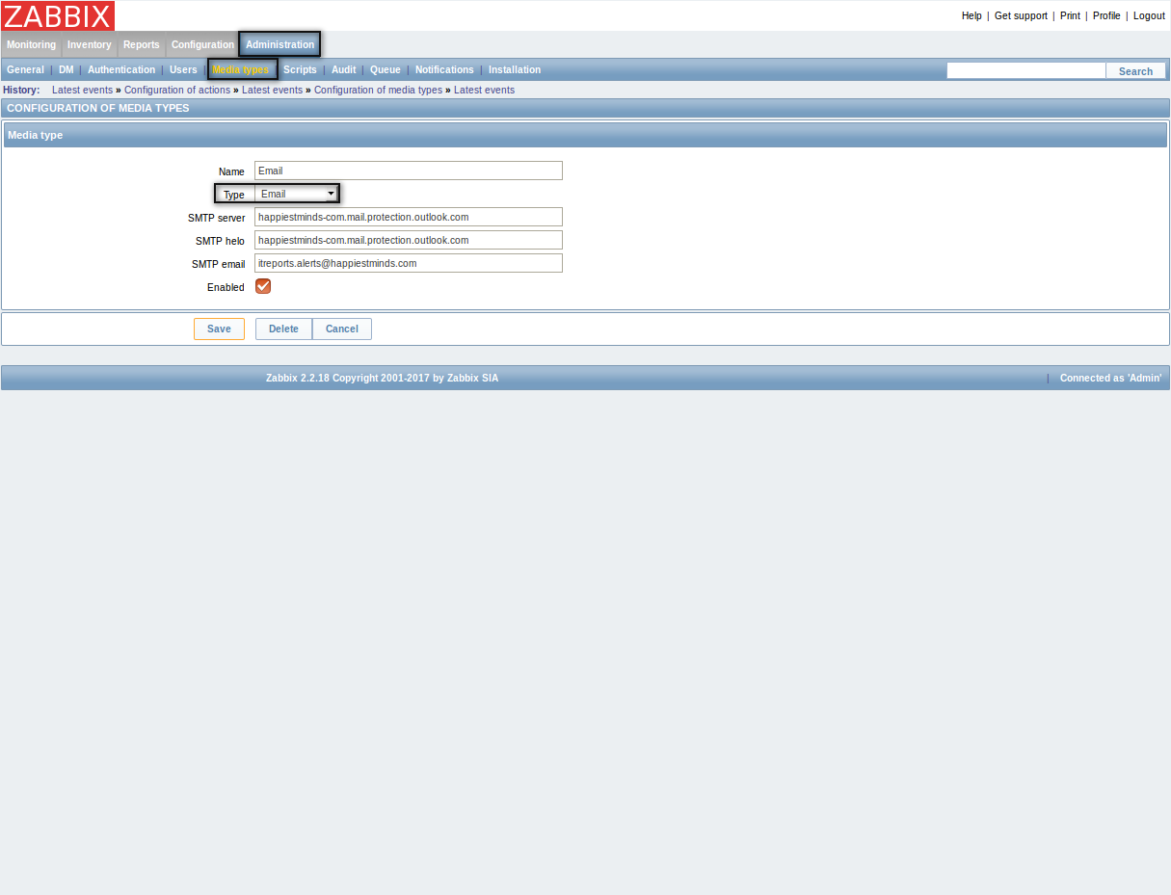

3. Now You need to create action that will run as some event fired that initiate mail. For it go to Configuration->Actions and make Action as

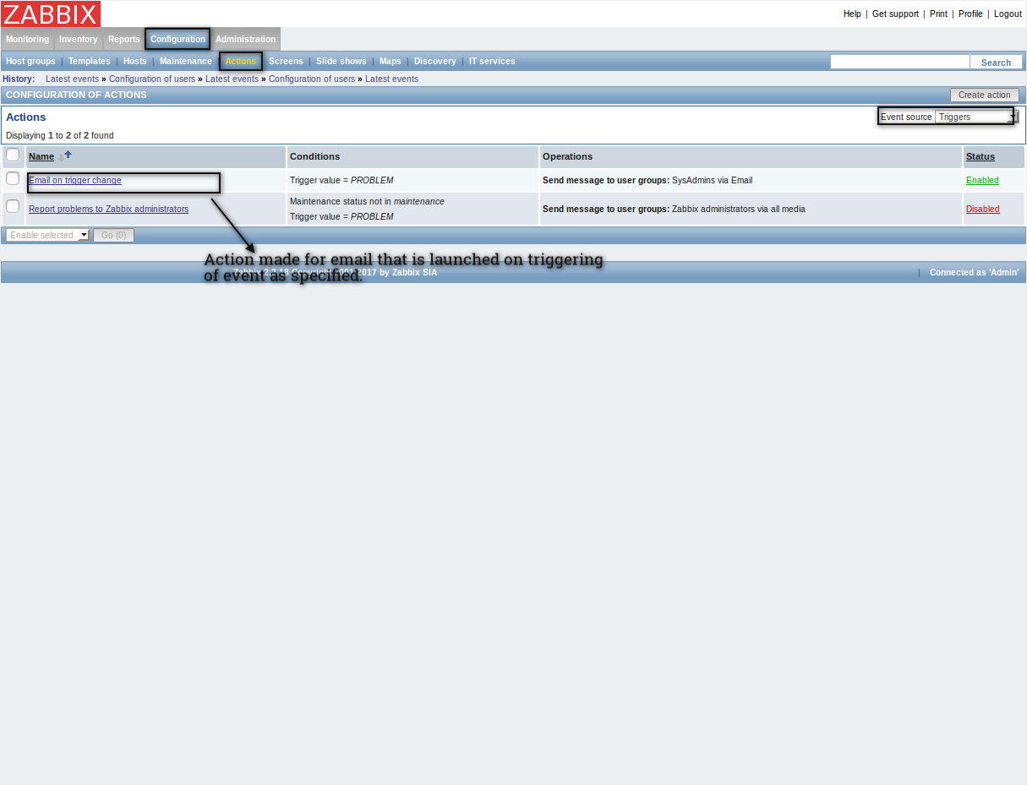

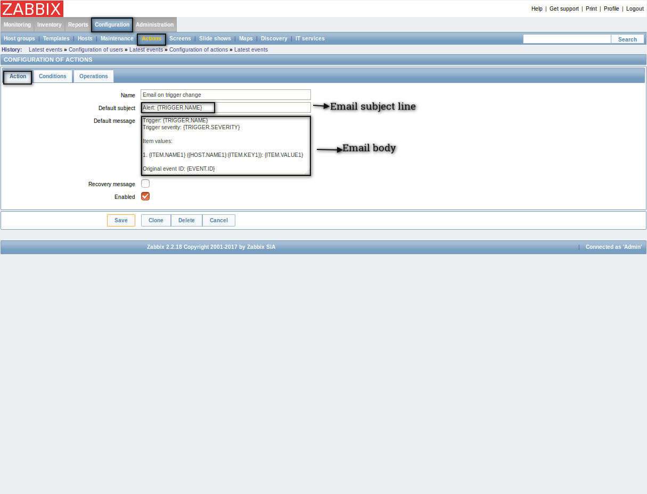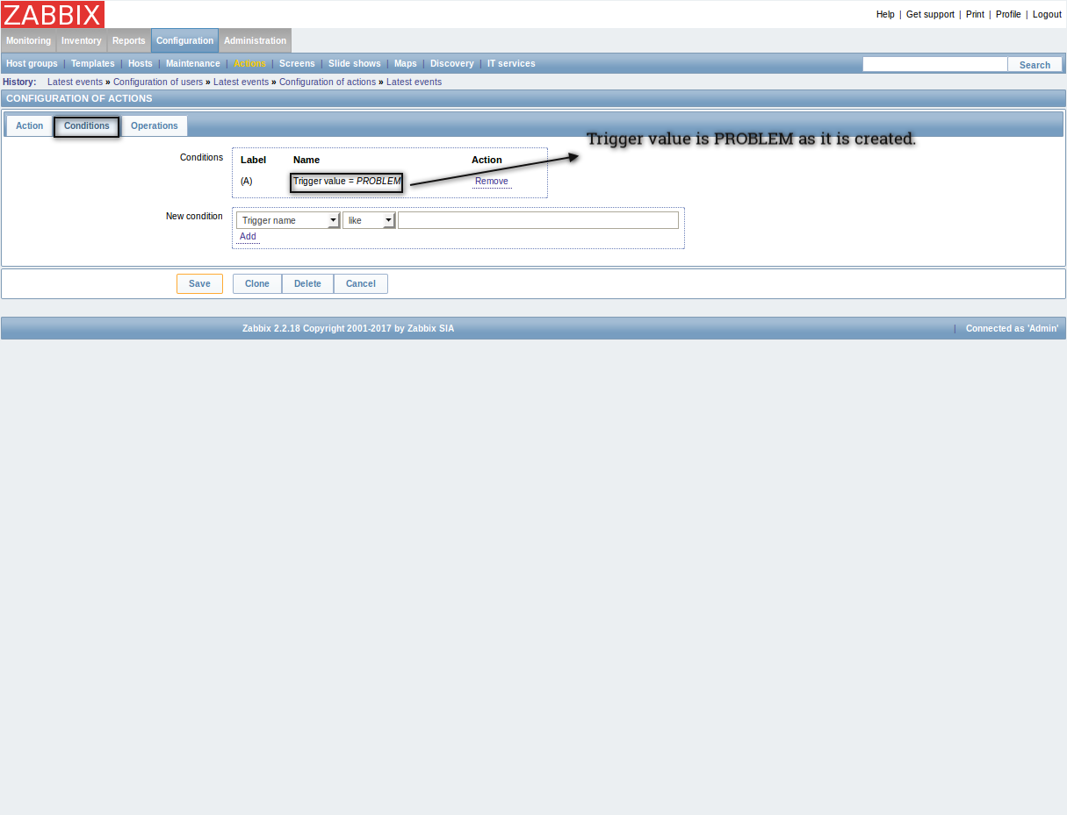

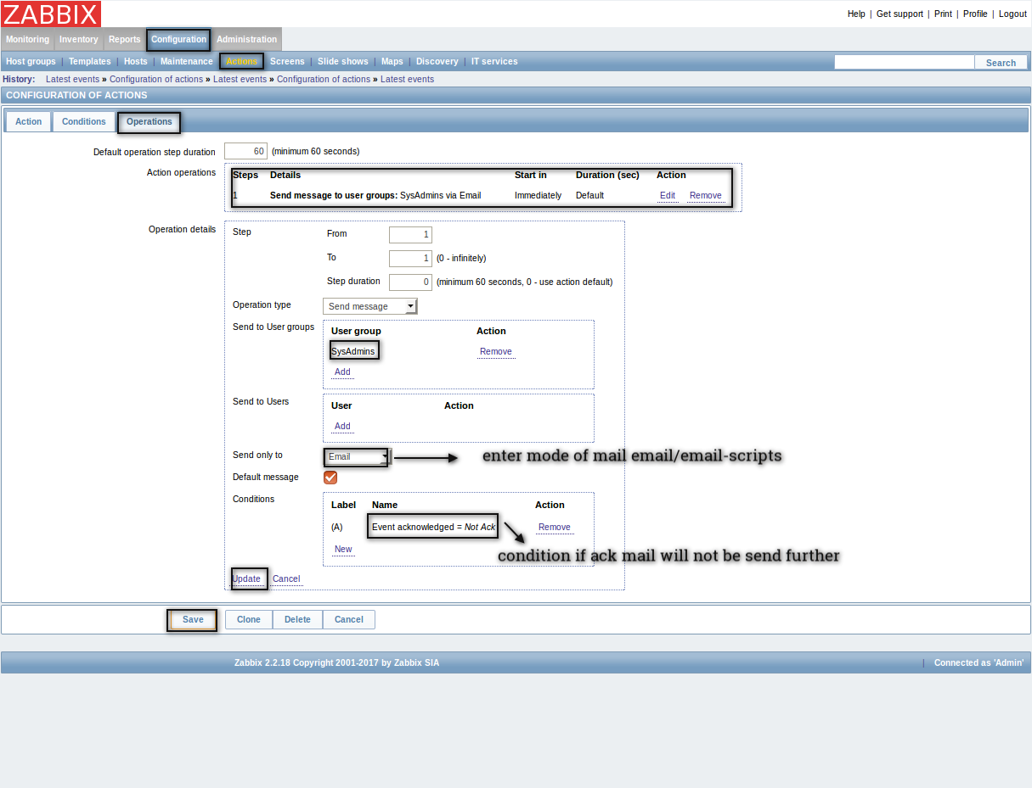

NOTE: Its essential to create media type first. As in action you need to select Media Types. Here mode of mail is actually media type.

4. Now you need to provide mail Id that to send mail in case Action condition satisfied. For it go to Administrator->Users-> Select Users from drop box and edit User (that is added in group mentioned in action) as

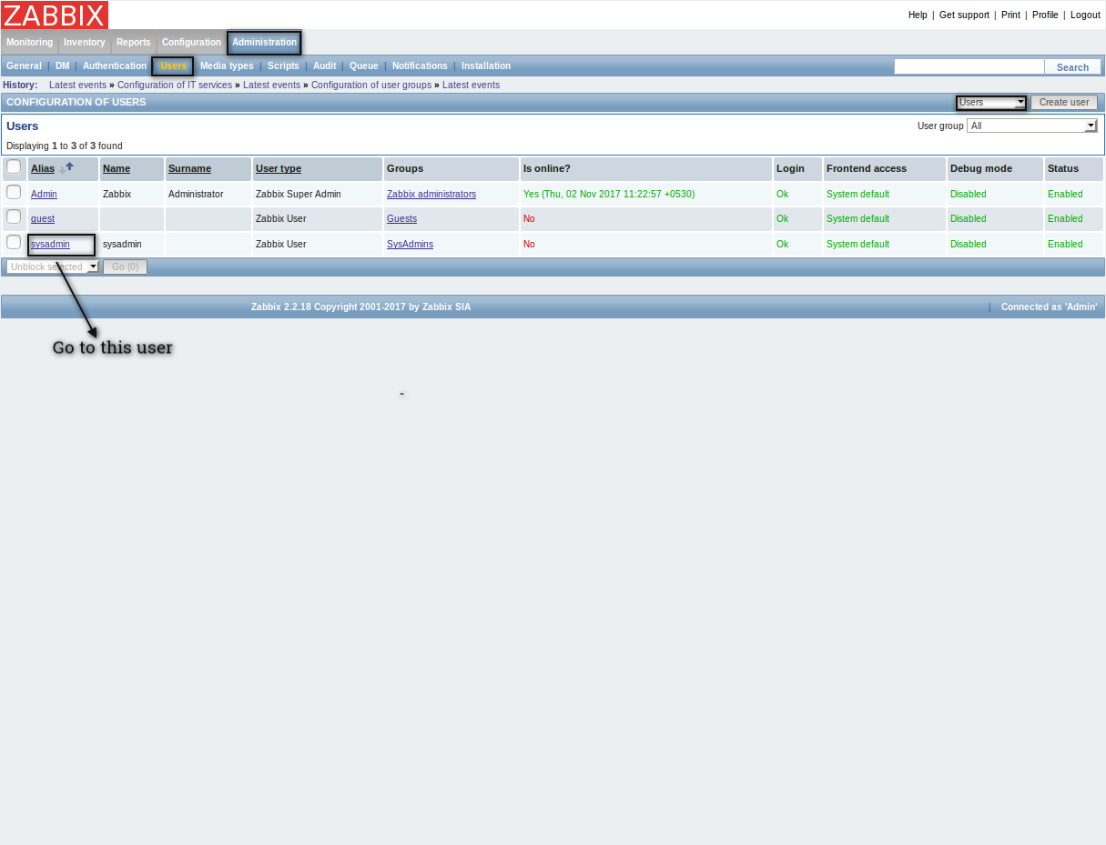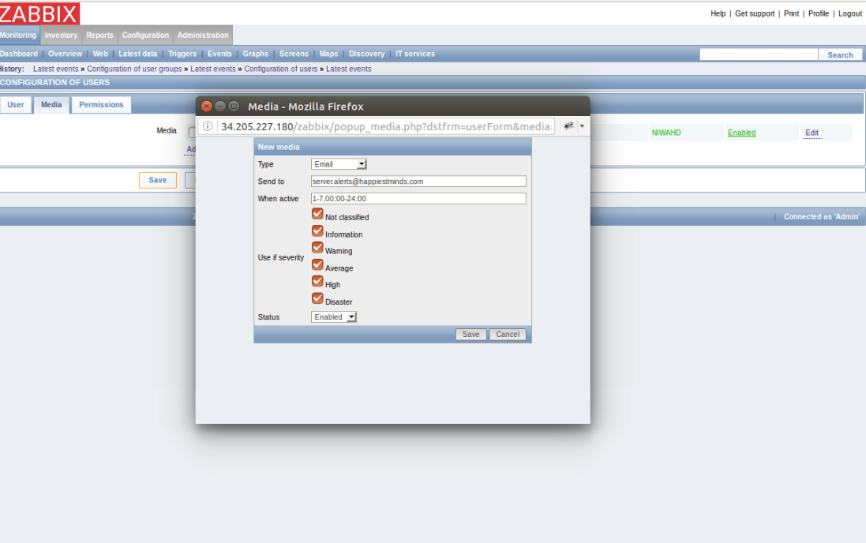

Now Ensure this user must be in group that is added in action. And create trigger condition that satisfy action and check for mail.