Unable to use yum in Centos Virtual machine
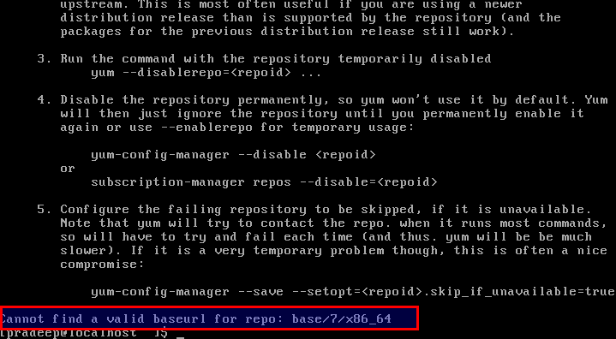

Use
sudo dhclient

and then you will be able to use yum.

