American Consumers Cannot Afford Trump’s Trade Policy any Longer

February 17, Trump readdressed on X that he will charge “a reciprocal tariff for the purpose of fairness.” He couldn’t make it more clearer: everything is about reciprocity, a matter of ensuring that other nations do not take economic advantage of the United States.

Trump’s economic nationalism had been heavy on rhetoric. In his campaign, He promised to impose tariffs of at least 60 percent against Chinese imports if reelected. As expected, he did not hesitate to impose an additional ten percent tariff on imports from China and Hong Kong right after he took office.
One of the most significant changes is the revocation of the “de minimis” exception, which previously allowed packages valued under $800 to enter the U.S. duty-free.
Seemingly a strategic move to prevent imports from “exploiting” the “de minimis” exemption, trade friction has aggravated. This policy shift has sent shockwaves through e-commerce platforms like Amazon, Temu, and Shein, where millions of Americans turn for affordable household goods.
Couriers such as UPS and DHL soon stopped accepting parcels from China and Hong Kong briefly, sending out warnings about delays and potential tax charges. Meanwhile, millions of imported packages pile up at the customs, leaving them unprepared for inspection or paperwork within such a short period of time due to a lack of clearance logistics.

Less than two weeks later, Trump postponed the decision until April 1.

A Recurring Trade Strategy
Under Trump's second administration, trade partners are better prepared. In response to a 10% U.S. tariff, China imposed a 15% retaliatory tariff on American coal and liquefied natural gas the same day.
Trump has long used brinkmanship in trade negotiations. In 2018, the U.S. imposed a 25% tariff on Chinese industries like robotics, aerospace, and automobiles, worth $50 million. A few months later, China retaliated with the same tariff on U.S. soybeans, pork, and aircraft.
His goal to reduce trade deficits, however, did not yield the intended results. In 2018, Trump broke the record, resulting in a trade deficit of 417.3 billions owed to China.
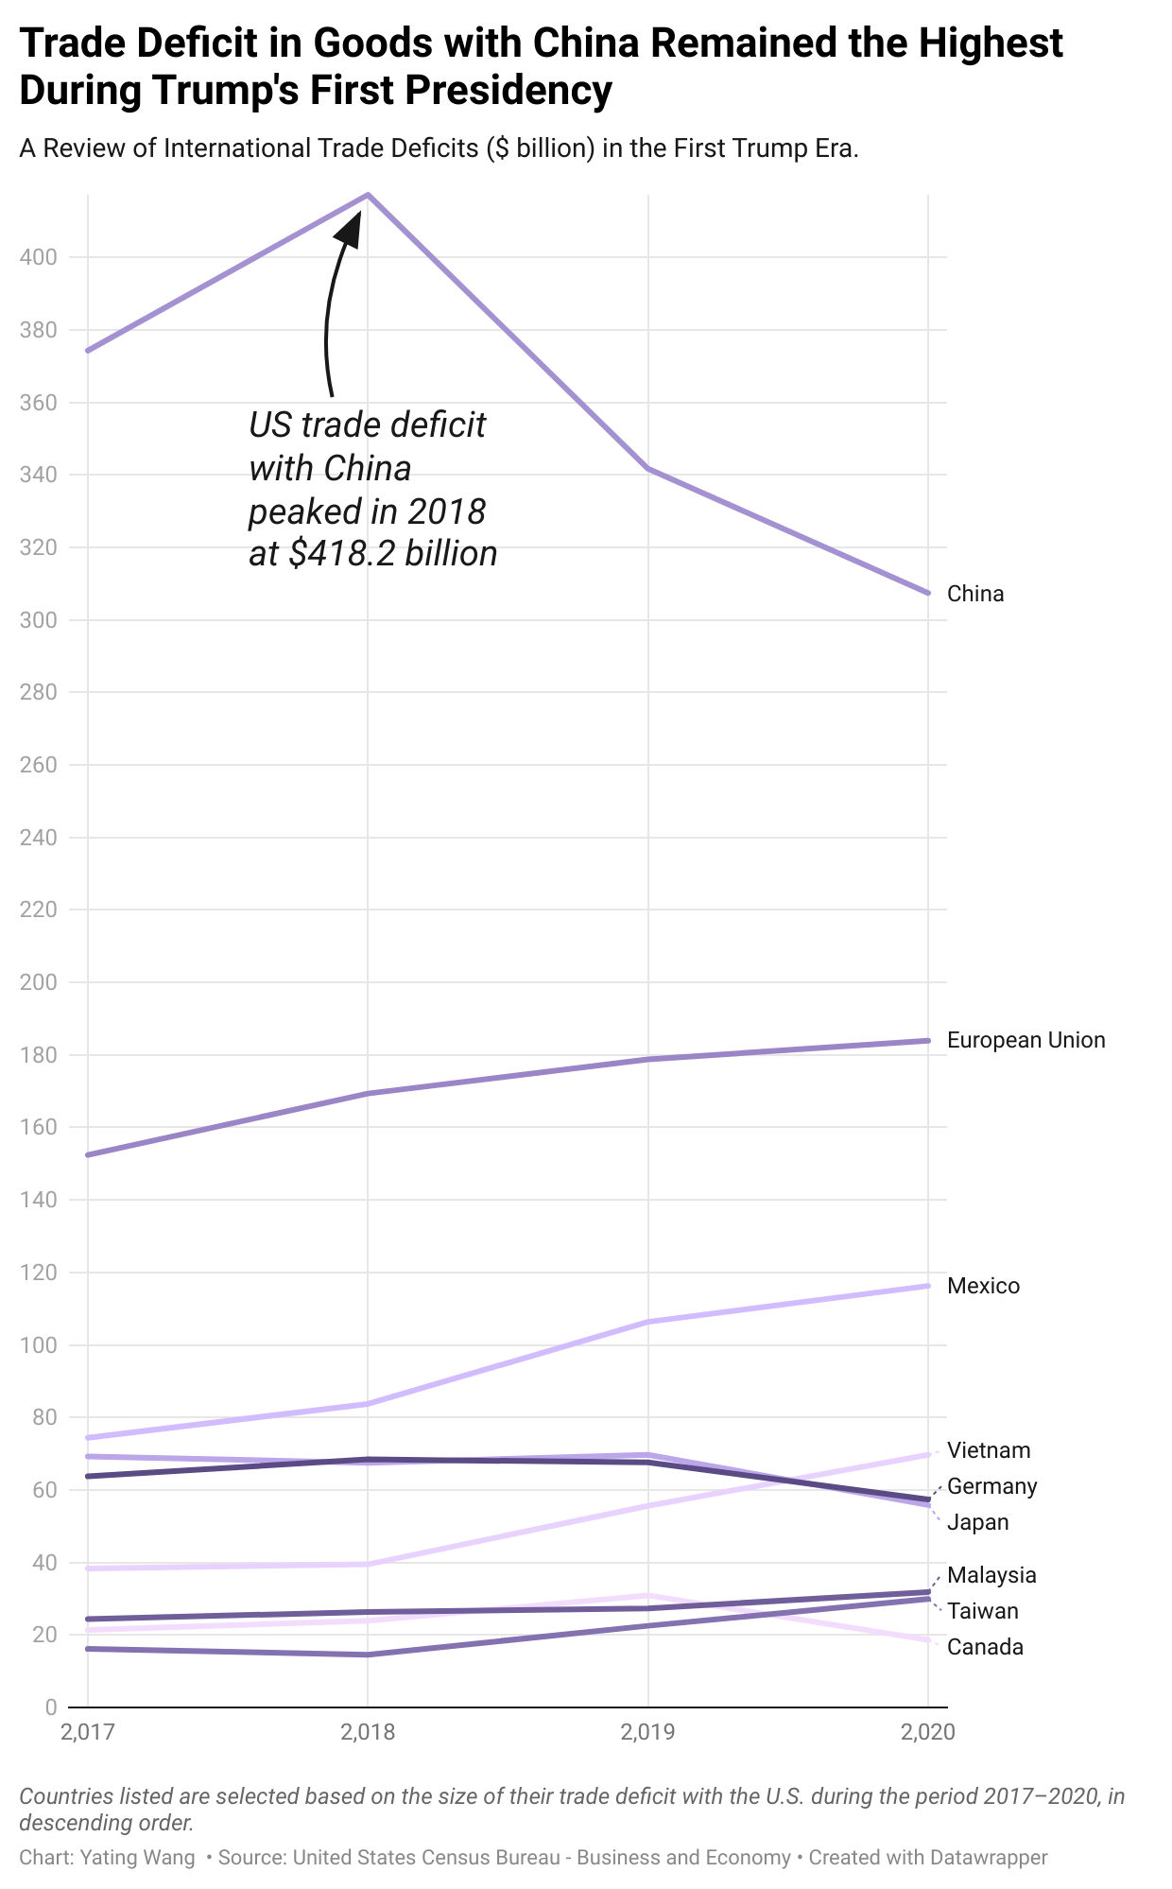
The total trade deficit also ballooned from $516.9 billions in 2017 to $653.7 billions in 2020. A figure that had not been observed since 2008.
The End of a Golden Era for Chinese Imports and E-commerce?
The imposition of these tariffs could signal the end of the golden era for Chinese imports in the U.S. market. However, the U.S.’ reliance on imported goods from China makes it difficult to sever ties completely.
In 2024, China was the largest source of U.S. imports, accounting for $439 billion in goods. A 10% tariff on this volume will translate into an additional $43.9 billion in costs.

Low-value consumer goods in the U.S. are significantly sourced from China. The amount of de minimis imports from China was roughly one-third of the $54.5 billion total de minimis imports from all countries in 2023, according to the U.S. Census Bureau’s report.
In 2024, the US market reveals a higher dependence on consumer goods manufactured in China. Over 70% of imported cookware, cutlery, and tools come from Chinese manufacturers. Similarly, China accounts for 66% of imported toys, games, and sporting goods, as well as 62% of glassware and chinaware. Even in sectors where reliance is slightly lower, such as cell phones and other household goods (57%), footwear (43%) and apparel (38%), China remains a dominant supplier. Trump’s tariffs do nothing to change the reality that American consumers—especially those in lower-income brackets—depend on these imports.
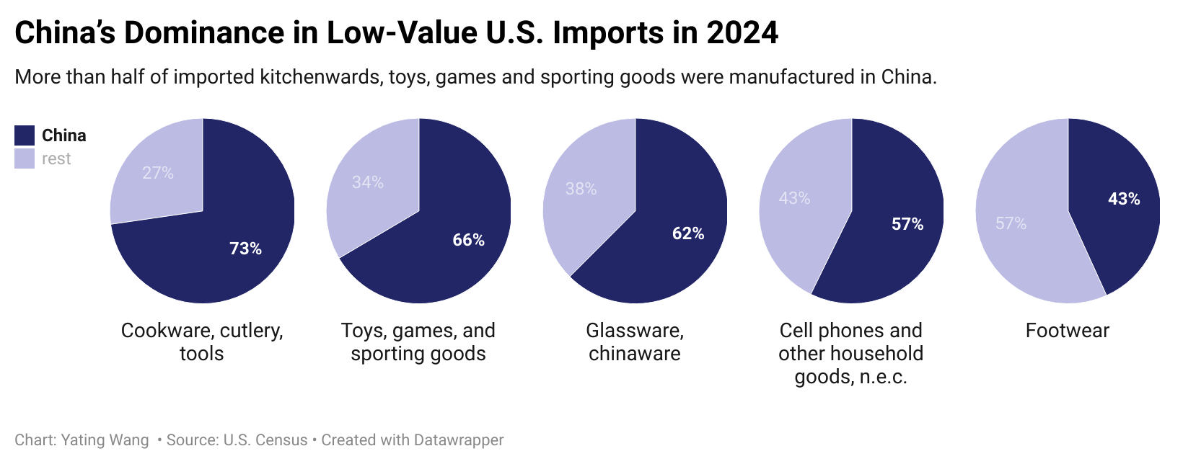
Chinese-manufactured goods don’t just fill store shelves—they increasingly dominate online marketplaces, with more than 80 percent imported for e-commerce sales.
The rise of online shopping is rapid. In the third quarter of 2024, e-commerce sales reached $300.1 billion, a 7.4% increase from the same period in 2023. Online transactions now account for 16.2% of all retail sales, the highest share in the past five years.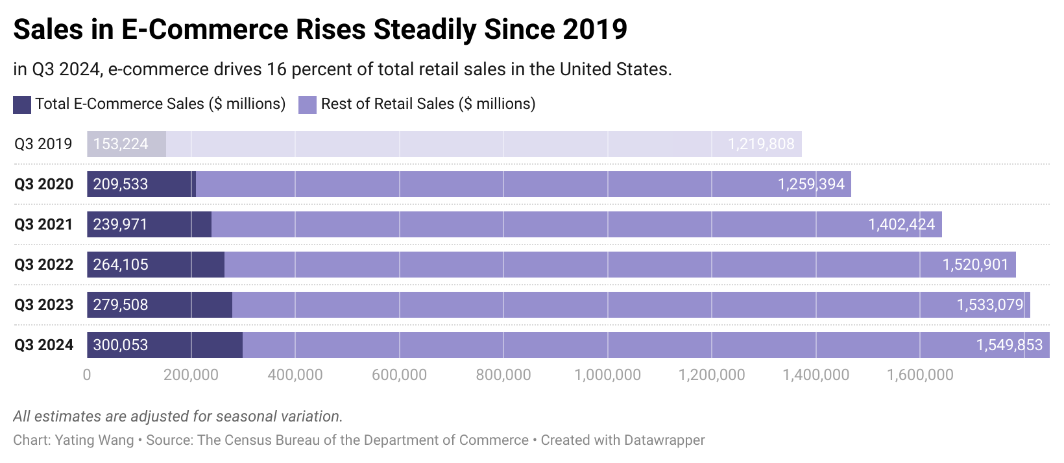
Temu, a Chinese e-commerce company that entered the U.S. market in 2022, contributed to this surge. Following Amazon’s business model, Chinese platforms have linked thousands of small Chinese factories to growing U.S. customer demand to create a cheap but more stable supply chain.
Their success hinges on startlingly low prices: storage bins for $3.28, 20 clothes hangers for $4.33, and dishcloths for just $1.08, often with free shipping. Shein, in particular, operates on a demand-driven model using real-time consumer data to adjust production, as explained by Professor John A. Deighton at Harvard Business School. By closely monitoring fashion trends on social media, Shein determines whether to reorder or discontinue items, adding thousands of new products daily.
Today, Temu and Shein are the top two most downloaded shopping apps.
Reciprocity or Retaliation?
Trump’s so-called reciprocity has, in practice, resulted in retaliation, and ordinary Americans are bearing the brunt far more than foreign adversaries. Consider the everyday low-value goods Americans rely on - from phone cases one can get rid of quickly, 6-pair of socks, a new lamp to a piece of dish cloth and your child’s favorite lego set - most of these are manufactured in China or assembled with Chinese-made components.
The reality is bleak: American consumers cannot afford to alway pay a penny more on every single product for the next four years. The sudden hike in tariff inflates the price, forcing consumers to absorb it. Unless the tariff is halted, “a loss of share in the small item market is very likely to happen if the tariff is converted into a financial pressure onto the customers,” said National Economic Advisor Lael Brainard. The price advantage of Chinese e-commerce, a major reason why Chinese e-commerce is beloved in the US, will erode.

Trump also insists that his tariffs will make room for domestic manufacturers and bring jobs back, but previous efforts in shifting manufacturing out of China have failed, as trade deficits with China remained the highest during his first presidency. Retail suppliers now are expected to look for new sourcing options in lower-cost manufacturing hubs, such as Vietnam, India, and Mexico.
Trump has vowed to "bring Fairness and Prosperity" back to the U.S. trade system, but China, instead of absorbing the cost passively, has also adapted under his wayward tax imposition.
Historically, Temu relied on direct shipping from China, taking advantage of the de minimis exemption to avoid tariffs. Now, by partnering with WINIT and Easy Export in 2024, Temu has established local warehouses closer to US customers. Instead of shipping 10 to 20 individual orders per day from China, sellers now can consolidate inventory and ship in bulk to U.S. warehouses, significantly reducing per-unit shipping costs. These moves will ultimately blunt the impact of Trump’s tariffs on Chinese exporters while leaving American consumers stuck with higher prices.
Local warehousing is not free of risks. While it offers a more stable and financially viable supply chain, it could still face regulatory scrutiny, especially if the US CBP introduces new restrictions on foreign e-commerce operations. However, the shift to domestic warehouses allows Temu to provide faster shipping speeds, which in turn drives higher sales volumes and offsets additional warehousing expenses.
As the U.S. government weighs tighter trade policies, every extra cent tacked onto an everyday purchase is another reminder that Trump’s trade policies do not serve the most. Whether these shifts will be enough to counteract potential tariffs remains to be seen, but one thing is clear: For Trump, the appearance of being “tough on China” is more important than the long-term financial burden he is imposing on millions of Americans.

