**C++ and JAVA**

[Minor Project (PR-03)]

*“Students Records Management System”*

**Submitted to: Submitted by:**

Dr. M Syamala Devi Yatin Mehndiratta

MCA (Evening)

33395

**Certification**

I hereby declare that this submission is my own work and that, to the best of my knowledge and belief, it contains no material previously published or written by other, which to a substantial extent has been accepted for the award of any other degree of any University or Institute.

**Acknowledgement**

I would like to express my special thanks of gratitude to my teacher **Dr. M Syamala Devi** who gave me the golden opportunity to do this wonderful project on the topic **Student Management System**, which also helped me in doing a lot of Research and I came to know about so many new things I am really thankful to them.

Secondly I would also like to thank my parents and friends who helped me a lot in finalizing this project within the limited time frame.

**Introduction**

The overall objective of my project is to record students’ information, delete it, modifying it, searching records and displaying. For which I have used two text files - One for recording information of BCA students (“bca.txt”) and second file for recording information of MCA students (“mca.txt”).

The record will be stored in particular file – if you will enter course name as BCA or bca, the record will automatically be stored in bca.txt file and similarly for MCA.

* Inserting a Record
* Deleting a Record
* Searching a Record
* Editing a Record
* Displaying the Records

**Language used**

C++

**Compiler used**

Code::Blocks 17.12

**Operating System used**

Microsoft Windows

**Features of C++ used:**

* Classes
* Functions
* Structures
* File Handling
* Switch Case

**Complete Code of Project:**

#include<iostream>

#include<stdlib.h>

#include<string.h>

#include<fstream>

#include<conio.h>

using namespace std;

struct student

{

char name[20];

char reg[15];

char course[10];

float cgpa;

char phone[10];

};

fstream file;

student obj;

//-------------------------------------------------start of class------------------------------------------------------

class studentrec

{

public:

void add()

{

cout<<"\n Enter Name: ";

cin>>obj.name;

cout<<"\n Enter Registration Number: ";

cin>>obj.reg;

cout<<"\n Enter Course: ";

cin>>obj.course;

cout<<"\n Enter CGPA: ";

cin>>obj.cgpa;

cout<<"\n Enter Phone Number: ";

cin>>obj.phone;

if(strcmp(obj.course,"bca")==0 || strcmp(obj.course,"BCA")==0)

{

file.open("bca.txt",ios::app);

}

else if(strcmp(obj.course,"mca")==0 || strcmp(obj.course,"MCA")==0)

{

file.open("mca.txt",ios::app);

}

file.write((char*)&obj,sizeof(obj));

file.close();

}

//-----------------------------------------------------------------------------------------------------

void show_all()

{

system("cls");

char filetoopen[10];

cout<<"Which file you would like to open, BCA or MCA ? ";

cin>>filetoopen;

if(strcmp(filetoopen,"bca")==0 || strcmp(filetoopen,"BCA")==0)

{

file.open("bca.txt",ios::in);

}

else if(strcmp(filetoopen,"mca")==0 || strcmp(filetoopen,"MCA")==0)

{

file.open("mca.txt",ios::in);

}

file.read((char*)&obj,sizeof(obj));

while (file.eof()==0)

{

cout<<"Name: "<<obj.name<<endl;

cout<<"Registration Number: "<<obj.reg<<endl;

cout<<"Course: "<<obj.course<<endl;

cout<<"CGPA: "<<obj.cgpa<<endl;

cout<<"Phone: "<<obj.phone<<endl<<endl;

file.read((char*)&obj,sizeof(obj));

}

file.close();

}

//------------------------------------------------------------------------------------------------------

void search()

{ system("cls");

char filetosearchin[10];

cout<<"In which file would you like to Search in, BCA or MCA ? ";

cin>>filetosearchin;

if(strcmp(filetosearchin,"bca")==0 || strcmp(filetosearchin,"BCA")==0)

{

file.open("bca.txt",ios::in);

}

else if(strcmp(filetosearchin,"mca")==0 || strcmp(filetosearchin,"MCA")==0)

{

file.open("mca.txt",ios::in);

}

char regno[20];

cout<<"\n Enter Registration Number: ";

cin>>regno;

// file.open("bca.txt",ios::in);

file.read((char*)&obj,sizeof(obj));

while (file.eof()==0)

{

if (strcmp(obj.reg,regno)==0)

{

cout<<"\nName: "<<obj.name<<endl;

cout<<"Registration Number: "<<obj.reg<<endl;

cout<<"Course: "<<obj.course<<endl;

cout<<"CGPA: "<<obj.cgpa<<endl;

cout<<"Phone: "<<obj.phone<<endl;

}

file.read((char*)&obj,sizeof(obj));

}

file.close();

}

//-------------------------------------------------------------------------------------------------

void edit()

{

system("cls");

char regno[15];

cout<<"Enter Registration Number: ";

cin>>regno;

char filetoeditin[10];

cout<<"in which file you would like to edit record in, bca or mca ? "<<endl;

cin>>filetoeditin;

if(strcmp(filetoeditin,"bca")==0 || strcmp(filetoeditin,"BCA")==0)

{

file.open("bca.txt",ios::in|ios::out);

}

else if(strcmp(filetoeditin,"mca")==0 || strcmp(filetoeditin,"MCA")==0)

{

file.open("mca.txt",ios::in|ios::out);

}

//file.open("bca.txt",ios::in|ios::out);

file.read((char*)&obj,sizeof(obj));

while (file.eof()==0)

{

if (strcmp(obj.reg,regno)==0)

{

cout<<"Name: "<<obj.name<<endl;

cout<<"Registration Number: "<<obj.reg<<endl;

cout<<"Course: "<<obj.course<<endl;

cout<<"CGPA: "<<obj.cgpa<<endl;

cout<<"Phone: "<<obj.phone<<endl;

cout<<"\nEnter New Phone Number: ";

cin>>obj.phone;

file.seekp(file.tellg()-sizeof(obj)); // move one record backward from current position

file.write((char*)&obj,sizeof(obj));

cout<<"\n\n------------------ File Updated ------------------\n\n";

break;

}

file.read((char*)&obj,sizeof(obj));

}

file.close();

}

//--------------------------------------------------------------------------------------------------------

void deleterecord()

{

char regnumber[50],another;

ifstream fp;

ofstream ft;

system("cls");

char filetodeletefrom[10];

cout<<"in which file you would like to delete record from, bca or mca ? "<<endl;

cin>>filetodeletefrom;

if(strcmp(filetodeletefrom,"bca")==0 || strcmp(filetodeletefrom,"BCA")==0)

{

fp.open("bca.txt",ios::in);

another = 'Y';

while (another == 'Y'|| another == 'y')

{

cout << "\n Enter the registration number of the student to delete its record: ";

cin >> regnumber;

ft.open("temp.txt",ios::out);

fp.seekg(0,ios::beg);

while(fp.read((char*)&obj,sizeof(obj)))

{

if (strcmp(obj.reg,regnumber) != 0)

ft.write((char*)&obj,sizeof(obj));

}

fp.close();

ft.close();

remove("bca.txt");

rename("temp.txt","bca.txt");

cout<<"\n\n---- Student with Registration Number " << regnumber <<" is Deleted Successfully ----\n\n";

cout << "\n Delete Another Record (Y/N) ";

fflush(stdin);

another = getchar();

}

}

else if(strcmp(filetodeletefrom,"mca")==0 || strcmp(filetodeletefrom,"MCA")==0)

{

fp.open("mca.txt",ios::in);

another = 'Y';

while (another == 'Y'|| another == 'y')

{

cout << "\n Enter the registration no. of the student to delete his/her record: ";

cin >> regnumber;

ft.open("temp.txt",ios::out);

fp.seekg(0,ios::beg);

while(fp.read((char*)&obj,sizeof(obj)))

{

if (strcmp(obj.reg,regnumber) != 0)

ft.write((char*)&obj,sizeof(obj));

}

fp.close();

ft.close();

remove("mca.txt");

rename("temp.txt","mca.txt");

cout<<"\n\n------------ Student with Registration Number " << regnumber <<" is Deleted Successfully ------------\n\n";

cout << "\n Delete Another Record (Y/N) ";

fflush(stdin);

another = getchar();

}

}

// fp.open("bca.txt",ios::in); //opened the file in read mode from which data which we need is to be copied

}

};

//----------------------------------------------end of class-----------------------------------------

int main()

{

int option;

studentrec sturec;

cout<<"\n\n\n ******************************* ";

cout<<"\n\n STUDENT MANAGEMENT SYSTEM \n\n";

cout<<" ******************************* ";

cout<<"\n\n\n\n\n Project by Yatin Mehndiratta ";

cout<<"\n\n\n\n\n\n\n Press Any Key to Enter the Project";

getch();

system("cls");

while(1)

{

cout<<"\n 1. Insert Record";

cout<<"\n 2. Display Records";

cout<<"\n 3. Search Records";

cout<<"\n 4. Edit Phone Number";

cout<<"\n 5. Delete Record";

cout<<"\n 6. Exit";

cout<<"\n\n Enter a Choice (1-6) ";

cin>>option;

switch(option)

{

case 1: sturec.add();

cout<<"\n\n-------- Record Entered Successfully --------\n\n";

break;

case 2: sturec.show_all();

break;

case 3: sturec.search();

break;

case 4: sturec.edit();

break;

case 5: sturec.deleterecord();

break;

case 6: exit(0);

}

}

}

**Output Screens:**

Main Screen

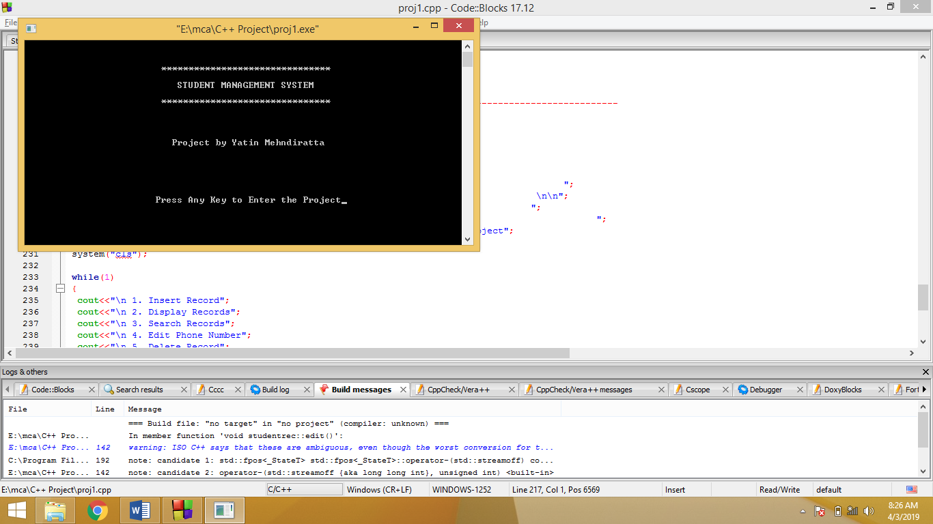

Make a Choice Screen

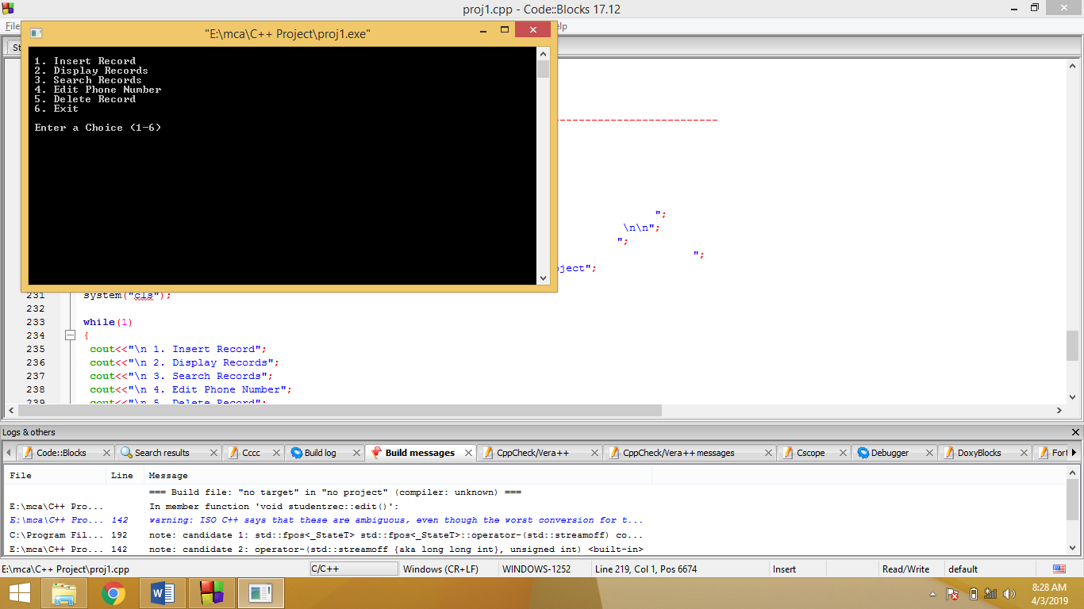

Inserting a Record Screen

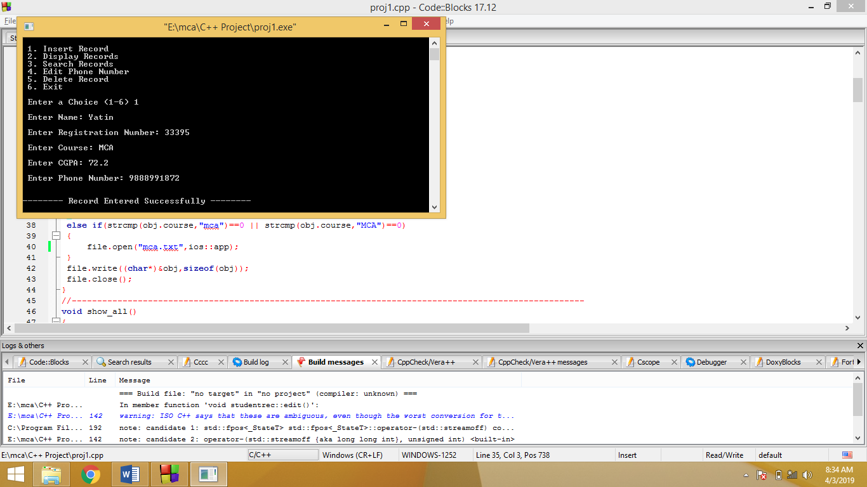

Displaying Records: Screen 1

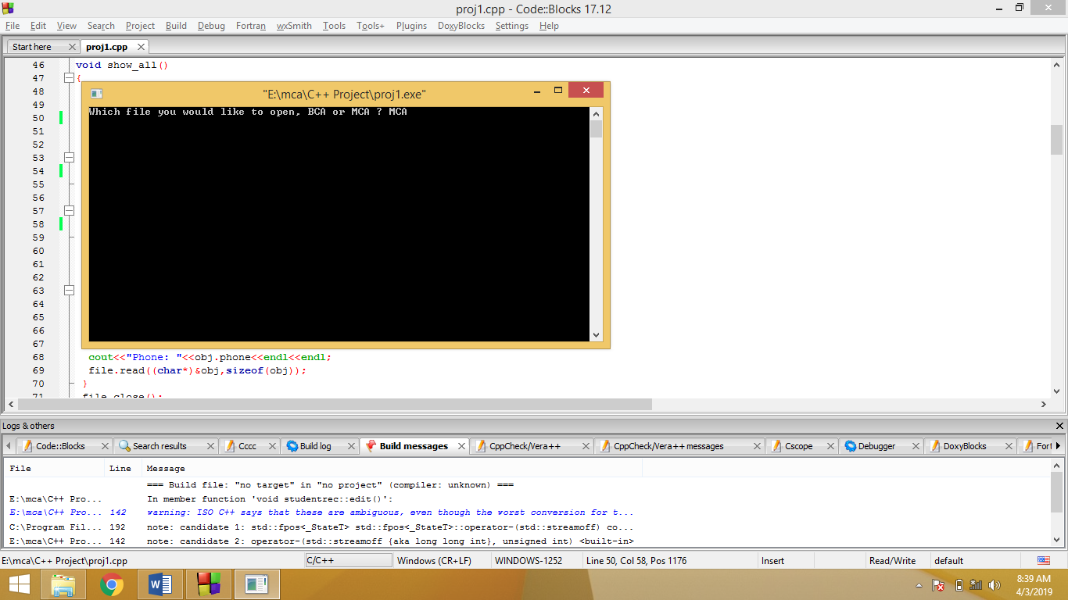

Screen 2

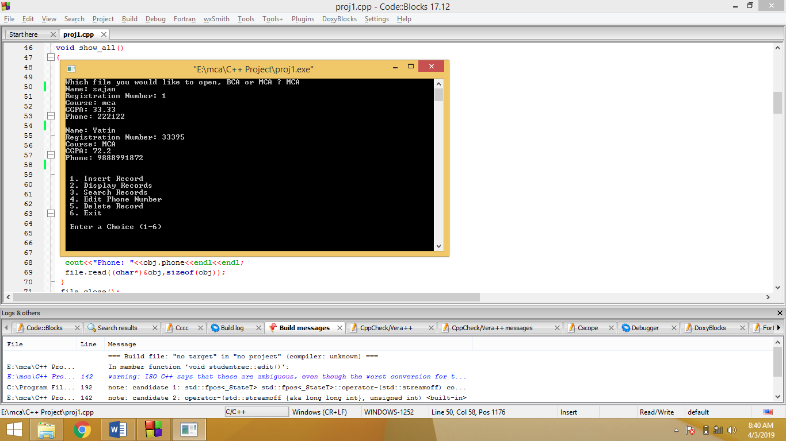

Searching Records Screen

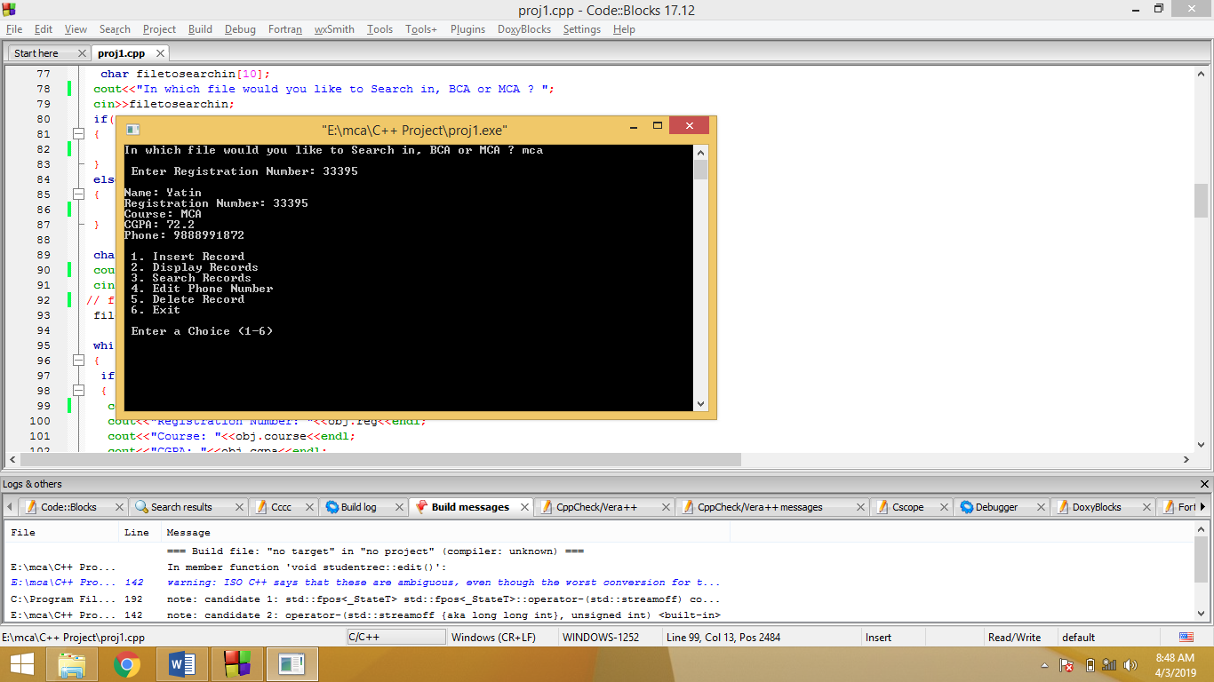

Editing Records Screen

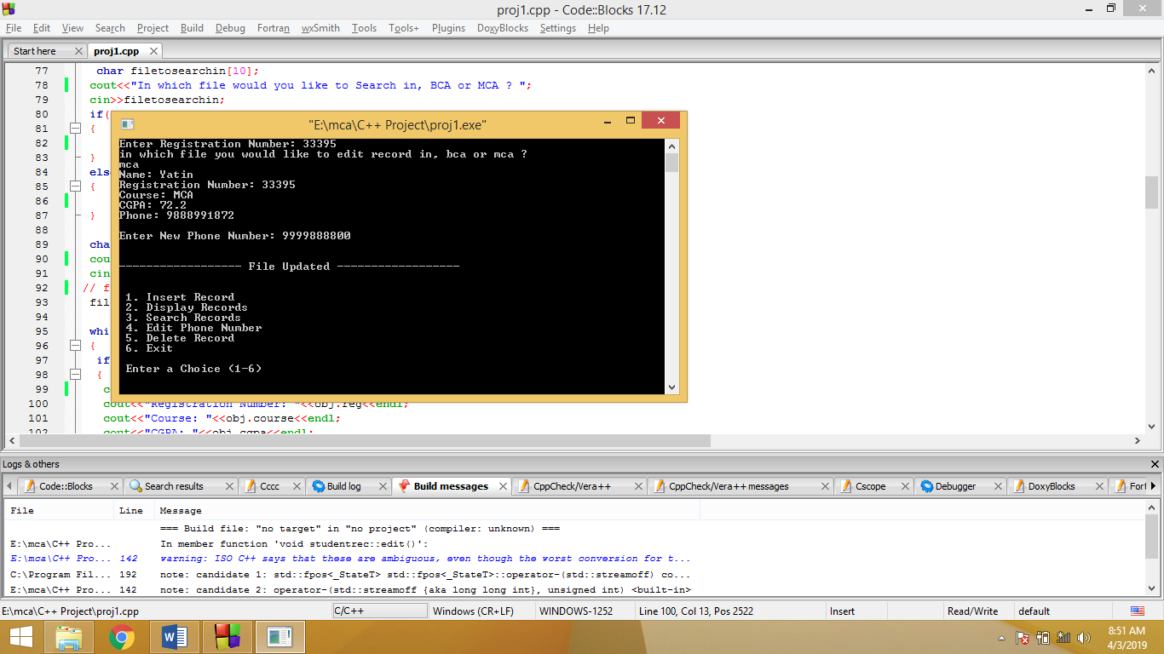

Deleting a Record Screen

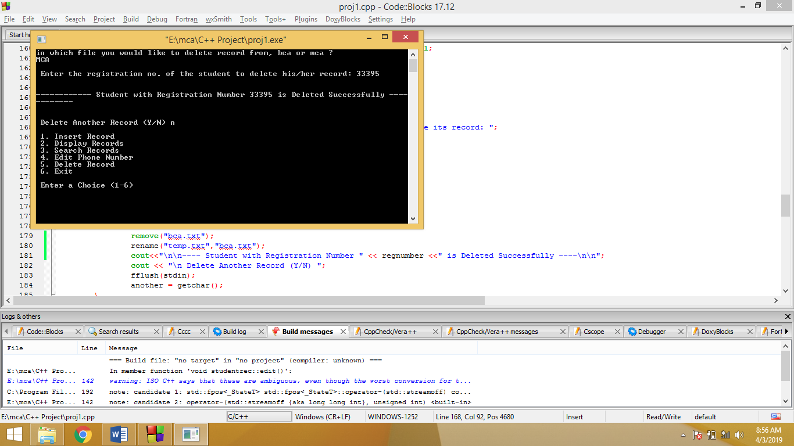

**Scope of Improvement:**

* Searching can be done using other primary keys like Roll Number.
* Searching could be made possible using Students’ Marks, other Details etc.
* Editing Phone Number is one thing, you can also edit other Student’s info too.
* Deletion of Records can be based on any primary key, like in my case, is based on Registration Number, else all the record with similar data will be deleted at once.