Name : Yatin Nargotra

Roll no: 32491

Class : TE 8

Batch : N8

Dept roll no: 76

Write an asembly level program to transfer block of ten memory location to the given other location

1.transfer memory block starting from 20H to memory starting from 40H

2.transfer memory block starting from 20H to memory starting from 25H

------------------------------------------------------------------------------------------------------------------------------------------------------------------------------------------------------------------------------------------------------------------------------------

Code for 1st part

ORG 00H

MOV R2,#0AH

MOV R0,#20H

MOV R1,#40H

lbl: MOV A,@R0

MOV @R1,A

INC R0

INC R1

DJNZ R2,lbl

END

------------------------------------------------------------------------------------------------------------------------------------------

Output

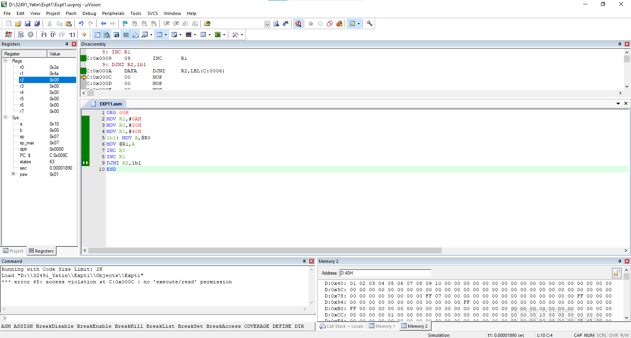

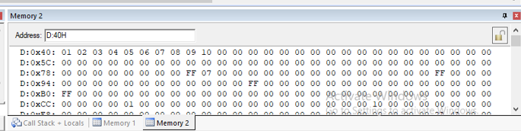

Code for 2nd Part

ORG 00H

MOV R2,#0AH

MOV R0,#29H

MOV R1,#2EH

lbl: MOV A,@R0

MOV @R1,A

DEC R0

DEC R1

DJNZ R2,lbl

END

------------------------------------------------------------------------------------------------------------------------------------------

Output