A. KPI’s

1. Total Revenue of sales.  
     
   Query  
   select sum(total_price) as Total_Revenue from Pizza_Sales;  
     
   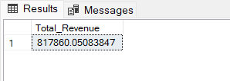
2. Average order value.  
     
   Query  
   select (sum(total_price) / count(distinct(order_id))) as Avg_order_id from Pizza_sales;  
   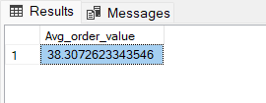
3. Total Pizza Sold.  
     
   Query  
   select sum(quantity) as Total_Pizza_sold from Pizza_Sales;  
     
   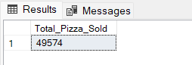
4. Total order pizza sales

Query  
select count(distinct order_id) as Total_orders from Pizza_Sales;  
  
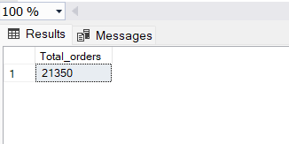

1. Average Pizza per Order.  
     
   Query  
   select cast(cast(sum(quantity) as decimal(10,2)) / cast(count(distinct order_id) as decimal(10,2)) as decimal(10,2)) from Pizza_Sales;  
     
   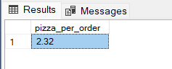
2. Daily Trends for Total Order.

Query  
select datename(dw, order_date), count(distinct order_id) as total_order from Pizza_Sales group by datename(dw, order_date) order by total_order desc;  
  
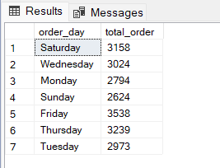

1. Monthly Trends for Total Order.  
     
   Query  
   select datename(month, order_date) as order_by_month, count(distinct order_id) as total_order from Pizza_Sales group by datename(month, order_date) order by total_order desc;  
     
   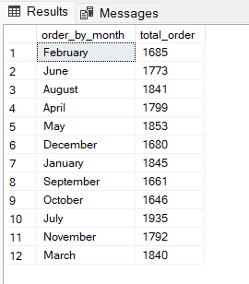
2. % of sales by pizza category.  
     
   Query  
   Select pizza_category, sum(total_price) * 100 / (select sum(total_price) from Pizza_Sales where month(order_date) = 1) as PCT  
   from Pizza_Sales  
   where month(order_date) = 1  
   group by pizza_category ;  
     
   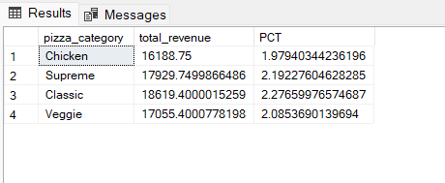
3. % of sales by pizza size.  
     
   Query  
   select pizza_size, cast(sum(total_price) as decimal (10,2)) as total_revenue, cast(sum(total_price) * 100 / (select sum(total_price) from Pizza_Sales) as decimal(10,2)) As PCT   
   from Pizza_Sales  
   group by Pizza_Size  
   order by Pizza_Size;  
     
   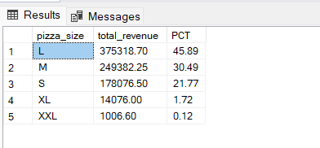
4. Total pizza sold by pizza category.  
     
   Query  
   select pizza_category, sum(quantity) as Total_qty_sold  
   from pizza_sales  
   group by pizza_category  
   order by Total_qty_sold desc;  
     
   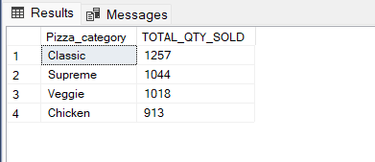
5. Top 5 Pizza By Revenue.  
     
   Query  
   select top 5 pizza_name, sum(total_price) as total_revenue  
   from pizza_sales  
   group by pizza_name  
   order by total_revenue desc;  
     
   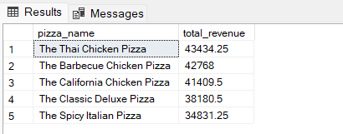
6. Bottom 5 pizza revenue.  
     
   Query  
   select pizza_name, sum(total_price) as total_revenue  
   from pizza_sales  
   group by pizza_name  
   order by total_revenue asc;  
     
   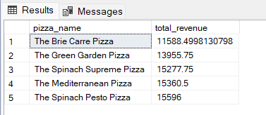
7. Top 5 Pizza By Quantity.  
     
   Query  
   select pizza_name, sum(quantity)as total_pizza_sold  
   from pizza_sales  
   group by pizza_name  
   order by total_pizza_solds desc;  
     
   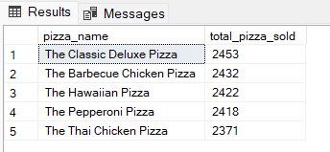
8. Bottom 5 Pizza By Quantity.  
     
   Query  
   select pizza_name, sum(quantity)as total_pizza_sold  
   from pizza_sales  
   group by pizza_name  
   order by total_pizza_solds Asc;  
     
   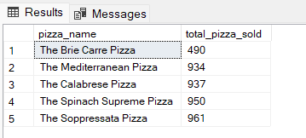
9. Top 5 pizza by total orders.  
     
   Query  
   select top 5 pizza_name, count(distinct order_id) as total_order from pizza_sales  
   group by pizza_name  
   order by total_order desc;

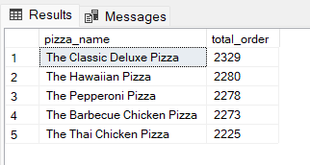

Bottom 5 pizza by total orders.  
  
Query  
select top 5 pizza_name, count(distinct order_id) as total_order from pizza_sales  
group by pizza_name  
order by total_order Asc;

