PROJECT DOCUMENTATION
Attendance
Management System
System overview | Architecture | Data model | API reference
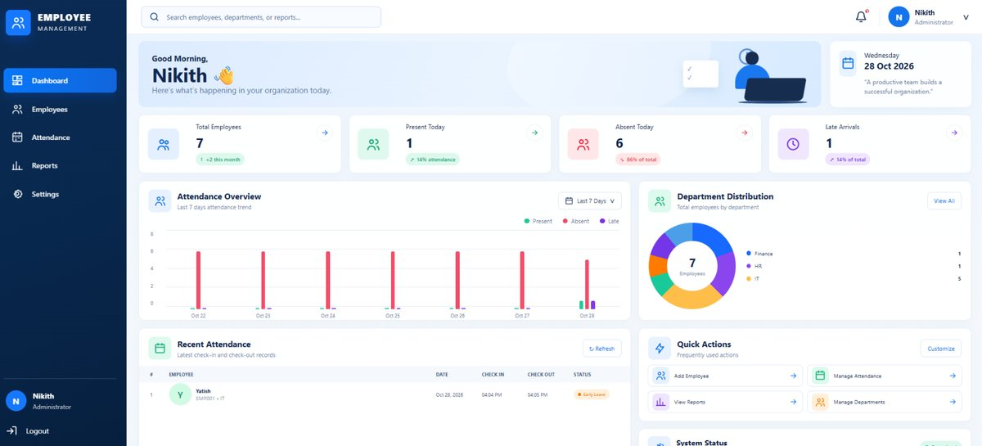
Administrator workspace — representative project screenshot.
DOCUMENT | PROJECT | SNAPSHOT
Technical project documentation | Attendance Management System (AMS) | 28 October 2026

PUBLIC PROJECT REPOSITORY
github.com/yatish-17/AttendanceManagementSystem

1. Project overview
The Attendance Management System is a browser-based application for maintaining employee attendance records and providing role-specific views for administrators and employees. A React single-page application communicates with a Node.js/Express REST API, which reads and updates an AttendanceDB relational database in Microsoft SQL Server.
The product brings daily attendance operations, employee administration, history, and reporting into one workspace. Administrators see organization-level information; employees see their own attendance and profile information.

Product objectives
- Provide employee-code/password sign-in and direct each account to the correct role-specific workspace.
- Record daily check-in and check-out timestamps and show the resulting attendance status.
- Give administrators workforce, attendance, department, and report views.
- Allow authorized administrators to maintain employee records and account activation status.
- Allow employees to review personal attendance history and profile information.

User roles
Role | Responsibilities | Product areas
Administrator (Admin) | Oversees employee records and organization attendance; reviews summaries and reports. | Dashboard, employees, attendance, reports, settings placeholder.
Employee | Records personal check-in/out and reviews personal attendance. | Dashboard, My Attendance, profile.

Product scope
The current implementation includes authentication, role-aware navigation and API authorization, department-linked employee administration, daily attendance, filterable history, aggregate dashboard/report views, and CSV export. It is configured as a local Windows application using SQL Server on localhost; hosted, multi-tenant, and mobile deployments are outside the inspected scope.

2. Administrator experience
The administrator interface is the operational control area for workforce attendance. Its dashboard combines employee and attendance metrics, a recent-activity view, a short trend, and department distribution. Supporting screens maintain employee accounts, review attendance, and generate reports.
Figure 1. Administrator dashboard.
Screen | Purpose
Dashboard | Headline attendance totals, weekly trend, department mix, and recent activity.
Employees | Search/filter employees; create/update records; disable or reactivate accounts.
Attendance | Filter records by date, employee, department, and status; record, employee, calendar, and summary views; CSV export.
Reports | Detailed, department, employee, and monthly views; date filters, report export, and local export history.
Settings | Displays planned organization settings; configuration controls are placeholders, not implemented operations.

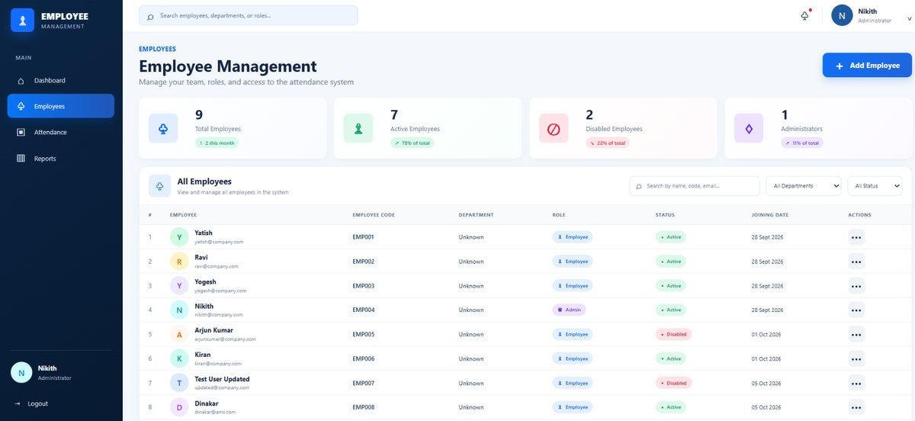  Figure 2. Employee management | 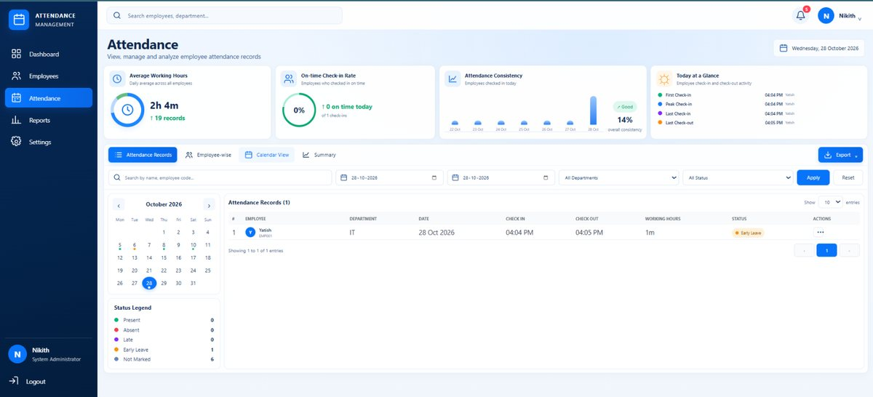  Figure 3. Attendance management
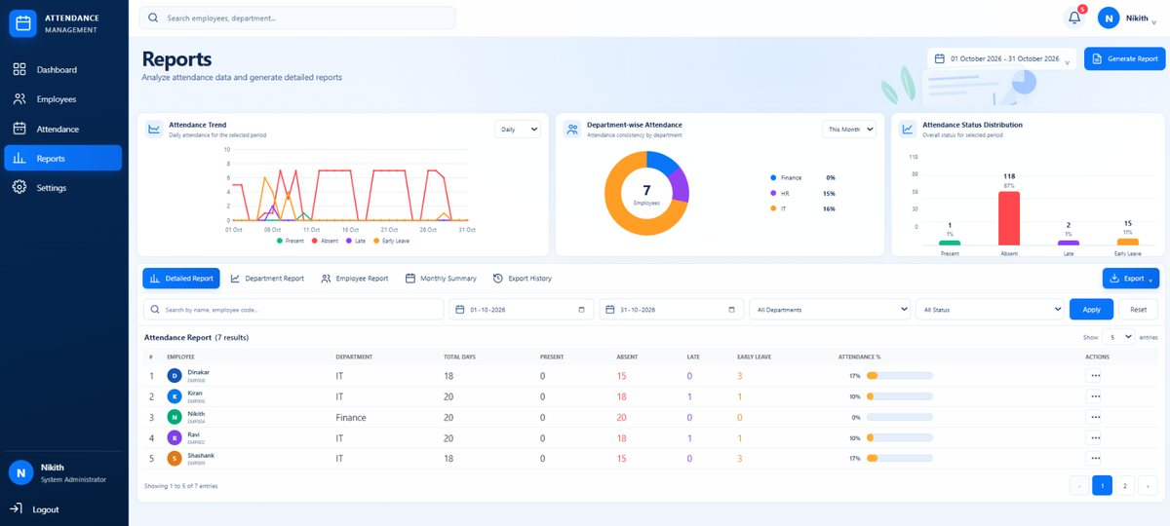
Figure 4. Attendance reports

3. Employee experience
The employee area is self-service. Its dashboard summarizes today's attendance and recent records; attendance history provides personal date/status filters; the profile displays account information returned during login.
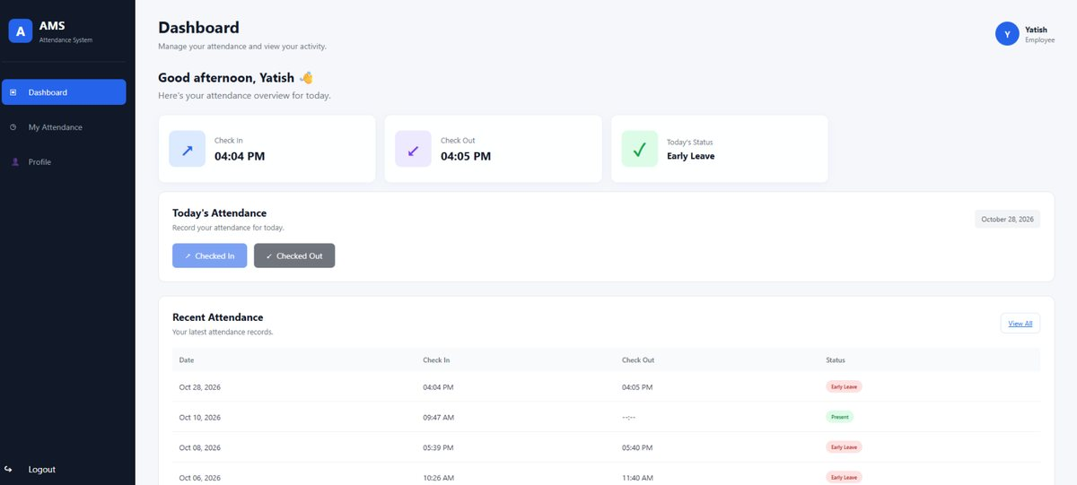
Figure 5. Employee dashboard.
Screen | Displayed information
Dashboard | Today's check-in/out and status, recent history, and check-in/out actions when available.
My Attendance | Signed-in employee's records with date and status filters.
Profile | Employee code, name, email, role, account status, and employee identifier from the session profile.

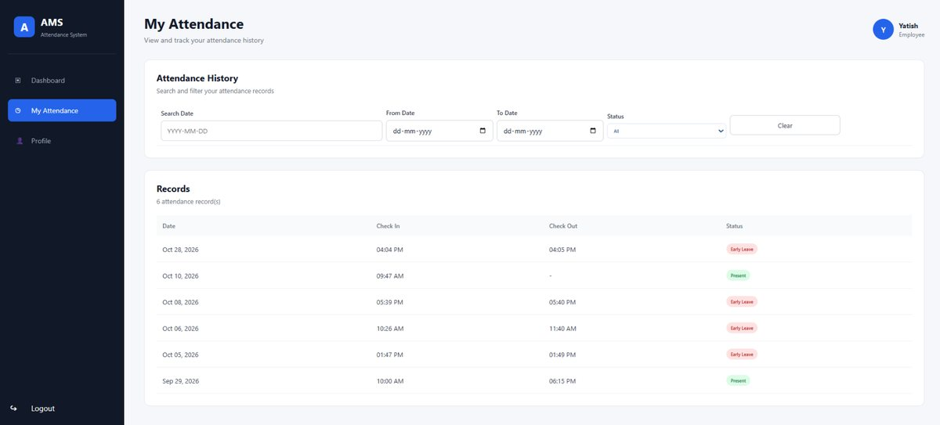  Figure 6. My Attendance | 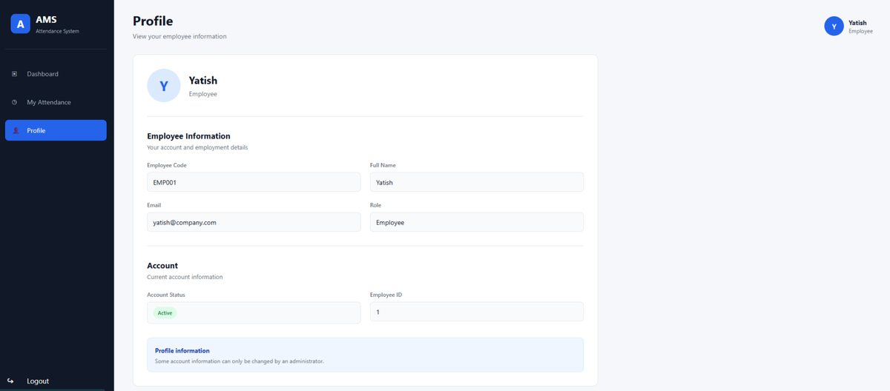  Figure 7. Employee profile

4. Technical architecture
The solution is organized into three application tiers plus the user's browser. The browser renders the React interface; the Express API owns authentication, access checks, and server-side attendance operations; SQL Server persists department, employee, and attendance data.
BROWSER | REACT SPA | EXPRESS REST API | SQL SERVER
Admin and employee users | React 19; React Router 7; Vite | Node.js; Express 5; JWT and role middleware | AttendanceDB; departments, employees, attendance

Primary flow: browser interface -> JSON API over HTTP -> parameterized SQL operations through mssql/msnodesqlv8 -> SQL Server. The frontend's API client uses http://localhost:5000/api.
Layer | Responsibilities
Presentation | Login and role-specific pages; filters and report presentation; sends HTTP requests to the API.
API | REST routes, JWT verification, role authorization, employee/attendance operations, dashboard response assembly.
Persistence | SQL Server relational storage; foreign keys, unique constraints, and attendance-date index.

Codebase boundaries
Location | Purpose
frontend/src/pages/ | Administrator and employee screens.
frontend/src/services/api.js | Shared API request functions.
frontend/src/components/ProtectedRoute.jsx | Client-side route gate based on locally stored role.
backend/src/routes/ | HTTP routes and per-route middleware.
backend/src/controllers/ | Business operations and SQL query execution.
backend/src/middleware/ | JWT authentication and role checks.
backend/src/config/db.js | SQL Server driver and connection configuration.
database/01_create_tables.sql | Initial database/table/index definitions.

5. Data model
Three relational tables support the primary workflow. Department assignment is optional. Attendance belongs to one employee and is unique per employee per calendar date.
Table | Key fields | Constraints / relationship
Departments | Department_id (PK); Department_name | Unique department name; referenced by Employees.
Employees | Employee_id; Employee_code; Name; Email; Role; Department_id; Joining_Date; Password_hash; Is_Active | Unique code/email; role is Admin or Employee; optional department FK.
Attendance | Attendance_id; Employee_id (FK); Attendance_Date; In_time; Out_time; Status | One row per employee/date; optional check-out; indexed by attendance date.

Relationship summary
- Departments 1 -> 0..many Employees. Employees may have no department.
- Employees 1 -> 0..many Attendance records; the database allows at most one row per employee/date.
- Password_hash stores a bcrypt hash, not a plaintext password. Account status is represented by Is_Active.
- Absence is derived from no attendance row for an active employee whose joining date is on/before the selected date; there is no separate Absence table.

Attendance and reporting semantics
Rule | Current behavior
On-time / late arrival | Check-in after 10:00 is marked Late; exactly 10:00 is not late.
Early departure | Check-out before 18:00 changes the record status to Early Leave.
Duplicate daily attendance | The API checks for an existing row; a database unique constraint also enforces employee/date uniqueness.
Report eligibility | Report totals use active employees and weekdays in the selected period, starting no earlier than the joining date.
Time source | The Node.js process's local clock determines dates and times for check-in/out.

Schema note
The supplied SQL is a fresh-install baseline. Existing databases and seed data should be reviewed separately before applying schema changes.

6. Core application workflows

Authentication and role selection
- The user submits an employee code and password to POST /api/auth/login.
- The API loads the employee, rejects invalid or disabled accounts, and compares the password with its bcrypt hash.
- On success, the API issues a JWT valid for one hour and returns the employee's profile fields.
- The browser stores the token and profile in localStorage and directs the user to the Admin or Employee route set.
- Protected API routes validate the Bearer token; administrator operations also require the Admin role.

Daily attendance
- An authenticated employee requests check-in; the API verifies the account is active and no attendance row exists for the server's local date.
- The API records the check-in and applies the on-time/late threshold; a database constraint protects daily uniqueness.
- Check-out requires a same-day check-in and may be saved only once. A checkout before 18:00 applies the early-departure rule.
- The employee interface refreshes its attendance list and shows the saved record/status.

API surface
Base path: http://localhost:5000/api. Authenticated requests use Authorization: Bearer <JWT>. Admin-only routes additionally enforce the Admin role.
Method / route | Access | Purpose
POST /auth/login | Public | Authenticate employee and issue JWT/profile.
GET /attendance | Signed in | Read attendance; employees are scoped to their records; optional search, date, and status filters.
POST /attendance/check-in | Signed in | Record today's check-in.
POST /attendance/check-out | Signed in | Record today's check-out.
GET /attendance/absent?date=... | Admin | List active eligible employees with no record on a required date.
GET /attendance/late?date=... | Admin | List active employees checked in after 10:00.
GET /attendance/early-leave?date=... | Admin | List active employees checked out before 18:00.
GET /dashboard?date=...&search=... | Admin | Return summaries, attendance rows, seven-day trend, and recent activity.

7. Administrative API and security model
Method / route | Access | Purpose
GET /employees | Admin | List employee records.
GET /employees/departments | Admin | List departments.
POST /employees | Admin | Create employee; server hashes submitted password.
PUT /employees/:id | Admin | Update employee attributes; optional password is hashed.
PATCH /employees/:id/disable | Admin | Deactivate employee account.
PATCH /employees/:id/reactivate | Admin | Reactivate employee account.
GET /health | Public | Basic API process health response.

Implemented protections
- bcryptjs password hashing/comparison.
- Signed one-hour JWT bearer tokens; signing secret is loaded from backend/.env.
- Role checks on administrator-only employee, dashboard, and attendance-summary endpoints.
- Employee attendance retrieval is scoped to the authenticated employee in the API controller.
- Parameterized SQL request inputs are used for several filters/attendance operations; employee CRUD uses tagged parameterized SQL queries.
- Git ignore rules exclude local .env files, generated frontend output, and dependency directories.

Operational security considerations
The current build is a local-development application rather than a hardened hosted service. Before public deployment, configure HTTPS, restrict CORS to approved front-end origins, protect and rotate the JWT secret, review token storage and expiry, validate incoming fields, configure production database credentials/permissions, and provide database-aware startup/readiness checks. The present connection targets local SQL Server using Windows Integrated Authentication; production connection configuration is not yet externalized.
Credential handling
The repository includes a placeholder environment template. Do not publish backend/.env, employee passwords, production secrets, database exports, or unredacted operational records.

8. Reporting and runtime profile
Administrator summaries and reports combine API data with client-side calculation for interactive charts, filters, and exports. The employee portal uses its own attendance endpoint so personal history remains scoped at the API boundary.
Area | Reporting behavior
Administrator dashboard | Date-based totals, attendance overview, department distribution, recent activity, and a seven-day present/late/absent trend.
Attendance workspace | Employee/search, date, department, and status filters; record/employee/calendar/summary views; filtered CSV export.
Reports | Detailed, department, employee, and monthly summaries; date filters, export, and local export history.
Employee dashboard | Today's check-in/out and status with recent attendance.
Employee history | Personal records with date/status filtering.

Current runtime configuration
Concern | Observed configuration
Frontend | React/Vite single-page application; API origin hard-coded as http://localhost:5000/api.
Backend | Express API listens on port 5000; /api/health is unauthenticated.
Database | SQL Server database AttendanceDB; localhost and Windows trusted connection; ODBC Driver 18.
Tooling | Node.js/npm with separate frontend and backend manifests/lockfiles.
Secrets/config | JWT secret loaded from backend/.env; SQL connection configuration is fixed in backend/src/config/db.js.

Known scope and implementation constraints
- Administrator Settings is a placeholder for future organization settings.
- There is no refresh-token flow; a JWT expires after one hour.
- Profile is read from the client-side login profile; there is no separate profile API endpoint in the current routes.
- CORS is permissive, and the server starts without awaiting a successful database connection; production readiness checks require further work.
- Automated backend tests are not included. The production frontend build passed during release preparation; the current frontend lint command reports existing issues in five screen components.

9. Maintenance and extension points

Maintainability structure
HTTP routes compose controllers with access middleware. Controllers encapsulate query and business operations; the frontend centralizes API calls in its API service. Separate JSX/CSS modules keep each page's interface and styling together, while the initial database schema remains independent of application code.

Recommended extension points
- Externalize API origin, backend port, SQL Server connection details, and permitted CORS origins.
- Introduce database migrations and repeatable, sanitized development-data fixtures.
- Add automated API/UI tests for role boundaries, attendance edge cases, time/date handling, and report calculations.
- Complete administrator settings for departments, work schedules, and organization preferences.
- Add pagination and server-side report aggregation as dataset sizes grow.

Project file map
Path | Description
frontend/src/App.jsx | Route map for login and role-specific views.
frontend/src/pages/ | Dashboards, attendance, employee management, reports, profile.
frontend/src/services/api.js | Shared frontend API helpers.
backend/src/server.js | Express app initialization, API mounting, and port binding.
backend/src/controllers/ | Authentication, attendance, dashboard, and employee handlers.
backend/src/middleware/ | Bearer-token validation and role authorization.
backend/src/config/db.js | SQL Server driver and connection helper.
database/01_create_tables.sql | Fresh-install SQL Server schema.
docs/screenshots/ | Optimized administrator and employee screenshots.

Glossary
Term | Meaning
Attendance record | One employee's entry for one day, including times and status.
JWT | Signed bearer token identifying the authenticated employee and role.
RBAC | Role-based access control using Admin or Employee roles.
Absence | Derived result when an eligible active employee has no record for the selected date.

Document basis
Prepared from the source repository and SQL schema on 28 October 2026. This document describes the inspected implementation snapshot; planned functions, deployment capabilities, and external integrations are not implied to be available.

