SEPM EXP 4

TO UNDERSTAND CONTINUOUS INTEGRATION, INSTALL AND CONFIGURE JENKINS WITH MAVEN / ANT / GRADLE TO SETUP A BUILD JOB

Yatish Shah

T21-91

AI&DS

Theory:

1. Introduction to Continuous Integration (CI)

Continuous Integration (CI) is a software development practice where developers frequently integrate code changes into a shared repository. Each integration is automatically verified through a build and test process to detect errors early.

* 1. Benefits of Continuous Integration  Early detection of defects.
* Faster debugging and deployment.
* Automated testing improves code quality.
* Reduces integration issues and conflicts.
  1. Tools for Continuous Integration
* Jenkins – An open-source automation server.
* Maven, Gradle, Ant – Build tools to compile, test, and package applications.

1. Installing and Configuring Jenkins
   1. Installing Jenkins
      1. Download Jenkins:
         * Get Jenkins from Jenkins official site.
         * Install using the appropriate installer for your OS.
         * Start Jenkins using:

 Windows: Run jenkins.exe

 Linux/Mac: Run java -jar jenkins.war --httpPort=8080

* + 1. Initial Setup:
       - Access Jenkins at [http://localhost:8080/.](http://localhost:8080/)
       - Enter the Administrator password (found in jenkins_home/secrets/initialAdminPassword).
       - Install suggested plugins and create an admin user.
  1. Installing Required Plugins
* Navigate to Manage Jenkins > Plugin Manager.
* Install the following plugins:
  + Maven Integration Plugin (for Maven builds).
  + Gradle Plugin (for Gradle support).
  + Pipeline Plugin (for defining CI/CD pipelines).

1. Configuring Maven, Gradle, or Ant in Jenkins
   1. Configuring Maven in Jenkins
      1. Install Maven on the system (or use Jenkins’ built-in Maven).
      2. Go to Manage Jenkins > Global Tool Configuration.
      3. Under Maven, click Add Maven, set a name (e.g., Maven-3.8.1), and provide the installation path.
   2. Configuring Gradle in Jenkins
      1. Install Gradle on your system.
      2. In Jenkins, go to Global Tool Configuration.
      3. Under Gradle, click Add Gradle, enter a name, and provide the installation path.
   3. Configuring Ant in Jenkins
      1. Install Apache Ant and set the environment variable (ANT_HOME).
      2. In Global Tool Configuration, add Ant with its installation path.
2. Creating a Build Job in Jenkins
   1. Steps to Set Up a Build Job
      1. Create a New Job o Open Jenkins and click New Item.
         * Select Freestyle Project, enter a job name, and click OK.
      2. Configure Source Code Management o Select Git and enter the repository URL. o Provide credentials if required.
      3. Configure Build Steps o For Maven: Add a build step → Invoke Maven Targets → Enter clean package.
         * For Gradle: Add a build step → Invoke Gradle Script → Enter build.
         * For Ant: Add a build step → Invoke Ant → Enter build.xml.
      4. Save and Build the Job o Click Save, then Build Now to execute.
         * Monitor logs in Console Output.

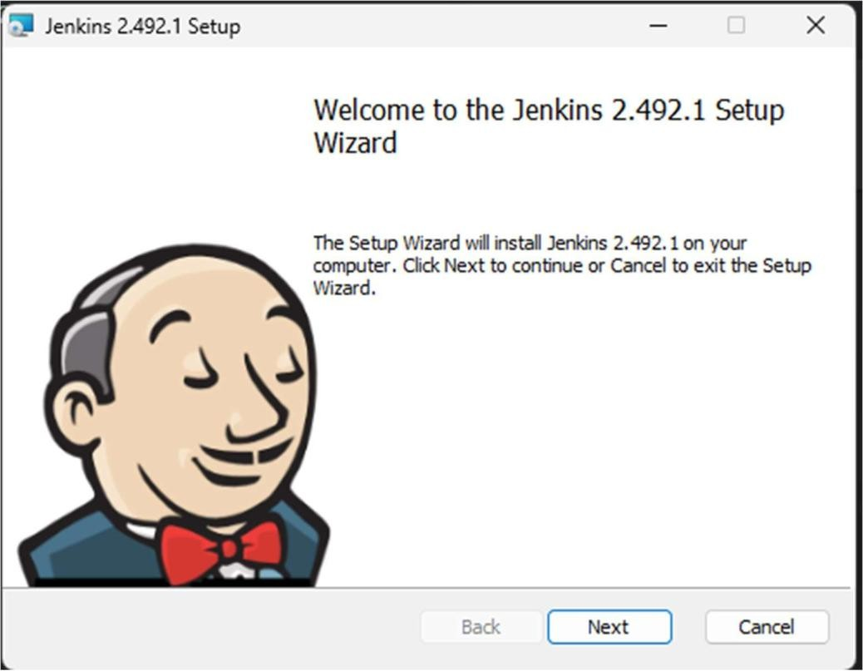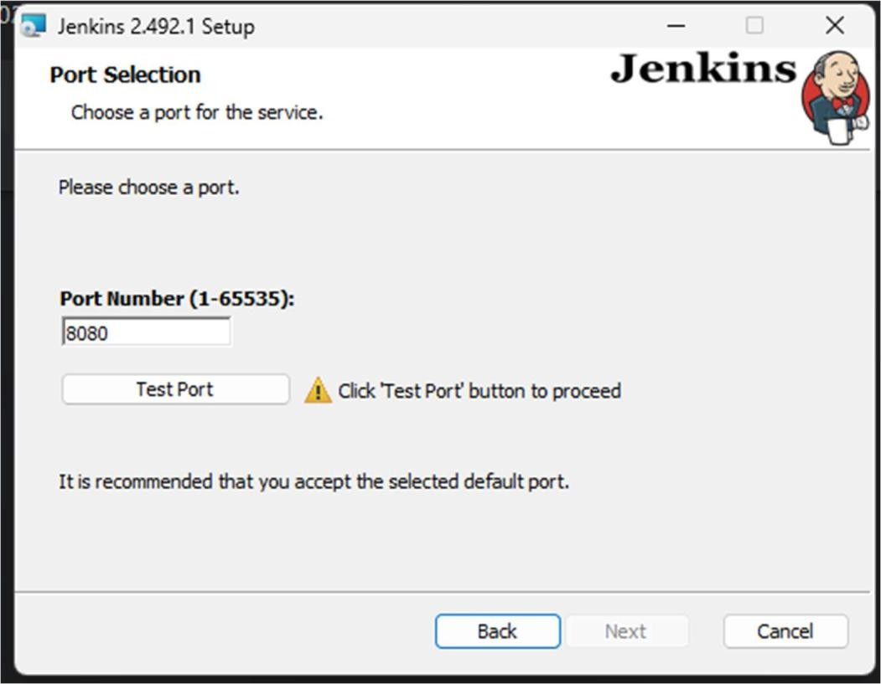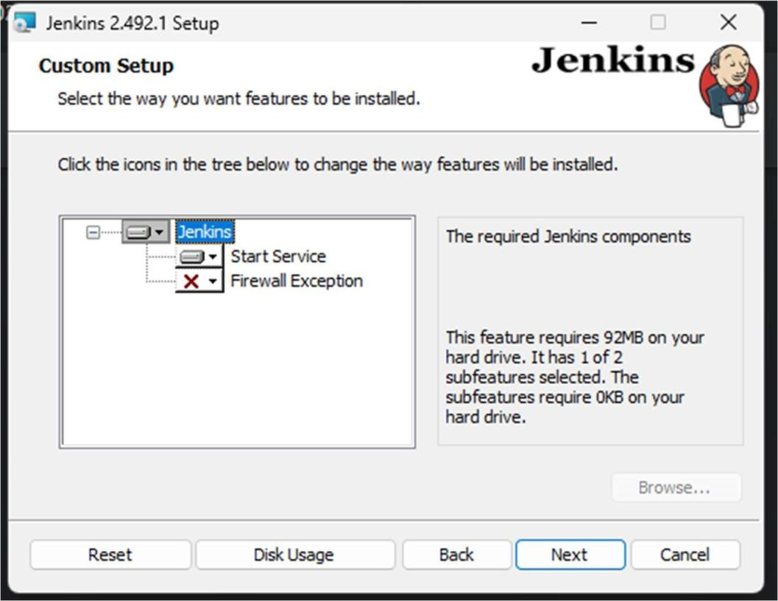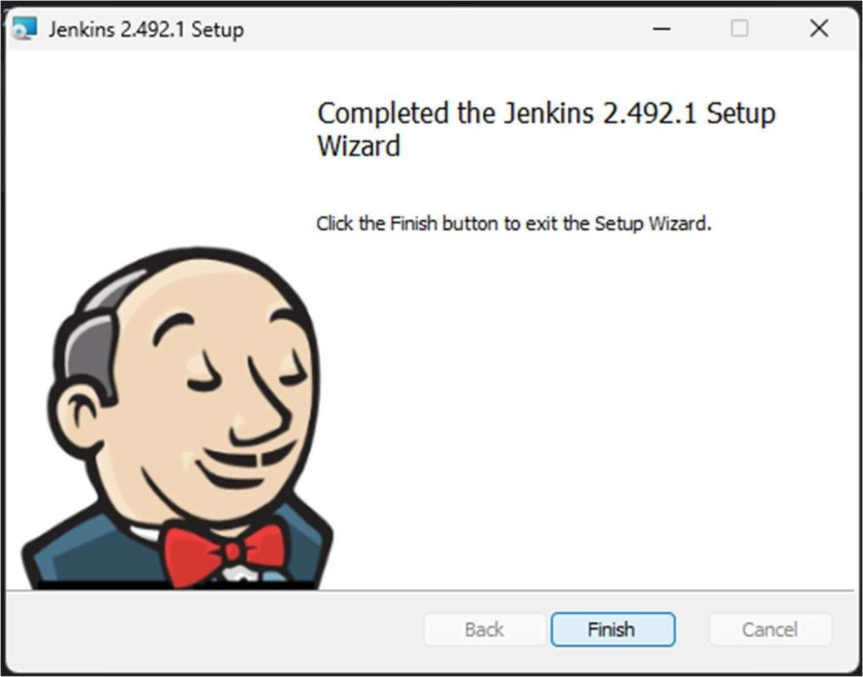

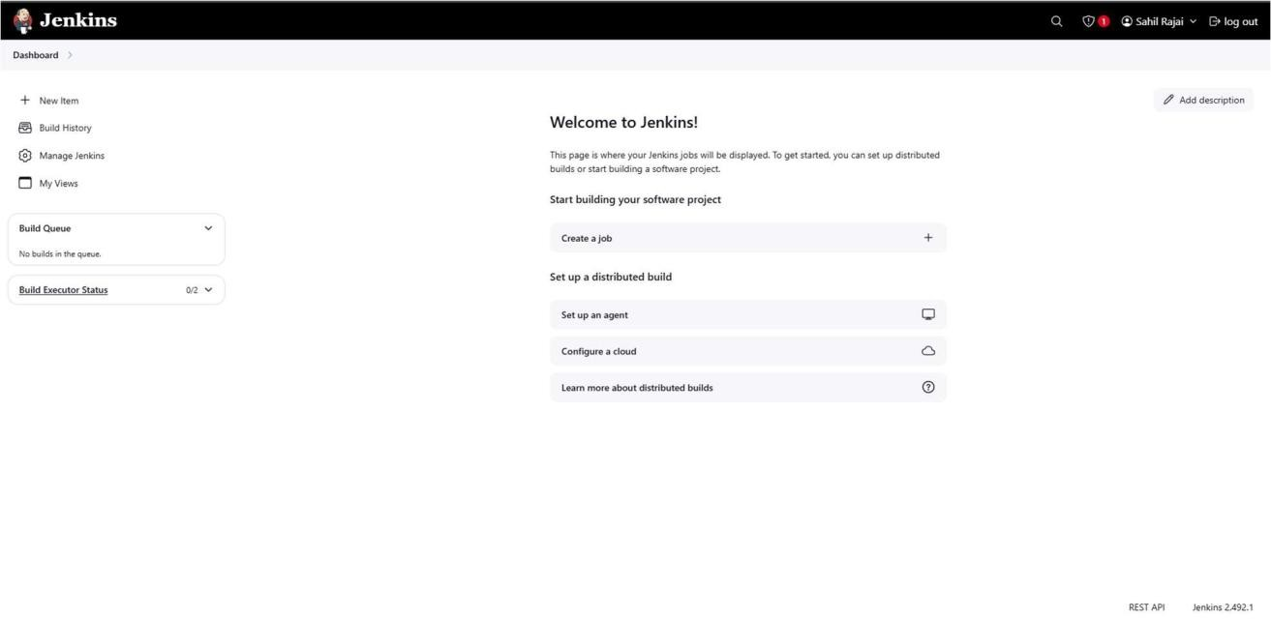

Conclusion

This experiment covered installing and configuring Jenkins for Continuous Integration, setting up build automation using Maven, Gradle, or Ant. By automating build jobs, we improve software quality, detect errors early, and enhance team collaboration.