**A PROJECT REPORT ON**

# TELECOMMUNICATION CHURN ANALYSIS

# USING MACHINE LEARNING AND FLASK

**Submitted in partial fulfilment for the completion of BE- V SEMESTER**

**in**

**INFORMATION TECHNOLOGY**

**By**

**KOTAGIRI SUMAN (160121737181)**

**YATISH MANNE (160121737184)**

**Under the guidance of**

**Ms. T. MADHURI**

**Assistant Professor,**

**Department of Information Technology**



**DEPARTMENT OF INFORMATION TECHNOLOGY CHAITANYA BHARATHI INSTITUTE OF TECHNOLOGY (A)**

**(Affiliated to Osmania University; Accredited by NBA(AICTE) and NAAC(UGC), ISO Certified 9001:2015)**

**GANDIPET, HYDERABAD – 500 075**

**Website:** [**www.cbit.ac.in**](http://www.cbit.ac.in/)

**2022-2023**



**CERTIFICATE**

This isto certify that the project work entitled “**Telecommunication Churn Analysis”** submitted to **CHAITANYA BHARATHI INSTITUTE OF TECHNOLOGY,** in partial fulfilment of the requirements for the award of the completion of V semester of B.E in Information Technology, during the academic year 2023-2024, is a record of original work done by **K Suman(160121737181), Yatish Manne (160121737184)** during the period of study in the Department of IT, CBIT, HYDERABAD, under our supervision and guidance.

**Project Guide** **Head of the Department**

### Ms. T. MADHURI Dr. RAJANIKANTH ALUVALU

Assistant Professor, Professor, Dept. of IT,

CBIT, Hyderabad. CBIT, Hyderabad.

## DECLARATION

This is to declare that the work reported in the present report titled "**Telecommunication Churn Analysis**" submitted in partial fulfilment for the completion of B.E., the IV semester, in the department of Information Technology, Chaitanya Bharathi Institute of Technology, Hyderabad, is a record of original work. No part of the report is copied from books/journals/internet and wherever the portion is taken, the same has been duly referred. The reported results are based on the project work done entirely by us and not copied from any other sources.

**K Suman Yatish Manne** **160121737183 1601217373198**

**ACKNOWLEDGEMENT**

With great pleasure I want to take this opportunity to express my heartfelt gratitude to all the people who helped in making this project work a grand success. First of all I would like to express my profound sense of gratitude to the principal Dr. **Prof. C. V. NARASIMHULU** for giving me the permission to carry out this project.

I express my deep gratitude and regards to Dr. Rajanikanth Aluvalu, Head of Department of Information Technology, and project guide Ms. T. Madhuri, Assistant Professor, Department in Information Technology for their encouragement and valuable guidance in bringing shape to this dissertation.

I am thankful to all the Technical Stall and Non-teaching staff in the department for their teachings and academic support.

### K Suman Yatish Manne 1601217371831 1601217373184

**ABSTRACT:**

"In the dynamic realm of telecommunication, effective customer engagement through data-driven insights is paramount. This project is dedicated to leveraging data analytics and machine learning techniques to revolutionize customer retention and satisfaction in the telecommunication industry. Focusing on the unique challenges of the telecommunication landscape, we harness a rich dataset encompassing customer behavior, network usage patterns, service preferences, and historical interactions.

The primary objective is to develop a predictive model using Flask, a Python web framework, that excels at analyzing customer profiles, identifying churn indicators, optimizing service offerings, and personalizing communication strategies. By doing so, telecommunication companies can anticipate customer attrition, tailor services to individual needs, and proactively engage at-risk customers. This predictive model serves as a strategic asset, enabling telecommunication providers to allocate resources efficiently and enhance customer experiences.

Through the implementation of our model, telecommunication companies can make data-informed decisions, reduce churn rates, and foster customer loyalty. The project's overarching aim is to equip telecommunication firms with a powerful tool that not only elevates their customer engagement strategies but also empowers them to thrive in the competitive telecommunications landscape. In an era where data-driven decisions are paramount, our project serves as a beacon guiding telecommunication companies toward a brighter, more customer-centric future."

**INDEX**

## PRELIMINARY PAGES

|  |  |
| --- | --- |
| TITLE PAGE | 01 |
| CERTIFICATE | 02 |
| DECLARATION | 03 |
| ACKNOWLEDGEMENT | 04 |
| ABSTRACT | 05 |

## CHAPTER 1: INTRODUCTION

|  |  |
| --- | --- |
| 1.1 INTRODUCTION | 09 – 10 |
| 1.2 OBJECTIVE | 11 |
| 1.3 EXISTING SYSTEM | 11 – 12 |
| 1.4 DISADVANTAGES | 12 |
| 1.5 PROPOSED SYSTEM | 13 |

## CHAPTER 2: TECHNOLOGIES

|  |  |
| --- | --- |
| 1.1 PYTHON | 15 – 16 |
| 1.2 FLASK | 16 |
| 1.3 MODULES OF PYTHON USED IN THE APPLICATION | 17 – 19 |
| 1.4 MACHINE LEARNING CLASSIFIERS | 19 - 20 |

## CHAPTER 3: SYSTEM REQUIREMENTS

|  |  |
| --- | --- |
| 3.1 HARDWARE REQUIREMENTS | 22 |
| 3.2 SOFTWARE REQUIREMENTS | 23 - 24 |

## CHAPTER 4: SYSTEM DESIGN

|  |  |
| --- | --- |
| 4.1 SYSTEM DESIGN | 26 |
| 4.2 UML DIAGRAMS | 26 |
| **CHAPTER 5: IMPLEMENTATION AND TESTING** |  |
| 5.1 IMPLEMENTATION DESCRIPTION | 28 |
| 5.2 SYSTEM TESTING | 29 - 30 |

## CHAPTER 6: SOURCE CODE

|  |  |
| --- | --- |
| 1.1 PYTHON | 32 – 36 |
| 1.2 HTML | 37 – 39 |
| 1.3 FLASK | 40 |

**CHAPTER 7: RESULTS 42**

**CONCLUSION 44**

## BIBLIOGRAPHY 45

# INTRODUCTION

## INTRODUCTION

## In the contemporary landscape of data-driven decision-making, the success of marketing campaigns stands as the cornerstone of business growth. This is especially pertinent for telecommunication companies aiming to forge deep and effective connections with their customer base. The "Telecommunication Campaign Success Prediction" project emerges as a cutting-edge fusion of advanced machine learning and web development, poised to redefine how telecommunication firms approach their marketing strategies.

## At its heart, this project features a sophisticated machine learning model meticulously trained on historical campaign data. This data encompasses a rich tapestry of information, including customer behavior, network usage patterns, service preferences, and communication interactions. Through the implementation of an intuitive Flask-based web interface, our model empowers telecommunication professionals to gaze into the future, offering precise predictions regarding campaign outcomes.

## Here's an introduction to the key parameters that shape the Telecommunication Churn Analysis Prediction model:

## Customer Behavior:

## Understanding the intricacies of customer behavior is paramount in our campaign success prediction model. It allows for the tailoring of marketing strategies to resonate with specific behavioral traits, ultimately enhancing the likelihood of campaign success.

## Network Usage Patterns:

## The way customers utilize the network is a goldmine of insights. Incorporating network usage patterns informs campaign customization, ensuring that offerings and messaging align with customers' specific usage habits, thereby optimizing campaign success.

## Service Preferences:

## Customers often have distinct preferences when it comes to telecommunication services. By considering these preferences, our model fine-tunes campaigns, delivering offerings and messages that precisely match individual service needs, thus influencing campaign outcomes positively.

## Communication Interactions:

## Understanding the history of communication interactions is crucial. It guides strategies for striking the right balance between maintaining customer interest and avoiding overexposure, ultimately shaping the overall effectiveness of the campaign.

## This project represents a pivotal step forward in the telecommunication industry, offering a robust framework for predictive analysis and data-driven decision-making. It empowers telecommunication companies to not only anticipate campaign outcomes but also to understand the 'why' behind those outcomes, fostering a new era of strategic marketing excellence.

## OBJECTIVE

The primary objective of this project is to empower telecommunication companies with a sophisticated and data-driven approach to their marketing endeavors. At its core, the project seeks to predict the success of marketing campaigns with a high degree of accuracy. By harnessing historical campaign data and leveraging advanced machine learning algorithms, the project aims to uncover hidden patterns and insights that can significantly enhance campaign outcomes. This predictive capability allows telecommunication firms to make informed decisions, allocate resources more efficiently, and tailor their marketing efforts precisely to meet the unique preferences and behaviors of their customer base.

Furthermore, the project aspires to bridge the gap between data science and practical marketing applications. It places a strong emphasis on interpretability, ensuring that the predictions generated by the model are not just numerical outputs but actionable insights. By understanding why a particular campaign is likely to succeed or fail, telecommunication professionals can fine-tune their strategies, optimizing factors such as customer behavior, network usage patterns, service preferences, and communication interactions. Ultimately, the overarching goal is to enable telecommunication companies to achieve higher customer engagement, improved customer retention rates, and a more significant return on their marketing investments, transforming marketing from a gamble into a strategic advantage in the competitive telecommunication industry.

## 1.3 EXISTING SYSTEM

In the real world, the existing systems within the realm of telecommunication marketing are diverse, reflecting a mix of traditional approaches and some technological advancements. Here's an overview of the pre-existing systems in the context of telecommunication marketing campaign management:

**1. Manual Decision Making**: Prior to the adoption of data-driven solutions, many telecommunication companies relied on manual decision-making processes. Marketing teams would analyze historical campaign performance, often using basic tools like spreadsheets. These manual assessments are time-consuming, subjective, and limited in their ability to process the vast amount of customer data generated in the telecommunication sector.

**2. Basic Analytics Tools**: Some telecommunication firms might have utilized basic analytics tools like Excel or simple database queries to extract insights from historical data. While these tools can offer fundamental statistics and trends, they lack the advanced analytics and predictive capabilities necessary for optimizing marketing strategies in a highly competitive industry.

**3. Segmentation Based on Demographics**: Pre-existing systems often employed segmentation primarily based on demographic information such as age, gender, and location. While this provides a basic understanding of customer groups, it may overlook more nuanced customer behaviors, preferences, and usage patterns.

**4. Limited Predictive Modeling**: Traditional systems typically lack robust predictive modeling capabilities. They may offer historical data analysis, but without predictive modeling, they cannot forecast future campaign outcomes accurately. This limitation hinders the ability to proactively optimize marketing strategies to meet evolving customer needs.

**5. Resource Allocation Challenges**: In the absence of data-driven insights, telecommunication companies might allocate marketing resources inefficiently. Without a clear understanding of which customer segments or channels are most likely to yield positive results, resources can be spread thin, leading to suboptimal campaign performance.

**6. Reactive Approach**: Many existing systems promote a reactive marketing approach. Telecommunication companies often respond to campaign outcomes after they occur, making adjustments based on past successes or failures. This reactive approach can result in missed opportunities to engage customers in real-time and adapt to rapidly changing market conditions.

## 1.4 DISADVANTAGES

## The primary disadvantage of pre-existing marketing decision systems in the context of our "Telecommunication Campaign Success Prediction" project lies in their limited capacity to harness data for predictive and proactive decision-making. These legacy systems often rely on manual analysis and basic tools, making them inefficient in processing vast datasets and identifying intricate patterns. As a result, telecommunication companies using such systems may struggle with resource allocation, as they lack precise insights into which customer segments or strategies are likely to succeed. Additionally, their reactive nature means that adjustments are made retrospectively, potentially leading to missed opportunities and suboptimal campaign outcomes. In today's data-driven landscape of the telecommunication industry, these limitations hinder companies from fully capitalizing on the potential of tailored marketing strategies and predictive analytics.

## 1.5 PROPOSED SYSTEM

The proposed "Telecommunication Campaign Success Prediction" system represents a groundbreaking advancement in the realm of data-driven marketing for telecommunication companies. At its core, this system harnesses the power of advanced machine learning techniques to predict the outcomes of marketing campaigns with an unprecedented degree of accuracy. By analyzing historical campaign data encompassing customer behavior, network usage patterns, service preferences, communication interactions, and more, the system extracts invaluable insights that guide the formulation of future marketing strategies.

Unlike traditional, manual decision-making processes, this system operates in real-time, offering marketing professionals a dynamic and agile platform for optimizing their campaigns. Through a user-friendly Flask-based web interface, telecommunication experts can input campaign parameters and receive instant predictions, empowering them to make informed decisions on-the-fly. This shift from intuition-based decisions to data-informed strategies represents a monumental advantage, enabling companies to allocate resources judiciously, tailor messaging precisely, and maximize customer engagement and retention rates.

## 

## TECHNOLOGIES

**2.1 PYTHON:**

Python is a high-level, interpreted programming language that is widely used in a variety of applications. It is known for its simplicity, readability, and versatility, and is a popular choice for beginners and experts alike.

One of the key advantages of Python is its ease of use. The language is designed to be straightforward and intuitive, with a syntax that is easy to read and write. This makes it an excellent choice for learning programming, as it allows users to focus on the core concepts of programming without getting bogged down in syntax and other details.

Another advantage of Python is its versatility. It is used in a wide range of applications, including web development, scientific computing, data analysis, artificial intelligence, and automation. Python has a large and active community of developers who have created a vast ecosystem of libraries and tools that extend the functionality of the language.

Python is also known for its strong support for object-oriented programming, functional programming, and other programming paradigms. This makes it a flexible language that can be used in a variety of programming styles.

Overall, Python is a powerful and popular programming language that is well-suited to a wide range of applications. Its ease of use, versatility, and strong community support make it an excellent choice for beginners and experts alike.

Python is widely used for machine learning because it offers several key advantages for th is field:

1. Large and Active Community: Python has a large and active community of developers who have created a vast ecosystem of libraries and tools that are specifically designed for machine learning. Some of the most popular machine learning libraries in Python include TensorFlow, PyTorch, Scikit-learn, Keras, and Pandas.
2. Simple and Readable Syntax: Python is known for its simple and readable syntax, which makes it easy to write and understand machine learning code. This can save time and reduce the risk of errors when working on complex machine learning projects.
3. Flexibility: Python is a highly flexible language that can be used for a wide range of applications, including machine learning. It supports a variety of programming paradigms, including object-oriented programming and functional programming, and can be used with both structured and unstructured data.
4. Rapid Prototyping: Python's ease of use and flexibility make it well-suited for rapid prototyping in machine learning. With Python, developers can quickly experiment with different algorithms and approaches, and iterate on their models until they find the best solution.

Overall, Python's combination of a large and active community, simple and readable syntax, flexibility, and rapid prototyping capabilities make it an ideal language for machine learning.

**2.2 FLASK:**

Flask is a lightweight and flexible web framework for Python. It is designed to make it easy to build web applications quickly and with minimal code. Flask provides a set of tools and libraries for building web applications, including support for URL routing, templates, and request/response handling.

One of the key advantages of Flask is its simplicity. Flask is easy to learn and use, and is a popular choice for small to medium-sized web applications. Flask also provides a lot of flexibility, allowing developers to choose which components they want to use and how they want to structure their application.

Flask is also highly extensible, with a large and active community of developers who have created a wide range of extensions and plugins for the framework. These extensions provide additional functionality for things like database integration, authentication, and form handling. Another advantage of Flask is its lightweight nature. Flask has a small codebase and minimal dependencies, making it easy to deploy and scale. This makes it a popular choice for developers who want to build simple and efficient web applications.

Overall, Flask is a powerful and flexible web framework that is well-suited for building small to medium-sized web applications. Its simplicity, flexibility, and extensibility make it an ideal choice for developers who want to build web applications quickly and with minimal code.

**2.3 MODULES OF PYTHON USED IN THE APPLICATION**

**NUMPY:**

NumPy (short for "Numerical Python") is a popular Python library used for scientific computing and data analysis. It provides a powerful array processing capability that allows for efficient operations on large, multi-dimensional arrays and matrices.

NumPy provides a set of tools for working with arrays, including a wide range of mathematical functions for performing element-wise operations, linear algebra operations, and statistical analysis. It also provides tools for working with complex numbers and Fourier transforms, as well as tools for generating random numbers.

One of the key advantages of NumPy is its performance. NumPy is designed to be fast and efficient, with optimized code that allows for quick execution of mathematical operations on arrays. This makes it well-suited for scientific computing applications that require intensive computation on large datasets.

Another advantage of NumPy is its ease of use. NumPy provides a simple and intuitive interface for working with arrays, making it easy to get started with data analysis and scientific computing. It also integrates well with other Python libraries, such as Pandas and Matplotlib, making it a key component of the scientific Python ecosystem.

Overall, NumPy is a powerful and versatile library that is widely used for scientific computing and data analysis in Python. Its performance, ease of use, and rich set of tools make it a key component of the scientific Python ecosystem.

**PANDAS:**

Pandas is a popular open-source Python library used for data manipulation and analysis. It provides a flexible and powerful set of tools for working with structured data, including data frames and series.

Pandas provides a wide range of features for data manipulation and analysis, including:

1. Data structures: Pandas provides two main data structures, Data Frames and Series, for working with structured data. Data Frames are two-dimensional tables with rows and columns, while Series are one-dimensional arrays with labeled indexes.
2. Data cleaning: Pandas provides a range of tools for cleaning and transforming data, including handling missing values, filtering, sorting, and merging data sets.
3. Data analysis: Pandas provides a range of tools for data analysis, including statistical functions, time series analysis, and data visualization.
4. Data input/output: Pandas provides support for reading and writing data in a wide range of formats, including CSV, Excel, SQL, and JSON, among others. Pandas is widely used in data science and analysis because of its ease of use, flexibility, and powerful set of tools. It integrates well with other Python libraries, such as NumPy and Matplotlib, making it a key component of the scientific Python ecosystem.

Overall, Pandas is a versatile and powerful library that is essential for working with structured data in Python. Its rich set of tools and easy-to-use interface make it a popular choice for data analysis and manipulation.

**SKLEARN:**

Scikit-learn, also known as sklearn, is a popular machine learning library in Python. It provides a wide range of tools for various tasks in machine learning, including data preprocessing, classification, regression, clustering, model selection, and more. Scikit-learn provides a simple and consistent interface for working with various machine learning models. It includes a wide range of models, such as linear regression, logistic regression, decision trees, random forests, support vector machines, k-nearest neighbors, and more. It also provides tools for evaluating the performance of these models using various metrics. One of the strengths of Scikit-learn is its ease of use and accessibility.

It provides a consistent and intuitive API for working with machine learning models, which makes it easy for beginners to get started with machine learning. At the same time, it also provides advanced features and tools for more experienced users, such as hyperparameter tuning and model selection.

Scikit-learn also integrates well with other popular Python libraries for data manipulation and visualization, such as Pandas, NumPy, and Matplotlib.

Overall, Scikit-learn is a powerful and versatile machine learning library in Python that simplifies the process of building and evaluating machine learning models. Its ease of use, consistency, and wide range of features make it a popular choice for data scientists and machine learning practitioners. And many other machine learning and data-visualization packages are used.

**2.4 Machine Learning Classifiers:**

The machine learning-based classifiers have been trained based on the training data and tested the performance using the test data. The best classifier will be selected on the basis of their classification performance. Finally, the best performing classifier has been used on the validation data to forecast the rainy days based on the feature set. The sklearn library has been used to import these classifiers. The models have been trained using the X_train and y_train sets and tested on the X_test data for predicting whether the day will be rainy or not.

**Random Forest :**

Random forest is a machine learning algorithm that is supervised. The bagging approach is used to train a forest, which is a collection of decision trees. Random forest generates a large number of decision trees and then combines them to get a consistent and accurate classification. The Random Forest algorithm has the advantage of being able to be used for both classification and regression analysis. Random Forest Algorithm follows the rules of Decision Tree. The difference in them is decision tree algorithm gives the output by considering only one factor whereas Random Forest Algorithm compares many no of decision trees and gives the result satisfying majority no of decision trees.

Random Forest Algorithm builds a strong model which satisfies the models many no of decision tree, this model is applied on the testing dataset for getting the required output. Firstly, for building a model we require a training dataset, from that training dataset we consider the subset of training dataset known as bootstrap dataset1. This bootstrap dataset1 consists of set of variables. From these variables we consider only two variables from these two variables we make a root node for one variable which produces accurate output than the other variable. In this format we build a decision tree from the bootstrap dataset1. We consider another subset of dataset from the training dataset, let us say bootstrap dataset2. As we build a decision tree for the bootstrap dataset 1one in the same way we build a dataset for the bootstrap dataset2. We have to follow these steps until we get many no of decision tree. After getting many no of decision trees we compare the entire decision tree and build a model which satisfies these entire decision trees. The obtained model is known as Strong Model. In this way a model is built from the training dataset.

This model is applied on the testing data set and it produces a required output. The obtained output is accurate because a strong model is built from many no. of decision trees.

In this format, when we upload a training dataset then the system builds a model using Random forests Algorithm then when upload the testing dataset by using the model system provides the required output. The output consists of two class labels yes/no. Yes indicates that the client is eligible for approval of loan and no indicates that the client is not eligible for the approval of loan. Like this, the system provides the required output.

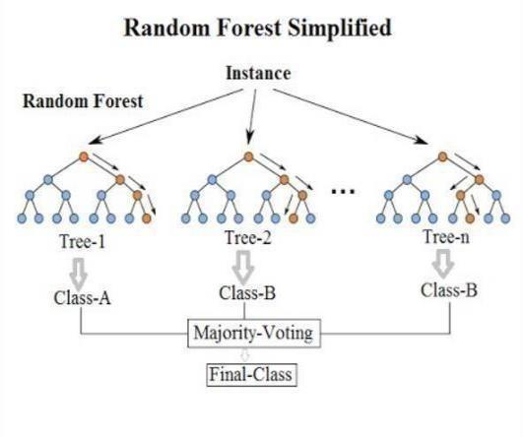

It builds the number of decision tree models from the trained dataset and all these models are combined and form a new model which satisfies all the tree models. The obtained model is said to be known as a strong model since it satisfies all the decision tree models.

### SYSTEM REQUIREMENTS

**3.1 HARDWARE REQUIREMENTS:**

For a project Forecasting Water Quality, you will need system software that can handle data analysis and machine learning tasks. Here are some software requirements to consider:

1. Operating System: The operating system should be a version of Windows, Linux, or macOS that supports data analysis and machine learning tools.
2. Programming Language: The project will require programming skills, so you will need a programming language that is well-suited for data analysis and machine learning. Python is a popular choice for this purpose, with libraries like NumPy, Pandas, Scikit-learn, and TensorFlow.
3. Integrated Development Environment (IDE): You will need an IDE to write, run, and debug your code. Some popular options for Python development include PyCharm, Spyder, and Jupyter Notebooks.
4. Data Analysis Tools: You will need tools for data manipulation, visualization, and exploration. This could include software like Excel, Tableau, or Matplotlib.
5. Machine Learning Framework: You will need a machine learning framework to build, train, and evaluate your models. Some popular options include TensorFlow, PyTorch, and Scikit-learn.
6. Database Management System: You will need a database management system to store and retrieve your data. This could include software like MySQL, PostgreSQL, or MongoDB.
7. Version Control: You will need version control software to manage changes to your codebase. Git is a popular option for this purpose.

**PROGRAMMING LANGUAGES:**

* + **HTML**
  + **CSS**
  + **BOOTSTRAP**

#### • PYTHON

* **FLASK**

**3.2 SOFTWARE REQUIREMENTS:**

**FUNCTIONAL REQUIREMNTS :**

Requirement analysis is a software engineering that is composed of the various tasks that determine the needs or conditions that are to be met for a new or altered product, taking into consideration the possible conflicting requirements of the various users. Functional requirements are those requirements that are used to illustrate the internal working nature of the system, the description of the system, and explanation of each subsystem. The functional requirements identified are:

* **USERS INPUT :**

In order for the application to work the user should provide some inputs of which specifications they want. They can give inputs or can select from different options.

* **OUTPUT:**

The model then works on the given inputs and perform the random forest model to predict whether the campaign will be a success or a failure according to the given parameters.

* **ALERTS:**

If user enters any wrong or nil input then application sends an alert to the user.

**NON-FUNCTIONAL REQUIREMNTS :**

* **RESPONSE TIME:**

The system should have high performance rate when executing user’s input and should be able to provide feedback or response within a short time span usually 50 seconds for highly complicated task.

* **ERROR HANDLING:**

Error should be considerably minimized and an appropriate error message that guides the user to recover from an error should be provided. Validation of user’s input is highly essential. Also, the standard time taken to recover from an error should be 15 to 20 seconds.

**INPUT DESIGN:**

Input design is responsible for converting the user given inputs into the modal required parameters. This is done internally in the backend in the flask application. It typically converts the given inputs into 0 and 1 according to the specifications.

**OUTPUT DESIGN:**

Computer output is the most important and direct source of information to the user. Output design is a very important phase since the output needs to be in an efficient manner. Efficient and intelligible output design improves the system relationship with the user and helps in decision making.

### SYSTEM DESIGN

**4.1 SYSTEM DESIGN:**

System Design is the most creative and challenging. The System Design Document describes the system requirements, operating environment, system and subsystem architecture, files and database design, input formats, output layouts, human-machine interfaces, detailed design, processing logic and external interfaces. The system is designed to satisfy the user requirements based on analysis of the system. In system design we move from logical to the physical aspects. The requirements identified in the requirements analysis phase are transformed into a System Design Document that accurately describes the design of the system and that can be used as an input to system development in the next phase. During the Design Phase we have to consider about a key question “**HOW SHOULD BE PROBLEM SOLVED?**”

**4.2 UML DIAGRAMS :**

UML diagrams show a collection of classes, interfaces, associations, collaborations and constraints. It is also known as Structural diagram. The purpose of the UML diagrams is to model the static view of an application. UML diagrams are the only diagrams which can be directly mapped with object-oriented languages such that widely used at the time of construction.

UML diagrams like Activity diagram, Sequence diagram can only give the sequence flow of the application however UML diagrams is a bit different. It is the most popular UML diagram in the coder community.

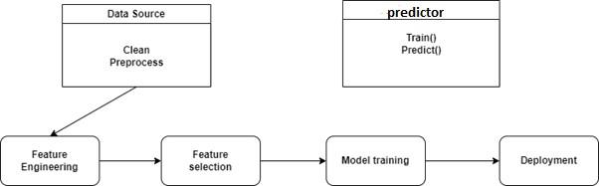

**IMPLEMENTATION**

**AND**

**TESTING**

**5.1 Implementation Description:**

**Data Collection and Monitoring:**

Establish a robust data collection system to acquire telecommunication campaign data from diverse sources, including telecommunication companies' records, government repositories, and historical archives. Implement continuous real-time monitoring mechanisms to ensure a constant inflow of up-to-date information.

**Data Preprocessing:**

Initiate data preprocessing procedures to address missing values, detect and handle outliers, and rectify inconsistencies in the collected data. Standardize data formats and units to ensure seamless compatibility across different datasets.

**Feature Selection and Engineering:**

Identify pivotal features (parameters) that exert significant influence on the success of telecommunication campaigns. Employ feature engineering techniques to create new features or transform existing ones, enhancing the predictive capabilities of the model.

**Choice of Prediction Models:**

Carefully select prediction models, considering a spectrum of options, including statistical, machine learning, or mathematical models. Evaluate model complexity and suitability for various campaign parameters, tailoring the choice to the specific needs of the telecommunication context.

**Data Splitting and Validation:**

Partition the dataset into distinct subsets for training, validation, and testing purposes. This division enables the training, fine-tuning, and rigorous evaluation of the models. Implement cross-validation methodologies to assess the robustness and generalizability of the chosen models.

**Model Training and Tuning:**

Initiate the training process for prediction models using the curated dataset, systematically adjusting hyperparameters to achieve optimal performance. Maintain a dynamic approach by regularly updating and retraining models to accommodate the evolving landscape of telecommunication campaigns. This adaptability ensures that the predictive power of the system remains aligned with the dynamic nature of the telecommunication industry.

By following this comprehensive implementation framework, the "Telecommunication Campaign Success Prediction" project aims to empower telecommunication companies with data-driven insights, enabling them to make informed decisions, optimize resource allocation, and elevate the success rates of their campaigns in the ever-evolving telecommunication landscape.

**5.2 SYSTEM TESTING :**

**UNIT TESTING** :

Each module is considered independently, it focuses on each unit of software as implemented in the source code, it is white box testing.

**INTEGRATION TESTING :**

Integration testing aims at constructing the program structure while at the same constructing tests to uncover errors associated with interfacing the modules. Modules are integrated by using the top-down approach.

**FUNCTIONAL TESTING :**

Functional testing is a type of software testing that validates the software system against the functional specifications. The purpose of Functional test is o test each function of the software application, by providing appropriates the functional requirements. Functional testing mainly involves black box testing and it is concerned about the source code of the application. This testing checks User Interface, APIs, Database, Security, Client/Server communication.

**SYSTEM TESTING :**

It is executing programs to check logical changes made in it with intention of finding errors in system is tested for online response, volume of transaction, recovery from failure etc. System testing is done to ensure that the system satisfies all the user requirements.

**WHITE BOX TESTING :**

In this technique, the close examination of the logical parts through the software is tested by cases that exercise species sets of conditions or loops. All logical parts of the software checked once. Errors that can be corrected using this technique are typography errors, logical expressions which should be executed once may be getting executed more than once and error resulting by using wrong controls and loops. When the box testing tests all the independent part within a module a logical decision on their true and the false side are exercised, all loops and bounds within their operational bounds were exercised and internal data structure to ensure their validity were exercised once.

**BLACK BOX TESTING :**

This method enables the software engineer to device sets of input techniques that fully exercise all functional requirements for a program. Black box testing tests the input output and the external data. It checks whether the input data is correct and whether we are getting the desired output.

## SOURCE CODE

## 

**6.1 Python:**

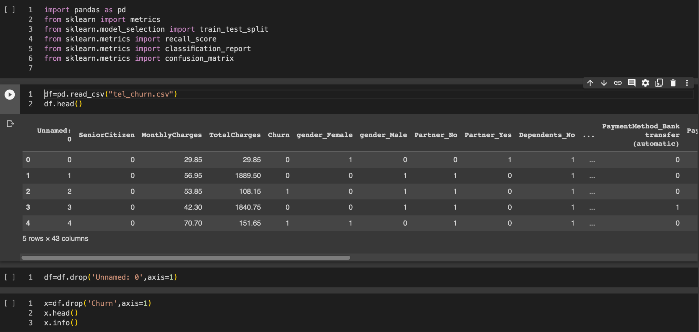

**6.2 HTML:**

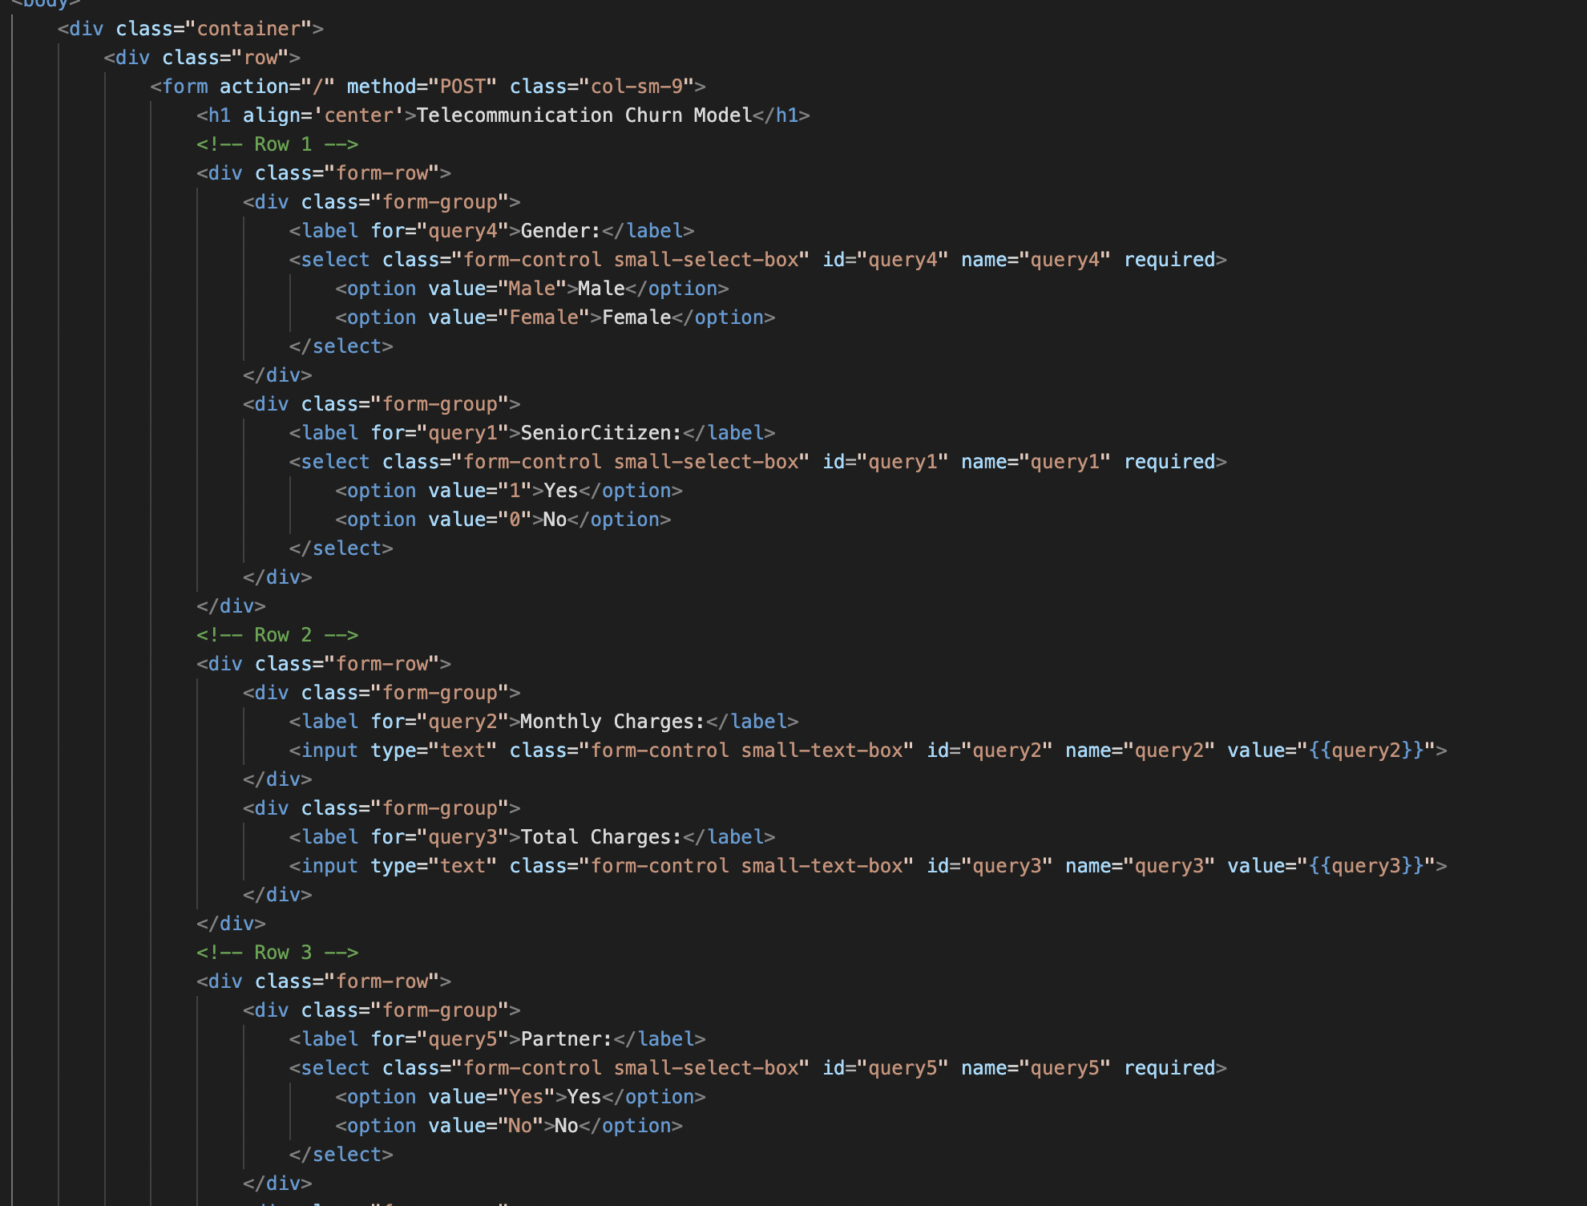

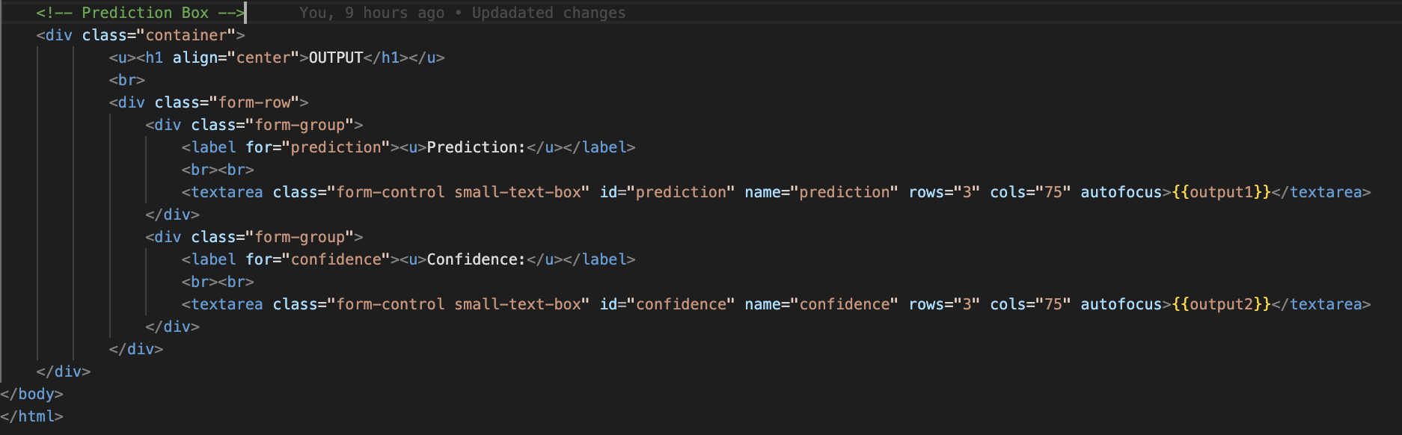

**6.3 FLASK:**

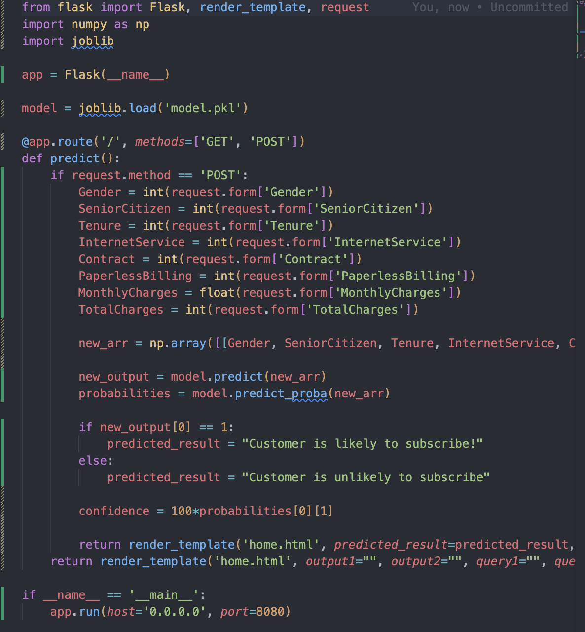

## RESULTS

### CONCLUSION

In conclusion, the "Telecommunication Campaign Success Prediction" project marks a revolutionary advancement in the realm of marketing for telecommunication companies. This initiative seamlessly integrates state-of-the-art machine learning capabilities with an intuitive user interface, empowering telecommunication firms to unlock the full potential of their data for marketing success. It effectively addresses the limitations of traditional marketing decision-making, where past experiences and instinct often guided campaign strategies.

With this innovative system in place, telecommunication companies gain a significant competitive edge. They can foresee campaign outcomes with exceptional precision, allocate resources strategically, and tailor messaging to align with the specific preferences of their diverse customer base. This shift from reactive marketing to a proactive, data-driven approach not only enhances campaign success but also optimizes resource allocation, reducing inefficiencies. Moreover, the system's commitment to interpretability fosters trust among marketing professionals, enabling them to comprehend the reasoning behind each prediction and make strategic refinements.

In conclusion, this project signifies the next evolution of marketing in the telecommunication industry, providing a pathway to excel in the era of data-driven decision-making. It not only enhances the efficiency and effectiveness of marketing campaigns but also elevates customer engagement, retention rates, and, ultimately, financial performance. As a testament to the power of data-driven insights, it transcends being a mere tool in the marketing toolkit; it is a catalyst for telecommunication companies to redefine their strategies, achieve unprecedented success, and maintain a leading position in the competitive landscape.

**BIBILOGRAPHY :**

**PYTHON - REFERENCE**

* **TUTORIAL - CODEGNAN IT SOLUTIONS**
* **RESOURCES -** [**https://tinyurl.com/cgmlcbit**](https://tinyurl.com/cgmlcbit)

#### FLASK, MACHINE LEARNING – REFERENCE

##### ❖ TUTORIAL - CODEGNAN IT SOLUTIONS

* **RESOURCES -**  [**https://tinyurl.com/cgmlcbit**](https://tinyurl.com/cgmlcbit)
* **YOUTUBE TUTORIAL - https://youtu.be/yBDHkveJUf4?feature=shared**

**DATASET SOURCES**

1. Did surveys in our college and in our families.
2. Scrapped from various Websites.