Semantic Segmentation of a COCO Subset Using a MobileNetV2–U-Net Model
Author: Yatish Chandra Sai Udutha
Student Id: 23030677
Code Link

Introduction
This report deals with deep learning-based image segmentation on a small portion of COCO 2017 dataset, with four classes person, cat, sports ball, and book. MobileNetV2-based U-Net architecture to predict pixel-wise class labels from RGB images was implemented. Along with that, this report talks about data characteristics, model design, training behavior, and segmentation performance, and critically evaluates the advantages and limitations of this approach under limited data and computational constraints.

Literature review
Deep learning segmentation has progressed from fully convolutional networks to encoder–decoder and instance aware models. Long[1] showed that classification CNNs can be converted into FCNs to get dense, per-pixel predictions and significantly improve semantic segmentation, but their outputs remain relatively uneven around object boundaries.
Ronneberger[2] said with U-Net, a encoder–decoder which is symmetric, with skip connections and heavy data augmentation, achieving precise localisation from few annotated images matching our small COCO subset.
For computational efficiency, Sandler[3] gave MobileNetV2, an inverted-residual backbone that attains competitive accuracy for classification, detection, and semantic segmentation at reduced cost.
These works jointly justify our MobileNetV2-U-Net semantic segmenter: it balances accuracy and efficiency, while we acknowledge that instance-segmentation models such as Mask R-CNN[4] could yield richer per-object masks but with resource complexity.

Exploratory Data Analysis
There are 300 training, 300 validation and finally 30 unlabeled test images in the dataset. Each labelled split includes a COCO-style labels.json file. For this assignment, I restrict the problem to four classes: person, cat, sports ball, and book, plus background.

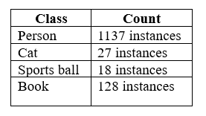
Fig.1: Per-class instances count
First, I checked the annotation file to compute basic statistics. In Fig.1 instance counts revealed a strong class imbalance, with person dominating the dataset and relatively few examples of cat and especially sports ball. Counting images per class showed that many images contain at least one person, but some classes appear only in a small subset of scenes.
Histograms (Fig.2) of image widths and heights indicated moderate variation in resolution but with most images in the 480 to 720-pixel range.

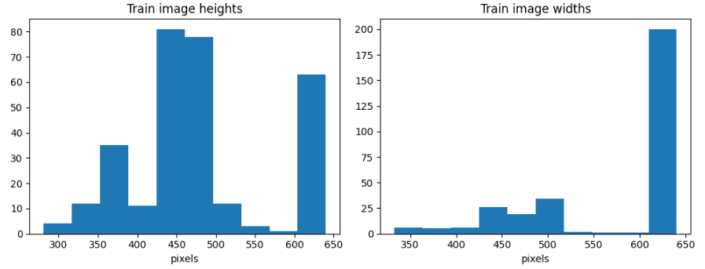
Fig.2: Histogram plot for image width and height.
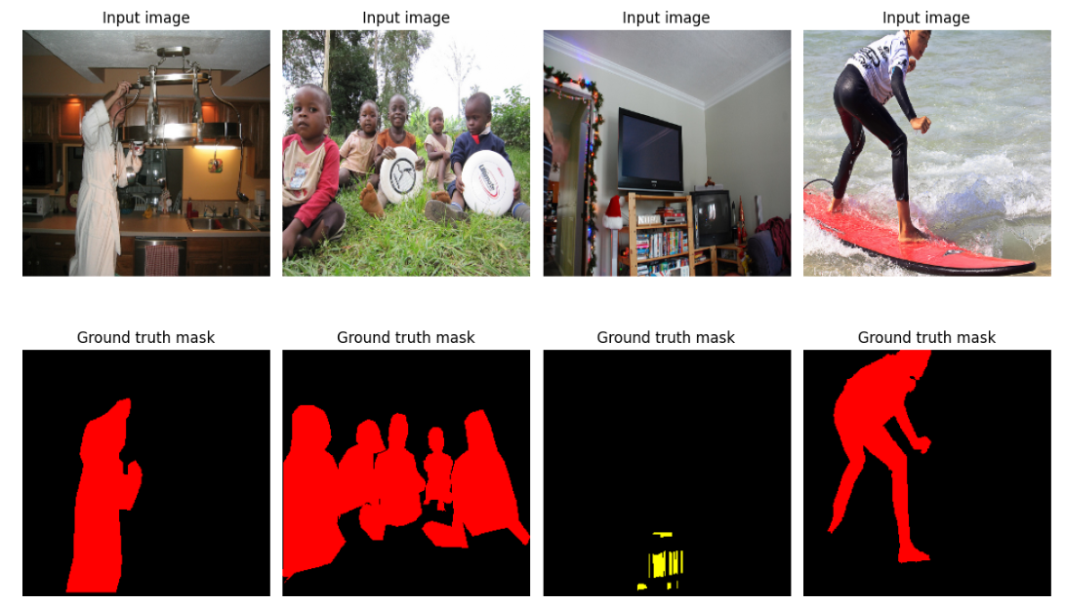
Fig.3: Masked Images

To understand spatial characteristics (Fig.3), I highlighted small objects (balls, books) and cluttered scenes with multiple examined the distribution of object areas (in pixels) and visualised a sample of images with their segmentation masks covered. The people and blockings, suggesting that both class imbalance and object scale would challenge the segmentation model.

Methodology

Data preparation.
COCO-style annotations are parsed to extract images and instance masks for the four target classes. For each image, individual instance masks are merged into a single semantic mask with integer labels (0 = background, 1–4 = target classes). Images and masks are resized to a fixed 256×256 resolution. A pipeline loads, preprocesses and batches the data: images are normalised with the MobileNetV2 preprocessing function, while masks are kept as integer label maps. Simple augmentations (e.g. random horizontal flip) are applied to improve generalisation.

Model architecture
I took a U-Net–style encoder–decoder implemented in TensorFlow/Keras. The encoder reuses a pre-trained MobileNetV2 backbone (ImageNet weights), from which several intermediate feature maps are tapped for skip connections. A series of transposed convolution blocks gradually up-samples the bottleneck features, concatenating them with encoder features at matching resolutions. The final 1×1 convolution outputs per-pixel logits over five classes.

Training and evaluation
Model is trained with the help of Sparse Categorical Cross-Entropy and Adam-optimiser. Early stopping based on validation loss reduces overfitting. During training, I track loss and sparse categorical accuracy, after training, I compute per-class Intersection-over-Union(IoU) on validation set and perform qualitative analysis on validation and test images.

Results and Discussion:
In Figure4, training loss decreases to ~0.12, while validation loss stays around 0.3. Training accuracy continues to rise and validation accuracy stabilises at 0.9, showing little overfitting. This is expected given the small dataset and frozen encoder: the decoder learns class-specific refinements while the pre-trained backbone provides stable features.
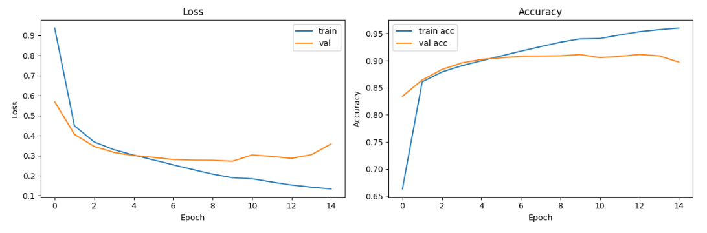
Fig4: Learning Curves

Per-class IoU on the validation set reveals a strong dependence on data distribution. The model performs better for background and person classes, reflecting that these pixels dominate both images and annotations. Cat reaches 0.42, which is better, considering the limited number of examples and the network sometimes confuses cat pixels with background. Sports ball and book have 0.00 IoU, meaning that predicted masks never overlap substantially with ground truth, the model effectively collapses these classes into background or person, consistent with the class-imbalance.

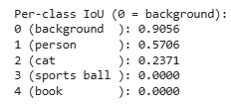
Fig5: Per-class IOU

In Fig.6 and 7, the samples validate these metrics. In the tennis image, the player is roughly segmented, but the mask is noisy and misses limbs and the racket. In the crowded kitchen scene, nearly all people are detected but merged into thick blobs with over-smoothed boundaries, illustrating the limitation of treating an instance problem as pure semantic segmentation.
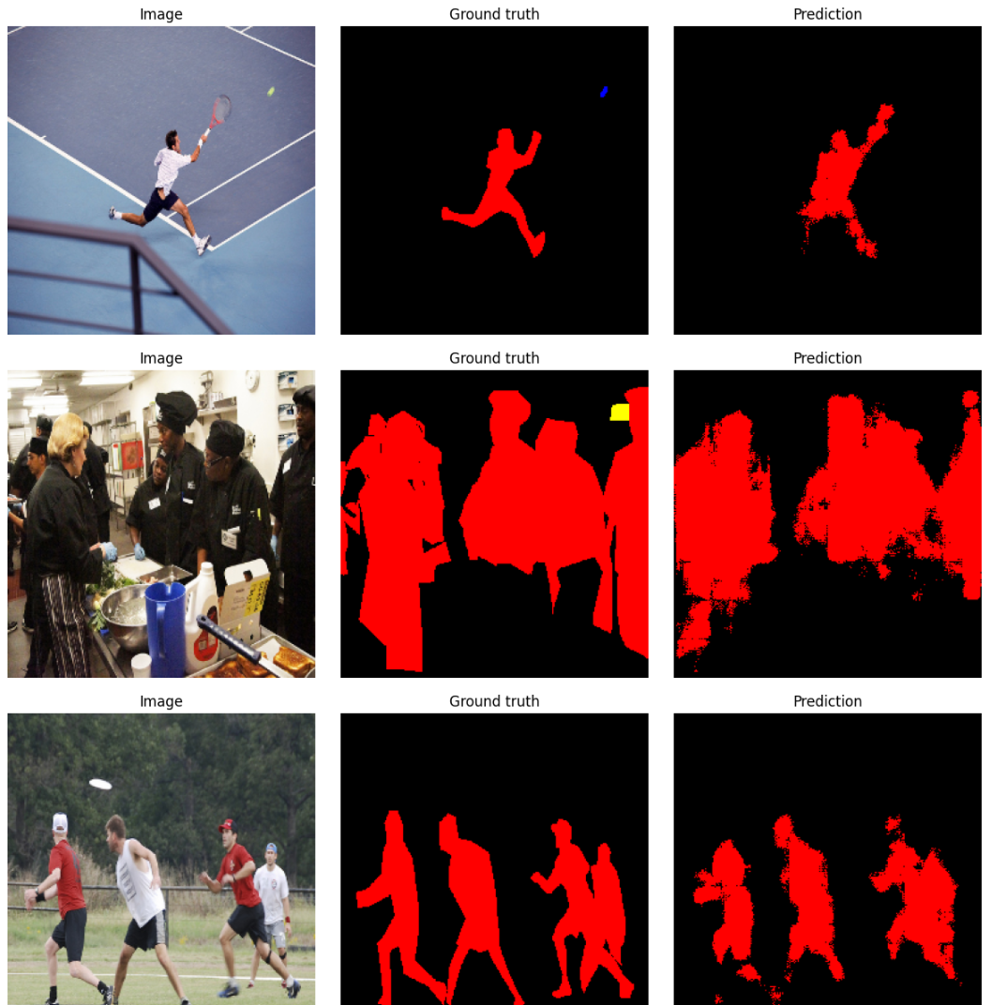
Fig6: validation sample results

Test Data Results
In Fig.7, the network successfully highlights the main people in the scene, but produces rough outlines that ignore fine details and fail to capture non-person objects. This indicates reasonable generalisation to new images for the majority class but very poor transfer for minority classes.
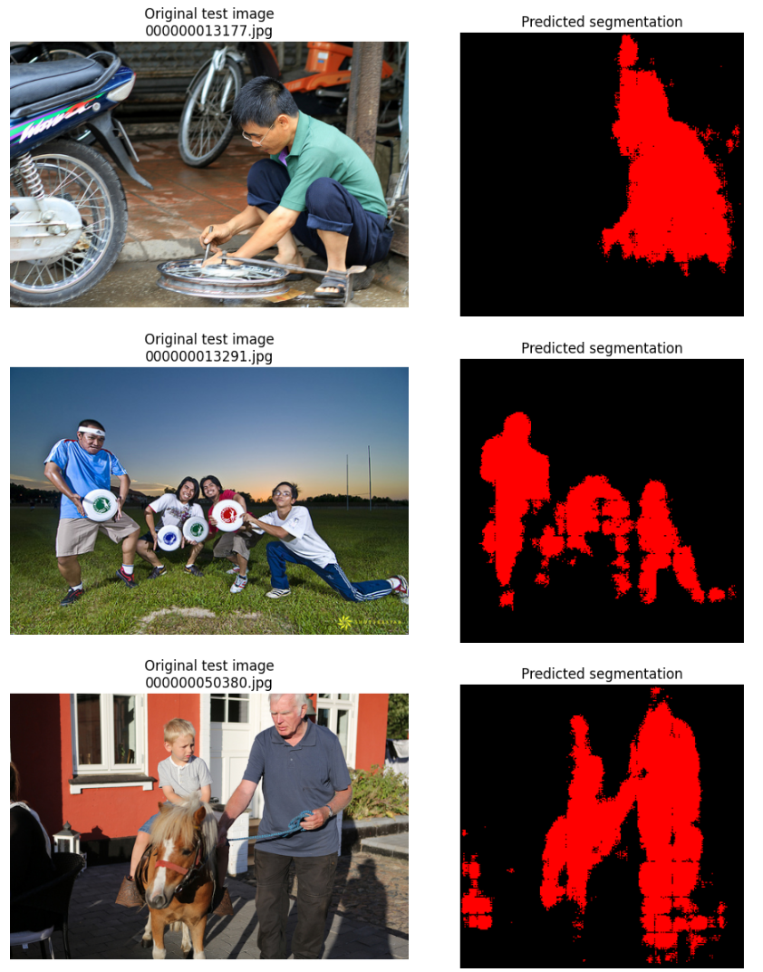
Fig7: Test sample results

Overall, the model performs well when objects are large and frequent, but struggles with small or under-represented categories and cannot distinguish individual instances. Addressing these issues would require more balanced data, stronger augmentation targeting small objects, loss re-weighting, or moving towards a true instance-segmentation architecture such as Mask R-CNN.

Future work
Class imbalance using loss re-weighting, focal loss, or class-balanced sampling, plus augmentation focused on small objects. Additional annotated data for minority classes would improve generalisation. Architecturally, adding ASPP or atrous convolutions and fine-tuning MobileNetV2, or moving to Mask R-CNN, could further enhance segmentation quality.

References:
- Long, J., Shelhamer, E., & Darrell, T. (2015). Fully convolutional networks for semantic segmentation. CVPR. Link to paper
- Ronneberger, O., Fischer, P., & Brox, T. (2015). U-Net: Convolutional networks for biomedical image segmentation. MICCAI. Link to paper
- Sandler, M., Howard, A., Zhu, M., Zhmoginov, A., & Chen, L.-C. (2018). MobileNetV2: Inverted residuals and linear bottlenecks. CVPR. Link to paper
- He, K., Gkioxari, G., Dollár, P., & Girshick, R. (2017). Mask R-CNN. ICCV. Link to paper

Appendix

# imports & drive
import numpy as np
import matplotlib.pyplot as plt
import tensorflow as tf
import os, random
from tensorflow import keras
from tensorflow.keras import layers
from pycocotools.coco import COCO
import skimage.io as skio
from tensorflow.keras.applications.mobilenet_v2 import preprocess_input as mobilenet_preprocess
from collections import Counter
from google.colab import drive
drive.mount("/content/drive")

"""# Load and prepare data

"""

# Defining paths and create COCO objects
# COCO APIs for train & validation

drive_path = "/content/drive/MyDrive/Individual assignment 2"

# Paths for training, validation and test splits
path_train = os.path.join(drive_path, "train-300")
path_val = os.path.join(drive_path, "validation-300")
path_test = os.path.join(drive_path, "test-30")

# Paths to COCO-style annotation files
ann_train_ = os.path.join(path_train, "labels.json")
ann_val_ = os.path.join(path_val, "labels.json")

# Create COCO API objects for train and validation sets
train_set_coco = COCO(ann_train_)
val_set_coco = COCO(ann_val_)

# Inspect categories and define target classes
# Restrict segmentation to four specific classes

# All categories in training JSON
cat_ID = train_set_coco.getCatIds()
catego = train_set_coco.loadCats(cat_ID)
print("Categories total in JSON:", len(catego))
print("First 5 categories:\n", catego[:5])

# Define target classes
target_class__ = ["person", "cat", "sports ball", "book"]

# Get their COCO IDs
target_class_id_s = train_set_coco.getCatIds(catNms=target_class__)
print("Target_class:", target_class__)
print("Target class IDs:", target_class_id_s)

# Mapping COCO category_id -> our label index (1..4)
# 0 will be reserved for background
id_cat_to_label = {c_id: (i + 1) for i, c_id in enumerate(target_class_id_s)}
print("COCO cat_id -> segmentation label:", id_cat_to_label)

#Collect unique training/validation images that contain at least one target class

def collect_unique_images_with_targets(coco, target_class_id_s):
"""
Collecting unique image records.

Parameters
----------
coco_obj : COCO API object.
target_class_ids : list[int] Category IDs to filter images by.
seed : int, optional Random seed used for shuffling the result list.

Returns
-------
list[dict]
List of unique image-info dictionaries.
"""
imges = []
for cat_id in target_class_id_s:
img_id = coco.getImgIds(catIds=[cat_id])
imges += coco.loadImgs(img_id)

# remove duplicates
uniq_imgs = []
for img in imges:
if img not in uniq_imgs:
uniq_imgs.append(img)

random.seed(0)
random.shuffle(uniq_imgs)
return uniq_imgs

# Build lists of train/validation image metadata restricted to the 4 classes
train_images_info = collect_unique_images_with_targets(train_set_coco, target_class_id_s)
val_images_info = collect_unique_images_with_targets(val_set_coco, target_class_id_s)

print(f" Unique TRAIN images with at least one target count: {len(train_images_info)}")
print(f"Unique VAL images with at least one target count: {len(val_images_info)}")

"""# Exploratory Data Analysis

1. 300 training, 300 validation and 30 unlabeled test images are taken. Each labelled split includes a COCO-style labels.json file. For this assignment, I restrict the problem to four classes: person, cat, sports ball, and book, plus background.

2. First, I checked the annotation file to compute basic statistics. In Fig.1 instance counts revealed a strong class imbalance, with person dominating the dataset and relatively few examples of cat and especially sports ball. Counting images per class showed that many images contain at least one person, but some classes appear only in a small subset of scenes.

"""

# class frequencies (instances per class) in training set
#instance counts revealed a strong class imbalance, with person dominating
# the dataset and relatively few examples of cat and especially sports ball.
# Counting images per class showed that many images contain at least one person,
# but some classes appear only in a small subset of scenes.

ann_ids__ = train_set_coco.getAnnIds()
anns_ = train_set_coco.loadAnns(ann_ids__)

instance_counts = Counter()
image_counts = Counter()

for a in anns_:
c_id = a["category_id"]
if c_id in target_class_id_s:
instance_counts[c_id] += 1
image_counts[a["image_id"]] += 1

print("Instance counts for target classes:")
for c_id in target_class_id_s:
c_name = train_set_coco.loadCats([c_id])[0]["name"]
print(f"{c_name:12s}: {instance_counts[c_id]} instances")

# Image size distribution (train)
#Histograms of image widths and heights indicated moderate variation
# in resolution but with most images in the 480 to 720-pixel range.

tr_heights = [i["height"] for i in train_images_info]
tr_widths = [i["width"] for i in train_images_info]

print("Height – min:", np.min(tr_heights), "max:", np.max(tr_heights), "mean:", np.mean(tr_heights))
print("Width – min:", np.min(tr_widths), "max:", np.max(tr_widths), "mean:", np.mean(tr_widths))

plt.figure(figsize=(8,5))
plt.subplot(1,2,1)
plt.hist(tr_heights, bins=10) # histogram plot
plt.title("Train image heights") # title
plt.xlabel("pixels")

plt.subplot(1,2,2)
plt.hist(tr_widths, bins=10) # histogram plot
plt.title("Train image widths") # Title
plt.xlabel("pixels")
plt.tight_layout()
plt.show()

# visualise an example image + its instance masks

def show_example_with_masks(coco, im_info, data_path, target_class_id_s):

"""
Visualise one image with its COCO annotations.

Parameters
----------
coco_obj : COCO
COCO API object.
img_info : dict
Image-info dictionary from COCO.
data_path : str
Path to folder containing the `data/` subfolder with images.
target_class_ids : list[int]
Category IDs to display.
figsize : tuple, optional
Figure size passed to matplotlib.
"""

im_id = im_info["id"]

image = skio.imread(os.path.join(data_path, "data", im_info["file_name"]))

ann_ids_ = coco.getAnnIds(imgIds=[im_id], catIds=target_class_id_s, iscrowd=None)
anns_ = coco.loadAnns(ann_ids_)

plt.figure(figsize=(8,8))
plt.imshow(image)
coco.showAnns(anns_, draw_bbox=True)
plt.axis("off")
plt.title("Image with COCO annotations")
plt.show()

example_img_info = train_images_info[0]
show_example_with_masks(train_set_coco, example_img_info, path_train, target_class_id_s)

# function to build a semantic mask for one image

def build_semantic_mask_for_image(coco, im_info, target_class_ids, cat_id_to_label):
"""
Build a 2D semantic mask for a single image by merging all instance masks.

Parameters
----------
coco_obj : COCO
COCO API object.
im_info : dict
Image-info dictionary from COCO.
target_class_ids : list[int]
Category IDs to include in the mask.
cat_id_to_label : dict[int, int]
Mapping from COCO category_id to internal label index (1..num_classes-1).
ignore_crowd : bool, optional
If True, ignore annotations where iscrowd==1.

Returns
-------
np.ndarray
Mask of shape (H, W) with integer labels in {0..num_classes-1}
"""
img_id = im_info["id"]
ann_ids_ = coco.getAnnIds(imgIds=[img_id], catIds=target_class_ids, iscrowd=None)
anns_ = coco.loadAnns(ann_ids_)
mask_ = np.zeros((im_info["height"], im_info["width"]), dtype=np.uint8)

for a in anns_:
c_id = a["category_id"]
if c_id not in target_class_ids:
continue

idx_label = cat_id_to_label[c_id] # 1..4
ann_mask_ = coco.annToMask(a) # 0/1 mask of shape (H, W)
# Assign class label where ann_mask == 1 (later instances overwrite earlier ones)
mask_[ann_mask_ == 1] = idx_label

return mask_

# quick check on example
sem_mask = build_semantic_mask_for_image(train_set_coco, example_img_info, target_class_id_s, id_cat_to_label)
print("Shape of Semantic mask :", sem_mask.shape)
print("Uniq labels in_mask:", np.unique(sem_mask))
plt.figure(figsize = (5,5))
plt.imshow(sem_mask, cmap="viridis")
plt.colorbar()
plt.title("Semantic mask (example)")
plt.axis("off")
plt.show()

"""## Data Generator & Pipeline build

COCO-style annotations are parsed to extract images and instance masks for the four target classes. For each image, individual instance masks are merged into a single semantic mask with integer labels (0 = background, 1–4 = target classes). Images and masks are resized to a fixed 256×256 resolution. Apipeline loads, preprocesses and batches the data: images are normalised with the MobileNetV2 preprocessing function, while masks are kept as integer label maps. Simple augmentations (e.g. random horizontal flip) are applied to improve generalisation.
"""

# data generator and pipeline
#Images and masks are resized to a fixed 256×256 resolution.
#A pipeline loads, preprocesses and batches the data:
#images are normalised with the MobileNetV2 preprocessing function,
# while masks are kept as integer label maps. Simple augmentations
# (e.g. random horizontal flip) are applied to improve generalisation.

IMG_SIZE__ = 256 # All images or masks resized to 256x256
BATCH_SIZE = 4 # Small batch size due to GPU memory
NUM_CLASSES = len(target_class__) + 1 # 4 foreground + 1 background

def image_mask_generator(images_info_list, coco, data_path, target_class_id_s, id_cat_to_label, img_size):
"""
Yield (image, mask) pairs as numpy arrays.

Parameters

images_info_list : list[dict]
List of image-info dictionaries.
coco_obj : COCO
COCO API object.
data_path : str
Path to folder containing the `data/` subfolder with images.
target_class_ids : list[int]
Category IDs to include.
cat_id_to_label : dict[int, int]
Mapping from COCO category_id to internal label index.
img_size : int
Target height/width after resizing.
preprocess_fn : callable
Function that preprocesses the image (e.g., MobileNetV2 preprocessor).

Yields

image_resized : np.ndarray, float32
Resized and preprocessed image, shape (img_size, img_size, 3).
mask_resized : np.ndarray, int32
Resized mask, shape (img_size, img_size).
"""
for ig_info in images_info_list:
file_name = ig_info["file_name"]
img_path = os.path.join(data_path, "data", file_name)

# Load img as RGB
img = skio.imread(img_path)
if img.ndim == 2:
# grayscale -> 3 channels
img = np.stack([img]*3, axis=-1)
elif img.shape[2] == 4:
# RGBA -> RGB
img = img[:, :, :3]

mask = build_semantic_mask_for_image(coco, ig_info, target_class_id_s, id_cat_to_label)

# Resize image and mask
image_resized = tf.image.resize(img, (img_size, img_size)).numpy().astype(np.float32)
mask_resized = tf.image.resize(np.expand_dims(mask, axis=-1),
(img_size, img_size), method="nearest").numpy().astype(np.int32)
mask_resized = np.squeeze(mask_resized, axis=-1)

# Preprocess image for MobileNetV2 (-1..1)
image_resized = mobilenet_preprocess(image_resized)

yield image_resized, mask_resized

output_signature = (
tf.TensorSpec(shape=(IMG_SIZE__, IMG_SIZE__, 3), dtype=tf.float32),
tf.TensorSpec(shape=(IMG_SIZE__, IMG_SIZE__), dtype=tf.int32),
)

def make_dataset(images_info_list, coco, data_path, shuffle=True):
ds = tf.data.Dataset.from_generator(
lambda: image_mask_generator(
images_info_list, coco, data_path, target_class_id_s, id_cat_to_label, IMG_SIZE__
),
output_signature=output_signature,
)
if shuffle:
ds = ds.shuffle(buffer_size=64, reshuffle_each_iteration=False, seed = 23030677)
ds = ds.batch(BATCH_SIZE).prefetch(tf.data.AUTOTUNE)
return ds

train_ds = make_dataset(train_images_info, train_set_coco, path_train, shuffle=True)
val_ds = make_dataset(val_images_info, val_set_coco, path_val, shuffle=False)

for batch_imag, batch_mask in train_ds.take(1):
print("Batch image shape:", batch_imag.shape)
print("Batch mask shape:", batch_mask.shape)

#visualisation of batch (image & mask)
# colour map for 5 classes (background + 4)
#I highlighted small objects (balls, books) and cluttered scenes with multiple
# examined the distribution of object areas (in pixels) and visualised a sample
# of images with their segmentation masks covered. The people and blockings,
#suggesting that both class imbalance and object scale would challenge model.

COLORS = np.array([
[0, 0, 0], # background - black
[255, 0, 0], # person - red
[0, 255, 0], # cat - green
[0, 0, 255], # sports ball - blue
[255, 255, 0],], dtype=np.uint8)# book - yellow

def decode_mobilenet_image(x):
# inverse of preprocess_input: from [-1,1] to [0,1]
return (x + 1.0) / 2.0

def colorize_mask(mask):
# mask: (H, W) with ints 0..4
"""
Convert an integer label mask into an RGB colour mask.

Parameters
----------
mask : np.ndarray, shape (H, W)
num_classes : int
colors : np.ndarray, shape (num_classes, 3)

Returns
-------
np.ndarray, shape (H, W, 3)
"""

h,w = mask.shape
color_mask = np.zeros((h,w,3), dtype=np.uint8)
for cls_idx in range(NUM_CLASSES):
color_mask[mask == cls_idx] = COLORS[cls_idx]
return color_mask

batch_images, batch_masks = next(iter(train_ds))

plt.figure(figsize=(12, 8))
for i in range(min(BATCH_SIZE, 4)):
img = decode_mobilenet_image(batch_images[i].numpy())
mask = batch_masks[i].numpy()

plt.subplot(2, 4, i+1)
plt.imshow(img)
plt.axis("off")
plt.title("Input image")

plt.subplot(2, 4, i+5)
plt.imshow(colorize_mask(mask))
plt.axis("off")
plt.title("Ground truth mask")
plt.tight_layout()
plt.show()

"""# Model Building
I took a U-Net–style encoder–decoder implemented in TensorFlow/Keras. The encoder reuses a pre-trained MobileNetV2 backbone (ImageNet weights), from which several intermediate feature maps are tapped for skip connections. A series of transposed convolution blocks gradually up-samples the bottleneck features, concatenating them with encoder features at matching resolutions. The final 1×1 convolution outputs per-pixel logits over five classes.
"""

# U-Net style model with MobileNetV2 backbone
#The encoder reuses a pre-trained MobileNetV2 backbone (ImageNet weights),
#from which several intermediate feature maps are tapped for skip connections.

base_model = tf.keras.applications.MobileNetV2(
input_shape=(IMG_SIZE__, IMG_SIZE__, 3),include_top=False,weights="imagenet")

# Use these layers' outputs for skip connections
layer_names = [
"block_1_expand_relu", # 128x128
"block_3_expand_relu", # 64x64
"block_6_expand_relu", # 32x32
"block_13_expand_relu", # 16x16
"block_16_project", # 8x8
]

layers_outputs = [base_model.get_layer(name).output for name in layer_names]
down__stack = tf.keras.Model(inputs=base_model.input, outputs=layers_outputs)
down__stack.trainable = False # start with frozen encoder

def up__sample(filters, size, apply_dropout=False):
initializer = tf.random_normal_initializer(0.0, 0.02)
res = tf.keras.Sequential()
res.add(
layers.Conv2DTranspose(filters,size,strides=2,padding="same",
kernel_initializer=initializer,use_bias=False))
res.add(layers.BatchNormalization())
res.add(layers.ReLU())
if apply_dropout:
res.add(layers.Dropout(0.5))
return res

up__stack = [
up__sample(512, 3), # 8x8 -> 16x16
up__sample(256, 3), # 16x16-> 32x32
up__sample(128, 3), # 32x32-> 64x64
up__sample(64, 3), # 64x64->128x128
]

def model_UNET(output_channels):
inputs = layers.Input(shape=(IMG_SIZE__, IMG_SIZE__, 3))

# Down-sampling through the model
skip = down__stack(inputs)
x = skip[-1] # bottleneck
skip = reversed(skip[:-1])

# Up-sampling and skip connections
for up, s in zip(up__stack, skip):
x = up(x)
x = layers.Concatenate()([x, s])

# Last upsample to get back to IMG_SIZE
last = layers.Conv2DTranspose(
output_channels,
3,
strides=2,
padding="same",
) # no activation -> logits

x = last(x)

return keras.Model(inputs=inputs, outputs=x)

model = model_UNET(NUM_CLASSES)
model.summary()

# compile model
# The model is trained with Sparse Categorical Cross-Entropy and Adam-optimiser.
# Early stopping based on validation loss reduces overfitting.
#During training, track loss and sparse categorical accuracy, after training,
# compute per-class Intersection-over-Union(IoU) on validation set and
# perform qualitative analysis on validation and test images.

loss_fn = keras.losses.SparseCategoricalCrossentropy(from_logits=True)

model.compile(
optimizer=keras.optimizers.Adam(learning_rate=1e-4),
loss=loss_fn,
metrics=["sparse_categorical_accuracy"],
)

EPOCHS = 20

# callbacks: early stopping & best model checkpoint
checkpoint_path = "/content/drive/MyDrive/Individual assignment 2/best_segmentation_model.h5"

callbacks__ = [
keras.callbacks.ModelCheckpoint(
checkpoint_path,
monitor="val_loss",
save_best_only=True,
verbose=1,
),
keras.callbacks.EarlyStopping(
monitor="val_loss",
patience=5,
restore_best_weights=True,
verbose=1,
),
]

history__ = model.fit(
train_ds,
validation_data=val_ds,
epochs=EPOCHS,
callbacks=callbacks__,
)

# Plot training and validation loss / accuracy
#training loss decreases to ~0.12, while validation loss stays around 0.3.
# Training accuracy continues to rise and validation accuracy stabilises at 0.9,
# showing little overfitting. This is expected given the small dataset and
#frozen encoder: the decoder learns class-specific refinements
# while the pre-trained backbone provides stable features.

plt.figure(figsize=(12,4))
plt.subplot(1,2,1)
plt.plot(history__.history["loss"], label="train")
plt.plot(history__.history["val_loss"], label="val")
plt.xlabel("Epoch")
plt.ylabel("Loss")
plt.legend()
plt.title("Loss")

plt.subplot(1,2,2)
plt.plot(history__.history["sparse_categorical_accuracy"], label="train acc")
plt.plot(history__.history["val_sparse_categorical_accuracy"], label="val acc")
plt.xlabel("Epoch")
plt.ylabel("Accuracy")
plt.legend()
plt.title("Accuracy")

plt.tight_layout()
plt.show()

# compute IoU per class on validation set
#Per-class IoU on the validation set reveals a strong dependence on data
#distribution. The model performs better for background and person classes,
# reflecting that these pixels dominate both images and annotations.
# Cat reaches 0.42, which is better, considering the limited number of examples
# and the network sometimes confuses cat pixels with background. Sports ball and
# book have 0.00 IoU, meaning that predicted masks never overlap substantially
#with ground truth, the model effectively collapses these classes into
# background or person, consistent with the class-imbalance.

def compute_iou_per_class(model, dataset, num_classes):
ious = {cls_id_: {"inter": 0, "union": 0} for cls_id_ in range(num_classes)}

for imgs__batch, masks__batch in dataset:
logits_ = model.predict(imgs__batch, verbose=0)
preds_ = np.argmax(logits_, axis=-1).astype(np.int32) # (B,H,W)

true_masks = masks__batch.numpy()

for cls_id_ in range(num_classes):
# ignore background IoU if you prefer (cls_id_ == 0)
pred_cls_ = (preds_ == cls_id_)
true_cls_ = (true_masks == cls_id_)

#intersction = np.logical_and(pred_cls, true_cls).sum()
#unio = np.logical_or(pred_cls, true_cls).sum()

ious[cls_id_]["inter"] += np.logical_and(pred_cls_, true_cls_).sum()
ious[cls_id_]["union"] += np.logical_or(pred_cls_, true_cls_).sum()

iou_scores = {}
for cls_id_ in range(num_classes):
inter = ious[cls_id_]["inter"]
union = ious[cls_id_]["union"]
if union == 0:
iou = np.nan
else:
iou = inter / union
iou_scores[cls_id_] = iou

return iou_scores

iou_scores = compute_iou_per_class(model, val_ds, NUM_CLASSES)

print("Per-class IoU (0 = background):")
for cls_id_, iou in iou_scores.items():
if cls_id_ == 0:
cls_name_ = "background"
else:
cls_name_ = target_class__[cls_id_ - 1]
print(f"{cls_id_} ({cls_name_:12s}): {iou:.4f}")

# Show predictions vs ground truth for some validation samples
#In the tennis image, the player is roughly segmented, but the mask is noisy
# and misses limbs and the racket. In the crowded kitchen scene, nearly
#all people are detected but merged into thick blobs with over-smoothed
#boundaries, illustrating the limitation of treating an instance problem
#as pure semantic segmentation.

def show_predictions(dataset, model, num_samples=3):
for img__batch, mask__batch in dataset.take(1):
logits_ = model.predict(img__batch, verbose=0)
preds_ = np.argmax(logits_, axis=-1)

for i in range(num_samples):
img = decode_mobilenet_image(img__batch[i].numpy())
tru__mask = mask__batch[i].numpy()
pred__mask = preds_[i]

plt.figure(figsize=(12,4))

plt.subplot(1,3,1)
plt.imshow(img)
plt.axis("off")
plt.title("Image")

plt.subplot(1,3,2)
plt.imshow(colorize_mask(tru__mask))
plt.axis("off")
plt.title("Ground truth")

plt.subplot(1,3,3)
plt.imshow(colorize_mask(pred__mask))
plt.axis("off")
plt.title("Prediction")

plt.tight_layout()
plt.show()

show_predictions(val_ds, model, num_samples=3)

"""# Working on test data"""

#Test dataset (no labels), predictions + visualisation

def test_imgs_load(test_path):
imags_ = []
filenames_ = []
data_folder_ = os.path.join(test_path)
for f in sorted(os.listdir(data_folder_)):
if f.lower().endswith((".jpg", ".jpeg", ".png")):
img_path = os.path.join(data_folder_, f)
img = skio.imread(img_path)
if img.ndim == 2:
img = np.stack([img]*3, axis=-1)
elif img.shape[2] == 4:
img = img[:, :, :3]
imags_.append(img)
filenames_.append(f)
return imags_, filenames_

test_images_, test_filenames_ = test_imgs_load(path_test)
print("Number of test images:", len(test_images_))

#Run model on a few testing images and visualise

def predict_and_show_on_test(model, images, filenames, num_samples=5):
num_samples_ = min(num_samples, len(images))
for i in range(num_samples_):
img = images[i]
fname = filenames[i]

# resize & preprocess
img_resized = tf.image.resize(img, (IMG_SIZE, IMG_SIZE)).numpy().astype(np.float32)
img_preproc = mobilenet_preprocess(img_resized)
logits = model.predict(np.expand_dims(img_preproc, axis=0), verbose=0)
pred_mask = np.argmax(logits[0], axis=-1)

plt.figure(figsize=(10,4))
plt.subplot(1,2,1)
plt.imshow(img)
plt.axis("off")
plt.title(f"Original test image\n{fname}")

plt.subplot(1,2,2)
plt.imshow(colorize_mask(pred_mask))
plt.axis("off")
plt.title("Predicted segmentation")
plt.tight_layout()
plt.show()

predict_and_show_on_test(model, test_images_, test_filenames_, num_samples=5)

"""#Results:
1. The network successfully highlights the main people in the scene, but produces rough outlines that ignore fine details and fail to capture non-person objects. This indicates reasonable generalisation to new images for the majority class but very poor transfer for minority classes.

2. Overall, the model performs well when objects are large and frequent, but struggles with small or under-represented categories and cannot distinguish individual instances. Addressing these issues would require more balanced data, stronger augmentation targeting small objects, loss re-weighting, or moving towards a true instance-segmentation architecture such as Mask R-CNN.
"""

