MAX Bilingüe: Spanish CSS Additions
File: bilingue/css/styles.css
Location: between /* ===== Yassine added: Spanish styles START ===== */ and /* ===== Yassine added: Spanish styles END ===== */ at the end of the file.
English rules: unchanged. Every addition applies only to the bilingual pages (classes lang-es / lang-en, strand-crossling, or new class names).

1. Color tokens
New colors defined in the same -rgb format as the template. Spanish orange and English navy, plus the strand token for the cross-linguistic lesson.
No visual change, so no screenshot.
CSS
:root {
/* new tokens, same -rgb pattern as the template's :root */
--color-spanish-rgb: 209, 73, 0;
--color-english-rgb: 35, 40, 118;
/* inline strand script builds var(--color-<body class>-rgb) */
--color-strand-crossling-rgb: var(--color-spanish-rgb);
}

2. Header bar
Header color shows the page language: orange on Spanish pages, navy on English pages. Text sizes and the dot spacing follow Figma.
Spanish page g4-u2-50-50_lesson6.html
English page g4-u2-50-50_lesson9.html
CSS
/* Header bar shows the page language */
.lang-es .top-sequence-wrap {
background-color: rgb(var(--color-spanish-rgb));
border-top: 0;
}

.lang-en .top-sequence-wrap {
background-color: rgb(var(--color-english-rgb));
border-top: 0;
}

.lang-es .sequence-block,
.lang-en .sequence-block {
gap: 0;
}

.lang-es .sequence-meta,
.lang-en .sequence-meta {
font-size: 16.56px;
line-height: 26px;
}

.lang-es .lesson-type,
.lang-en .lesson-type {
font-size: 15px;
font-weight: 700;
line-height: 26px;
}

/* Strand / lesson-name dot: 6px gap each side, per Figma (the space alone gives 4px) */
.lang-es .lesson-type .sequence-dot-inline,
.lang-en .lesson-type .sequence-dot-inline {
margin: 0 2px;
}

3. Cross-linguistic header pattern
Dotted pattern and navy end of the header on the cross-linguistic lesson. It fills the full header height and repeats downward when the header wraps; on phones it gets narrower so the lesson text keeps its room.
Cross-linguistic lesson g4-u2-50-50_lesson7.html
Tablet (900px): pattern repeats down the taller header g4-u2-50-50_lesson7.html
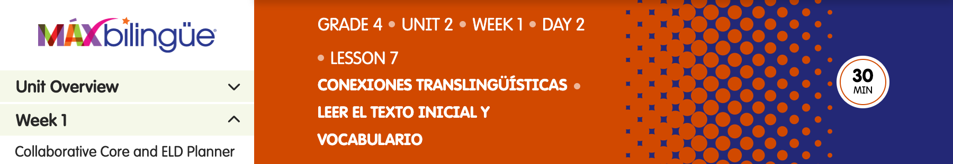
Phone (390px): narrower pattern g4-u2-50-50_lesson7.html
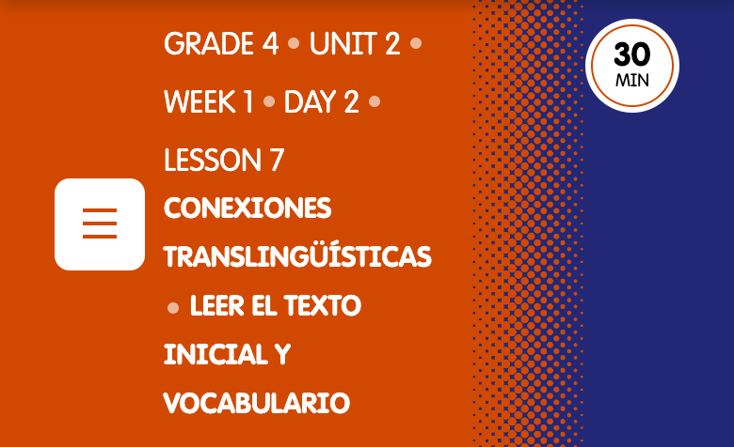
CSS
/* Cross-linguistic strand: dotted pattern + navy end of the header bar */
.crossling-pattern {
position: relative;
align-self: stretch;
flex: 0 0 200px;
width: 200px;
min-height: 72px;
margin: -10px -30px -10px auto;
/* repeats downward when the header wraps onto more lines */
background: url('../images/crossling_header_pattern.png') repeat-y center top / 200px auto;
}

.crossling-pattern::after {
content: '';
position: absolute;
top: 0;
bottom: 0;
left: 100%;
width: 100vw;
background-color: rgb(var(--color-english-rgb));
}

.top-sequence-wrap:has(.crossling-pattern) {
overflow: hidden;
}

.top-sequence-wrap:has(.crossling-pattern) .lesson-time-bg,
.top-sequence-wrap:has(.crossling-pattern) .sequence-left {
position: relative;
z-index: 1;
}

/* Phones and small tablets: narrower pattern (same proportions) so the lesson text keeps its room */
@media (max-width: 768px) {
.crossling-pattern {
flex-basis: 90px;
width: 90px;
background-size: 90px auto;
}
}

@media (max-width: 480px) {
.crossling-pattern {
flex-basis: 60px;
width: 60px;
background-size: 60px auto;
}
}

@media (max-width: 374.98px) {
.crossling-pattern {
flex-basis: 30px;
width: 30px;
background-size: 30px auto;
}
}

4. Left nav
MAX Bilingüe logo size and the ES / EN language badges on the Day 2 items.
Nav with language badges g4-u2-50-50_lesson6.html
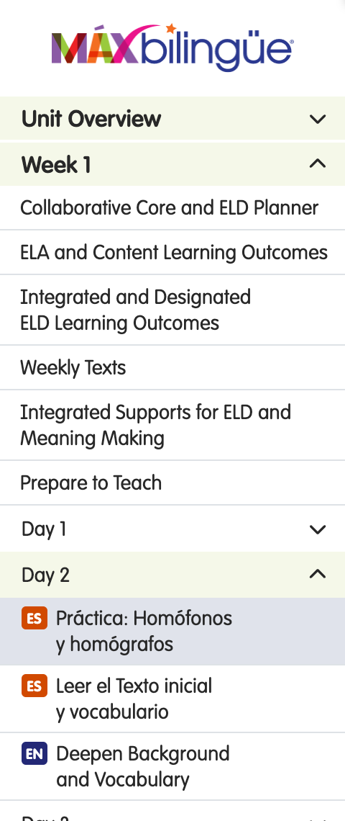
CSS
/* Left nav: MAX Bilingüe logo and language badges */
.offcanvas-start .offcanvas-logo.offcanvas-logo--bilingue {
width: 169px;
max-width: 169px;
}

.lang-badge {
display: inline-flex;
align-items: center;
justify-content: center;
flex: 0 0 auto;
height: 16px;
margin-top: 1px;
border-radius: 3px;
color: #fff;
font-size: 10px;
font-weight: 700;
line-height: 18px;
letter-spacing: 0.3px;
}

.lang-badge--es {
width: 18px;
background-color: rgb(var(--color-spanish-rgb));
}

.lang-badge--en {
padding: 0 3px;
background-color: rgb(var(--color-english-rgb));
}

.pro-sidebar .card-body .card-body a[data-type='internal']:has(> .lang-badge) {
justify-content: flex-start;
align-items: flex-start;
gap: 6px;
padding: 5px 10px 5px 15px;
}

5. Lesson headings and spacing
Lesson title on one line on wide screens (1440px and up, where the 70px column gap exists), spacing between lesson parts, sub-step headings (h3) and filled dots for nested bullets.
Title on one line g4-u2-50-50_lesson6.html
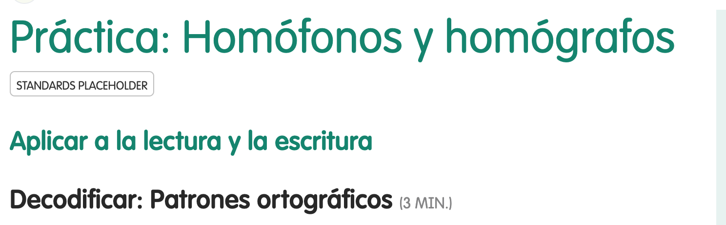
Spacing between lesson parts g4-u2-50-50_lesson6.html

Sub-step heading (h3) g1-u2-50-50_lesson7.html
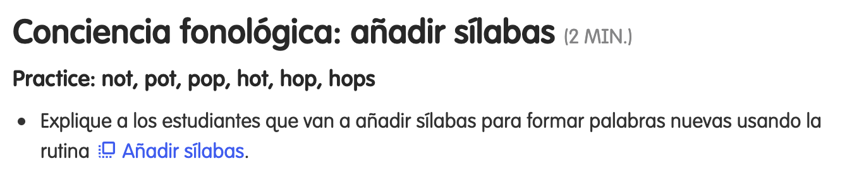
Nested bullet g1-u2-90-10_lesson6.html
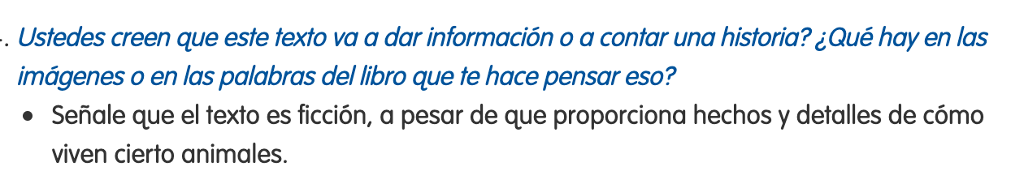
CSS
/* Lesson body spacing and links, per Figma */
/* Title may use the 70px column gap (one line, as in Figma); the template
only has a 70px gap from 1440px, below that it would run under the rail. */
@media (min-width: 1440px) {
.lang-es .lesson-content h1,
.lang-en .lesson-content h1 {
margin-right: -70px;
}
}

/* script.js wraps each part in a section, so a part heading (h1 / h2.aa-head)
ends up as the last child of the previous section. */
.lang-es .lesson-content :is(p, ul, ol, div, table) + :is(h1, h2.aa-head),
.lang-en .lesson-content :is(p, ul, ol, div, table) + :is(h1, h2.aa-head) {
margin-top: 60px;
}

.lang-es .lesson-content h1 + h2.aa-head,
.lang-en .lesson-content h1 + h2.aa-head {
margin-top: 10px;
}

.lang-es .lesson-content h2.aa-head + section > h2.sticky-top,
.lang-en .lesson-content h2.aa-head + section > h2.sticky-top,
.lang-es .lesson-content section:has(> h2.aa-head:last-child) + section > h2.sticky-top,
.lang-en .lesson-content section:has(> h2.aa-head:last-child) + section > h2.sticky-top {
margin-top: 20px;
}

/* Lesson sub-steps (Demostrar, Practicar, …): existing h3 size, Figma spacing */
.lang-es .lesson-content h3,
.lang-en .lesson-content h3 {
margin-top: 30px;
margin-bottom: 10px;
color: #282828;
line-height: 21.2px;
}

.lang-es .lesson-content h2.sticky-top + h3,
.lang-en .lesson-content h2.sticky-top + h3 {
margin-top: 10px;
}

/* Nested bullets use filled dots in Figma */
.lang-es .lesson-content li ul,
.lang-en .lesson-content li ul {
list-style-type: disc;
}

6. Links in the lesson text
Modal links wrap with the sentence, with 7px before the icon and 6px after it. Punctuation after a link inside teacher talk stays upright.
Modal link in a sentence g4-u2-50-50_lesson6.html
Upright period after a link in teacher talk g4-u2-50-50_lesson7.html
CSS
.lang-es .lesson-content .icon_baseline_shift > a,
.lang-en .lesson-content .icon_baseline_shift > a {
display: inline;
padding: 0;
font-weight: 400;
font-style: normal;
}

/* Upright punctuation after a link inside teacher talk (Figma) */
.lesson-text-roman {
color: #282828;
font-style: normal;
}

/* Modal links in the lesson text: 7px before the icon, 6px after it (Figma);
the space character alone gives 4px before the icon. */
.lang-es .lesson-content .icon_baseline_shift > a > .icon:first-child,
.lang-en .lesson-content .icon_baseline_shift > a > .icon:first-child {
margin-left: 3px;
margin-right: 2px;
}

7. Callout icons
Spanish callout icons (EVALUAR, iSLD, ACCESO, AMPLIAR) and English callout icons (iELD, ACCESS, ASSESS, EXTEND). PNG, exported from Figma at 4x.
EVALUAR g4-u2-50-50_lesson6.html
iSLD g4-u2-50-50_lesson6.html

ACCESO g4-u2-50-50_lesson7.html
AMPLIAR g1-u2-50-50_lesson7.html
iELD g4-u2-50-50_lesson9.html

ACCESS g4-u2-50-50_lesson9.html
ASSESS g1-u2-50-50_lesson9.html
EXTEND g4-u2-50-50_lesson9.html
CSS
/* Callout icons (PNG, exported from Figma at 4x) */
.icon-evaluar {
width: 93.21px;
height: 22px;
background-image: url('../images/icons/icon-evaluar-es.png');
}

.icon-isld {
width: 43px;
height: 26px;
background-image: url('../images/icons/icon-isld-es.png');
}

.icon-acceso {
width: 64.03px;
height: 26px;
background-image: url('../images/icons/icon-acceso-es.png');
}

.icon-ampliar {
width: 95.5px;
height: 22px;
background-image: url('../images/icons/icon-ampliar-es.png');
}

.icon-ield-en {
width: 42.55px;
height: 26px;
background-image: url('../images/icons/icon-ield-en.png');
}

.icon-access-en {
width: 64.03px;
height: 26px;
background-image: url('../images/icons/icon-access-en.png');
}

.icon-assess-en {
width: 78px;
height: 22px;
background-image: url('../images/icons/icon-assess-en.png');
}

.icon-extend-en {
width: 87.56px;
height: 22px;
background-image: url('../images/icons/icon-extend-en.png');
}

8. Other icons
Transfer icon, time-saver, slide and modal-link icons as PNG; the smaller slide thumbnail; the Professional Learning header icon (AP / PL).
Transfer icon in a heading g4-u2-50-50_lesson6.html
Time-saver icon g4-u2-50-50_lesson6.html
Slide label icon g4-u2-50-50_lesson6.html
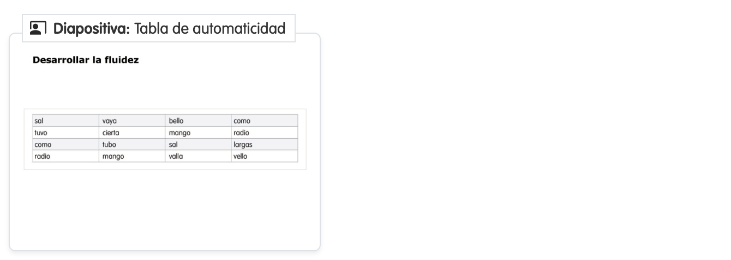
Smaller slide thumbnail g4-u2-50-50_lesson6.html

AP icon (Spanish) g4-u2-50-50_lesson6.html
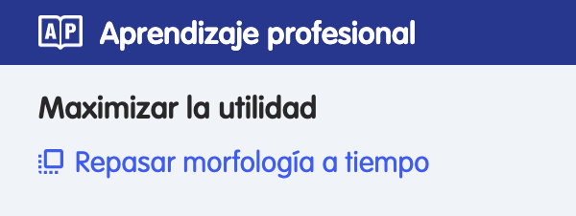
PL icon and small transfer icon (English) g1-u2-50-50_lesson9.html
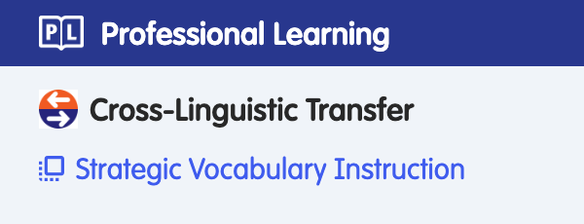
CSS
.icon-transfer-dl {
width: 23px;
height: 23px;
margin-right: 8px;
margin-bottom: 4px;
background-image: url('../images/icons/icon-transfer-dl.png');
}

/* PNG versions of icons that already exist as SVG in the English template */
.icon-timesaver-trs {
width: 19.53px;
height: 19.53px;
background-image: url('../images/icons/icon-timesaver-trs.png');
}

.icon-modal-trs {
width: 13px;
height: 13px;
background-image: url('../images/icons/icon-modal-trs.png');
}

.icon-slide-trs {
width: 20px;
height: 20px;
background-image: url('../images/icons/icon-slide-trs.png');
}

.slide-label .icon-slide-trs {
margin: 0;
}

.slide-thumb.slide-thumb--small img {
width: 216px;
}

.pd-header-icon.pd-header-icon--trs {
width: 23px;
height: 18.65px;
flex: 0 0 23px;
}

/* "Connecting Dual Language Lessons" (G1 EN pages): split-arrow label icon + strand-tinted box */
.icon-dl-split {
width: 24px;
height: 20px;
margin-right: 8px;
margin-bottom: 4px;
background-image: url('../images/icons/icon-dl-split-en.png');
}

/* 20px DL transfer icon (Professional Learning item) */
.icon-transfer-dl.icon-transfer-dl--sm {
width: 20px;
height: 20px;
margin-right: 6px;
}

9. Right rail
Rail heading color, blue bullets for linked resources, and the two book-cover sizes used in Figma.
Rail, portrait cover g4-u2-50-50_lesson6.html
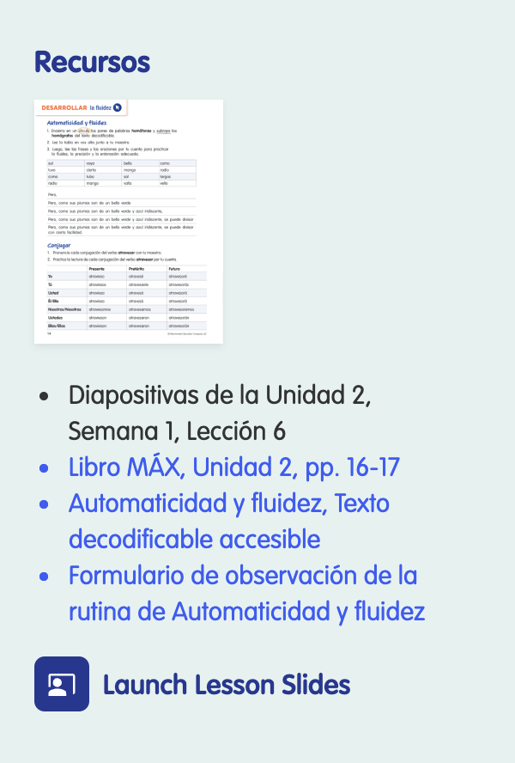
Rail, two-page cover g4-u2-50-50_lesson7.html
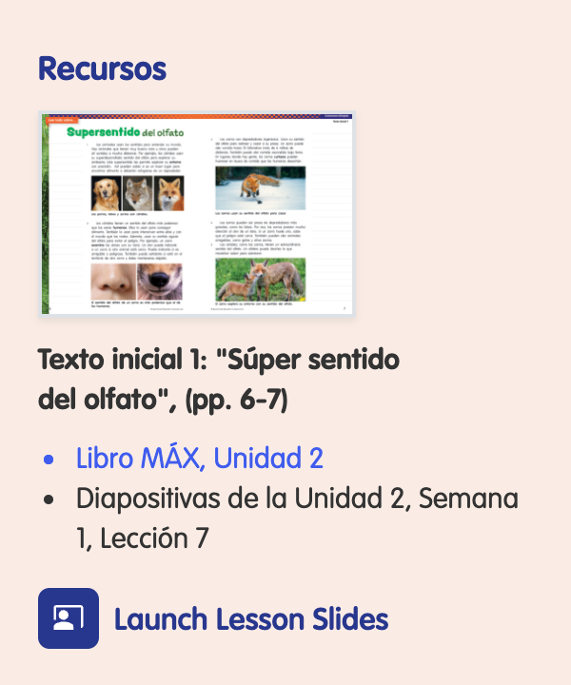
CSS
/* Right rail */
.lang-es aside .resources-area h2,
.lang-en aside .resources-area h2 {
color: rgb(var(--color-max-blue-rgb));
font-weight: 700;
}

.lang-es .lesson-rail .resources-area li:has(> a)::marker,
.lang-en .lesson-rail .resources-area li:has(> a)::marker {
color: var(--link-color);
}

.resource-cover.resource-cover--portrait {
width: 110px;
max-width: 110px;
}

.resource-cover.resource-cover--spread {
width: 167px;
max-width: 167px;
border: 1px solid #dee2e6;
}

10. WINN Time / Tiempo de GANA
Tab image and text block at the end of a lesson.
Tiempo de GANA g4-u2-50-50_lesson6.html

WINN Time g4-u2-50-50_lesson9.html

CSS
/* WINN Time / Tiempo de GANA tab */
.winn-time-block {
display: flex;
flex-direction: column;
align-items: flex-start;
gap: 8px;
margin-top: 50px;
padding-top: 16px;
}

.winn-time-tab {
display: block;
width: auto;
height: 23px;
}

.winn-time-block p {
margin-bottom: 0;
}

11. Tables
Dictation table, one-column dictation list, vocabulary tables, page / word / definition table and the sound / word list. On phones the tables fit the screen.
Dictation table g4-u2-50-50_lesson6.html
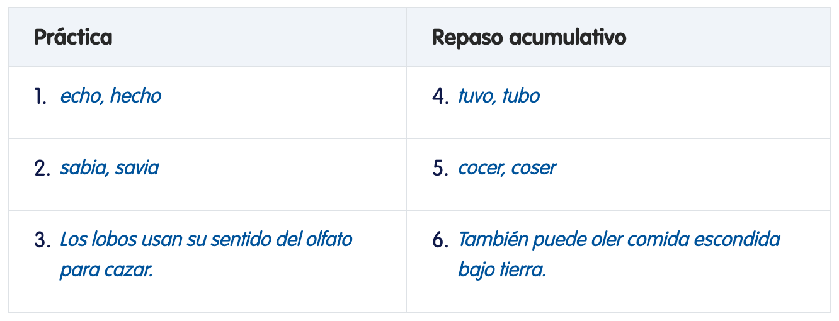
Dictation list g1-u2-90-10_lesson5.html
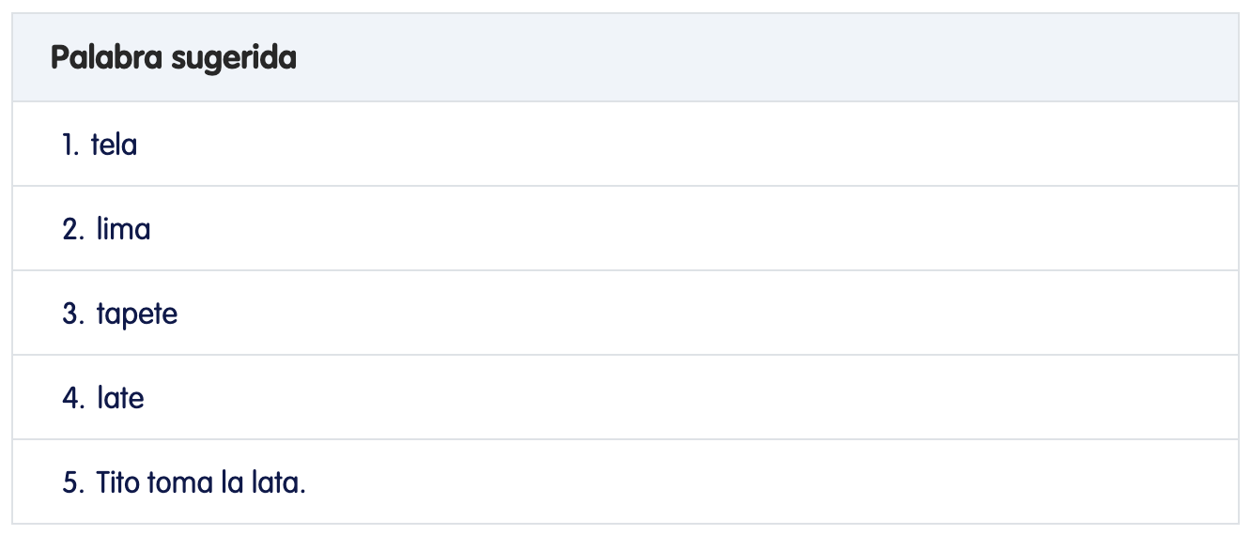
Vocabulary table g1-u2-50-50_lesson7.html
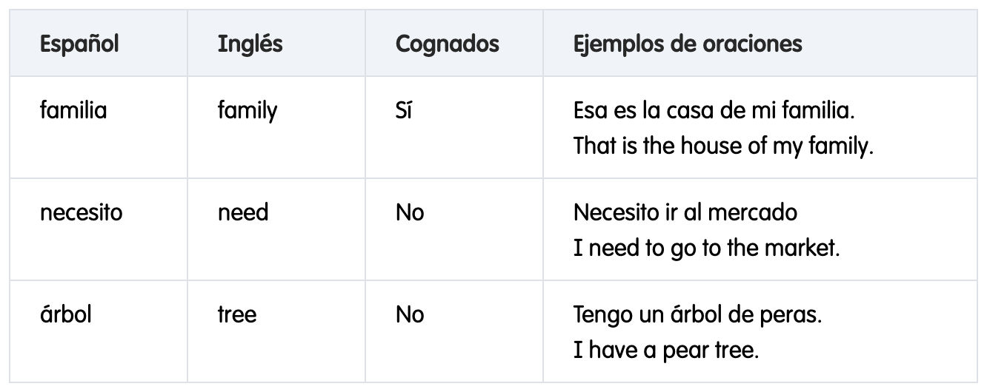
Page / word / definition table g1-u2-50-50_lesson8.html
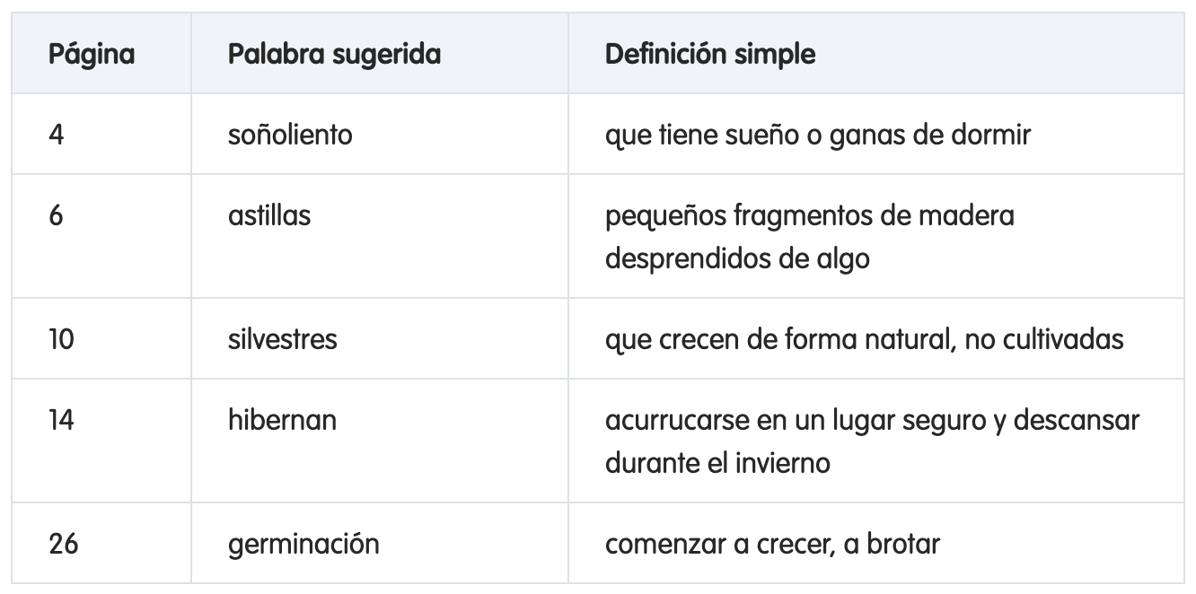
Sound / word list g1-u2-90-10_lesson2.html
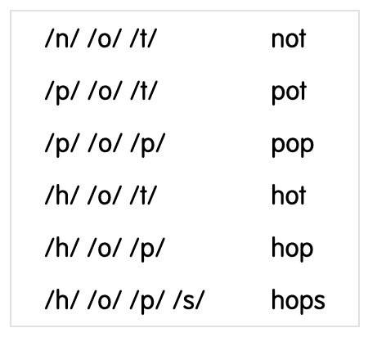
Vocabulary table on a phone (390px) g1-u2-90-10_lesson2.html
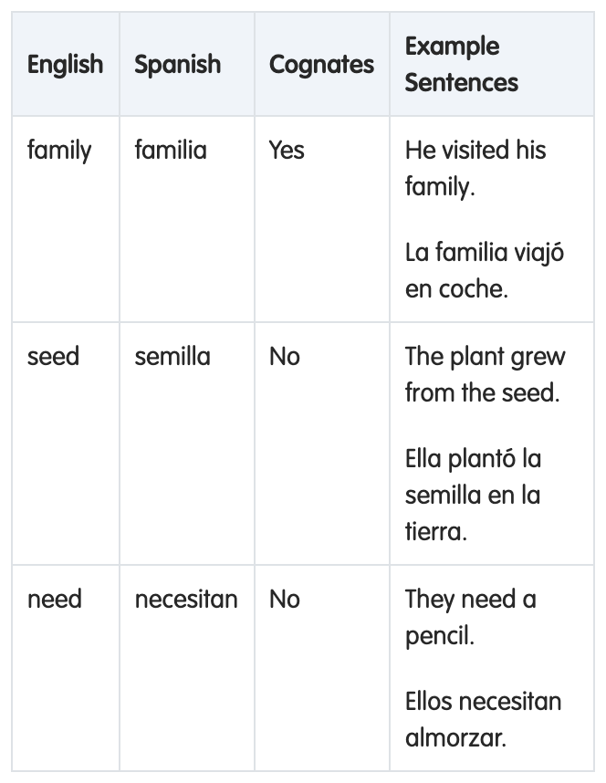
CSS
/* Dictation table (Práctica / Repaso acumulativo) */
.dictation-table {
width: 100%;
margin: 30px 0;
}

.dictation-table th {
padding: 10px 20px;
background-color: #f0f4f9;
color: #282828;
font-size: 17.5px;
font-weight: 700;
line-height: 26px;
text-align: left;
vertical-align: middle;
}

.dictation-table td {
padding: 10px 20px;
vertical-align: top;
}

.dictation-item {
display: flex;
align-items: flex-start;
gap: 6px;
}

.dictation-num {
flex: 0 0 14px;
color: #0f1949;
font-size: 17.5px;
line-height: 27px;
}

/* Vocabulary transfer table (Español / Inglés / Cognados / Ejemplos) */
.dictation-table.dictation-table--vocab th {
font-size: 16px;
font-weight: 600;
line-height: 24px;
}

.dictation-table.dictation-table--vocab th:nth-child(-n + 3) {
width: 120px;
}

/* Dictation guide: one column, numbered words at body size */
.dictation-table--list .dictation-item {
padding-left: 6px;
color: #0f1949;
}

.dictation-table--list .dictation-num {
flex: 0 0 auto;
font-size: 16px;
line-height: 24px;
}

/* Vocabulary table (English / Spanish / Cognates / Example Sentences) */
.vocab-table th {
font-size: 16px;
font-weight: 600;
line-height: 24px;
}

.vocab-table th:not(:last-child),
.vocab-table td:not(:last-child) {
width: 120px;
}

.vocab-table td {
color: #282828;
line-height: 24px;
}

/* Page / word / definition table (Página, Palabra sugerida, Definición simple) */
.vocab-table.vocab-table--pages th:first-child,
.vocab-table.vocab-table--pages td:first-child {
width: 100px;
}

.vocab-table.vocab-table--pages th:nth-child(2),
.vocab-table.vocab-table--pages td:nth-child(2) {
width: 210px;
}

/* Phones: let the vocabulary tables fit the screen (fixed column widths are for desktop) */
@media (max-width: 575.98px) {
.vocab-table th:not(:last-child),
.vocab-table td:not(:last-child),
.vocab-table.vocab-table--pages th,
.vocab-table.vocab-table--pages td,
.dictation-table.dictation-table--vocab th:nth-child(-n + 3) {
width: auto;
}

.dictation-table th,
.dictation-table td {
padding: 8px 8px;
font-size: 14px;
line-height: 20px;
}

.dictation-table td p {
font-size: inherit;
line-height: inherit;
}
}

/* Sound / word practice list (e.g. /n/ /o/ /t/ - not): 32px rows, 20px side padding (Figma) */
.sound-list-table td {
padding: 4px 20px;
line-height: 24px;
}

12. Dual-language boxes
Tinted box for "Connecting Dual Language Lessons" and the English / Spanish column title colors inside the template's transfer border.
Connecting Dual Language Lessons box g1-u2-50-50_lesson9.html
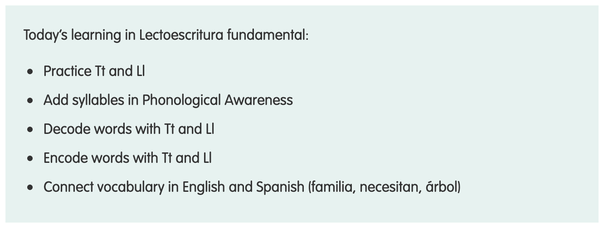
English / Spanish column titles g1-u2-50-50_lesson9.html
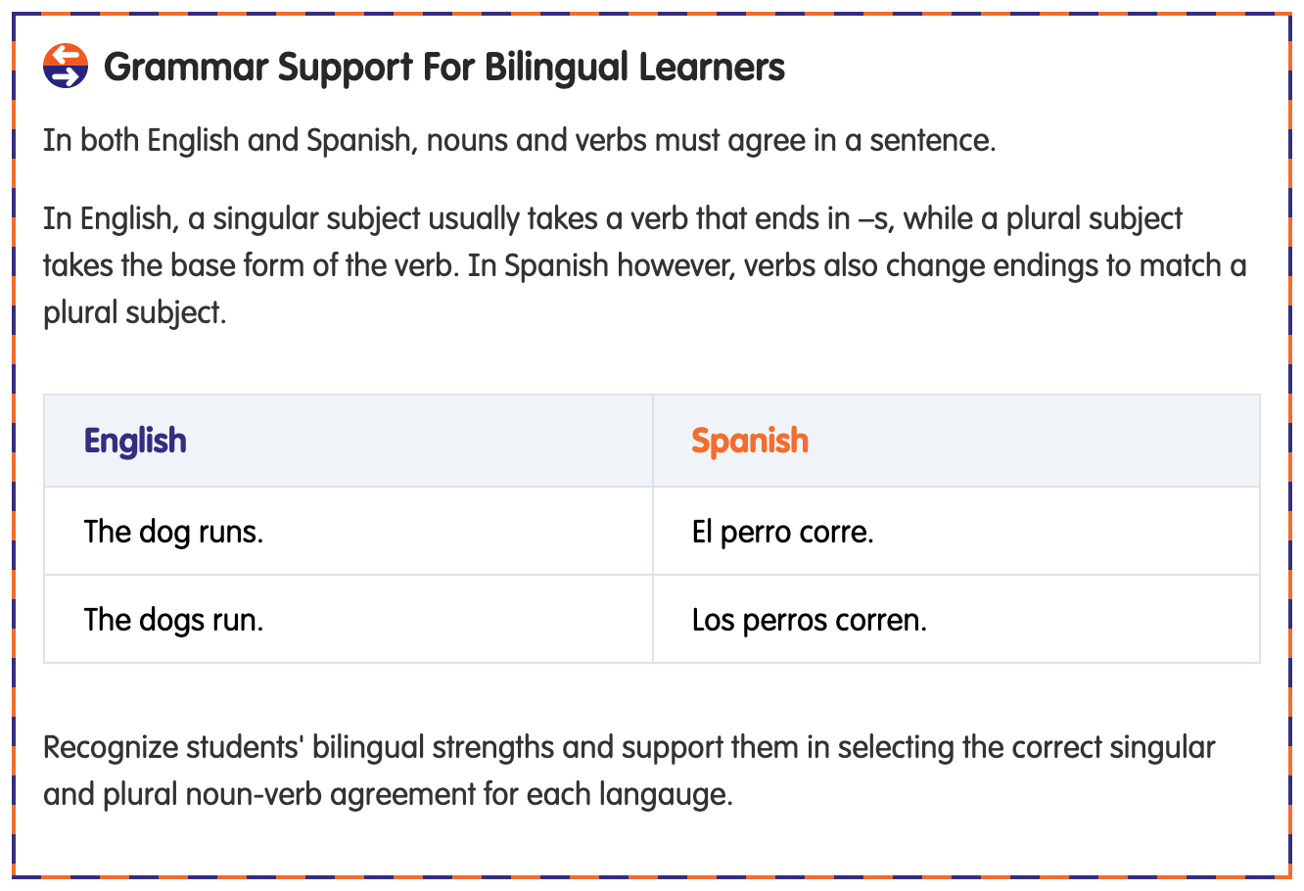
CSS
.dl-intro-box {
padding: 20px;
background-color: rgba(var(--strand-rgb), 0.1);
}

.dl-intro-box > :last-child {
margin-bottom: 0;
}

/* English / Spanish column titles inside .transfer-border use its own colors */
.transfer-border .text-english {
color: var(--english);
}

.transfer-border .text-spanish {
color: var(--spanish);
}

13. Grade color
Sets the template's --grade-color-rgb from the page grade (grade-1, grade-4). No visual change on its own.
No visual change, so no screenshot.
CSS
/* Grade color: --grade-color-rgb follows the page grade */
.grade-1 {
--grade-color-rgb: var(--color-grade-1-rgb);
}

.grade-4 {
--grade-color-rgb: var(--color-grade-4-rgb);
}

14. Relative paths
Relative versions of three template background images (nav chevron, mobile rail caret, Launch Lesson Slides icon), so pages open directly from the folder. No visual change.
No visual change, so no screenshot.
CSS
/* Relative-path versions of template rules that use root paths (/fonts, /images),
so the pages also open straight from the file system. */
.lang-es .nav-caret::after,
.lang-en .nav-caret::after {
background-image: url('../fonts/chevron-icon.svg');
}

.lang-es .mobile-rail-caret,
.lang-en .mobile-rail-caret {
background-image: url('../fonts/chevron-icon.svg');
}

.lang-es .icon-launch-lesson-slides,
.lang-en .icon-launch-lesson-slides {
background-image: url('../images/icons/launch-lesson-slides.svg');
}

