IntentFlow — One-Page Report

Problem
Most websites show the same homepage to every visitor, regardless of why they arrived. Enterprise companies solve this with expensive personalization tools (Optimizely, Dynamic Yield — $50K+ annually). Small and medium businesses, Shopify stores, and independent websites cannot access this technology, leaving massive conversion potential untapped.

Solution
IntentFlow is a plug-and-play AI personalization widget installable via a single <script> tag. It detects visitor intent from context signals and instantly personalizes the hero section with the optimal template, image, headline, and CTA — all client-side, with zero backend required.

How It Works
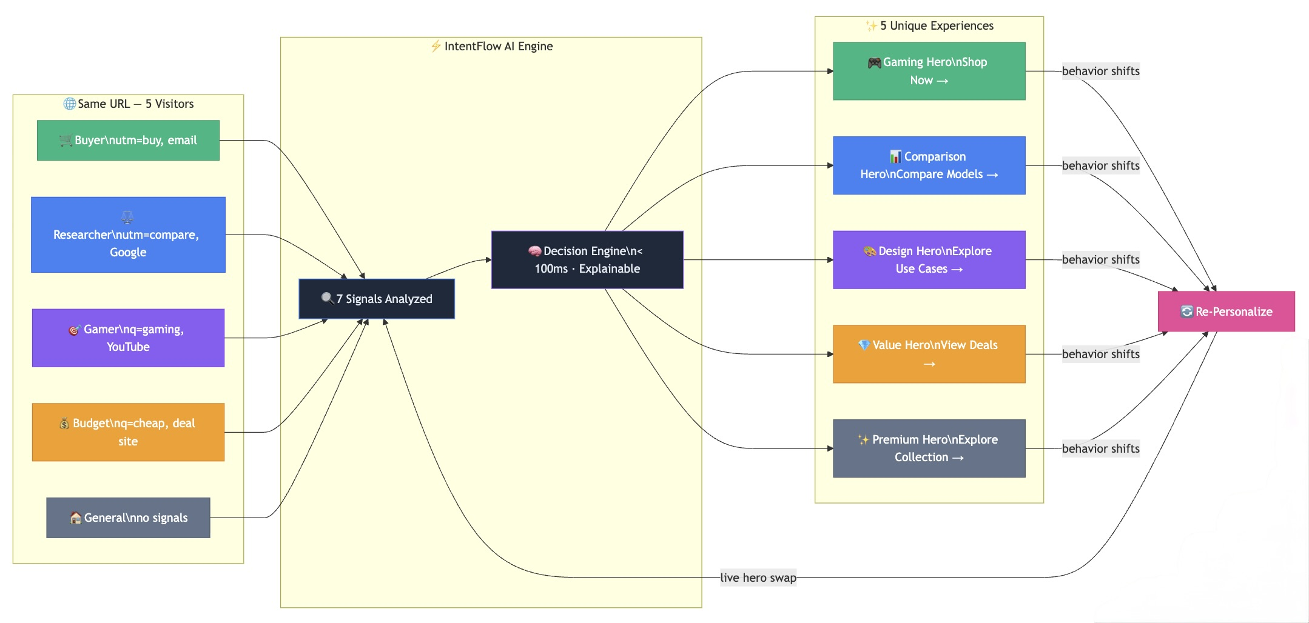
IntentFlow Architecture
Core Pipeline: Visitor → Intent Detector (7 signals) → Decision Engine → DOM Injector → Personalized Hero
Feedback Loop: Context Observer watches real-time behavior → re-triggers Intent Detector → re-personalizes mid-session
- Intent Detection — Analyzes 7 signal types: URL/UTM params, referrer, behavior, persona toggle, device type, time of day, and screen size
- Decision Engine — Scores signals, selects the best template and content from a finite registry, outputs an explainable decision object with confidence and reasoning
- DOM Injection — Safely swaps hero content with smooth transitions; graceful fallback on error
- Context Observer — Watches real-time behavior (scroll velocity, clicks, hover dwell, section visibility) and re-personalizes mid-session
- A/B Explorer — Random variant split per intent with automatic winner selection
- Multi-Page — Page-aware personalization across homepage, product, category, and landing pages

Technical Highlights
Component | Implementation
Architecture | 100% client-side JavaScript, zero dependencies, no build tools
Intent Signals | 7 types: UTM/query params, referrer, behavior, persona toggle, device type, time of day, screen size
Templates | 3 hero layouts: Impact, Comparison, Value — stored as JSON registry
Assets | 6 hero images, 6 badge icons, 5 content variants per intent
Explainability | Every decision outputs structured JSON with signals, confidence, and reasoning
Re-Personalization | Real-time behavioral observer adapts hero DURING visit (IntersectionObserver, scroll velocity, click patterns)
Safety | Finite templates (no generation), fallback to default, error boundary
Developer Tools | Debug overlay (Ctrl+Shift+D), preview mode, event tracking console
A/B Exploration | Random variant split per intent, localStorage CTR tracking, auto-winner selection
Multi-Page | Page-aware personalization: homepage, product, category, and landing pages
Analytics Dashboard | Conversion funnel, intent distribution, signal breakdown, ROI projections

Results & Demo
The demo store (UltraView Monitors) demonstrates 5 distinct hero experiences based on visitor intent: - Buy Now → Gaming hero + “Shop Now” CTA - Compare → Split-screen comparison + “Compare Models” CTA - Use Case → Design studio + “Explore by Use Case” CTA - Budget → Value-focused + “View Deals” CTA - Default → Premium general hero
All variants are accessible via URL parameters (?intent=buy_now) or the live persona toggle bar.

Market Opportunity
Personalization for the long tail — 6M+ Shopify stores, millions of SMB websites, all currently showing static content. IntentFlow is the “Stripe for website experiences”: simple to install, powerful under the hood. If plug-and-play personalization becomes easy and safe, it becomes a default growth lever for every small business online.

Built by Yannik Trinn | 4th Hack-Nation Global AI Hackathon 2026 | github.com/yatrinn/intentflow

