## Redesign Rationale

Our low-fidelity system prototype was generally well-received by the participants whom took part in the task-centered walk-throughs we performed in Phase II, and they expressed excitement about the idea of being able to group, annotate and share tabs based on tasks. However, from the point of view of the evaluators and interviewers, we were concerned about the complexity of the tasks that were presented to the participants; given that there are various paths a user can take to achieve the same tasks in a web browser (i.e. there are multiple ways of accessing the bookmarks, such as through the popup sidebar or the persistent bookmark toolbar above the tabs), it was difficult for the task walk-throughs to cover all cases. Such limitations might have prevented our participants to properly and critically evaluate the more detailed interactions associated with our design. Despite these possible deficiencies, we carry through our Phase III implementation by keeping most of the features that we originally came up with in order to more thoroughly evaluate the task-focus browser interface. Namely, these features are grouping, suspension and resumption, annotation and sharing of tasks. Related to these features, we identified two key points that needed be improve upon, which includes the default hiding of task management features and transparent sharing. In the following sub-sections, we detailed the improvement approaches we have taken for the medium fidelity prototype.

### Default Hiding of Task Management

While the task-focus approach allows the user to easier organize tabs and is more suitable for complex task switching and management, it might not always be necessary when the users are performing their daily web browsing routines; we intend our interface to not hinder or interfere with the users’ regular browser activities.

The initial low-fidelity system prototype relies on a task sidebar to manage all the tasks associated with the users, which can be either active or inactive, as shown in the screenshot of our paper prototype in Figure 1. Participants’ feedback suggested that the sidebar should be hid away when task management is not in used. While due to time constraint, such shrink-away feature was not

Figure 1. TabFour paper prototype with task sidebar

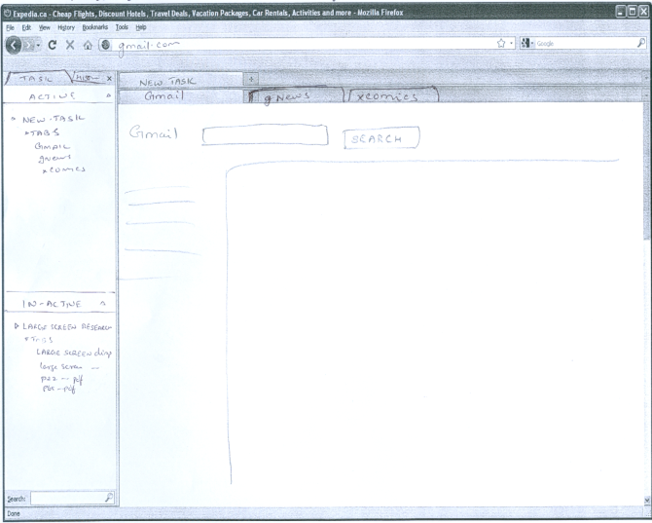

implemented in our medium fidelity prototype, we introduce a default task to our design such that the user can perform all the browsing practices they are accustomed to. Since tasks and tabs need to be actively managed by the users, the default task provides a pathway for the user to return to existing browsing mechanisms without utilizing any of the task management features of our design.

The default task is essentially the same as any other organized task; as the users feel the need to start organizing the numerous tabs that are being opened in the default task, they can easily rename and annotate, or even create new tasks to better handle the increasing browsing complexity. Figure 2 shows a screenshot of our browser prototype that initializes to the default task.

Figure 2. TabFour Browser showing the default task

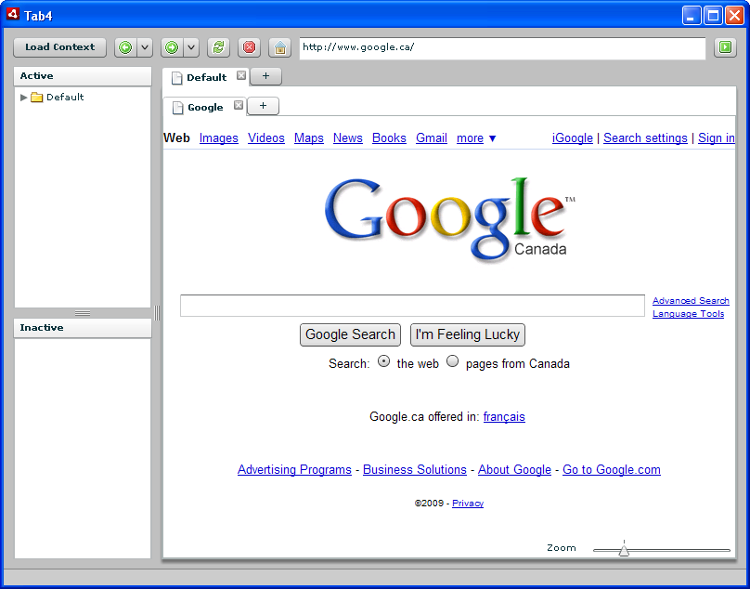

### Transparent Sharing

In our initial design, we intend our system to support sharing of an entire context by saving it as a “context file”, which can by transfer through emails or other mean to the receiving party. The context file is essentially a XML data file that contains all the information associated with the task, including opened links, annotations and bookmarks, so the user would be able to share more effectively multiple artifacts associated with a task with other parties. Our participants expressed concerns with the sharing mechanism in several ways. First of all, even though sharing an entire context file simplifies the need to transfer multiple links, it still heavily relies on the emailing or whichever file transfer protocols. Second, what if there are errors or corruptions to the file, or even viruses? Third, these files cannot be easily updated. If two parties were to collaborate on a browsing task, i.e. a research project that requires sharing the same task back and forth multiple times, multiple versions of the context file have to be created and transferred, which can be a daunting and non-trivial procedure.

A large part of our interface redesign surrounds the sharing feature in order to address these concerns. We designed two new mechanisms that allow the user to better share the task information which are drag-and-drop and cloud sharing.

Compared to the concept of a context file, the drag-and-drop design allows the user to more easily transport all the artifacts associated with a task to other applications that support html-format or plain text, such as an email client or a text file. The mechanism simplifies the process of the storage and sharing of browsing information that not only includes the tabs, but also bookmarks and annotations that have accumulated throughout the lifetime of the task. Figure 3 illustrates the drag-and-drop operation from our browser prototype to a web email client.

Figure 3. Drag-and-drop sharing

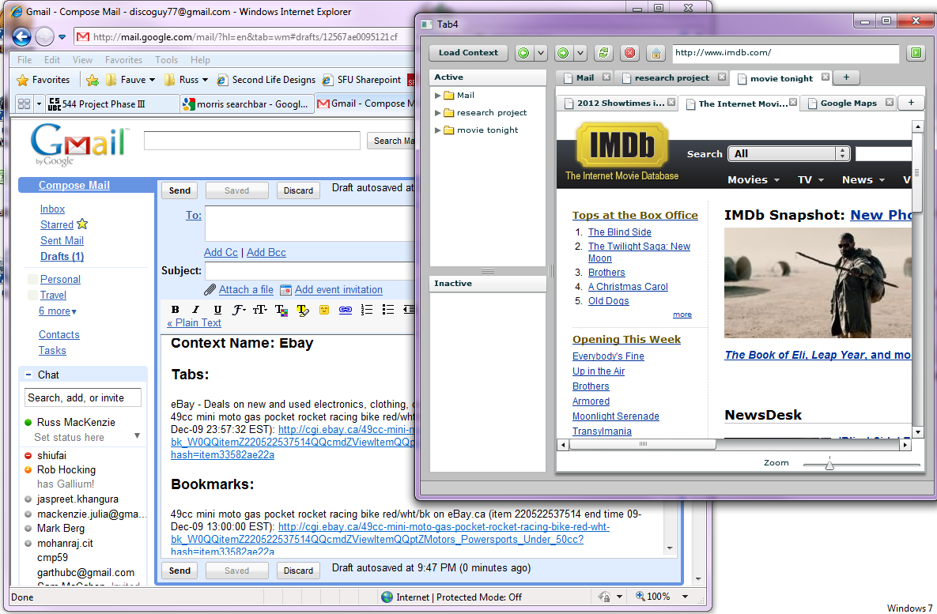

Another interesting sharing mechanism that we hope to explore and evaluate more in-depth in the future is the concept of cloud sharing of tasks. Besides dragging and dropping, we implemented the cloud sharing feature in the prototype that allows users to share the same task information through a simple web-service, referenced by a filename. The same task, along with all the tabs, bookmarks and annotations, can be obtained by other users by referencing to the same file name. The transfer is lightweight, as only the file name needs to be communicated, and updating the task to be shared again is simple, as the same file can be updated through the web. Not only does it promotes easy sharing, eliminating the back-and-forth transfer problem aforementioned, the cloud sharing feature of our prototype should encourage interesting browsing behaviours, such as randomly accessing task names that are of the user’s interest to explore what web pages, annotations and bookmarks other users have made in the same task space.