A task-focused approach to support sharing and interruption recovery in web browsers

Abstract

Copyright is held by the author/owner(s).

CHI 2010, April 10–15, 2010, Atlanta, Georgia, USA.
ACM 978-1-60558-930-5/10/04.
Mohan Raj Rajamanickam
Dept. of Computer Science
University of British Columbia
201-2366 Main Mall
Vancouver, BC V6T 1Z4 CANADA
mohanr@cs.ubc.ca

Russell MacKenzie
Dept. of Computer Science
University of British Columbia
201-2366 Main Mall
Vancouver, BC V6T 1Z4 CANADA
rmacken1@cs.ubc.ca
Billy Lam
Dept. of Electrical and Computer Engineering
University of British Columbia
5500-2332 Main Mall
Vancouver, BC V6T 1Z4 CANADA
billyl@ece.ubc.ca

Tao Su
Dept. of Computer Science
University of British Columbia
201-2366 Main Mall
Vancouver, BC V6T 1Z4 CANADA
taosu@cs.ubc.ca
Over the last two decades a vast number of services have moved online, and many new services have been created. Previous work shows that many users are overloaded by the number of webpages they use simultaneously. We introduce TabFour, a prototype web browser which integrates three features that address the design requirements identified in an initial design study. Webpages can be grouped into tasks, providing a unified target for resumption after an interruption. Tasks and pages can be annotated, supporting resumption after longer intervals. Finally, tasks can be shared through a simple yet novel web-service, allowing users to share groups of webpages more easily than with existing tools.

Keywords
Web browser, task focused interface, interruption, context sharing.

ACM Classification Keywords
H.5.2. User Interfaces – user-centered design, graphical user interfaces (GUI), prototyping. H.3.3. Information search and retrieval:Search process. H.4.3. Communications Applications: Information Browsers.

General Terms
Design, Human Factors.

Introduction
Over the past decade, tasks accomplished using a web browser have increased in complexity and density [3]. Users are spending more time in their web browsers, working on varied tasks such as shopping, research and communication. Tasks are often performed in parallel, and users frequently switch between tasks due to either self-initiated or external interrupts [2,4]. Hence, users often find it difficult to accomplish a task in a single session [5]. In a recent study, 83% of users reported resuming a web-based information seeking task, and 24% of those had resumed the task more than a week after suspending it [9]. Despite the evidence that many users are overloaded, modern web browsers provide only basic support for handling the interruption and resumption of tasks.
Motivated by the apparent difficulty of managing tasks, we conducted a series of interviews to explore users’ browsing habits and coping mechanisms. We generated a set of five design requirements. These informed the design of TabFour, a task-focused prototype web browser, in which webpages can be grouped into tasks, annotated, and shared through a simple web-service.
To evaluate our design, we conducted a small user study in our usability lab. We briefly describe the experimental protocol, and report results from the questionnaire data collected.

Related Work
Previous work addressing the problem of supporting interruption and resumption of tasks in web browsers have typically been created as browser extensions [8,9] or separate helper applications [5]. To leverage the authors’ skill sets, we chose to rapidly prototype a standalone web browser using Adobe AIR instead.
SearchBar [9] creates new tasks from search queries performed by the user. Tasks are shown in a sidebar while user annotations and bookmarks are presented in a summary page. Though binding the creation of a new task to a user's search activity seems like a good approach for those users who resort to passive mechanisms for task resumption, it is still unclear whether users actually prefer this mechanism to more direct methods. TabFour relies on explicit user actions to create tasks, which allow a user to continue using a more traditional interface without tasks until the more complex features are required.
Prior work by MacKay [8] includes a horizontal task-bar below the URL bar to manage tasks, which can be stopped and resumed. However, TabFour further supports task-specific bookmarks and annotations, as well as sharing of tasks over the web.
Jhaveri and Räihä’s Session Highlights tool shows thumbnails of the pages visited by the user, grouping them spatially based on the time the page was accessed [5]. TabFour shows annotated thumbnails of the current and bookmarked pages, grouped by task.

Formative evaluation
To explore the ongoing trouble users have with switching between tasks, we conducted a small formative evaluation. We began by conducting semi-structured interviews with 9 students, aged 18 to 29, ranging from novice to expert users of web browsers. The interviews focused on browsing behaviour, such as common or recent tasks performed; the use of existing tools, such as browsers and browser extensions; features within those tools, such as tabs, bookmarks, and history; search behaviours; and the sharing of webpages with other people.
We observed that most participants relied on search when revisiting a page, either by using a search engine or the auto-complete feature of the address bar, rather than using history or bookmarks. In fact, history was rarely used; several users were not aware of how to invoke the history feature of their preferred browser. Common complaints were that there were simply too many items in the history, and that items were difficult to find because it was hard to remember exactly when they had been visited. These observations coincide with those made by Morris [9] and by other researchers over the past decade [1,7,10].
Similarly, bookmarks were rarely used, except those placed on the bookmarks toolbar, which were used frequently. Users again complained that scanning the bookmark menu was cumbersome.
Participants often used sites together. For example, one participant opened several news sites simultaneously at the beginning of each day. Another recently planned a trip where she cross referenced flights, hotels, driving directions, and course schedules, all from different websites. Participants employed several coping strategies for saving these task states, such as sending themselves an email containing annotated URLs, or noting down URLs in a simple text document on the computer desktop. These and other strategies have been previously identified by other researchers [6,9].
We believe that these coping mechanisms provide several advantages over traditional tools such as book-marks or history. The presence of an artifact, such as an email or document, provides a powerful reminder of the pending tasks [2,4]. This is akin to how office workers tend to organize their documents in visibly separate piles along their workspace as reminders [2,6]. Artifacts like email can carry annotations, adding contextual information pertaining to the task and facilitating rapid task resumption even after long periods of time. Finally, these artifacts may be accessible from multiple computers, and users find them more reliable and less prone to loss, for example due to operating system upgrades [6].
Finally, we noted that users frequently had difficulty sharing webpages or groups of webpages; a few reported that they had previously avoided sharing URLs or had given up while trying to share webpages.

Design Requirements
From the rich, qualitative data we collected we derived several design requirements, intended to support advanced, multi-session web browsing:
R1. Support the grouping of webpages into tasks
R2. Facilitate task switching and resumption
R3. Include navigation artifacts, such as bookmarks
and history, as part of a task
R4. Allow annotation of webpages and tasks
R5. Ease sharing of pages and tasks between users
These design requirements informed the design of our TabFour prototype, detailed in the next section.

The TabFour Browser
We developed a prototype browser, shown in Figure 1, to support users who regularly use browsers for myriad tasks. In this section, we relate specific features of the TabFour browser to the design requirements. TabFour relies on explicit user actions to create tasks, which allows a user to use the interface without tasks until these features are required.
Grouping of webpages (R1) is accomplished by organizing them into tasks, which appear in an additional bar located above the tab bar. Only those pages which belong to the current task are shown in the tab bar, reducing clutter in the tab bar and increasing the number of pages the user is able to successfully manage. Tasks are also listed in the “Active” and “Inactive” panels on the left. Suspending a task to the Inactive panel frees space in the task bar, making it easier to separate immediate tasks from long term tasks; this increases the visibility of current tasks and facilitates task resumption and switching (R2).
Bookmarks can be added to a particular task (R3); this reduces clutter and keeps users from having to scan a long list of bookmarks. When completed, a task and its associated content can be removed.
When a user hovers over an item in the task sidebar, a popup panel displays a thumbnail view of the current webpage within the task, which provides an overview of the task and facilitates task switching (R2). The panel also contains a text box that can be used to add annotations to the task (R4).
Annotations can be added both to an individual page, such as to summarize a document, or to an entire task, such as to synthesize information from various sources. When sharing a task (R5), an annotation could be used to provide an overview or instructions for the recipient.
Sharing of tasks is accomplished in two ways. First, a task may be drag-and-dropped to any application which accepts either plain or HTML-formatted text. The task contents, including the task name, tab titles and addresses, bookmarks, and annotations, are formatted and pasted into the application. This is easier than copying and pasting URLs into an email (R5), which was a common behaviour observed in our interviews.
Additionally, users may share tasks over the internet using a simple web-service. To do this, the user right clicks the task, selects “Share task” (not shown in figure), and enters a textual string. They can then instruct another user to load the task by telling them the string, such as in an email or instant message. The other user simply presses the “Load task” button on their browser and enters the same string; the task, including all tabs, annotations and bookmarks are immediately loaded as an active task and displayed. This is easier than opening many URLs one by one (R5). All shared tasks are currently public and in the same namespace; future work could tie these tasks to individuals or groups of users.

Evaluation
We ran a small lab study with 8 subjects to examine the suitability of our design to support task switching in a high-pressure, interruption-ridden setting. We were unable to include our other design contributions in this preliminary evaluation. After a brief introduction, the primary task was to plan flights for two vacation trips using Mozilla Firefox and TabFour in counter-balanced
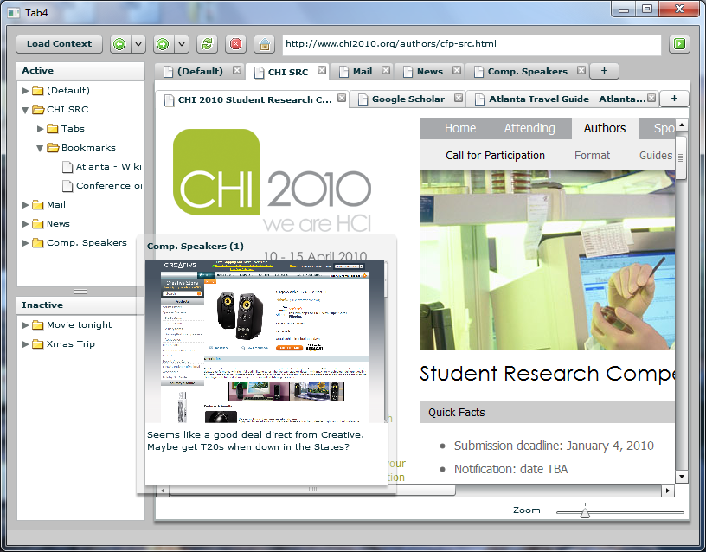
Clicking this button presents a dialog asking for the name of a task to load. A task can be shared using the right-click menu.

Some tasks are frequently used, such as “Mail” or “News”. Others are used only a few times, such as the task about purchasing computer speakers.

figure 1. Screenshot of the TabFour browser in action. The user is currently using five tasks, including the “CHI SRC” task, shown in tabs directly below the address bar. Within the current task, three webpages are open in tabs. Currently open tasks are shown in the “Active” sidebar on the left-hand side.
Since these bookmarks are specific
to the CHI SRC task, they don’t get
in the way while using other tasks.
The user is currently hovering over the Computer Speakers task, causing a transient popup to appear. The popup shows a thumbnail view of a tab within the task, and supports annotations in the text box at the bottom of the popup.
The “Inactive” sidebar lists two tasks which are currently suspended; double-clicking an inactive task activates it.
order; they were interrupted twice by an experimenter, observing through one-way glass and wall mounted cameras, who assigned additional tasks by email or instant message. These tasks required the subject to frequently shift their focus, then return to the original task when done. Subjects completed questionnaires about their task load, and another comparing the two browsers. In total, the experiment took about 40 minutes. None of the task load comparisons showed statistically significant differences, presumably due to a lack of power. However, all subjects stated that task-based browsing was useful, and made it easier to complete the tasks; that they would use task-based browsing if available in their primary web browser; and that it was easier to share webpages in TabFour than in Firefox. One user commented, “The organization is great to keep everything in order.” Another stated, “It was easier to jump in to a new task whenever I wanted and to leave the first task temporarily unfinished.”

Limitations and future work
Due to time constraints we chose to implement only a selected subset of features which would still address our design requirements. We structured our evaluation to account for the limited feature set by avoiding tasks which would require their use. Long-term, real world evaluations of a functionally complete system, using logging and critical incident interviews, will be crucial to understanding the adoption of task-focused browsing.

Conclusion
We have presented TabFour, a task-focused browser that supports grouping webpages into tasks and annotating them, in order to support task switching and resumption, and sharing tasks via email or a simple web-service. In a lab evaluation involving rapid task switching, all users reported that task-based browsing was useful and helped them complete their tasks.

References
[1] Byrne, M. D., John, B. E., Wehrle, N. S., Crow, D. C. The tangled Web we wove: a taskonomy of WWW use. In Proc. of CHI 1999, ACM Press (1999), 544-551.
[2] González, V. M. and Mark, G. "Constant, constant, multi-tasking craziness": managing multiple working spheres. In Proc. of CHI 2004, 113-120.
[3] How many tabs do people use? http://dubroy.com/
blog/how-many-tabs-do-people-use-now-with-real-data
[4] Iqbal, S. T. and Horvitz, E. Disruption and recovery of computing tasks: field study, analysis, and directions. In Proc. of CHI 2007, 677-686.
[5] Jhaveri, N. and Räihä, K. The advantages of a cross-session web workspace. In Proc. of CHI 2005 Extended Abstracts, ACM Press (2005), 1949-1952.
[6] Jones, W., Bruce, H., and Dumais, S. Keeping found things found on the web. Proc. of CIKM 2001, 119-126.
[7] Kellar, M., Watters, C., and Shepherd, M. The impact of task on the usage of web browser navigation mechanisms. In Proc. of GI 2006, 235-242.
[8] MacKay, B. and Watters, C. Exploring multi-session web tasks. In Proc. of CHI 2008, 1187-1196.
[9] Morris, D., Ringel Morris, M., and Venolia, G. SearchBar: a search-centric web history for task resumption and information re-finding. In Proc. of CHI 2008, ACM Press (2008), 1207-1216.
[10] Tauscher, L., Greenberg, L. Revisitation patterns in World Wide Web navigation, In Proc. of CHI 1997, ACM Press (1997), 399-406.

