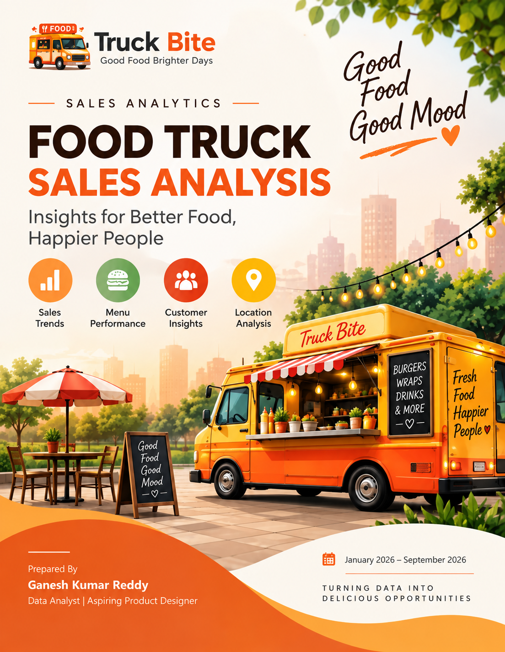

EXECUTIVE SUMMARY
This report presents a data-driven analysis of a food truck business's sales performance for the January–December 2024 period. Drawing on 10,000 order-level transaction records, it examines revenue and profit trends, menu category and item performance, store location performance, payment behavior, and weekly demand patterns to support better operating and menu decisions.
- Strong overall performance: the business generated ₹147K in total revenue and ₹85K in profit across 10,000 orders, at a healthy 58% profit margin and an average order value of ₹15.
- Chinese cuisine leads the menu: the Chinese category alone contributes ₹58.11K (39.64%) of total revenue, ahead of Rice (30.27%) and South Indian (19.04%), with Snacks the smallest but a high-margin category.
- Chicken Biryani is the star performer: it is the top revenue item (₹23K from ~2.6K units) and the top profit contributor (₹12K), while Samosa (2 Pieces) is the single most ordered item by quantity.
- Revenue outpaces order volume growth: monthly order counts stay in a relatively narrow 980–1.4K band, while revenue swings more widely, peaking around September, pointing to higher-value baskets in strong months rather than simply more orders.
- Location performance is uneven: Times Square leads on both average order value (₹32K) and total profit (₹18K), while Coney Island Boardwalk trails on both, a 4x profit and AOV gap between the strongest and weakest sites.
- Weekends drive demand: Saturday and Sunday each generate 1.7K orders, roughly 30% higher than an average weekday, underscoring the importance of weekend staffing and inventory planning.
- Digital payments dominate: Credit Card is the preferred payment method at 34.68% of orders, followed by Apple Pay and Google Pay, reflecting a broader shift away from cash.

TABLE OF CONTENTS
No. | Report Section | Page
1 | Introduction | 4
2 | Objectives | 5
3 | Methodology | 6
4 | Business Overview | 7
5 | Revenue & Profit Analysis | 8
6 | Category-Wise Performance | 10
7 | Product & Menu Analysis | 11
8 | Monthly Order Trends | 13
9 | Store & Location Analysis | 14
10 | Payment Method Analysis | 16
11 | Day-of-Week Demand Analysis | 17
12 | Key Insights | 18
13 | Recommendations | 19
14 | Conclusion | 21
15 | References | 22

EXECUTIVE SUMMARY
This report provides a full-year review of the food truck's FY 2024 sales performance using 10,000 order-level transaction records. The analysis covers revenue, profit, order volume, menu categories, individual products, six operating locations, five payment methods, and weekly demand patterns.
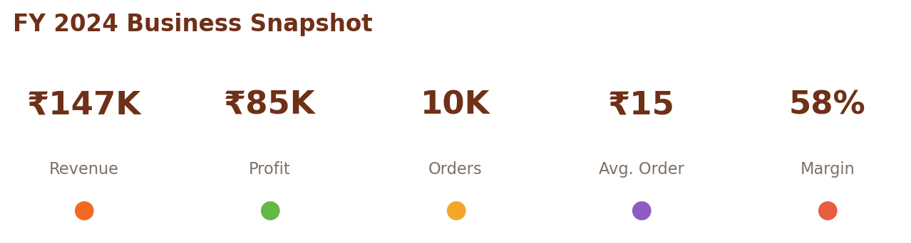
Core FY 2024 KPIs reported in the analysis.
The business generated ₹147K in total revenue and ₹85K in profit across 10,000 orders. The reported average order value is ₹15 and the reported profit margin is 58%. The report also notes improvement in profit, order volume, and average order value versus the prior reporting period, despite a modest decline in headline revenue.
The strongest menu contributor is Chicken Biryani, with ₹23K in revenue, approximately 2.6K units sold, and ₹12K in profit. Chinese is the largest category at ₹58.11K, while Samosa (2 Pieces) is the highest-volume individual item by quantity.
Performance varies significantly by location. Times Square leads the network on reported average order value (₹32K) and profit (₹18K), while Coney Island Boardwalk is lowest on both measures. Demand is also stronger on Saturday and Sunday, each at approximately 1.7K orders.

1. INTRODUCTION
Food trucks require fast, practical decisions because their sales depend on what is sold, where it is sold, when demand occurs, and how customers pay. A full-year transaction dataset makes it possible to move from intuition to evidence by comparing menu performance, location economics, seasonal demand, and payment behavior.
This report analyses the January–December 2024 trading period. The underlying dataset contains 10,000 order-level transactions and the analysis is organised around three linked dashboard perspectives: Overview, Product & Category Analysis, and Store & Customer Analysis.
1.1 Purpose & Scope
- Measure revenue, profit, order volume, average order value, and profit margin.
- Identify top- and bottom-performing menu categories and individual items.
- Compare performance across six operating locations.
- Analyse five payment methods and identify the dominant channels.
- Understand monthly and day-of-week demand patterns for planning.
- Translate the findings into practical menu, location, and operational recommendations.
1.2 Business Scope
- 4 menu categories: Chinese, Rice, South Indian, and Snacks.
- 6 locations: Times Square, Brooklyn Bridge Park, Wall Street, Central Park South, Flushing Main Street, and Coney Island Boardwalk.
- 5 payment methods: Credit Card, Apple Pay, Google Pay, Debit Card, and Cash.
- Metrics include revenue, profit, quantity, average order value, and profit margin.
1.3 Why This Analysis Matters
Beyond descriptive reporting, this analysis is intended to function as a decision-support tool for the owner-operator. Because a single food truck typically runs on thin working capital and a small crew, small shifts in menu mix, site allocation, or staffing timing can have an outsized effect on cash flow. Framing the FY 2024 results as a set of levers, rather than a static scorecard, is intended to make the findings directly actionable for the next planning cycle.
- Distinguish between metrics the operator can influence directly, such as menu mix and staffing, and those that are largely structural, such as location footfall and seasonality.
- Flag which findings warrant immediate action versus which require further testing before a decision is made.
- Provide a shared reference point so that menu, location, and staffing decisions are grounded in the same underlying data.
- Create a baseline against which FY 2025 performance can be measured.

2. OBJECTIVES
The analysis is designed to answer a set of business questions rather than simply present numbers. The primary objective is to identify the operational drivers behind revenue and profit so that management can protect winning products, improve weaker locations, plan capacity around demand, and make better use of customer payment behavior.
- How much revenue and profit did the business generate in FY 2024?
- Which categories and products contribute most to revenue and profit?
- Does order volume move in the same way as revenue?
- Which locations create the strongest customer value and profit?
- Which payment methods dominate transactions?
- Which days of the week require additional staffing and preparation?
These questions are deliberately framed at the level of the whole operation rather than any single dashboard, since menu, location, and staffing decisions are interdependent in a food truck business. A change made in one area, such as a menu simplification, can shift demand patterns in another, such as weekend staffing needs.
2.1 Success Criteria
- A clear ranking of which categories, items, and locations drive most revenue and profit.
- A defensible explanation for the gap between the strongest and weakest locations.
- Practical guidance on staffing and inventory timing based on demand patterns.
- Recommendations specific enough to be implemented within a single quarter.

3. METHODOLOGY
3.1 Data Collection
The report states that order-level sales data was collected from the food truck's point-of-sale system for the full FY 2024 trading period. The records capture transactions across menu items and operating locations.
3.2 Data Preparation & Validation
The 10,000-row dataset was cleaned and validated. Revenue, cost, and gross profit were checked against selling price × quantity and cost × quantity respectively. This validation step supports consistency between the underlying transaction records and the dashboard calculations.
3.3 Aggregation
Records were aggregated by month, category, item, location, payment method, and day of week. These grouped views were then used to create the KPI cards, ranking charts, trend charts, and distribution views in the three dashboards.
3.4 Interpretation Approach
The report focuses on relative performance: which products lead, which locations lag, where demand concentrates, and whether revenue changes appear to be associated with order volume or basket composition. Where the source report uses approximate values, this report preserves that approximate framing.
3.5 Limitations & Assumptions
As with any dashboard-based analysis, several limitations apply. The report relies on the categorisations and approximate values used in the source dashboards rather than re-deriving figures from raw transaction rows, so headline numbers such as revenue and profit are reported to the nearest thousand rupees rather than to the rupee. Seasonal patterns reflect a single trading year and may not repeat identically in future years, particularly where local events, weather, or competitor activity shift footfall at a given site.
- Figures are presented as reported in the source dashboards, including any rounding already applied.
- Category and item names follow the naming conventions used in the underlying point-of-sale system.
- The analysis does not adjust for inflation, promotional discounting, or one-off events during FY 2024.
- Location-level comparisons assume broadly similar operating hours and staffing levels across sites unless otherwise noted.

4. BUSINESS OVERVIEW
The business operates across six high-footfall locations and offers four menu categories. The headline KPI view establishes the scale of the operation before moving into product, category, location, and customer-payment analysis.
What the KPIs mean
- Total Revenue (₹147K): the reported sales value generated during the FY 2024 period.
- Total Profit (₹85K): the reported profit contribution after the stated cost treatment.
- Total Orders (10K): the number of order-level transactions analysed.
- Average Order Value (₹15): the reported average value per order.
- Profit Margin (58%): the reported profitability ratio for the period.
Taken together, the KPI profile indicates a profitable operation with a strong reported margin. The key management question is therefore not simply how to increase transaction count, but how to preserve margin while increasing the value and quality of the business mix.
4.1 Operating Model
The business operates a single-truck, multi-site model, moving between six locations rather than operating from a fixed premises. This model allows the operator to chase footfall across different parts of the city on different days, but it also means that performance is a function of both the menu and the site calendar. Understanding how much of the location gap is due to footfall versus menu execution is therefore an important follow-up question for management.
- Revenue and profit are pooled across all six locations rather than tracked as separate businesses.
- Each location may draw a different customer profile, such as office workers, tourists, or weekend visitors, which affects average order value.
- Operating hours and days at each site are not detailed in the source dashboards but should be documented going forward.
- The four menu categories are offered consistently across all six locations.

5. REVENUE & PROFIT ANALYSIS
FY 2024 revenue reached ₹147K while profit reached ₹85K. The source report highlights a notable pattern: profit, order volume, and average order value improved versus the prior reporting period even though headline revenue dipped slightly. This suggests that efficiency and mix are important parts of the performance story.
5.1 Revenue and Profit Interpretation
A food truck can improve profitability without relying exclusively on more customers. Higher-value menu choices, stronger margins, pricing, better product mix, or lower operating costs can increase profit even when overall revenue growth is modest. The source report interprets the FY 2024 results in this direction.
5.2 Monthly Revenue Pattern
The report describes revenue as rising from January through the middle of the year, dipping briefly around July, then reaching a clear high around September before easing in October and rebounding again in December. The exact monthly revenue series is not reproduced here because the source report describes the pattern rather than providing a complete monthly revenue table.
5.3 Key Management Takeaway
The most useful comparison is revenue versus order volume. If order volume is relatively stable while revenue moves more widely, management should examine basket composition and item mix rather than treating footfall alone as the growth lever.
5.4 Seasonal Drivers
The September peak in revenue coincides with a period when order volume is also near its highest point, suggesting that both higher footfall and stronger basket value contributed to that month's performance. The July dip, by contrast, occurs even though order volume remains comparatively high, which points more toward a mix or pricing effect than a footfall effect. Management should treat these two months as useful case studies when planning promotions for the next year, since they illustrate different routes to the same revenue outcome.

6. CATEGORY-WISE PERFORMANCE
The menu contains four categories. Chinese is the largest revenue contributor, followed by Rice, South Indian, and Snacks. The category distribution shows that the business has a strong core rather than depending on a single category.
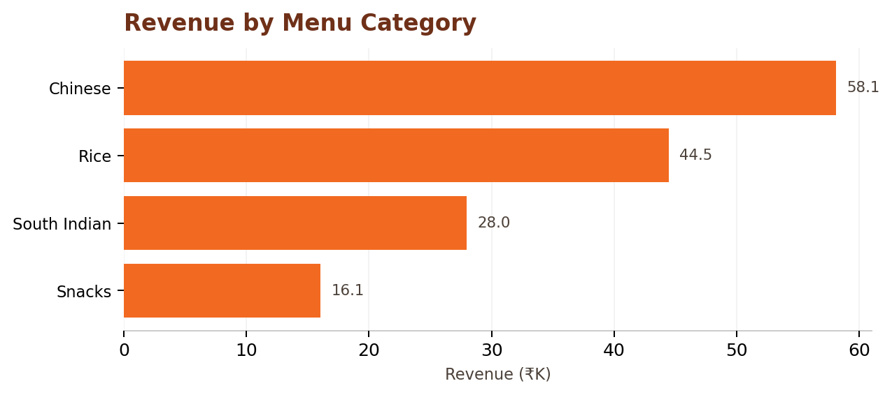
Reported category revenue values from the FY 2024 analysis.
Chinese contributes ₹58.11K, or 39.64% of total revenue. Rice contributes ₹44.46K (30.27%), South Indian ₹27.97K (19.04%), and Snacks ₹16.06K (10.95%). Chinese and Rice together therefore account for nearly 70% of total revenue.
6.1 Category Implications
- Chinese is the main revenue engine and should receive strong attention in sourcing, consistency, and promotion.
- Rice is a second major pillar, providing diversification while remaining a large contributor.
- South Indian provides meaningful revenue diversity rather than being a niche category.
- Snacks are the smallest revenue category, but the source report highlights their high-margin potential.
6.2 Cross-Category Bundling
Because Chinese and Rice together account for nearly 70% of revenue, there is an opportunity to design combo offers that pair a Chinese main with a Rice side, or a South Indian item with a Snacks add-on, to lift average order value without introducing new menu complexity. Cross-category bundling can also help even out demand for lower-share categories such as South Indian and Snacks by attaching them to already popular choices.

7. PRODUCT & MENU ANALYSIS
Item-level analysis identifies the dishes that anchor sales and the items that create volume or profit. This is important because category-level results can hide major differences between individual products.
7.1 Top Items by Revenue
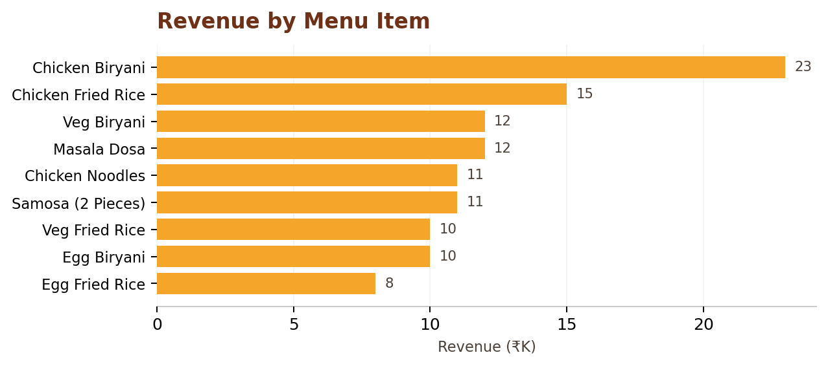
Revenue ranking of the reported menu items.
Chicken Biryani leads with ₹23K in revenue, followed by Chicken Fried Rice at ₹15K. Veg Biryani and Masala Dosa each contribute ₹12K, while Chicken Noodles and Samosa (2 Pieces) each contribute ₹11K. The remaining listed items range from ₹8K to ₹10K.
7.2 Top Items by Profit
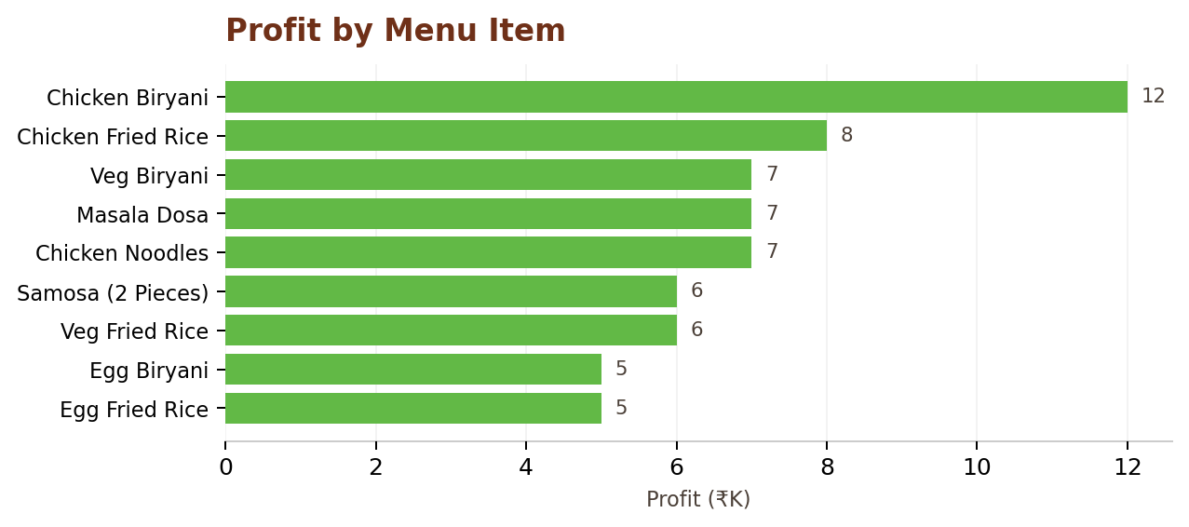
Profit ranking of the reported menu items.
Chicken Biryani is also the top profit contributor at ₹12K. Chicken Fried Rice contributes ₹8K, while Masala Dosa, Veg Biryani, and Samosa (2 Pieces) each contribute approximately ₹7K. This alignment between revenue leadership and profit leadership makes Chicken Biryani the clearest anchor product.
7.3 Quantity and Upsell Opportunity
Samosa (2 Pieces) is the most-ordered individual item by quantity at approximately 2.6K units. The source report also describes it as a high-margin snack. This combination makes it a strong candidate for add-on placement or combo offers designed to increase basket value.
7.4 Menu Simplification
The report notes that the top five revenue items account for the majority of sales. This supports a focused menu strategy: protect the proven winners while using promotions or limited-time offers to test weaker products before deciding whether they should remain permanent menu items.
7.5 Menu Pricing Considerations
The gap between the highest and lowest revenue items in the reported ranking is relatively narrow, roughly three-fold from Chicken Biryani to Egg Fried Rice, compared with the four-fold gap seen between the best and worst locations. This suggests that item-level pricing and portioning are already reasonably well balanced, and that the larger opportunity for margin improvement lies in location strategy and basket-building rather than repricing individual dishes.
- Consider a small combo discount that pairs Chicken Biryani with a Snacks item to increase basket size.
- Monitor Egg Biryani and Egg Fried Rice for a limited period before deciding whether to retain, reprice, or retire them.
- Use Chicken Fried Rice and Masala Dosa as anchor items for a chef's-picks board at weaker-performing locations.

8. MONTHLY ORDER TRENDS
Order volume is considerably more stable than the revenue pattern. The source report describes a range from approximately 980 orders in January to roughly 1.4K orders in July and September.
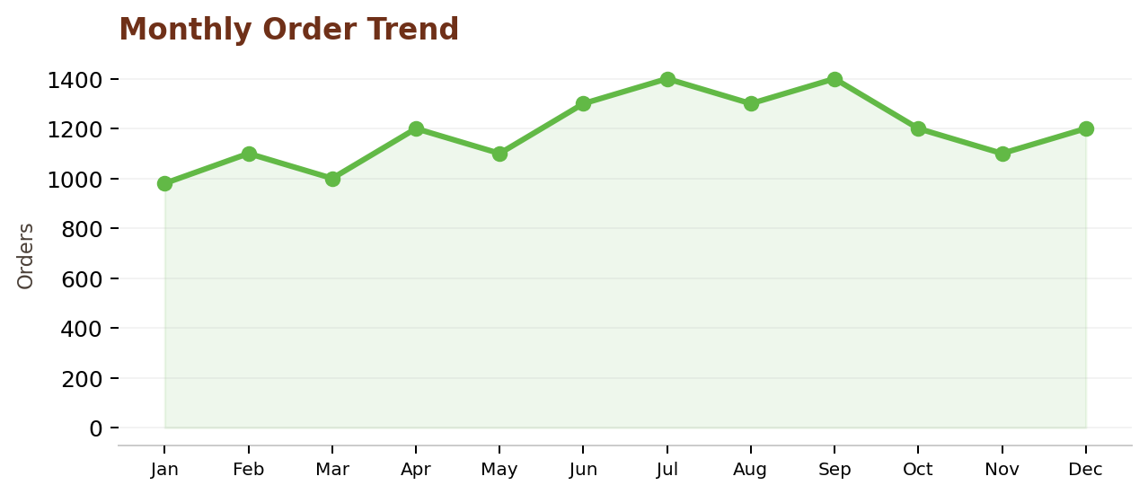
Monthly order counts as reported/approximated in the source analysis.
The important pattern is not simply that orders rise and fall, but that the range is relatively narrow compared with the larger movement described for revenue. This supports the conclusion that basket composition and higher-value selling contribute meaningfully to strong revenue months.
8.1 Planning Use
- Use order volume for staffing and production capacity planning.
- Use revenue alongside order volume to detect changes in basket value.
- Prepare for higher-volume periods without assuming every revenue peak is caused by more customers.
- Use monthly trends to schedule seasonal promotions and specials.
8.2 Seasonality Considerations
The narrow band of monthly order counts, from roughly 980 to 1.4K, indicates a business that has already reached a fairly stable level of demand rather than one experiencing large swings in customer traffic. This stability is useful for staffing and procurement planning, since it means labour and ingredient orders can be set close to a consistent baseline, with targeted increases only around the July and September peaks and light adjustments around the quieter January period.

9. STORE & LOCATION ANALYSIS
Location is one of the strongest differentiators in the dataset. The six operating sites do not perform equally, and the source report identifies Times Square as the strongest location and Coney Island Boardwalk as the weakest on the two reported measures.
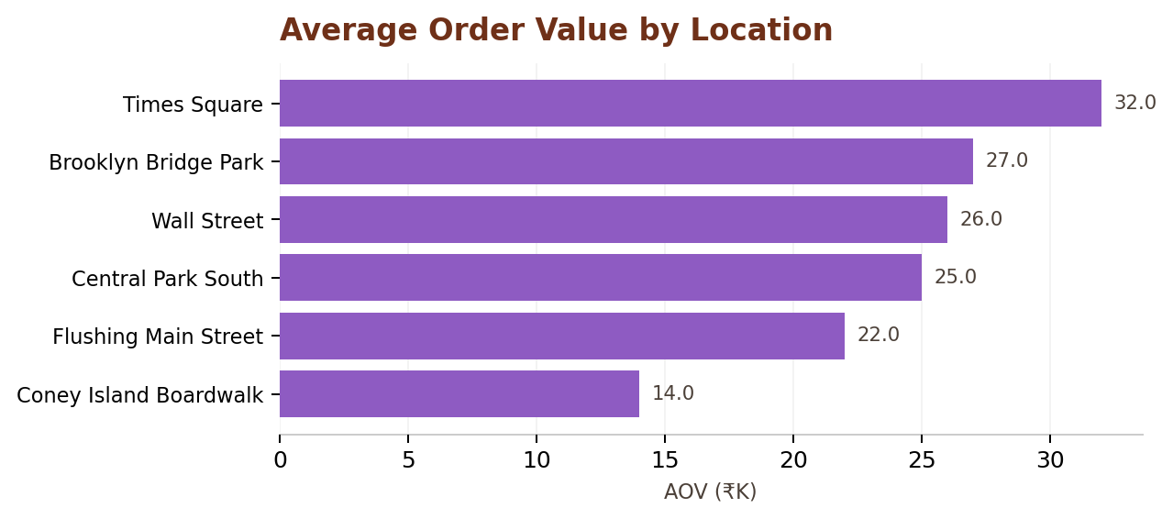
Reported average order value by location.
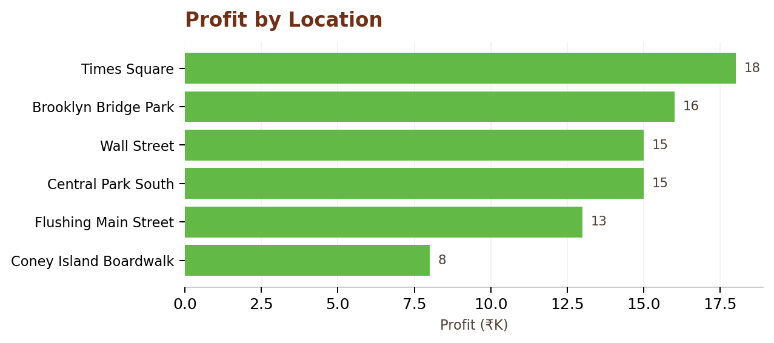
Reported profit by location.
Times Square records ₹32K on the reported average-order-value measure and ₹18K in profit. Brooklyn Bridge Park follows at ₹27K and ₹16K. Wall Street is at ₹26K and ₹15K, while Central Park South is at ₹25K and ₹15K. Flushing Main Street records ₹22K and ₹13K. Coney Island Boardwalk records ₹14K and ₹8K.
9.1 Strategic Interpretation
The source report describes the gap between the strongest and weakest locations as roughly fourfold on AOV and profit. This makes location strategy a major profitability lever. Management should investigate foot traffic, customer mix, events, operating hours, and menu mix at the leading sites and compare those factors with the weaker site before making location decisions.
9.2 Expansion Considerations
Before adding a seventh location, management should first confirm whether Coney Island Boardwalk's weaker performance reflects genuinely lower footfall potential or a fixable operating issue such as limited hours, an unfavourable pitch, or a mismatch between the menu offered and passer-by preferences at that site. Testing a corrective change at the weakest existing site is a lower-risk way to improve overall profit than opening a new location.
9.3 Site-Level Action Plan
- Times Square: protect the current schedule and consider testing premium or limited-edition items given the high average order value.
- Brooklyn Bridge Park and Wall Street: maintain current operations while monitoring for opportunities to close the gap with Times Square.
- Central Park South: review weekday versus weekend performance to see whether hours can be adjusted to capture more high-value traffic.
- Flushing Main Street: assess whether menu mix matches the local customer base, given its mid-table performance.
- Coney Island Boardwalk: run a short, structured test of operating hours, pricing, or menu mix before making a longer-term decision about the site.

10. PAYMENT METHOD ANALYSIS
Payment behavior is heavily weighted toward cashless transactions. Credit Card is the largest individual method, followed by Apple Pay and Google Pay.
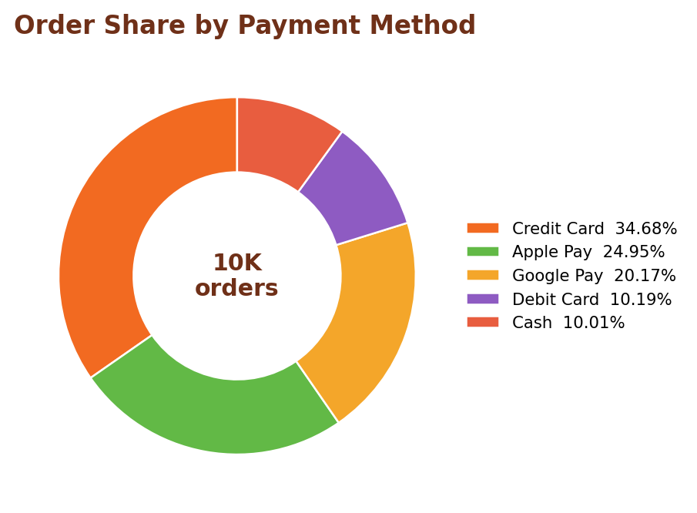
Reported share of orders by payment method.
Credit Card represents 34.68% of orders, Apple Pay 24.95%, Google Pay 20.17%, Debit Card 10.19%, and Cash 10.01%. The combined share of the four cashless methods is approximately 90%, making digital checkout an important part of the operating model.
10.1 Operational Implications
- Keep contactless checkout fast and reliable during peak periods.
- Prioritise payment uptime and reconciliation processes.
- Use digital payment adoption as an operational efficiency advantage.
- Do not remove cash entirely without a separate business or customer-policy decision; the source data still shows a measurable cash share.

11. DAY-OF-WEEK DEMAND ANALYSIS
Weekly demand is not evenly distributed. Saturday and Sunday each record approximately 1.7K orders, while Friday and the other weekdays are around 1.3K in the source dashboard/report.
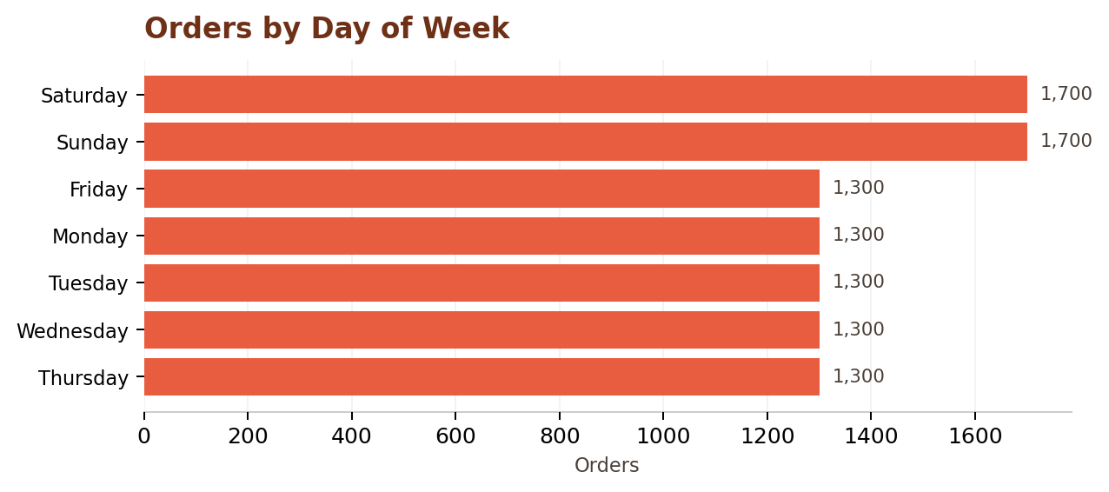
Reported order volume by day of week.
The weekend pattern is operationally important because it indicates a predictable surge rather than an isolated event. The source report estimates that Saturday and Sunday are roughly 30% higher than a typical weekday.
11.1 Staffing & Inventory Implications
- Increase staffing coverage on Saturday and Sunday.
- Pre-position ingredients and packaging before weekend peaks.
- Protect availability of the top-selling items during high-demand periods.
- Review queue times and production bottlenecks after peak weekends.
11.2 Demand Smoothing Ideas
While weekend demand is unlikely to be fully replicated on weekdays, targeted promotions on the quietest days, such as a weekday lunch bundle or a loyalty incentive, could modestly lift midweek order volume and make labour scheduling more efficient across the full week. Any such promotion should be tested against the existing weekday baseline of approximately 1.3K orders before being rolled out permanently.

12. KEY INSIGHTS
Insight | What it means
Menu concentration | Chinese and Rice together generate nearly 70% of total revenue, making these categories central to menu consistency and quality.
Hero product | Chicken Biryani contributes ₹23K in revenue and ₹12K in profit, making it the clearest anchor item.
High-volume snack | Samosa (2 Pieces) reaches approximately 2.6K units and is highlighted as a high-margin snack, creating an upsell opportunity.
Revenue vs orders | Revenue shows more variation than order volume, pointing toward basket mix/value as an important driver of strong periods.
Location gap | Times Square leads at ₹32K AOV and ₹18K profit, while Coney Island Boardwalk is lowest at ₹14K and ₹8K.
Weekend demand | Saturday and Sunday each reach approximately 1.7K orders, above the weekday level.
Cashless behavior | About 90% of transactions use cashless payment methods, led by Credit Card at 34.68%.
Overall economics | The reported 58% profit margin and ₹15 average order value indicate healthy reported unit economics.
12.1 How to Use These Insights
These eight insights are intended to be read together rather than in isolation. For example, the menu concentration finding and the hero product finding both point toward Chicken Biryani and the Chinese category as priorities, while the location gap and weekend demand findings both point toward Times Square as a site worth studying in more depth for replicable practices. Management should treat the table as a checklist to revisit each quarter as new data becomes available.

13. RECOMMENDATIONS
13.1 Menu Strategy
- Protect and promote Chicken Biryani, Chicken Fried Rice, Veg Biryani, Masala Dosa, and Chicken Noodles.
- Bundle Samosa (2 Pieces) and other high-margin snacks as add-ons to increase basket value.
- Review the lowest-revenue items such as Egg Biryani and Egg Fried Rice through limited-time promotions before considering menu simplification.
- Use seasonal specials around the September and December revenue peaks.
13.2 Location Strategy
- Study the operating characteristics behind Times Square and Brooklyn Bridge Park performance.
- Compare foot traffic, customer mix, event calendars, operating hours, and menu mix between high- and low-performing sites.
- At Coney Island Boardwalk, test menu mix, pricing, and operating-hour changes before making a larger location decision.
- Use high-AOV locations to feature premium or high-margin products.
13.3 Operations
- Increase weekend staffing and pre-preparation because Saturday and Sunday demand is materially higher.
- Maintain reliable contactless payment infrastructure.
- Track revenue and orders together every month so management can distinguish footfall-driven growth from basket-value-driven growth.
- Use dashboard alerts for unusually weak locations, products, or demand periods.
13.4 Marketing & Customer Engagement
- Highlight Chicken Biryani and other top sellers prominently on menu boards and social media.
- Consider a simple loyalty stamp card to encourage repeat visits at the stronger locations.
- Use slower weekday periods for promotional testing rather than peak weekend service.
- Track customer feedback qualitatively alongside the quantitative dashboard metrics.

14. CONCLUSION
The FY 2024 analysis presents a food truck business with strong reported profitability and clear areas for improvement. The operation generated ₹147K in revenue, ₹85K in profit, and 10K orders, with a reported 58% profit margin and ₹15 average order value.
The menu has a clear set of winners. Chinese is the leading category, Rice is the second major contributor, and Chicken Biryani is the strongest individual product across both revenue and profit. Samosa (2 Pieces) adds a complementary opportunity because of its high unit volume and the high-margin role described in the source report.
Location performance is the largest structural gap identified by the analysis. Times Square materially outperforms Coney Island Boardwalk on both reported AOV and profit, so understanding and replicating the drivers of the best locations should be a priority.
Finally, weekend demand and digital-payment adoption provide practical operating signals. The business should align staffing and inventory with the weekend surge and maintain fast cashless checkout. Overall, the dashboards and analysis provide a practical evidence base for menu, location, and operational decisions in the next planning cycle.
14.1 Next Steps
Looking ahead to FY 2025, the most immediate priorities are to test a corrective change at Coney Island Boardwalk, formalise combo offers that pair top revenue items with high-margin snacks, and confirm weekend staffing levels are adequate to protect service quality during the Saturday and Sunday surge. Revisiting this analysis on a quarterly basis, rather than only at year-end, would allow management to catch emerging trends earlier and adjust operating plans before they affect a full trading year.

15. REFERENCES
- Internal POS Sales Dataset — 10,000 order-level transaction records, January 2024 – December 2024.
- Food Truck Sales Overview Dashboard — revenue, profit, order, and category summary views.
- Product & Category Analysis Dashboard — item-level revenue, profit, and quantity breakdowns.
- Store & Customer Analysis Dashboard — location, payment method, and day-of-week performance views.
Note: Values and interpretations in this report are based on the supplied food-truck analysis materials. Approximate values are intentionally described as approximate where the source itself uses that framing.
🚚 Good Food • Good Data • Good Mood 🚚

