LLMs:
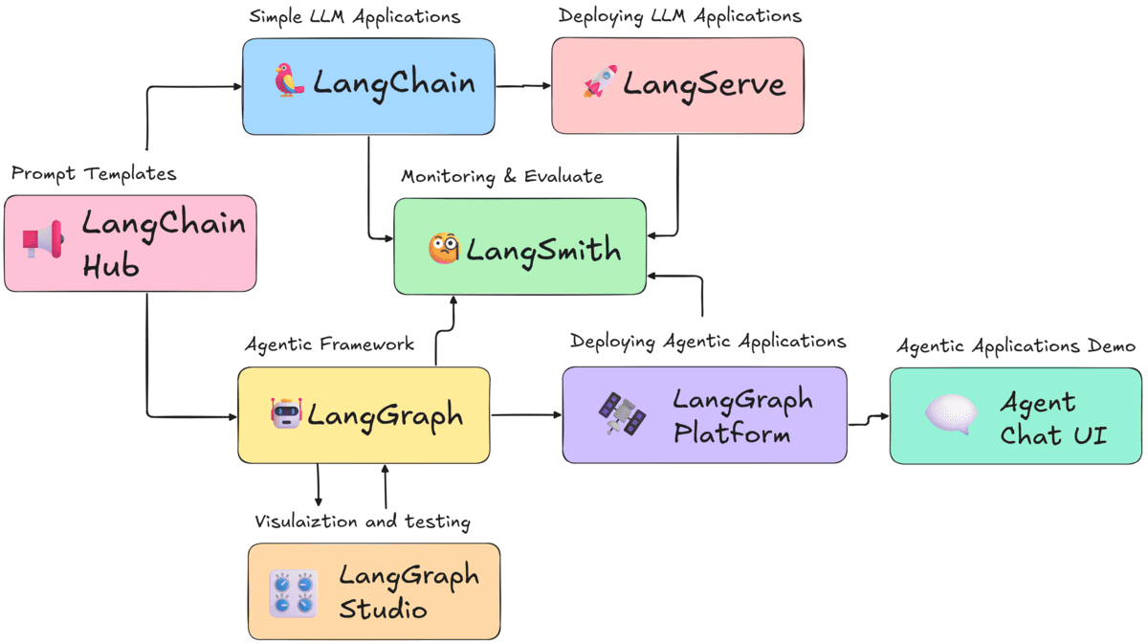
It shows how different tools in the LangChain + LangGraph ecosystem work together to build, test, deploy, and monitor LLM and Agentic applications.
1️⃣ LangChain Hub (Prompt Templates)
- A public hub containing ready-made prompts, templates, and chains.
- Developers can search, reuse, and share prompts easily.
- Feeds templates to LangChain and LangGraph.

2️⃣ LangChain (Simple LLM Applications)
- This is the core library for building:
  - LLM chains
  - Tool calling
  - Retrieval-Augmented apps
  - Simple chatbots
- Works for non-agentic, linear workflows.
Example:
Chain → LLM → Output
3️⃣ LangServe (Deploy LLM Applications)
- A framework to deploy LangChain apps as APIs.
- Lets you host your chain on a server and expose as REST endpoints.
Example:
/predict endpoint for your chatbot.

4️⃣ LangSmith (Monitoring & Evaluation)
- Tracks your LLM application's performance:
  - Logs
  - Traces
  - Evaluation
  - Error analysis
- Works for LangChain + LangGraph apps.

5️⃣ LangGraph (Agentic Framework)
- Framework to build multi-step, stateful agent workflows.
- Useful for:
  - Multi-agent systems
  - Tools orchestration
  - Memory-based reasoning
  - Long-running workflows
- More powerful than standard LangChain.
Example:
Agent → Plan → Tools → Reflect → Continue Loop

6️⃣ LangGraph Studio (Visualization & Testing)
- A development UI for testing LangGraph apps.
- Helps visualize:
  - States
  - Transitions
  - Node execution
  - Errors
Similar to seeing a flowchart of your agent.

7️⃣ LangGraph Platform (Deploy Agentic Applications)
- Production deployment environment specifically for LangGraph agents.
- Handles:
  - Hosting
  - Scaling
  - Long-running agent loops
  - Persistence
More advanced than LangServe; tailored for agents.

8️⃣ Agent Chat UI (Demo Application)
- A ready-made chat interface to test your deployed agentic apps.
- Connects to LangGraph Platform outputs.

🔗 Overall Workflow (Full Picture)
Prompt Templates → LangChain → LangServe → LangSmith
Used to build and deploy simple LLM apps.
Prompt Templates → LangGraph → LangGraph Studio → LangGraph Platform → Agent Chat UI → LangSmith
Used to build and deploy advanced agentic AI systems.

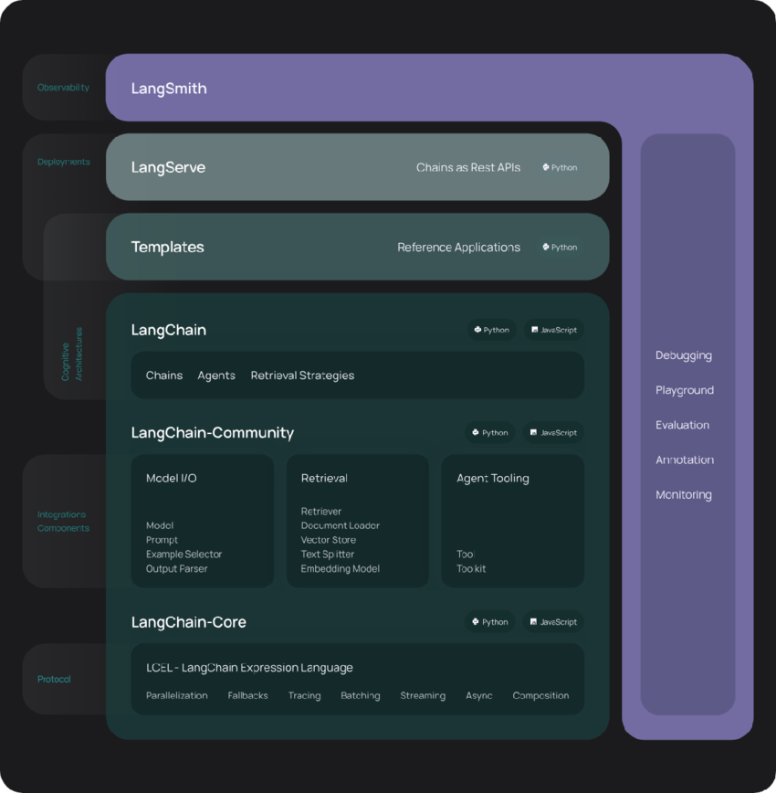

ere is a clear and simple explanation of the LangChain ecosystem diagram you uploaded.
This diagram describes the full architecture stack of LangChain—showing how apps are built, deployed, monitored, and extended.

🚀 High-Level Structure
The diagram is divided into 5 layers:
- Observability Layer → LangSmith
- Deployment Layer → LangServe
- Templates Layer → Ready-made apps
- Creative Architecture Layer → LangChain
- Core + Integrations Layer → LangChain-Community + LangChain-Core
All together, they form everything you need to build production-grade AI applications.

🟪 1. LangSmith (Observability Layer)
Purpose: Monitoring, evaluation, debugging.
You use LangSmith to:
- Trace LLM calls
- Evaluate outputs
- Compare models
- Debug chains and agents
- Monitor performance in production
It is like the control room for your LLM apps.

🟫 2. LangServe (Deployments Layer)
Purpose: Turn LLM apps into REST APIs.
With LangServe, you can:
- Deploy your chain as an API endpoint
- Host LLM pipelines
- Integrate with frontend and mobile apps
Example:
Your chain becomes /api/predict.
This is your deployment engine.

🟦 3. Templates (Starter Layer)
Purpose: Provide ready-made reference applications.
Templates include:
- Chatbots
- RAG (retrieval apps)
- Agents
- Tools integration examples
This layer helps you start fast by reusing working examples.

🟩 4. LangChain (Creative Architecture Layer)
This layer contains the core building blocks that developers use daily.
Includes:
- Chains (sequential pipelines)
- Agents (dynamic reasoning with tools)
- Retrieval strategies (RAG, vector search)
This is where your “AI app logic” lives.

🟦 5. LangChain-Community (Integrations Layer)
Provides all the connectors to external systems.
🔌 Model I/O
- LLM models (OpenAI, Anthropic, etc.)
- Prompts
- Output parsers
- Example selectors
📚 Retrieval
- Retrievers
- Vector stores
- Document loaders
- Text splitters
- Embedding models
🤖 Agent Tooling
- Tools
- Toolkits
- Tool management
This layer makes LangChain compatible with all AI tools and services.

🔵 6. LangChain-Core (Protocol Layer)
This is the foundation of everything.
Core features include:
- LCEL (LangChain Expression Language)
- Parallelization
- Streaming
- Async support
- Tracing
- Fallbacks
- Composition features
This is the engine that powers everything else.

