AIML with LLMs, Generative AI & Agentic Systems
From Python Foundations to Generative, Agentic AI & Industry-Grade Deployment
Vision of institute:
To shape the future workforce by delivering cutting-edge AI & ML education that bridges the gap between academic knowledge and real-world application.
Program Overview:
- Artificial Intelligence is the core driver of innovation across industries such as Finance, Banking, E-Commerce, Healthcare, SaaS, and global digital platforms.
- A career-focused Advanced AI Program that progresses from programming fundamentals to LLMs, Generative AI, Agentic AI, and real-world deployment, ensuring strong foundations, hands-on expertise, and future-ready AI expertise.
Who This Program Is For: Final-year students and fresh graduates.
Technical Prerequisites:
- No prior AI experience required. Curriculum begins with Python fundamentals and progresses step-by-step to advanced AI systems
- Logical thinking, and willingness to learn are essential.
Learning Outcomes:
- Develop multiple hands-on mini projects across ML, DL, NLP, and Generative AI
- Build an end-to-end, industry-grade capstone project
- Apply AI solutions to Finance, Banking, and E-Commerce use cases
- Create a strong, job-ready project portfolio
Program Highlights
- End-to-End Learning Path – Beginner to Advanced
- Strong Mathematical & Conceptual Foundation
- Hands-on Coding with Real-World Datasets
- LLMs, GPT, BERT, Transformers & Agentic AI
- Production-Level MLOps & Deployment
- Finance & E-Commerce Domain Use-Cases
- Multiple Mini Projects + Final Capstone Project
Course overview:
- Python Programming
- Numpy
- Pandas
- Matplotlib & Seaborn
- MYSQL
- Mongodb
- Machine Learning
- Deep Learning & Computer Vision
- NLP, Transformers & LLMs
- Generative AI & Agentic Systems
- Fast API
- Streamlit
- git
- Domain-Focused AI Applications
- Capstone Project
Curriculum Structure
Phase 1: Python Programming Foundations
A strong programming base is critical for any AI professional. This phase builds logical thinking, problem-solving ability, and coding confidence.
Key Topics Covered:
- Python syntax, features & execution flow
- Data types, variables, operators & expressions
- Conditional statements & control flow
- Loops, pattern printing & nested logic
- Lists, tuples, sets & dictionaries
- Searching & sorting algorithms
- Strings & advanced string manipulation
- Stack & Queue implementations
- Functions, recursion, lambda expressions
- Decorators, generators & file handling
- Object-Oriented Programming (OOP)
- Inheritance, abstraction, exception handling
Outcome: Strong Python coding foundation for ML & backend systems
Phase 2: Data Analysis & Visualization
Learn how to handle, clean, analyze, and visualize real-world data.
Tools & Libraries:
- Vectors & matrices
- Probability concepts
- Statistics for data analysis
- Calculus fundamentals for optimization
- NumPy (arrays, vectorized operations)
- Pandas (DataFrames, Series, feature engineering)
- Data cleaning & preprocessing
- Exploratory Data Analysis (EDA)
- Matplotlib & Seaborn visualizations
- Correlation & statistical insights
- SQL & DBMS fundamentals
- Advanced SQL queries & joins
- MongoDB (NoSQL)
- CRUD operations & aggregation pipelines
Outcome: Ability to understand how ML & DL models actually work, Industry-ready data handling skills
Phase 3: Machine Learning (Core ML Algorithms)
This phase builds strong ML fundamentals, crucial for interviews and real projects.
Algorithms Covered:
- Linear & Logistic Regression
- K-Nearest Neighbors (KNN)
- Decision Trees & Random Forests
- Ensemble methods
- Support Vector Machines (SVM)
- Naïve Bayes
- Clustering (Unsupervised Learning)
- Dimensionality Reduction
- Model evaluation & validation
- Bias-Variance tradeoff
- Feature selection & engineering
- Saving& Loading ML models
- Hands-on ML Mini Projects
Outcome: Confidence to build, evaluate & explain ML models
Phase 4: Deep Learning & Computer Vision
Move beyond traditional ML into neural networks and vision systems.
Key Topics:
- Neural networks & tensors
- Loss functions & optimizers
- Regularization & hyperparameter tuning
- CNNs & image augmentation
- Transfer learning
- Object detection & image segmentation
- Vision Transformers (ViT)
Outcome: Ability to work on image-based AI systems
Phase 5: NLP, Transformers & LLMs
This is the core differentiator of the program.
Advanced Topics:
- NLP preprocessing & word embeddings
- RNN, LSTM, GRU & Bidirectional RNNs
- Encoder-Decoder architectures
- Transformers fundamentals
- BERT, GPT & HuggingFace pipelines
- Multimodal AI
- Chatbot development using LLMs
Outcome: Hands-on experience with modern NLP & LLM systems
Phase 6: Generative AI & Agentic Systems
Learn how modern AI products like ChatGPT, Copilot, Auto-GPT are built.
Key Topics:
- GANs & Diffusion models
- Stable Diffusion architecture
- Prompt Engineering
- LLM fine-tuning
- Embeddings & Vector Databases
- LangChain & LangGraph
- Autonomous Agents & Agentic Pipelines
- OpenAI APIs & AI agents
- GenAI Mini Project included
Outcome: Ability to design autonomous AI systems
Phase 7: MLOps & Model Deployment
Learn how AI moves from notebooks to production.
Key Topics:
- Production Python for ML
- Git & GitHub workflows
- Data Version Control (DVC)
- Experiment tracking
- API building using FastAPI
- FastAPI security (JWT, RBAC)
- FastAPI for model serving
- Streamlit dashboards
- Model integration & monitoring
Outcome: Deploy AI models like a professional ML Engineer
Phase 8: Domain-Focused AI Applications
AI in Finance / Banking / FinTech
- Credit scoring models
- Fraud detection systems
- Risk & default prediction
- Time-series forecasting (LSTM, Transformers)
- Customer segmentation & churn prediction
AI in E-Commerce / Retail
- Recommendation systems
- Search relevance & ranking
- Vector search
- Demand forecasting
- Multimodal product search
Outcome: Domain-ready AI expertise
Phase 9: Capstone Project:
Final Industry-Grade Project
- End-to-end AI pipeline
- Data → Model → API → UI → Deployment
- Real-world problem statement
- Portfolio-ready project

Tootls coverd:
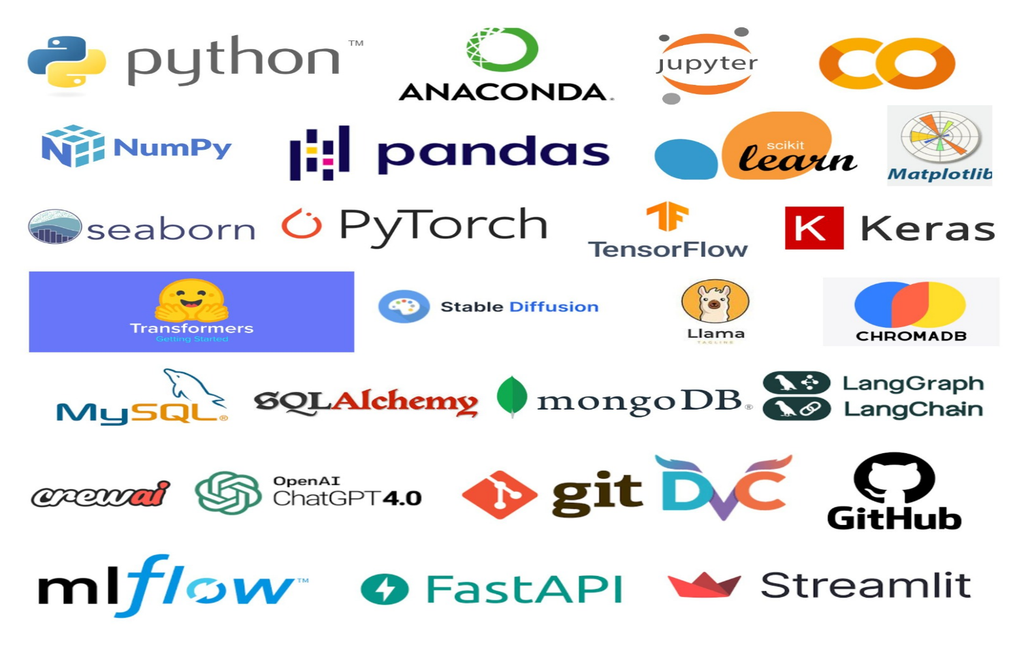

About Institute:
Vector India was established with a vision to inspire enthusiastic freshers by bridging the gap between industry requirements and enhancing their skill sets. We are pioneers in the fields of Embedded Systems, Full Stack Development and AIML training, with over 20 years of unparalleled competency. We have garnered several awards and accolades for our exceptional contributions.
About Trainers:
Dynamic Computer Science professionals with over 10+ years of combined experience in academic instruction and corporate technical training. Proven record of training 5000+ students through innovative, industry aligned programs that bridge theory and real-world practice. Demonstrates mastery in curriculum design, technical mentoring, and learning outcome optimization across Python, Java, full stack, Machine Learning, Data Analysis, Deep learning, NLP and Gen and Agentic AI.
Training Process:
Our training process is industry-oriented, structured, and outcome-driven, designed to transform learners from beginners to job-ready professionals through a well-defined learning journey.
- 6-Days a week, theory(1-1.5 hrs) and practical (2hrs) sessions.
- Weekly assignments and assessments
- Mock interviews & Project guidance.
- Parallel classes will be conducted when required
Eligibility for placements Assistance:
Candidates must meet all the following criteria to be eligible for placement assistance.
Criteria | Minimum  Attendance | Minimum  Internal Score | Mock Interview
Theory | 75% | 50% | Recommendation
Lab | 75% | 50% | Recommendation
Communication | 75% | 50% | Recommendation
Aptitude | 75% | 50% | Not Applicable

