Introduction to Machine Learning (ML):
Machine Learning (ML) is a branch of Artificial Intelligence (AI) that enables computers to learn from data and make predictions or decisions without being explicitly programmed.
ML is about training a model using data so that it can recognise patterns and make decisions on new, unseen data. In traditional programming, humans write rules for the computer to follow. In ML, the computer learns the rules from data.
Example:
Instead of programming all the conditions for detecting spam emails, we feed an ML model with thousands of examples of “spam” and “not spam” emails. The model learns the patterns automatically.
Why Machine Learning Matters:
Traditional programming is limited by hardcoded rules and struggles with complex tasks like natural language understanding or large-scale data processing. Machine learning enables computers to tackle these challenges by learning from examples and iteratively improving performance as they process more data. This leads to more accurate automated decision-making across fields like healthcare, finance, and e-commerce.
How Does Machine Learning Work?
The fundamental process of machine learning involves:


- Define Strategy: Clearly identify the problem to solve, Decide: What is the goal? (prediction, classification, recommendation, etc.). What success looks like (accuracy, cost reduction, speed).
- Data Collection: Collecting relevant examples, such as text, images, or numbers.​
- Preprocessing: Cleaning and organizing data to ensure quality and relevance.
- Data Modeling: Choosing the best mathematical method (e.g., linear regression, decision trees, neural networks) for the task, Define model architecture and parameters.
- Training: Feeding the data into algorithms so they adjust their parameters to predict outcomes more accurately.
- Evaluation and feedback: Comparing predictions to actual results and iterating to improve future accuracy.
- Generalization: The ultimate goal is for the trained model to perform well on new, unseen data—this is called generalization or AI inference. A model that performs well on training data but poorly on new data is said to be overfit.
Real-World Examples
- Image and speech recognition used in healthcare and smartphones.​
- Fraud detection tools in banking, analyzing transaction patterns in real-time.​
- Recommendation engines on streaming and shopping platforms like Netflix and Amazon.​
- Voice assistants such as Siri and Alexa continuously improve as they interact with more users.
Main Types of Machine Learning:
- Machine Learning is broadly categorised into three main paradigms based on the type of data and the learning goal:

Type | Data Used | Goal | Example Application
Supervised Learning | Labeled Data (input-output pairs) | To predict the "correct" output for a given input. | Image Classification (is this a cat or a dog?), Price Prediction (Regression).
Unsupervised Learning | Unlabeled Data (inputs only) | To find intrinsic patterns, structures, or groupings within the data. | Customer Segmentation (Clustering), Data Compression (Dimensionality Reduction).
Reinforcement Learning (RL) | Environment, Actions, and Rewards | To train an agent to make a sequence of decisions to maximize a cumulative reward. | Training a robot to walk, developing an AI to play a game like chess or Go.

Data Preparation for ML:
Data Preparation is a crucial step in Machine Learning that converts raw data into a clean, structured, and model-ready format. Good data preparation directly improves model accuracy and reliability.
- Data Collection:
Data Collection is the process of gathering relevant and reliable data that will be used to train, validate, and test a machine learning model. The quality of collected data directly affects model performance.
Sources of Data Collection: Primary Data Sources- Data collected directly for a specific problem, Surveys & questionnaires, Sensors & IoT devices, User feedback forms, Experiments. Secondary Data Sources- Data already collected by others like Public datasets (Kaggle, UCI ML Repository), Company databases, Government portals, Logs & historical records.
Methods of Data Collection- Manual entry, Automated scripts, APIs, Web scraping, Database queries.
Types of Data Collected- Structured (tables, rows, columns), Unstructured (text, images, audio, video), Semi-structured (JSON, XML).
Key Considerations- Data relevance to the problem, Data quality and accuracy,
Data volume (enough samples), Bias and fairness, Privacy and legal compliance.
Challenges in Data Collection- Missing or incomplete data, Noisy or inconsistent data, Biased datasets, High data acquisition cost.
- Data Understanding(Exploratory Data Analysis – EDA):
Analyze data structure and quality, Identify- Data types, Missing values, Outliers, Relationships between features, Use statistics and visualizations. After EDA, we decide: How to handle missing values, Which features to keep/remove, Which transformations to apply, Which ML model suits best.
- Data Cleaning:
Data Cleaning is the process of detecting, correcting, or removing inaccurate, incomplete, inconsistent, or irrelevant data from a dataset so that it becomes suitable for analysis and machine learning.
Handling Missing Values:
Remove Missing Values- Remove Rows When missing values are few
df.dropna()
Remove Columns- When a column has many missing values (>40–50%)
df.dropna(axis=1)
Imputation (Most Common Approach):
Mean Imputation (Numerical Data):
df['Age'].fillna(df['Age'].mean(), inplace=True)
Works well for normally distributed data. Not suitable for categorical data, Poor choice if data is skewed or has outliers.
Median Imputation (Numerical – Preferred):
df['Salary'].fillna(df['Salary'].median(), inplace=True)
Robust to outliers, Common in real-world datasets
Mode Imputation (Categorical Data):
df['Gender'].fillna(df['Gender'].mode()[0], inplace=True)
Forward Fill & Backward Fill (Time Series Data): Used in stock prices, sensor data
df.fillna(method='ffill', inplace=True) # Forward fill
df.fillna(method='bfill', inplace=True) # Backward fill
Constant Value Imputation:
df['Experience'].fillna(0, inplace=True) #Useful when 0 has meaning (e.g., no experience)
Advanced Imputation Techniques:
KNN Imputation: Uses nearest neighbors
from sklearn.impute import KNNImputer
imputer = KNNImputer(n_neighbors=5)
df_imputed = imputer.fit_transform(df)
Model-Based Imputation: Predict missing values using ML models like
Linear Regression, Random Forest
Handling Missing Values in Scikit-Learn Pipeline:
from sklearn.impute import SimpleImputer
imputer = SimpleImputer(strategy='median')
X = imputer.fit_transform(X)
Removing Duplicate Data: Duplicate records increase bias
Check Duplicate Rows: df.duplicated()

Count Duplicate Rows: df.duplicated().sum()
View Duplicate Rows: df[df.duplicated()]
Remove Exact Duplicates: df.drop_duplicates(inplace=True)
Keep Last Occurrence: df.drop_duplicates(keep='last', inplace=True)
Remove Duplicates Based on Specific Columns: df.drop_duplicates(subset=['ID'], inplace=True)
Remove Partial Duplicates: df.drop_duplicates(subset=['Name', 'Age'], inplace=True)
Fixing Incorrect Data Types:
df['price'] = df['price'].astype(float)
df['date'] = pd.to_datetime(df['date'])
Handling Inconsistent Data
Examples:
- "Male", "male", "M"
- "Yes", "Y", "1"
df['gender'] = df['gender'].str.lower().replace({'m':'male'})
Outlier Detection and Treatment: Extremely high or low values
Detect → Boxplot, IQR, Z-score, Isolation Forest
Treat → Remove, Cap, Transform, Model choice
Box Plot:
import seaborn as sns
sns.boxplot(x=df['Salary'])
Scatter Plot:
plt.scatter(df['Age'], df['Salary'])
Histogram: df['Salary'].hist()
IQR (Interquartile Range) Method – Best for Skewed Data:
IQR = Q3 − Q1
Lower Bound = Q1 − 1.5 × IQR
Upper Bound = Q3 + 1.5 × IQR
Q1 = df['Salary'].quantile(0.25)
Q3 = df['Salary'].quantile(0.75)
IQR = Q3 - Q1
outliers = df[(df['Salary'] < Q1 - 1.5*IQR) |
(df['Salary'] > Q3 + 1.5*IQR)]
Z-Score Method (Normal Distribution):
Z = (x − mean) / std
Threshold: |Z| > 3
from scipy import stats
df['z_score'] = stats.zscore(df['Salary'])
outliers = df[df['z_score'].abs() > 3]
(or)
mean = df['Salary'].mean()
std = df['Salary'].std()
df['z_score'] = (df['Salary'] - mean) / std
outliers = df[df['z_score'].abs() > 3]
print(outliers)
Isolation Forest:
from sklearn.ensemble import IsolationForest
iso = IsolationForest(contamination=0.05)
df['outlier'] = iso.fit_predict(df[['Salary']])

Remove Outliers:
df = df[(df['Salary'] >= lower_bound) & (df['Salary'] <= upper_bound)]
Cap / Winsorization: Replace extreme values with boundary values
df['Salary'] = df['Salary'].clip(lower=lower_bound, upper=upper_bound)
Transformation: Reduce effect of outliers
Log Transformation- df['Salary'] = np.log(df['Salary'])
Square Root Transformation
Imputation
Replace outliers with:
- Median
- Mean
Feature Selection & Removal
- Remove irrelevant or redundant columns
df.drop(['customer_id'], axis=1, inplace=True)
- Feature Encoding:
Feature Encoding is the process of converting categorical (non-numeric) data into numerical form so that machine learning algorithms can understand and process it.
Types of Categorical Data
Nominal Data (No Order):
  - Color: Red, Blue, Green
  - City: Delhi, Mumbai, Chennai
Ordinal Data (Has Order):
  - Education: School < College < Postgraduate
  - Rating: Low < Medium < High

Label Encoding: Assigns a unique number to each category
Color | Encoded
Red | 0
Blue | 1
Green | 2
from sklearn.preprocessing import LabelEncoder
le = LabelEncoder()
df['color'] = le.fit_transform(df['color'])
One-Hot Encoding: Creates a new column for each category
Color | Red | Blue | Green
Red | 1 | 0 | 0
Blue | 0 | 1 | 0
df = pd.get_dummies(df, columns=['color'])
Ordinal Encoding: Encodes based on meaningful order
Education | Encoded
School | 1
College | 2
PG | 3

from sklearn.preprocessing import OrdinalEncoder
oe = OrdinalEncoder(categories=[['School','College','PG']])
df['education'] = oe.fit_transform(df[['education']])

Label Encoding vs One-Hot Encoding:
Feature | Label Encoding | One-Hot Encoding
Output | Single column | Multiple columns
Order impact | Yes | No
Suitable for | Ordinal data | Nominal data
Model risk | Bias in linear models | Safer
- Feature Scaling: Feature Scaling is the process of bringing all numerical features to a similar scale so that no feature dominates the model due to its larger magnitude.
When Feature Scaling is Required:
Scaling REQUIRED- Linear Regression, Logistic Regression, KNN, K-Means, SVM, Neural Networks.
Scaling NOT Required- Decision Tree, Random Forest, XGBoost
Types of Feature Scaling:
- Standardization (Z-score Scaling):
$$X^{'}=\frac{X-μ}{σ}$$
Mean = 0, Standard Deviation = 1
Use When Data follows normal distribution.
from sklearn.preprocessing import StandardScaler
scaler = StandardScaler()
X_scaled = scaler.fit_transform(X)
- Normalization (Min-Max Scaling)

$$X^{'}=\frac{X-X_{min}}{X_{max}-X_{min}}$$
Range: 0 to 1
Use When Data does not follow normal distribution, Neural networks.
from sklearn.preprocessing import MinMaxScaler
scaler = MinMaxScaler()
X_scaled = scaler.fit_transform(X)
- Robust Scaling:
$$X^{'}=\frac{X-\text{Median}}{IQR}$$
Use When Dataset has outliers
from sklearn.preprocessing import RobustScaler
scaler = RobustScaler()
X_scaled = scaler.fit_transform(X)
- Max Absolute Scaling:
Scales data between -1 and 1
from sklearn.preprocessing import MaxAbsScaler
scaler = MaxAbsScaler()
X_scaled = scaler.fit_transform(X)
Used for sparse data.
Method | Range | Outlier Resistant | Use Case
StandardScaler | Mean=0, Std=1 | ❌ | Normal data
MinMaxScaler | 0–1 | ❌ | NN, images
RobustScaler | Median-based | ✔ | Outlier-heavy
MaxAbsScaler | -1 to 1 | ✔ | Sparse data

- Feature Engineering: Feature Engineering is the process of creating, transforming, or selecting input variables (features) to improve the performance of a machine learning model.
Feature Creation- Creating new features from existing data.
Date | Sales
2024-01-01 | 200
New Features
- Day
- Month
- Year
- Is_Weekend
df['Date'] = pd.to_datetime(df['Date'])
df['Day'] = df['Date'].dt.day
df['Month'] = df['Date'].dt.month
df['Is_Weekend'] = df['Date'].dt.weekday >= 5
- Data Splitting: Data Splitting is the process of dividing a dataset into separate subsets to train, validate, and test a machine learning model.
Why Data Splitting is Important
- Prevents overfitting
- Tests generalization ability
- Gives realistic model performance
- Avoids data leakage
Train–Test Split:
Common Ratios : 80% Train – 20% Test or 70% Train – 30% Test
from sklearn.model_selection import train_test_split

X = df.drop('Price', axis=1)
y = df['Price']

X_train, X_test, y_train, y_test = train_test_split(
X, y, test_size=0.2, random_state=42)
Train–Validation–Test Split:
Split | Percentage
Training | 60–70%
Validation | 15–20%
Test | 15–20%
X_temp, X_test, y_temp, y_test = train_test_split(X, y, test_size=0.2)
X_train, X_val, y_train, y_val = train_test_split(X_temp, y_temp, test_size=0.25)
Stratified Splitting: Preserves class distribution (Classification), Important for imbalanced datasets.
from sklearn.model_selection import train_test_split
X_train, X_test, y_train, y_test = train_test_split(
X, y, test_size=0.2, stratify=y, random_state=42)
Cross-Validation (CV):
More reliable evaluation
- Dataset divided into k folds
- Model trained k times
- Each fold used once as test data
from sklearn.model_selection import cross_val_score
from sklearn.linear_model import LinearRegression
model = LinearRegression()
scores = cross_val_score(model, X, y, cv=5)
print(scores.mean())

Time-Series Data Splitting: Time-Series Data Splitting is the method of dividing data based on time order, not randomly, to correctly evaluate models that learn from sequential data. Never shuffle time-series data.
In time-series:
- Order of data matters
- Future data must not influence the past
- Random splitting causes data leakage
train_size = int(len(df) * 0.8)
train = df.iloc[:train_size]
test = df.iloc[train_size:]
- Data Balancing (if required): Data Balancing is the process of adjusting the class distribution in a classification dataset so that all classes are represented fairly.
When data is imbalanced, models tend to:
- Predict the majority class most of the time
- Show high accuracy but poor real performance
- Fail to detect minority classes (fraud, disease, churn)
Class | Count
No Fraud | 9,500
Fraud | 500
Model may predict “No Fraud” always → 95% accuracy
Types of Data Balancing Techniques:
- Undersampling (Reduce Majority Class):
from sklearn.utils import resample
majority = df[df['target'] == 0]
minority = df[df['target'] == 1]

majority_downsampled = resample(
majority,
replace=False,
n_samples=len(minority),
random_state=42
)
balanced_df = pd.concat([majority_downsampled, minority])
Disadvantage: Loss of valuable information
- Oversampling (Increase Minority Class):
minority_upsampled = resample(
minority,
replace=True,
n_samples=len(majority),
random_state=42
)
balanced_df = pd.concat([majority, minority_upsampled])
Disadvantage: Overfitting risk
- SMOTE (Synthetic Minority Over-sampling Technique): Creates synthetic data points, Most popular method.
from imblearn.over_sampling import SMOTE
X = df.drop('target', axis=1)
y = df['target']
smote = SMOTE(random_state=42)
X_resampled, y_resampled = smote.fit_resample(X, y)
Better than simple oversampling, Not suitable for time-series data
- ADASYN: Focuses on harder-to-learn samples
from imblearn.over_sampling import ADASYN
adasyn = ADASYN(random_state=42)
X_resampled, y_resampled = adasyn.fit_resample(X, y)
- Data Validation: Data Validation is the process of checking data quality, correctness, consistency, and reliability before using it for analysis or machine learning.
Schema Validation, Data Type Validation, Range Validation, Missing Value Validation, Uniqueness Validation, Format Validation, Consistency Validation, Outlier Validation and Statistical Validation
- Bias, Variance:
Bias- Bias is the error caused by oversimplifying assumptions in a model. High bias model Learns too little from data, Misses important patterns, Performs poorly on training data, This leads to Underfitting.
Variance- Variance is the error caused by a model being too sensitive to training data. High variance model Learns noise instead of signal, Performs very well on training data, Performs poorly on unseen data, This leads to Overfitting.
Overfitting- A model fits training data too well, including noise, and fails to generalize.
Underfitting- Model is too simple to capture patterns.
Aspect | Bias | Variance
Error source | Wrong assumptions | Sensitivity to data
Model complexity | Low | High
Training error | High | Low
Test error | High | High
Problem | Underfitting | Overfitting

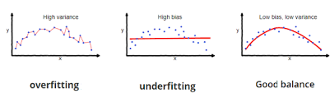
Bias–Variance Tradeoff:

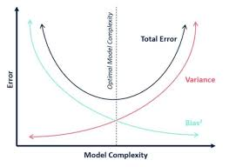
Regularization: Regularization is a technique used in machine learning to prevent overfitting, which occurs when a model learns the training data too well, including its noise and outliers, and performs poorly on new, unseen data. Regularization helps create models that generalize better to new data by adding a penalty to the loss function (the function the model tries to minimize during training), which keeps the model’s parameters (like weights in a neural network) smaller and simpler.
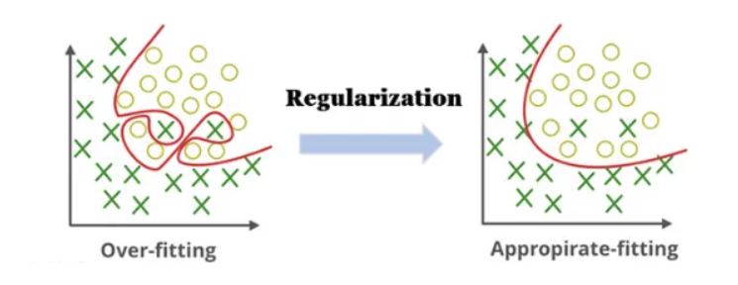
Regularization is implemented by modifying the loss function. In a typical machine learning model, the loss function measures how well the model’s predictions match the actual data. Regularization adds an extra term to this loss function that penalizes large weights.
Loss = Original Loss + λ × Regularization Term
Types of Regularization:
L1 Regularization (Lasso Regression): Loss = Original Loss + λ ∑ᵢ |Wᵢ|
Imagine we have a dataset with many features (variables), but not all of them are important for predicting the output. Using L1 regularization can help the model focus on the most significant features by reducing the weights of less important ones to zero.
from sklearn.linear_model import Lasso
model = Lasso(alpha=0.1)
model.fit(X_train, y_train)
L2 Regularization (Ridge Regression): It adds the square of the weights to the loss function.
Loss = Original Loss + λ ∑ᵢ Wᵢ²
Suppose we’re building a model to predict house prices based on various features like size, number of rooms, age, location, etc. L2 regularization helps ensure that the model doesn’t assign too much importance to any one feature and considers all of them in a balanced way.
from sklearn.linear_model import Ridge
model = Ridge(alpha=1.0)
model.fit(X_train, y_train)
Elastic Net:
Combination of L1 + L2
Loss = Error + λ₁Σ|w| + λ₂Σw²
from sklearn.linear_model import ElasticNet
model = ElasticNet(alpha=0.1, l1_ratio=0.5)

Supervised Learning : Supervised learning is a type of machine learning where the model is trained using labeled data — that means we already know the correct answers (output values).
Basic Idea- We have a dataset with: (x_1,y_1),(x_2,y_2),...,(x_n,y_n)
x_i: input features, y_i: output (label or target), Goal: Learn a function f(x)≈y so that for new data x_new, we can predict f(x_new).
Types of Supervised Learning:
- Regression- The output $y$is continuous (real numbers).
- Classification- The output $y$is categorical (discrete labels).
How Supervised Learning Works:
- Collect Data:Gather a dataset with features (X) and labels (Y).
- Split Dataset: Divide into: Training set (usually 70–80%), Testing set (20–30%)
- Train the Model: Feed training data to the algorithm to learn patterns.
- Test the Model: Check performance using unseen test data.
- Evaluate Metrics: Regression → MSE, RMSE, R² score, Classification → Accuracy, Precision, Recall, F1-score, ROC-AUC
Regression:
- Linear Regression:
Linear Regression is a Supervised Learning algorithm used to predict continuous values based on the relationship between input features (X) and output (Y).
It assumes a linear relationship between X and Y: $Y=mX+c$
or in general for multiple features: $Y=w_{1}x_{1}+w_{2}x_{2}+...+w_{n}x_{n}+b$where:
- $Y$: predicted output
- $x_{i}$: input feature
- $w_{i}$: weight (slope / coefficient)
- $b$: bias (intercept)
Goal:
- Find the best line (or hyperplane) that minimizes the error between predicted and actual values.
- We find $w$ and $b$ such that: $\text{Error}=∑(Y_{pred}-Y_{actual})^{2}$ is minimum.
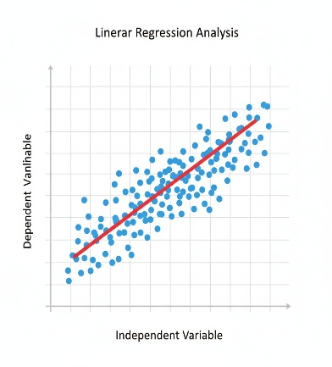
Optimization (Gradient Descent)
To minimize $J(w,b)$, we update weights iteratively:
$$w:=w-α\frac{∂J}{∂w} \\ b:=b-α\frac{∂J}{∂b}$$
where α (alpha) is the learning rate.
import numpy as np
from sklearn.linear_model import LinearRegression
import matplotlib.pyplot as plt
# Sample data
X = np.array([[1], [2], [3], [4], [5]]) # hours studied
y = np.array([2, 4, 6, 8, 10]) # scores
model = LinearRegression()
model.fit(X, y)
# Predict
y_pred = model.predict(X)
# Plot
plt.scatter(X, y, color='blue', label='Actual data')
plt.plot(X, y_pred, color='red', label='Regression line')
plt.xlabel("Hours Studied")
plt.ylabel("Exam Score")
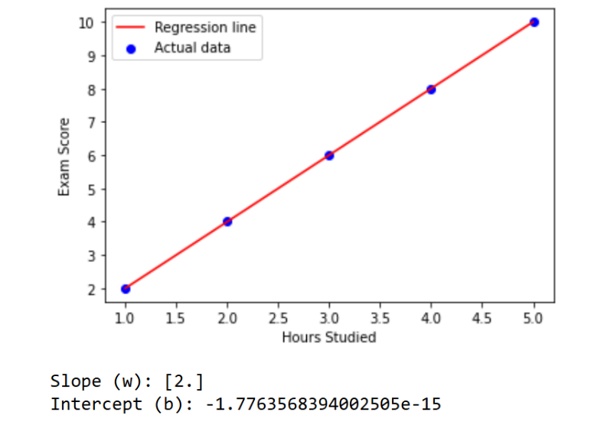
plt.legend()
plt.show()
# Coefficients
print("Slope (w):", model.coef_)
print("Intercept (b):", model.intercept_)
x = np.array([1, 2, 3, 4, 5])
# Reshape x → 2D
x = x.reshape(-1, 1) # now shape = (5, 1)
Quick Explanation of .reshape(-1, 1)
- -1 → automatically calculates number of rows
- 1 → number of columns (features)
Evaluation Metrics
Metric | Formula | Meaning
MSE | $$\frac{1}{n}∑(y_{i}-\hat{y_{i}})^{2}$$ | Average squared error
RMSE | $$\sqrt{MSE}$$ | Square root of MSE
R² (R-squared) | $$1-\frac{SS_{res}}{SS_{tot}}$$ | How well line fits data (0–1 scale)
Where:
- $SS_{res}$→ Residual Sum of Squares
- $SS_{res}=∑(y_{i}-\hat{y_{i}})^{2}$
- $SS_{tot}$→ Total Sum of Squares
- $SS_{tot}=∑(y_{i}-\overset{ˉ}{y})^{2}$
- $y_{i}$: actual value
- $\hat{y_{i}}$: predicted value
- $\overset{ˉ}{y}$: mean of actual values
- Multiple Linear Regression: is a supervised machine learning model used to predict a continuous target variable using two or more independent variables.
It extends simple linear regression by allowing more than one feature.
import numpy as np
import pandas as pd
from sklearn.model_selection import train_test_split
from sklearn.linear_model import LinearRegression
from sklearn.metrics import r2_score, mean_absolute_error
import matplotlib.pyplot as plt
# Sample dataset
data = {
"Area": [1200, 1500, 1800, 2400, 3000, 3500],
"Bedrooms": [2, 3, 3, 4, 4, 5],
"Age": [10, 8, 5, 3, 2, 1],
"Price": [120, 150, 180, 240, 300, 350]
}
df = pd.DataFrame(data)
# Features and target
X = df[["Area", "Bedrooms", "Age"]]
y = df["Price"]
# Train-test split
X_train, X_test, y_train, y_test = train_test_split(X, y, test_size=0.3, random_state=42)
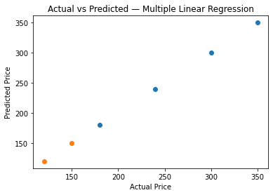
# Model
model = LinearRegression()
model.fit(X_train, y_train)
# Prediction
y_pred = model.predict(X_test)
# Results
print("Coefficients:", model.coef_)
print("Intercept:", model.intercept_)
print("R2 Score:", r2_score(y_test, y_pred))
print("MAE:", mean_absolute_error(y_test, y_pred))
# Visualization: Actual vs Predicted
plt.scatter(y_train, model.predict(X_train), label="Train")
plt.scatter(y_test, y_pred, label="Test")
plt.xlabel("Actual Price")
plt.ylabel("Predicted Price")
plt.title("Actual vs Predicted — Multiple Linear Regression")
plt.show()
Coefficients: [ 1.00000000e-01 -1.81221493e-14 -1.22917979e-14]
Intercept: 0.0
R2 Score: 1.0
MAE: 1.0658141036401503e-13
- Polynomial Regression:Polynomial Regression is a type of linear regression where the relationship between X and y is nonlinear. Instead of fitting a straight line, it fits a curved line.
Example:
$$y=b_{0}+b_{1}x+b_{2}x^{2}+b_{3}x^{3}+⋯+b_{n}x^{n}$$
This allows the model to learn complex patterns in data.
Choosing the Right Degree
- Degree 1 → straight line
- Degree 2 → parabola
- Degree 3 → S-shaped curve
- Degree too high → overfitting
You can test degrees 2–5 and choose based on R² score.
import numpy as np
import matplotlib.pyplot as plt
from sklearn.linear_model import LinearRegression
from sklearn.preprocessing import PolynomialFeatures

# Sample dataset (1D feature)
X = np.array([1, 2, 3, 4, 5, 6]).reshape(-1, 1)
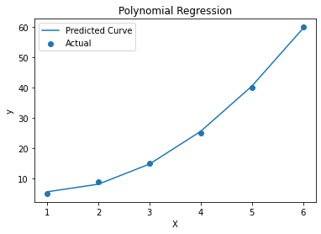
y = np.array([5, 9, 15, 25, 40, 60])
# Polynomial degree
degree = 2
poly = PolynomialFeatures(degree=degree)
X_poly = poly.fit_transform(X)
# Fit model
model = LinearRegression()
model.fit(X_poly, y)
# Predict
y_pred = model.predict(X_poly)
# Print coefficients
print("Coefficients:", model.coef_)
print("Intercept:", model.intercept_)
# Visualization
plt.scatter(X, y, label="Actual")
plt.plot(X, y_pred, label="Predicted Curve")
plt.xlabel("X")
plt.ylabel("y")
plt.title("Polynomial Regression")
plt.legend()
plt.show()
Working on ISLR dataset: Goal: Predict sales using advertising budget
import pandas as pd
import numpy as np
from sklearn.model_selection import cross_val_score
from sklearn.preprocessing import PolynomialFeatures
from sklearn.linear_model import LinearRegression
from sklearn.pipeline import Pipeline
from sklearn.metrics import mean_squared_error
# Load original ISLR dataset
url = "https://www.statlearning.com/s/Advertising.csv"
df = pd.read_csv(url, index_col=0)
# Features and target
X = df[["TV", "radio", "newspaper"]]
y = df["sales"]
degrees = range(1, 6) # Try polynomial degrees 1 to 5
cv_scores = []

for d in degrees:
model = Pipeline([
('poly', PolynomialFeatures(degree=d, include_bias=False)),
('linreg', LinearRegression())
])
scores = cross_val_score(model, X, y, cv=5, scoring='neg_mean_squared_error')
cv_scores.append(-scores.mean()) # Convert negative MSE to positive
# Best degree (lowest MSE)
best_degree = degrees[np.argmin(cv_scores)]
print("Best Polynomial Degree:", best_degree)

# Train final model using the best degree
best_model = Pipeline([
('poly', PolynomialFeatures(degree=best_degree, include_bias=False)),
('linreg', LinearRegression())
])
best_model.fit(X, y)
y_pred = best_model.predict(X)
# Final model MSE
mse = mean_squared_error(y, y_pred)
print("Final Model MSE:", mse)
# Cross-validation results
for d, score in zip(degrees, cv_scores):
print(f"Degree {d} CV MSE: {score:.4f}")
# PLOT 1: CV ERROR vs DEGREE
plt.figure(figsize=(8, 5))
plt.plot(degrees, cv_scores, marker='o')
plt.xlabel("Polynomial Degree")
plt.ylabel("Cross-Validation MSE")
plt.title("CV Error vs Polynomial Degree (Advertising Dataset)")
plt.grid(True)
plt.show()
# ----------------------------
# PLOT 2: ACTUAL vs PREDICTED
# ----------------------------
plt.figure(figsize=(6, 6))
plt.scatter(y, y_pred)
plt.xlabel("Actual Sales")
plt.ylabel("Predicted Sales")
plt.title(f"Actual vs Predicted Sales (Degree = {best_degree})")
plt.grid(True)
plt.show()
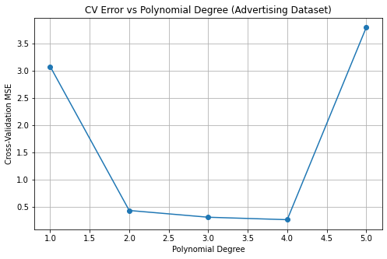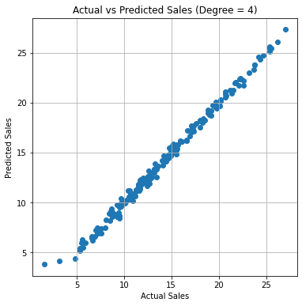

Decision Tree Regressor:
A Decision Tree Regressor is a supervised machine learning algorithm used when the target variable is continuous (numerical).
It predicts values by learning rules from the data and splitting it based on features.
How it Works (Intuition)
- The algorithm tries to split the dataset into groups so that each group has similar target values.
- It chooses the best feature and split point that reduces error the most.
- It continues splitting until:
  - max depth is reached
  - minimum samples left
  - or no improvement happens.
- Final prediction = average of values in the leaf node.
Term | Meaning
Root Node | First split of the tree
Internal Nodes | Decision points
Leaf Nodes | Final prediction values
Gini/Entropy (Classifier) | For classification only
MSE (Mean Squared Error) | Used for regression splits
import matplotlib.pyplot as plt
from sklearn.datasets import load_diabetes
from sklearn.model_selection import train_test_split
from sklearn.tree import DecisionTreeRegressor, plot_tree
# Load a real regression dataset
data = load_diabetes()
X = data.data
y = data.target
feature_names = data.feature_names
# Train-test split
X_train, X_test, y_train, y_test = train_test_split(
X, y, test_size=0.3, random_state=42)
# Train Decision Tree Regressor
model = DecisionTreeRegressor(max_depth=3, random_state=42)
model.fit(X_train, y_train)
# Plot the Decision Tree
plt.figure(figsize=(18, 10))
plot_tree( model, feature_names=feature_names, filled=True,
rounded=True, fontsize=10)
plt.title("Decision Tree Regressor (Diabetes Dataset)")
plt.show()

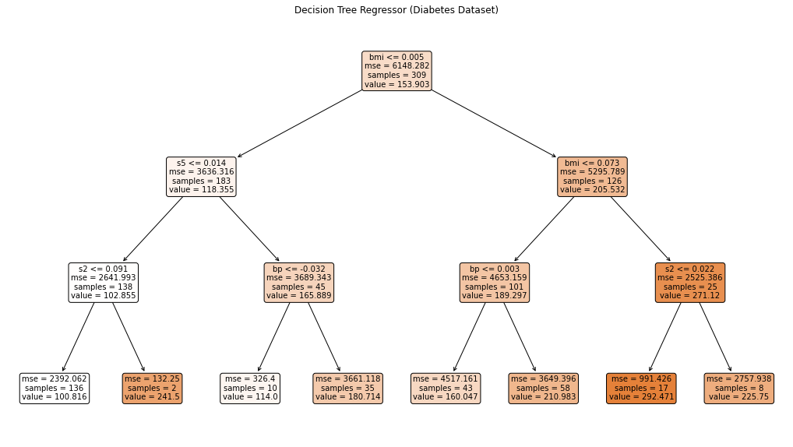

Random Forest Regressor :
A Random Forest Regressor is an ensemble model that builds many Decision Trees and averages their predictions.Because averaging reduces overfitting and improves accuracy.
How it Works
- Creates many random decision trees:
  - Each tree gets a random sample of data (bootstrapping)
  - Each split uses a random subset of features
- Makes a prediction by averaging all tree outputs.
Example:
If 5 trees predicted prices:
50, 55, 53, 58, 52
Final prediction = (50+55+53+58+52)/5 = 53.6
import matplotlib.pyplot as plt
from sklearn.datasets import load_diabetes
from sklearn.model_selection import train_test_split
from sklearn.ensemble import RandomForestRegressor
from sklearn.tree import plot_tree
# Load dataset
data = load_diabetes()
X = data.data
y = data.target
feature_names = data.feature_names
# Split dataset
X_train, X_test, y_train, y_test = train_test_split( X, y, test_size=0.3, random_state=42)

# Train Random Forest
model = RandomForestRegressor(
n_estimators=3, # small number so we can visualize all
max_depth=4, # limit tree depth for readability
random_state=42
)
model.fit(X_train, y_train)
# Plot each tree
for i, tree in enumerate(model.estimators_):
plt.figure(figsize=(20, 12))
plot_tree( tree, feature_names=feature_names, filled=True, rounded=True, fontsize=8 )
plt.title(f"Random Forest Tree #{i+1}")
plt.show()
SVM Regressor (SVR) — Simple Explanation
SVM Regressor tries to fit the best possible line (or curve) within a margin (ε-tube) such that:
- Errors inside the ε margin are ignored
- Errors outside the ε margin are penalized
- It tries to keep the model as flat as possible
SVR works very well for:
- Non-linear regression
- Small or medium datasets
- Smooth curves

import numpy as np
import matplotlib.pyplot as plt
from sklearn.svm import SVR
# sample data
X = np.array([1, 2, 3, 4, 5]).reshape(-1,1)
y = np.array([2, 3, 2.5, 5, 4.5])
# SVR models
svr_linear = SVR(kernel='linear', C=100)
svr_rbf = SVR(kernel='rbf', C=100, gamma=0.5)
# fit
svr_linear.fit(X, y)
svr_rbf.fit(X, y)
# prediction points
X_test = np.linspace(1,5,100).reshape(-1,1)
# predictions
y_pred_linear = svr_linear.predict(X_test)
y_pred_rbf = svr_rbf.predict(X_test)
# visualize
plt.scatter(X, y, label='Actual Data')
plt.plot(X_test, y_pred_linear, label='SVR Linear', linewidth=2)
plt.plot(X_test, y_pred_rbf, label='SVR RBF', linewidth=2)
plt.legend()
plt.xlabel("X")
plt.ylabel("y")
plt.title("SVR Regression Example")
plt.show()
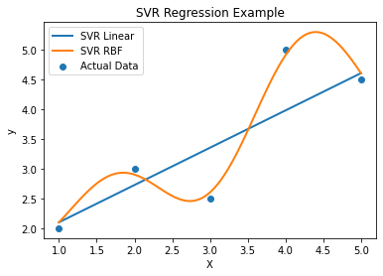

Kernel | Best For | Formula Strength | Notes
Linear | Linear patterns | Fast | Good for high-dimensional data
Polynomial | Curved but smooth boundaries | Captures interactions | Can overfit
RBF | General non-linear | Very flexible | Most used kernel
Sigmoid | Neural network-like | Experimental | Not widely preferred

- Classification: Classification is a supervised learning task where the target variable is categorical.
Types of Classification- Based on output classes
Binary Classification → 2 classes Yes/No, 0/1, True/False
Example: Spam detection
Multi-class Classification → More than 2 classes 0–9 digits, Cat/Dog/Horse
Example: Digit recognition
Multi-label Classification → Multiple outputs at once Movie genres: Action + Comedy
Example: Recommendation systems
Logistic Regression:
- Uses Sigmoid function to map output between 0 and 1
- Predicts probability, then applies a threshold (usually 0.5)
Formula:
$$h(x)=\frac{1}{1+e^{-z}},z=wX+b$$
Decision Rule:
- If probability ≥ 0.5 → Class 1
- Else → Class 0
The model must find the best parameters:
$$b_{0},b_{1},...,b_{n}$$
It does this by minimizing a cost function.
Cost Function: Log Loss (Cross Entropy)
$$J=-\frac{1}{m}\sum_{i=1}^{m}{[y_{i}log⁡(p_{i})+(1-y_{i})log⁡(1-p_{i})]}$$This penalizes: high probability on wrong class, low probability on right class
Classification Metrics
Confusion Matrix
Actual / Predicted | Positive | Negative
Positive | TP | FN
Negative | FP | TN
Common Metrics
- Accuracy
$$\frac{TP+TN}{TP+TN+FP+FN}$$
- Precision
$$\frac{TP}{TP+FP}$$
- Recall (Sensitivity)
$$\frac{TP}{TP+FN}$$
- F1-Score
$$2×\frac{Precision×Recall}{Precision+Recall}$$
- ROC-AUC
  - Measures ranking quality
  - Robust to class imbalance
Use Precision/Recall/F1 when classes are imbalanced.

# Logistic Regression on Breast Cancer Dataset:
from sklearn.datasets import load_breast_cancer
from sklearn.model_selection import train_test_split
from sklearn.linear_model import LogisticRegression
from sklearn.metrics import accuracy_score, confusion_matrix, classification_report
import matplotlib.pyplot as plt
import seaborn as sns
# 1. Load real dataset
data = load_breast_cancer()
X = data.data
y = data.target
print("Feature Names:", data.feature_names)
print("Target Names:", data.target_names)
# 2. Train-test split
X_train, X_test, y_train, y_test = train_test_split( X, y, test_size=0.2, random_state=42)
# 3. Logistic Regression model
model = LogisticRegression(max_iter=500)
model.fit(X_train, y_train)
# 4. Predictions
y_pred = model.predict(X_test)
# 5. Evaluation
print("Accuracy:", accuracy_score(y_test, y_pred))
print("\nClassification Report:\n", classification_report(y_test, y_pred))
# 6. Confusion Matrix
cm = confusion_matrix(y_test, y_pred)
plt.figure(figsize=(6, 4))
sns.heatmap(cm, annot=True, fmt="d", cmap="Blues")
plt.title("Confusion Matrix — Logistic Regression")
plt.xlabel("Predicted")
plt.ylabel("Actual")
plt.show()
Accuracy: 0.956140350877193
Classification Report:
precision recall f1-score support

0 0.97 0.91 0.94 43
1 0.95 0.99 0.97 71

accuracy 0.96 114
macro avg 0.96 0.95 0.95 114
weighted avg 0.96 0.96 0.96 114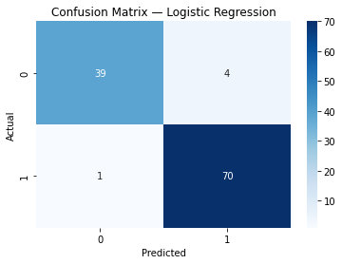

Multiclass Logistic Regression with Real Dataset (Iris)
The Iris dataset has 3 classes:
- 0 → Setosa
- 1 → Versicolor
- 2 → Virginica
It has 4 features: sepal length, sepal width, petal length, petal width
from sklearn.datasets import load_iris
from sklearn.model_selection import train_test_split
from sklearn.linear_model import LogisticRegression
from sklearn.metrics import accuracy_score, classification_report, confusion_matrix
import seaborn as sns
import matplotlib.pyplot as plt
# 1. Load real dataset
iris = load_iris()
X = iris.data
y = iris.target
# 2. Train-test split
X_train, X_test, y_train, y_test = train_test_split(X, y, test_size=0.2, random_state=42)
# 3. Logistic Regression (Multiclass)
model = LogisticRegression(max_iter=500) # increased iterations for convergence
model.fit(X_train, y_train)
# 4. Predictions
y_pred = model.predict(X_test)
# 5. Accuracy
print("Accuracy:", accuracy_score(y_test, y_pred))

# 6. Classification Report
print("\nClassification Report:")
print(classification_report(y_test, y_pred, target_names=iris.target_names))
# 7. Confusion Matrix
cm = confusion_matrix(y_test, y_pred)
sns.heatmap(cm, annot=True, cmap='Blues', xticklabels=iris.target_names, yticklabels=iris.target_names)
plt.xlabel("Predicted")
plt.ylabel("Actual")
plt.title("Logistic Regression - Multiclass")
plt.show()
Accuracy: 1.0
Classification Report:
precision recall f1-score support
setosa 1.00 1.00 1.00 10
versicolor 1.00 1.00 1.00 9
virginica 1.00 1.00 1.00 11
accuracy 1.00 30
macro avg 1.00 1.00 1.00 30
weighted avg 1.00 1.00 1.00 30
KNN: KNN classifies a new data point based on the majority class of its K nearest neighbors in the training dataset.
Compute distance between the test point and all training points
Common distance metrics:
- Euclidean distance (most common):Used for continuous features:
$$d=\sqrt{∑(x_{i}-y_{i})^{2}}$$
- Manhattan distance:
d=∑∣xi​−yi​∣
- Minkowski distance:
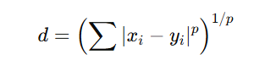
p = 1 → Manhattan
p = 2 → Euclidean
- Hamming distance (categorical):
For two data points X and Y with n features:
$$\text{Hamming Distance}=\frac{1}{n}\sum_{i=1}^{n}{I(}x_{i}≠y_{i})$$
Where:
- I(x_i ≠ y_i) = 1 if values are different
- I(x_i = y_i) = 0 if values are same

Find K Nearest Neighbors- Sort distances, Select the K smallest distances, The class with maximum votes becomes the prediction.
from sklearn.neighbors import KNeighborsClassifier
from sklearn.model_selection import train_test_split
from sklearn.datasets import load_iris
# Load dataset
data = load_iris()
X = data.data
y = data.target

# Split
X_train, X_test, y_train, y_test = train_test_split(X, y, test_size=0.2)
# Model
knn = KNeighborsClassifier(n_neighbors=5, metric='euclidean')
# Train
knn.fit(X_train, y_train)
# Predict
y_pred = knn.predict(X_test)
# Accuracy
print(knn.score(X_test, y_test))

Decision Tree Classifier: A Decision Tree Classifier is a supervised machine learning algorithm used for classification (and regression). It works by splitting data into branches based on feature conditions, forming a tree-like structure.
How Does a Tree Choose the Best Feature?
Using impurity measures:
1. Gini Index (CART)
$$Gini=1-∑p_{i}^{2}$$
- Measures how often a random sample is incorrectly classified
- Lower Gini → better split
2. Entropy (Information Gain)
$$Entropy=-∑p_{i}{log⁡}_{2}(p_{i}) \\ Information Gain=Entropy(parent)-∑Entropy(children)$$
- Higher information gain → better split
3. Misclassification Error
$$Error=1-max⁡(p_{i})$$
from sklearn.tree import DecisionTreeClassifier
from sklearn.model_selection import train_test_split
from sklearn.datasets import load_iris
# Load data
data = load_iris()
X = data.data
y = data.target
# Split
X_train, X_test, y_train, y_test = train_test_split(
X, y, test_size=0.2, random_state=42)
# Model
dt = DecisionTreeClassifier( criterion='gini', max_depth=3,
random_state=42)
# Train
dt.fit(X_train, y_train)
# Predict
y_pred = dt.predict(X_test)
# Accuracy
print(dt.score(X_test, y_test))
Decision trees easily overfit.

Ensemble Methods in Machine Learning:
Ensemble methods combine multiple models (learners) to produce a stronger and more accurate model than any single model.
Single models suffer from High variance (Decision Tree), High bias (Linear models), Sensitivity to noise.
Ensembles reduce bias, variance, or both Improve generalization, Increase stability & accuracy.
Types of Ensemble Methods:
Bagging (Bootstrap Aggregation): Bagging is an ensemble technique designed to reduce variance and prevent overfitting, especially for high-variance models like Decision Trees.
Bagging:
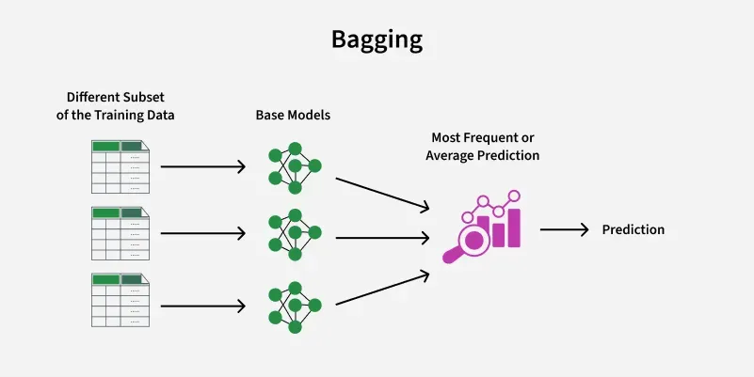

Random Forest Classification:
Random Forest is an ensemble learning algorithm that builds multiple decision trees and combines their predictions to improve accuracy, stability, and generalization.
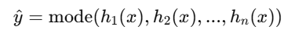
Where:
- $h_{i}(x)$= prediction of i-th tree
- mode = majority class
Predict whether a tumor is Malignant (cancerous) or Benign (non-cancerous)
from sklearn.datasets import load_breast_cancer
from sklearn.model_selection import train_test_split
from sklearn.ensemble import RandomForestClassifier
from sklearn.metrics import accuracy_score, classification_report, confusion_matrix
data = load_breast_cancer()
X = data.data
y = data.target
X_train, X_test, y_train, y_test = train_test_split(X, y, test_size=0.2, random_state=42)
rf = RandomForestClassifier(n_estimators=100, random_state=42)
rf.fit(X_train, y_train)
y_pred = rf.predict(X_test)
print("Accuracy:", accuracy_score(y_test, y_pred))
print("Classification Report:")
print(classification_report(y_test, y_pred))
print("Confusion Matrix:")
print(confusion_matrix(y_test, y_pred))

Boosting:
Boosting is an ensemble learning technique where models are trained sequentially, and each new model focuses more on the mistakes made by previous models. The final prediction is a weighted combination of all models.
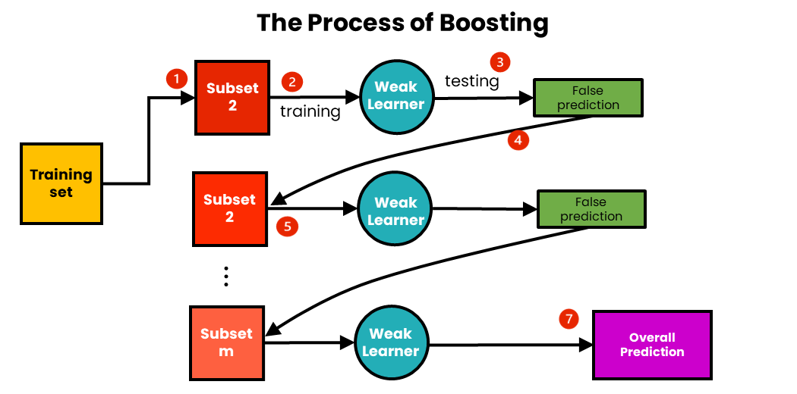
Boosting works with the following steps:
- We sample m-number of subsets from an initial training dataset.
- Using the first subset, we train the first weak learner.
- We test the trained weak learner using the training data. As a result of the testing, some data points will be incorrectly predicted.
- Each data point with the wrong prediction is sent into the second subset of data, and this subset is updated.
- Using this updated subset, we train and test the second weak learner.
- We continue with the next subset until reaching the total number of subsets.
- We now have the total prediction. The overall prediction has already been aggregated at each step, so there is no need to calculate it.
Boosting mainly helps when:
- Model is underfitting
- Data is complex & non-linear
- You want high accuracy
- AdaBoost (Adaptive Boosting):
AdaBoost trains weak learners sequentially and gives more weight to misclassified samples so that future models focus on difficult cases.
Initialize Sample Weights
For N samples:
$$w_{i}=\frac{1}{N}$$
Each classifier predicts:
$$h_{t}(x_{i})∈\{-1,+1\}$$Compute Error
$$ε_{t}=\sum_{i=1}^{N}{w_{i}}⋅I(y_{i}≠h_{t}(x_{i}))$$
Where:
$I$= Indicator function
Compute Classifier Weight
$$α_{t}=\frac{1}{2}ln⁡\left(\frac{1-ε_{t}}{ε_{t}}\right)$$
Better classifiers get higher α
Update Sample Weights
$$w_{i}=w_{i}⋅e^{-α_{t}y_{i}h_{t}(x_{i})}$$
- Misclassified → weight increases
- Correct → weight decreases
Then normalize:
$$∑w_{i}=1$$
Final Prediction
$$H(x)=\text{sign}\left(\sum_{t=1}^{T}{α_{t}}h_{t}(x)\right)$$When to Use AdaBoost?
- Binary classification
- Medium-sized datasets
- Clean data
- When weak learners are slightly better than random

import numpy as np
import pandas as pd
from sklearn.datasets import load_breast_cancer
from sklearn.model_selection import train_test_split
from sklearn.ensemble import AdaBoostClassifier
from sklearn.tree import DecisionTreeClassifier
from sklearn.metrics import accuracy_score, classification_report
data = load_breast_cancer()
X = data.data
y = data.target
X_train, X_test, y_train, y_test = train_test_split(X, y, test_size=0.2, random_state=42)
base_model = DecisionTreeClassifier(max_depth=1)
ada = AdaBoostClassifier(
estimator=base_model,
n_estimators=100,
learning_rate=1.0,
random_state=42
)
ada.fit(X_train, y_train)
y_pred = ada.predict(X_test)
print("Accuracy:", accuracy_score(y_test, y_pred))
print(classification_report(y_test, y_pred))

- Gradient Boosting (GBM): Builds models sequentially, Each new model learns to correct the mistakes of the previous models, Uses gradient descent in function space.
It combines: Weak learners (usually shallow decision trees), Additive modeling, Gradient descent optimization.
Initialize model
For squared loss:
$$F_{0}(x)=\text{mean}(y)$$Compute residuals
$$r_{i}=y_{i}-{\hat{y}}_{i}$$
Train a decision tree on residuals.
Update model
$$F_{m}(x)=F_{m-1}(x)+η⋅h_{m}(x)$$
Where:
- $η$= learning rate
- $h_{m}(x)$= new tree

from sklearn.datasets import load_breast_cancer
from sklearn.ensemble import GradientBoostingClassifier
from sklearn.model_selection import train_test_split
from sklearn.metrics import accuracy_score, classification_report

# Load data
X, y = load_breast_cancer(return_X_y=True)
# Split
X_train, X_test, y_train, y_test = train_test_split(
X, y, test_size=0.2, random_state=42)
# Model
gbc = GradientBoostingClassifier(
n_estimators=150,
learning_rate=0.1,
max_depth=3)
# Train
gbc.fit(X_train, y_train)
# Predict
y_pred = gbc.predict(X_test)
# Evaluation
print("Accuracy:", accuracy_score(y_test, y_pred))
print(classification_report(y_test, y_pred))

- XGBoost:
XGBoost is an optimized and regularized implementation of Gradient Boosting designed for: High speed, High performance, Large-scale data, Better overfitting control
XGBoost = Gradient Boosting + Regularization + System Optimization
- Initial Prediction: Start with an initial prediction, typically a base score like the average of target variables in regression or 0.5 probability in binary classification.
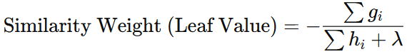
h_{i} =prop*(1-prop)
Gain=Score(left)+Score(right)−Score(parent)
from xgboost import XGBClassifier
from sklearn.datasets import load_breast_cancer
from sklearn.model_selection import train_test_split
from sklearn.metrics import accuracy_score
X, y = load_breast_cancer(return_X_y=True)
X_train, X_test, y_train, y_test = train_test_split(
X, y, test_size=0.2, random_state=42)
model = XGBClassifier(
n_estimators=200,
learning_rate=0.1,
max_depth=5)
model.fit(X_train, y_train)
pred = model.predict(X_test)
print("Accuracy:", accuracy_score(y_test, pred))

Stacking: 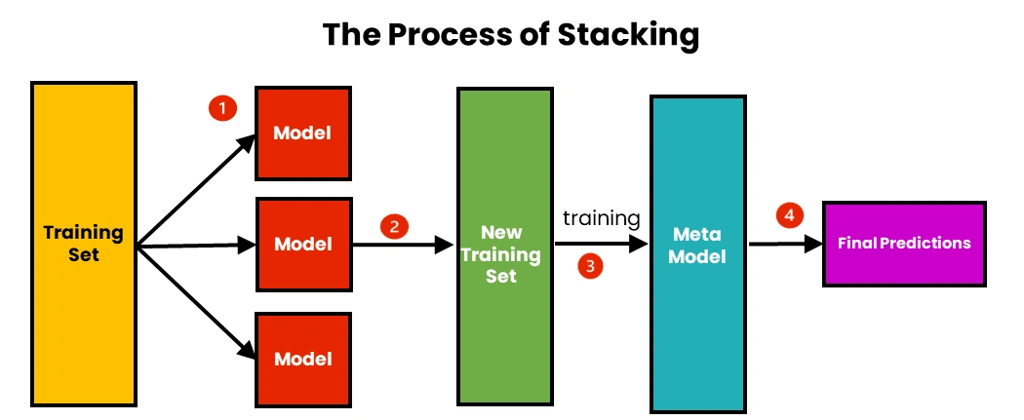
The steps of Stacking are as follows:
- We use initial training data to train m-number of algorithms.
- Using the output of each algorithm, we create a new training set.
- Using the new training set, we create a meta-model algorithm.
- Using the results of the meta-model, we make the final prediction. Combining the result using weighted averaging.
Base Models: Logistic Regression, Decision Tree, Random Forest, XGBoost, SVM
Meta-Model: Logistic Regression (most common), Linear Regression, XGBoost
from sklearn.datasets import load_breast_cancer
from sklearn.model_selection import train_test_split
from sklearn.linear_model import LogisticRegression
from sklearn.ensemble import RandomForestClassifier, StackingClassifier
from sklearn.svm import SVC
from sklearn.metrics import accuracy_score

# Data
X, y = load_breast_cancer(return_X_y=True)
X_train, X_test, y_train, y_test = train_test_split(
X, y, test_size=0.2, random_state=42)
# Base models
estimators = [ ('rf', RandomForestClassifier(n_estimators=100)),
('svm', SVC(probability=True))]
# Meta model `
meta_model = LogisticRegression()
# Stacking model
stack = StackingClassifier(
estimators=estimators,
final_estimator=meta_model,
cv=5)
# Train
stack.fit(X_train, y_train)
# Predict
pred = stack.predict(X_test)
print("Accuracy:", accuracy_score(y_test, pred))

SVM: A Support Vector Machine (SVM) is a powerful and versatile machine learning algorithm capable of performing linear or non-linear classification, regression, and even outlier detection. It's primarily used for classification tasks.
The core idea behind SVM is to find the "best" hyperplane that separates different classes of data points in a feature space. This "best" hyperplane is the one that has the largest margin between the two classes.
Linear SVM Classification
When data can be perfectly separated by a straight line (or hyperplane), it's called linearly separable. In this case, a linear SVM works very well. It finds the optimal hyperplane that maximizes the margin.
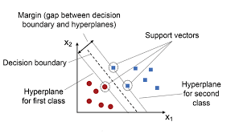

65
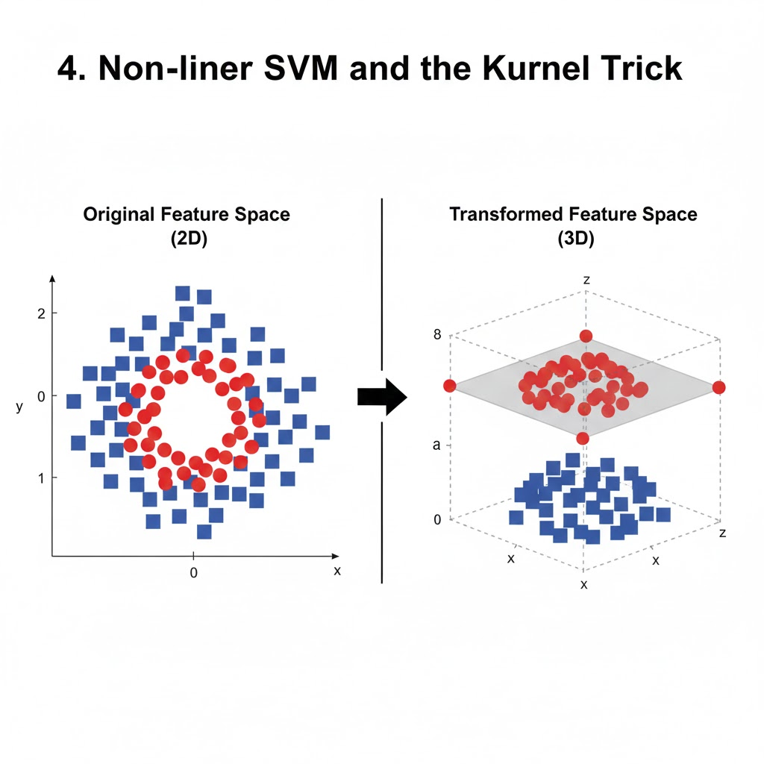

from sklearn.datasets import load_breast_cancer
from sklearn.model_selection import train_test_split
from sklearn.svm import SVC
from sklearn.metrics import accuracy_score
X, y = load_breast_cancer(return_X_y=True)
X_train, X_test, y_train, y_test = train_test_split(
X, y, test_size=0.2, random_state=42)
model = SVC( kernel='rbf', C=1, gamma='scale')
model.fit(X_train, y_train)
pred = model.predict(X_test)
print("Accuracy:", accuracy_score(y_test, pred))

Naïve Bayes Classifier:
Naïve Bayes is a probabilistic supervised learning algorithm based on Bayes’ Theorem, mainly used for: Classification problems, Text classification (spam, sentiment analysis), Medical diagnosis.
Bayes’ Theorem (Core Formula)
$$\boxed{P(C∣X)=\frac{P(X∣C) P(C)}{P(X)}}$$
Where:
- $P(C∣X)$→ Posterior probability
- $P(X∣C)$→ Likelihood
- $P(C)$→ Prior probability
- $P(X)$→ Evidence (constant for all classes)
Prior Probability Formula:
$$\boxed{P(C)=\frac{\text{Number of samples in class }C}{\text{Total samples}}}$$
- For features $X=(x_{1},x_{2},...,x_{n})$:
$$P(X∣C)=P(x_{1}∣C) P(x_{2}∣C) ... P(x_{n}∣C)$$

We predict the class with maximum probability:
$$\hat{C}=arg⁡\underset{C}{max⁡}P(C)∏P(x_{i}∣C)$$
Types of Naïve Bayes :
Gaussian Naïve Bayes
Used when features are continuous
$$P(x∣C)=\frac{1}{\sqrt{2πσ^{2}}}exp⁡\left( − \frac{\left(x − μ)^{2}\right.}{2σ^{2}}\right)$$
Example: Height, weight, salary

Multinomial Naïve Bayes
Used for text data
$$P(x_{i}∣C)=\frac{\text{count}(x_{i},C)+1}{∑\text{count}(C)+V}$$
Example: Spam detection
Bernoulli Naïve Bayes: Used for binary features
Feature values: 0 or 1
$$\boxed{P(x_{i}∣C)=p_{i}^{x_{i}}(1-p_{i})^{\left(1 − x_{i}\right)}}$$
Where:
- $p_{i}=P(x_{i}=1∣C)$

Example: Word present or not (0/1)
from sklearn.datasets import load_iris
from sklearn.model_selection import train_test_split
from sklearn.naive_bayes import GaussianNB
from sklearn.metrics import accuracy_score

# Load dataset
X, y = load_iris(return_X_y=True)

# Split data
X_train, X_test, y_train, y_test = train_test_split(
X, y, test_size=0.2, random_state=42
)

# Model
model = GaussianNB()
model.fit(X_train, y_train)

# Predict
y_pred = model.predict(X_test)

print("Accuracy:", accuracy_score(y_test, y_pred))

Unsupervised Learning – Clustering:
Unsupervised learning is a type of machine learning where: No labeled output (no target variable), Model finds hidden patterns or structures in data.
Clustering is an unsupervised learning technique where: Similar data points are grouped into clusters, Dissimilar points go into different clusters
Goal: Maximize similarity within clusters and minimize similarity between clusters.
(Distance Metrics)
Euclidean Distance (Most Common)
$$\boxed{d(x,y)=\sqrt{\sum_{i=1}^{n}{(}x_{i}-y_{i})^{2}}}$$
Manhattan Distance
$$\boxed{d(x,y)=\sum_{i=1}^{n}{∣}x_{i}-y_{i}∣}$$

Cosine Similarity (Text Data)
$$\boxed{\text{cosine}(x,y)=\frac{x⋅y}{∥x∥∥y∥}}$$
K-Means Clustering: Divide data into K clusters, Each cluster has a centroid, Choose K, Initialize centroids, Assign points to nearest centroid, Update centroids, Repeat until convergence.

Objective Function:
$$\boxed{J=\sum_{k=1}^{K}{\sum_{x_{i}∈C_{k}}{∥}}x_{i}-μ_{k}∥^{2}}$$
Minimize Within Cluster Sum of Squares (WCSS)

Centroid Formula:
$$\boxed{μ_{k}=\frac{1}{∣C_{k}∣}\sum_{x_{i}∈C_{k}}{x_{i}}}$$

from sklearn.cluster import KMeans
from sklearn.datasets import make_blobs

X, _ = make_blobs(n_samples=300, centers=3, random_state=42)

kmeans = KMeans(n_clusters=3, init='k-means++', random_state=42)
kmeans.fit(X)

print(kmeans.cluster_centers_)
print(kmeans.labels_)

Hierarchical Clustering: Hierarchical clustering is an unsupervised learning algorithm used to group similar data points into clusters. It builds a multilevel hierarchy of clusters by either merging smaller clusters into larger ones (agglomerative) or dividing a large cluster into smaller ones (divisive). This results in a tree-like structure known as a dendrogram.

A dendrogram is a visual representation that illustrates the arrangement of clusters and their relationships with each other. The height of the branches in a dendrogram represents the distance or dissimilarity at which clusters merge. Lower heights indicate clusters joined at smaller distances, thus representing higher similarity.

Distance Calculation (Euclidean)
$$d(x,y)=\sqrt{\left(x_{1}-y_{1})^{2}+(x_{2}-y_{2})^{2}\right.}$$How It Works (Agglomerative Example):
Start: Treat each data point as its own cluster.
Merge: Find the two closest (most similar) clusters and merge them.
Repeat: Continue merging the closest clusters until all data points are in one large cluster
Linkage | Meaning
single | Min distance
complete | Max distance
average | Avg distance
ward | Minimizes variance

import numpy as np
import matplotlib.pyplot as plt
from sklearn.datasets import load_iris
from scipy.cluster.hierarchy import dendrogram, linkage
from sklearn.cluster import AgglomerativeClustering
iris = load_iris()
X = iris.data # only features
linked = linkage(X, method='ward')

plt.figure(figsize=(12, 6))
dendrogram(linked)
plt.title("Dendrogram - Hierarchical Clustering")
plt.xlabel("Data Points")
plt.ylabel("Distance")
plt.show()
model = AgglomerativeClustering(
n_clusters=3,
linkage='ward'
)

labels = model.fit_predict(X)
print(labels)
plt.scatter(X[:, 0], X[:, 1], c=labels)
plt.xlabel("Sepal Length")
plt.ylabel("Sepal Width")
plt.title("Hierarchical Clustering Result")
plt.show()

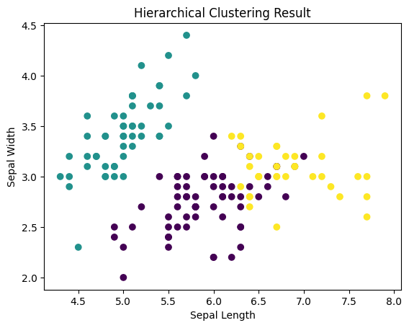
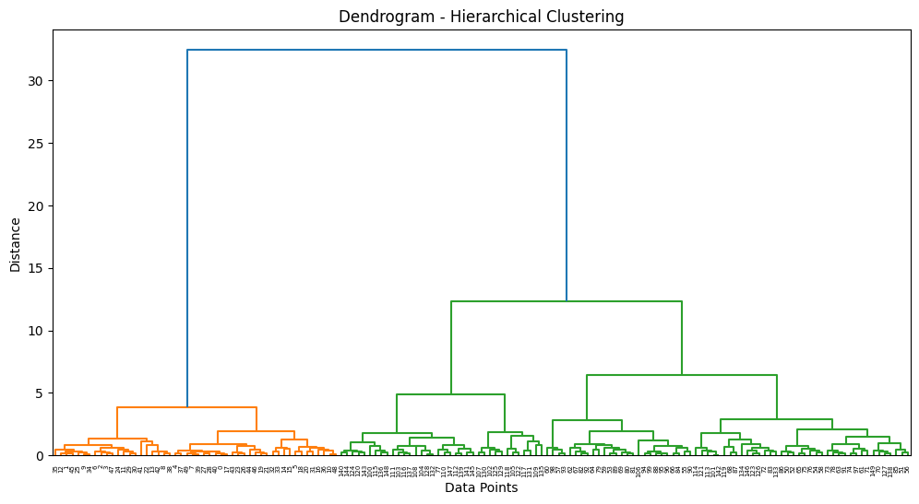

DBSCAN – Density-Based Spatial Clustering:
DBSCAN is a density-based unsupervised clustering algorithm that can find arbitrary-shaped clusters and detect outliers (noise). Density based clustering algorithms divides your entire dataset into dense regions separated by sparse regions.
Measuring density around a point is straightforward — we define a region around the point and assess the number of points within that designated area. This approach serves as a practical method for gauging the density surrounding a specific point.
ε (Epsilon)
- Radius of neighborhood
- Defines how close points must be
Mathematically:
$$N_{ε}(p)=\{q∣distance(p,q)≤ε\}$$MinPts

Minimum number of points required inside ε-radius

Controls minimum cluster density

Rule of thumb:

2D → MinPts ≥ 4

Higher dimensions → MinPts ≥ 2 × dimensions

Types of Points in DBSCAN
Core Point
A point p is a core point if:
$$∣N_{ε}(p)∣≥MinPts$$
Meaning: dense region

Border Point
- Lies within ε of a core point
- But does NOT satisfy MinPts itself

Noise (Outlier)
- Not core
- Not reachable from any core point
Density Reachability: Point q is density-reachable from p if:
- p is a core point
- q lies within ε of p
Density Connectivity
Two points p and q are density-connected if:
- There exists a point o
- Both p and q are density-reachable from o
DBSCAN Algorithm – Step by Step
Algorithm
- Pick an unvisited point
- Find all points within ε
- If neighbors < MinPts → mark as noise
- Else:
  - Create new cluster
  - Add neighbors to cluster
  - Expand cluster by checking neighbors of neighbors
- Repeat until all points visited
import numpy as np
import pandas as pd
import matplotlib.pyplot as plt

from sklearn.datasets import load_iris
from sklearn.cluster import DBSCAN
from sklearn.preprocessing import StandardScaler
iris = load_iris()
X = iris.data # features
y = iris.target # actual labels (only for comparison)
scaler = StandardScaler()
X_scaled = scaler.fit_transform(X)
dbscan = DBSCAN(
eps=0.6, # neighborhood radius
min_samples=5 # minimum points to form dense region)

clusters = dbscan.fit_predict(X_scaled)
unique_clusters = np.unique(clusters)
print("Clusters found:", unique_clusters)
df = pd.DataFrame(X, columns=iris.feature_names)
df['cluster'] = clusters
df['actual_class'] = y
plt.figure(figsize=(8,6))

plt.scatter(
df['petal length (cm)'],
df['petal width (cm)'],
c=df['cluster'],
cmap='rainbow',
s=50)

plt.xlabel("Petal Length")
plt.ylabel("Petal Width")
plt.title("DBSCAN Clustering on Iris Dataset")
plt.show()
noise_points = np.sum(clusters == -1)
print("Noise points:", noise_points)

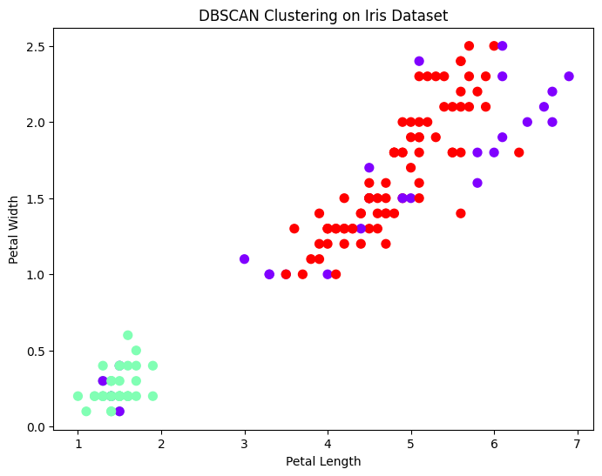

Model Pipelining: Model pipelining is the process of chaining multiple ML steps

Typical ML Pipeline Structure:
Raw Data Missing Value Handling Encoding (Categorical) Feature Scaling Feature Selection (optional) ML Model Predictions

# Step 1: Import Libraries
import pandas as pd
import numpy as np

from sklearn.model_selection import train_test_split
from sklearn.pipeline import Pipeline
from sklearn.compose import ColumnTransformer

from sklearn.preprocessing import StandardScaler, OneHotEncoder
from sklearn.impute import SimpleImputer

from sklearn.linear_model import LogisticRegression
from sklearn.metrics import mean_squared_error, r2_score
# Step 2: Load Dataset Directly from URL
url = "https://raw.githubusercontent.com/datasciencedojo/datasets/master/titanic.csv"
df = pd.read_csv(url)

print("Dataset shape:", df.shape)

df.head()
# Step 3: Separate Features and Target
X = df.drop("Survived", axis=1)
y = df["Survived"]
# Step 4: Identify Numerical and Categorical Columns
numeric_features = X.select_dtypes(include=['int64', 'float64']).columns
categorical_features = X.select_dtypes(include=['object']).columns
# Step 5: Preprocessing Pipelines
# Numerical Pipeline
num_pipeline = Pipeline(steps=[
('imputer', SimpleImputer(strategy='median')),
('scaler', StandardScaler())
])

# Categorical Pipeline
cat_pipeline = Pipeline(steps=[
('imputer', SimpleImputer(strategy='most_frequent')),
('encoder', OneHotEncoder(handle_unknown='ignore'))
])
# Step 6: Combine Pipelines
preprocessor = ColumnTransformer(transformers=[
('num', num_pipeline, numeric_features),
('cat', cat_pipeline, categorical_features)
])
# Step 7: Full ML Pipeline with Logistic Regression
model_pipeline = Pipeline(steps=[
('preprocessing', preprocessor),
('classifier', LogisticRegression(max_iter=1000))
])
# Step 8: Train-Test Split
X_train, X_test, y_train, y_test = train_test_split(
X, y, test_size=0.2, random_state=42
)
# Step 9: Train the Pipeline
model_pipeline.fit(X_train, y_train)
# Step 10: Predict & Evaluate
y_pred = model_pipeline.predict(X_test)

from sklearn.metrics import accuracy_score, classification_report

print("Accuracy:", accuracy_score(y_test, y_pred))
print("\nClassification Report:\n", classification_report(y_test, y_pred))
# Step 11: Predict on New Sample
new_sample = X_test.iloc[:1] # take one row
predicted_class = model_pipeline.predict(new_sample)
print("Predicted Class (Survived=1 / Not Survived=0):", predicted_class)

Dimensionality Reduction:
Dimensionality Reduction is the process of reducing the number of input features (variables) in a dataset while preserving as much important information as possible.
Why it's important
- Solves Curse of Dimensionality: High dimensions lead to sparse data, making patterns hard to find.
- Reduces Overfitting: Fewer features mean simpler models that generalize better to new data.
- Improves Efficiency: Faster training and deployment due to less data.
- Aids Visualization: Easier to visualize data in 2D or 3D.
Feature Selection: Selects a subset of original features.
Methods: Filter methods (based on statistics), Wrapper methods (using model performance), Embedded methods (part of model training).

Feature Extraction: Transforms features into a new, lower-dimensional space.
Principal Component Analysis (PCA): Finds orthogonal components (principal components) that capture maximum variance, transforming data into a new feature space.

When to use
- When datasets have hundreds or thousands of features (e.g., image, text data).
- To simplify complex models and reduce training time.
- To overcome data sparsity and improve model generalization.
Principal Component Analysis (PCA):
- Standardize data.
- Calculate the covariance matrix.
- Find eigenvectors (principal components) and eigenvalues (variance explained).
- Select top components (those with largest eigenvalues) to form the new, lower-dimensional dataset

Standardization:
$$Z=\frac{X-μ}{σ}$$
Covariance Matrix:

$$Σ=\frac{1}{n}Z^{T}Z$$
Eigen Decomposition
$$Σv=λv$$
- Eigenvectors → directions (principal components)
- Eigenvalues → variance captured
Sort & Select Components
Choose top k eigenvectors with highest eigenvalues.
Projection
$$X_{reduced}=Z⋅W_{k}$$Explained Variance
$$\text{Explained Variance Ratio}=\frac{λ_{i}}{∑λ}$$
Used to decide number of components.

from sklearn.preprocessing import StandardScaler
from sklearn.decomposition import PCA
from sklearn.datasets import load_breast_cancer

X, y = load_breast_cancer(return_X_y=True)

X_scaled = StandardScaler().fit_transform(X)

pca = PCA(n_components=2)
X_pca = pca.fit_transform(X_scaled)

print("Explained variance:", pca.explained_variance_ratio_)

PCA in Real-World Applications
- Image compression
- Face recognition
- Noise reduction
- Genomics
- Finance risk analysis
Saving & Loading the model: Storing a trained machine learning model (and its preprocessing logic) to disk so it can be reused later without retraining.

import pandas as pd
import numpy as np
import joblib
from sklearn.model_selection import train_test_split
from sklearn.preprocessing import OneHotEncoder, StandardScaler
from sklearn.compose import ColumnTransformer
from sklearn.pipeline import Pipeline
from sklearn.metrics import r2_score, mean_absolute_error
from sklearn.ensemble import RandomForestRegressor
df = pd.read_csv("./Carprice_Assignment.csv")
# Drop ID column
df.drop("car_ID", axis=1, inplace=True)
# Extract company name from CarName
df["Company"] = df["CarName"].apply(lambda x: x.split(" ")[0])
df.drop("CarName", axis=1, inplace=True)
X = df.drop("price", axis=1)
y = df["price"]
categorical_cols = X.select_dtypes(include="object").columns
numerical_cols = X.select_dtypes(exclude="object").columns
numeric_transformer = Pipeline(
steps=[
("scaler", StandardScaler())
]
)

categorical_transformer = Pipeline(
steps=[
("onehot", OneHotEncoder(handle_unknown="ignore"))
]
)

preprocessor = ColumnTransformer(
transformers=[
("num", numeric_transformer, numerical_cols),
("cat", categorical_transformer, categorical_cols)
])
model = RandomForestRegressor(
n_estimators=300,
random_state=42,
n_jobs=-1
)

pipeline = Pipeline(
steps=[
("preprocessor", preprocessor),
("model", model)
]
)

X_train, X_test, y_train, y_test = train_test_split(
X, y, test_size=0.2, random_state=42
)
pipeline.fit(X_train, y_train)
y_pred = pipeline.predict(X_test)

print("R2 Score:", r2_score(y_test, y_pred))
print("MAE:", mean_absolute_error(y_test, y_pred))
joblib.dump(pipeline, "./car_price_pipeline.pkl")
print("Model saved successfully")
import pandas as pd
import joblib
model = joblib.load("./car_price_pipeline.pkl")
new_car = pd.DataFrame({
"symboling": [2],
"fueltype": ["gas"],
"aspiration": ["std"],
"doornumber": ["four"],
"carbody": ["sedan"],
"drivewheel": ["fwd"],
"enginelocation": ["front"],
"wheelbase": [98.4],
"carlength": [176.6],
"carwidth": [65.2],
"carheight": [54.3],
"curbweight": [2337],
"enginetype": ["ohc"],
"cylindernumber": ["four"],
"enginesize": [109],
"fuelsystem": ["mpfi"],
"boreratio": [3.19],
"stroke": [3.40],
"compressionratio": [10.0],
"horsepower": [102],
"peakrpm": [5500],
"citympg": [24],
"highwaympg": [30],
"Company": ["audi"]
})
predicted_price = model.predict(new_car)
print("Predicted Car Price:", predicted_price[0])

Deep Learning: Deep Learning (DL) is a subset of Machine Learning (ML) that uses artificial neural networks with many layers (deep networks) to learn complex patterns from data automatically.
Why Deep Learning?
Traditional ML requires manual feature engineering.
Deep Learning:
- Learns features automatically
- Works extremely well with large and unstructured data
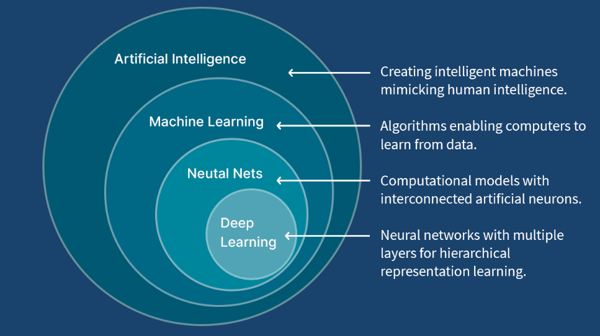
Neural network:
Neural networks are AI models inspired by the human brain, using layers of interconnected nodes (neurons) to learn patterns from data, enabling tasks like image recognition and language processing. They consist of an input layer, hidden layers for processing, and an output layer, with connections having adjustable "weights" that are tuned during training to improve accuracy. This process involves feeding data forward, calculating errors, and using "backpropagation" to adjust weights, allowing the network to identify complex patterns without explicit rules.

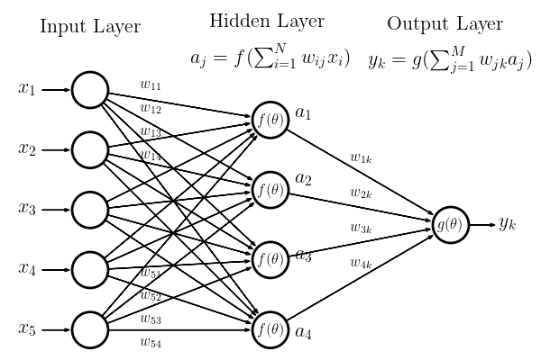
A neural network consists of several layers:
- Input Layer: Receives data or features, which refer to the individual measurable properties or characteristics of the data used as input. These features are the elements that the neural network uses to learn patterns, make predictions, or classify information. For example, in an image recognition task, the features might include aspects like pixel values, edges, or shapes; in a financial model, features could be variables such as income, expenses, or stock prices
- Hidden Layers: Perform computations and transformations on the input data. A network can have one or more hidden layers, with each layer composed of neurons. This process transforms the data, allowing the network to capture non-linear relationships and deeper patterns that are not immediately obvious in the raw input.
- Output Layer: Produces the final result or prediction, based on the data processed through the previous layers. It directly interacts with the hidden layers and uses their processed information to generate an output that matches the task the network is designed to perform.
Each neuron in a layer is connected to neurons in the subsequent layer, and each connection has a weight that determines the strength of the connection. These weights are adjusted as the network learns.
How neural networks learn
Neural networks learn through a process called “training”, which involves:
- Forward Propagation: Input data is passed through the network, layer by layer, to generate an output prediction.
- Loss Function: A comparison is made between the network’s prediction and the actual target value (in supervised learning). The difference is called error or loss, calculated using a loss function.
- Backpropagation: To minimize the error, the network adjusts the weights using a technique called backpropagation. In this process, the network computes the gradient (derivative) of the loss function with respect to each weight and updates the weights to reduce the error.
- Optimization: An optimization algorithm will used to adjust the weights iteratively until the network learns to make accurate predictions.
Types of Neural Networks:
- Feedforward Neural Networks
- Convolutional Neural Networks (CNNs)
- Recurrent Neural Networks (RNNs)
- Long Short-Term Memory Networks (LSTMs)
- Gated Recurrent Units (GRUs)
- Radial Basis Function Networks (RBFNs)
- Self-Organizing Maps (SOMs)
- Deep Belief Networks (DBNs)
- Generative Adversarial Networks (GANs)
- Autoencoders (AE)
- Transformer Networks
- Siamese Neural Networks
- Capsule Networks (CapsNet)
- Spiking Neural Networks (SNN)

  - Feedforward Neural Networks: A Feedforward Neural Network is the simplest type of neural network in which:
- Information flows in one direction only
- From input layer → hidden layer(s) → output layer
- There are no loops or feedback connections

Also called:
- Artificial Neural Network (ANN)
- Multilayer Perceptron (MLP)

How Feedforward Neural Networks Work

The working of a feedforward neural network involves two phases: the feedforward phase and the backpropagation phase.
- Feedforward Phase: In this phase, the input data is fed into the network, and it propagates forward through the network. At each hidden layer, the weighted sum of the inputs is calculated and passed through an activation function, which introduces non-linearity into the model. This process continues until the output layer is reached, and a prediction is made.

- Backpropagation Phase: Once a prediction is made, the error (difference between the predicted output and the actual output) is calculated. This error is then propagated back through the network, and the weights are adjusted to minimize this error. The process of adjusting weights is typically done using a gradient descent optimization algorithm.
Important Deep Learning Terms
- Epoch – The number of times the algorithm runs on the whole training dataset.
- Sample – A single row of a dataset.
- Batch – It denotes the number of samples to be taken to for updating the model parameters.
- Learning rate – It is a parameter that provides the model a scale of how much model weights should be updated.
- Cost Function/Loss Function – A cost function is used to calculate the cost, which is the difference between the predicted value and the actual value.
- Weights/ Bias – The learnable parameters in a model that controls the signal between two neurons.

Activation Functions Used:

Function | Use Case
ReLU | Hidden layers
Sigmoid | Binary classification
Softmax | Multi-class classification
Linear | Regression
Loss Function: Measures error between predicted and actual output.
Task | Loss Function
Regression | Mean Squared Error
Binary Class | Binary Cross-Entropy
Multi-Class | Categorical Cross-Entropy

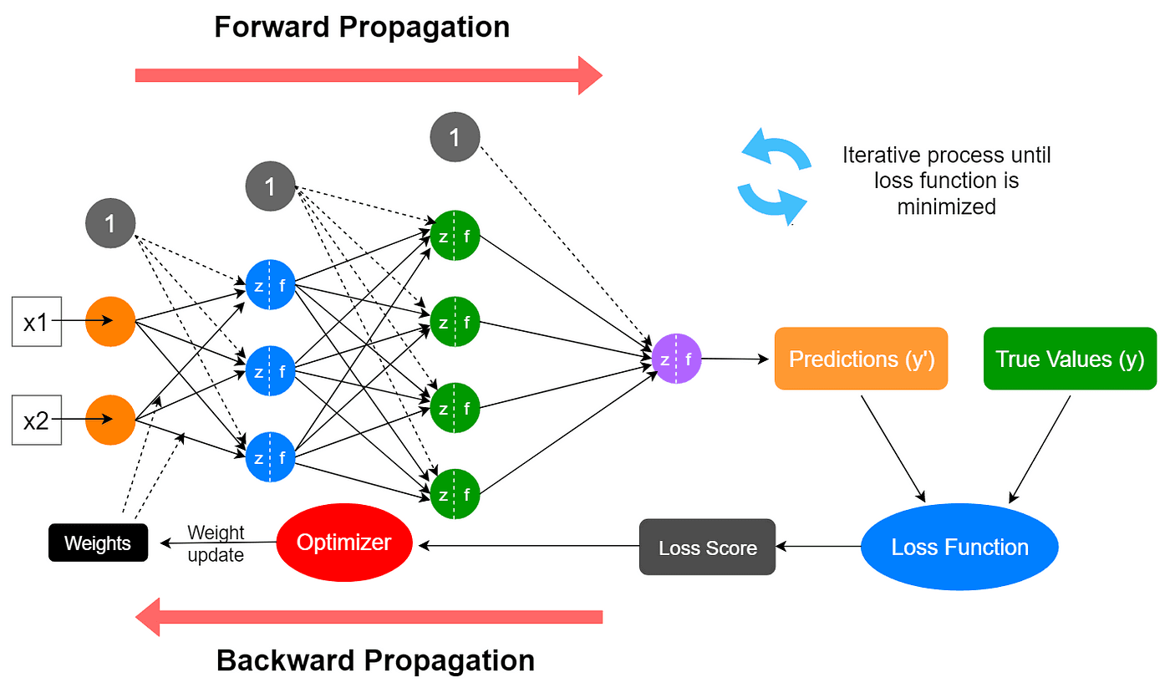
Each neuron computes:
z = w1x1 + w2x2 + ... + b
output = activation(z)
Where:
- w → weights
- b → bias
- activation → ReLU, Sigmoid, etc.
Optimizers
Used to update weights efficiently: Gradient Descent, Adam, RMSprop
Learning Rate: Controls step size during training
- Too high → unstable training
- Too low → slow convergence
Implementation: Customer Churn Prediction using a Neural Network
Customer churn means when a customer stops using a company’s service. Goal to Predict whether a customer will churn (Yes/No).
This is a binary classification problem.
import pandas as pd
data = pd.read_csv('./customer_churn_dataset-training-master.csv')
data.head()
 | CustomerID | Age | Gender | Tenure | Usage Frequency | Support Calls | Payment Delay | Subscription Type | Contract Length | Total Spend | Last Interaction | Churn
0 | 2.0 | 30.0 | Female | 39.0 | 14.0 | 5.0 | 18.0 | Standard | Annual | 932.0 | 17.0 | 1.0
1 | 3.0 | 65.0 | Female | 49.0 | 1.0 | 10.0 | 8.0 | Basic | Monthly | 557.0 | 6.0 | 1.0
2 | 4.0 | 55.0 | Female | 14.0 | 4.0 | 6.0 | 18.0 | Basic | Quarterly | 185.0 | 3.0 | 1.0
3 | 5.0 | 58.0 | Male | 38.0 | 21.0 | 7.0 | 7.0 | Standard | Monthly | 396.0 | 29.0 | 1.0
4 | 6.0 | 23.0 | Male | 32.0 | 20.0 | 5.0 | 8.0 | Basic | Monthly | 617.0 | 20.0 | 1.0
data.drop('CustomerID', axis=1, inplace=True)
data.ffill( inplace=True)
X=data.drop('Churn', axis=1)
y=data['Churn
catcols=['Gender','Subscription Type','Contract Length']
numcols=[col for col in X.columns if col not in catcols]
from sklearn.preprocessing import OneHotEncoder, StandardScaler
from sklearn.compose import ColumnTransformer
preprocessor = ColumnTransformer(
transformers=[
('num', StandardScaler(), numcols),
('cat', OneHotEncoder(), catcols) ])
from sklearn.model_selection import train_test_split
X_train, X_test, y_train, y_test = train_test_split(X, y, test_size=0.2, random_state=42)
X_train = preprocessor.fit_transform(X_train)
X_test = preprocessor.transform(X_test)
from tensorflow.keras.models import Sequential
from tensorflow.keras.layers import Dense, Dropout
from tensorflow.keras.optimizers import Adam
from tensorflow.keras.callbacks import EarlyStopping
model = Sequential()
model.add(Dense(128, activation='relu', input_shape=(X_train.shape[1],)))
model.add(Dropout(0.2))
model.add(Dense(64, activation='relu'))
model.add(Dropout(0.2))
model.add(Dense(1, activation='sigmoid'))
model.summary()
Model: "sequential_2"
┏━━━━━━━━━━━━━━━━━━━━━━━━━━━━━━━━━┳━━━━━━━━━━━━━━━━━━━━━━━━┳━━━━━━━━━━━━━━━┓
┃ Layer (type) ┃ Output Shape ┃ Param # ┃
┡━━━━━━━━━━━━━━━━━━━━━━━━━━━━━━━━━╇━━━━━━━━━━━━━━━━━━━━━━━━╇━━━━━━━━━━━━━━━┩
│ dense_6 (Dense) │ (None, 128) │ 2,048 │
├─────────────────────────────────┼────────────────────────┼───────────────┤
│ dropout_2 (Dropout) │ (None, 128) │ 0 │
├─────────────────────────────────┼────────────────────────┼───────────────┤
│ dense_7 (Dense) │ (None, 64) │ 8,256 │
├─────────────────────────────────┼────────────────────────┼───────────────┤
│ dropout_3 (Dropout) │ (None, 64) │ 0 │
├─────────────────────────────────┼────────────────────────┼───────────────┤
│ dense_8 (Dense) │ (None, 1) │ 65 │
└─────────────────────────────────┴────────────────────────┴───────────────┘
Total params: 10,369 (40.50 KB)
# Use binary crossentropy for a single-sigmoid (binary) output and ensure labels are integers
model.compile(optimizer=Adam(learning_rate=0.001),
loss='binary_crossentropy',
metrics=['accuracy'])

y_train = y_train.astype('int32')
y_test = y_test.astype('int32')

early_stopping = EarlyStopping(monitor='val_loss', patience=5, restore_best_weights=True)
history = model.fit(X_train, y_train,
validation_split=0.2,
epochs=50,
batch_size=32,
callbacks=[early_stopping])
test_loss, test_accuracy = model.evaluate(X_test, y_test)
print(f'Test Loss: {test_loss}, Test Accuracy: {test_accuracy}')

Epoch 1/50
8817/8817 ━━━━━━━━━━━━━━━━━━━━ 52s 6ms/step - accuracy: 0.9814 - loss: 0.0546 - val_accuracy: 0.9930 - val_loss: 0.0227
Epoch 2/50
8817/8817 ━━━━━━━━━━━━━━━━━━━━ 47s 5ms/step - accuracy: 0.9929 - loss: 0.0239 - val_accuracy: 0.9952 - val_loss: 0.0173

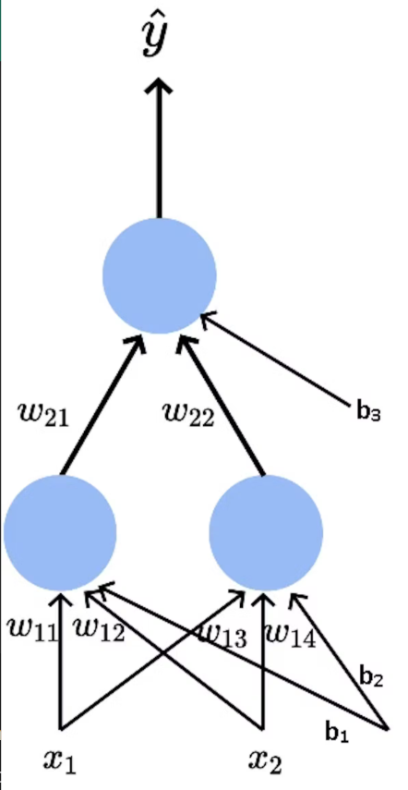
Mathematical equations:
Hidden neuron 1
Weights: $w_{11},w_{12}$
Bias: $b_{1}$
$$z_{1}=w_{11}x_{1}+w_{12}x_{2}+b_{1} \\ h_{1}=f(z_{1})$$Hidden neuron 2
Weights: $w_{13},w_{14}$
Bias: $b_{2}$
$$z_{2}=w_{13}x_{1}+w_{14}x_{2}+b_{2} \\ h_{2}=f(z_{2})$$
$f(⋅)$is the hidden-layer activation function (e.g., ReLU, sigmoid, tanh).

Output layer (1 neuron)
Weights: $w_{21},w_{22}$
Bias: $b_{3}$
$$z_{3}=w_{21}h_{1}+w_{22}h_{2}+b_{3} \\ \hat{y}=g(z_{3})$$
$g(⋅)$is the output activation function
Substitute hidden neurons into the output:
$$\hat{y}=g(w_{21}f(w_{11}x_{1}+w_{12}x_{2}+b_{1})+w_{22}f(w_{13}x_{1}+w_{14}x_{2}+b_{2})+b_{3})$$
Matrix form (compact)
Hidden layer
$$z^{\left(1\right)}=\left[\begin{matrix}w_{11} & w_{12} \\ w_{13} & w_{14}\end{matrix}\right]\left[\begin{aligned}x_{1} \\ x_{2}\end{aligned}\right]+\left[\begin{aligned}b_{1} \\ b_{2}\end{aligned}\right] \\ h=f(z^{\left(1\right)})$$Output layer
$$z^{\left(2\right)}=\left[\begin{matrix}w_{21} & w_{22}\end{matrix}\right]h+b_{3} \\ \hat{y}=g(z^{\left(2\right)})$$Loss function equations
Mean Squared Error (Regression)
$$\boxed{L=\frac{1}{2}(\hat{y}-y)^{2}}$$Binary Cross-Entropy (Classification)
$$\boxed{L=-[ylog⁡(\hat{y})+(1-y)log⁡(1-\hat{y})]}$$Chain rule structure (core idea)
Backprop is repeated application of:
$$\boxed{\frac{∂L}{∂a}=\frac{∂L}{∂b}⋅\frac{∂b}{∂a}}$$

Output layer gradients (with full chain rule)
Gradient w.r.t. output $z_{3}$
$$\frac{∂L}{∂z_{3}}=\frac{∂L}{∂\hat{y}}⋅\frac{∂\hat{y}}{∂z_{3}} \\ \frac{∂L}{∂\hat{y}}=(\hat{y}-y) \\ \frac{∂\hat{y}}{∂z_{3}}=g^{'}(z_{3}) \\ \boxed{δ_{3}=(\hat{y}-y) g^{'}(z_{3})}$$Gradients w.r.t. output weights
$w_{21}$:
$$\frac{∂L}{∂w_{21}}=\frac{∂L}{∂z_{3}}⋅\frac{∂z_{3}}{∂w_{21}} \\ \frac{∂z_{3}}{∂w_{21}}=h_{1} \\ \boxed{\frac{∂L}{∂w_{21}}=δ_{3}⋅h_{1}}$$
$w_{22}$:
$$\boxed{\frac{∂L}{∂w_{22}}=δ_{3}⋅h_{2}}$$
Bias $b_{3}$
$$\boxed{\frac{∂L}{∂b_{3}}=δ_{3}}$$Hidden layer gradients (with nested chain rule)
Hidden neuron 1 error term
$$\frac{∂L}{∂z_{1}}=\frac{∂L}{∂z_{3}}⋅\frac{∂z_{3}}{∂h_{1}}⋅\frac{∂h_{1}}{∂z_{1}} \\ \frac{∂z_{3}}{∂h_{1}}=w_{21} \\ \frac{∂h_{1}}{∂z_{1}}=f^{'}(z_{1}) \\ \boxed{δ_{1}=δ_{3}⋅w_{21}⋅f^{'}(z_{1})}$$

Hidden neuron 2 error term
$$\boxed{δ_{2}=δ_{3}⋅w_{22}⋅f^{'}(z_{2})}$$
5. Hidden layer weight gradients (full chain rule)
Weight $w_{11}$
$$\frac{∂L}{∂w_{11}}=\frac{∂L}{∂z_{1}}⋅\frac{∂z_{1}}{∂w_{11}} \\ \frac{∂z_{1}}{∂w_{11}}=x_{1} \\ \boxed{\frac{∂L}{∂w_{11}}=δ_{1}⋅x_{1}}$$
Weight $w_{12}$
$$\boxed{\frac{∂L}{∂w_{12}}=δ_{1}⋅x_{2}}$$
Bias $b_{1}$
$$\boxed{\frac{∂L}{∂b_{1}}=δ_{1}}$$
Weight $w_{13}$
$$\boxed{\frac{∂L}{∂w_{13}}=δ_{2}⋅x_{1}}$$
Weight $w_{14}$
$$\boxed{\frac{∂L}{∂w_{14}}=δ_{2}⋅x_{2}}$$
Bias $b_{2}$
$$\boxed{\frac{∂L}{∂b_{2}}=δ_{2}}$$
$$\boxed{δ^{\left(l\right)}=\left(W^{(l+1)T}δ^{\left(l + 1\right)}\right)⊙f^{'}(z^{\left(l\right)})}$$
Problem overview (MNIST)
- Dataset: 70,000 grayscale images of handwritten digits
- Image size: $28×28=784$pixels
- Classes: digits 0–9 (10 classes)
Goal:
Given an image $x∈R^{784}$, predict the digit label $y∈\{0,…,9\}$.
import tensorflow as tf
from tensorflow.keras.datasets import mnist
from tensorflow.keras.models import Sequential
from tensorflow.keras.layers import Dense, Flatten
from tensorflow.keras.utils import to_categorical
(x_train, y_train), (x_test, y_test) = mnist.load_data()
# Normalize
x_train = x_train / 255.0
x_test = x_test / 255.0
# One-hot encode labels
y_train = to_categorical(y_train, 10)
y_test = to_categorical(y_test, 10)
model = Sequential([
Flatten(input_shape=(28, 28)),
Dense(128, activation='relu'),
Dense(10, activation='softmax')])
model.compile(
optimizer='adam',
loss='categorical_crossentropy',
metrics=['accuracy'])
# Train
model.fit(x_train, y_train, epochs=10, batch_size=32)
# Evaluate
test_loss, test_acc = model.evaluate(x_test, y_test)
print("Test accuracy:", test_acc)
import numpy as np
pred = model.predict(x_test[:1])
digit = np.argmax(pred)
print("Predicted digit:", digit)
vanishing gradient:
During backpropagation, gradients become extremely small as they are propagated backward through many layers → early layers stop learning.
This happens because of repeated multiplication of small numbers in the chain rule.
Where chain rule comes in (core idea)
Backpropagation uses the chain rule:
$$\frac{∂L}{∂w^{\left(1\right)}}=\frac{∂L}{∂z^{\left(L\right)}}⋅\frac{∂z^{\left(L\right)}}{∂z^{\left(L − 1\right)}}⋅…⋅\frac{∂z^{\left(2\right)}}{∂z^{\left(1\right)}}⋅\frac{∂z^{\left(1\right)}}{∂w^{\left(1\right)}}$$
Gradients are products of many derivatives
Why gradients vanish (numerical reason)
Case: Sigmoid activation
$$f^{'}(z)=σ(z)(1-σ(z))$$
Max value:
$$max⁡f^{'}(z)=0.25$$
So each layer multiplies the gradient by ≤ 0.25

Activation function:
An activation function introduces non-linearity into a neural network.
Without it network becomes just a linear model, no matter how deep.
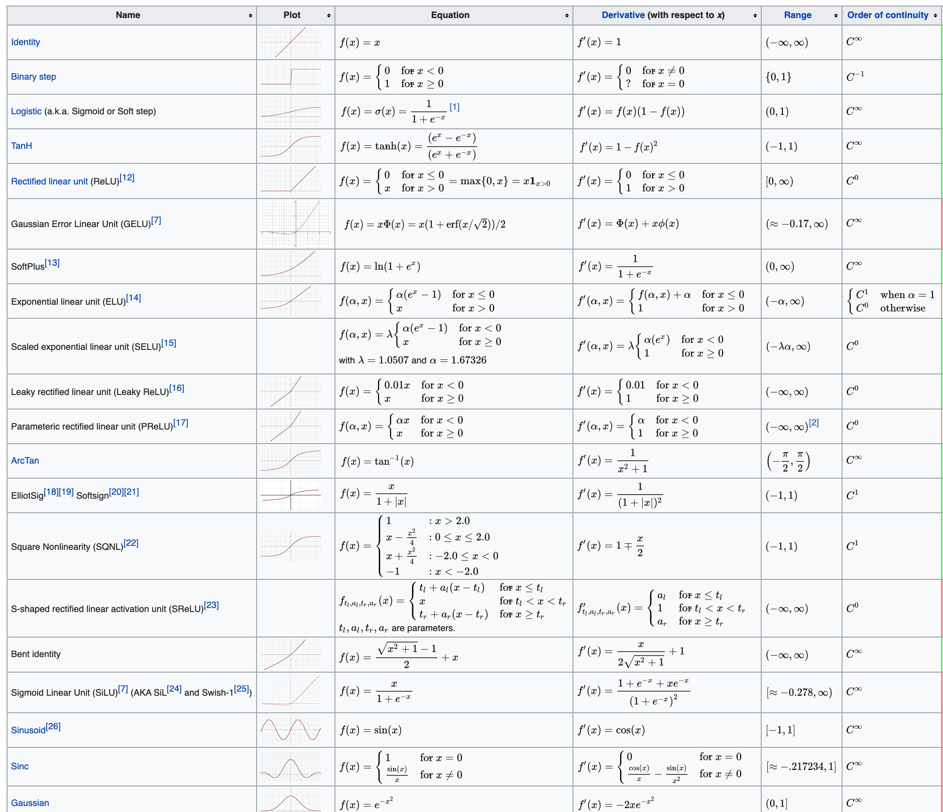

Loss function:
A loss function measures how wrong a model’s prediction is compared to the true target.
$$\text{Loss}=\text{Difference}(\text{Prediction},\text{Ground Truth})$$

Mean Squared Error (MSE)
Formula
$$L_{MSE}=\frac{1}{n}∑(y-\hat{y})^{2}$$
Gradient
$$\frac{∂L}{∂\hat{y}}=2(\hat{y}-y)$$
Binary Cross-Entropy (Log Loss)
Formula
$$L_{BCE}=-[ylog⁡(\hat{y})+(1-y)log⁡(1-\hat{y})]$$Gradient
$$\boxed{\frac{∂L}{∂z}=\hat{y}-y}$$
Categorical Cross-Entropy
Formula
$$L_{CCE}=-\sum_{i=1}^{C}{y_{i}}log⁡({\hat{y}}_{i})$$
Gradient simplification
$$\boxed{\frac{∂L}{∂z_{i}}={\hat{y}}_{i}-y_{i}}$$
Optimizers: Optimizers are algorithms or methods used to minimize an error function(loss function)or to maximize the efficiency of production.
Gradient Descent:
Gradient Descent is an optimization algorithm used to minimize the loss function of a neural network by iteratively updating model parameters (weights & biases). In simple words “Move the weights in the direction that reduces error the fastest.”
Gradient descent updates weights as:
$$\boxed{w_{new}=w_{old}-η\frac{∂L}{∂w}}$$
Where:
- $η$= learning rate
- $\frac{∂L}{∂w}$= gradient (slope)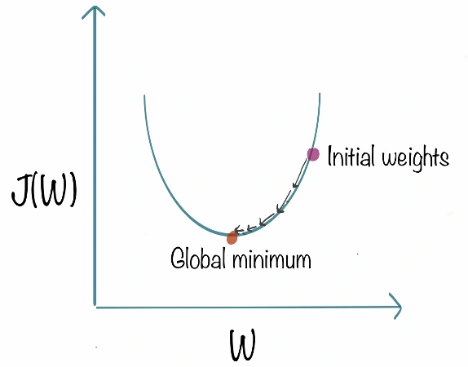
Gradient points in steepest increase direction.
So we move in:
$$-∇L$$
Example:
- If slope is positive → move left
- If slope is negative → move right
Types of Gradient Descent:
- Batch Gradient Descent: Uses entire dataset
✔ Stable
❌ Slow for large data
- Stochastic Gradient Descent (SGD): Uses 1 sample at a time
✔ Fast
❌ Noisy updates
Mini-Batch Gradient Descent : Uses small batches
✔ Balanced & efficient
✔ Used in deep learning
Common Problems:
Problem | Cause | Fix
Vanishing Gradient | Sigmoid/Tanh | ReLU
Slow convergence | Poor LR | Adam
Local minima | Bad init | Momentum
Oscillation | High LR | RMSProp

AdaGrad(Adaptive Gradient Descent)
In all the algorithms that we discussed previously the learning rate remains constant. The intuition behind AdaGrad is can we use different Learning Rates for each and every neuron for each and every hidden layer based on different iterations.
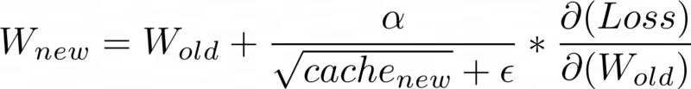
Advantages of AdaGrad
- Learning Rate changes adaptively with iterations.
- It is able to train sparse data as well.
Disadvantage of AdaGrad
- If the neural network is deep the learning rate becomes very small number which will cause dead neuron problem.
RMS-Prop (Root Mean Square Propagation)
RMS-Prop is a special version of Adagrad in which the learning rate is an exponential average of the gradients instead of the cumulative sum of squared gradients. RMS-Prop basically combines momentum with AdaGrad.
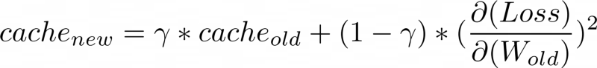
Advantages of RMS-Prop
- In RMS-Prop learning rate gets adjusted automatically and it chooses a different learning rate for each parameter.
Disadvantages of RMS-Prop
- Slow Learning
AdaDelta
Adadelta is an extension of Adagrad and it also tries to reduce Adagrad’s aggressive, monotonically reducing the learning rate and remove decaying learning rate problem. In Adadelta we do not need to set the default learning rate as we take the ratio of the running average of the previous time steps to the current gradient.
Advantages of Adadelta
- The main advantage of AdaDelta is that we do not need to set a default learning rate.
Disadvantages of Adadelta
- Computationally expensive
Adam(Adaptive Moment Estimation)
Adam optimizer is one of the most popular and famous gradient descent optimization algorithms. It is a method that computes adaptive learning rates for each parameter. It stores both the decaying average of the past gradients , similar to momentum and also the decaying average of the past squared gradients , similar to RMS-Prop and Adadelta. Thus, it combines the advantages of both the methods.
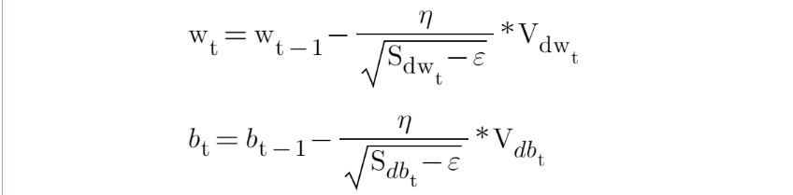
Advantages of Adam
- Easy to implement
- Computationally efficient.
- Little memory requirements.

CNN:
A Convolutional Neural Network (CNN) is a deep learning model for grid-like data (like images) that uses convolutional layers, pooling layers, and fully connected layers to automatically learn hierarchical features, from simple edges to complex objects, by sliding filters (kernels) across inputs to detect patterns, making them highly effective for tasks like image recognition, object detection, and video analysis, with applications in self-driving cars, medical imaging, and virtual assistants.
Core Idea
- Inspired by Biology: Mimics the visual cortex of animals, detecting patterns in a hierarchical manner (edges -> shapes -> objects).
- Feature Extraction: Uses filters (kernels) to scan images, detecting specific features like edges, textures, and colors.
- Spatial Hierarchy: Learns increasingly complex features in deeper layers, combining simpler features from earlier layers.
Key Components & Layers
Conv Layer:
Applies filters (small matrices) to input data (e.g., image pixels). Performs a "convolution" (sliding dot product) to create a feature map, highlighting where features are detected. Uses shared weights, reducing parameters and making it translation-invariant (detects features anywhere).
For input image X and kernel K:
$$Y(i,j)=\sum_{m=0}^{k-1}{\sum_{n=0}^{k-1}{X(i+m,j+n)⋅K(m,n)}}$$
For RGB images:
$$Y=\sum_{c=1}^{C}{X_{c}}*K_{c}$$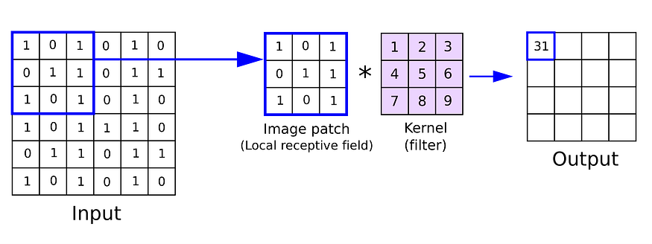
Output Size Formula
$$\text{Output size}=\frac{\left(N-F+2P\right)}{S}+1$$
Where:
N = input size, F = filter size, P = padding, S = stride
Activation Function (e.g., ReLU):Introduces non-linearity, allowing the network to learn complex relationships.ReLU sets negative values to zero, keeping positive ones.
Pooling Layer (e.g., Max Pooling): Down samples (reduces) the spatial dimensions (width/height) of feature maps. Reduces computational load and helps prevent overfitting. Max pooling takes the maximum value from a window, retaining the most prominent features.
Output Size
$$\frac{N-F}{S}+1$$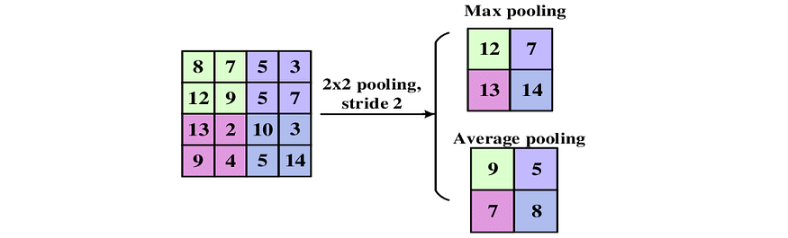
Fully Connected Layer:
  - Flattens the pooled feature maps into a single vector.
  - Connects to a standard neural network layer for final classification (e.g., "cat," "dog").
How it Works (Simplified)
- Input Image: A grid of pixel values.
- Conv Layers: Detect simple features (edges, corners) -> combine into textures -> combine into parts (eyes, wheels).
- Pooling Layers: Condense the feature maps.
- Flattening: Prepare for final classification.
- FC Layer: Classifies the image based on the learned features.
Applications
- Image & Video Recognition (Face ID, object detection).
- Medical Image Analysis (Tumor detection).
- Natural Language Processing (Text classification).
- Autonomous Vehicles (Scene understanding).
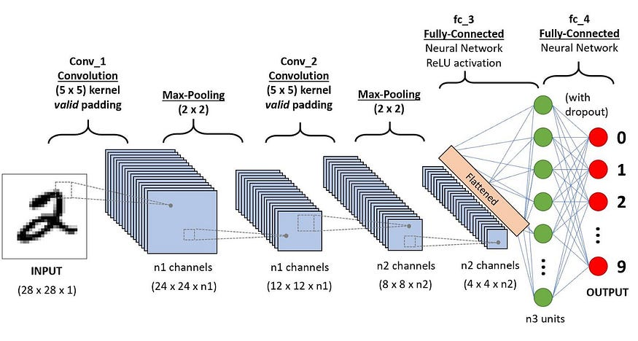
Stride
Stride is a parameter of the neural network’s filter that modifies the amount of movement over the image or video. we had stride 1 so it will take one by one. If we give stride 2 then it will take value by skipping the next 2 pixels.
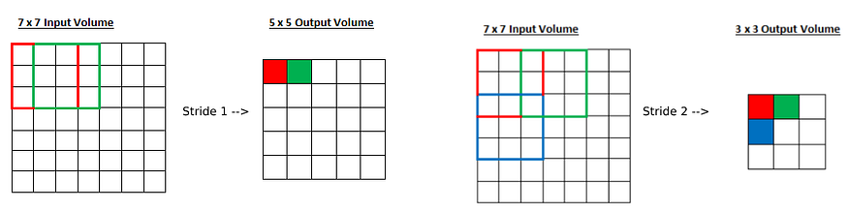
Padding
Padding is a term relevant to convolutional neural networks as it refers to the number of pixels added to an image when it is being processed by the kernel of a CNN. For example, if the padding in a CNN is set to zero, then every pixel value that is added will be of value zero. When we use the filter or Kernel to scan the image, the size of the image will go smaller. We have to avoid that because we wanna preserve the original size of the image to extract some low-level features. Therefore, we will add some extra pixels outside the image.
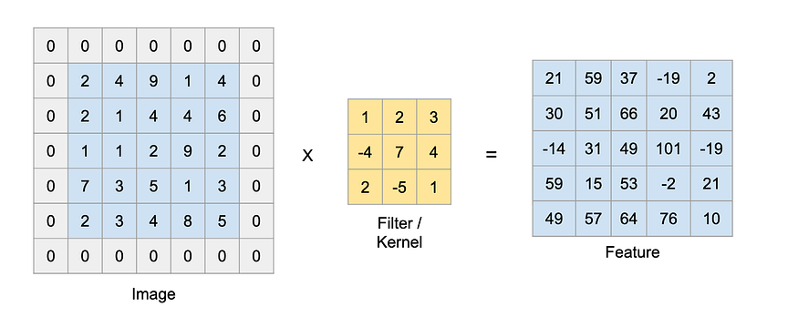
Flatten
Flattening is used to convert all the resultant 2-Dimensional arrays from pooled feature maps into a single long continuous linear vector. The flattened matrix is fed as input to the fully connected layer to classify the image.
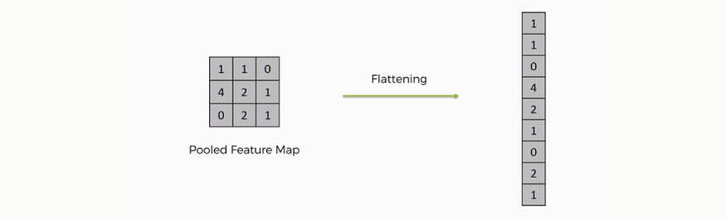
Loss Function:
Categorical Cross-Entropy
$$L=-∑ylog⁡(\hat{y})$$
Binary Cross-Entropy
$$L=-[ylog⁡(p)+(1-y)log⁡(1-p)]$$Weight update (SGD / Adam)
$$W=W-η\frac{∂L}{∂W}$$Common CNN Architectures:
Architecture | Key Concept
LeNet | First CNN
AlexNet | ReLU + GPU
VGG | Small filters, deep
GoogLeNet | Inception module
ResNet | Skip connections
DenseNet | Feature reuse
MobileNet | Mobile optimization
EfficientNet | Compound scaling
YOLO | Real-time detection

Simple CNN implementations:
import tensorflow as tf
from tensorflow.keras import datasets, layers, models
import matplotlib.pyplot as plt
import numpy as np
(X_train, y_train), (X_test, y_test) = datasets.cifar10.load_data()
X_train, X_test = X_train / 255.0, X_test / 255.0
class_names = ['airplane', 'automobile', 'bird', 'cat', 'deer',
'dog', 'frog', 'horse', 'ship', 'truck']
model = models.Sequential()
# 1st Convolution Block
model.add(layers.Conv2D(32, (3, 3), activation='relu',
input_shape=(32, 32, 3)))
model.add(layers.MaxPooling2D((2, 2)))
# 2nd Convolution Block
model.add(layers.Conv2D(64, (3, 3), activation='relu'))
model.add(layers.MaxPooling2D((2, 2)))
# 3rd Convolution Block
model.add(layers.Conv2D(64, (3, 3), activation='relu'))
# Fully Connected Layers
model.add(layers.Flatten())
model.add(layers.Dense(64, activation='relu'))
model.add(layers.Dense(10, activation='softmax'))
model.summary()
model.compile(optimizer='adam', loss='sparse_categorical_crossentropy',
metrics=['accuracy'])
model.fit(X_train, y_train, epochs=10, batch_size=64,
validation_data=(X_test, y_test))
test_loss, test_acc = model.evaluate(X_test, y_test)
print("Test accuracy:", test_acc)
predictions = model.predict(X_test)
predicted_label = np.argmax(predictions[0])
true_label = y_test[0][0]
print("Predicted:", class_names[predicted_label])
print("Actual:", class_names[true_label])
━━━━━━━━━━━━━━━━━━━━━━━━━━━━━━━━━┳━━━━━━━━━━━━━━━━━━━━━━━━┳━━━━━━━━━━━━━━━┓
┃ Layer (type) ┃ Output Shape ┃ Param # ┃
┡━━━━━━━━━━━━━━━━━━━━━━━━━━━━━━━━━╇━━━━━━━━━━━━━━━━━━━━━━━━╇━━━━━━━━━━━━━━━┩
│ conv2d (Conv2D) │ (None, 30, 30, 32) │ 896 │
├─────────────────────────────────┼────────────────────────┼───────────────┤
│ max_pooling2d (MaxPooling2D) │ (None, 15, 15, 32) │ 0 │
├─────────────────────────────────┼────────────────────────┼───────────────┤
│ conv2d_1 (Conv2D) │ (None, 13, 13, 64) │ 18,496 │
├─────────────────────────────────┼────────────────────────┼───────────────┤
│ max_pooling2d_1 (MaxPooling2D) │ (None, 6, 6, 64) │ 0 │
├─────────────────────────────────┼────────────────────────┼───────────────┤
│ conv2d_2 (Conv2D) │ (None, 4, 4, 64) │ 36,928 │
├─────────────────────────────────┼────────────────────────┼───────────────┤
│ flatten (Flatten) │ (None, 1024) │ 0 │
├─────────────────────────────────┼────────────────────────┼───────────────┤
│ dense (Dense) │ (None, 64) │ 65,600 │
├─────────────────────────────────┼────────────────────────┼───────────────┤
│ dense_1 (Dense) │ (None, 10) │ 650 │

Total params: 122,570 (478.79 KB)
Trainable params: 122,570 (478.79 KB)
Predicted: cat
Actual: cat

AlexNet: A Revolutionary Deep Learning Architecture. AlexNet is an Image Classification model that transformed deep learning. It was introduced by Geoffrey Hinton and his team in 2012 and marked a key event in the history of deep learning, showcasing the strengths of CNN architectures and its vast applications.
Before AlexNet, people were skeptical about whether deep learning could be applied successfully to very large datasets. However, a team of researchers aimed to prove that Deep Neural Architectures were the future, and succeeded in it; AlexNet exploded the interest in deep learning post-2012.
ImageNet is a vast visual database designed for object recognition research. It consists of over 14 million hand-annotated images with over 20,000 categories. This dataset played a major role in the success of AlexNet and the advancements in DL, as there was no large dataset on which Deep NNs could be trained previously.
The ImageNet project also conducts an annual ImageNet Large Scale Visual Recognition Challenge (ILSVRC) where researchers evaluate their algorithms to classify objects and scenes correctly.
The competition is important because it enables researchers to push the limits of existing models and invent new methodologies. Several breakthrough models have been unveiled in this competition, AlexNet being one of them.
Here are the key innovations introduced:
- Deep Architecture: This model utilized deep architecture compared to any NN model released previously. It consisted of five convolutional layers followed by three fully connected layers.
- ReLU Nonlinearity: CNNs at that time used functions such as Tanh or Sigmoid to process information between layers. These functions slowed down the training. In contrast, ReLU (Rectified Linear Unit) made the entire process simpler and many times faster. It outputs only if the input is given to it as positive, otherwise, it outputs a zero.
- Overlapping Pooling: Overlapping pooling is just like regular max pooling layers, but in overlapping pooling, as the window moves across, it overlaps with the previous window. This improved the error percentage in AlexNet.
- Use of GPU: Before AlexNet, NNs were trained on the CPU, which made the process slow. However, the researcher of AlexNet incorporated GPUs, which accelerated computation time significantly. This proved that Deep NNs can be trained feasibly on GPUs.
- Local Response Normalization (LRN): This is a process of normalizing adjacent channels in the network, which normalizes the activity of neurons within a local neighborhood.
The AlexNet Architecture:
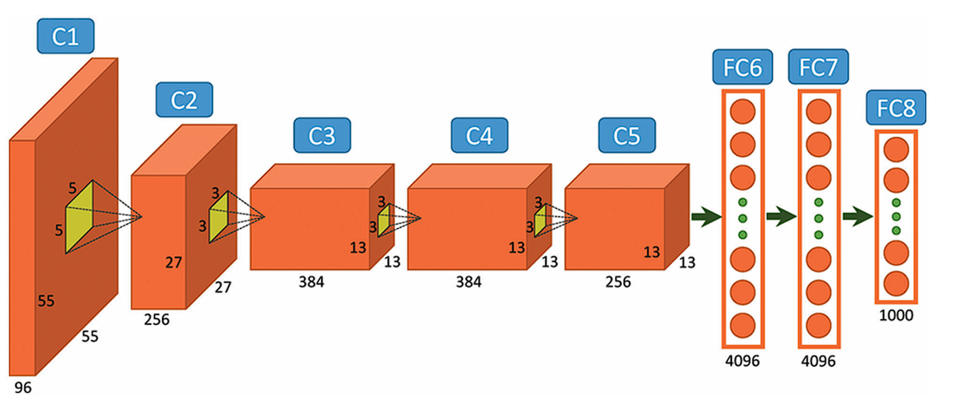
AlexNet comprises a rather simple architecture compared to the latest Deep Learning Models. It consists of 8 layers: 5 convolutional layers and 3 fully connected layers.
However, it integrates several key innovations of its time, including the ReLU Activation Functions, Local Response Normalization (LRN), and Overlapping Max Pooling. We will look at each of them below.
Input Layer
AlexNet takes images of the Input size of 227x227x3 RGB Pixels.
Convolutional Layers
- First Layer: The first layer uses 96 kernels of size 11×11 with a stride of 4, activates them with the ReLU activation function, and then performs a Max Pooling operation.
- Second Layer: The second layer takes the output of the first layer as the input, with 256 kernels of size 5x5x48.
- Third Layer: 384 kernels of size 3x3x256. No pooling or normalization operations are performed on the third, fourth, and fifth layers.
- Fourth Layer: 384 kernels of size 3x3x192.
- Fifth Layer: 256 kernels of size 3x3x192.
Fully Connected Layers
The fully connected layers have 4096 neurons each.
Output Layer
The output layer is a SoftMax layer that outputs probabilities of the 1000 class labels.
Stochastic Gradient Descent
AlexNet uses stochastic gradient descent (SGD) with momentum for optimization. SGD is a variant of Gradient Descent. In SGD, instead of performing calculations on the whole dataset, which is computationally expensive, SGD randomly picks a batch of images, calculates the loss, and updates the weight parameters.
Weight Decay
L_{new}(w) = L_{original}(w) + λw^{T}w
Weight decay adds a penalty on the size of the weights. By penalizing larger weights, weight decay encourages the model to learn smaller weights that capture the underlying patterns in the data, rather than memorizing specific details that result in overfitting.
Data Augmentation
Data Augmentation artificially increases the size and diversity of the training data using transformations that don’t change the actual object in the image. This forces the model to learn better and increase its ability to cater to unseen images. AlexNet used Random Cropping and Flipping, and Color Jitter Augmentations.
Dropout:This is a regularization technique (a technique used to address overfitting) that “drops out” or turns off neurons.
This is a simple method that prevents the model from overfitting. It does this by making the model learn more robust features and stopping the model from condensing features in a single area of the network.Dropout increases the training time; however, the model learns to generalize better.
Overlapping Pooling
Pooling layers in CNNs summarize the outputs of neighboring groups of neurons in the same kernel map. Traditionally, the neighborhoods summarized by adjacent pooling units do not overlap. However, in Overlapping pooling the adjacent pooling operations overlap with each other. This approach:
- Reduces the size of the network
- Provides slight translational invariance.
- Makes it difficult for the model to overfit.
Implementation:
import tensorflow as tf
from tensorflow.keras import layers, models, optimizers
import tensorflow_datasets as tfds
import numpy as np
IMG_SIZE = (227, 227)
BATCH_SIZE = 32
NUM_CLASSES = 2
EPOCHS = 20
LEARNING_RATE = 0.001
# LOCAL RESPONSE NORMALIZATION (LRN)
def lrn(x):
return tf.nn.local_response_normalization(
x, depth_radius=2, bias=2, alpha=1e-4, beta=0.75 )

def AlexNet(input_shape=(227, 227, 3), num_classes=2):
model = models.Sequential(name="AlexNet_Cats_Dogs")
# Conv1
model.add(layers.Conv2D(96, 11, strides=4,
activation='relu', input_shape=input_shape))
model.add(layers.Lambda(lrn))
model.add(layers.MaxPooling2D(3, strides=2))
# Conv2
model.add(layers.Conv2D(256, 5, padding='same', activation='relu'))
model.add(layers.Lambda(lrn))
model.add(layers.MaxPooling2D(3, strides=2))
# Conv3
model.add(layers.Conv2D(384, 3, padding='same', activation='relu'))
# Conv4
model.add(layers.Conv2D(384, 3, padding='same', activation='relu'))
# Conv5
model.add(layers.Conv2D(256, 3, padding='same', activation='relu'))
model.add(layers.MaxPooling2D(3, strides=2))
# Fully Connected
model.add(layers.Flatten())
model.add(layers.Dense(4096, activation='relu'))
model.add(layers.Dropout(0.5))
model.add(layers.Dense(4096, activation='relu'))
model.add(layers.Dropout(0.5))
model.add(layers.Dense(num_classes, activation='softmax'))
return model

# LOAD CATS VS DOGS DATASET (AUTO DOWNLOAD)
(train_ds, val_ds), ds_info = tfds.load(
"cats_vs_dogs",
split=["train[:80%]", "train[80%:]"],
as_supervised=True,
with_info=True
)
print("Classes:", ds_info.features["label"].names)
# PREPROCESSING
def preprocess(image, label):
image = tf.image.resize(image, IMG_SIZE)
image = tf.cast(image, tf.float32) / 255.0 # normalize
label = tf.one_hot(label, depth=NUM_CLASSES)
return image, label

train_ds = (
train_ds.map(preprocess, num_parallel_calls=tf.data.AUTOTUNE)
.shuffle(1000).batch(BATCH_SIZE).prefetch(tf.data.AUTOTUNE))

val_ds = (
val_ds.map(preprocess, num_parallel_calls=tf.data.AUTOTUNE)
.batch(BATCH_SIZE).prefetch(tf.data.AUTOTUNE))
model = AlexNet(input_shape=(227, 227, 3), num_classes=NUM_CLASSES)
model.summary()

model.compile(
optimizer=optimizers.SGD(
learning_rate=LEARNING_RATE,
momentum=0.9),
loss="categorical_crossentropy",
metrics=["accuracy"]
)
history = model.fit(
train_ds,
validation_data=val_ds,
epochs=EPOCHS
)
loss, acc = model.evaluate(val_ds)
print(f"Validation Accuracy: {acc:.4f}")
for images, labels in val_ds.take(1):
preds = model.predict(images)
print("Predicted:", np.argmax(preds[:5], axis=1))
print("Actual :", np.argmax(labels[:5], axis=1))
Model: "AlexNet_Cats_Dogs"
┏━━━━━━━━━━━━━━━━━━━━━━━━━━━━━━━━━┳━━━━━━━━━━━━━━━━━━━━━━━━┳━━━━━━━━━━━━━━━┓
┃ Layer (type) ┃ Output Shape ┃ Param # ┃
┡━━━━━━━━━━━━━━━━━━━━━━━━━━━━━━━━━╇━━━━━━━━━━━━━━━━━━━━━━━━╇━━━━━━━━━━━━━━━┩
│ conv2d_5 (Conv2D) │ (None, 55, 55, 96) │ 34,944 │
├─────────────────────────────────┼────────────────────────┼───────────────┤
│ lambda_2 (Lambda) │ (None, 55, 55, 96) │ 0 │
├─────────────────────────────────┼────────────────────────┼───────────────┤
│ max_pooling2d_3 (MaxPooling2D) │ (None, 27, 27, 96) │ 0 │
├─────────────────────────────────┼────────────────────────┼───────────────┤
│ conv2d_6 (Conv2D) │ (None, 27, 27, 256) │ 614,656 │
├─────────────────────────────────┼────────────────────────┼───────────────┤
│ lambda_3 (Lambda) │ (None, 27, 27, 256) │ 0 │
├─────────────────────────────────┼────────────────────────┼───────────────┤
│ max_pooling2d_4 (MaxPooling2D) │ (None, 13, 13, 256) │ 0 │
├─────────────────────────────────┼────────────────────────┼───────────────┤
│ conv2d_7 (Conv2D) │ (None, 13, 13, 384) │ 885,120 │
├─────────────────────────────────┼────────────────────────┼───────────────┤
│ conv2d_8 (Conv2D) │ (None, 13, 13, 384) │ 1,327,488 │
├─────────────────────────────────┼────────────────────────┼───────────────┤
│ conv2d_9 (Conv2D) │ (None, 13, 13, 256) │ 884,992 │
├─────────────────────────────────┼────────────────────────┼───────────────┤
│ max_pooling2d_5 (MaxPooling2D) │ (None, 6, 6, 256) │ 0 │
├─────────────────────────────────┼────────────────────────┼───────────────┤
│ flatten_1 (Flatten) │ (None, 9216) │ 0 │
├─────────────────────────────────┼────────────────────────┼───────────────┤
│ dense_3 (Dense) │ (None, 4096) │ 37,752,832 │
├─────────────────────────────────┼────────────────────────┼───────────────┤
│ dropout_2 (Dropout) │ (None, 4096) │ 0 │
├─────────────────────────────────┼────────────────────────┼───────────────┤
│ dense_4 (Dense) │ (None, 4096) │ 16,781,312 │
├─────────────────────────────────┼────────────────────────┼───────────────┤
│ dropout_3 (Dropout) │ (None, 4096) │ 0 │
├─────────────────────────────────┼────────────────────────┼───────────────┤
│ dense_5 (Dense) │ (None, 2) │ 8,194 │
└─────────────────────────────────┴────────────────────────┴───────────────┘
Total params: 58,289,538 (222.36 MB)
Trainable params: 58,289,538 (222.36 MB)
Epoch 20/20
582/582 ━━━━━━━━━━━━━━━━━━━━ 46s 77ms/step - accuracy: 0.9181 - loss: 0.1982 - val_accuracy: 0.8783 - val_loss: 0.3209
146/146 ━━━━━━━━━━━━━━━━━━━━ 6s 41ms/step - accuracy: 0.8850 - loss: 0.3211
Validation Accuracy: 0.8783

VGG-Net: VGG stands for Visual Geometry Group. The term “deep” describes the number of layers, with VGG-16 or VGG-19 having 16 or 19 convolutional layers, respectively. The VGGNet, created as a deep neural network, outperforms benchmarks on a variety of tasks and datasets outside of ImageNet. It also remains one of the most often used image recognition architectures today.
The VGG19 model (also known as VGGNet-19) has the same basic idea as the VGG16 model, with the exception that it supports 19 layers. The numbers “16” and “19” refer to the model’s weight layers (convolutional layers). In comparison to VGG16, VGG19 contains three extra convolutional layers.
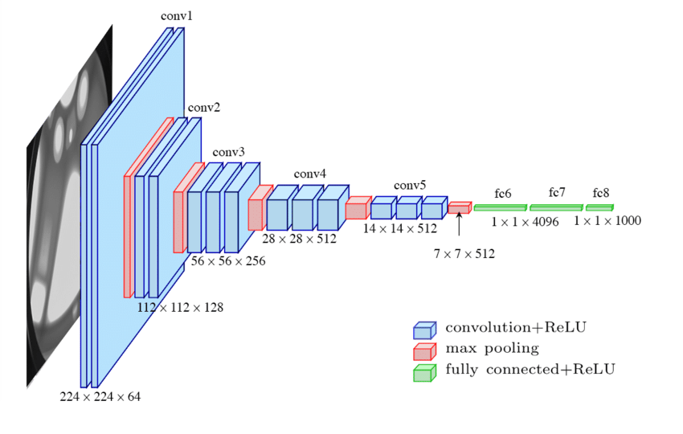
- Input: The VGGNet takes in an image input size of 224×224. For the ImageNet competition, the creators of the model cropped out the center 224×224 patch in each image to keep the input size of the image consistent.
- Convolutional Layers: VGG’s convolutional layers leverage a minimal receptive field, i.e., 3×3, the smallest possible size that still captures up/down and left/right. Moreover, there are also 1×1 convolution filters acting as a linear transformation of the input. This is followed by a ReLU unit, which is a huge innovation from AlexNet that reduces training time. ReLU stands for rectified linear unit activation function; it is a piecewise linear function that will output the input if positive; otherwise, the output is zero. The convolution stride is fixed at 1 pixel to keep the spatial resolution preserved after convolution (stride is the number of pixel shifts over the input matrix).
- Hidden Layers: All the hidden layers in the VGG network use ReLU. VGG does not usually leverage Local Response Normalization (LRN) as it increases memory consumption and training time. Moreover, it makes no improvements to overall accuracy.
- Fully-Connected Layers: The VGGNet has three fully connected layers. Out of the three layers, the first two have 4096 channels each, and the third has 1000 channels, 1 for each class.
Fine-tuning a model means taking a large, pre-trained AI model and training it further on a smaller, specific dataset to specialize it for a particular task or domain, making it an expert in that niche rather than a generalist, which saves time and resources compared to training from scratch. It leverages the general knowledge the model already has, adapting its capabilities for things like industry-specific language, unique formats, or custom functions, like medical diagnosis or legal analysis.
VGGNet Fine-Tuning for CIFAR-10 dataset:
import tensorflow as tf
from tensorflow.keras import layers, models
from tensorflow.keras.applications import VGG16
(x_train, y_train), (x_test, y_test) = tf.keras.datasets.cifar10.load_data()
def preprocess(images, labels):
images = tf.image.resize(images, (224, 224))
images = tf.keras.applications.vgg16.preprocess_input(images)
return images, labels
train_ds = tf.data.Dataset.from_tensor_slices((x_train, y_train))
train_ds = train_ds.map(preprocess).batch(32).prefetch(tf.data.AUTOTUNE)

test_ds = tf.data.Dataset.from_tensor_slices((x_test, y_test))
test_ds = test_ds.map(preprocess).batch(32).prefetch(tf.data.AUTOTUNE)
base_model = VGG16(
weights="imagenet",
include_top=False,
input_shape=(224, 224, 3))
base_model.trainable = False
model = models.Sequential([
base_model,
layers.Flatten(),
layers.Dense(256, activation="relu"),
layers.Dropout(0.5),
layers.Dense(10, activation="softmax")
])
model.compile(
optimizer=tf.keras.optimizers.Adam(learning_rate=1e-4),
loss="sparse_categorical_crossentropy",
metrics=["accuracy"])
history = model.fit(train_ds,
validation_data=test_ds,
epochs=5)
#Fine-Tuning (Unfreeze Top Layers)
base_model.trainable = True
for layer in base_model.layers[:-4]:
layer.trainable = False
model.compile(
optimizer=tf.keras.optimizers.Adam(learning_rate=1e-5),
loss="sparse_categorical_crossentropy",
metrics=["accuracy"])
fine_tune_history = model.fit(
train_ds,
validation_data=test_ds,
epochs=5)

