# Data Discrepancy and RCA Report

Date: 12 August 2025

Prepared by: Tejas Gunjal

## A) vw_rebateext

Problem Statement:  
Data in vw_rebateext is stale because underlying bronze tables are not receiving updated records.  
Affected Tables:  
- ana_prd_bronze.d365.ledgerjournaltrans  
- ana_prd_bronze.d365.generaljournalentry  
- ana_prd_bronze.d365.generaljournalaccountentry  
Observation:  
- Latest snapshots indicate these tables have not been updated recently.  
- This leads to outdated or incomplete results in the dependent view vw_rebateext.  
Impact:  
- All downstream silver/gold views or reports depending on vw_rebateext will reflect outdated journal transaction data.

Evidence:

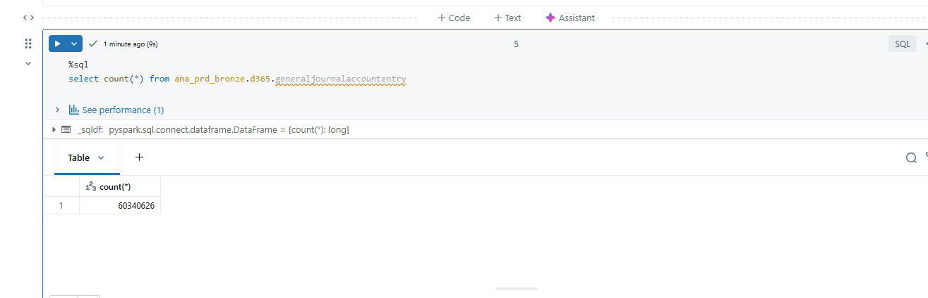

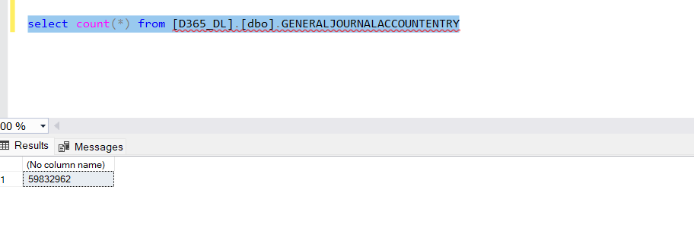

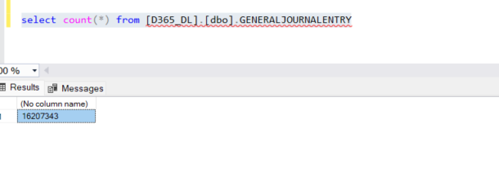

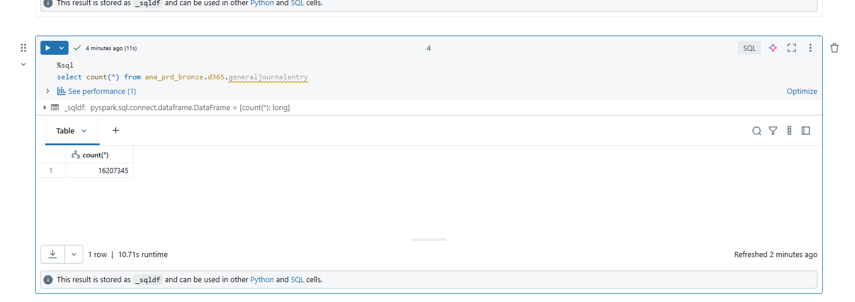

## B) ana_prd_silver.edw_stg.vw_freetext_invoice

Problem Statement:  
1) The view definition in Synapse SQL was changed after conversion & deployment to production in Databricks.  
2) Data count mismatch due to differences in underlying bronze data.  
Affected Tables:  
- ana_prd_bronze.d365.CustInvoiceTable  
- ana_prd_bronze.d365.CustInvoiceLine  
Observation:  
- Production view definition is not in sync with the original Synapse SQL definition.  
- Bronze tables have inconsistent or missing data, causing record count differences.  
Impact:  
- Inconsistent invoice reporting between old Synapse environment and new Databricks environment.  
- Possible financial reporting discrepancies.

Evidence:

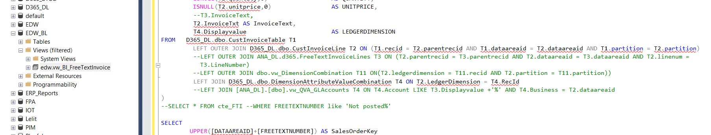

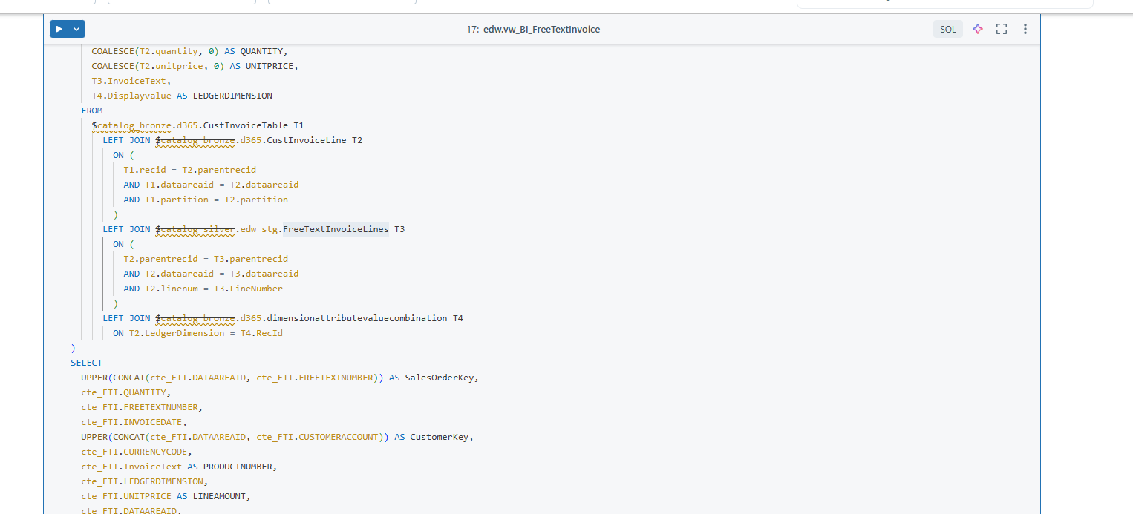

## C) usp_salesline_delta

Problem Statement:  
Data source for vw_ct_dynamic_bundle changed between 11 August and 12 August, resulting in different counts.  
Timeline:  
- 11 August: ana_prd_silver.beanz.vw_ct_dynamic_bundle contained dummy data.  
- 12 August: View recreated from table ana_prd_silver.beanz.ct_dynamic_bundle, which has different data counts.  
Observation:  
- Change in data source from a dummy dataset to actual table without proper change control communication.  
Impact:  
- Historical runs on or before 11 August will not match post-change results.  
- Potential downstream mismatches for dependent logic in usp_salesline_delta.

Evidence: [Insert Image Here]

## D) usp_LedgerJournalFact_Delta

Problem Statement:  
usp_LedgerJournalFact_Delta uses view vw_LedgerJournalFact, which in turn has underlying tables with mismatched counts.  
Observation:  
- Underlying source tables feeding vw_LedgerJournalFact have discrepancies in row counts compared to expected values.  
- Additional unidentified tables may also have count mismatches.  
Impact:  
- Ledger fact delta processing will be inconsistent.  
- Risk of partial or incorrect financial ledger facts in downstream systems.

Evidence: [Insert Image Here]