Certificate of Quality

Equipment: miniRaman Power 785 nm

Serial number: #10000

# Polystyrene spectrum

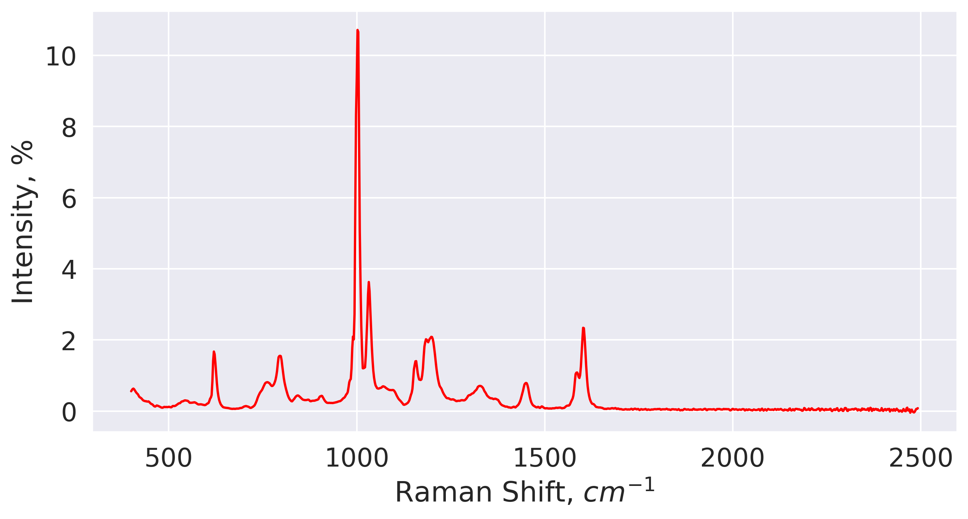

* Max intensity: 10.7%
* Peak position: 1002.0 cm^-1
* Test result: pass

Date: 2023-11-11

Operator: Yaroslav Aulin