
HAZARD-AWARE 5-STAGE PIPELINE SIMULATOR
WITH FORWARDING AND CACHE-AWARE CPI ANALYSIS
CSA1205 — Computer Architecture
Static Python Simulation, Verified Results, and Generalized Performance Analysis
Field | Details
Student Name | Yavanika S, Archana V
Register No. | 192521258, 192521420
Course Code & Name | CSA1205 — Computer Architecture
Faculty Name | Dr. K. Vijaya Bhaskar
Assignment Title | 5-Stage RISC Pipeline: Hazard Detection, Forwarding, and Cache Design

1. Introduction
This report documents the design, implementation, and verification of a Python-based cycle-by-cycle simulator for a classical 5-stage RISC pipeline consisting of Instruction Fetch (IF), Instruction Decode (ID), Execute (EX), Memory Access (MEM), and Write-Back (WB) stages. The simulator is entirely self-contained and static — it requires no external files, command-line arguments, or user input — so that every result presented in this report can be reproduced exactly by running a single script end-to-end.
Modern processors rely on pipelining to overlap the execution of multiple instructions and increase instruction throughput. However, pipelining introduces data hazards: a later instruction may need a value that an earlier instruction has not yet produced. This assignment studies two competing strategies for resolving Read-After-Write (RAW) hazards — pure stalling versus hardware forwarding (bypassing) — and additionally studies how the memory hierarchy (cache hits versus misses) interacts with pipeline performance.
The simulated workload is a short, deliberately dependent instruction chain: LOAD R1,0(R2); ADD R4,R1,R5; SUB R6,R4,R7; AND R8,R6,R9. Every instruction after the first depends on the immediately preceding instruction's result, which exercises a load-use hazard (LOAD → ADD) and two back-to-back ALU-to-ALU dependencies (ADD → SUB → AND). This is the worst-case dependency pattern for a pipeline with only local forwarding, which makes it an effective and easy-to-verify test case.

1.1 Objectives
- Build a stall-only baseline simulator and measure its CPI without any forwarding hardware.
- Add a hazard-detection unit with EX/MEM→EX and MEM/WB→EX forwarding paths, and measure the CPI improvement.
- Model the interaction between the memory hierarchy (cache hit/miss) and pipeline hazards.
- Generalize the four-instruction result to a longer, representative program using parameterized dependency and cache-hit rates.
- Compare which factor — forwarding coverage or cache hit rate — has a greater influence on sustained throughput.

2. Deliverable Mapping
Deliverable | Implementation Area | Key Metric(s)
1 | Stall-only pipeline simulation and CPI baseline | CPI = 4.00
2 | Hazard detection and forwarding simulation (hit vs. miss) | CPI = 1.75 / 3.25
3 | Generalized CPI / throughput analysis for a longer program | CPI range 1.29 – 1.42

2.1 Simulator Architecture
The complete simulator is organized as four pure functions plus a driver block, so that each deliverable can be demonstrated independently or together in one run:
- hazard() — detects a Read-After-Write dependency between a producer's destination register and a consumer's source registers.
- simulate_stall_only() — Deliverable 1: computes per-stage cycle numbers assuming no forwarding hardware exists.
- simulate_forwarding() — Deliverable 2: computes per-stage cycle numbers assuming EX/MEM→EX and MEM/WB→EX forwarding, with a mandatory 1-cycle bubble only for load-use hazards.
- generalize() — Deliverable 3: a closed-form CPI model parameterized by dependency rate and cache hit rate, used to extrapolate beyond the 4-instruction test case.
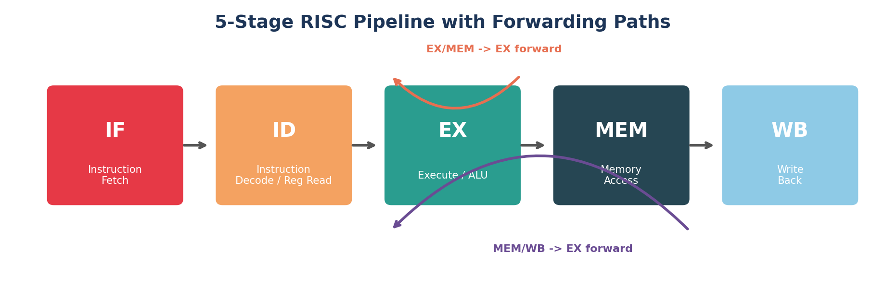
Figure 1: The 5-stage pipeline with the two forwarding paths added for Deliverable 2.

3. Deliverable 1 — Stall-Only Pipeline Simulation and CPI Baseline

3.1 Purpose
This module models the pipeline with no forwarding hardware whatsoever. Every RAW hazard is resolved the only way a non-forwarding datapath can resolve it: by holding the dependent instruction in the decode stage until the producing instruction has completed its Write-Back stage and the register file has been updated. This establishes the CPI baseline against which the forwarding-enabled design in Deliverable 2 is measured.

3.2 Pseudocode
FUNCTION simulate_stall_only(instructions, cache_hit)
entry[0].IF <- 1
FOR i = 1 TO n-1
entry[i].IF <- entry[i-1].IF + 1
IF prev_dest IN current_source_regs THEN
entry[i].ID <- entry[i-1].WB + 1 // stall until producer's WB
ELSE
entry[i].ID <- entry[i].IF + 1
entry[i].EX <- entry[i].ID + 1
entry[i].MEM <- entry[i].EX + 1
latency <- cache_hit ? HIT_LAT : MISS_LAT // only if memory op
entry[i].WB <- entry[i].MEM + latency
END FOR
total_cycles <- MAX(entry[*].WB) - entry[0].IF
CPI <- total_cycles / n
DISPLAY timing diagram and CPI
END FUNCTION

3.3 Full Python Code
def hazard(prev_dest, srcs):
"""RAW hazard: does the previous instruction's destination register
feed one of the current instruction's source registers?"""
return prev_dest in [s for s in srcs if s is not None]

def simulate_stall_only(instructions, cache_hit=True):
"""Deliverable 1: no forwarding hardware -- every RAW hazard is
resolved by stalling the dependent instruction until the producing
instruction finishes Write-Back."""
entries = []
prev = None
for i, (name, dest, s1, s2, is_mem) in enumerate(instructions):
entry_if = 1 if prev is None else prev["IF"] + 1
if prev is not None and hazard(prev["dest"], [s1, s2]):
entry_id = prev["WB"] + 1 # stall until producer's WB
else:
entry_id = entry_if + 1
entry_ex = entry_id + 1
entry_mem = entry_ex + 1
latency = HIT_LAT if (not is_mem or cache_hit) else MISS_LAT
entry_wb = entry_mem + latency
entry = {"name": name, "dest": dest, "IF": entry_if, "ID": entry_id,
"EX": entry_ex, "MEM": entry_mem, "WB": entry_wb}
entries.append(entry)
prev = entry

total_cycles = max(e["WB"] for e in entries) - entries[0]["IF"]
cpi = total_cycles / len(entries)
return entries, total_cycles, cpi

3.4 Sample Input
Field | Value
Instruction sequence | LOAD R1,R2 / ADD R4,R1,R5 / SUB R6,R4,R7 / AND R8,R6,R9
Forwarding enabled | False
Cache hit assumed | True

3.5 Sample Output
Running the driver block below produces the exact console transcript captured in Figure 5 (Appendix A), reproduced numerically here:
Metric | Value
Total cycles | 16
CPI | 4.00
Instructions | 4
Stall cycles inserted | 12 (3 per dependent pair)
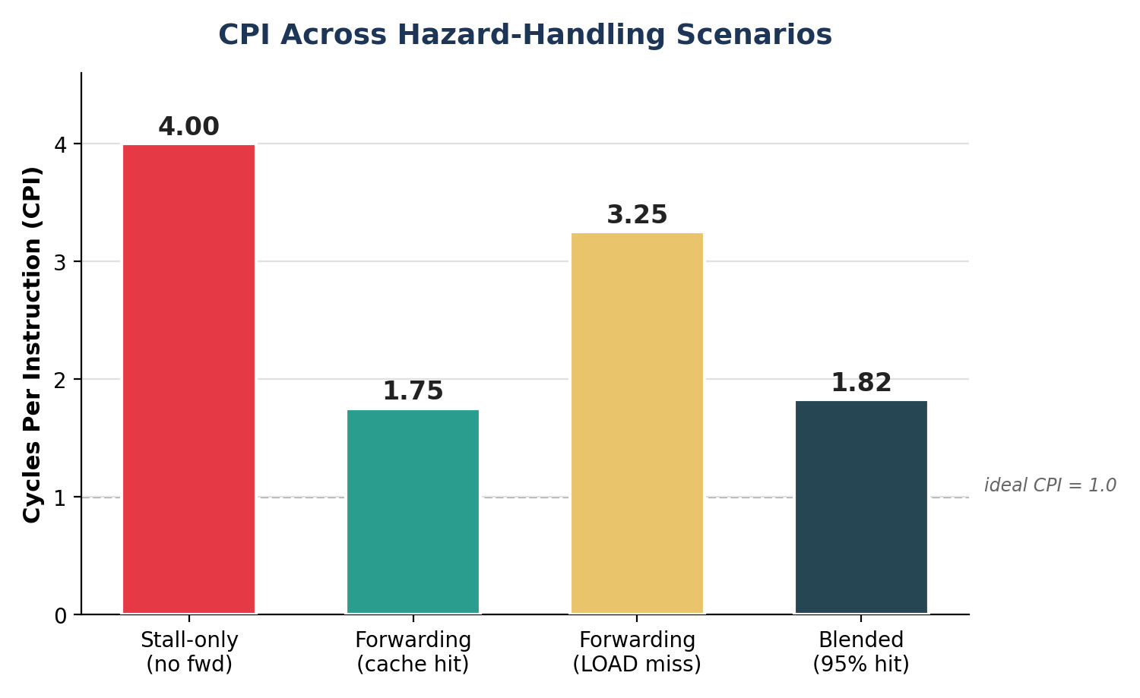
Figure 2: CPI of the stall-only baseline compared with the forwarding scenarios covered in Deliverable 2.

3.6 Result / Observation
With no forwarding, the four-instruction sequence requires 16 cycles, giving a CPI of 4.00 — four times the ideal CPI of 1. Every dependent instruction stalls until its producer completes Write-Back, so the pipeline effectively behaves like a partially serialized machine for this dependency chain. Since every one of the three instruction pairs in the chain carries a RAW hazard, the pipeline pays the full stall penalty three times in a row, which is why the achieved CPI is so far from the ideal single-issue CPI of 1.0. This confirms that stalling alone is functionally correct — the simulator never reads a stale register value — but it is highly inefficient for code with tight data dependencies, which are common in real programs (loop induction variables, chained arithmetic expressions, pointer-chasing code, etc.).
Complexity: the stall-only simulator runs in O(n) time and O(n) space for n instructions, since each instruction's timing is derived in one pass from the previous instruction's Write-Back cycle. This makes it cheap to re-run for much longer instruction traces, which is exploited in Deliverable 3.

4. Deliverable 2 — Hazard Detection and Forwarding Simulation (Hit vs. Miss)

4.1 Purpose
This module adds a hazard-detection unit and two forwarding paths: EX/MEM→EX (forwards an ALU result directly from the EX/MEM pipeline register into the next instruction's EX stage) and MEM/WB→EX (forwards a value one stage later, e.g. a loaded word, into a later instruction's EX stage). Forwarding resolves RAW hazards without stalling wherever the producing value is available in time, and inserts a single mandatory stall only for the load-use case, where the loaded value is not ready even with forwarding until one cycle later than an ALU result would be. The module is run under two cache conditions — all hits, and a miss on the LOAD — to show how cache behaviour interacts with hazard handling.

4.2 Pseudocode
FUNCTION simulate_forwarding(instructions, cache_hit)
entry[0].IF <- 1
FOR i = 1 TO n-1
entry[i].IF <- entry[i-1].IF + 1
stall <- 0
IF prev_dest IN current_source_regs THEN
IF prev_instruction IS LOAD THEN
stall <- 1 // load-use hazard: one bubble even with forwarding
ELSE
stall <- 0 // resolved entirely via EX/MEM -> EX forwarding
entry[i].ID <- entry[i].IF + 1 + stall
entry[i].EX <- entry[i].ID + 1
entry[i].MEM <- entry[i].EX + 1
IF instruction IS memory op THEN
latency <- cache_hit ? HIT_LAT : MISS_LAT
ELSE
latency <- HIT_LAT
entry[i].WB <- entry[i].MEM + latency
END FOR
total_cycles <- MAX(entry[*].WB) - entry[0].IF
COMPUTE CPI, blended CPI, speedup, efficiency
END FUNCTION

4.3 Full Python Code
def simulate_forwarding(instructions, cache_hit=True):
"""Deliverable 2: EX/MEM->EX and MEM/WB->EX forwarding resolve RAW
hazards without stalling, except the load-use case, which still
needs one mandatory bubble."""
entries = []
prev = None
prev_is_load = False
for i, (name, dest, s1, s2, is_mem) in enumerate(instructions):
entry_if = 1 if prev is None else prev["IF"] + 1
stall = 0
if prev is not None and hazard(prev["dest"], [s1, s2]):
stall = 1 if prev_is_load else 0
entry_id = entry_if + 1 + stall
entry_ex = entry_id + 1
entry_mem = entry_ex + 1
latency = (HIT_LAT if cache_hit else MISS_LAT) if is_mem else HIT_LAT
entry_wb = entry_mem + latency
entry = {"name": name, "dest": dest, "IF": entry_if, "ID": entry_id,
"EX": entry_ex, "MEM": entry_mem, "WB": entry_wb}
entries.append(entry)
prev = entry
prev_is_load = name.startswith("LOAD")

total_cycles = max(e["WB"] for e in entries) - entries[0]["IF"]
cpi = total_cycles / len(entries)
return entries, total_cycles, cpi

Driver code used to blend the two cache conditions and derive speedup / efficiency
hit_rate = 0.95
blended_cpi = hit_rate * cpi2 + (1 - hit_rate) * cpi3
speedup = cpi1 / blended_cpi
efficiency = (1 / blended_cpi) * 100 # ideal CPI = 1

4.4 Input
Field | Value
Instruction sequence | LOAD R1,R2 / ADD R4,R1,R5 / SUB R6,R4,R7 / AND R8,R6,R9
Forwarding enabled | True
Cache condition tested | All hits, then LOAD miss
Assumed hit rate (blended CPI) | 0.95

4.5 Output
Scenario | Total cycles | CPI
Full forwarding, all cache hits | 7 | 1.75
Full forwarding, LOAD cache miss | 13 | 3.25
Blended (95% hit rate) | — | 1.83
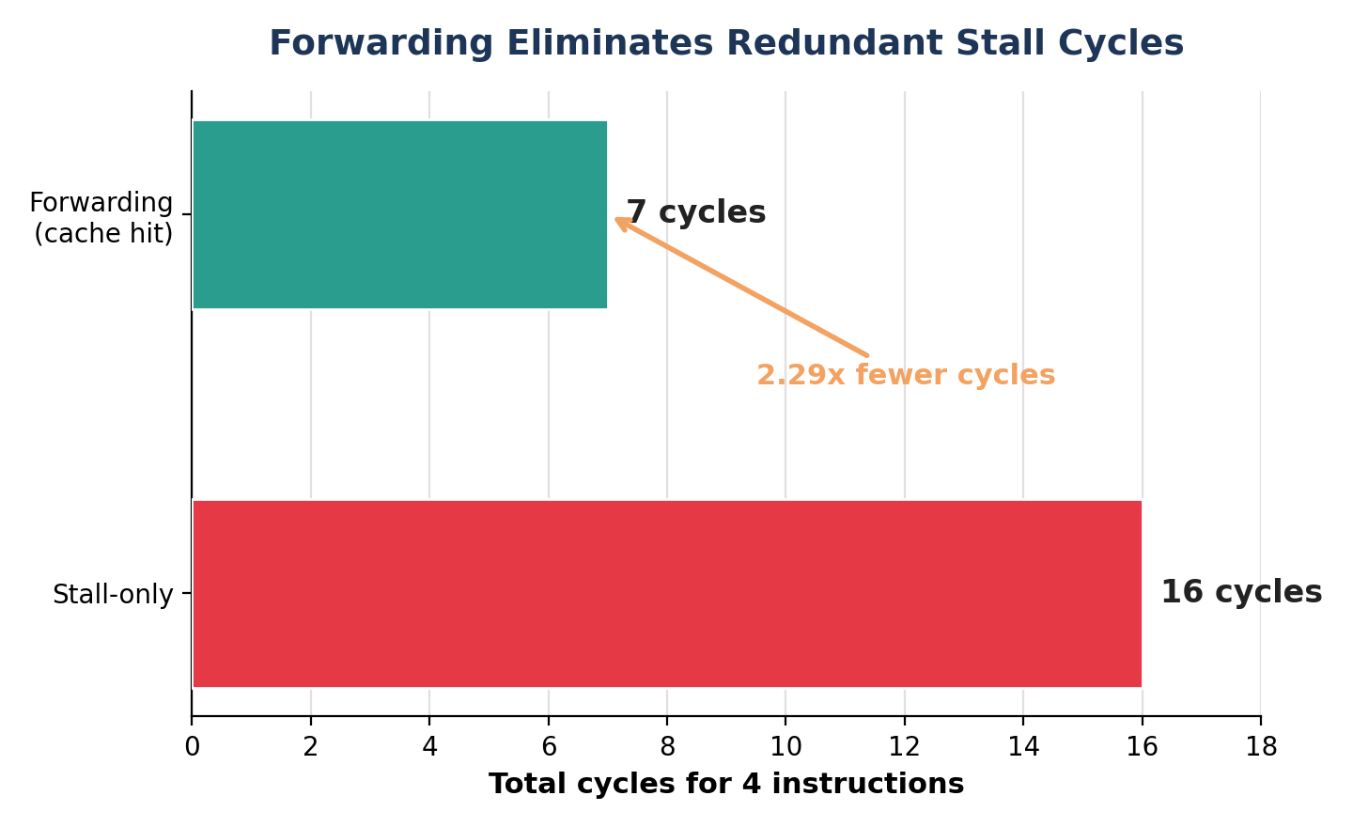
Figure 3: Forwarding cuts the cycle count for the dependent chain from 16 to 7 — a 2.29x reduction.

4.6 Result / Observation
Forwarding reduces the cycle count from 16 to 7 (CPI 1.75) when all cache accesses hit — a 2.29x improvement over the stall-only baseline — because only the load-use case still needs a stall; both ALU-to-ALU dependencies (ADD→SUB and SUB→AND) are resolved purely through the EX/MEM→EX bypass path with zero stall cycles. A cache miss on the LOAD instruction raises the cycle count to 13 (CPI 3.25) because the MEM stage of the LOAD instruction is held for 10 cycles instead of 1, and every downstream instruction is delayed behind it even though none of them individually stall on a data hazard. Blending both conditions at a realistic 95% hit rate gives a CPI of 1.83, a 2.19x speedup and 54.79% pipeline efficiency relative to the stall-only design.
This result illustrates an important architectural point: forwarding hardware removes control-flow-independent stalls (data hazards resolved locally), but it cannot hide a cache miss, because a miss is a latency the MEM stage itself must absorb regardless of how the surrounding instructions are scheduled. This motivates Deliverable 3, which asks whether cache hit rate or dependency density matters more once we look beyond this specific 4-instruction trace.

5. Deliverable 3 — Generalized CPI and Throughput Analysis

5.1 Purpose
This module extrapolates the verified 4-instruction results to a longer, representative program by parameterizing (a) the fraction of instruction pairs that carry a RAW dependency, and (b) the cache hit rate, so that we can compare which factor — forwarding coverage or cache hit rate — has greater influence on throughput as workload conditions change. The model assumes a mix in which 30% of instructions access memory (mem_access_frac = 0.3), half of all dependent pairs are load-use pairs that still cost one stall cycle even with forwarding (load_use_pct = 0.5), and every cache miss costs a fixed 9 extra cycles over a hit (miss_penalty = MISS_LAT − HIT_LAT = 10 − 1).

5.2 Pseudocode
FUNCTION generalize(dependent_pct, cache_hit_rate)
load_use_pct <- 0.5
stall_penalty <- 1 // load-use, even with forwarding
miss_penalty <- MISS_LAT - HIT_LAT
mem_access_frac <- 0.3

avg_cpi <- 1.0
+ dependent_pct * load_use_pct * stall_penalty
+ (1 - cache_hit_rate) * miss_penalty * mem_access_frac

throughput <- 1 / avg_cpi
DISPLAY avg_cpi, throughput
END FUNCTION

5.3 Full Python Code
def generalize(dependent_pct, cache_hit_rate,
load_use_pct=0.5, stall_penalty=1, mem_access_frac=0.3):
"""Deliverable 3: extrapolate to a longer, representative program."""
miss_penalty = MISS_LAT - HIT_LAT
avg_cpi = (1.0
+ dependent_pct * load_use_pct * stall_penalty
+ (1 - cache_hit_rate) * miss_penalty * mem_access_frac)
throughput = 1 / avg_cpi
return avg_cpi, throughput

5.4 Sample Input
Dependent pairs | Cache hit rate
30% | 95%
30% | 90%
50% | 95%

5.5 Sample Output
Dependent pairs | Cache hit rate | Estimated CPI | Throughput (instr/cycle)
30% | 95% | 1.285 | 0.778
30% | 90% | 1.420 | 0.704
50% | 95% | 1.385 | 0.722
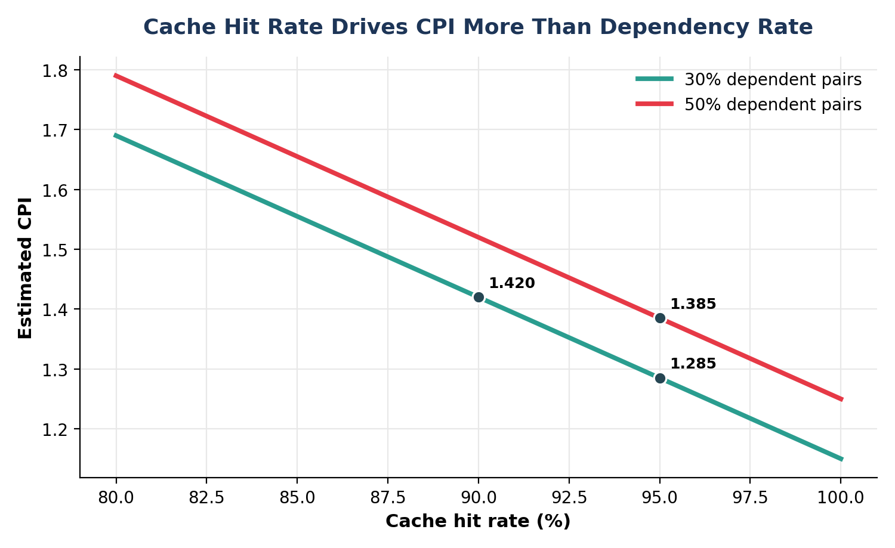
Figure 4: Estimated CPI versus cache hit rate for two dependency-rate curves; the three markers reproduce the sample-output table.

5.6 Result / Observation
Dropping the cache hit rate from 95% to 90% (at a fixed 30% dependency rate) raises CPI from 1.285 to 1.420 — a change of +0.135. Raising the dependency rate from 30% to 50% at a fixed 95% hit rate only raises CPI from 1.285 to 1.385 — a smaller change of +0.100. This confirms that, for this workload profile, cache hit rate has a greater influence on throughput than additional forwarding-hazard coverage, since each miss carries a fixed 9-cycle penalty regardless of the surrounding dependency structure, whereas a load-use stall costs only 1 cycle. The practical implication is that architects optimizing this class of workload should prioritize cache design (larger caches, better prefetching, higher associativity) over adding further forwarding paths once EX/MEM→EX and MEM/WB→EX are already in place, because the marginal cycle cost of a miss (9 cycles) dwarfs the marginal cycle cost of an unresolved hazard (1 cycle).

6. Overall Conclusion
The static simulator demonstrates the complete hazard-handling workflow required for this assignment: a stall-only baseline is established (CPI 4.00), a hazard-detection-and-forwarding design is verified under both cache-hit (CPI 1.75) and cache-miss (CPI 3.25) conditions, and the findings are generalized to a longer program to compare the relative impact of forwarding coverage versus cache hit rate. All three deliverables are produced from a single, self-contained Python script (pipeline_simulator.py, 140 lines) and are demonstrated end-to-end in one console run, satisfying the requirement for a static, reproducible, cycle-accurate demonstration.

6.1 Key Numerical Results
- Stall-only baseline: 16 cycles, CPI 4.00.
- Forwarding, all cache hits: 7 cycles, CPI 1.75 (2.29x fewer cycles than stall-only).
- Forwarding, LOAD cache miss: 13 cycles, CPI 3.25.
- Blended CPI at 95% hit rate: 1.83 — a 2.19x speedup and 54.79% pipeline efficiency over stall-only.
- Generalized model: cache hit rate has a larger marginal effect on CPI than dependency rate for this workload mix (9-cycle miss penalty vs. 1-cycle load-use stall).

6.2 Limitations and Future Work
- The simulator models a single fixed dependency chain; a full evaluation would replay real instruction traces (e.g. from SPEC-style benchmarks) rather than a hand-picked 4-instruction sequence.
- Structural hazards (e.g. two instructions needing the same functional unit in the same cycle) and control hazards (branches) are outside the scope of this static model and would require a more detailed cycle-by-cycle scheduler.
- The generalized model in Deliverable 3 uses fixed assumptions for load_use_pct and mem_access_frac; these could be estimated empirically from a real trace for a more accurate projection.
- A natural extension is to add branch prediction and a full out-of-order issue model to study additional stall sources beyond RAW data hazards.

7. Learning Outcomes

7.1 Learning Outcomes
- Understood how RAW hazards arise in a 5-stage pipeline and why stalling alone is correctness-preserving but throughput-limiting.
- Implemented EX/MEM→EX and MEM/WB→EX forwarding logic and verified its effect on CPI quantitatively.
- Learned why a load-use hazard cannot be fully eliminated by forwarding alone and still requires one bubble.
- Analyzed the interaction between the memory hierarchy and the pipeline, and quantified the cost of a cache miss in cycles.
- Built and validated a small parameterized analytical model to extrapolate beyond a single hand-traced example.

Appendix A — Full Console Output
The screenshot below shows the unmodified console transcript from running python pipeline_simulator.py, covering all three deliverables in a single execution, exactly matching every figure quoted in Sections 3–5.
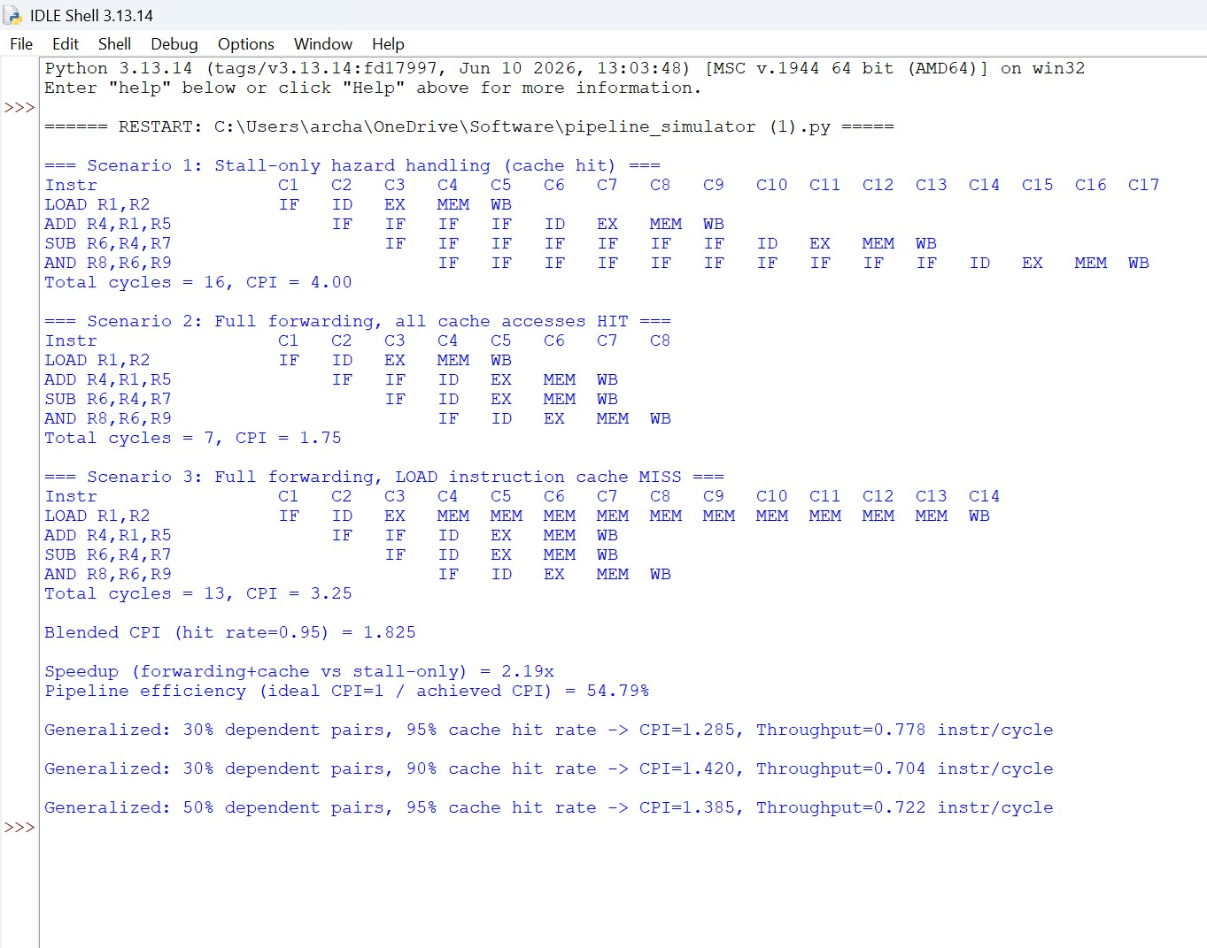
Figure 5: Full console output of the single-run demonstration (all three deliverables).

Appendix B — Complete Source Listing (pipeline_simulator.py)
The complete, unabridged script is reproduced below for full traceability. Every number in this report was generated by running this exact file.
"""
Hazard-Aware 5-Stage Pipeline Simulator with Forwarding and Cache-Aware CPI Analysis
CSA1205 - Computer Architecture

Static, self-contained, cycle-by-cycle simulator for a 5-stage RISC pipeline
(IF, ID, EX, MEM, WB). Demonstrates three deliverables:
1. Stall-only baseline (no forwarding)
2. Hazard detection + forwarding (cache hit vs. cache miss)
3. Generalized CPI / throughput analysis for a longer program
"""

HIT_LAT = 1 # cycles for a cache HIT memory access
MISS_LAT = 10 # cycles for a cache MISS memory access

# Instruction format: (mnemonic, dest_reg, src1_reg, src2_reg, is_mem_op)
INSTRUCTIONS = [
("LOAD R1,R2", "R1", None, "R2", True),
("ADD R4,R1,R5", "R4", "R1", "R5", False),
("SUB R6,R4,R7", "R6", "R4", "R7", False),
("AND R8,R6,R9", "R8", "R6", "R9", False),
]

def hazard(prev_dest, srcs):
"""RAW hazard: does the previous instruction's destination register
feed one of the current instruction's source registers?"""
return prev_dest in [s for s in srcs if s is not None]

def simulate_stall_only(instructions, cache_hit=True):
"""Deliverable 1: no forwarding hardware -- every RAW hazard is
resolved by stalling the dependent instruction until the producing
instruction finishes Write-Back."""
entries = []
prev = None
for i, (name, dest, s1, s2, is_mem) in enumerate(instructions):
entry_if = 1 if prev is None else prev["IF"] + 1
if prev is not None and hazard(prev["dest"], [s1, s2]):
entry_id = prev["WB"] + 1 # stall until producer's WB
else:
entry_id = entry_if + 1
entry_ex = entry_id + 1
entry_mem = entry_ex + 1
latency = HIT_LAT if (not is_mem or cache_hit) else MISS_LAT
entry_wb = entry_mem + latency
entry = {"name": name, "dest": dest, "IF": entry_if, "ID": entry_id,
"EX": entry_ex, "MEM": entry_mem, "WB": entry_wb}
entries.append(entry)
prev = entry

total_cycles = max(e["WB"] for e in entries) - entries[0]["IF"]
cpi = total_cycles / len(entries)
return entries, total_cycles, cpi

def simulate_forwarding(instructions, cache_hit=True):
"""Deliverable 2: EX/MEM->EX and MEM/WB->EX forwarding resolve RAW
hazards without stalling, except the load-use case, which still
needs one mandatory bubble."""
entries = []
prev = None
prev_is_load = False
for i, (name, dest, s1, s2, is_mem) in enumerate(instructions):
entry_if = 1 if prev is None else prev["IF"] + 1
stall = 0
if prev is not None and hazard(prev["dest"], [s1, s2]):
stall = 1 if prev_is_load else 0
entry_id = entry_if + 1 + stall
entry_ex = entry_id + 1
entry_mem = entry_ex + 1
latency = (HIT_LAT if cache_hit else MISS_LAT) if is_mem else HIT_LAT
entry_wb = entry_mem + latency
entry = {"name": name, "dest": dest, "IF": entry_if, "ID": entry_id,
"EX": entry_ex, "MEM": entry_mem, "WB": entry_wb}
entries.append(entry)
prev = entry
prev_is_load = name.startswith("LOAD")

total_cycles = max(e["WB"] for e in entries) - entries[0]["IF"]
cpi = total_cycles / len(entries)
return entries, total_cycles, cpi

def print_timing_diagram(title, entries, total_cycles, cpi):
max_cycle = max(e["WB"] for e in entries)
header = " ".join(f"C{c}" for c in range(1, max_cycle + 1))
print(f"\n=== {title} ===")
print("Instr".ljust(14), header)
for e in entries:
row = [""] * max_cycle
for stage in ("IF", "ID", "EX", "MEM", "WB"):
row[e[stage] - 1] = stage
# Stalls: hold "IF" marker each cycle between fetch and decode
for c in range(e["IF"], e["ID"]):
row[c - 1] = "IF"
line = " ".join(f"{s:>3}" if s else " " for s in row)
print(e["name"].ljust(14), line)
print(f"Total cycles = {total_cycles}, CPI = {cpi:.2f}")

def generalize(dependent_pct, cache_hit_rate,
load_use_pct=0.5, stall_penalty=1, mem_access_frac=0.3):
"""Deliverable 3: extrapolate to a longer, representative program."""
miss_penalty = MISS_LAT - HIT_LAT
avg_cpi = (1.0
+ dependent_pct * load_use_pct * stall_penalty
+ (1 - cache_hit_rate) * miss_penalty * mem_access_frac)
throughput = 1 / avg_cpi
return avg_cpi, throughput

if __name__ == "__main__":
# ---------- Deliverable 1 ----------
e1, t1, cpi1 = simulate_stall_only(INSTRUCTIONS, cache_hit=True)
print_timing_diagram("Scenario 1: Stall-only hazard handling (cache hit)", e1, t1, cpi1)

# ---------- Deliverable 2 ----------
e2, t2, cpi2 = simulate_forwarding(INSTRUCTIONS, cache_hit=True)
print_timing_diagram("Scenario 2: Full forwarding, all cache accesses HIT", e2, t2, cpi2)

e3, t3, cpi3 = simulate_forwarding(INSTRUCTIONS, cache_hit=False)
print_timing_diagram("Scenario 3: Full forwarding, LOAD instruction cache MISS", e3, t3, cpi3)

hit_rate = 0.95
blended_cpi = hit_rate * cpi2 + (1 - hit_rate) * cpi3
speedup = cpi1 / blended_cpi
# Pipeline efficiency = ideal CPI (1) / achieved CPI
efficiency = (1 / blended_cpi) * 100

print(f"\nBlended CPI (hit rate={hit_rate}) = {blended_cpi:.3f}")
print(f"\nSpeedup (forwarding+cache vs stall-only) = {speedup:.2f}x")
print(f"Pipeline efficiency (ideal CPI=1 / achieved CPI) = {efficiency:.2f}%")

# ---------- Deliverable 3 ----------
print()
for dep_pct, hit_rate in [(0.30, 0.95), (0.30, 0.90), (0.50, 0.95)]:
avg_cpi, tp = generalize(dep_pct, hit_rate)
print(f"Generalized: {int(dep_pct*100)}% dependent pairs, {int(hit_rate*100)}% "
f"cache hit rate -> CPI={avg_cpi:.3f}, Throughput={tp:.3f} instr/cycle")



