Tata Power EV Charging Infrastructure Analytics
Milestone Project 1: findings and expansion recommendations
Data window 11 Aug – 8 Nov 2024 | Prepared by Yavan Pratap, Cohort 13, WsCube Tech | Tools: Excel, Power Query, Power Pivot, DAX
114,000  Charging sessions | 2.86 M kWh  Energy delivered | ₹4.97 Cr  Revenue (₹17.4/kWh) | 8,000  Customers | ₹436  Revenue / session
1. Executive summary
Tata Power’s Bengaluru network of 65 stations (390 plugs) delivered 2.86 million kWh across 114,000 sessions, earning ₹4.97 crore. Demand is steady rather than growing, at about 1,280 sessions and 32,100 kWh a day. The real differences are in when, where and who:
- Time of day: 08:00–15:59 carries 50% of energy and 16:00–19:59 another 20%; overnight plugs run at only 39% of peak load.
- Customers: Mid-Range income customers pay ₹23.12/kWh against ₹13.85–14.48 for the other tiers, giving 48% of revenue from 36% of energy.
- Economics: 70% EBITDA margin on ₹13,922 lakh of planned CAPEX, but a 4.3-year payback (4.1 with subsidy) and a 16% five-year portfolio ROI.
- Expansion: Plugs must grow from 390 to 1,067 (+677). Jayanagar, HSR Layout and Banashankari combine strong ROI with a large gap and should go first.
2. Network usage and station utilisation
Sessions are spread almost evenly: 1,754 sessions and 43,996 kWh per station, or 292 per plug (range 287 in Banashankari to 297 in HSR Layout and Electronic City). The busiest station (24) logged 1,862 sessions, 6.2% above average; the weakest (75) logged 1,635, 6.8% below, with stations 155 and 151 also at the low end. Station density is 5 per district in 3 districts, 4 in 7, 3 in 6 and 2 in just 2. Each customer averages 14.25 sessions, 357.5 kWh and ₹6,212 of revenue; an average session is 25.09 kWh and ₹435.91.
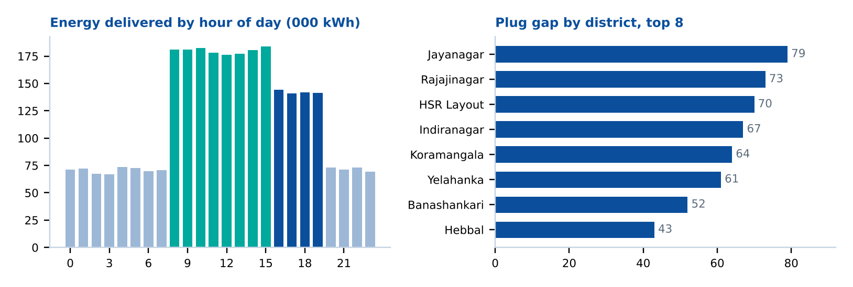
3. Customers and vehicles
Income tier | Customers | Revenue (₹ lakh) | Revenue share | kWh share | Revenue per kWh
High | 1,190 | 128.69 | 26% | 31% | ₹14.48
Low-Mid | 3,990 | 130.68 | 26% | 33% | ₹13.85
Mid-Range | 2,820 | 237.57 | 48% | 36% | ₹23.12
Total | 8,000 | 496.94 | 100% | 100% | ₹17.38

Across 25 EV models (average battery 31.4 kWh), the Mahindra XUV400 EC Pro (158k kWh), Hyundai Kona (157k) and Tata Punch (145k) lead; the Tata Nexon EV Max trails at 71k. Mid-size batteries (25–40 kWh) draw the most energy per model, 32% above small packs and 78% above large ones (40–65 kWh), while premium packs (>65 kWh) sit about 22% below the mid band. The High-income tier owns 9 of the 25 models yet shows the lowest usage.
4. Financial performance and expansion
Across 98 proposed projects, CAPEX is ₹13,921.62 lakh against annual revenue of ₹4,628.64 lakh (CAPEX is 3.0× revenue), OPEX of ₹1,390.11 lakh (30%) and EBITDA of ₹3,238.53 lakh (70% margin). The ten largest projects hold ₹3,474 lakh (25% of CAPEX); the top three (PRJ007, PRJ017, PRJ012) alone are 10.6%. Of the 98 sites, 54 are High priority (55%), 7 Medium and 37 Low; 55 are subsidy-eligible. Payback with subsidy rises with charger power: 2.0 years for AC 7.4 kW, 3.0 for AC 22 kW, 5.7 for DC 50 kW and 9.6 for DC 150 kW.
Projected EVs of 35,200 imply about 33 vehicles per planned plug, against roughly 90 per existing plug today. Combining district ROI with the plug gap gives the sequencing below.
Action | Districts | Rule applied
Deploy first | Jayanagar, HSR Layout, Banashankari | ROI ≥ 45% and gap ≥ 50 plugs
Quick win | Bommanahalli, Electronic City, JP Nagar, Marathahalli | ROI ≥ 50%, gap < 50 plugs
Phase 2 | Rajajinagar, Yelahanka | ROI 30–45%, gap ≥ 60 plugs
Pilot only | Hebbal | ROI below 30%
District ROI (top 10): Bommanahalli 133%, Electronic City 78%, JP Nagar 66%, HSR Layout 57%, Marathahalli 53%, Jayanagar 49%, Banashankari 45%, Yelahanka 42%, Rajajinagar 33%, Hebbal 19%. Indiranagar (+67 plugs) and Koramangala (+64) have no ROI in the model and are not scored.
5. Recommendations
- Deploy High-priority sites first and sequence districts using the table above.
- Favour AC Level-2 and DC Fast chargers; limit 150 kW ultra-fast units to proven corridors, since their payback is 9.6 years.
- Fix weak economics before scaling: Hebbal and districts outside the top-10 ROI list pull the portfolio to 16%.
- Price by time and tier: use overnight offers to lift the overnight 30% energy share, and protect the Mid-Range yield of ₹23/kWh.
- Review stations 75, 155 and 151, the lowest-loaded sites, for placement, signage and uptime.
6. Data notes and limitations
The dataset is synthetic and covers about 90 days, so August and November are part-months. Every station has a uniform 6 plugs, which is a placeholder. The data dictionary states a range to 31 Dec 2024, but the file ends on 8 Nov. Per-model vehicle counts are unavailable, land lease and infrastructure are not split out, and the priority thresholds above are analyst-defined. Two source-dashboard KPIs were restated: “1,754 per plug” is per station, and “25.1 per station” is per session.

