Contents

1. Project Introduction and Overview: 2

Introduction 2

Objective: 2

Features: 2

Technologies Used: 2

How It Works: 3

Project Background 3

Problem Statement 3

Approach: 4

System Design 5

1. Implementation 5

2. Output 7

# Project Introduction and Overview:

## Introduction

Welcome to the Insurance Policy HelpMate AI project! This notebook demonstrates how to build an AI-driven assistant that helps users understand, compare, and manage insurance policies efficiently.

## Objective:

The goal is to create an intelligent system that assists users in navigating insurance policies by providing:

* **Personalized recommendations** based on user needs.
* **Comparison of different policies** to highlight key differences.
* **Guidance on the claims process** to simplify documentation and submission.
* **Regulatory insights** to explain legal terms and policy conditions.

## Features:

* **Policy Recommendations:** Suggest the best insurance policy based on coverage needs and budget.
* **Policy Comparison:** Highlight differences in coverage, premium, exclusions, and benefits.
* **Claims Assistance:** Guide users through the claims process with documentation support.
* **Renewal Alerts:** Remind users about policy renewals and suggest alternatives if needed.
* Technologies Used:
* OpenAI's GPT Model: For natural language processing and conversational capabilities.
* APIs: To fetch live travel data, such as flights, accommodations, and activities.
* Python Libraries: For data processing, visualization, and integration with external services.

## Technologies Used:

* **OpenAI's GPT Model:** For understanding user queries and generating policy recommendations.
* **APIs:** To fetch live insurance data, premium rates, and claim status updates.
* **Python Libraries:** For data processing, visualization, and integration with external services.

## How It Works:

1. **User Inputs** details such as insurance type (health, auto, life, etc.), budget, and coverage requirements.
2. **AI Processes** the data and retrieves relevant policy information.
3. **Personalized Recommendations** are generated based on affordability and coverage suitability.
4. **Comparison & Explanation** help users make informed decisions.
5. **Ongoing Assistance**includes claim support, policy renewal reminders, and answering user queries.

## Project Background

Choosing the right insurance policy is a complex and often overwhelming task. Consumers must navigate a wide range of options, comparing coverage, premiums, exclusions, and terms across different providers. Understanding policy details, filing claims, and staying updated on renewals can be daunting, especially for those unfamiliar with insurance terminology and regulations.

With the advancement of AI technologies like ChatGPT, we have an opportunity to simplify this process. By leveraging natural language processing, machine learning, and real-time data integration, we can develop an intelligent assistant that helps users understand, compare, and manage insurance policies effectively.

This project aims to create an **AI-powered Insurance Policy HelpMate**, providing users with personalized recommendations, easy-to-understand policy comparisons, and real-time assistance with claims and renewals. By automating and simplifying these processes, the system will enhance decision-making and improve the overall user experience.

## Problem Statement

Navigating insurance policies can be challenging due to several key issues:

1. **Complexity of Policy Terms:** Insurance documents are often filled with technical jargon, making it difficult for users to understand coverage details and exclusions.
2. **Overwhelming Choices:** Consumers are presented with a vast number of insurance providers and plans, leading to decision fatigue.
3. **Lack of Personalization:** Many existing insurance recommendation tools provide generic suggestions that may not align with individual needs and financial situations.
4. **Inefficient Claims Process:** Users struggle with understanding claim procedures, required documents, and processing times, leading to frustration and delays.
5. **Policy Management Challenges:** Tracking policy renewals, premium due dates, and coverage changes is often cumbersome, leading to lapses in coverage.

To address these challenges, we propose **Insurance Policy HelpMate AI**, an AI-driven assistant designed to provide users with personalized policy recommendations, simplified explanations, easy-to-use comparison tools, and step-by-step claims guidance. This system will enhance accessibility, transparency, and efficiency in managing insurance policies.

## Approach:

**Project Implementation:** Three-Layer Approach

The project should implement all three layers effectively. It will be key to try out various strategies and experiments in each layer to build an effective search system. Let's explore what you need to do in each of the layers and the possible experimentations that you can perform based on various choices.

**The Embedding Layer**

The PDF document needs to be effectively processed, cleaned, and chunked for the embeddings. Here, the choice of the chunking strategy will have a large impact on the final quality of the retrieved results. So, make sure that you try out various strategies and compare their performances.

Another important aspect in the embedding layer is the choice of the embedding model. You can choose to embed your chunks using the OpenAI embedding model or any model from the SentenceTransformers library on HuggingFace.

**The Search Layer**

1. Design Queries
   * First need to design at least three queries against which you will test the system.
   * Skim through the document and accordingly come up with queries whose answers can be found in the policy document.
2. Query Embedding and Search
   * Embed the queries and search ChromaDB vector database against each query.
   * Implementing a cache mechanism is also mandatory.
3. Re-Ranking Block
   * Finally, need to implement the re-ranking block.
   * Can choose from a range of cross-encoding models on HuggingFace.

**The Generation Layer**

In the generation layer, the final prompt that you design is the major component.

* Ensure that the prompt is exhaustive in its instructions.
* The relevant information should be correctly passed to the prompt.

## System Design

# Implementation

**Stage 1: Embedding Layer**

The embedding layer is typically the first component of a RAG (Retrieval-Augmented Generation) model. It contains an embedding model trained on a vast dataset of text and code, enabling it to learn relationships between words and phrases. This layer generates embeddings that represent these relationships, allowing the system to comprehend the meaning of the text it processes and its semantic connection to the query.

By converting text into numerical representations, the embedding layer enables the RAG model to interpret user queries and retrieve relevant information. This foundational step is essential for tasks such as question answering, summarization, and machine translation, as it ensures the model understands the meaning and context of the input.

**Stage 2: Search and Re-Rank Layer**

The search and re-rank layer is a critical component responsible for retrieving relevant information from an external knowledge base, ranking it based on relevance to the input query, and passing it to the generation layer for further processing. This ensures that the retrieved content is accurate, contextually appropriate, and useful for generating responses.

The search and re-rank layer consists of two key components:

* **Search Component**: Uses various techniques, including semantic similarity, to identify and retrieve relevant documents from the knowledge base. Semantic similarity measures how closely two pieces of text relate in meaning, helping the model find the most relevant documents.
* **Re-Rank Component**: Refines the retrieved results by applying different ranking techniques, such as:
  + **Relevance Ranking**: Prioritizes documents based on their relevance to the user’s query.
  + **Popularity Ranking**: Ranks documents based on their popularity (e.g., number of views or shares).
  + **Freshness Ranking**: Prioritizes recently published or updated content.

This layer plays a vital role in enhancing the accuracy of AI-driven tasks like question answering, summarization, and machine translation. By retrieving and re-ranking relevant documents efficiently, the search and re-rank layer significantly improves the performance of RAG models in generating high-quality responses.

**Stage 3: Generation Layer**

The generation layer is typically the final stage of a RAG model and consists of a foundation large language model trained on extensive text and code datasets. As the name suggests, this layer is responsible for generating new text in response to user queries.

By synthesizing the retrieved information, the generative model constructs coherent and contextually appropriate responses. This capability is crucial for various AI-driven applications, including question answering, summarization, machine translation, and generative search, particularly in the context of RAG-based search engines.

In the search domain, the generation layer enhances results by providing natural language capabilities and contextual understanding, making responses more meaningful and tailored to user queries.

# Output

**Top 3 Results from the Search Layer:**

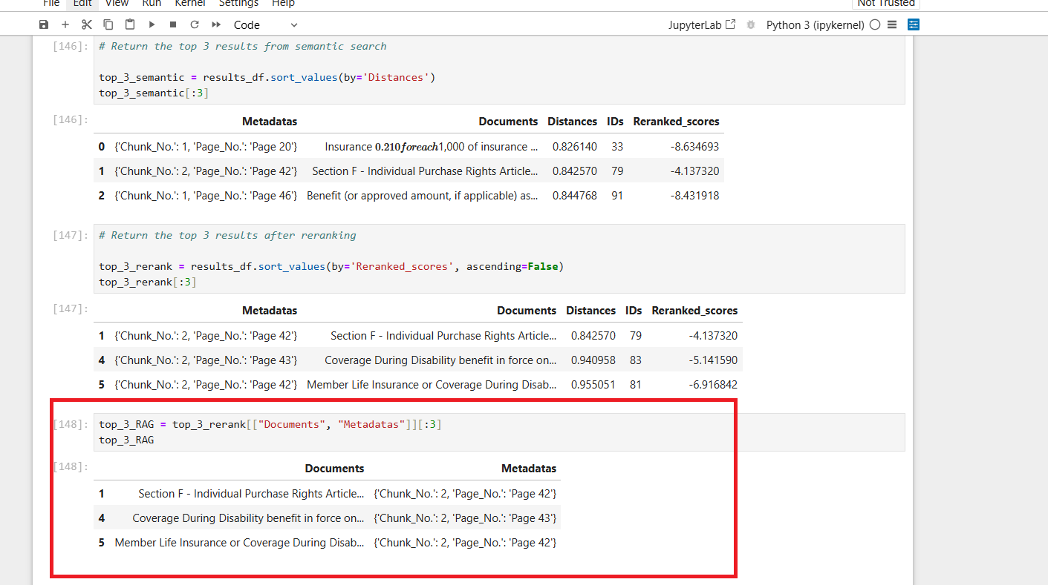

**Final Generated Answer from the Generation Layer:**

