**I. Profile the following table in the Northwind Traders Database. The first two have been done for you in the previous part.**

|  |  |  |  |  |
| --- | --- | --- | --- | --- |
| **Table** | **Type** | **Row Count** | **Business Key** | **One Row Is** |
| Employees | Master Data | 9 | None (PK used) | An Employee |
| EmployeeTerritories | Business Process | 49 | None (PK’s used) | An Employee assigned to a territory. |
| Customers | Master Data | 91 | None (PK used) | A customer |
| Suppliers | Master Data | 29 | None (PK used) | A supplier |
| Products | Master Data | 77 | None (PK’s used) | A product detail |
| Shipments (of Orders) | Business Process | 830 | OrderID | The shipment detail of an order |
| Details (of an Order) | Business Process | 2155 | None (PK’s used) | The product details of an order |

**II. Write SQL Queries to answer the following questions which might be associated with functional business requirements in a data warehouse. For each of the following provide a screen shot of the SQL query, its output, and make sure your name or netid appears in the screenshot.**

1. List the customer contact names and titles sorted by company name.

**select ContactName, ContactTitle from Customers order by CompanyName**

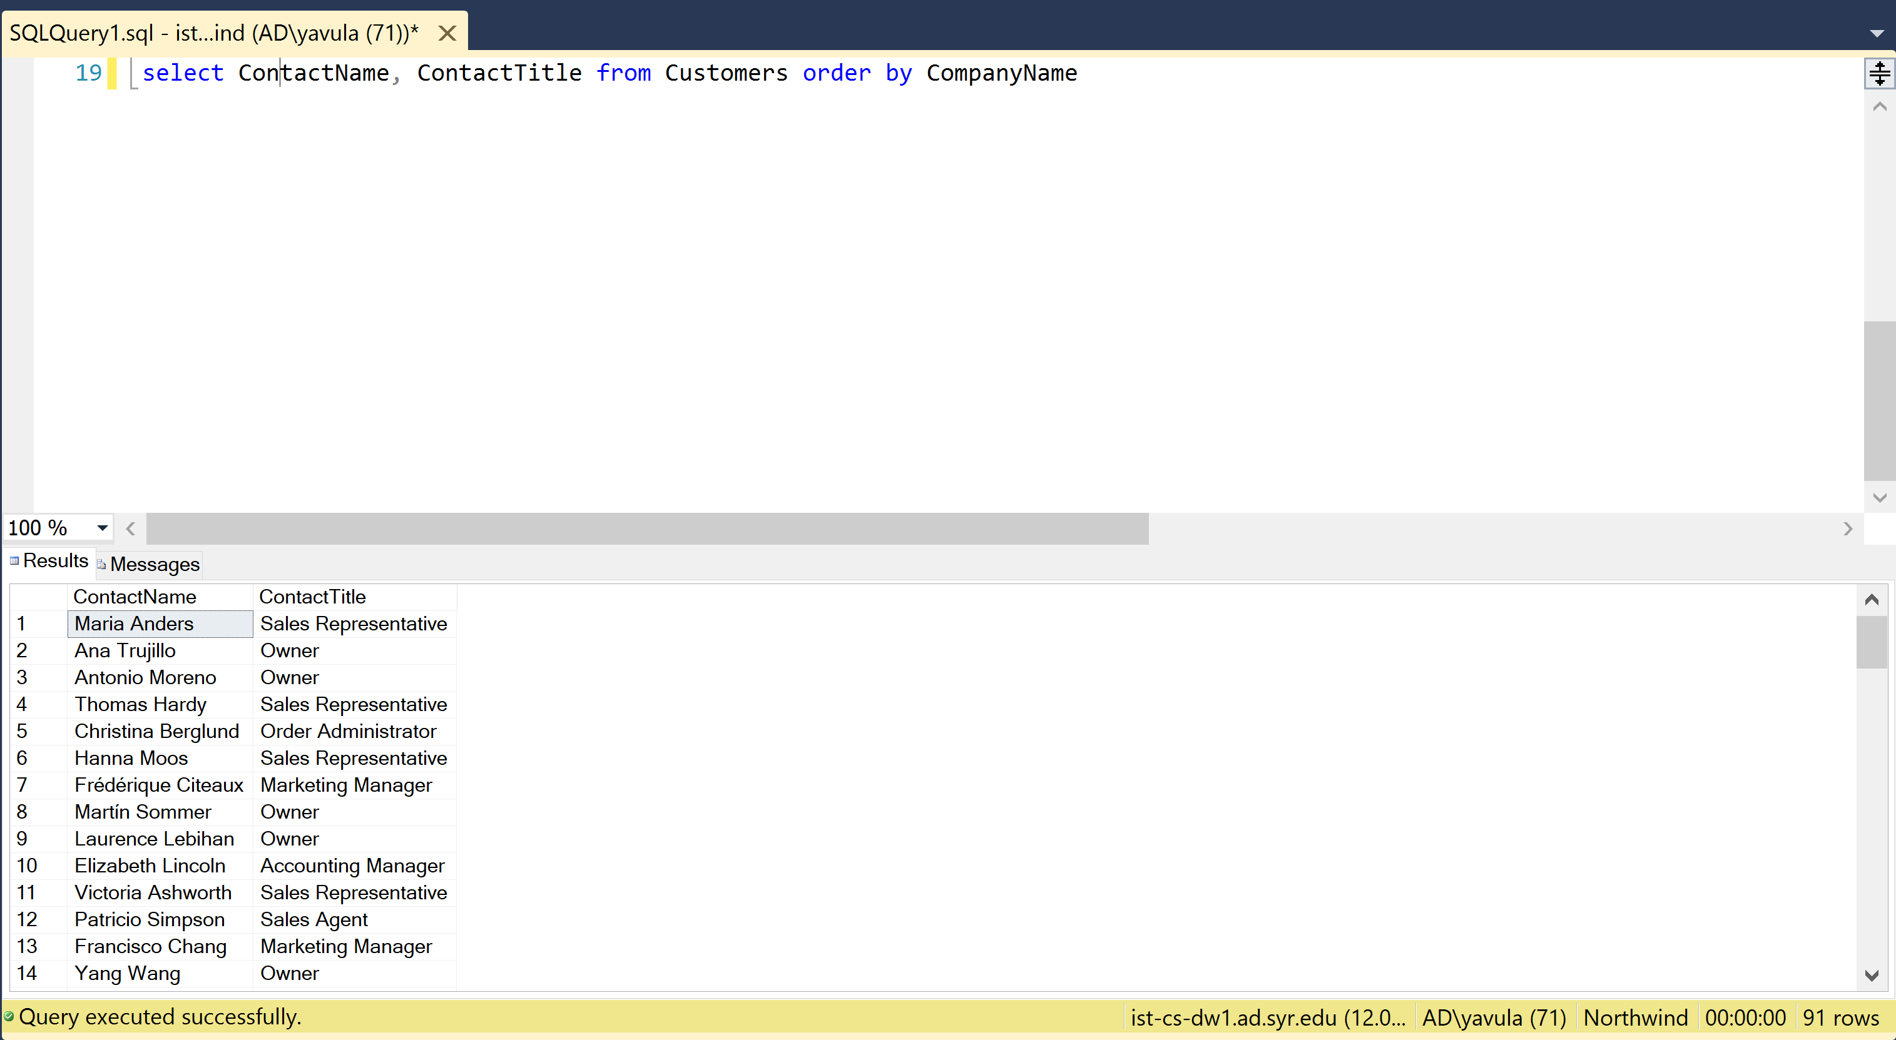

1. Factoring in discounts, what is total amount of product sold?

**select ProductID,(UnitPrice*Quantity)-((UnitPrice*Quantity)*Discount) as TotalProductAmount from [Order Details]**

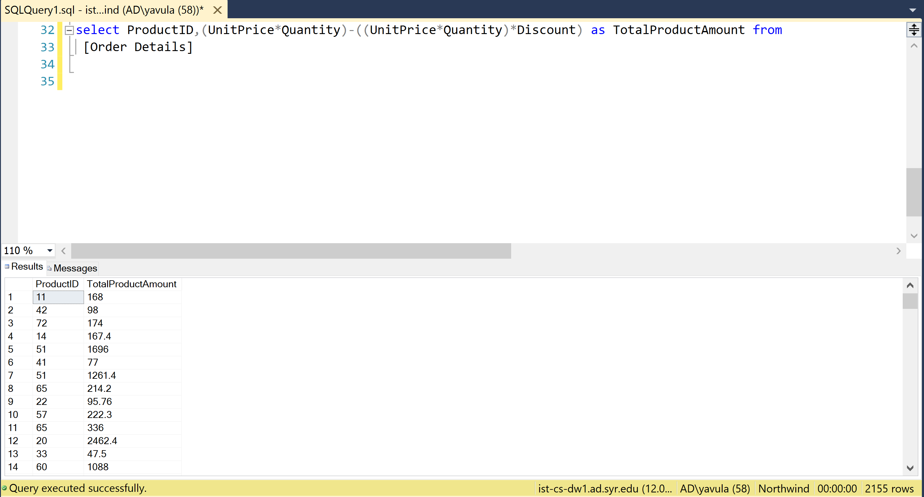

1. Provide a list of product category names with counts of products in each category.

**select x.CategoryName,count(y.ProductID) as ProductCount from Categories x join Products y on x.CategoryID=y.CategoryID group by x.CategoryName**

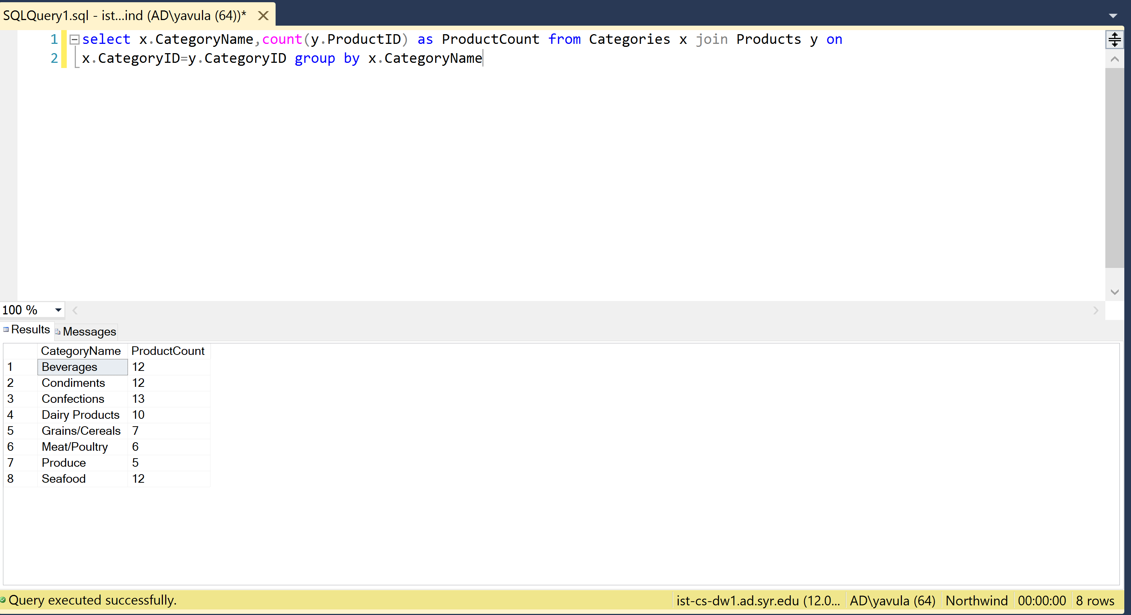

1. Select a specific customer and display that customer’s orders with total amount of product sold for each order.

**select x.ContactName, y.OrderID, round(sum(UnitPrice*(1-Discount)* Quantity), 2) As totalAmount from Customers x Join Orders y on x.CustomerID = y.CustomerID Join [Order Details] z On y.OrderID = z.OrderID where x.CustomerID = 'PRINI' group by y.OrderID, x.ContactName**

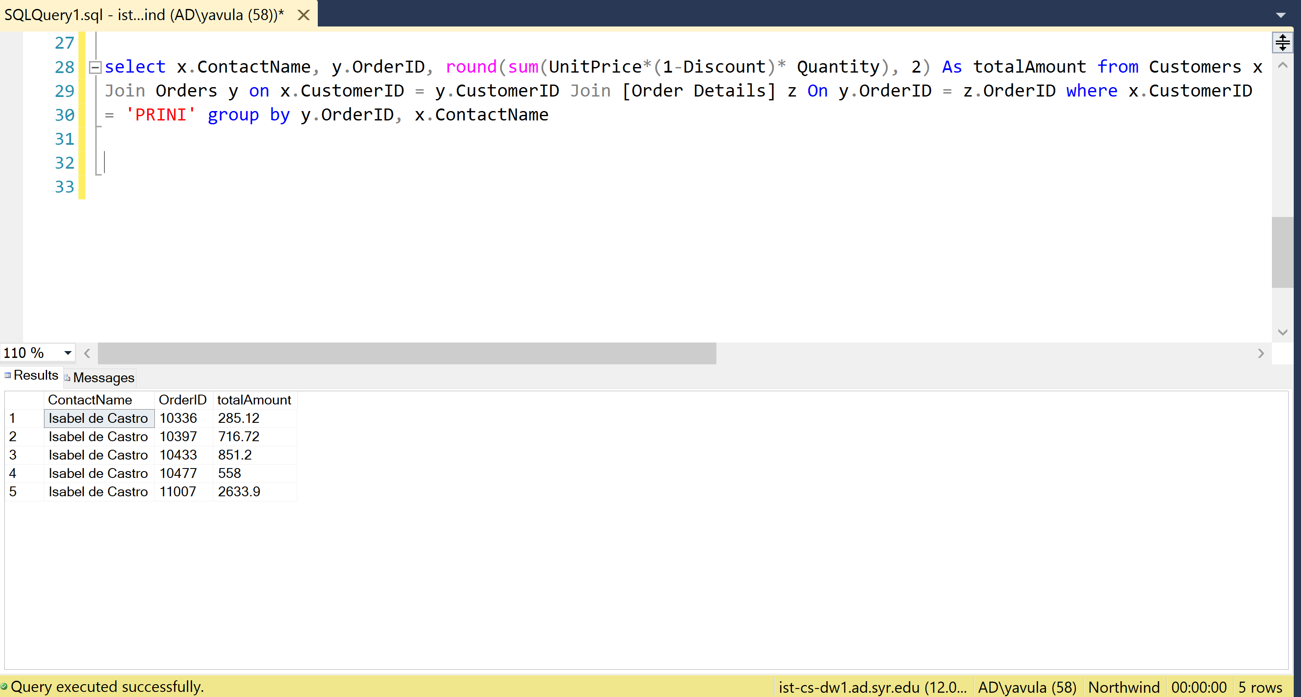

1. Select a specific employee and each order, how it was shipped (shipvia) company who shipped it, and the total number of days elapsed from order date to shipped date.

**select x.EmployeeID, y.OrderID, y.ShipVia, z.CompanyName, datediff(day, y.OrderDate, y.ShippedDate) As TotNumOfDays from Orders y join Employees x on y.EmployeeID = x.EmployeeID join Shippers z on y.ShipVia = z.ShipperID where x.EmployeeID = 9 group by x.EmployeeID, y.OrderID, y.ShipVia, y.OrderDate, y.ShippedDate, z.CompanyName**

