Pivot Table showing the quantity, sales count and sold amount of a category of product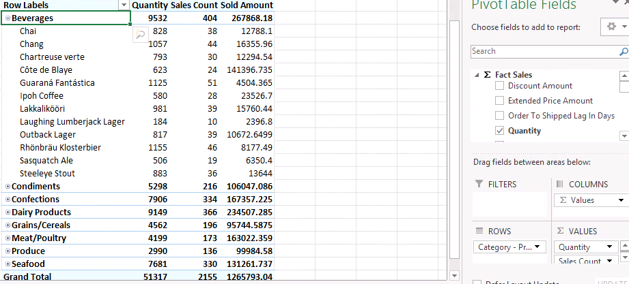

Power pivot of a product where the order to shipped lag in days is seen as per a hierarchy of whether it is a weekday, what day of week it is and what is the date on that day.  
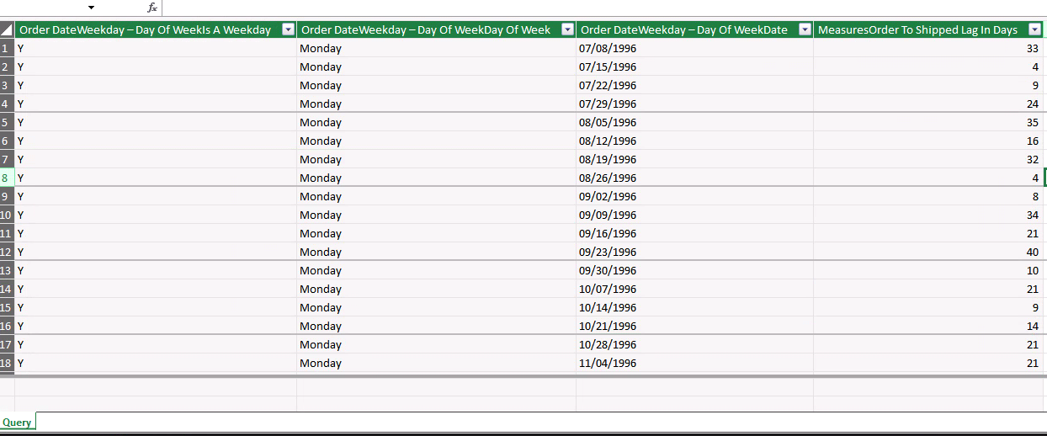

Power View of the above pivot table where the order to shipped lag in days is grouped by the day of week.

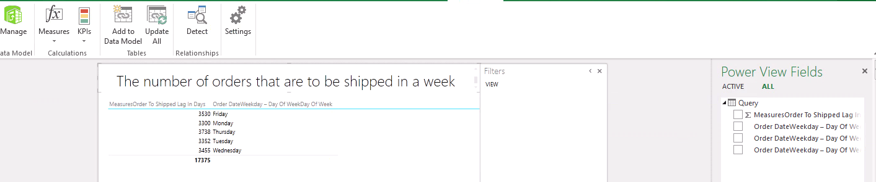

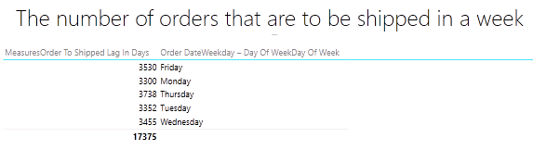

Power BI dashboard showing the sold amount and discount amount by a particular employee having a particular supervisor.

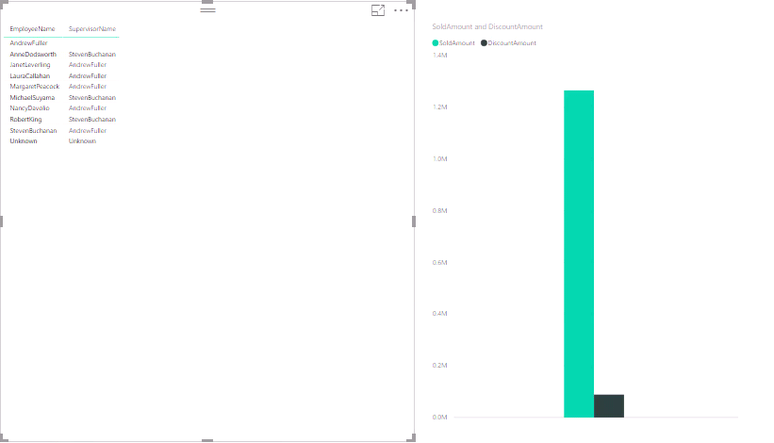

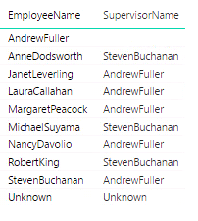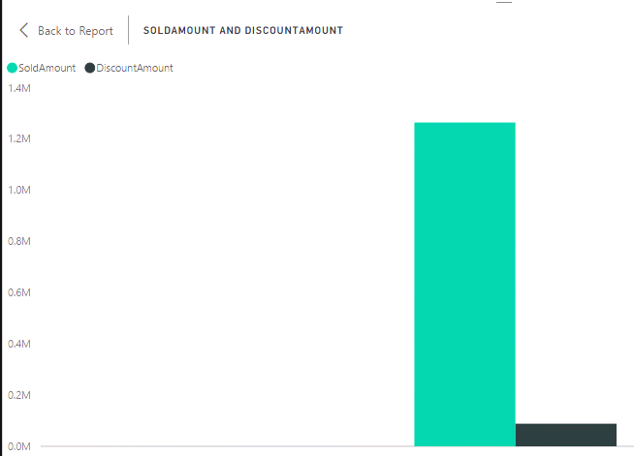

The following figure is more specific version of the above visualization where a specific employee is chosen. It gives the supervisor of that particular employee and the level of amount sold and discount given by that employee-supervisor pair as compared to the overall amount sold and discount given by the employee-supervisor pairs.

