PROJECT REPORT

Aadhaar Enrollment & Update Gap Analysis
Using UIDAI Open Data

Submitted for
AICTE | IBM SkillsBuild Data Analytics with AI
Academic Internship Program 2026
Conducted by BharatCares in association with AICTE

Submitted by
P Yawan Kumar
B.Tech —HITAM, Computer Science & Engineering
September 2026

1. Problem Statement & Approach

1.1 Problem Statement
Analyzing Aadhaar Enrollment and Update Trends Across Age Groups and Regions to Identify Gaps in Access to Government Digital Identity Services.

1.2 The Core Challenge
While Aadhaar enrollment has reached near-saturation, the maintenance of digital identity (biometric/demographic updates) remains uneven. This analysis identifies specific "Update Deserts" — regions and demographics where citizens are enrolled but digitally dormant due to accessibility barriers.

1.3 Our Approach
- Data Aggregation: Merged fragmented datasets (Enrollment, Demographic, Biometric) into a unified state-level view.
- Gap Analysis: Compared "Static Enrollment" vs. "Active Updates" to measure service engagement.
- Vulnerability Mapping: Used Heatmaps and Scatter Plots to identify age groups (specifically children) excluded from the update ecosystem.

2. Datasets Used
Source: UIDAI Open Data Platform (aggregated levels).

Key Datasets
- Aadhaar Enrollment Data: Used to establish the baseline user base (Columns: State, Age_0_5, Age_5_17, Age_18+).
- Demographic Update Data: Used to measure voluntary citizen engagement (Columns: Update_Count, Age_Group).
- Biometric Update Data: Used to track mandatory lifecycle changes and workforce migration trends.

3. Methodology

3.1 Data Preprocessing & Cleaning
- Standardization: Normalized state names across multiple CSV files to ensure consistent merging.
- Handling Missing Values: Imputed NaN values with 0 for count-based columns to maintain aggregate accuracy.
- Date Parsing: Converted heterogeneous date formats to a standard datetime object for trend analysis.

3.2 Feature Engineering
- The 'Update Ratio' Metric: Created a custom metric (Total Updates / Total Enrollment) to normalize activity levels across large and small states.
- Cohort Segmentation: Grouped data into "Future Talent" (0–18) and "Workforce" (18+) to analyze age-specific service gaps.

4. Data Analysis & Key Insights

4.1 Regional Disparity in Enrollment

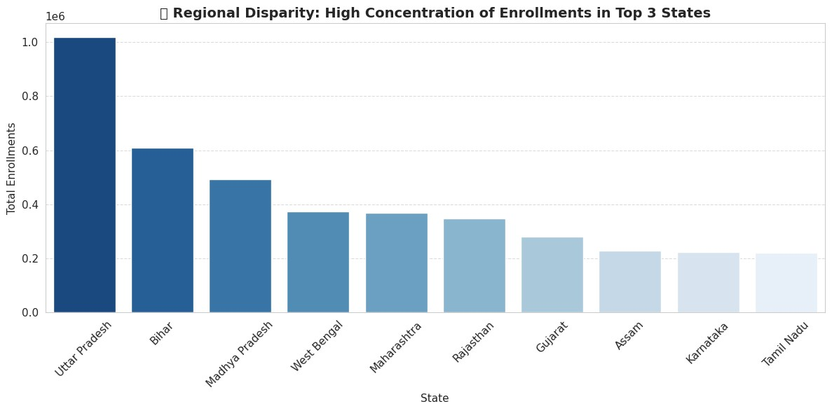
Insight: Enrollment is heavily skewed. The top 3 states (Uttar Pradesh, Bihar, Madhya Pradesh) hold the majority of the "Static User Base."

4.2 New Enrollment Demographics

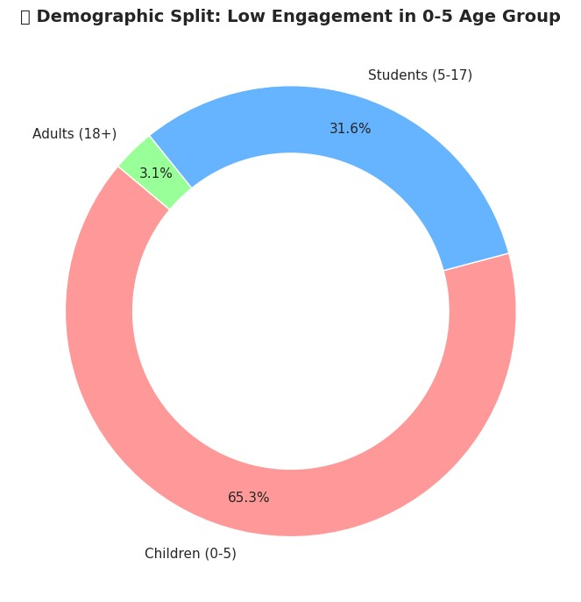
Insight: 65.3% of new enrollments are children (0–5 years). The adult market is largely saturated. The system’s challenge has shifted from "Onboarding Adults" to "Managing Newborns."

4.3 The Service Gap (Enrollment vs. Activity)

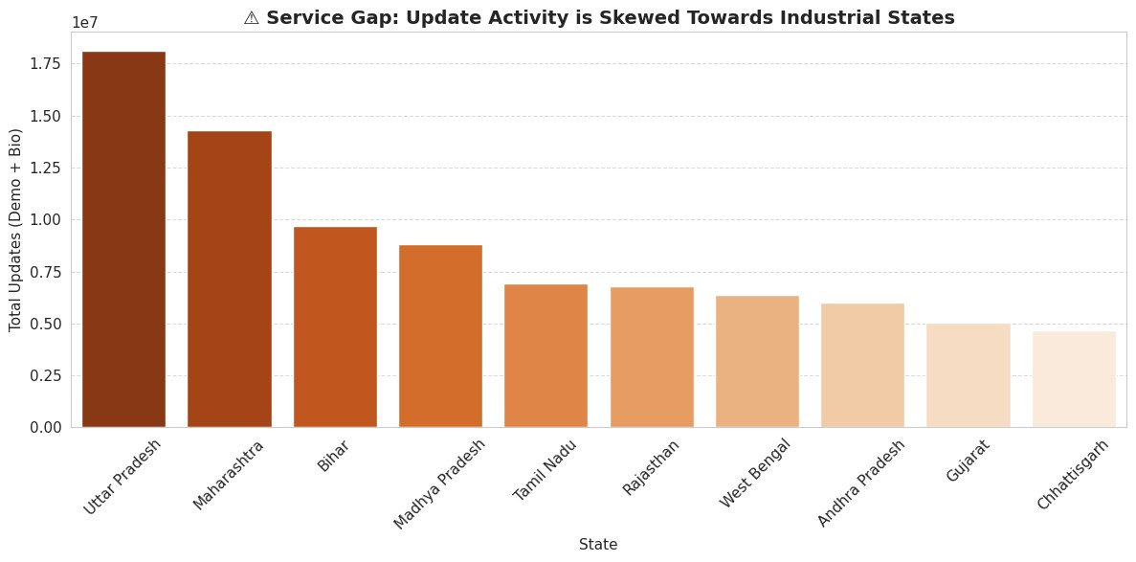
Insight: While Uttar Pradesh leads in enrollment, industrial states like Maharashtra jump to #2 in updates. This indicates "Migration-Driven Activity" — people update Aadhaar primarily when migrating for jobs, leaving non-migrant populations in source states with outdated data.

4.4 Post-Enrollment Service Gap (Scatter Plot Analysis)

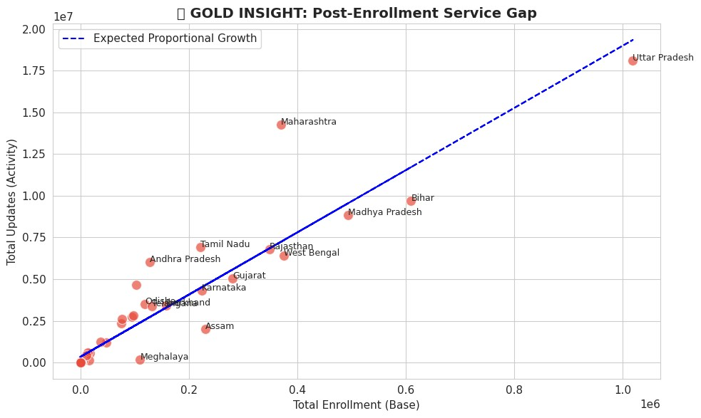
Insight: States significantly below the ideal growth line (e.g., Bihar, Assam) have high enrollment but disproportionately low updates. These are the "Dormant Zones" requiring immediate intervention.

4.5 Age-Exclusion Heatmap

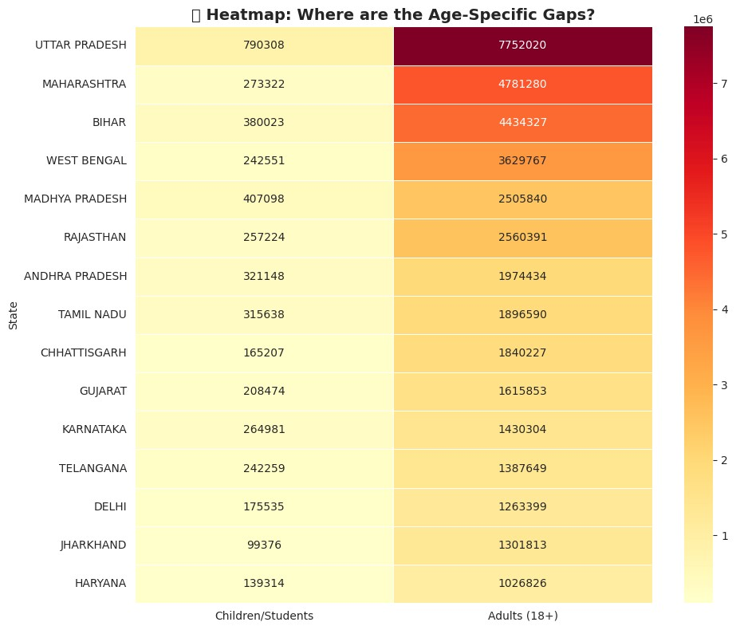
Key Insight: The heatmap reveals a structural bias. The "Adults" column is active (high intensity), while the "Children" column is pale across almost all states. The infrastructure serves independent adults but fails dependent children.

4.6 Efficiency Score (Update Ratio)

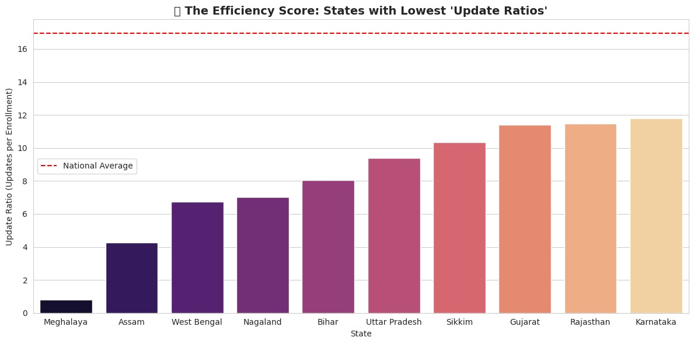
Insight: Even major states fall below the National Average in update efficiency. This metric proves that high enrollment does not guarantee sustained digital access.

5. Technology Stack
- Python — Main programming language
- Pandas & NumPy — Data cleaning, transformation, and numerical analysis
- Matplotlib & Seaborn — Data visualization and statistical charts
- Jupyter Notebook / Google Colab — Analysis environment
- AI Tools (ChatGPT / Gemini) — Assisted in code generation, insight framing, and documentation

6. Impact & Conclusion

6.1 Applicability
- Policy: The "Update Ratio" acts as a live metric for the Ministry of Electronics and IT (MeitY) to track digital identity health.
- Feasibility: Instead of nationwide campaigns, resources can be targeted specifically at the "Yellow Zones" (Children in rural districts) identified in the Heatmap.

6.2 Conclusion
Our analysis proves that while India has solved the Identity Creation challenge, the Identity Maintenance challenge persists. By focusing on the "Service Gaps" identified in this report, UIDAI can ensure that Aadhaar remains a dynamic, accessible tool for every citizen, regardless of age or region.

7. Internship Context
This project is submitted as part of the AICTE | IBM SkillsBuild Data Analytics with AI Internship 2026 conducted by BharatCares.
The analysis demonstrates end-to-end data analytics skills including data cleaning, feature engineering, exploratory data analysis, gap identification, visualization, and conversion of insights into actionable recommendations — aligned with the Business Intelligence approach taught in the program.

8. Author
Name: P Yawan Kumar
Program: B.Tech — Computer Science & Engineering,HITAM
Interests: Data Analytics | Business Intelligence | AI & Data-driven Problem Solving
GitHub: Github
Project Repository: Aadhaar-Enrollment-Update-Gap-Analysis

